Hibiscus sabdariffa synthesized gold nanoparticles ameliorate aluminum chloride induced memory deficits through inhibition of COX-2/BACE-1 mRNA expression in rats
Scholastica O. Anadozie^{a*}, Duncan O. Effiomª, Olusola B. Adewaleª, Jodie Judeª, Itumeleng Zosela^{b}, Oluwole B. Akawa^{cd}, Juliet N. Olayinka^{e} and Saartjie Roux^{b}
ªBiochemistry Program, Department of Chemical Sciences, Afe Babalola University, P.M.B 5454, Ado-Ekiti, Nigeria.
^{b}Department of Human Physiology, Nelson Mandela University, P.O Box 77000, Port Elizabeth, South Africa.
^{c}Department of Pharmacology and Toxicology, College of Pharmacy, Afe Babalola University, P.M.B 5454, Ado-Ekiti, Nigeria.
^{d}Molecular Biocomputation and Drug Design Laboratory, School of Health Sciences, University of KwaZulu-Natal, Westville Campus, Durban, 4001, South Africa.
^{e}Department of Pharmacology and Therapeutics, College of Medicine and Health Sciences, Afe Babalola University, P.M.B 5454, Ado-Ekiti, Nigeria.
*Author to whom correspondence should be addressed.
Email address: anadozieso@abuad.edu.ng;scholanad2019@gmail.com
Mobile number: +234 813 3254 737
ORCID: 0000-0003-4118-4611

Table S1: UV-vis absorption values of H. sabdariffa synthesized-AuNPs at 1, 24 and 48 h interval
HS-AuNPs
Absorbance Spectrum 1
Wavelength: 350-750 nm
Wavelength | 1 hr after synthesis (centrifuged) | 24hr after synthesis (centrifuged) | 48hr after synthesis (centrifuged)
350 | 0.403 | 0.404 | 0.404
351 | 0.403 | 0.403 | 0.404
352 | 0.402 | 0.402 | 0.402
353 | 0.401 | 0.401 | 0.402
354 | 0.401 | 0.401 | 0.402
355 | 0.400 | 0.400 | 0.401
356 | 0.400 | 0.400 | 0.400
357 | 0.399 | 0.399 | 0.400
358 | 0.399 | 0.398 | 0.399
359 | 0.398 | 0.398 | 0.399
360 | 0.397 | 0.397 | 0.399
361 | 0.396 | 0.396 | 0.398
362 | 0.396 | 0.396 | 0.397
363 | 0.395 | 0.395 | 0.396
364 | 0.394 | 0.394 | 0.396
365 | 0.394 | 0.394 | 0.395
366 | 0.393 | 0.393 | 0.394
367 | 0.392 | 0.392 | 0.393
368 | 0.391 | 0.391 | 0.392
369 | 0.390 | 0.390 | 0.391
370 | 0.390 | 0.390 | 0.390
371 | 0.388 | 0.388 | 0.389
372 | 0.387 | 0.387 | 0.388
373 | 0.386 | 0.386 | 0.387
374 | 0.385 | 0.385 | 0.387
375 | 0.384 | 0.384 | 0.386
376 | 0.384 | 0.384 | 0.384
377 | 0.383 | 0.383 | 0.384
378 | 0.382 | 0.382 | 0.383
379 | 0.381 | 0.381 | 0.382
380 | 0.381 | 0.381 | 0.382
381 | 0.380 | 0.380 | 0.381
382 | 0.379 | 0.379 | 0.380
383 | 0.378 | 0.378 | 0.379
384 | 0.378 | 0.378 | 0.378
385 | 0.377 | 0.377 | 0.378
386 | 0.376 | 0.376 | 0.377
387 | 0.375 | 0.375 | 0.376
388 | 0.374 | 0.374 | 0.375
389 | 0.373 | 0.373 | 0.374
390 | 0.373 | 0.373 | 0.373
391 | 0.372 | 0.372 | 0.373
392 | 0.371 | 0.371 | 0.372
393 | 0.370 | 0.370 | 0.371
394 | 0.369 | 0.369 | 0.370
395 | 0.368 | 0.368 | 0.369
396 | 0.368 | 0.368 | 0.368
397 | 0.366 | 0.366 | 0.367
398 | 0.366 | 0.366 | 0.366
399 | 0.365 | 0.365 | 0.366
400 | 0.364 | 0.364 | 0.365
401 | 0.364 | 0.364 | 0.364
402 | 0.363 | 0.363 | 0.364
403 | 0.362 | 0.362 | 0.362
404 | 0.362 | 0.362 | 0.362
405 | 0.361 | 0.361 | 0.362
406 | 0.361 | 0.361 | 0.361
407 | 0.360 | 0.360 | 0.361
408 | 0.359 | 0.359 | 0.360
409 | 0.359 | 0.359 | 0.360
410 | 0.358 | 0.358 | 0.359
411 | 0.358 | 0.358 | 0.358
412 | 0.357 | 0.357 | 0.358
413 | 0.356 | 0.356 | 0.357
414 | 0.356 | 0.356 | 0.356
415 | 0.356 | 0.356 | 0.356
416 | 0.355 | 0.355 | 0.355
417 | 0.355 | 0.355 | 0.355
418 | 0.354 | 0.354 | 0.354
419 | 0.353 | 0.353 | 0.354
420 | 0.353 | 0.353 | 0.353
421 | 0.352 | 0.352 | 0.352
422 | 0.352 | 0.352 | 0.353
423 | 0.352 | 0.352 | 0.352
424 | 0.351 | 0.351 | 0.352
425 | 0.351 | 0.351 | 0.351
426 | 0.351 | 0.351 | 0.351
427 | 0.350 | 0.350 | 0.350
428 | 0.350 | 0.350 | 0.350
429 | 0.350 | 0.350 | 0.350
430 | 0.349 | 0.349 | 0.349
431 | 0.349 | 0.349 | 0.349
432 | 0.349 | 0.349 | 0.349
433 | 0.349 | 0.349 | 0.349
434 | 0.348 | 0.348 | 0.348
435 | 0.348 | 0.348 | 0.348
436 | 0.348 | 0.348 | 0.348
437 | 0.348 | 0.348 | 0.348
438 | 0.348 | 0.348 | 0.348
439 | 0.348 | 0.348 | 0.348
440 | 0.347 | 0.347 | 0.348
441 | 0.347 | 0.347 | 0.347
442 | 0.347 | 0.347 | 0.347
443 | 0.347 | 0.347 | 0.347
444 | 0.347 | 0.347 | 0.347
445 | 0.347 | 0.347 | 0.347
446 | 0.347 | 0.347 | 0.347
447 | 0.347 | 0.347 | 0.347
448 | 0.348 | 0.348 | 0.348
449 | 0.348 | 0.348 | 0.348
450 | 0.348 | 0.348 | 0.348
451 | 0.348 | 0.348 | 0.348
452 | 0.349 | 0.349 | 0.348
453 | 0.349 | 0.349 | 0.349
454 | 0.349 | 0.349 | 0.349
455 | 0.349 | 0.349 | 0.349
456 | 0.350 | 0.350 | 0.350
457 | 0.350 | 0.350 | 0.350
458 | 0.351 | 0.351 | 0.350
459 | 0.351 | 0.351 | 0.351
460 | 0.351 | 0.351 | 0.351
461 | 0.352 | 0.352 | 0.352
462 | 0.352 | 0.352 | 0.352
463 | 0.353 | 0.353 | 0.353
464 | 0.354 | 0.354 | 0.354
465 | 0.355 | 0.355 | 0.355
466 | 0.356 | 0.356 | 0.356
467 | 0.357 | 0.357 | 0.357
468 | 0.358 | 0.358 | 0.358
469 | 0.360 | 0.360 | 0.359
470 | 0.361 | 0.361 | 0.360
471 | 0.362 | 0.362 | 0.362
472 | 0.364 | 0.364 | 0.363
473 | 0.365 | 0.365 | 0.365
474 | 0.367 | 0.367 | 0.366
475 | 0.368 | 0.368 | 0.367
476 | 0.370 | 0.370 | 0.369
477 | 0.371 | 0.371 | 0.371
478 | 0.373 | 0.373 | 0.373
479 | 0.374 | 0.374 | 0.374
480 | 0.377 | 0.377 | 0.376
481 | 0.378 | 0.378 | 0.378
482 | 0.381 | 0.381 | 0.380
483 | 0.383 | 0.383 | 0.383
484 | 0.385 | 0.385 | 0.385
485 | 0.387 | 0.387 | 0.387
486 | 0.390 | 0.390 | 0.389
487 | 0.393 | 0.393 | 0.392
488 | 0.397 | 0.397 | 0.396
489 | 0.399 | 0.399 | 0.399
490 | 0.403 | 0.403 | 0.402
491 | 0.407 | 0.407 | 0.407
492 | 0.411 | 0.411 | 0.410
493 | 0.414 | 0.414 | 0.414
494 | 0.418 | 0.418 | 0.418
495 | 0.423 | 0.423 | 0.422
496 | 0.427 | 0.427 | 0.426
497 | 0.431 | 0.431 | 0.430
498 | 0.434 | 0.434 | 0.434
499 | 0.438 | 0.438 | 0.437
500 | 0.442 | 0.442 | 0.441
501 | 0.446 | 0.446 | 0.445
502 | 0.450 | 0.450 | 0.449
503 | 0.453 | 0.453 | 0.452
504 | 0.457 | 0.457 | 0.456
505 | 0.461 | 0.461 | 0.459
506 | 0.465 | 0.465 | 0.463
507 | 0.468 | 0.468 | 0.467
508 | 0.473 | 0.473 | 0.471
509 | 0.477 | 0.477 | 0.475
510 | 0.481 | 0.481 | 0.479
511 | 0.485 | 0.485 | 0.484
512 | 0.489 | 0.489 | 0.488
513 | 0.494 | 0.494 | 0.492
514 | 0.498 | 0.498 | 0.497
515 | 0.502 | 0.502 | 0.501
516 | 0.506 | 0.506 | 0.504
517 | 0.510 | 0.510 | 0.508
518 | 0.513 | 0.513 | 0.512
519 | 0.516 | 0.516 | 0.515
520 | 0.519 | 0.519 | 0.517
521 | 0.522 | 0.522 | 0.520
522 | 0.524 | 0.524 | 0.523
523 | 0.526 | 0.526 | 0.525
524 | 0.528 | 0.528 | 0.527
525 | 0.531 | 0.531 | 0.528
526 | 0.532 | 0.532 | 0.530
527 | 0.533 | 0.533 | 0.531
528 | 0.535 | 0.535 | 0.533
529 | 0.536 | 0.536 | 0.534
530 | 0.536 | 0.536 | 0.535
531 | 0.537 | 0.537 | 0.535
532 | 0.538 | 0.538 | 0.536
533 | 0.538 | 0.538 | 0.537
534 | 0.539 | 0.539 | 0.537
535 | 0.539 | 0.539 | 0.537
536 | 0.539 | 0.539 | 0.537
537 | 0.538 | 0.538 | 0.537
538 | 0.538 | 0.538 | 0.536
539 | 0.537 | 0.537 | 0.535
540 | 0.536 | 0.536 | 0.533
541 | 0.534 | 0.534 | 0.532
542 | 0.533 | 0.533 | 0.531
543 | 0.532 | 0.532 | 0.529
544 | 0.529 | 0.529 | 0.527
545 | 0.527 | 0.527 | 0.525
546 | 0.525 | 0.525 | 0.523
547 | 0.523 | 0.523 | 0.521
548 | 0.522 | 0.522 | 0.520
549 | 0.519 | 0.519 | 0.516
550 | 0.517 | 0.517 | 0.515
551 | 0.515 | 0.515 | 0.512
552 | 0.512 | 0.512 | 0.510
553 | 0.509 | 0.509 | 0.507
554 | 0.506 | 0.506 | 0.505
555 | 0.504 | 0.504 | 0.502
556 | 0.500 | 0.500 | 0.498
557 | 0.497 | 0.497 | 0.495
558 | 0.493 | 0.493 | 0.492
559 | 0.490 | 0.490 | 0.488
560 | 0.486 | 0.486 | 0.484
561 | 0.482 | 0.482 | 0.480
562 | 0.478 | 0.478 | 0.476
563 | 0.473 | 0.473 | 0.471
564 | 0.469 | 0.469 | 0.468
565 | 0.465 | 0.465 | 0.463
566 | 0.461 | 0.461 | 0.459
567 | 0.457 | 0.457 | 0.455
568 | 0.453 | 0.453 | 0.450
569 | 0.448 | 0.448 | 0.447
570 | 0.445 | 0.445 | 0.444
571 | 0.442 | 0.442 | 0.441
572 | 0.438 | 0.438 | 0.437
573 | 0.434 | 0.434 | 0.433
574 | 0.431 | 0.431 | 0.429
575 | 0.428 | 0.428 | 0.427
576 | 0.425 | 0.425 | 0.423
577 | 0.421 | 0.421 | 0.419
578 | 0.417 | 0.417 | 0.415
579 | 0.413 | 0.413 | 0.412
580 | 0.409 | 0.409 | 0.407
581 | 0.406 | 0.406 | 0.404
582 | 0.401 | 0.401 | 0.400
583 | 0.395 | 0.395 | 0.395
584 | 0.391 | 0.391 | 0.390
585 | 0.387 | 0.387 | 0.386
586 | 0.383 | 0.383 | 0.382
587 | 0.378 | 0.378 | 0.377
588 | 0.373 | 0.373 | 0.372
589 | 0.369 | 0.369 | 0.368
590 | 0.366 | 0.366 | 0.365
591 | 0.361 | 0.361 | 0.360
592 | 0.357 | 0.357 | 0.356
593 | 0.352 | 0.352 | 0.352
594 | 0.348 | 0.348 | 0.348
595 | 0.347 | 0.347 | 0.346
596 | 0.343 | 0.343 | 0.342
597 | 0.339 | 0.339 | 0.338
598 | 0.335 | 0.335 | 0.335
599 | 0.332 | 0.332 | 0.332
600 | 0.329 | 0.329 | 0.328
601 | 0.326 | 0.326 | 0.325
602 | 0.322 | 0.322 | 0.322
603 | 0.318 | 0.318 | 0.317
604 | 0.313 | 0.313 | 0.313
605 | 0.310 | 0.310 | 0.309
606 | 0.305 | 0.305 | 0.305
607 | 0.302 | 0.302 | 0.301
608 | 0.296 | 0.296 | 0.297
609 | 0.292 | 0.292 | 0.292
610 | 0.288 | 0.288 | 0.288
611 | 0.283 | 0.283 | 0.284
612 | 0.279 | 0.279 | 0.280
613 | 0.276 | 0.276 | 0.275
614 | 0.270 | 0.270 | 0.271
615 | 0.267 | 0.267 | 0.266
616 | 0.264 | 0.264 | 0.264
617 | 0.261 | 0.261 | 0.261
618 | 0.257 | 0.257 | 0.257
619 | 0.254 | 0.254 | 0.254
620 | 0.251 | 0.251 | 0.251
621 | 0.247 | 0.247 | 0.248
622 | 0.244 | 0.244 | 0.245
623 | 0.241 | 0.241 | 0.241
624 | 0.238 | 0.238 | 0.238
625 | 0.234 | 0.234 | 0.235
626 | 0.231 | 0.231 | 0.232
627 | 0.228 | 0.228 | 0.228
628 | 0.224 | 0.224 | 0.225
629 | 0.220 | 0.220 | 0.221
630 | 0.217 | 0.217 | 0.217
631 | 0.214 | 0.214 | 0.214
632 | 0.209 | 0.209 | 0.209
633 | 0.207 | 0.207 | 0.206
634 | 0.203 | 0.203 | 0.204
635 | 0.199 | 0.199 | 0.199
636 | 0.195 | 0.195 | 0.196
637 | 0.193 | 0.193 | 0.193
638 | 0.190 | 0.190 | 0.190
639 | 0.187 | 0.187 | 0.188
640 | 0.183 | 0.183 | 0.185
641 | 0.181 | 0.181 | 0.181
642 | 0.180 | 0.180 | 0.180
643 | 0.177 | 0.177 | 0.177
644 | 0.174 | 0.174 | 0.175
645 | 0.172 | 0.172 | 0.173
646 | 0.170 | 0.170 | 0.171
647 | 0.167 | 0.167 | 0.168
648 | 0.166 | 0.166 | 0.165
649 | 0.164 | 0.164 | 0.163
650 | 0.160 | 0.160 | 0.162
651 | 0.158 | 0.158 | 0.159
652 | 0.156 | 0.156 | 0.156
653 | 0.152 | 0.152 | 0.154
654 | 0.150 | 0.150 | 0.151
655 | 0.147 | 0.147 | 0.148
656 | 0.145 | 0.145 | 0.146
657 | 0.143 | 0.143 | 0.144
658 | 0.141 | 0.141 | 0.141
659 | 0.139 | 0.139 | 0.140
660 | 0.136 | 0.136 | 0.137
661 | 0.135 | 0.135 | 0.136
662 | 0.133 | 0.133 | 0.132
663 | 0.131 | 0.131 | 0.132
664 | 0.129 | 0.129 | 0.130
665 | 0.128 | 0.128 | 0.128
666 | 0.126 | 0.126 | 0.127
667 | 0.125 | 0.125 | 0.125
668 | 0.122 | 0.122 | 0.123
669 | 0.121 | 0.121 | 0.122
670 | 0.121 | 0.121 | 0.121
671 | 0.118 | 0.118 | 0.120
672 | 0.117 | 0.117 | 0.118
673 | 0.115 | 0.115 | 0.116
674 | 0.114 | 0.114 | 0.114
675 | 0.111 | 0.111 | 0.111
676 | 0.109 | 0.109 | 0.111
677 | 0.109 | 0.109 | 0.109
678 | 0.107 | 0.107 | 0.107
679 | 0.105 | 0.105 | 0.105
680 | 0.104 | 0.104 | 0.104
681 | 0.102 | 0.102 | 0.104
682 | 0.100 | 0.100 | 0.103
683 | 0.100 | 0.100 | 0.102
684 | 0.098 | 0.098 | 0.100
685 | 0.098 | 0.098 | 0.098
686 | 0.096 | 0.096 | 0.097
687 | 0.095 | 0.095 | 0.095
688 | 0.095 | 0.095 | 0.095
689 | 0.093 | 0.093 | 0.095
690 | 0.093 | 0.093 | 0.093
691 | 0.091 | 0.091 | 0.093
692 | 0.091 | 0.091 | 0.092
693 | 0.090 | 0.090 | 0.092
694 | 0.089 | 0.089 | 0.090
695 | 0.088 | 0.088 | 0.089
696 | 0.087 | 0.087 | 0.087
697 | 0.087 | 0.087 | 0.087
698 | 0.085 | 0.085 | 0.085
699 | 0.084 | 0.084 | 0.085
700 | 0.084 | 0.084 | 0.085
701 | 0.083 | 0.083 | 0.084
702 | 0.082 | 0.082 | 0.082
703 | 0.081 | 0.081 | 0.081
704 | 0.080 | 0.080 | 0.081
705 | 0.079 | 0.079 | 0.080
706 | 0.079 | 0.079 | 0.079
707 | 0.078 | 0.078 | 0.079
708 | 0.078 | 0.078 | 0.079
709 | 0.076 | 0.076 | 0.078
710 | 0.076 | 0.076 | 0.077
711 | 0.076 | 0.076 | 0.077
712 | 0.075 | 0.075 | 0.076
713 | 0.075 | 0.075 | 0.075
714 | 0.073 | 0.073 | 0.075
715 | 0.073 | 0.073 | 0.074
716 | 0.072 | 0.072 | 0.074
717 | 0.073 | 0.073 | 0.073
718 | 0.072 | 0.072 | 0.073
719 | 0.072 | 0.072 | 0.072
720 | 0.071 | 0.071 | 0.072
721 | 0.070 | 0.070 | 0.071
722 | 0.070 | 0.070 | 0.071
723 | 0.069 | 0.069 | 0.069
724 | 0.067 | 0.067 | 0.071
725 | 0.068 | 0.068 | 0.069
726 | 0.067 | 0.067 | 0.069
727 | 0.066 | 0.066 | 0.068
728 | 0.066 | 0.066 | 0.068
729 | 0.066 | 0.066 | 0.068
730 | 0.066 | 0.066 | 0.067
731 | 0.065 | 0.065 | 0.068
732 | 0.065 | 0.065 | 0.066
733 | 0.065 | 0.065 | 0.066
734 | 0.064 | 0.064 | 0.066
735 | 0.064 | 0.064 | 0.064
736 | 0.064 | 0.064 | 0.065
737 | 0.064 | 0.064 | 0.065
738 | 0.064 | 0.064 | 0.065
739 | 0.064 | 0.064 | 0.064
740 | 0.063 | 0.063 | 0.064
741 | 0.063 | 0.063 | 0.064
742 | 0.062 | 0.062 | 0.062
743 | 0.062 | 0.062 | 0.063
744 | 0.062 | 0.062 | 0.062
745 | 0.061 | 0.061 | 0.061
746 | 0.061 | 0.061 | 0.062
747 | 0.060 | 0.060 | 0.062
748 | 0.061 | 0.061 | 0.061
749 | 0.060 | 0.060 | 0.060
750 | 0.060 | 0.060 | 0.060
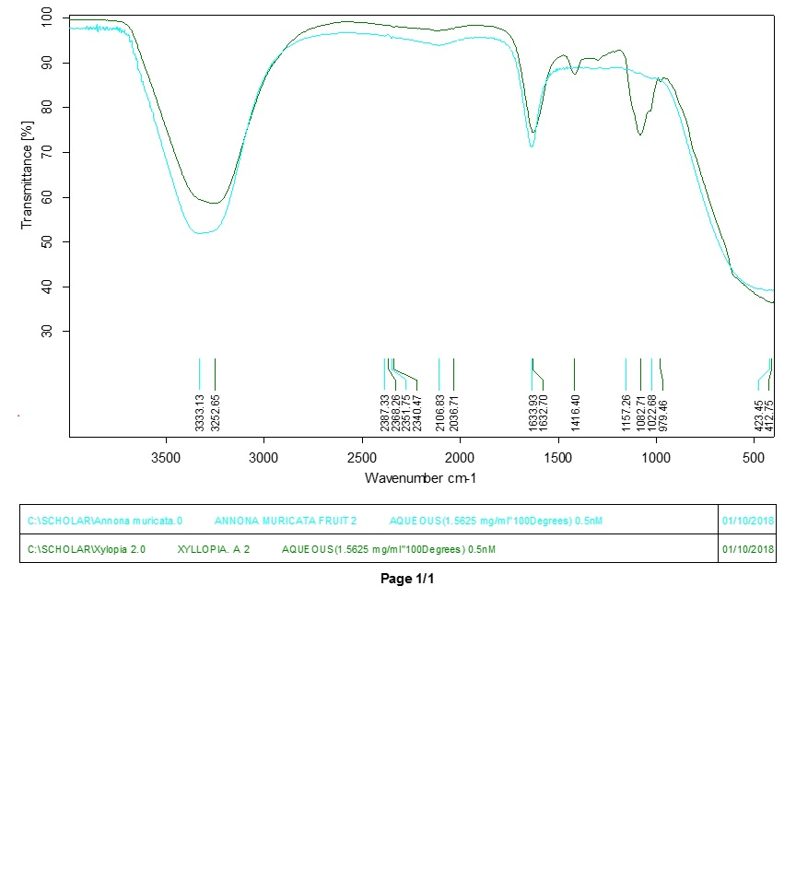

Figure S2: FT-IR absorption spectroscopic measurement of H. sabdariffa synthesized gold nanoparticles

