Supplementary data

Constructing recyclable photocatalytic BiOBr/Ag nanowires/cotton fabric for efficient dye degradation under visible light

Lili Wang¹, Xiaohui Ren¹, Lei Chen¹, Haiyan Mao¹, Dawei Gao^{1,} *, Yuyang Zhou^{2,} *

1 College of Textiles and Clothes, Yancheng Institute of Technology, Yancheng, 224051, China
2 National Engineering Laboratory for Modern Silk, College of Textile and Clothing Engineering, Soochow University, Suzhou 215123, China

Corresponding authors:
gaodawei@ycit.edu.cn (D. Gao)
yuyangzhou@suda.edu.cn; zhouyuyang_suda@hotmail.com (Y. Zhou)

Figure S1 The absorption spectra of RhB solution.

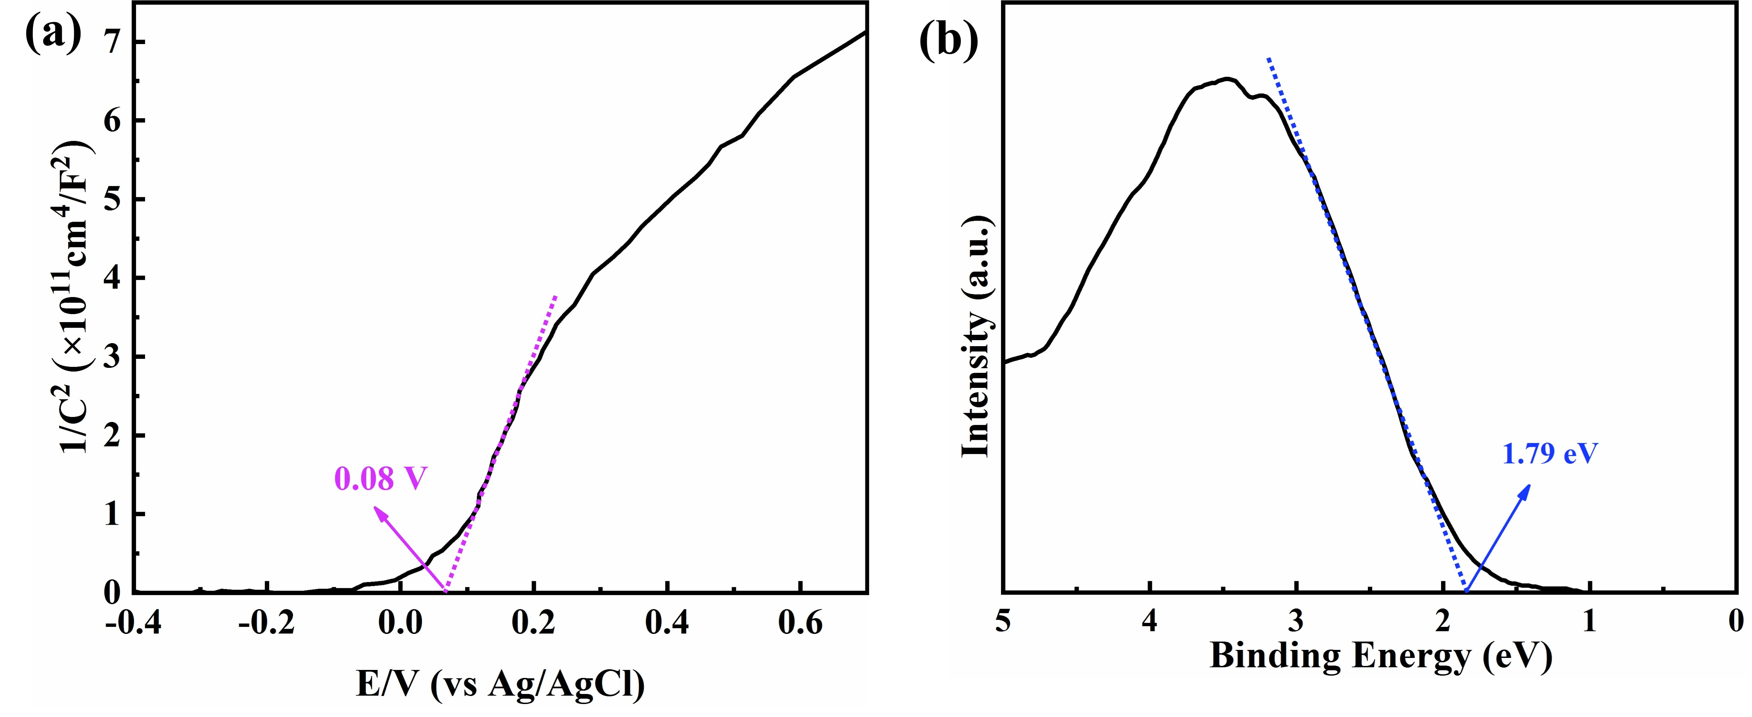
Figure S2 (a) Mott-Schottky plot and (b) valence band XPS spectra of 9BiOBr/AgNW/CF.

Figure S3 Photocatalytic degradation efficiencies of RhB over different photocatalysts.

Figure S4 Photodegradation of MO, MB and RhB of 9BiOBr/AgNW/CF.

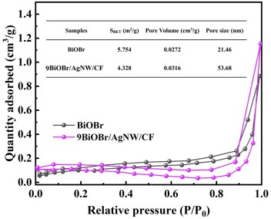
Figure S5 Nitrogen adsorption-desorption isotherms of BiOBr and 9BiOBr/AgNW/CF.

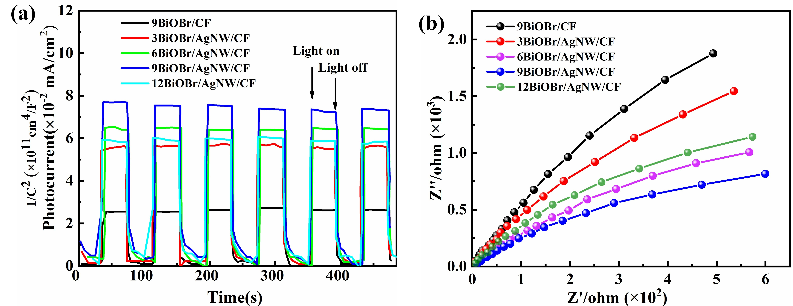
Figure S6 (a) Transient photocurrent response and (b) EIS plots of the as-prepared samples.

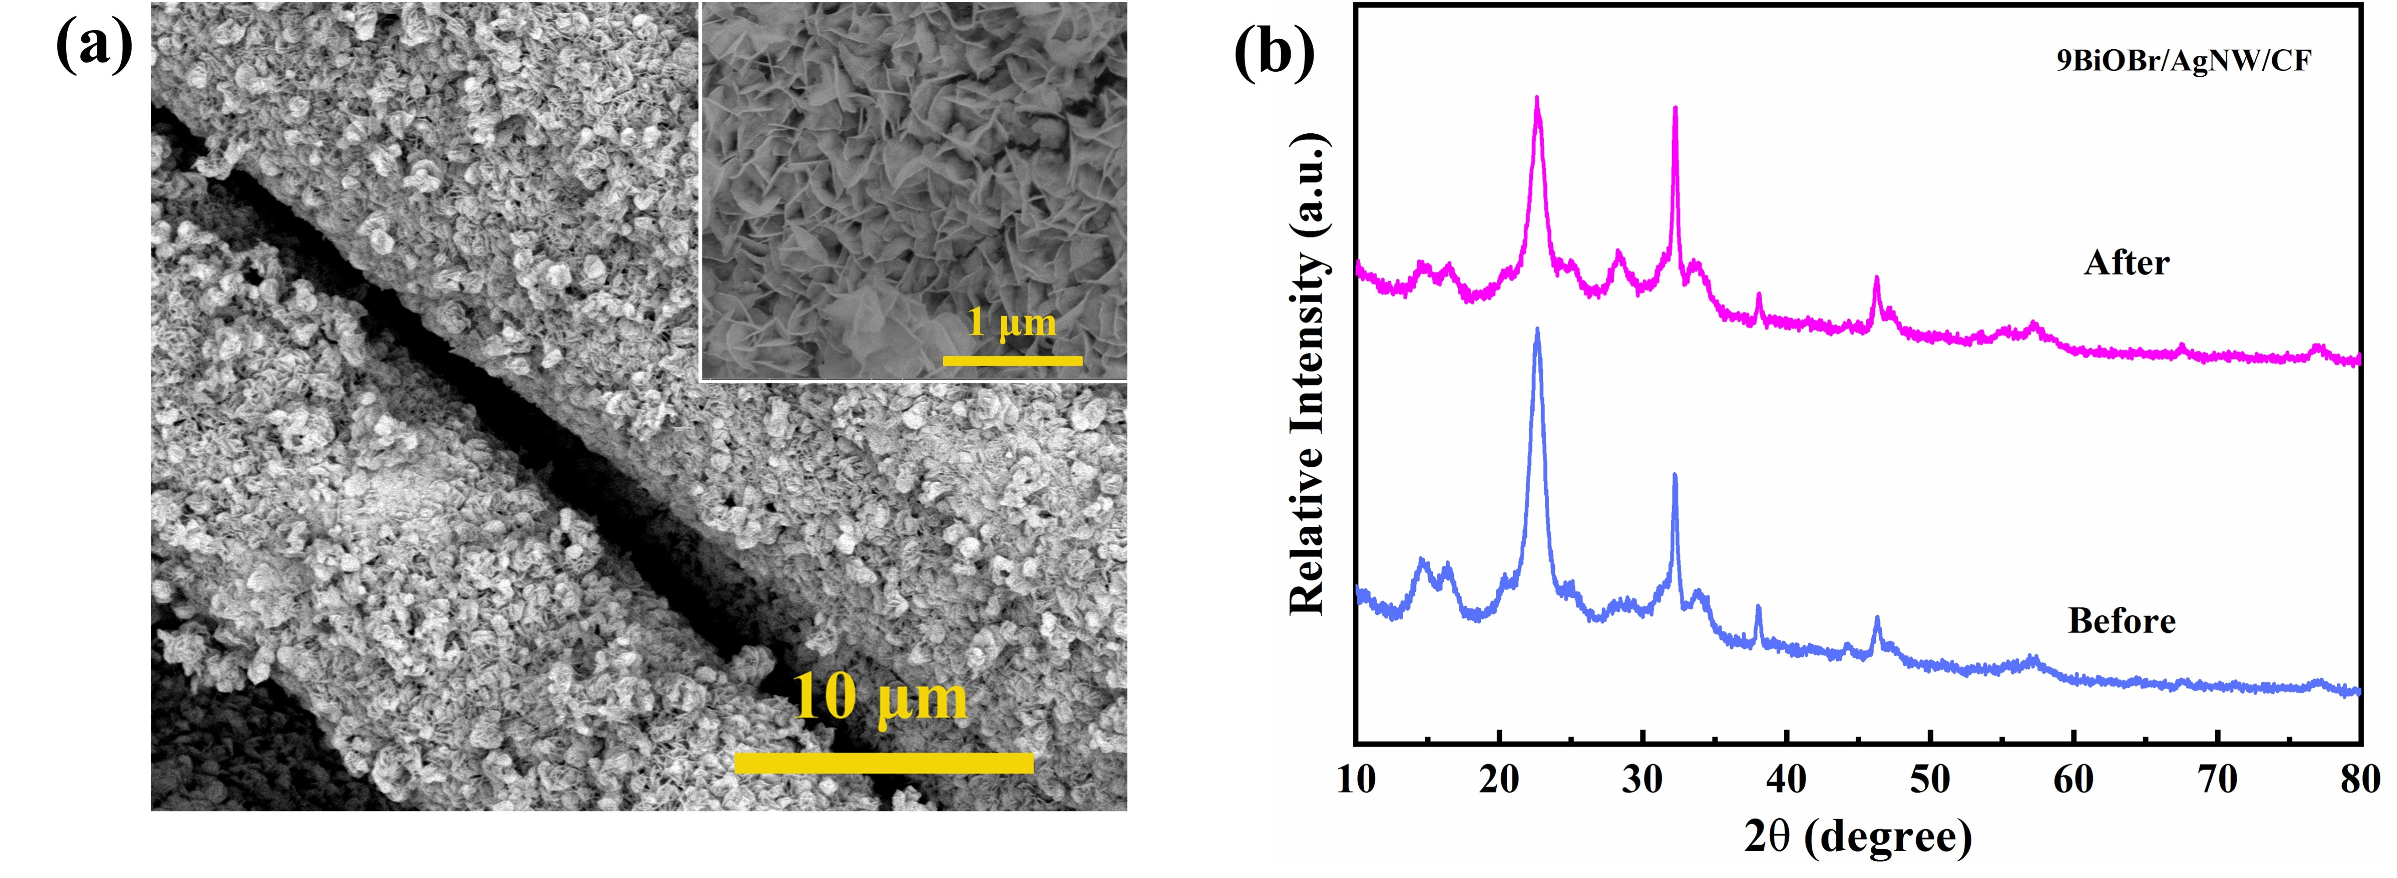
Figure S7 (a) SEM images and (b) XRD patterns of 9BiOBr/AgNW/CF after 5 cycles’ photocatalysis.

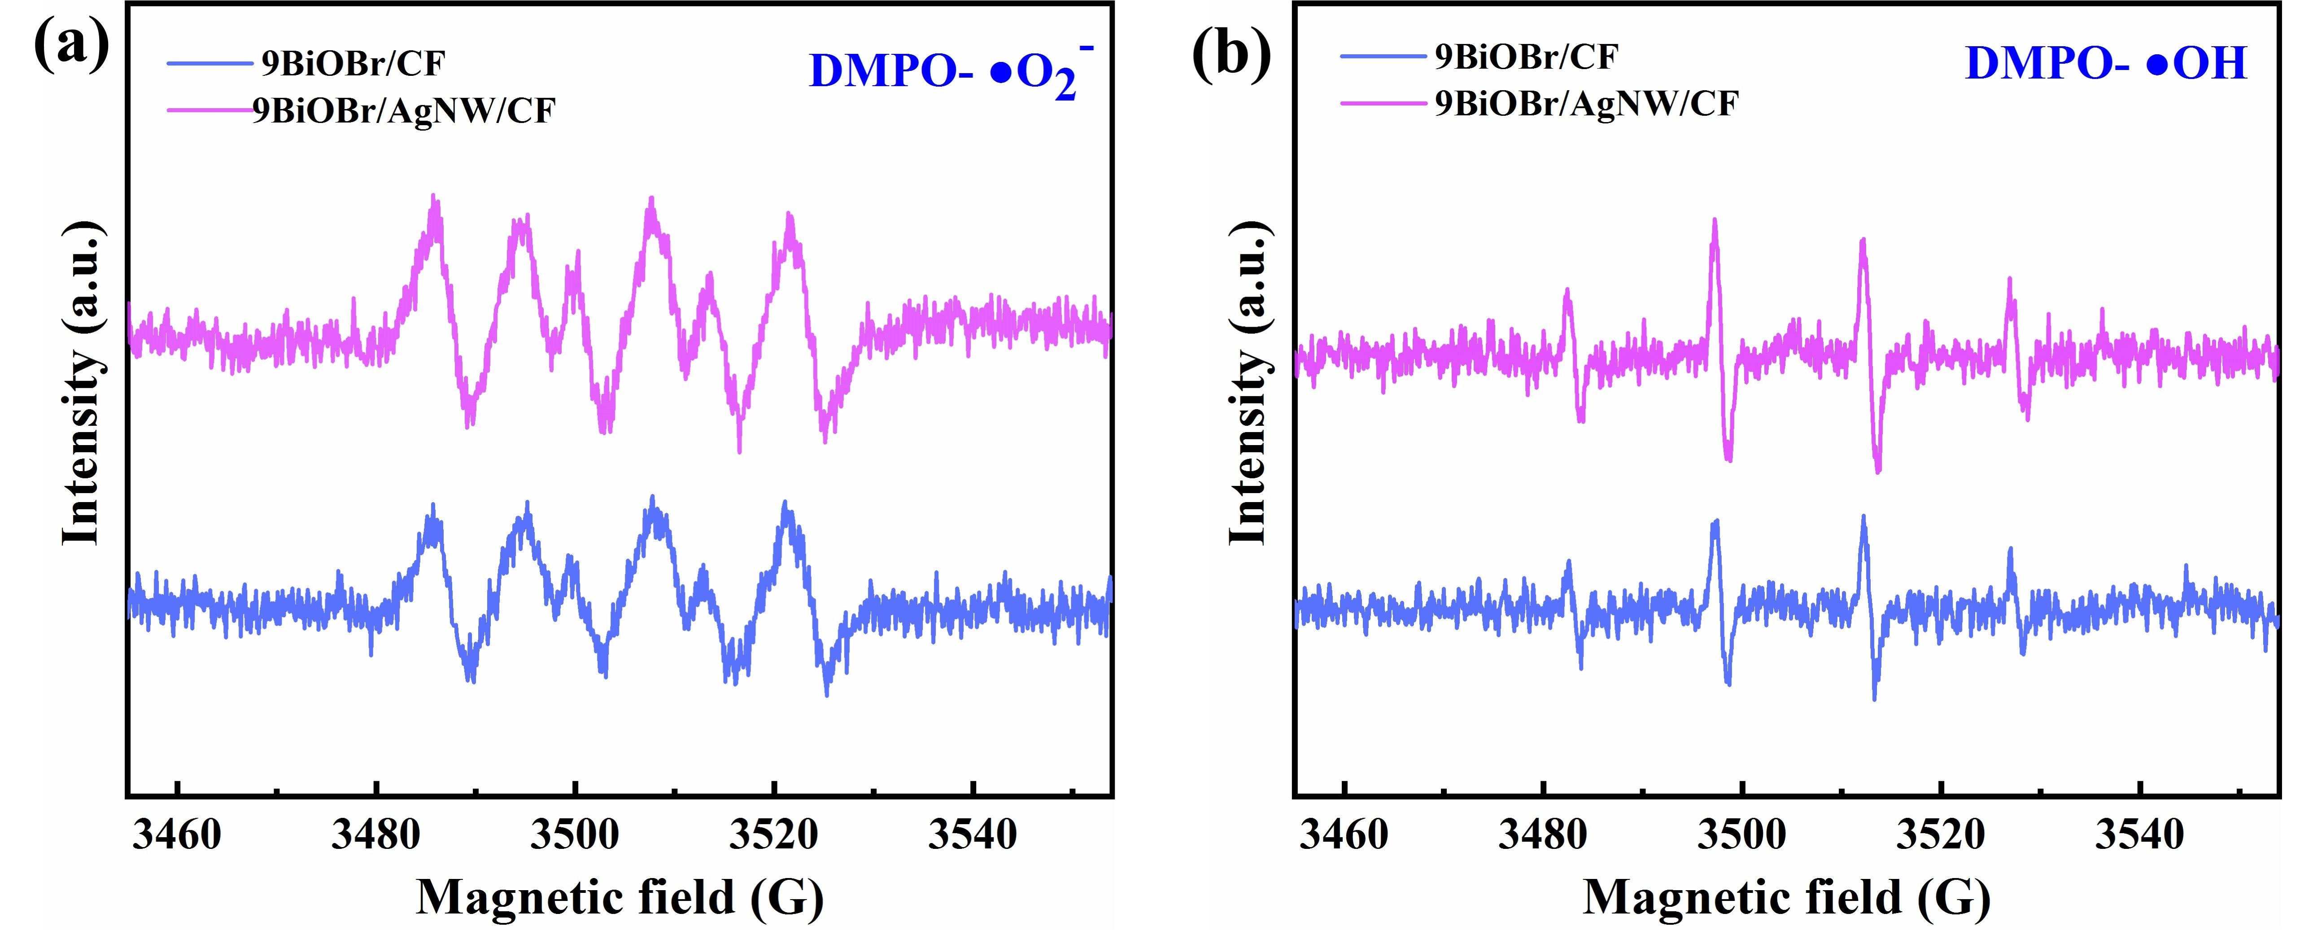
Figure S8 The ESR signals of (a) ·O₂⁻ and (b) ·OH.

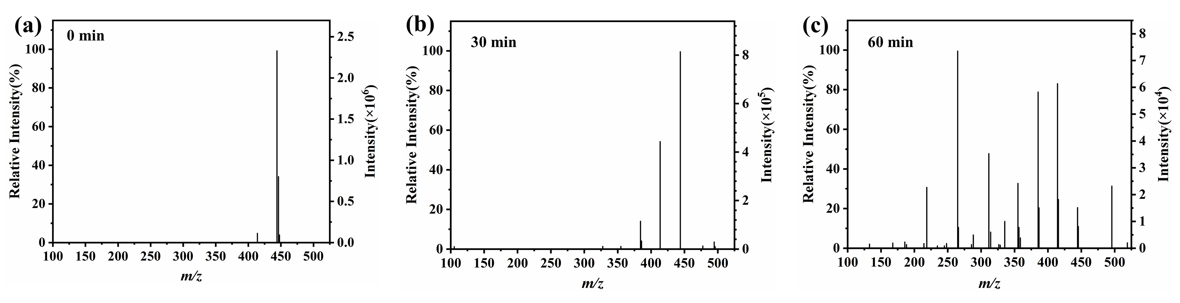
Figure S9 Mass spectra of intermediates from the degradation of RhB.

