**Supporting Information**

**Fabrication of a Novel Electrochemical Sensor Based on Tin Disulfide/Multi-walled Carbon Nanotubes-modified Electrode for Rutin Determination in Natural Vegetation**

Ying Liang1,3, Lingyu Zhang3, Hongmei Wang2,3, Xinru Cai3, Li Zhang3, Yixin Xu3, Chunxia Yao2*, Wenshuai Si2*, Zhipeng Huang1*, Guoyue Shi5

1School of Chemical Science and Engineering, Tongji University, Shanghai 200092, P. R. China

2Institute for Agro-food Standards and Testing Technology, Shanghai Key Laboratory of Protected Horticultural Technology, Laboratory of Quality and Safety Risk Assessment for Agro-products (Shanghai), Ministry of Agriculture, Shanghai Academy of Agricultural Sciences, 1000 Jingqi Road, Shanghai 201403, China

3School of Pharmacy, Shanghai University of Medicine and Health Sciences, Shanghai 201318, P. R. China

4College of Marine Ecology and Environment, Shanghai Ocean University, Shanghai, 201306, China

5Department of Chemistry, East China Normal University, 500 Dongchuan Road, Shanghai 200241, China

*Corresponding author

E-mail addresses: [67749801@qq.com](mailto:67749801@qq.com), [siwenshuai021@163.com](mailto:siwenshuai021@163.com), [zphuang@tongji.edu.cn](mailto:zphuang@tongji.edu.cn)

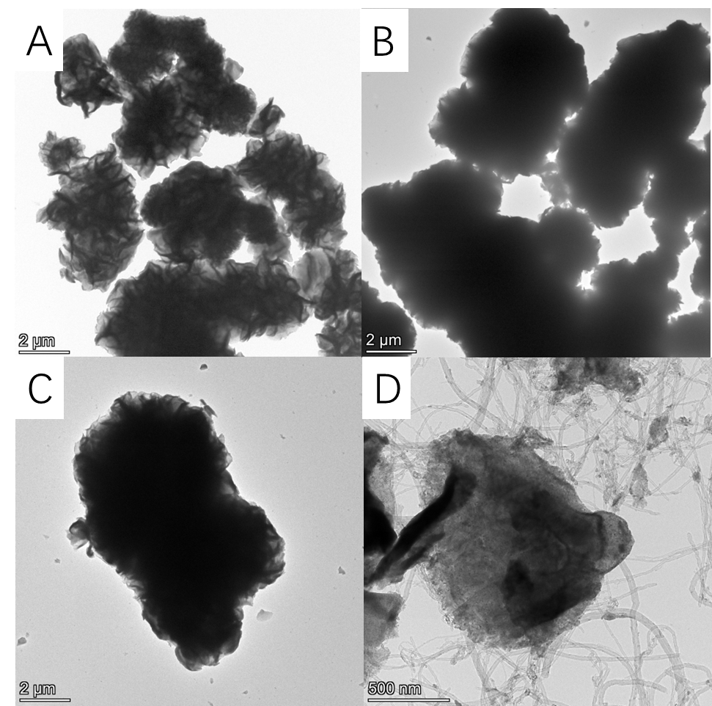

Fig. S1 TEM images of SnS2 and SnS2/CNTs:(A) 4h-SnS2, (B) 6h-SnS2, (C) 8h-SnS2, (D) 4h-SnS2/CNTs.

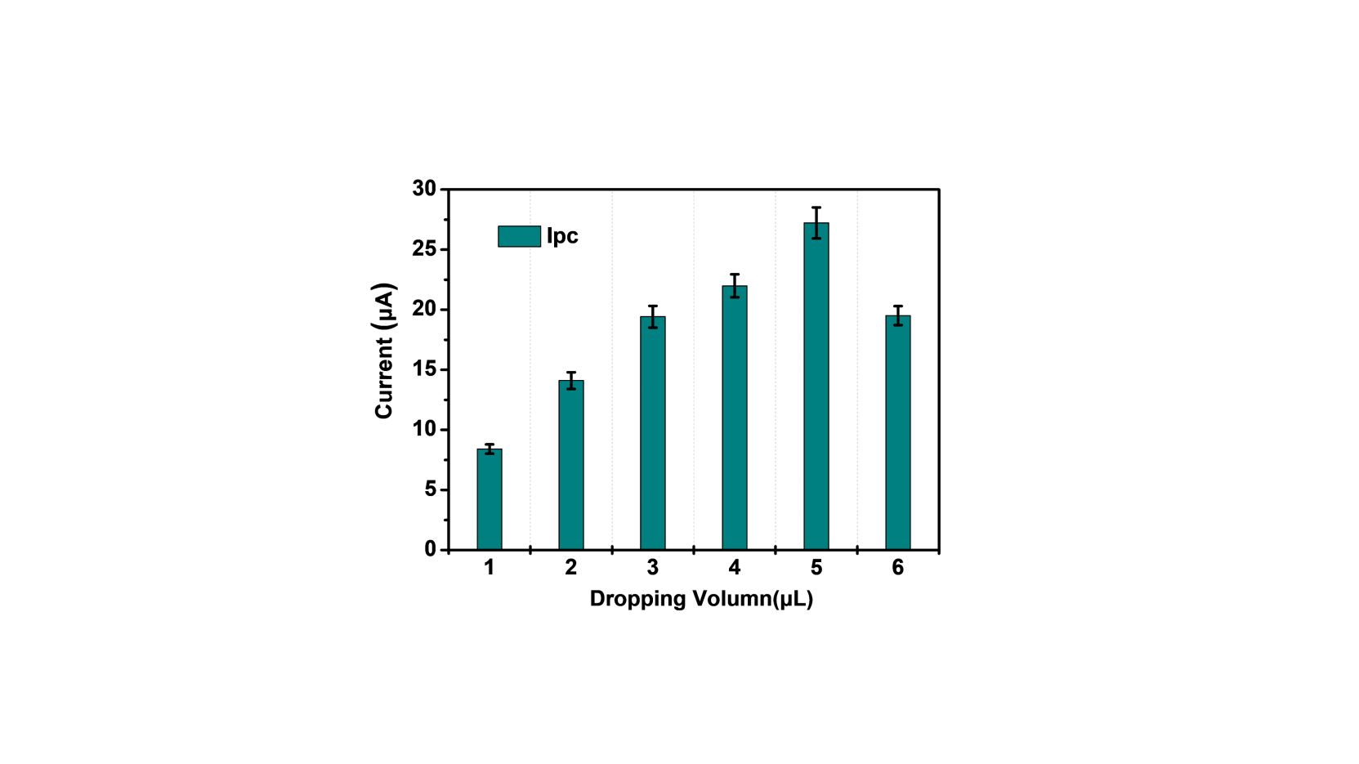

Fig. S2 Electrochemical responses of 4h-SnS2/CNTs composite with different modification amounts to rutin.



Fig. S3 DPV curve of blank solution.

Table S1 Elemental weight distribution and atomic content of 4h-SnS2 and 4h-SnS2/CNTs

|  |  |  |  |  |  |
| --- | --- | --- | --- | --- | --- |
| **Substance** | **Element** | **S** | **Sn** | **C** | **Sum** |
| 4h-SnS2 | Weight (%) | 35.46 | 62.52 | 0 | 100.00 |
| Atom (%) | 65.46 | 31.18 | 0 | 100.00 |
| 4h-SnS2/CNTs | Weight (%) | 25.87 | 44.03 | 30.11 | 100.00 |
| Atom (%) | 21.90 | 10.07 | 68.03 | 100.00 |

**The HPLC method**

A Gas chromatograph method was applied (Liao et al., 2015). The residues of samples were extracted directly with 70% ethanol solution and were determined by Gas Chromatograph with pulsed flame-photometric detection (Waters ACQUITY Arc /2489UV). The GC analytical column was C18 column (250 mm× 4.6 mm, 5 μm). The experiment conditions were as follows: the injection volume was 10 µL, the mobile phase was 2 % HCOOH-CH3OH (6:4, v/v), and the flow rate was 1.0 mL/min. The detector was a TUV detector, the detection wavelength was 360 nm, and the column temperature was 20 ℃. The rutin content was calculated by integrating the areas of the separated chromatographic peaks.

Under the GC conditions, the concentration of plants samples was diluted. The good linearity for the rutin was achieved at the concentration range of 0.0 ~ 200.0 μg/mL. The average recoveries were 96.0 % ~ 116.9 %, with relative standard deviations of 0.4 % ~ 3.7 % at the three levels of 10.0, 50.0 and 100.0 μg/mL.

**References**

Liao, J., Qu, B., Da, L., Zheng, N., 2015. New method to enhance the extraction yield of rutin from Sophora japonica using a novel ultrasonic extraction system by determining optimum ultrasonic frequency . Ultrasonics Sonochemistry, 27, 110-116. <https://doi.org/10.1016/j.ultsonch.2015.05.005>.