Supplementary Information

COVID-19 Chloroquine Drug Detection Using Novel, Highly Sensitive SnO2-Based Electrochemical Sensor

*Ayman AbdelHamid1, Abdelaziz Elgamouz1,Monther Khanfer1, Abdel-Nasser Kawde1\**

1 Pure and Applied Chemistry Research Group, Department of Chemistry, College of Sciences, University of Sharjah, P.O. Box 27272, Sharjah, United Arab Emirates

*E-mail: akawde@sharjah.ac.ae

**SWV Optimization**

Full optimization was carried out for the SWV analytical technique, including SWV parameters such as potential increment, pulse period, pulse amplitude, and sampling width, and also accumulation conditions, such as accumulation potential and time. SWV potential increment was studied in the range of 10‒40 mV. It was observed that the peak current increased with the increase in the potential increment due to the direct correlation with the scan rate (Fig*.* S1a‒b). The pulse period has an inverse effect on the scan rate. Thus, we observed a decreasing oxidation peak current with an increasing pulse period in the 50‒300 ms (Fig*.* S1c‒d). Pulse amplitude and sampling width were studied in ranges of 1‒10 ms (Fig*.*S1e‒f) and 60‒150 mV (Fig*.* S1g‒h) and optimized to be 5 ms and 120 mV, respectively. Accumulation potential was studied in the range of -0.3‒0.4 V, with open circuit potential (OCP) determined to be ~0.1 V (Fig. S2a‒b). The accumulation potential did not significantly impact the peak current, which indicated the absence of significant electrostatic interaction between CQP and the electrode surface, so OCP was used as the defacto accumulation potential.

On the contrary, accumulation time significantly influenced the oxidation peak current of CQP, where the peak current increased by ~163% as the accumulation time increased from 30 s to 5 min. It increased by ~22% as the time accumulation time was extended to 10 min (Fig. S2c‒d). The strong influence of the accumulation time on the oxidation peak signal of CQP could be explained by the adsorption-controlled mechanism of CQP oxidation that was elaborated on earlier and the large electrode surface area of SnO2-CPE that allowed high CQP adsorption. The longer accumulation time allowed more CQP adsorption, which resulted in a higher oxidation peak current. Considering the negative effect of too long accumulation time on the practical application of electrochemical sensors and that the rate of current increase with accumulation time decreased beyond 5 min, the optimal accumulation time was determined to be 5 min and was used for further investigations. The optimized analytical technique is summarized in Table S1.

**Table S1.** Optimized conditions for electrochemical analysis of CQP.

|  |  |
| --- | --- |
| **Parameter** | **Optimal** |
| Technique | SWV |
| Potential increment | 40 mV |
| Pulse period | 50 ms |
| Sampling width | 5 ms |
| Pulse amplitude | 120 mV |
| Accumulation potential | OCP (100 mV) |
| Accumulation time | 5 min |

**Table S2.** EIS quantitative analysis of CPEs with different SnO2 content.

|  |  |  |
| --- | --- | --- |
| SnO2 content (wt%) | Rs (Ω) | RCT (Ω) |
| 0 | 136 | 2840 |
| 10 | 125 | 1380 |
| 20 | 135 | 316 |
| 30 | 121 | 130 |
| 40 | 176 | 44 |
| 50 | 303 | 103 |

**Table S3.** Comparison of the performance of SnO2-CPE for CQP detection with the literature.

|  |  |  |  |  |  |
| --- | --- | --- | --- | --- | --- |
| Electrode | Technique | Linear range (µM) | LOD (µM) | Sensitivity (µA/µM.cm2) | Ref |
| SnO2-CPE | SWV | 0.1-23.3 | 0.01 | 35.7 | This work |
| DNA/CPE | DPV | 0.1-10 | 0.03 | - | [1] |
| Cu(OH)2 nanowires/CPE | DPV | 0.13-13.3 | 0.02 | - | [2] |
| B-doped diamond | SWV | 0.01-0.25 | 0.002 | 12.2 | [3] |
| rGO@WS2/GCE | DPV | 0.5-82.4 | 0.04 | 0.8 | [4] |
| ZnSe-rGO/SPE | DPV | 0.2-250 | 0.0014 | 43.9 | [5] |

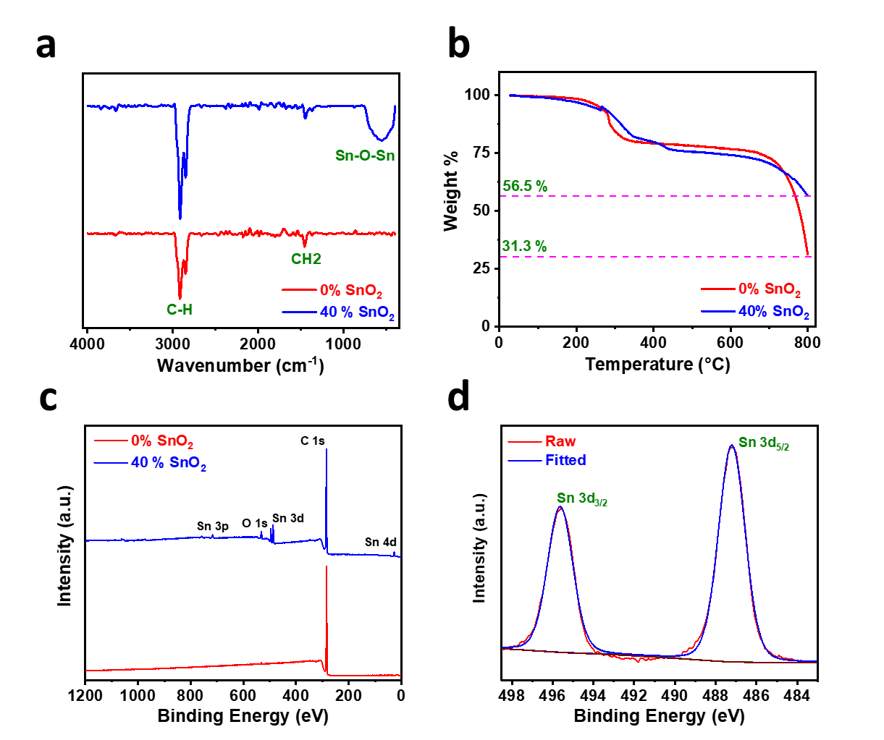

**Fig. S1**. (a) FTIR spectra, (b) TGA profiles, (c) XPS survey spectra, and (d) XPS Sn 3d core-level spectrum of (a‒c) 0% and 40% SnO2-CPE and (d) 40%-SnO2 CPE.

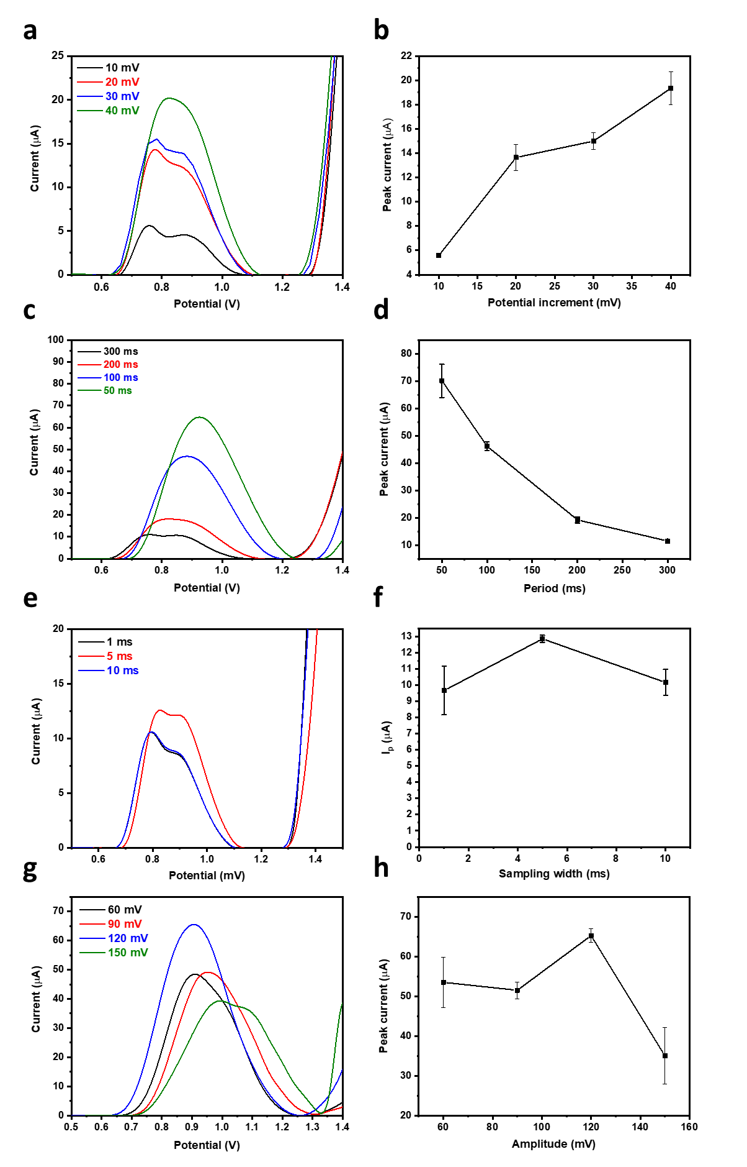

**Fig*.* S2.** Optimization of SWV parameters of (a‒b) potential increment, (c‒d) pulse period, (e‒f) sampling width, and (g‒h) pulse amplitude using 35 µM CQP in pH 7.3 phosphate buffer and 40% SnO2-CPE.

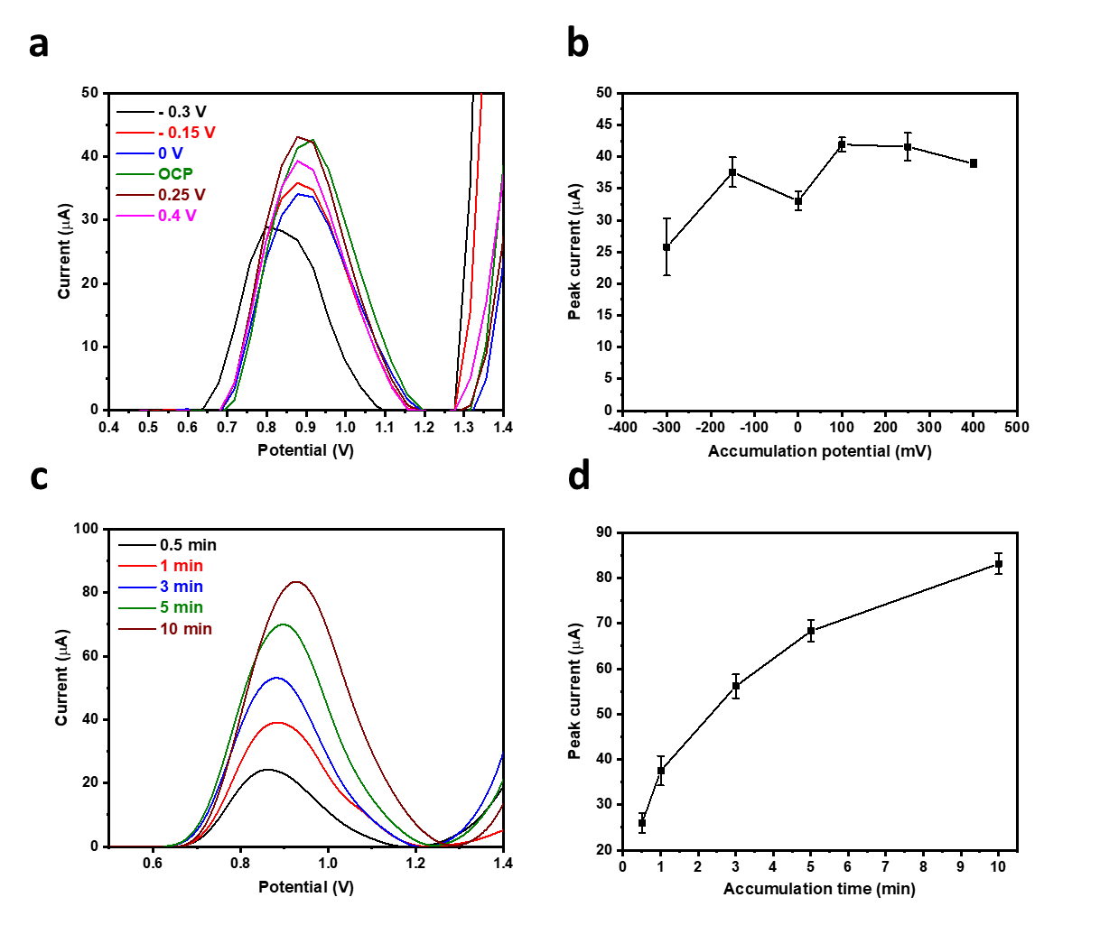

**Fig. S3.** Optimization of accumulation (a‒b) potential and (c‒d) time using 35 µM CQP in pH 7.3 phosphate buffer and 40% SnO2-CPE.

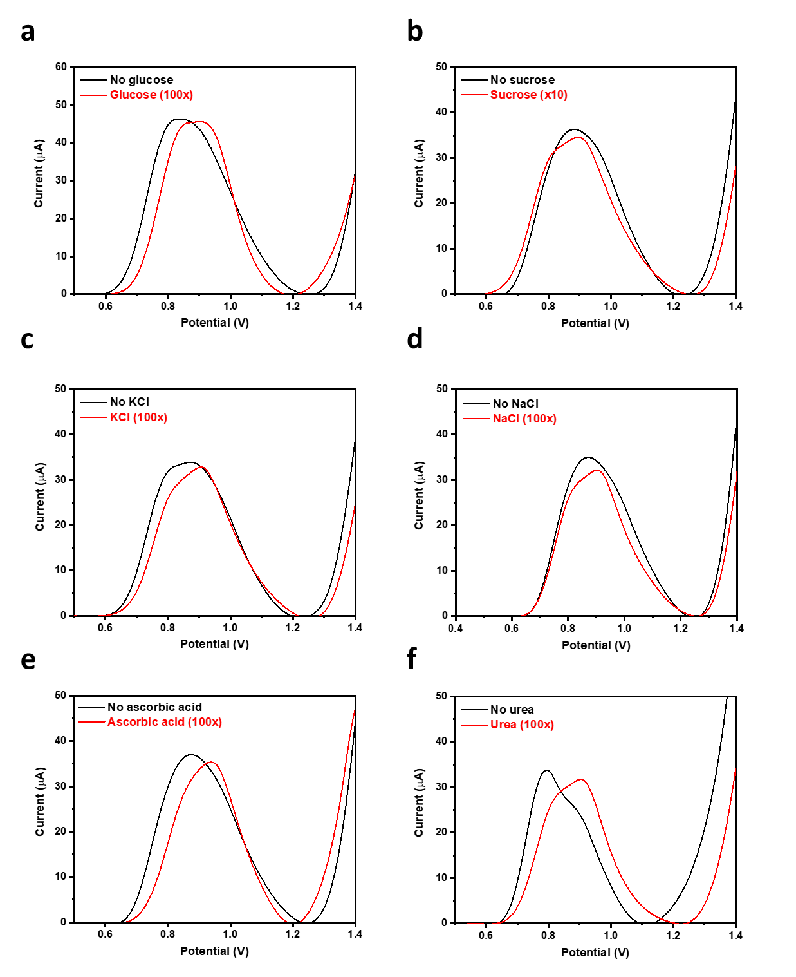

**Figure S4.** SWV profiles of CQP in the presence of various interferents at 10‒100 $×$ molar ratio

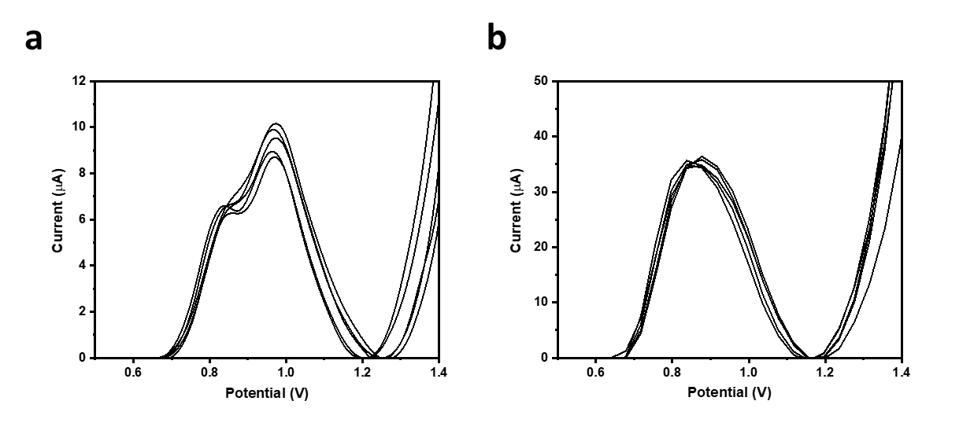

**Figure S5.** SWV profiles of (a) 4.9 µM and (b) 35 µM CQP in pH 7.3 phosphate buffer, conducted five times using (a) the same and (b) different CPEs.

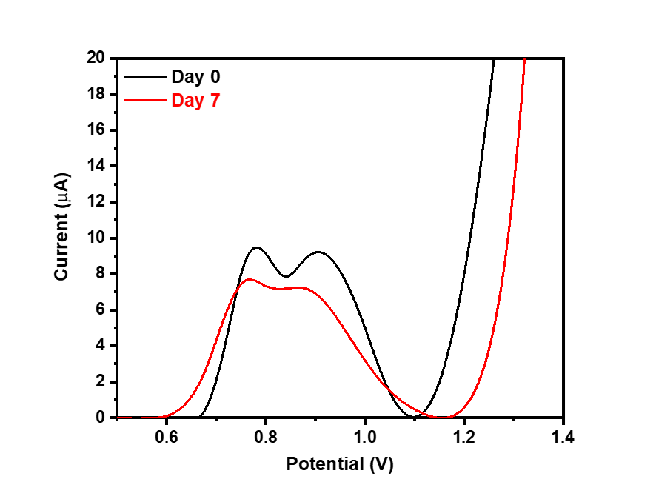

**Figure S6.** SWV profiles of CQP in pH 7.3 phosphate buffer before and after storage for seven days.

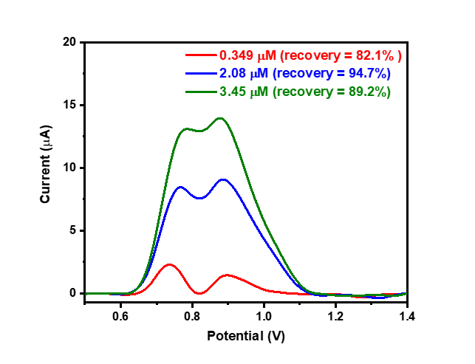

**Figure S7.** SWV profiles of CQP spiked into a wastewater sample at different concentrations.

**References**

[1] A. Radi, Accumulation and trace measurement of chloroquine drug at DNA-modified carbon paste electrode, Talanta, 65 (2005) 271-5.

[2] M.H. Mashhadizadeh, M. Akbarian, Voltammetric determination of some anti-malarial drugs using a carbon paste electrode modified with Cu(OH)2 nano-wire, Talanta, 78 (2009) 1440-5.

[3] G.G. Oliveira, D.C. Azzi, T.A. Silva, P.R.d. Oliveira, O. Fatibello-Filho, B.C. Janegitz, Sensitive Voltammetric Detection of Chloroquine Drug by Applying a Boron-Doped Diamond Electrode, C, 6 (2020) 75.

[4] M. Srivastava, P. Tiwari, V.K. Mall, S.K. Srivastava, R. Prakash, Voltammetric determination of the antimalarial drug chloroquine using a glassy carbon electrode modified with reduced graphene oxide on WS2 quantum dots, Mikrochim. Acta, 186 (2019) 415.

[5] A. Ganguly, K.Y. Hwa, Construction of zinc selenide microspheres decorated with octadecylamine-functionalized reduced graphene oxide as an effective catalyst for the dual-mode detection of chloroquine phosphate, Mater. Today Chem., 24 (2022) 100862.