Supporting Information

Preparation of polyprenol/poly (β-amino ester)/galactose targeted micelle carrier for enhancing cancer therapy
Hua Yuan, ª Changwei Zhang, *^{abc} Peng Zhou, ^{d} Xiaoran Yang, ª Ran Tao, ^{abc} Jianzhong Ye ^{abc}, Chengzhang Wang *^{abc}

ª Institute of Chemical Industry of Forest Products, CAF, Nanjing, Jiangsu, China.
^{b} Institute of Ecological Conservation and Restoration, CAF, Beijing, China.
^{c} Co-Imnovation Center of Efficient Processing and Utilization of Forest Resources, Nanjing Forestry University, Nanjing, Jiangsu,China.
^{d} College of Materials Science and Engineering, Central South University of Forestry and Technology, Changsha, Hunan, China.

- Supplement of methods
  - Synthesis of 2, 2-dithiodiethyl diacrylate (DSEA)
2,2-dithiodiethyl diacrylate (DSEA) was synthesized according to the method of Wang et al. (Wang et al., 2022), its synthetic route was demonstrated in Figure S1. Briefly, 50 mL of anhydrous dichloromethane, 75 mM of triethylamine and 30 mM of dithiodiethanol were successively added into 500 mL of three-necked flask under nitrogen atmosphere, then the mixture was stirred in an ice bath for 2 h. Next, acryloyl chloride was added dropwise (one drop per second) and reacted for 6 h. The reactants were filtered and centrifuged for 10 min at the speed of 5000 rpm to obtain the lower layer solution. Then, anhydrous magnesium sulfate was added into the above solution stood for 12 h to remove water. DSEA was obtained after distillation and vacuum drying (yield: 92.3 wt%). ¹H NMR (400 MHz, CDCl₃) δ 6.47 (m, 1H), 6.16(m, 1H), 5.89 (m, J = 5.7 Hz, 1H), 4.47 (m, 2H), 2.96 (dt, 2H).
1.2. Cell uptake
The cells at logarithmic growth phase were digested and inoculated into confocal dishes with 1×10⁵ cells /dish. After the cells adhered to the wall, the corresponding drug-containing medium was added according to the group setting, and the medium without any drugs was set as the negative control group. After treatment for 0.5, 2 and 4 h, the cells were cleaned with PBS for 3 times and dyed by nuclear dye Hoechst33342 (diluting at a ratio of 1:1000) to incubate for 15 min in darkness, and then washed with PBS for 3 times. Fluorescence expression of DOX was observed under confocal microscope. Meanwhile, cells were further digested with 0.25% trypsin (centrifugation at 1000 rpm, 5 min) and washed with PBS twice to adjust and collect the cells with concentration of 1×10⁶ cells/mL. The quantitative detection of cellular uptake was performed by flow cytometry. (Excitation and emission wavelengths of Hoechst 33258 are 346 nm and 460 nm, respectively. The excitation and emission wavelengths of DOX are 470 nm and 590 nm, respectively).
1.3. Targeting performance analysis
The targeting performance of GBP-PBAE-Gal@DOX to HepG2 cells were analyzed by confocal laser scanning microscopy (CLSM) and flow cytometry (FCM). In detail, the HepG2 cells were digested and inoculated into confocal dishes with 1 x 10⁵ cells/dish, and further incubated for 24 h to adhere to the wall of dish. Then, the HepG2 cells in the experimental group were pre-saturated with 20 mM galactose for 2 h and followed treat with GBP-PBAE-Gal@DOX micelles (5 μg/mL) for 4 h after the removing of medium contained galactose. The HepG2 cells unsaturated by galactose were incubated with GBP-PBAE-Gal@DOX micelles and set as a negative control group. After incubation, the HepG2 cells were washed 3 times with PBS, stained with Hoechst 33342, a nuclear dye diluted at a ratio of 1:1000 and incubated for 15 min away from light. The HepG2 cells were washed 3 times with PBS and the DOX fluorescence expression in HepG2 cells was observed under confocal microscope to take photos of 3 highly expressed areas for preservation (600X).
The HepG2 cells were digested and counted to prepare a cell suspension of 5◊10⁵ cells/mL. 1 mL of each well was inoculated in a six-well plate and incubated for 24 h. Then, the adherent cells were first treated with 20 mM galactose for 2 h and the galactose medium was replaced by GBP-PBAE-Gal@DOX micelles (5 μg/mL) to incubate HepG2 cells for 4 h. The HepG2 cells were collected by the digestion with 0.25% trypsin (without EDTA), washed twice with PBS (centrifugation at 1000 rpm for 5 min), and then adjusted to obtain a cell concentration of 1◊10⁶ cells/mL. The fluorescence expression of DOX in HepG2 cells were assayed by flow cytometry. The HepG2 cells unsaturated by galactose were incubated with GBP-PBAE-Gal@DOX micelles and set as a negative control group.
1.4. Cell Cycle
The cell suspensions of 5×10⁵ cells/mL were obtained via centrifugation and washing by PBS, then fixed with 70 % ethanol for 2 h or overnight. The cell samples were collected after removing the fixative with PBS, and bathed with 100 μL of RNASE A at 37 ℃ for 30 min, and then 400 μL PI staining was added and mixed with cell samples to react at 4 ℃ for 30 min. Then, the red fluorescence in cell samples was recorded at excitation wavelength of 488 nm, and the changes of cell cycle after drug treatment in each group were analyzed via the excluding of adhesion cells and debris by gate setting technique after the collection of 10000 cells by FSC/SSC scatter plot.
1.5. Cell apoptosis
Apoptosis of HepG2 cells treated with GBP-PBAE-Gal@DOX micelles was detected by TUNEL assay. HepG2 cells treated with GBP-PBAE-Gal@DOX for 24 h were collected and fixed in 4 % paraformaldehyde solution for 30 min or overnight, then bathed in PBS for 3 times (3 min each time). Next, the cell samples were leaved in 1 % of triton-100 and 3 % of H₂O₂-methanol solution for 15min, cleaned by PBS for 3 times, then treated by 50 µL of TdT enzyme solution in a warm box at 37 ℃ for 60 min away from light, and rinsing by PBS for 3 times away from light. Then 50 µL of streptavidin-fluorescein labeling fluid was added to each cell samples and placed in a wet box for 30 min under light protection. Finally, the cell samples were soaked and cleaned by PBS and re-stained by DAPI staining solution and sealed by appropriate amount of sealing tablets for microscopic observation.
- Supplement of figure
Fig. S1. The synthetic route of 2,2-dithiodiethyl diacrylate.
Fig. S2. ¹H NMR spectra of 2,2-dithiodiethyl diacrylate.
Fig. S3. ¹H NMR spectra of GBP-NH₂.

Fig. S4. The PDI variation of micellar size in the dilution condition (A), storage at room temperature (B) and in the presence of serum (C).
Fig. S5. Release fitting curves of GBP-PBAE-Gal@DOX micelles under the acidic medium: Zero order model (A), First order model (B), Higuchi model (C), Korsmeyer-Peppas model (D), Peppas-Sahlin model (E), and the Relaxation contribution (R) / Fickian contribution (F) ratio with respect to time (F) under the acidic medium and pH/GSH dual medium.
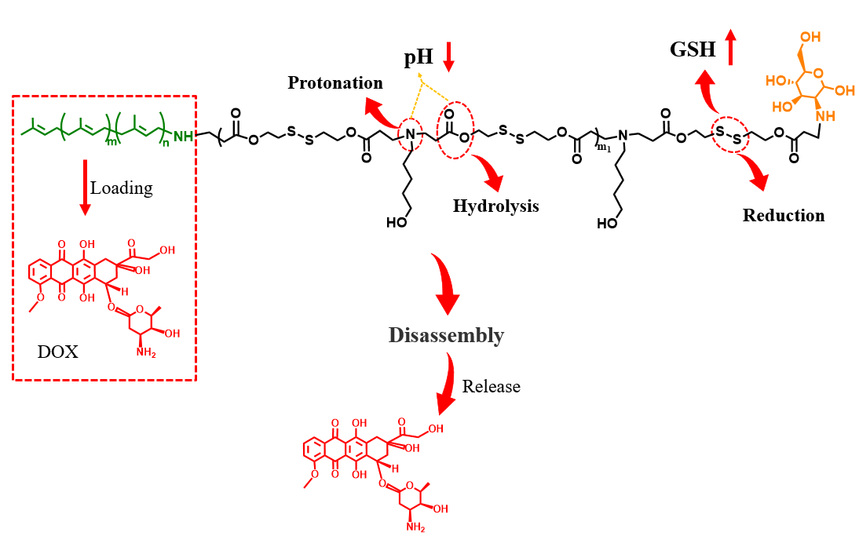
Fig. S6. The release mechanism of GBP-PBAE-Gal@DOX micelles.
Fig. S7. The morphology of red blood cells treated with GBP-PBAE-Gal micelles (A) and normal saline (NS) and triton-100 (X-100) (B) for 4 h of incubation

Fig. S8. The apoptosis rate of HepG2 cells treated with GBP-PBAE-Gal@DOX micelles (pre-saturated (+Gal) and unsaturated with galactose (-Gal)) and free DOX (mean ± SD, n = 3). *p < 0.05, **p < 0.01 and ***p < 0.001.

3. Supplement of table
Table S1. log P of GBP and GBP-PBAE-Gal
Sample | C_{o}/(μg/mL) | C_{w}/(μg/mL) | log P
GBP | 7.64 | 5.87×10⁻⁵ | 5.21
GBP-PBAE-Gal | 2.96 | 9.54×10⁻⁴ | 2.46
C_{o}: the concentration of sample in N-octanol phase; C_{w}: the concentration of sample in water phase.

Table S2. Fitting results for DOX released from GBP-PBAE-Gal@DOX micelles in vitro.
Model | Parameters | GBP-PBAE-Gal@DOX micelles
 |  | pH=7.4 | pH=6.4 | pH=5.0 | pH=7.4,  10 mM GSH | pH=6.4,  10 mM GSH | pH=5.0,  10 mM GSH
Zero order model | K | 0.5729 | 1.4999 | 2.2539 | 1.6148 | 1.8831 | 2.6323
 | R² | 0.9878 | 0.9284 | 0.9243 | 0.9208 | 0.8813 | 0.8749
First-order kinetics | k₁ | -168.9889 | 44.9181 | 72.4233 | 50.2815 | 63.6552 | 91.1032
 | k₂ | -0.0031 | 0.1156 | 0.1532 | 0.1356 | 0.1491 | 0.1849
 | R² | 0.9739 | 0.9602 | 0.9777 | 0.9792 | 0.9407 | 0.9866
Higuchi model | k | 3.5743 | 9.7691 | 15.0074 | 10.6324 | 12.9251 | 17.9081
 | R² | 0.9497 | 0.9342 | 0.9168 | 0.9333 | 0.8655 | 0.8842
Korsmeyer-Peppas model | k | 0.4717 | 8.2467 | 18.6688 | 11.2536 | 16.3638 | 27.8048
 | n | 1.0546 | 0.5313 | 0.4387 | 0.4773 | 0.4373 | 0.3899
 | R² | 0.9751 | 0.9291 | 0.9251 | 0.9346 | 0.9435 | 0.9061
Peppas-Sahlin model | k₁ | -1.07518 | -104.7539 | -196.0243 | 7.2004 | -106.9383 | 134.0149
 | k₂ | 1.1922 | 108.0480 | 104.9493 | 0.2718 | 104.1517 | 148.2137
 | m | 0.8441 | 0.1567 | 0.0364 | 1.0707 | 0.0119 | 0.0095
 | R² | 0.9767 | 0.9511 | 0.9629 | 0.9782 | 0.9122 | 0.9701

Note：the Peppas-Sahlin model as shown in Equation:
${M_{t}}/{M_{∞}}={k_{1}t}^{m}+k_{2}t^{2m}$ (1)
$R/{F={k_{2}t^{m}}/{k_{1}}}$ (2)
Where m is the Fickian diffusional exponent, k₁ and k₂ are kinetic constants. The k₁t^{m} represents the Fickian diffusion contribution (F), and the k₂t^{2m} refers to the erosion contribution (R) on the overall release mechanism. When R/F = 1, the release mechanism contains both erosion and diffusion equally. If R/F > 1, the relaxation (erosion) dominates, while for R/F < 1, diffusion dominates.

Wang, Y., M. Hou, S. Duan, et al., 2022. Macrophage-targeting gene silencing orchestrates myocardial microenvironment remodeling toward the anti-inflammatory treatment of ischemia-reperfusion (IR) injury. Bioact Mater. 17, 320-333. https://doi.org/10.1016/j.bioactmat.2022.01.026

