**Cu(II)/polyimide linked COF: an effective mesoporous catalyst for solvent-free 1,5-benzodiazepine synthesis**

**Sima Pourghasem, Farid Moeinpour *, Fatemeh S. Mohseni-Shahri**

**Supplementary information**

***2.1. Synthesis of PI-COF***

No further purification was performed on the analytical-grade reagents, as they were obtained from Sigma.

***2.2 Synthesis of PI-COF***

An equimolar ratio (20 mmol) of MEL (melamine) and BTCD (benzene-1,2:4,5-tetracarboxylic dianhydride) were milled in an opal mortar for thirty minutes, and finally transferred the resulting mixture to an alumina pot and annealed to 325 °C for four hours at a heating speed of 5 °C min-1. After air cooling to ambient temperature, the obtained product was rinsed at 50 °C with water to eliminate remaining MEL precursor, and eventually desiccated at 80 °C to afford PI-COF with a yield of 70% (Han, Zhang et al. 2018).

**2.3 Synthetic method for Cu@PI-COF**

100 mg of the synthesized PI-COF was mixed with 30 mg Cu(CH3COO)2 dissolved in 30 ml absolute ethanol. During the four-hour stirring period, the solution was kept at ambient temperature, then rinsed with absolute ethanol. Therefore, the resulting Cu@PI-COF was then activated by vacuum at 80 °C.

In the experiments, melamine (MEL) and benzene-1,2:4,5-tetracarboxylic dianhydride (BTCD) were mixed and ground in an equimolar ratio. The mixture was then transferred to an aluminum pan and calcined at 325°C for 4 hours. After air-cooling to ambient temperature, the resulting product was rinsed with water to eliminate unreacted initial materials and finally desiccated to obtain high yields of PI-COF. This synthetic method is relatively simple, inexpensive, and environmentally friendly as it contains no solvents and generates no dangerous waste. Owing to the porous structure, exposure of N and O binding sites, this COF can act as a good platform for the incorporation of copper into the skeleton. Thereupon, Cu@PI-COF can be easily prepared by immersing the PI-COF in ethanolic solution of Cu(CH3COO)2 at ambient temperature. The total Cu incorporation was measured to be as high as 5.24 wt% by ICP-AES.

The FT-IR spectroscopy, X-ray diffraction (XRD), FESEM, TEM and TGA was used to characterize Cu@PI-COF catalyst. The BET method was utilized to determine the effective surface area and the pore size distribution. Fig. S1 displays the FT-IR spectra of MEL, BTCD, PI-COF and Cu@PI-COF. The FT-IR spectra of the PI-COF showed the band fadeaway at 1851 cm-1 related to the initial anhydride monomers (BTCD) (C = O symmetric stretching) and the decrease in intensity of the bands at 1652 cm-1, 3419 cm-1 and 3469 cm-1 due to the amino group terminus of the initial MEL monomer (Han, Zhang et al. 2018). 4 bands at 1772, 1725 (two imide carbonyl groups stretching), 1367 (C–N–C imide axial tension), 1117 (C–N–C imide transverse stretching) and 728 cm-1 (imide C – N – C out of plane bending) related to the specific absorption of the polyimides were detected, demonstrating that the product was fully converted to imide to form a polyimide (Snyder, Thomson et al. 1989, Dhakshnamoorthy, Vikram et al. 2012). However, FT-IR spectra of Cu@PI-COF showed no visible changes in PI-COF, indicating that Cu(CH3COO)2 does not alter the structure.

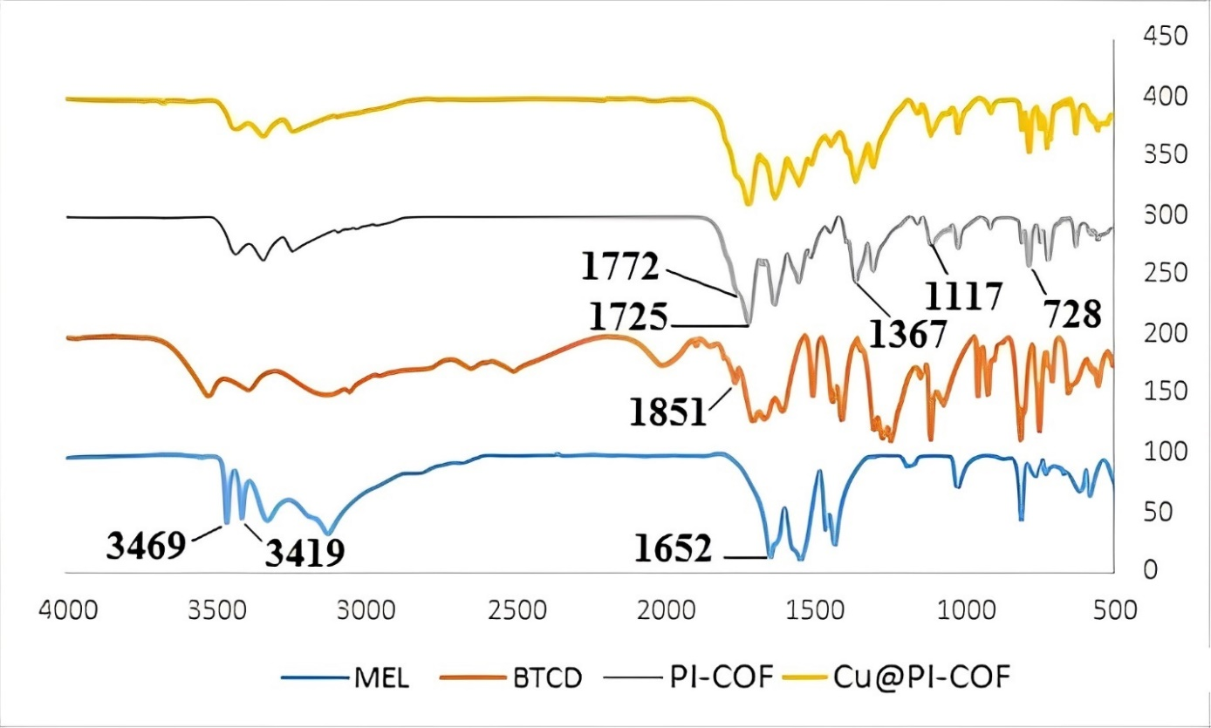

**Fig. S1** FT-IR spectra of MEL, BTCD, PI-COF and Cu@PI-COF

As a result of XRD analysis of PI-COF, diffraction peaks at 18.9 and 29.6° were observed, denoting acceptable crystallinity of the materials (Fig. S2). Compared to PI-COF, the well-preserved XRD pattern of Cu@PI-COF has further peaks at 12.8° (2θ) and 15.2° (2θ), indicating successful loading of Cu with a minimal loss of COF integrity and crystallinity (Bellini, Machado et al. 2002).

**Fig. S2** XRD patterns of (a) PI-COF and (b) Cu@PI-COF

The morphology of PI-COF and Cu@PI-COF was investigated by FESEM and TEM (Fig. S3). The PI-COF and Cu@PI-COF exhibited good crystallinity and an ordered structure. The images reveal that PI-COF possesses regular morphology, and the fundamental structure of organic frameworks seems to be the same after metal loading.



**(c)**

**Fig. S3** FESEM images of (a) PI-COF, (b) Cu(II)/PI-COF and (c) TEM image of PI-COF

D:\فایلهای دسکتاپ مهر 1401\مقاله پور قاسم\Fig 5a.tif D:\فایلهای دسکتاپ مهر 1401\مقاله پور قاسم\Fig 5b.tif

**Figure S4.** N2 adsorption−desorption isotherms of PI-COF (a) and Cu@/PI-COF (b)





Fig. S5 Pore size distribution of PI-COF (a) and Cu@/PI-COF (b)

**References**

Bellini, J., R. Machado, M. Morelli and R. Kiminami (2002). "Thermal, structural and morphological characterisation of freeze-dried copper (II) acetate monohydrate and its solid decomposition products." Materials Research **5**: 453-457.

Dhakshnamoorthy, M., S. Vikram and R. Vasanthakumari (2012). "Development of flexible low dielectric constant polyimide films based on iso-propylidene, aryl-ether linked dianhydride/diamine." Int. J. Sci. Eng. Res **3**: 2229-2234.

Han, Y., M. Zhang, Y.-Q. Zhang and Z.-H. Zhang (2018). "Copper immobilized at a covalent organic framework: an efficient and recyclable heterogeneous catalyst for the Chan–Lam coupling reaction of aryl boronic acids and amines." Green Chemistry **20**(21): 4891-4900.

Snyder, R., B. Thomson, B. Bartges, D. Czerniawski and P. Painter (1989). "FTIR studies of polyimides: thermal curing." Macromolecules **22**(11): 4166-4172.