Growth Phase Diagram and X-ray Excited Luminescence Properties of NaLuF4:Tb3+ Nanoparticles

Linyuan Zhang, Fanyuan Xu, Tingwei Lei, Xiaofeng Zhang, Bin Lan, Tuo Li, Jian Yu, Hongbing Lu\*, and WenliZhang\*

Authors Linyuan Zhang and Fanyuan Xu contributed equally.

School of Biomedical Engineering, Shaanxi Provincial Key Laboratory of Bioelectromagnetic Detection and Intelligent Perception, The Fourth Military Medical University, 169th Changle West Road, Xi’an, Shaanxi, 710032, China

\* wenlizhang1121@163.com，luhb@fmmu.edu.cn,

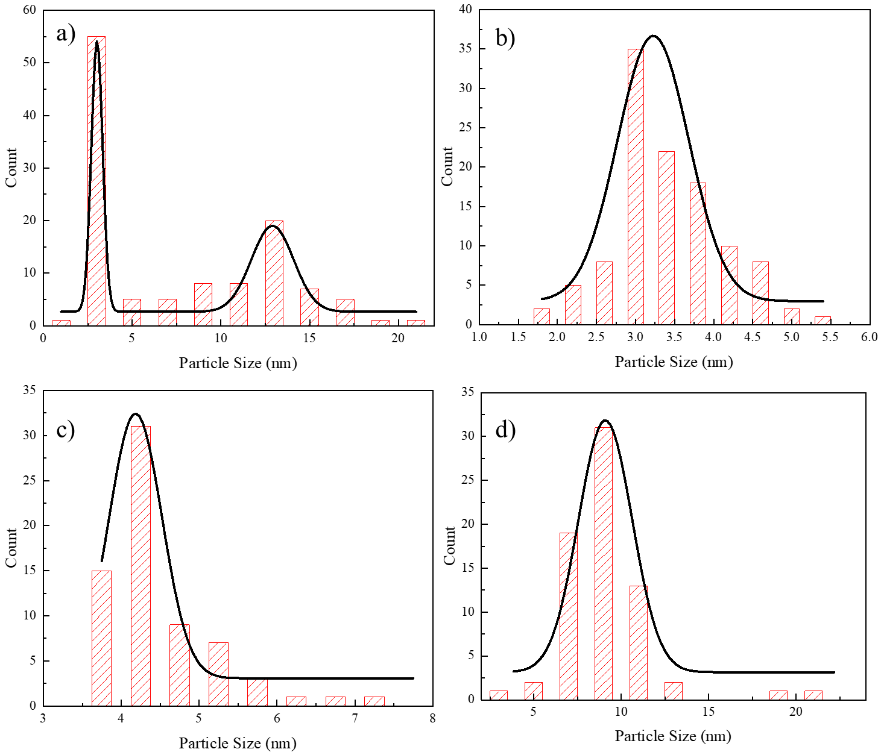

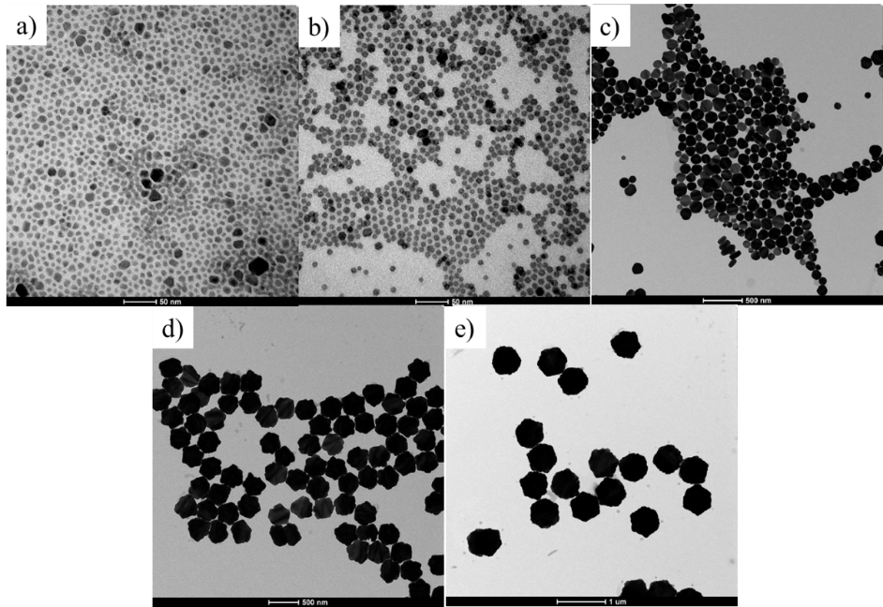Fig. S1. Size distribution of NaLuF4 particles: 15% Tb3+ NPs synthesized at a) 210 ℃ for 120 min, b) 240 ℃ for 60 min, c) 240 ℃ for 120 min and d) 270 ℃ for 120 min.

Fig. S2. TEM images of NaLuF4:15% Tb3+ reacted at 295 ℃ for a) 15 min, b) 30 min, c) 60 min, d) 90 min and e) 120 min.

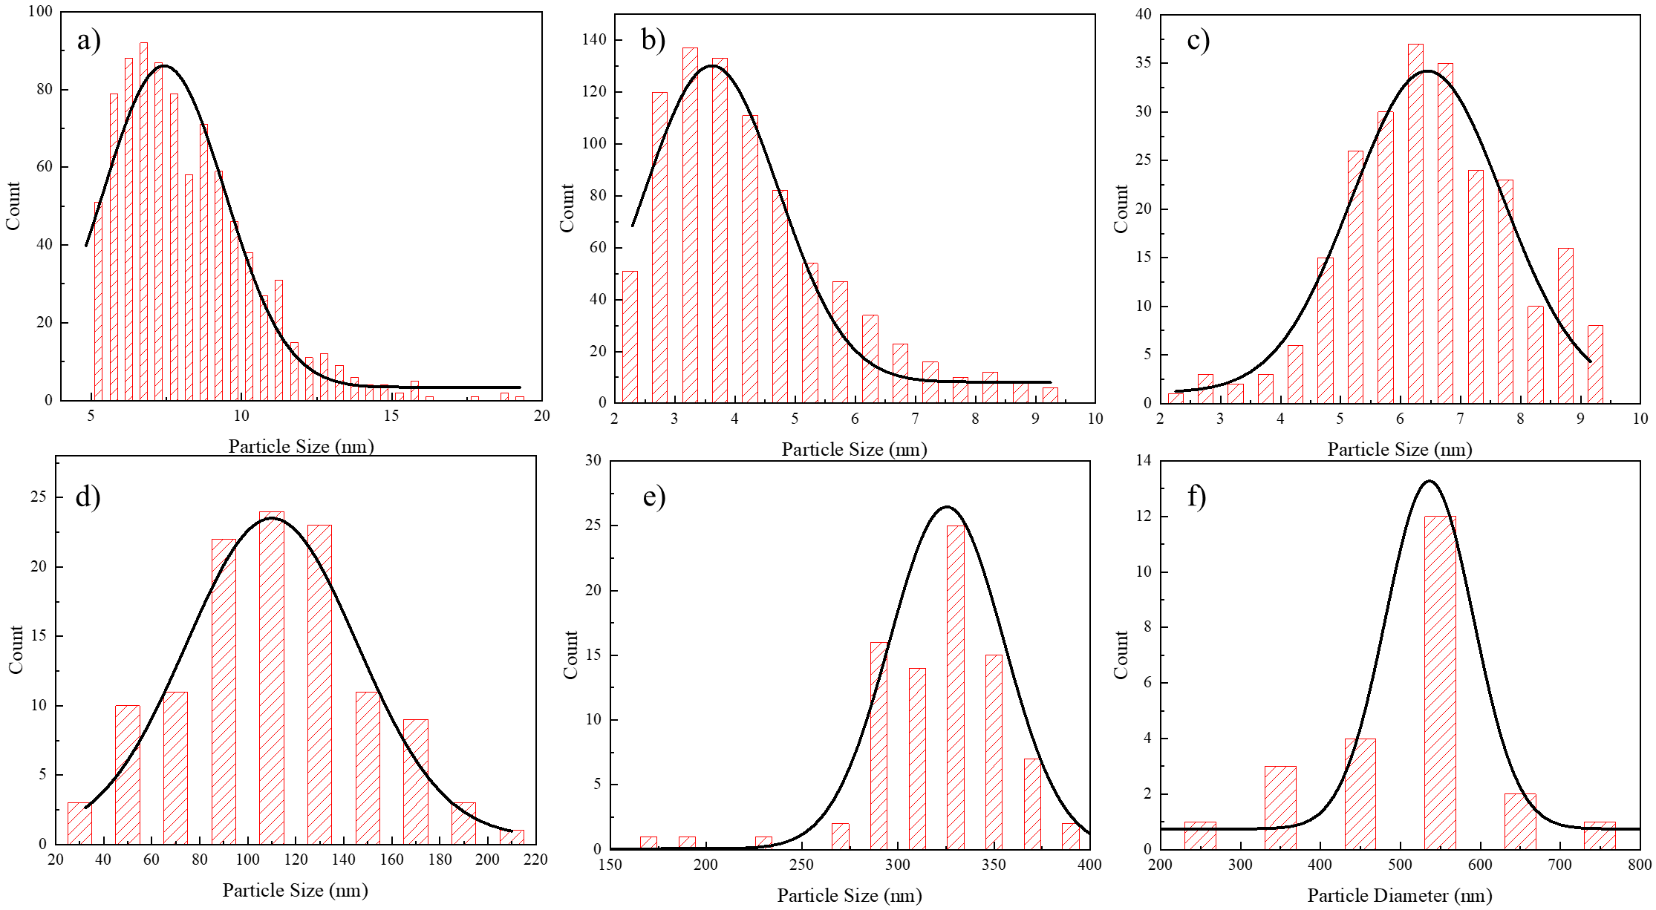

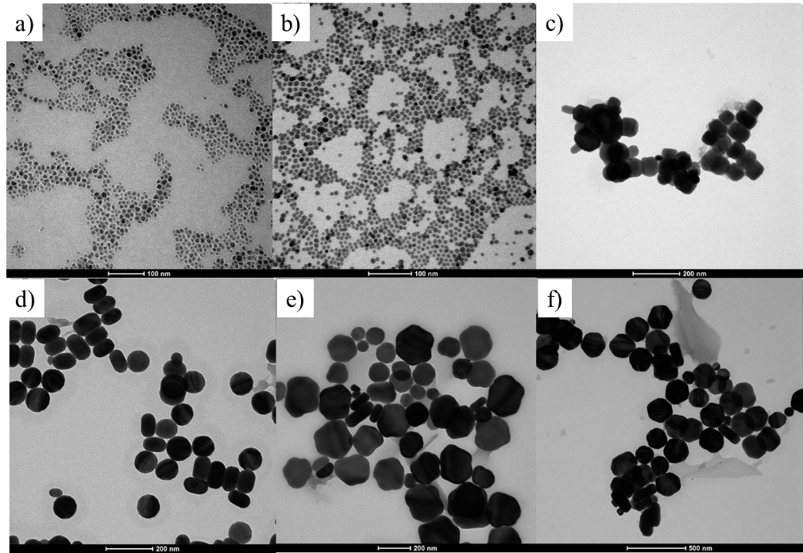Fig. S3. Size distribution of NaLuF4:15% Tb3+ NPs synthesized with different reaction times at 295 °C; a) 15 min, b) 30 min, c) 45 min, d) 60 min, e) 90 min and f) 120 min.

Fig. S4. TEM images of NaLuF4:15% Tb3+ reacted at 300 ℃ for a) 15 min, b) 25 min, c) 30 min, d) 45 min, e) 90 min and f) 120 min.

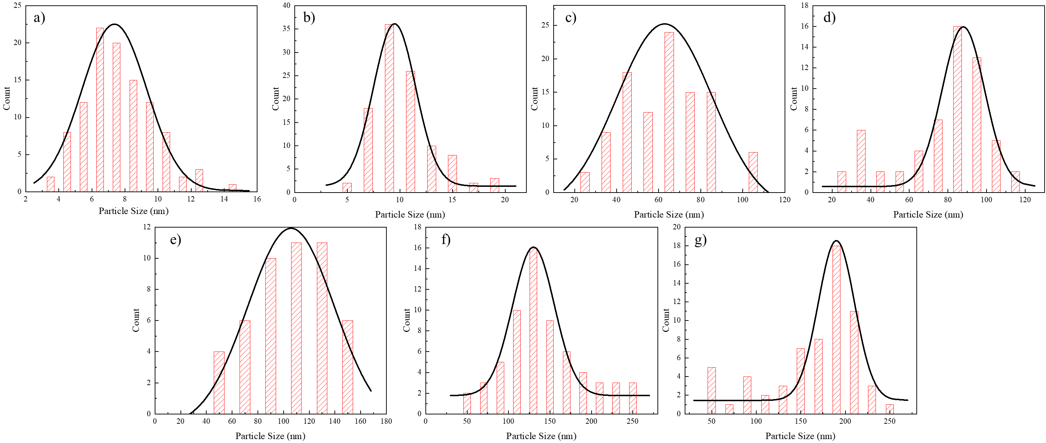Fig. S5. Particle size distributions of NaLuF4:15% Tb3+ NPs made with different reaction times at 300 °C, a) 15 min, b) 25 min, c) 30 min, d) 45 min, e) 60 min, f) 90 min, and g) 120 min.

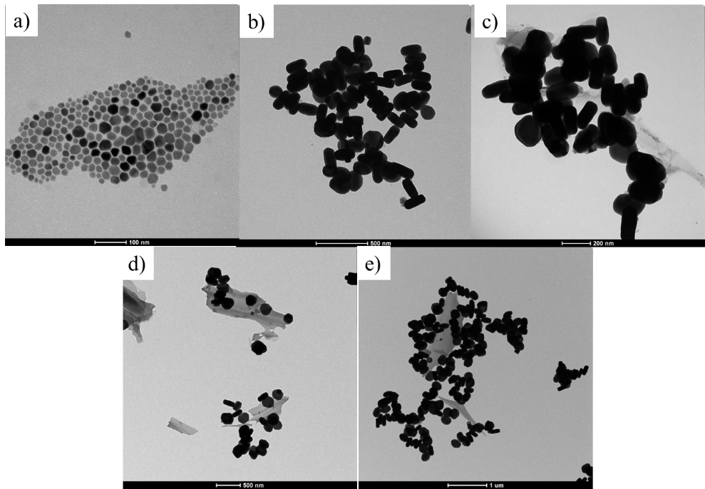

Fig. S6. TEM images of NaLuF4:15% Tb3+ reacted at 310 °C for a) 15 min, b) 30 min, c) 45 min, d) 55 min, and e) 60 min.

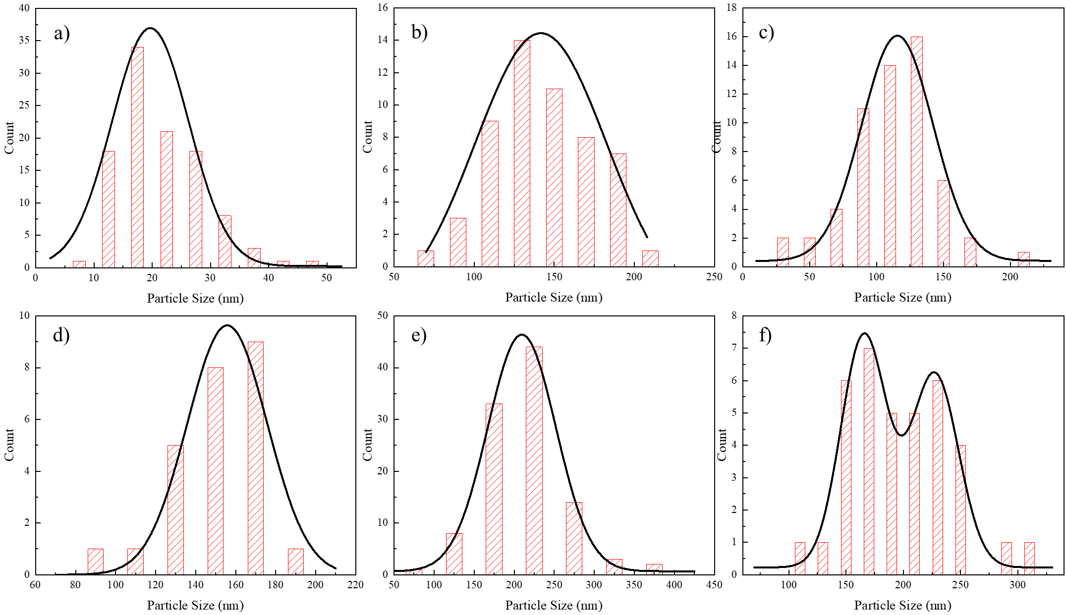Fig. S7. Particle size distributions of NaLuF4:15% Tb3+ NPs made with different reaction times at 310 °C; (a) 15 min, (b) 25 min, (c) 30 min, (d) 45 min, (e) 55 min, and f) 60 min.

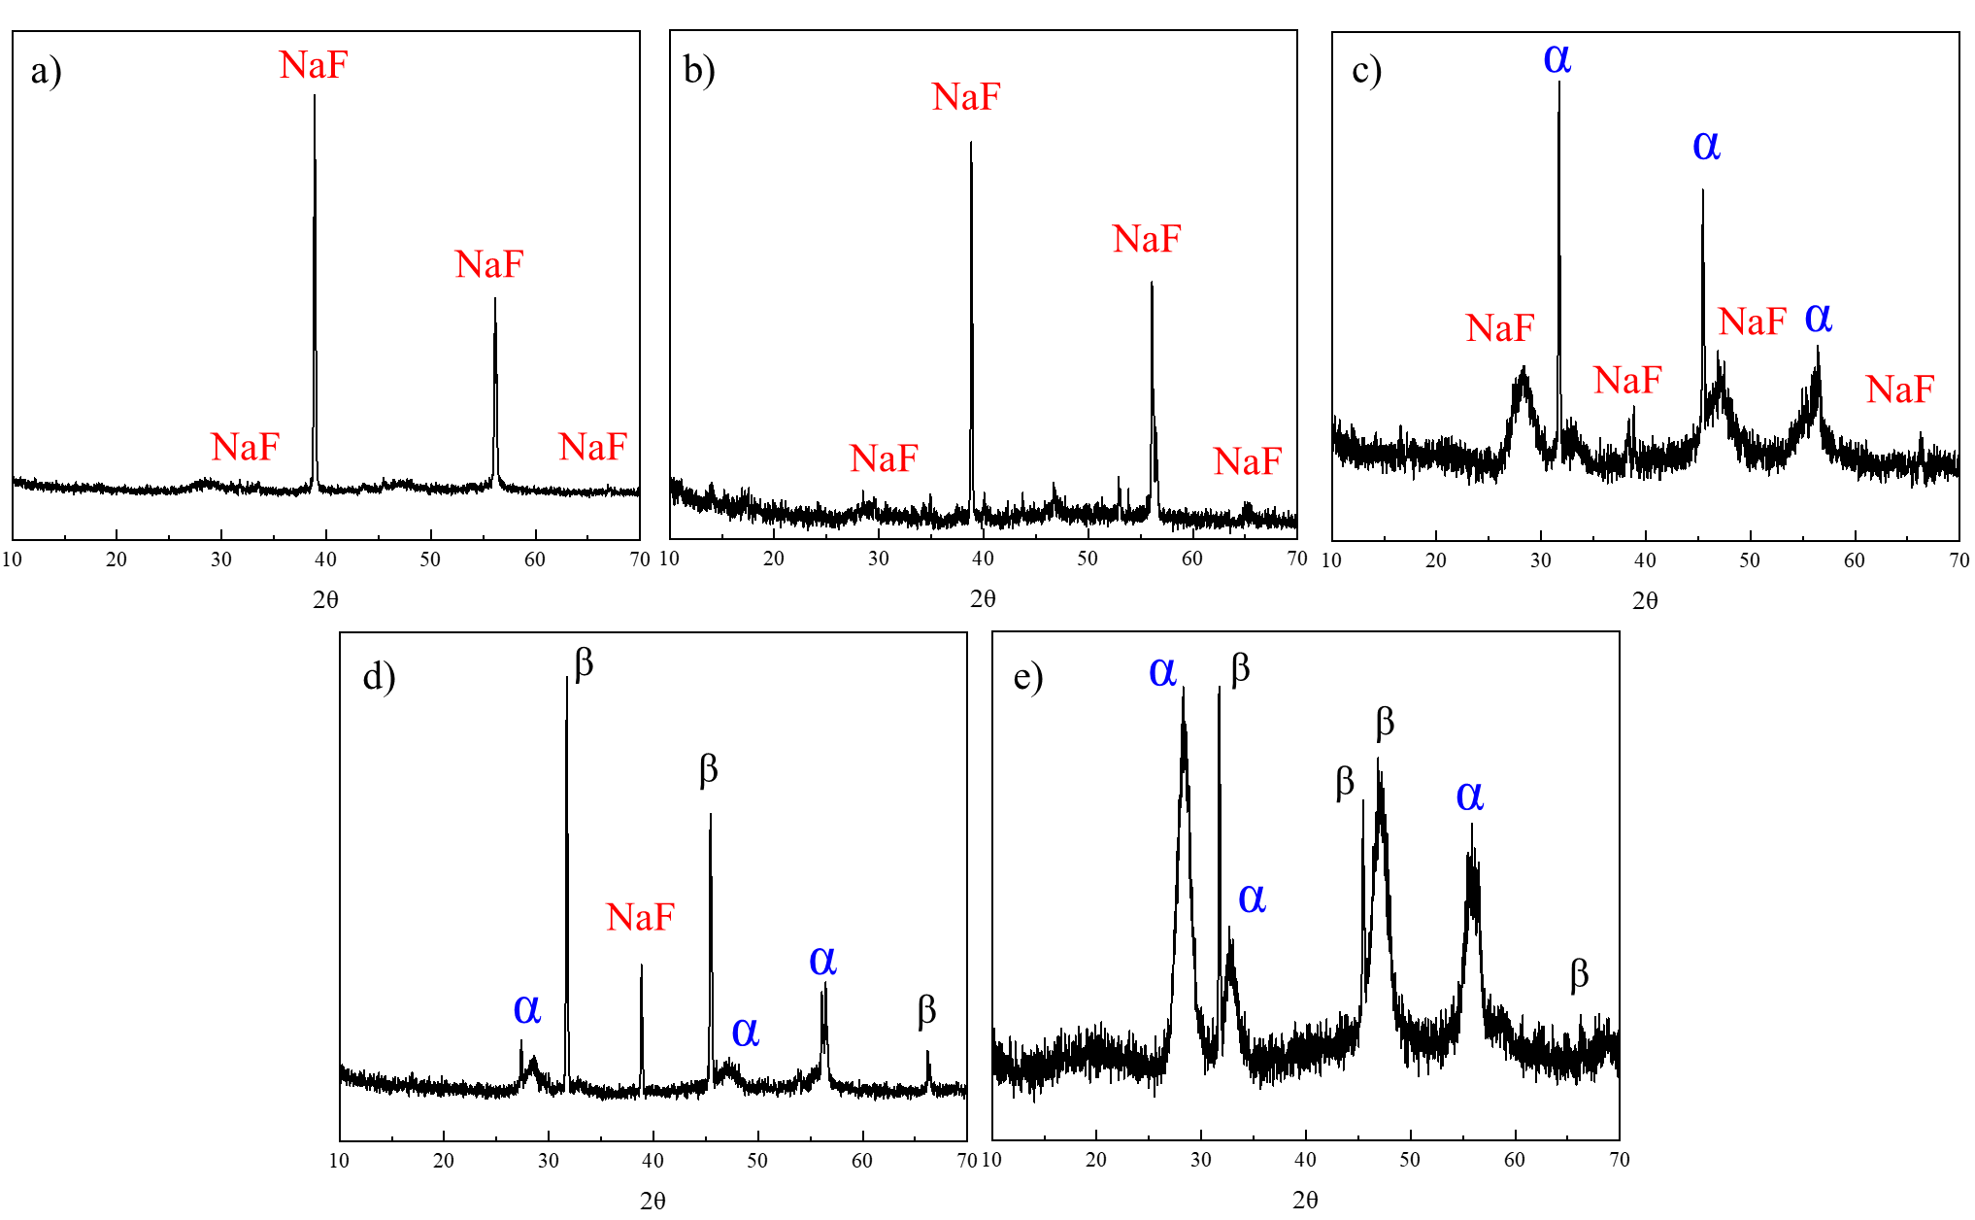

Fig. S8. XRD studies of NaLuF4:15% Tb3+ NPs synthesized at a) 160 ℃, b) 190 ℃, c) 210 ℃, d) 240 ℃ and e) 270 ℃ when the reaction reached equilibrium (triangles represent the characteristic XRD peaks of NaF. Oblique rectangles represent the characteristic XRD peaks of α-phase NaLuF4:15% Tb3+ NPs. Regular rectangles represents the characteristic XRD peaks of β-phase NaLuF4:15% Tb3+ NPs).

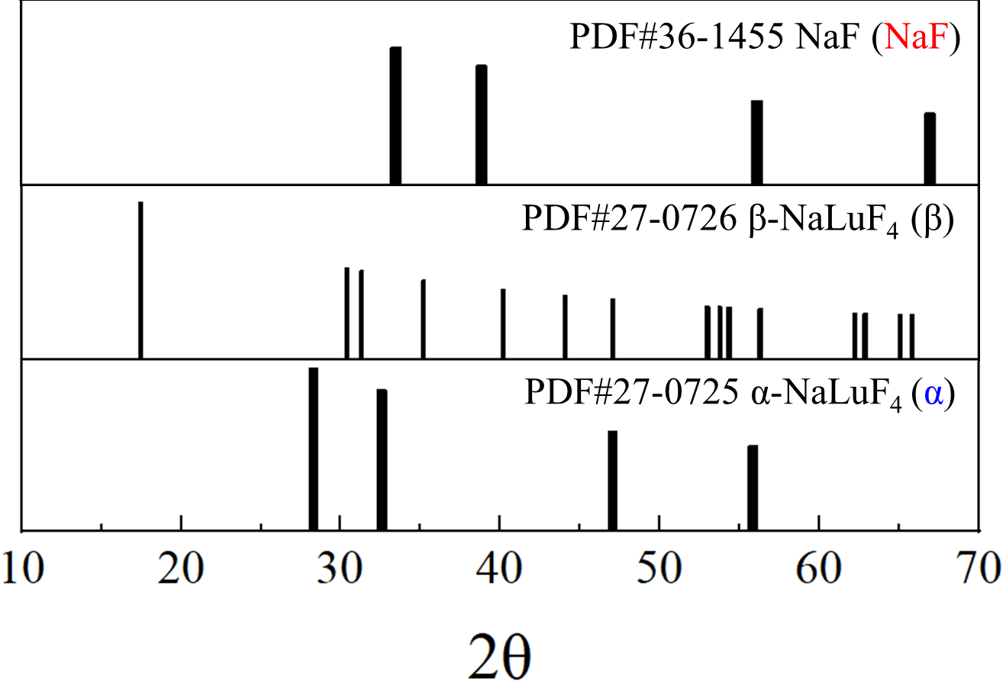

Fig. S9. Standard XRD patterns for NaF (PDF#36-1455), α-NaLuF4 (PDF#27-0725), and β-NaLuF4 (PDF#27-0726).

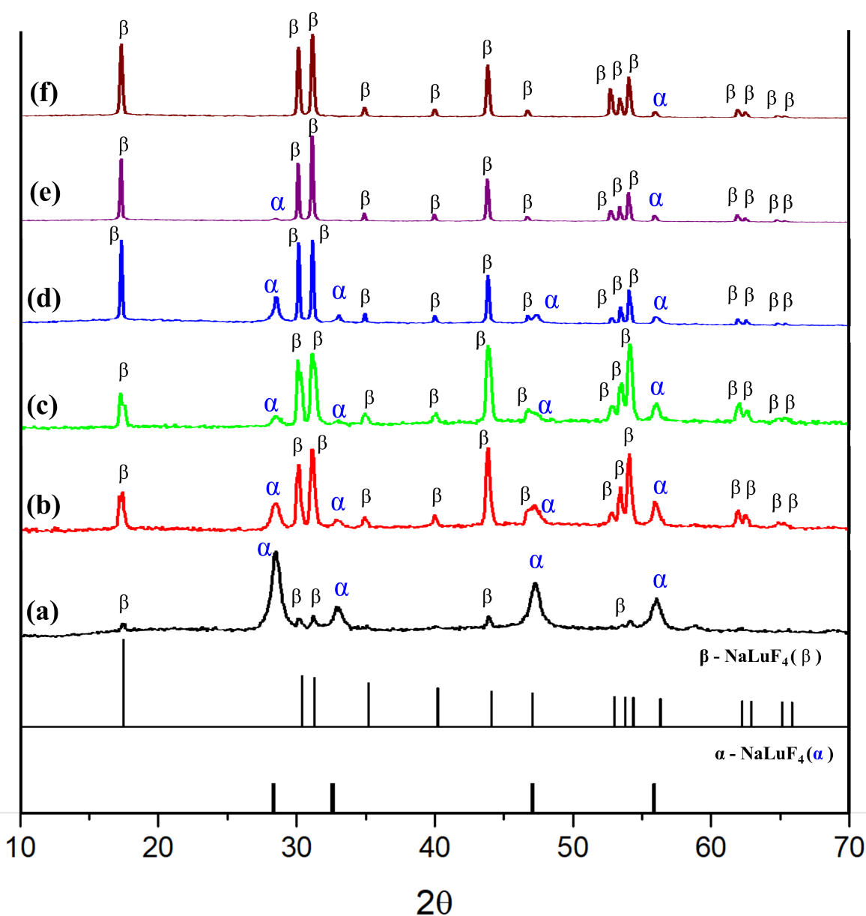

Fig. S10. XRD patterns for NaLuF4:15% Tb3+ NPs made with different reaction times at 295 °C; (a) 15 min, (b) 30 min, (c) 45 min, (d) 60 min, (e) 90 min, and (f) 120 min.

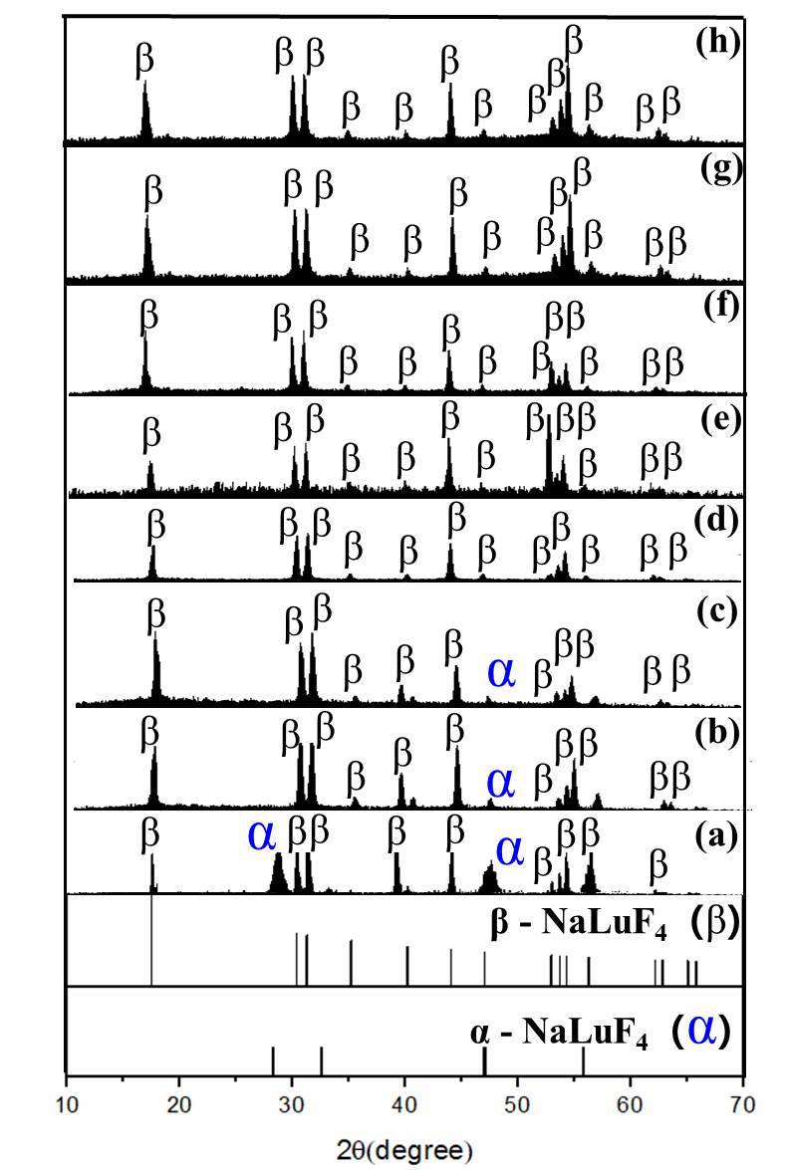

Fig. S11. XRD patterns of NaLuF4:15% Tb3+ NPs treated at 300° for different times; a) 15 min, b) 20 min, c) 25 min, d) 30 min, e) 45 min, f) 60 min, g) 90 min, and h) 120 min.

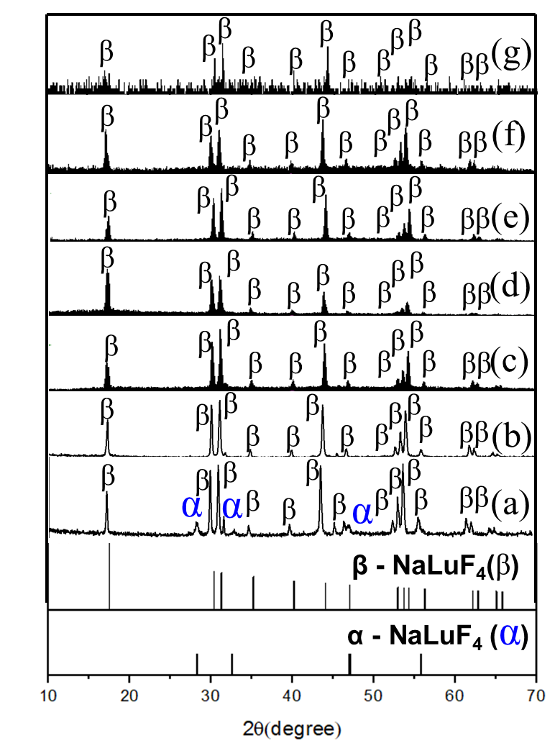

Fig. S12. XRD patterns of NaLuF4:15% Tb3+ NPs treated for different times at 310°; a) 15 min, b) 25 min, c) 30 min, d) 45 min, e) 55 min, and f) 60 min.

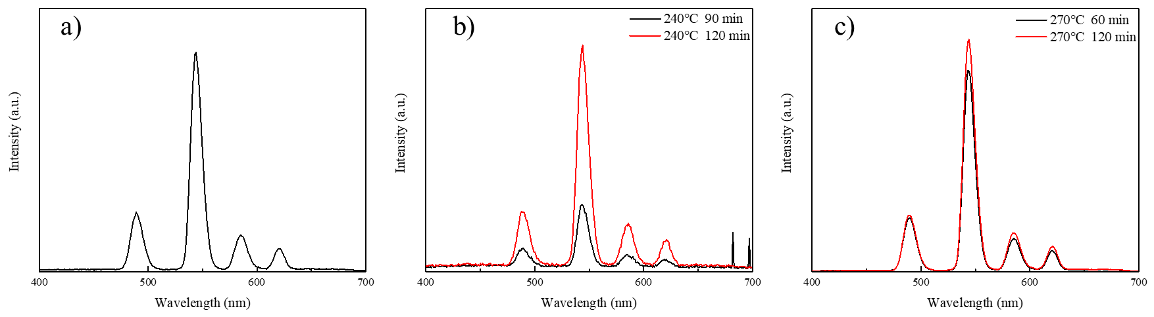

Fig. S13. X-ray excited luminescence spectra of NPs synthesized at different temperatures; a) 210 ℃, b) 240 ℃, and c) 270 ℃.

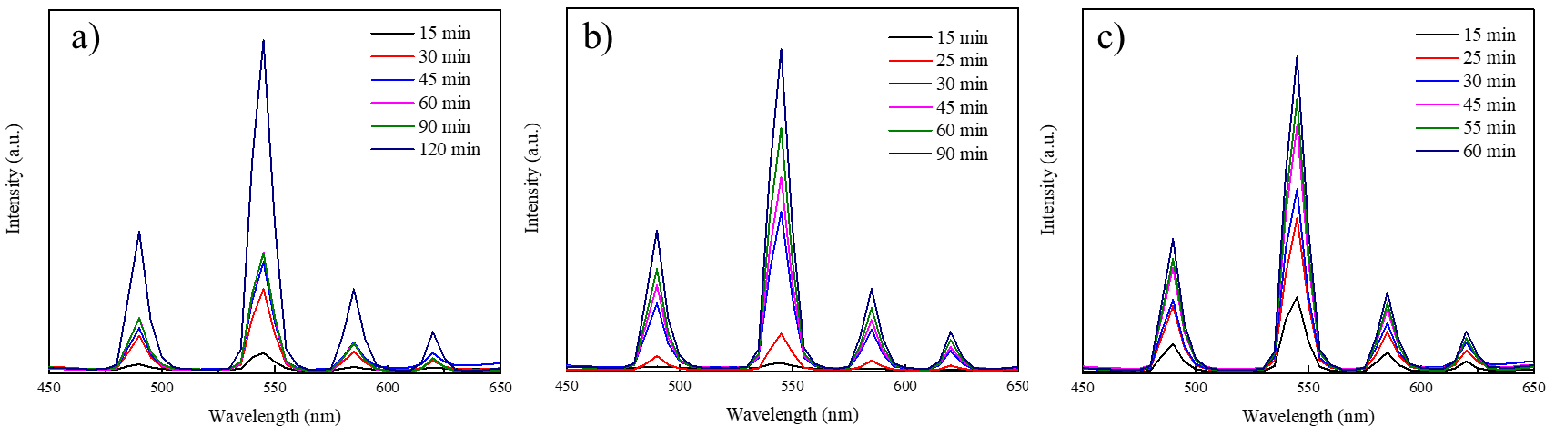

Fig. S14. X-ray excited luminescence spectra of NPs synthesized at different temperatures; a) 295 ℃, b) 300 ℃, and c) 310 ℃.

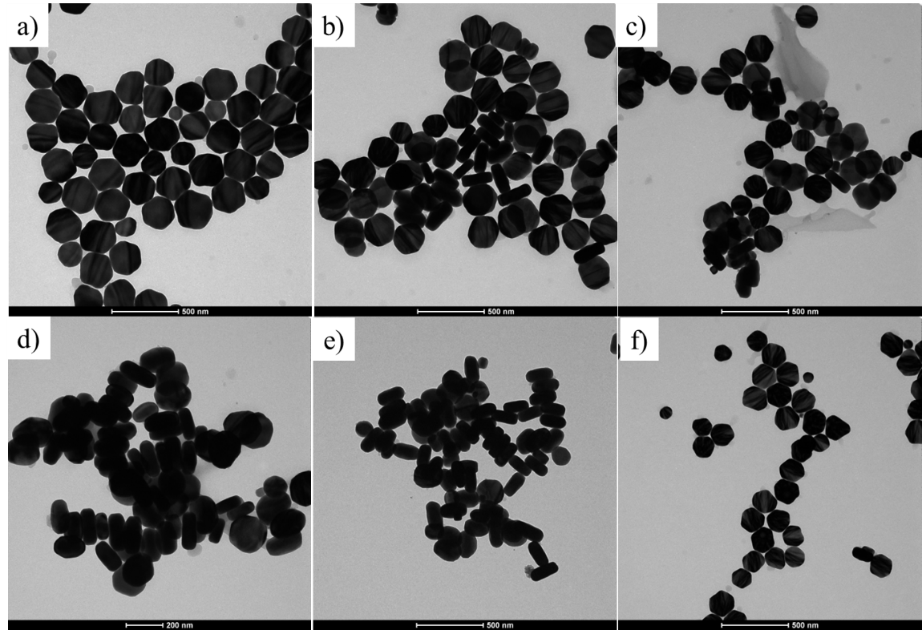

Fig. S15. TEM images of NaLuF4 synthesized at 300 ℃ with different Tb doping levels; a) 3%, b) 6%, c) 9%, d) 12%, e) 15%, and f) 21%.

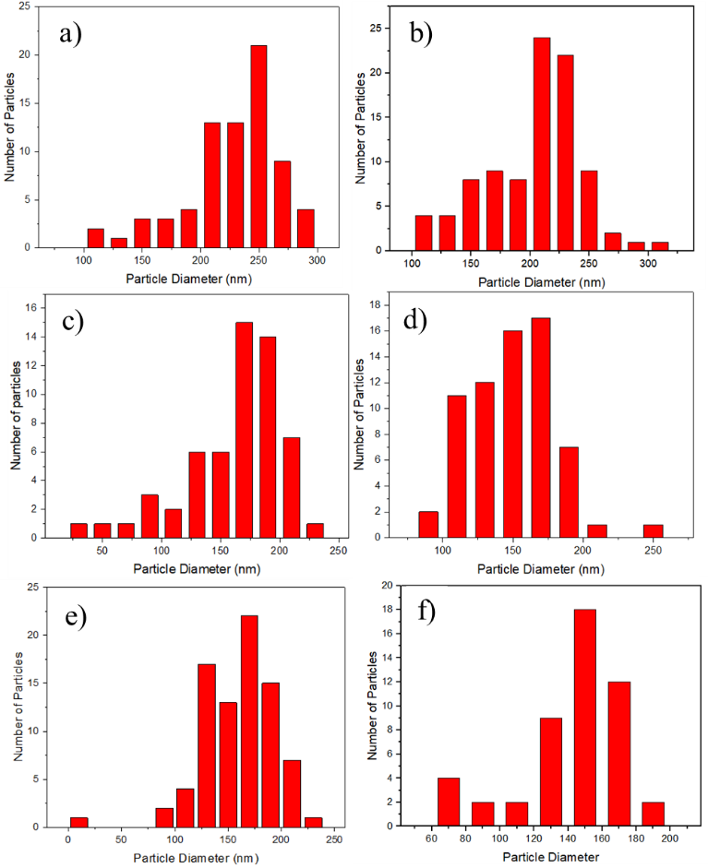

Fig. S16. Size distributions of NaLuF4 NPs synthesized at 310 °C with different Tb doping level; a) 3%, b) 6%, c) 9%, d) 12%, e) 15%, and f) 21%.

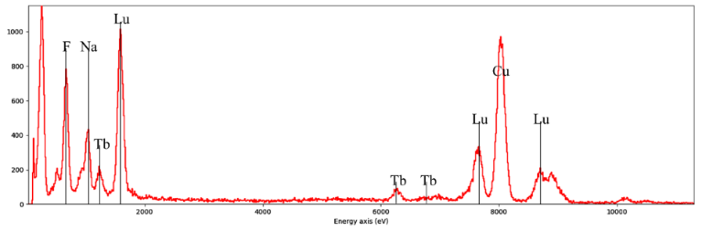

Fig. S17. EDX patterns of NaLuF4:15% Tb3+ NPs.