**Supporting Information**

**Phytogenic fabrication of iron oxide nanoparticles and evaluation of their *in vitro* antibacterial and cytotoxic activity**

**Sheik Aliyaa, Muruganantham Rethinasabapathya, Jingon Yooa,** **Eunsu Kima, Joo-Yoon Chungb,** **Jong-Ho Chab,c*,Yun Suk Huha\***

*a NanoBio High-Tech Materials Research Center, Department of Biological Sciences and Bioengineering, Inha University, Incheon, Republic of Korea*

*b Department of Biomedical Sciences, College of Medicine, Inha University, Incheon, Korea*

*c Department of Biomedical Science and Engineering, Graduate School, Inha University, Incheon, Korea*

*Corresponding author.

*E-mail addresses*: [yunsuk.huh@inha.ac.kr](mailto:yunsuk.huh@inha.ac.kr) (Y. S. Huh).

: [chajongho@inha.ac.kr](mailto:chajongho@inha.ac.kr) (J. H. Cha).

**Figure S1**. Light-brown colored FeCl3 into dark colored Fe3O4 after the addition of *N. sativa* extract in the presence citric acid stabilizer.

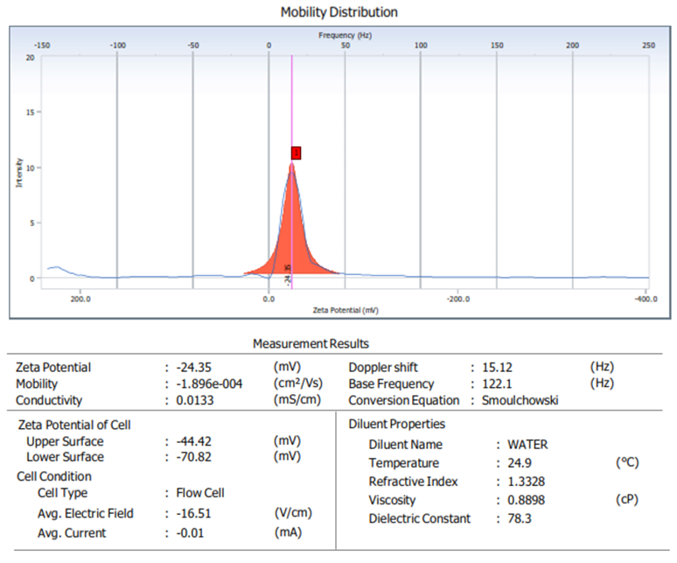

**Figure S2.** Zeta potential study of IONPs

**Figure S2a.** Zeta potential study of NS-IONPs synthesized using *Nigella sativa*.

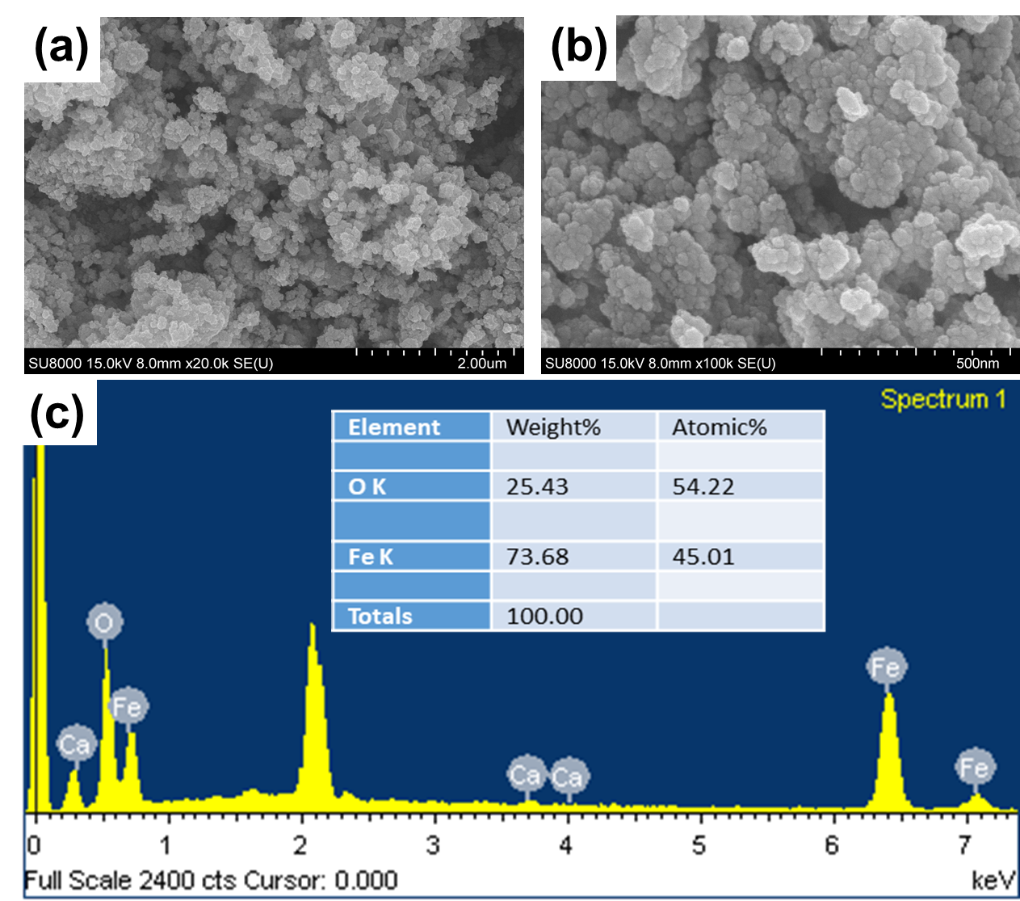

**Figure S3.** SEM and EDX analysis of NS-IONPs.

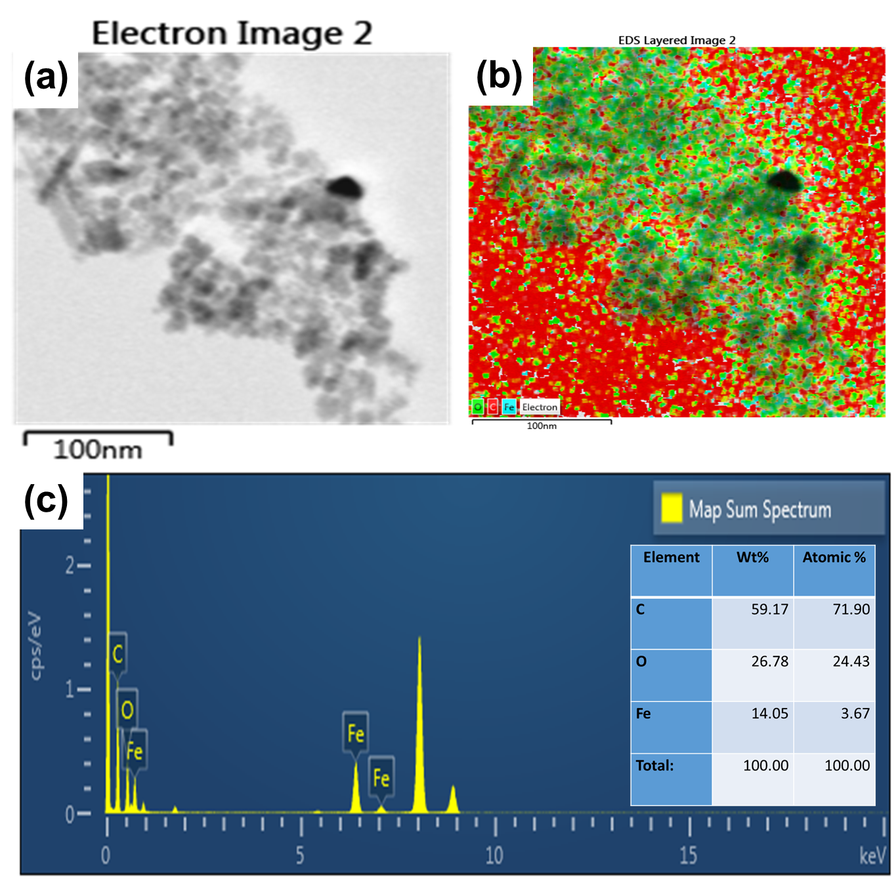

**Figure S4.** TEM and EDS analysis of NS-IONPs.

**Figure S5.** Bacterial inhibition assay.

**Figure S6.** Scanning electron microscopic images of *S.typhimurium* - Control and treated with NS-IONPs.

**Figure S7.** Effect ofNS-IONPs on the HCT116 and A549 cancer cell lines. The yellow arrows show cells undergone cell lysis.

**Figure S8.** Effect ofNS-IONPs on the A549 cancer cell line. (a) The yellow arrow shows the accumulation of NS-IONPs in the cytoplasm at 24 h. (b) The red arrow shows cell lysis at 48 h.

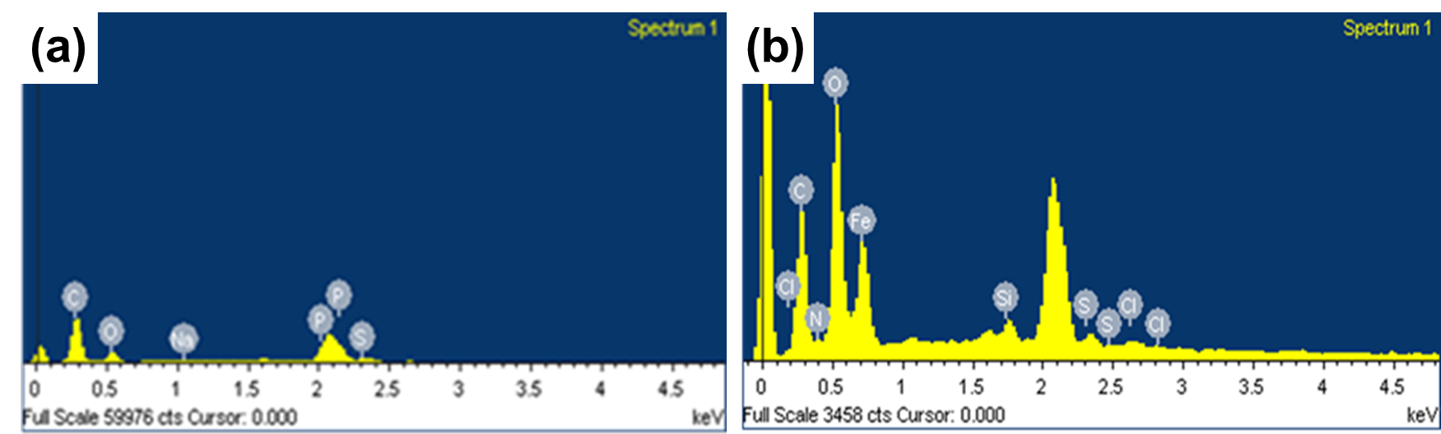

**Figure S9.** EDX analysis of (a) control cells and (b) treated cells.

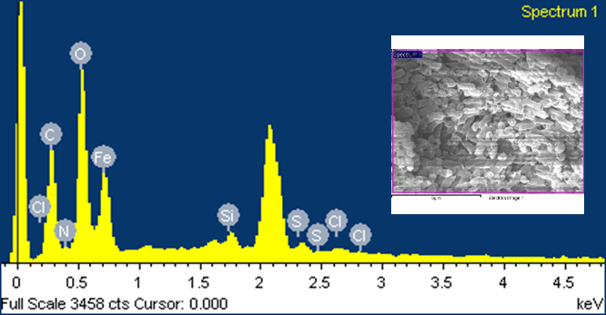

**Figure S10.** EDX analysis of *E. coli* treated with NS-IONPs.

**Figure S11.** Effect of NS-IONPs in colony formation in HCT116 and A549 cell lines.

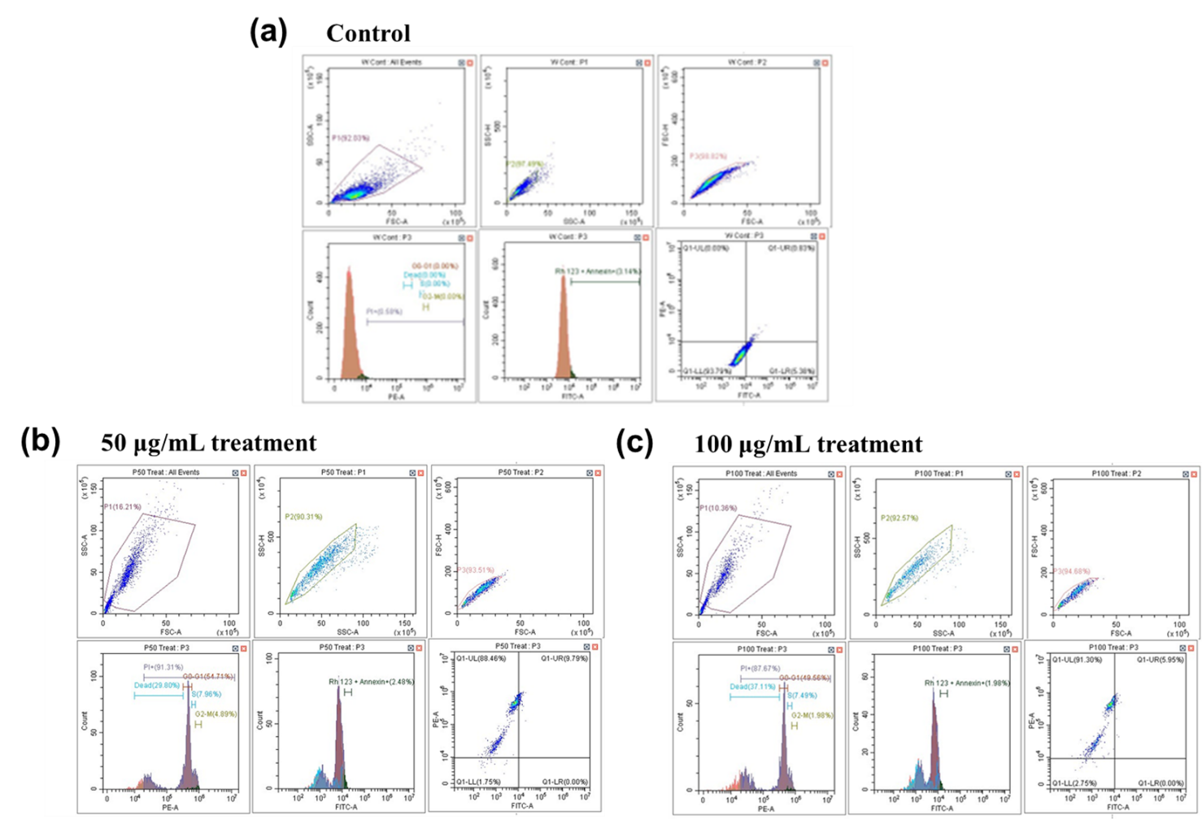

**Figure S12.** Cell cycle effects of NS-IONPs in lung cancer cell lines (A549). a. control without propidium iodide; b and c. effect of 50 µg/mL and 100 µg/mL increase in concentration of the NS-IONPs respectively.

**Table S1.** Gene specific primers for qRT-PCR analysis.

|  |  |  |
| --- | --- | --- |
| ` | Name (Gene Accession #) | ` |
| 1 | β-Actin | F: 5'-CCG AGG ACT TTG ATT GCA CAT TG-3'  R: 5'-TGG GGT GGC TTT TAG GAT GG-3' |
| 2 | TP53 | F: 5'-GGC CCA CTT CAC CGT ACT AA-3'  R: 5'-TGA GGT AGG TGC AAA TGC CA-3' |
| 3 | BCl2 | F: 5'-ATC GCC CTG TGG ATG ACT GA-3'  R: 5'-GGG CCG TAC AGT TCC ACA A-3' |
| 4 | BAX | F: 5'-AGC GAC TGA TGT CCC TGT CT-3'  R: 5'-CTC CCG CCA CAA AGA TGG TC-3' |