Influence of End-Capped Engineering on 3-Dimenional Star-Shaped Triphenylamine-Based Donor Materials for Efficient Organic Solar Cells
Muhammad Adnan, ^{a*1} Zobia Irshad, ^{b1} Riaz Hussain, ^{c*} Wonjong Lee, ª Jung Yup Yang, ^{d*} Jongchul Lim ^{a*}
ª Graduate School of Energy Science and Technology, Chungnam National University, 34134, Daejeon, Republic of Korea
^{b} Department of Chemistry, Chosun University, 61452, Gwangju, Republic of Korea
^{c} Department of Chemistry, University of Okara, Okara-56300, Pakistan
^{d} Department of Physics, Kunsan National University, Geonbuk, 54150 Republic of Korea
¹ Muhammad Adnan and Zobia Irshad contributed equally for the first authorship.
Corresponding authors:
Muhammad Adnan (Ph.D.) adnan5750@gmail.com, adnan@cnu.ac.kr
Riaz Hussain (Ph.D.) riazhussain@uo.edu.pk
Jung Yup Yang (Ph.D.) jungyup.yang@kunsan.ac.kr
Jongchul Lim (Ph.D.) jclim@cnu.ac.kr

Reference | STRO1
STRO2 | STRO3
STRO4 | STRO5
STRO6 | STRO7
STRO8

Figure S1: Chemical structure of STRO (R) along-with eight newly proposed star-shaped molecules (STRO1-STRO8).

Hole Electrons Overlap Heat Maps
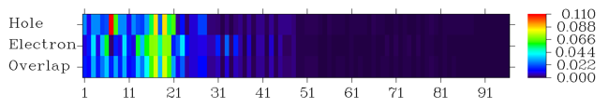
Reference
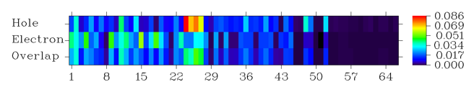
STRO1
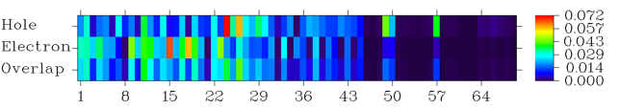
STRO2
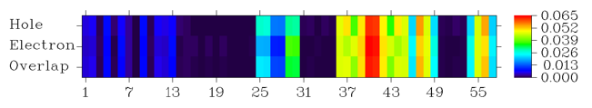
STRO3
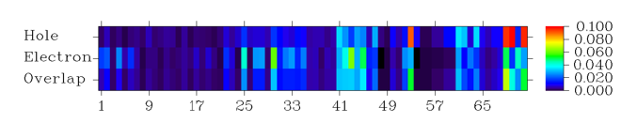
STRO4

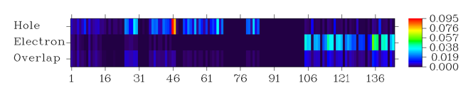
STRO5
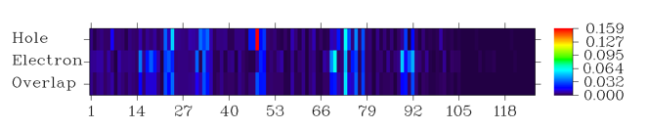
STRO6
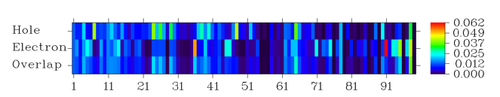
STRO7
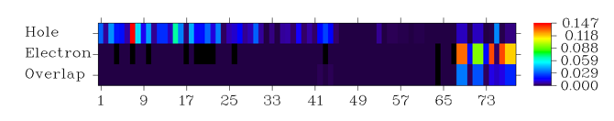
STRO8

Figure S2: The hole/electrons overlap heat maps of STRO (R) along-with eight newly proposed star-shaped molecules (STRO1-STRO8).

