**Supplementary**

**Phytochemical and bioactivity evaluation of secondary metabolites and essential oils of *Sedum rubens* growing wild in Jordan**

Ammar A. Odeh a, Hala I. Al-Jaber a*, Lina M. Barhoumi a, O’la Al-Fawares b, Ashok K. Shakya c, Mahmoud A. Al-Qudah d,e, and Ola Sanabra b

a Chemistry Department, Faculty of Science, Al-Balqa Applied University, Al-Salt, Jordan

b Department of Medical Laboratory Analysis, Faculty of Science, Al-Balqa Applied University, Al-Salt, Jordan

c Faculty of Pharmacy, Al-Ahliyya Amman University, Al-Salt, Jordan

d Department of chemistry, Faculty of Sciences, Yarmouk University, Irbid, Jordan.

e Department of Chemistry, College of Science, Imam Mohammad Ibn Saud Islamic University (IMSIU), Riyadh 11432, Saudi Arabia

*Corresponding author: Prof. Dr Hala I. Al-Jaber, Email: hala.aljaber@bau.edu.jo

**Abstract**

*Sedum rubens* L. (Crassulaceae family) is an interesting succulent medicinal plant that has never been investigated for its phytochemical constituents. Thus, the current study was designed to unveil its chemical constituents and bioactivity potentials. In the current study, the total phenol content (TPC), total flavonoid content (TFC) and DPPH radical scavenging properties of the hydroalcoholic (HA) and water extracts (W) were determined. Moreover, the presence of selected phenolic acids (gallic acid, chlorogenic acid, caffeic acid) and flavonoids (rutin, quercetin, hesperidin) was determined by HPLC-PDA. In addition, hydro-distilled essential oil (HDEO) composition of the plant at the pre-flowering (PF) and full-flowering (FF) stages was determined by GC/MS and GC/FID techniques. Results revealed that the FF hydroalcoholic extract had the highest TPC (136.9 mg gallic acid/g extract), TFC (234.7 mg quercetin/g extract) and DPPH• radical scavenging activity (7.10×10-2 ± 1.0×10-3 mg/mL). This extract was rich in gallic acid and caffeic acids (366, 243 mg/Kg dry plant, respectively). The study resulted in reporting four known compounds including α- & β-amyrin acetates, β-sitosterol and β-sitosterol glycoside for the first time from the plant. The HDEO at the PF and FF stages were dominated by oxygenated sesquiterpenes (21.92%) and aliphatic hydrocarbons (45.71%).

***Keywords:*** *Sedum rubens*; Secondary metabolites; - & -amyrine acetate; TPC; TFC; Antioxidant activity; HPLC-PDA

**Experimental**

**GC–MS and GC–FID analysis**

About 1 μL aliquot of each HD-EO oil sample, diluted to 5 μL in GC grade *n*-hexane, was subjected to GC/MS analysis. The GC/MS analysis was performed using Varian Chrompack CP-3800 GC/MS/MS-200 (Saturn, Netherlands) equipped with DP-5 (5% diphenyl, 95% dimethyl polysiloxane) GC cappillary column (30 m × 0.25 mm i.d., 0.25 μm film thicknesses), with helium as a carrier gas (flow rate 0.9 mL/min). The actual temperature in MS source was 180 °C and the ionization voltage was 70 eV. The column temperature was kept at 60 °C for 1 min (isothermal), and programmed to 246 °C at a rate of 3 °C/min, and kept constant at 246 °C for 3 min (isothermal).

A hydrocarbon mixture of n-alkanes (C8–C20) was analyzed separately by GC/MS under the same chromatographic conditions using the same DB-5 column.

For the quantitative analysis (% area), a Hewlett–Packard HP-8590 gas chromatograph equipped with a split–splitless injector (split ratio 1:50) and an FID detector was used. The column was an optima-5 (5% diphenyl, 95% dimethyl polysiloxan) fused silica capillary column (30 m × 0.25 mm, 0.25 μm film thickness). The temperature of the oven was increased at a rate of 10 °C/min from 60 to 250 °C and then held constant at 250 °C for 5 min. The temperatures of the injector and detector were maintained at 250 and 300 °C, respectively. The relative peak areas of the oil components were measured and then used to calculate the concentration of the detected.

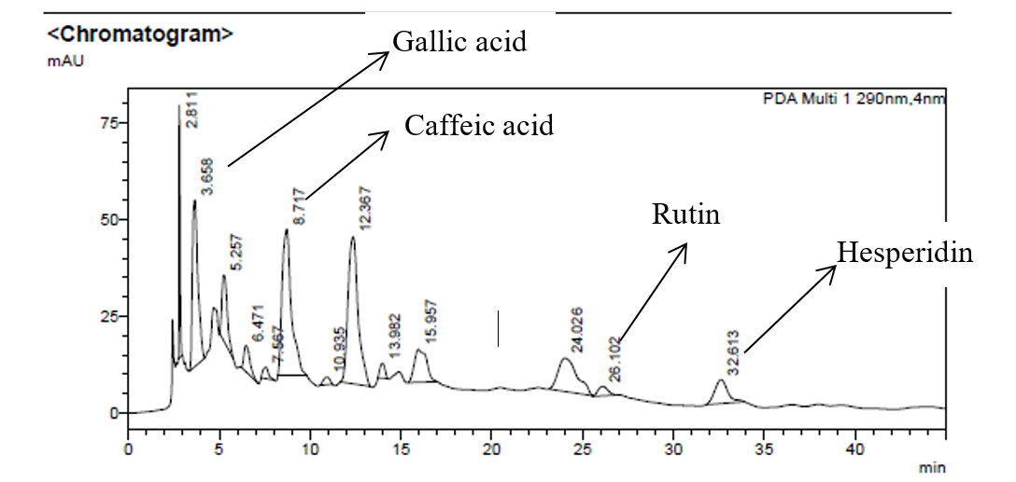

Fig. S1. HPLC-PDA chromatogram of Sr-HA extract obtained from *S. rubens* from Jordan.

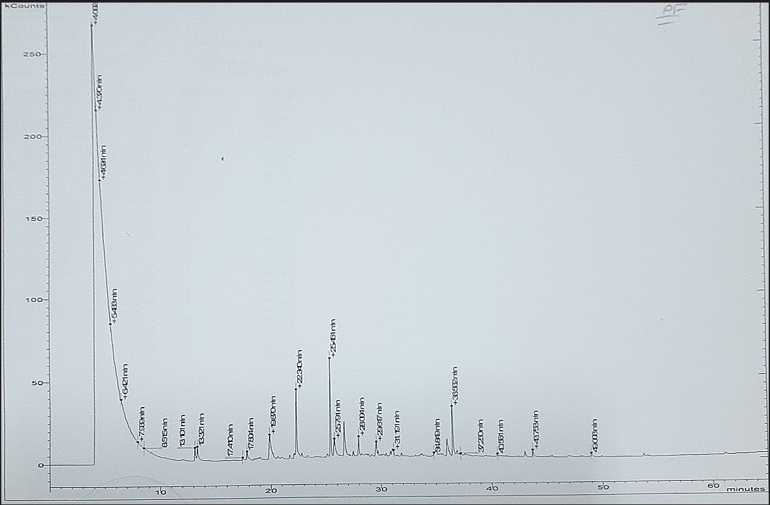

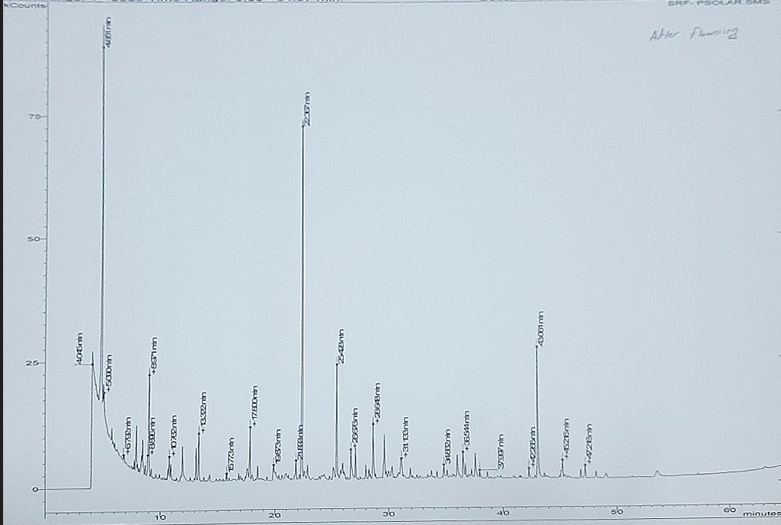

Fig. S2. GC/MS chromatograms of HD-EO of *S. rubens* from Jordan at PF (above) and FF (below) stages.