**Supporting Information**

**Novel coumarin derivatives as potential tyrosinase inhibitors: Synthesis, binding analysis and biological evaluation**

Li Lu a, †, Xin Zhang a, †, Yu Kang a, Zhuang Xiong a, Kun Zhang a, Xue-Tao Xu a, b*

**Synthesis of derivatives 4a~r and 5a~l……………………….………………..........…..2-9**

**1H NMR and 13C NMR of compouds…………………………………………..........…..10-39**

**Synthesis of derivatives 4a~r and 5a~l**

Substituted salicylaldehyde (**1**) (1.0 mmol) and ethyl acetoacetate (1.1 mmol) were added into 10 mL of ethanol containing piperidine (0.02 mmol), then reflowed at 80 °C until the reaction completed. Ice-cold water was added to quench the reaction, followed by filtration and recrystallization to obtain substituted acetyl coumarin (**2**). To the solution of **2** (1.0 mmol) in 10 mL of ethanol, hydroxylamine hydrochloride (3.0 mmol) and pyridine (0.04 mmol) were added and reacted at room temperature. The product was washed with ethanol to obtain substituted acetyl coumarin containing oxime (**3**). To the solution of **3** (1.0 mmol) in 3 mL of DCM, triethylamine (1.1 mmol) and substituted benzoic acid chlorides/cinnamic acid chlorides (1.0 mmol) were added, respectively, and reacted at room temperature. Then the reaction was quenched, extracted, washed, and dried, followed by column chromatography purification to produce derivatives**4a**~**r** and **5a**~**l**. All NMR, HRMS, yield, and m.p. data were summarized supporting materials.

***(4a****,* ***C20H15NO4)***. White sold; Yield 67%; m.p. 161 - 162 °C; 1H NMR (500 MHz, Chloroform-*d*) δ 8.16 (s, 1H), 7.88 (d, *J* = 16.0 Hz, 1H), 7.62 - 7.55 (m, 4H), 7.45 - 7.38 (m, 3H), 7.38 - 7.29 (m, 2H), 6.59 (d, *J* = 16.0 Hz, 1H), 2.49 (s, 3H); 13C NMR (126 MHz, CDCl3) δ 164.32, 162.14, 159.26, 154.34, 146.84, 143.39, 134.14, 132.96, 130.85, 129.06, 129.02, 128.35, 124.95, 123.58, 118.55, 116.68, 115.29, 77.32, 77.06, 76.81, 15.94; HRMS (ESI) [M+H]+ calcd. for C20H15NO4: 334.1070; found: 334.1074.

***(4b, C21H17NO4)***. White sold; Yield 62%; m.p. 154 - 155 °C; 1H NMR (500 MHz, DMSO-*d*6) δ 8.34 (s, 1H), 7.90 (dd, *J* = 7.8, 1.6 Hz, 1H), 7.81 (d, *J* = 16.1 Hz, 1H), 7.69 (dd, *J* = 7.5, 4.0 Hz, 3H), 7.48 (d, *J* = 8.3 Hz, 1H), 7.42 (td, *J* = 7.5, 1.1 Hz, 1H), 7.27 (d, *J* = 7.8 Hz, 2H), 6.79 (d, *J* = 16.0 Hz, 1H), 2.38 (s, 3H), 2.34 (s, 3H). 13C NMR (126 MHz, DMSO) δ 164.18, 162.56, 159.13, 154.19, 146.68, 143.72, 141.46, 133.63, 131.70, 130.07, 130.02, 129.14, 125.45, 123.64, 118.87, 116.68, 114.93, 40.48, 40.39, 40.31, 40.23, 40.14, 40.05, 39.98, 39.88, 39.81, 39.64, 39.47, 21.56, 16.15. HRMS (ESI) [M+H]+ calcd. for C21H17NO4: 348.1229; found: 348.1233.

***(4c, C20H14ClNO4)***. White sold; Yield 65%; m.p. 248 - 249 °C; 1H NMR (500 MHz, Chloroform-*d*) δ 8.15 (s, 1H), 7.83 (d, *J* = 16.0 Hz, 1H), 7.63 - 7.55 (m, 2H), 7.55 - 7.49 (m, 2H), 7.41 - 7.29 (m, 4H), 6.56 (d, *J* = 16.0 Hz, 1H), 2.48 (s, 3H). 13C NMR (126 MHz, CDCl3) δ 164.09, 162.28, 159.24, 154.32, 145.34, 143.43, 136.78, 133.02, 132.60, 129.52, 129.32, 129.07, 124.98, 123.49, 118.50, 116.69, 115.86, 77.35, 77.09, 76.84, 15.97. HRMS (ESI) [M+H]+ calcd. for C20H14ClNO4: 368.0682, found: 368.0687.

***(4d, C20H14BrNO4)***. White sold; Yield 69%; m.p. 182 - 183 °C; 1H NMR (500 MHz, Chloroform-*d*) δ 8.15 (s, 1H), 7.81 (d, *J* = 16.0 Hz, 1H), 7.62 - 7.53 (m, 4H), 7.52 – 7.43 (m, 2H), 7.38 - 7.30 (m, 2H), 6.58 (d, *J* = 16.0 Hz, 1H), 2.48 (s, 3H); 13C NMR (126 MHz, CDCl3) δ 164.10, 162.31, 159.26, 154.34, 145.44, 143.45, 133.03, 132.29, 129.71, 129.09, 125.20, 124.99, 123.50, 118.52, 116.71, 115.97, 77.31, 77.26, 77.06, 76.80, 15.98. HRMS (ESI) [M+H]+ calcd. For C20H14BrNO4: 412.0187; found: 412.0181.

***(4e****,* ***C20H14FNO4)***. White sold; Yield 67%; m.p. 166 - 170 °C; 1H NMR (500 MHz, Chloroform-*d*) δ 8.14 (s, 1H), 7.84 (d, *J* = 16.0 Hz, 1H), 7.58 (ddd, *J* = 9.4, 4.8, 2.3 Hz, 4H), 7.38 - 7.28 (m, 2H), 7.10 (t, *J* = 8.6 Hz, 2H), 6.51 (d, *J* = 16.0 Hz, 1H), 2.48 (s, 3H); 13C NMR (126 MHz, CDCl3) δ 165.21, 164.20, 163.20, 162.18, 159.24, 154.33, 145.47, 143.38, 132.98, 130.43, 130.40, 130.33, 130.26, 129.06, 124.96, 123.55, 118.52, 116.68, 116.30, 116.12, 115.04, 115.02, 77.33, 77.27, 77.07, 76.82, 15.93; HRMS (ESI) [M+H]+ calcd. for C20H14FNO4: 352.0975; found: 352.0982.

***(4f****,* ***C21H17NO5)***. White sold; Yield 68%; m.p. 150 - 152 °C; 1H NMR (500 MHz, Chloroform-*d*) δ 8.15 (s, 1H), 7.83 (d, *J* = 16.0 Hz, 1H), 7.59 - 7.53 (m, 4H), 7.37 - 7.30 (m, 2H), 6.94 - 6.92 (m, 2H), 6.45 (d, *J* = 16.0 Hz, 1H), 3.85 (s, 3H), 2.48 (s, 3H); 13C NMR (126 MHz, CDCl3) δ 164.70, 161.83, 159.30, 154.32, 146.52, 143.34, 132.92, 130.12, 129.05, 126.91, 124.94, 123.67, 118.57, 116.67, 114.44, 112.54, 77.32, 77.27, 77.07, 76.81, 55.46, 15.91; HRMS (ESI) [M+H]+ calcd. for C21H17NO5: 364.1178; found: 364.1182.

***(4g****,* ***C20H14N2O6)***. Yellow sold; Yield 70%; m.p. 221 - 222 °C; 1H NMR (500 MHz, Chloroform-*d*) δ 8.30 – 8.27 (m, 2H), 8.16 (s, 1H), 7.91 (d, *J* = 16.0 Hz, 1H), 7.76 - 7.74 (m, 2H), 7.60 (ddd, *J* = 14.2, 8.0, 1.6 Hz, 2H), 7.39 - 7.31 (m, 2H), 6.73 (d, *J* = 16.1 Hz, 1H), 2.50 (s, 3H); 13C NMR (126 MHz, CDCl3) δ 163.40, 162.80, 159.19, 154.37, 148.78, 143.74, 143.51, 140.12, 133.13, 129.09, 128.95, 125.02, 124.29, 123.35, 119.71, 118.46, 116.75, 77.30, 77.25, 77.05, 76.79, 16.02; HRMS (ESI) [M+H]+ calcd. for C20H14N2O6: 379.0923; found: 379.0927.

***(4h****,* ***C21H14F3NO4)***. White sold; Yield 75%; m.p. 169 - 171 °C; 1H NMR (500 MHz, Chloroform-*d*) δ 8.15 (s, 1H), 7.88 (d, *J* = 16.1 Hz, 1H), 7.71 - 7.65 (m, 4H), 7.61 - 7.56 (m, 2H), 7.37 - 7.30 (m, 2H), 6.66 (d, *J* = 16.1 Hz, 1H), 2.49 (s, 3H); 13C NMR (126 MHz, CDCl3) δ 163.76, 162.54, 159.21, 154.35, 144.86, 143.46, 133.06, 129.07, 128.47, 126.00, 125.97, 124.99, 123.42, 118.49, 117.96, 116.70, 77.32, 77.07, 76.81, 15.97; HRMS (ESI) [M+H]+ calcd. for C21H14F3NO4: 402.0944; found: 402.0951.

***(4i****,* ***C20H15NO5)***. White sold; Yield 75%; m.p. 156 - 158 °C; 1H NMR (500 MHz, DMSO-*d*6) δ 10.12 (d, *J* = 23.3 Hz, 1H), 8.33 (d, *J* = 23.1 Hz, 1H), 7.93 (d, *J* = 8.4 Hz, 1H), 7.78 - 7.48 (m, 5H), 6.83 (d, *J* = 8.5 Hz, 2H), 6.61 (d, *J* = 16.0 Hz, 1H), 2.37 (s, 4H); 13C NMR (126 MHz, DMSO) δ 164.49, 162.21, 160.73, 159.15, 154.18, 146.98, 143.66, 133.60, 131.22, 130.00, 125.51, 125.44, 123.73, 118.89, 116.68, 116.30, 116.26, 111.91, 40.56, 40.47, 40.39, 40.30, 40.22, 40.13, 40.06, 39.97, 39.89, 39.80, 39.63, 39.46, 16.12; HRMS (ESI) [M+H]+ calcd. for C20H15NO5: 350.1018; found: 350.1025.

***(4j****,* ***C18H13NO4)***. White sold; Yield 72%; m.p. 157 - 159 °C; 1H NMR (500 MHz, Chloroform-*d*) δ 8.20 (s, 1H), 8.13 (dd, *J* = 8.1, 1.5 Hz, 2H), 7.66 - 7.57 (m, 3H), 7.51 (t, *J* = 7.7 Hz, 2H), 7.39 - 7.30 (m, 2H), 2.55 (s, 3H); 13C NMR (126 MHz, CDCl3) δ 163.60, 162.71, 159.25, 154.37, 143.51, 133.67, 133.02, 129.76, 129.09, 128.71, 128.66, 124.98, 123.48, 118.53, 116.70, 77.33, 77.07, 76.82, 16.03; HRMS (ESI) [M+H]+ calcd. for C18H13NO4:308.0914; found: 308.0926.

***(4k****,* ***C19H15NO4)***. White sold; Yield 70%; m.p. 160 - 161 °C; 1H NMR (500 MHz, Chloroform-*d*) δ 8.20 (s, 1H), 8.02 (d, *J* = 8.0 Hz, 2H), 7.59 (t, *J* = 7.6 Hz, 2H), 7.37 (d, *J* = 8.3 Hz, 1H), 7.35 - 7.28 (m, 3H), 2.55 (s, 3H), 2.44 (s, 3H); 13C NMR (126 MHz, CDCl3) δ 163.76, 162.54, 159.21, 154.35, 144.86, 143.46, 133.06, 129.07, 128.47, 126.00, 125.97, 124.99, 123.42, 118.49, 117.96, 116.70, 77.32, 77.07, 76.81, 15.97; HRMS (ESI) [M+H]+ calcd. for C19H15NO4: 322.1071; found:322.1084.

***(4l****,* ***C18H12ClNO4)***. White sold; Yield 70%; m.p. 185 - 186 °C; 1H NMR (500 MHz, Chloroform-*d*) δ 8.19 (s, 1H), 8.06 (dd, *J* = 8.5, 1.6 Hz, 2H), 7.61 - 7.57 (m, 2H), 7.49 (dd, *J* = 8.4, 1.6 Hz, 2H), 7.39 - 7.31 (m, 2H), 2.55 (d, *J* = 1.5 Hz, 3H); 13C NMR (126 MHz, CDCl3) δ 162.98, 162.81, 159.23, 154.38, 143.59, 140.23, 133.12, 131.13, 129.12, 127.07, 125.02, 123.33, 118.48, 116.74, 77.31, 77.26, 77.05, 76.80, 16.09; HRMS (ESI) [M+H]+ calcd. for C18H12ClNO4: 342.0525; found: 342.0536.

***(4m****,* ***C18H12BrNO4)***. White sold; Yield 69%; m.p. 180 - 182 °C; 1H NMR (500 MHz, Chloroform-*d*) δ 8.18 (s, 1H), 8.00 - 7.97 (m, 2H), 7.66 - 7.64 (m, 2H), 7.62 - 7.57 (m, 2H), 7.38 - 7.31 (m, 2H), 2.54 (s, 3H); 13C NMR (126 MHz, CDCl3) δ 163.01, 162.94, 159.20, 154.38, 143.58, 133.12, 132.11, 131.22, 129.11, 128.91, 127.53, 125.02, 123.31, 118.48, 116.73, 77.32, 77.07, 76.81, 16.08; HRMS (ESI) [M+H]+ calcd. for C18H12BrNO4: 387.9997; found: 388.0004.

***(4n****,* ***C18H12FNO4)***. White sold; Yield 68%; m.p. 208 - 209 °C; 1H NMR (500 MHz, Chloroform-*d*) δ 8.19 (s, 1H), 8.17 - 8.14 (m, 2H), 7.61 - 7.58 (m, 2H), 7.39 - 7.31 (m, 2H), 7.19 (t, *J* = 8.6 Hz, 2H), 2.55 (s, 3H); 13C NMR (126 MHz, CDCl3) δ 167.17, 165.13, 162.82, 162.67, 159.23, 154.39, 143.54, 133.08, 132.41, 132.33, 129.10, 125.00, 124.89, 124.86, 123.38, 118.51, 116.73, 116.08, 115.90, 77.30, 77.25, 77.04, 76.79, 16.04; HRMS (ESI) [M+H]+ calcd. for C18H12FNO4: 326.0820; found: 326.0832.

***(4o****,* ***C19H15NO5)***. White sold; Yield 65%; m.p. 165 - 167 °C; 1H NMR (500 MHz, Chloroform-*d*) δ 8.20 (s, 1H), 8.10 – 8.08 (m, 2H), 7.59 (d, *J* = 7.7 Hz, 2H), 7.39 - 7.31 (m, 2H), 7.00 - 6.97 (m, 2H), 3.90 (s, 3H), 2.54 (s, 3H); 13C NMR (126 MHz, CDCl3) δ 163.93, 163.38, 162.21, 159.33, 154.36, 143.45, 132.97, 131.90, 129.08, 124.97, 123.60, 120.79, 118.57, 116.70, 114.00, 77.30, 77.25, 77.05, 76.79, 55.56, 16.00; HRMS (ESI) [M+H]+ calcd. for C19H15NO5: 338.1019; found: 338.1033.

***(4p****,* ***C18H12N2O6)***. Yellow sold; Yield 65%; m.p. 244 - 245 °C; 1H NMR (500 MHz, Chloroform-*d*) δ 8.38 – 8.36 (m, 2H), 8.32 – 8.29 (m, 2H), 8.19 (s, 1H), 7.64 - 7.59 (m, 2H), 7.40 - 7.33 (m, 2H), 2.58 (s, 3H)；13C NMR (126 MHz, CDCl3) δ 163.82, 161.81, 159.13, 154.43, 150.89, 143.74, 134.15, 133.30, 130.89, 129.16, 127.73, 125.09, 123.89, 123.80, 123.04, 118.40, 116.78, 77.30, 77.25, 77.05, 76.79, 16.20; HRMS (ESI) [M+H]+ calcd. for C19H15NO5: 338.1019; found: 338.1033.

***(4q****,* ***C19H12F3NO4)***. White sold; Yield 69%; m.p. 168 - 170 °C; 1H NMR (500 MHz, DMSO-*d*6) δ 8.37 (s, 1H), 8.03 – 8.01 (m, 2H), 7.91 (dd, *J* = 7.8, 1.7 Hz, 1H), 7.83 - 7.81 (m, 2H), 7.71 (ddd, *J* = 8.8, 7.4, 1.7 Hz, 1H), 7.51 - 7.47 (m, 1H), 7.43 (td, *J* = 7.5, 1.1 Hz, 1H), 2.45 (s, 3H); 13C NMR (126 MHz, DMSO) δ 163.93, 162.59, 159.07, 154.24, 143.92, 133.74, 132.69, 131.84, 130.08, 128.58, 127.85, 125.48, 123.43, 118.83, 116.71, 40.45, 40.38, 40.29, 40.21, 40.12, 40.04, 39.95, 39.87, 39.79, 39.62, 39.45, 16.35; HRMS (ESI) [M+H]+ calcd. for C19H15NO4: 402.0944; found: 402.0951.

***(4r****,* ***C18H13NO5)***. White sold; Yield 68%; m.p. 159 - 160 °C; 1H NMR (500 MHz, DMSO-*d*6) δ 10.53 (s, 1H), 8.36 (s, 1H), 7.98 - 7.94 (m, 2H), 7.91 (dd, *J* = 7.8, 1.6 Hz, 1H), 7.74 - 7.69 (m, 1H), 7.50 (d, *J* = 8.3 Hz, 1H), 7.43 (t, *J* = 7.5 Hz, 1H), 6.96 - 6.90 (m, 2H), 2.43 (s, 3H); 13C NMR (126 MHz, DMSO) δ 163.08, 162.98, 162.77, 159.17, 154.20, 143.71, 133.63, 132.28, 130.02, 125.46, 123.71, 118.94, 118.88, 116.69, 116.18, 40.45, 40.37, 40.28, 40.21, 40.12, 40.04, 39.95, 39.87, 39.78, 39.62, 39.45, 16.22; HRMS (ESI) [M+H]+ calcd. for C18H13NO5: 324.0863; found: 324.08.

***(5a****,* ***C20H14ClNO5)***. White sold; Yield 70%; m.p. 201 - 203 °C; 1H NMR (500 MHz, Chloroform-*d*) δ 10.48(s, 1H), 8.12 (s, 1H), 7.81 (d, *J* = 16.0 Hz, 1H), 7.57- 7.53 (m, 2H), 7.51 (d, *J* = 8.3 Hz, 1H), 7.47 - 7.43 (m, 2H), 7.37 (d, *J* = 1.9 Hz, 1H), 7.30 (dd, *J* = 8.4, 2.0 Hz, 1H), 6.57 (d, *J* = 16.0 Hz, 1H), 2.47 (s, 3H); 13C NMR (126 MHz, CDCl3) δ 164.00, 161.98, 158.54, 154.54, 145.53, 142.56, 139.10, 133.00, 132.30, 129.81, 129.70, 125.68, 125.24, 123.42, 117.09, 117.08, 115.88, 77.31, 77.26, 77.05, 76.80, 15.87; HRMS (ESI) [M+H]+ calcd. for C20H14ClNO5:383.9343; found: 383.9348.

***(5b****,* ***C20H14BrNO5)***. White sold; Yield 70%; m.p. 190 - 191 °C; 1H NMR (500 MHz, Chloroform-*d*) δ 10.53(s, 1H), 8.11 (s, 1H), 7.81 (d, *J* = 16.0 Hz, 1H), 7.58 - 7.53 (m, 3H), 7.48 - 7.42 (m, 4H), 6.57 (d, *J* = 16.0 Hz, 1H), 2.47 (s, 3H); 13C NMR (126 MHz, CDCl3) δ 164.00, 162.00, 158.48, 154.44, 145.56, 142.65, 132.99, 132.31, 129.89, 129.71, 128.52, 127.21, 125.25, 123.68, 120.05, 117.43, 115.86, 77.30, 77.25, 77.05, 76.80, 15.88; HRMS (ESI) [M+H]+ calcd. for C20H14BrNO5: 428.9282; found: 428.9286.

***(5c****,* ***C20H14FNO5)***. White sold; Yield 70%; m.p. 186 - 188 °C; 1H NMR (500 MHz, Chloroform-*d*) δ 10.37(s, 1H), 8.13 (s, 1H), 7.81 (d, *J* = 16.0 Hz, 1H), 7.56 (dd, *J* = 7.0, 5.0 Hz, 3H), 7.46 (d, *J* = 8.2 Hz, 2H), 7.08 (dt, *J* = 8.3, 1.7 Hz, 2H), 6.57 (d, *J* = 16.0 Hz, 1H), 2.47 (s, 3H); 13C NMR (126 MHz, CDCl3) δ 166.22, 164.18, 164.03, 162.06, 158.79, 155.63, 155.53, 145.49, 142.81, 133.01, 132.30, 132.20, 130.81, 130.73, 129.70, 125.23, 122.31, 122.28, 115.91, 115.27, 115.24, 113.45, 113.27, 104.53, 104.32, 77.30, 77.05, 76.79, 15.89; HRMS (ESI) [M+H]+ calcd. for C20H14FNO5: 367.0085; found: 367.0085.

***(5d****,* ***C21H17NO5)***. White sold; Yield 70%; m.p. 198 - 201 °C; 1H NMR (500 MHz, Chloroform-*d*) δ 10.53(s, 1H), 8.14 (s, 1H), 7.83 (d, *J* = 16.0 Hz, 1H), 7.59 - 7.55 (m, 2H), 7.48 - 7.45 (m, 3H), 7.20 - 7.13 (m, 2H), 6.60 (d, *J* = 16.0 Hz, 1H), 2.50 (s, 6H); 13C NMR (126 MHz, CDCl3) δ 164.11, 162.51, 159.51, 154.52, 145.32, 144.68, 143.46, 133.06, 132.28, 129.69, 128.74, 126.25, 125.15, 122.21, 116.84, 116.16, 116.06, 77.30, 77.25, 77.05, 76.80, 22.03, 15.97; HRMS (ESI) [M+H]+ calcd. for C21H17NO5: 363.0336; found: 363.0335.

***(5e****,* ***C21H17NO6)***. White sold; Yield 70%; m.p. 205 - 210 °C; 1H NMR (500 MHz, Chloroform-*d*) δ 10.49(s, 1H), 8.11 (s, 1H), 7.80 (d, *J* = 16.0 Hz, 1H), 7.57 - 7.53 (m, 2H), 7.49 - 7.43 (m, 3H), 6.88 (dd, *J* = 8.6, 2.4 Hz, 1H), 6.83 (d, *J* = 2.4 Hz, 1H), 6.57 (d, *J* = 16.0 Hz, 1H), 3.90 (s, 3H), 2.47 (s, 3H); 13C NMR (126 MHz, CDCl3) δ 164.16, 163.91, 162.61, 159.61, 156.44, 145.25, 143.58, 133.08, 132.27, 130.14, 129.68, 125.13, 119.67, 116.12, 113.44, 112.20, 100.53, 77.30, 77.25, 77.05, 76.79, 55.93, 15.93; HRMS (ESI) [M+H]+ calcd. for C21H17NO6: 379.0251; found: 379.0285.

***(5f****,* ***C20H15NO6)***. White sold; Yield 70%; m.p. 201 - 203 °C; 1H NMR (500 MHz, DMSO-*d*6) δ 11.45 (s, 1H), 10.17 (s, 1H), 8.13 (s, 1H), 7.90 – 7.79 (m, 2H), 7.67 (dd, *J* = 8.8, 2.4 Hz, 3H), 7.39 (d, *J* = 2.2 Hz, 1H), 7.25 (dd, *J* = 8.4, 2.3 Hz, 1H), 6.84 (d, *J* = 8.3 Hz, 3H), 6.66 (dd, *J* = 15.9, 3.3 Hz, 1H), 2.08 (s, 3H); 13C NMR (126 MHz, DMSO) δ 168.43, 162.08, 160.05, 160.03, 155.82, 152.38, 150.06, 144.65, 141.84, 130.83, 130.57, 125.72, 124.39, 121.00, 116.20, 115.77, 113.98, 111.70, 102.29, 40.45, 40.37, 40.28, 40.21, 40.12, 40.04, 39.95, 39.87, 39.78, 39.69, 39.61, 39.45, 14.02; HRMS (ESI) [M+H]+ calcd. for C20H15NO6

***(5g****,* ***C20H14ClNO5)***. White sold; Yield 70%; m.p. 201 - 203 °C; 1H NMR (500 MHz, Chloroform-*d*) δ 10.16(s, 1H), 8.06 (s, 1H), 7.82 (d, *J* = 16.0 Hz, 1H), 7.58 - 7.53 (m, 5H), 7.46 (d, *J* = 8.2 Hz, 2H), 7.33 - 7.30 (m, 1H), 6.58 (d, *J* = 16.0 Hz, 1H), 2.47 (s, 3H); 13C NMR (126 MHz, CDCl3) δ 163.98, 161.87, 158.62, 152.67, 145.61, 142.03, 132.99, 132.94, 132.31, 130.28, 129.72, 128.06, 125.26, 124.73, 119.52, 118.18, 115.82, 77.30, 77.25, 77.05, 76.79, 15.92; HRMS (ESI) [M+H]+ calcd. for C20H14ClNO5: 383.9771; found: 383.9769.

***(5h****,* ***C20H14BrNO5)****.* White sold; Yield 65%; m.p. 171 - 172 °C; 1H NMR (500 MHz, Chloroform-*d*) δ 10.48(s, 1H), 8.08 (s, 1H), 7.61 - 7.57 (m, 3H), 7.55 - 7.51 (m, 3H), 7.49 - 7.47 (m, 2H), 6.60 (d, *J* = 16.0 Hz, 1H), 2.50 (s, 3H); 13C NMR (126 MHz, CDCl3) δ 164.00, 161.85, 158.57, 153.14, 145.62, 141.94, 135.74, 132.99, 132.31, 131.13, 129.72, 125.26, 124.69, 120.01, 118.45, 117.55, 115.82, 77.30, 77.25, 77.04, 76.86, 76.79, 15.92; HRMS (ESI) [M+H]+ calcd. for C20H13Br2NO4: 428.9282; found: 428.9284.

***(5i****,* ***C20H14FNO5)***. White sold; Yield 65%; m.p. 192 - 193 °C; 1H NMR (500 MHz, Chloroform-*d*) δ 10.12(s, 1H), 8.08 (s, 1H), 7.81 (d, *J* = 15.9 Hz, 1H), 7.55 (d, *J* = 8.3 Hz, 2H), 7.45 (d, *J* = 8.3 Hz, 2H), 7.37 - 7.29 (m, 2H), 7.24 (d, *J* = 2.9 Hz, 1H), 6.57 (d, *J* = 16.0 Hz, 1H), 2.47 (s, 3H); 13C NMR (126 MHz, CDCl3) δ 163.98, 161.95, 159.87, 158.83, 157.92, 150.50, 150.48, 145.57, 142.32, 142.30, 132.99, 132.30, 129.71, 125.25, 124.70, 120.64, 120.44, 119.23, 119.16, 118.38, 118.32, 115.84, 114.19, 114.00, 77.31, 77.26, 77.05, 76.80, 15.91; HRMS (ESI) [M+H]+ calcd. for C20H14FNO5: 367.0089; found: 367.0085.

***(5j****,* ***C21H17NO5)***. White sold; Yield 70%; m.p. 182 - 183 °C; 1H NMR (500 MHz, Chloroform-*d*) δ 10.16(s, 1H), 8.09 (s, 1H), 7.85 - 7.78 (m, 1H), 7.58 - 7.53 (m, 2H), 7.48 - 7.43 (m, 2H), 7.39 (dd, *J* = 8.4, 2.1 Hz, 1H), 7.34 (d, *J* = 2.1 Hz, 1H), 7.25 - 7.21 (m, 1H), 6.58 (d, *J* = 16.0 Hz, 1H), 2.47 (s, 3H), 2.42 (s, 3H); 13C NMR (126 MHz, CDCl3) δ 164.12, 162.47, 159.48, 152.52, 145.39, 143.43, 134.76, 134.14, 133.05, 132.29, 129.70, 128.70, 125.17, 123.33, 118.27, 116.41, 116.01, 77.30, 77.25, 77.05, 76.79, 20.82, 15.99; HRMS (ESI) [M+H]+ calcd. for C21H17NO5: 363.0342; found: 363.0335.

***(5k****,* ***C21H17NO6)***. White sold; Yield 70%; m.p. 251 - 253 °C; 1H NMR (500 MHz, Chloroform-*d*) δ 10.16(s, 1H), 8.11 (s, 1H), 7.81 (d, *J* = 16.0 Hz, 1H), 7.56 (d, *J* = 8.2 Hz, 2H), 7.46 (d, *J* = 8.2 Hz, 2H), 7.29 (d, *J* = 9.1 Hz, 1H), 7.17 (dd, *J* = 9.1, 2.9 Hz, 1H), 6.98 (d, *J* = 2.9 Hz, 1H), 6.58 (d, *J* = 16.0 Hz, 1H), 3.85 (s, 3H), 2.48 (s, 3H); 13C NMR (126 MHz, CDCl3) δ 164.10, 162.40, 159.41, 156.36, 148.87, 145.42, 143.26, 133.03, 132.29, 132.27, 129.70, 125.19, 123.72, 121.08, 118.86, 117.75, 115.99, 110.54, 77.30, 77.25, 77.05, 76.80, 55.89, 15.95; HRMS (ESI) [M+H]+ calcd. for C21H17NO6: 379.0251; found: 379.0285.

***(5l****,* ***C21H16BrNO5)***. White sold; Yield 70%; m.p. 251 - 253 °C; 1H NMR (500 MHz, DMSO-*d*6) δ 10.16 (s, 1H), 8.64 (s, 1H), 7.84 – 7.78 (m, 2H), 7.67 (d, *J* = 8.5 Hz, 2H), 7.60 (dd, *J* = 9.0, 2.8 Hz, 1H), 7.54 (d, *J* = 8.9 Hz, 1H), 6.83 (d, *J* = 8.5 Hz, 2H), 6.67 (d, *J* = 16.0 Hz, 1H), 5.57 (d, *J* = 8.0 Hz, 2H), 2.59 (s, 3H); 13C NMR (126 MHz, DMSO) δ 195.59, 165.77, 160.92, 158.81, 152.58, 147.86, 147.12, 146.77, 131.38, 128.93, 125.49, 125.35, 123.25, 119.16, 117.75, 116.36, 113.00, 40.55, 40.46, 40.39, 40.30, 40.22, 40.13, 40.05, 39.96, 39.88, 39.80, 39.63, 39.46, 30.53.

**1H NMR and 13C NMR of compouds**

 Fig.1 **4a** (1H NMR)



Fig.2 **4a** (13C NMR)



Fig.3 **4b** (1H NMR)



Fig.4 **4b** (13C NMR)



Fig.5 **4c** (1H NMR)



Fig.6 **4c** (13C NMR)



Fig.7 **4d** (1H NMR)



Fig.8 **4d** (13C NMR)



Fig.9 **4e** (1H NMR)



Fig.10 **4e** (13C NMR)



Fig.11 **4f** (1H NMR)



Fig.12 **4f** (13C NMR)



Fig.13 **4g** (1H NMR)



Fig.14 **4g** (13C NMR)



Fig.15 **4h** (1H NMR)



Fig.16 **4h** (13C NMR)

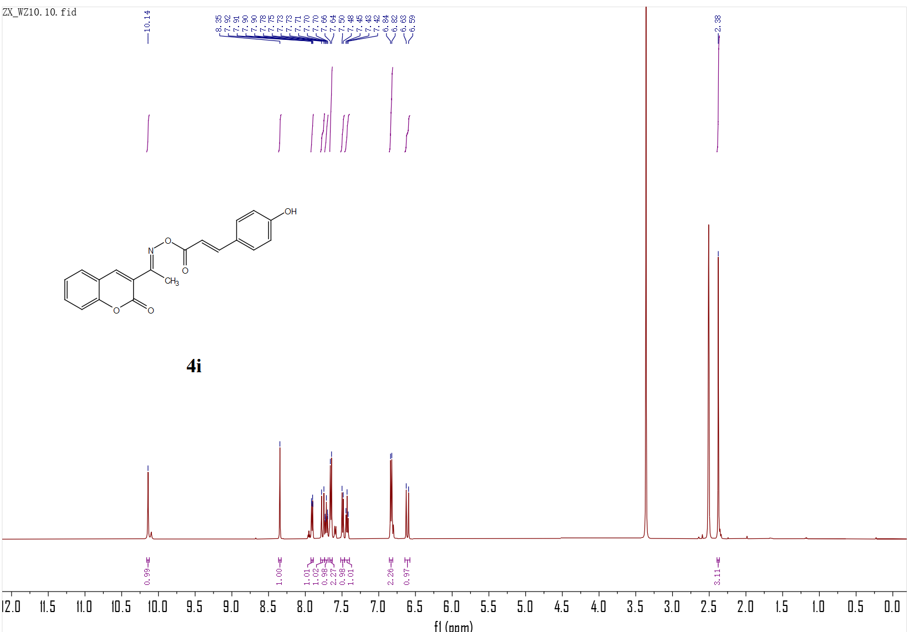

Fig.17 **4i** (1H NMR)

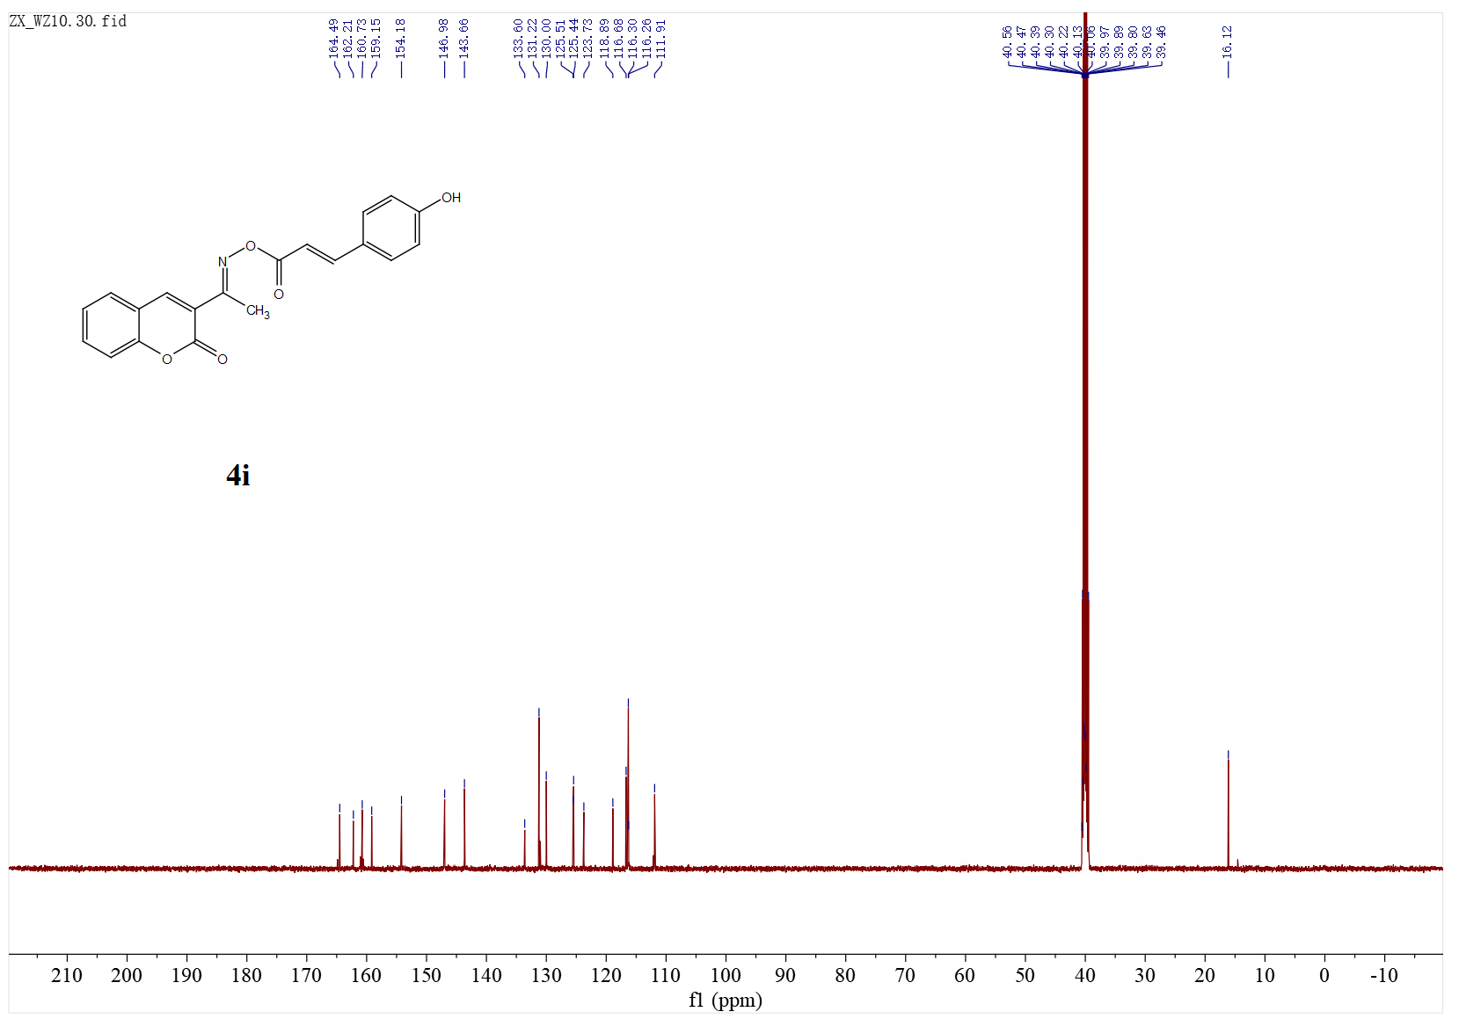

Fig.18 **4i** (13C NMR)

 Fig.19 **4j** (1H NMR) 

Fig.20 **4j** (13C NMR)



Fig.21 **4k** (1H NMR) 

Fig.22 **4k** (13C NMR)



Fig.23 **4l (**1H NMR) 

Fig.24 **4l** (13C NMR)



Fig.25 **4m** (1H NMR)



Fig.26 **4m** (13C NMR)



Fig.27 **4n** (1H NMR)



Fig.28 **4n** (13C NMR)



Fig.29 **4o** (1H NMR)



Fig.30 **4o** (13C NMR)

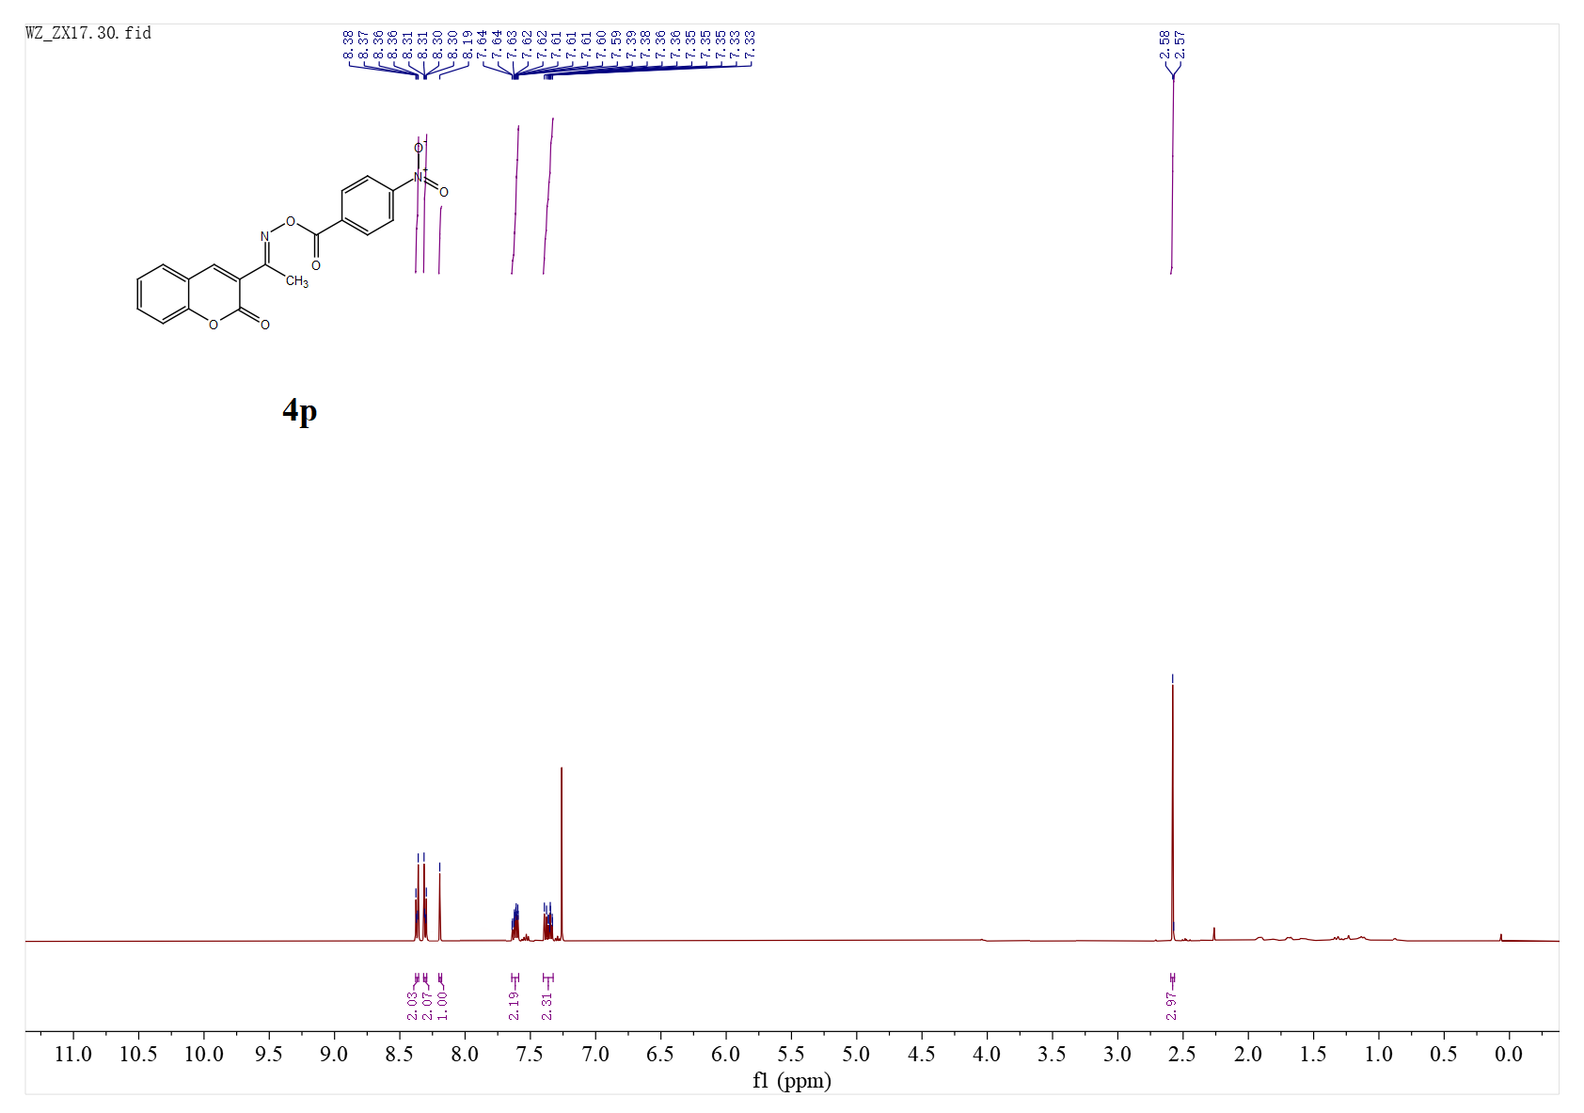

Fig.31 **4p** (1H NMR)

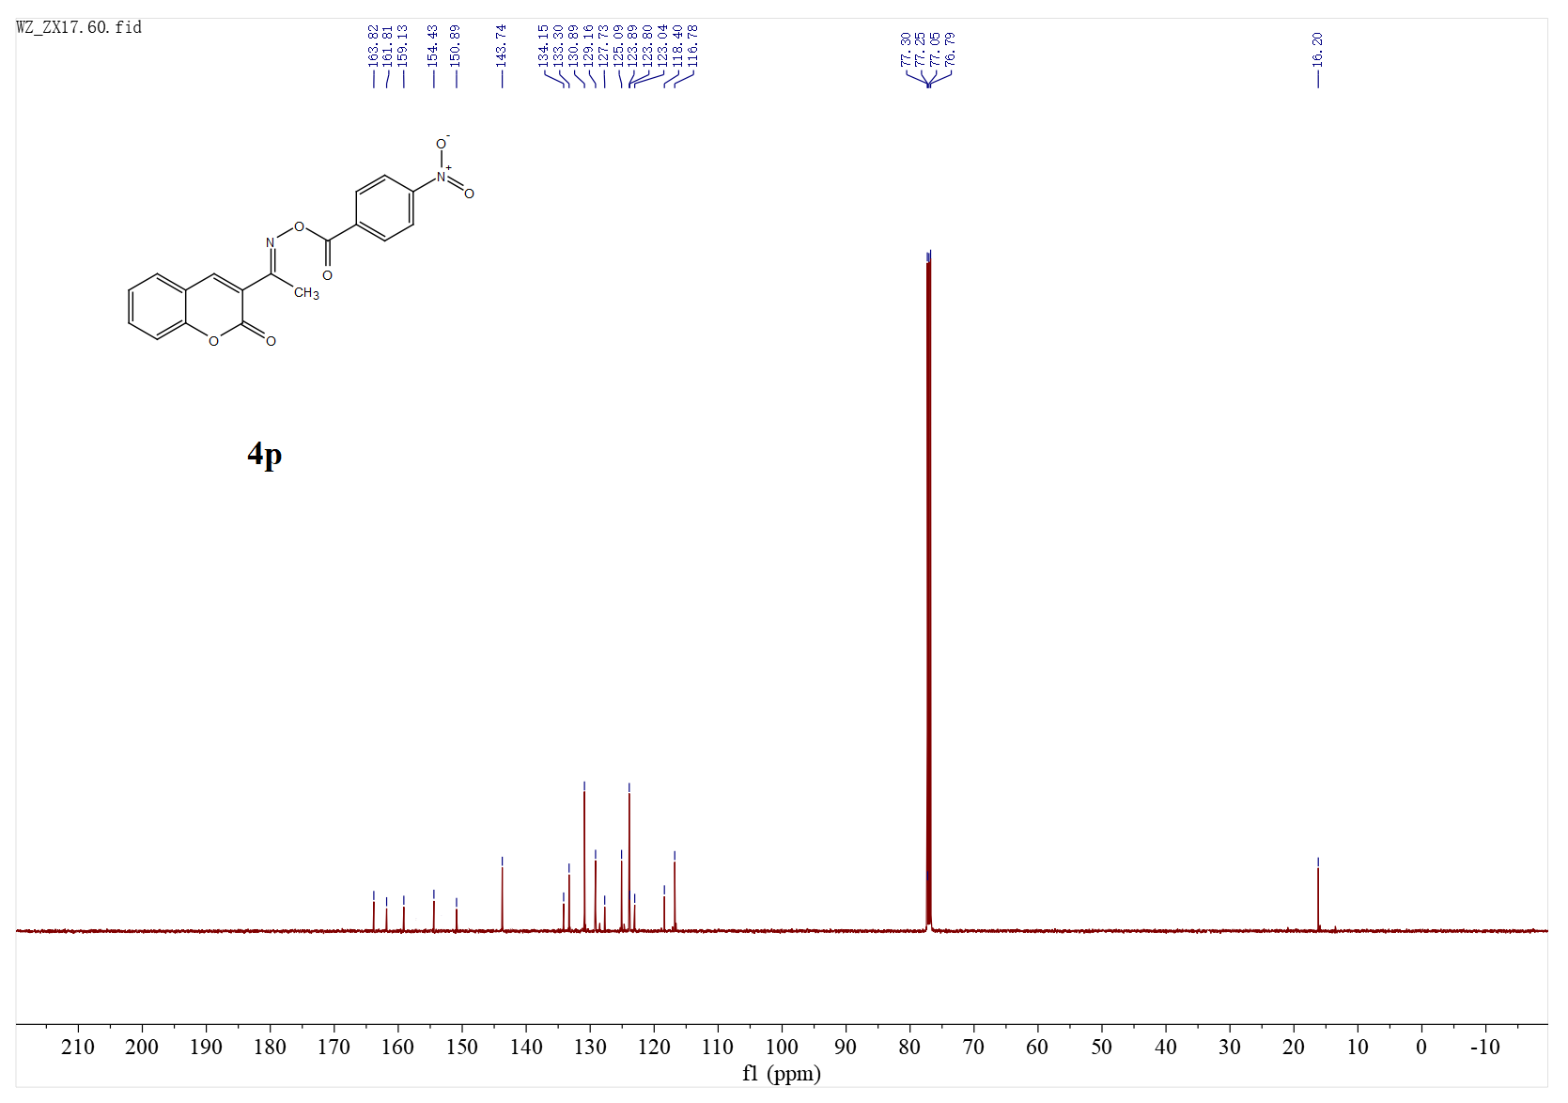

Fig.32 **4p** (13C NMR)



Fig.33 **4q** (1H NMR)



Fig.34 **4q** (13C NMR)



Fig.35 **4r** (1H NMR)

Fig.36 **4r** (13C NMR)

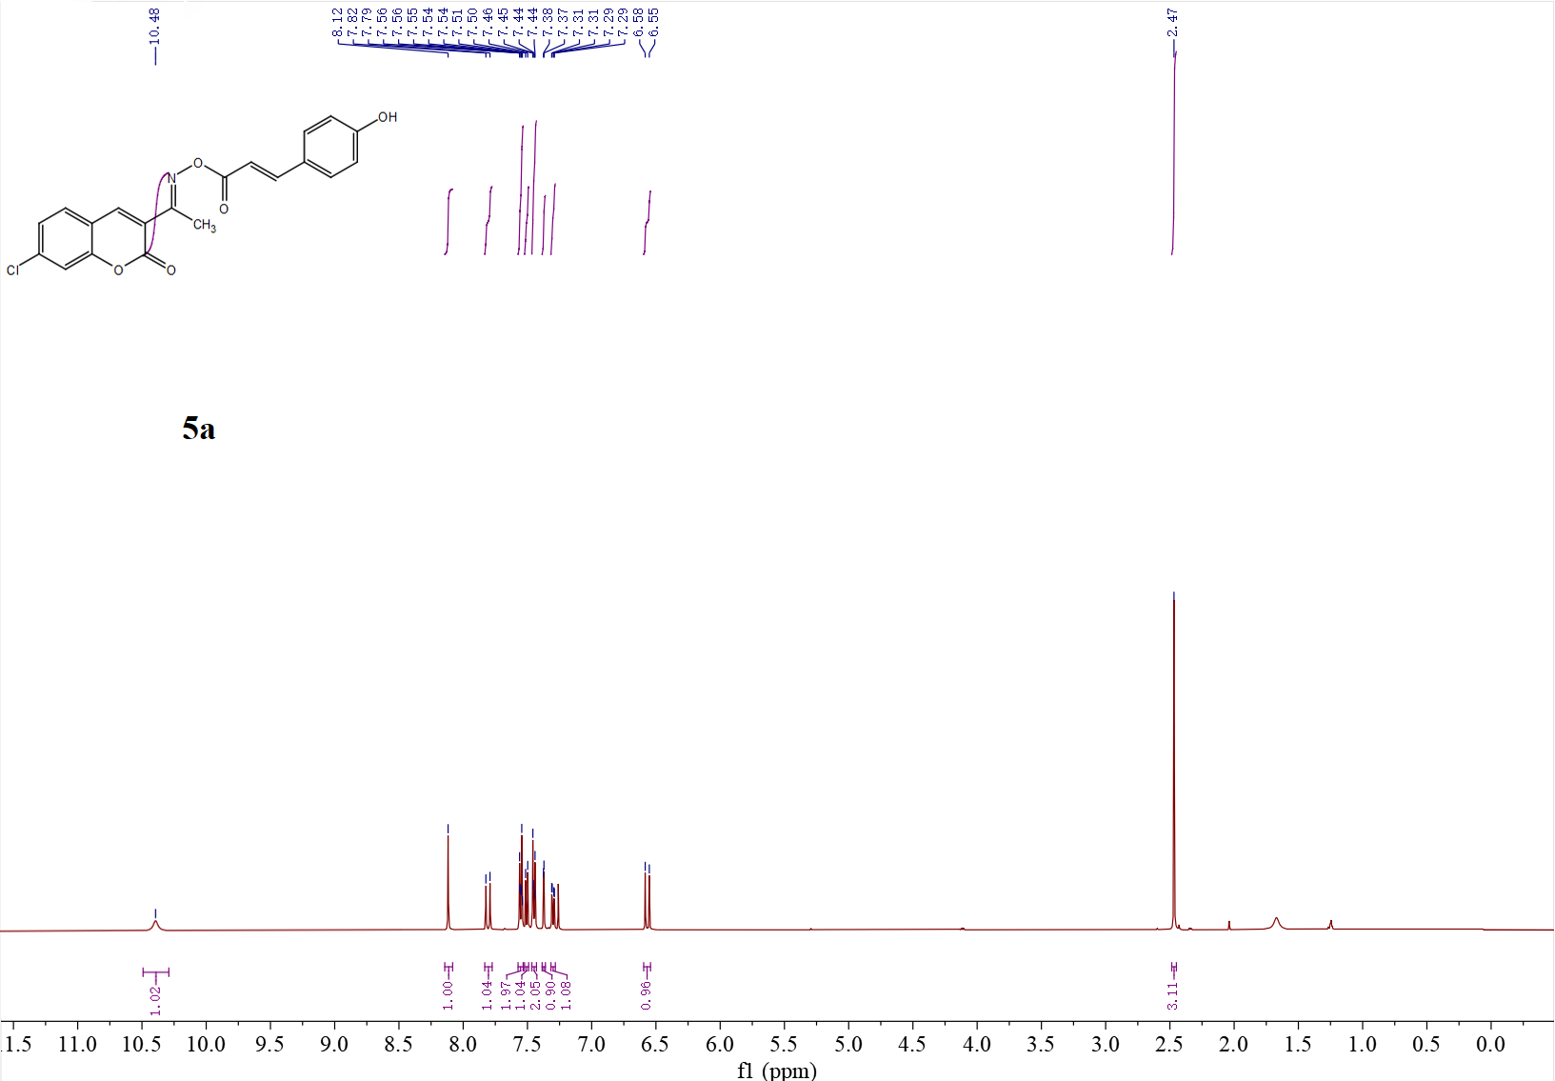

Fig.37 **5a** (1H NMR)



Fig.38 **5a** (13C NMR)

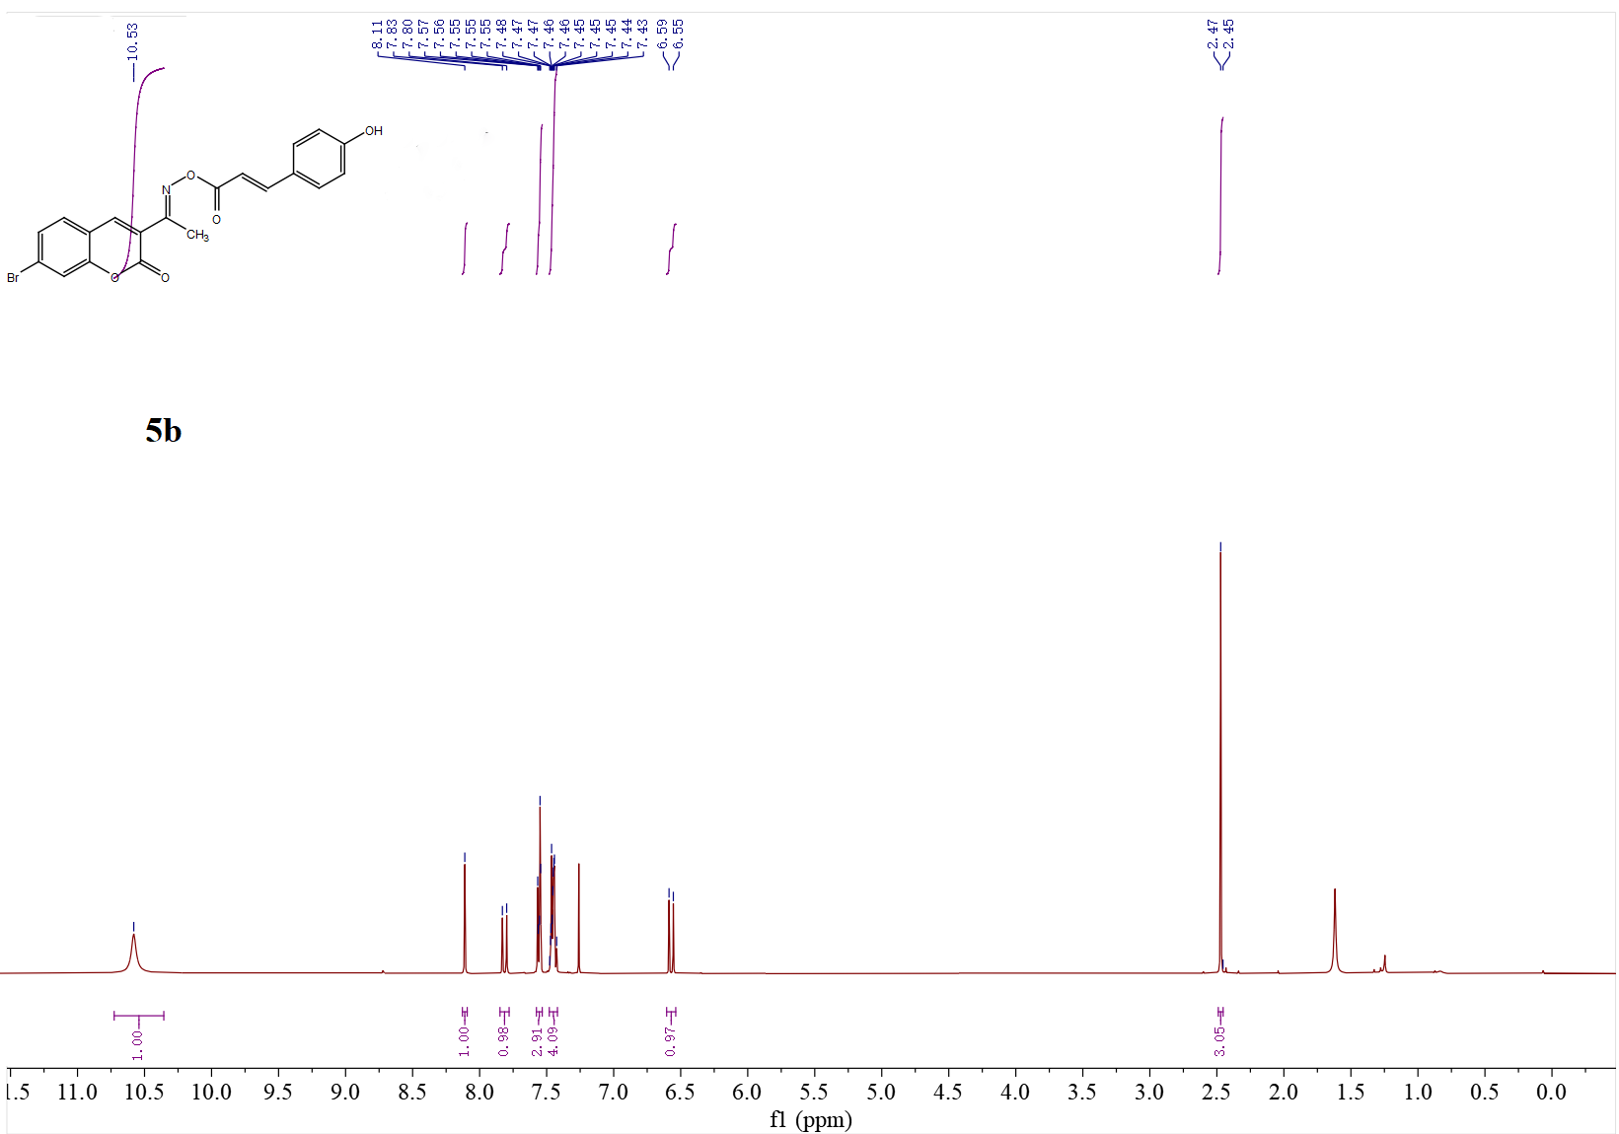 Fig.39 **5b** (1H NMR)

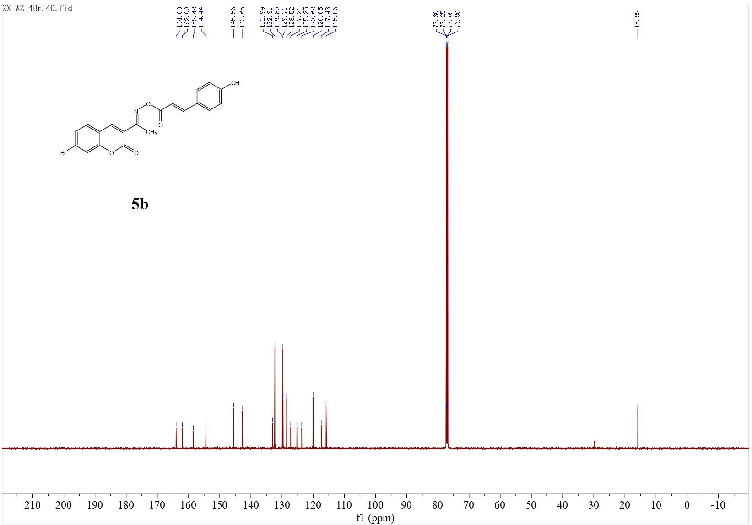

Fig.40 **5b** (13C NMR)

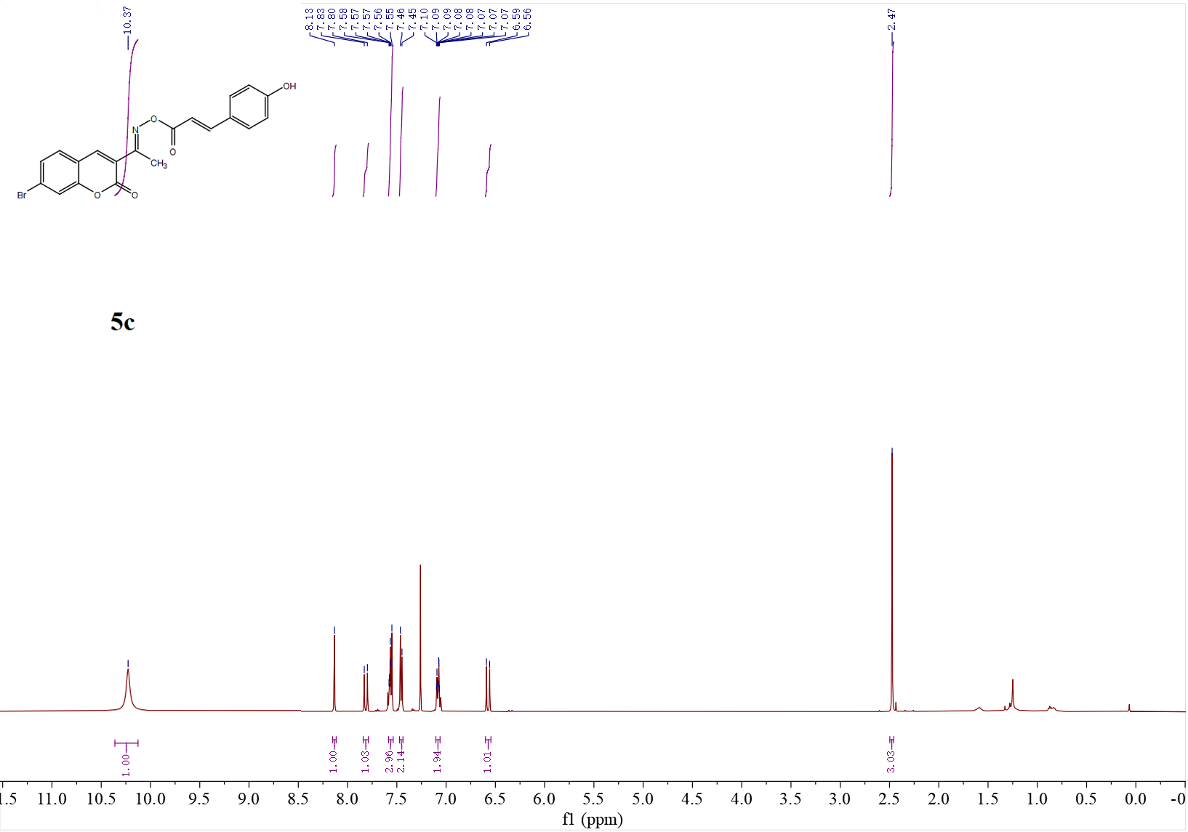

Fig.41 **5c** (1H NMR)



Fig.42 **5c** (13C NMR)

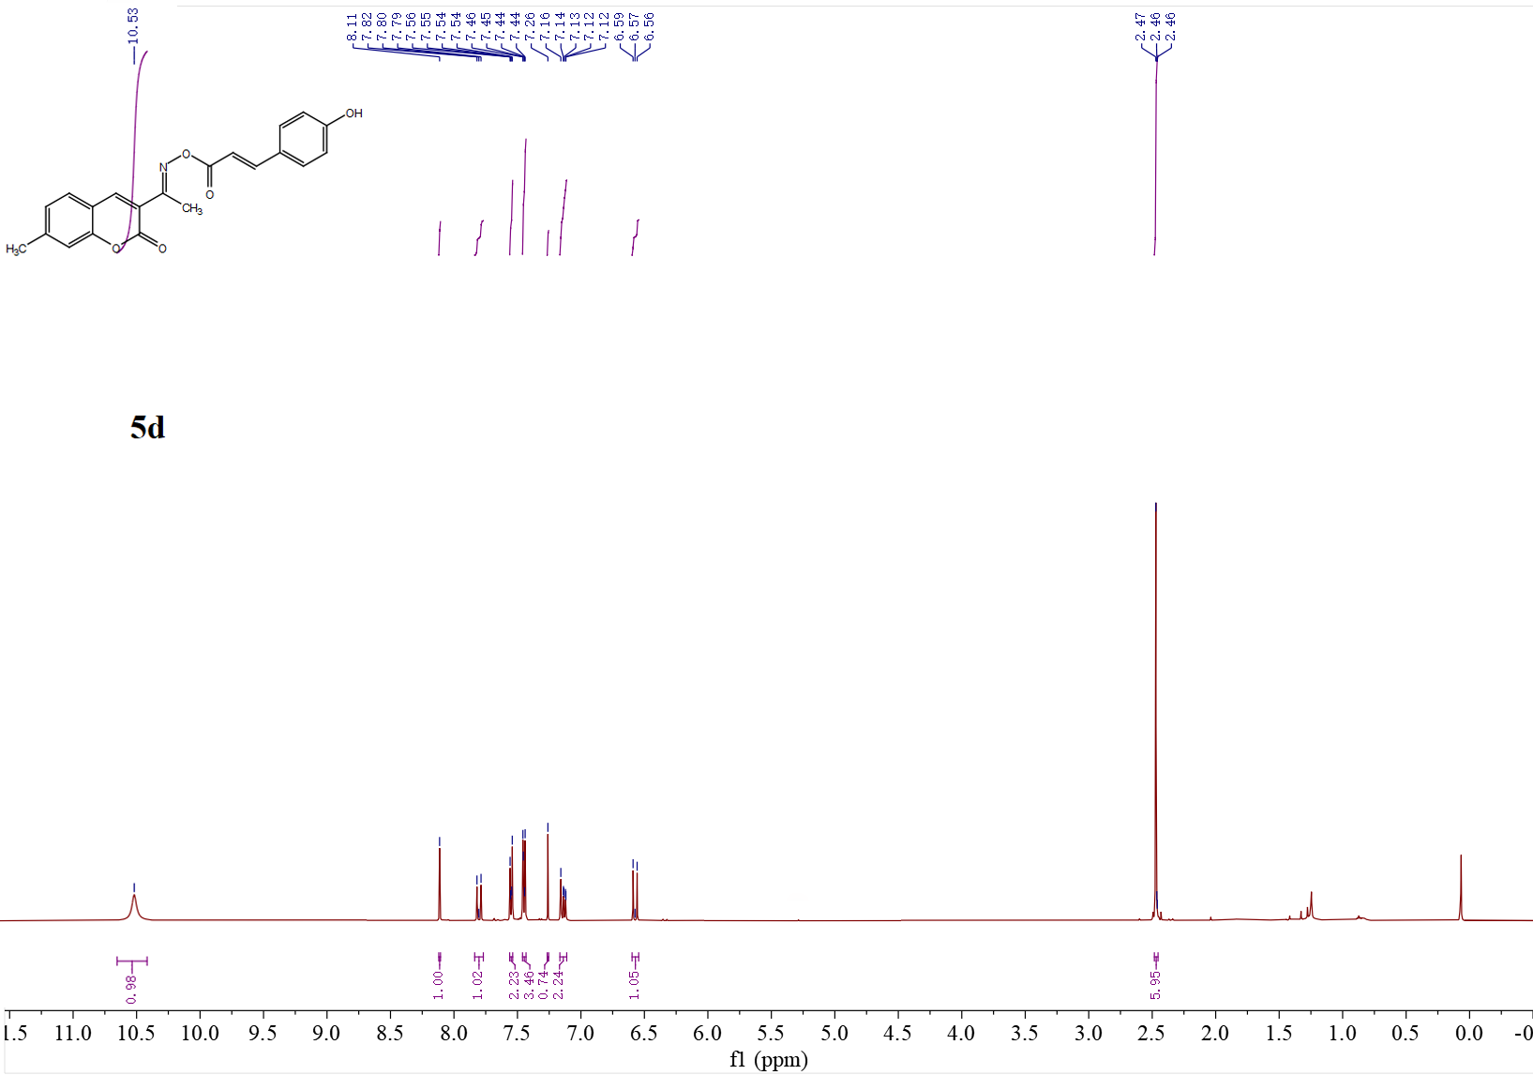

Fig.43 **5d** (1H NMR)

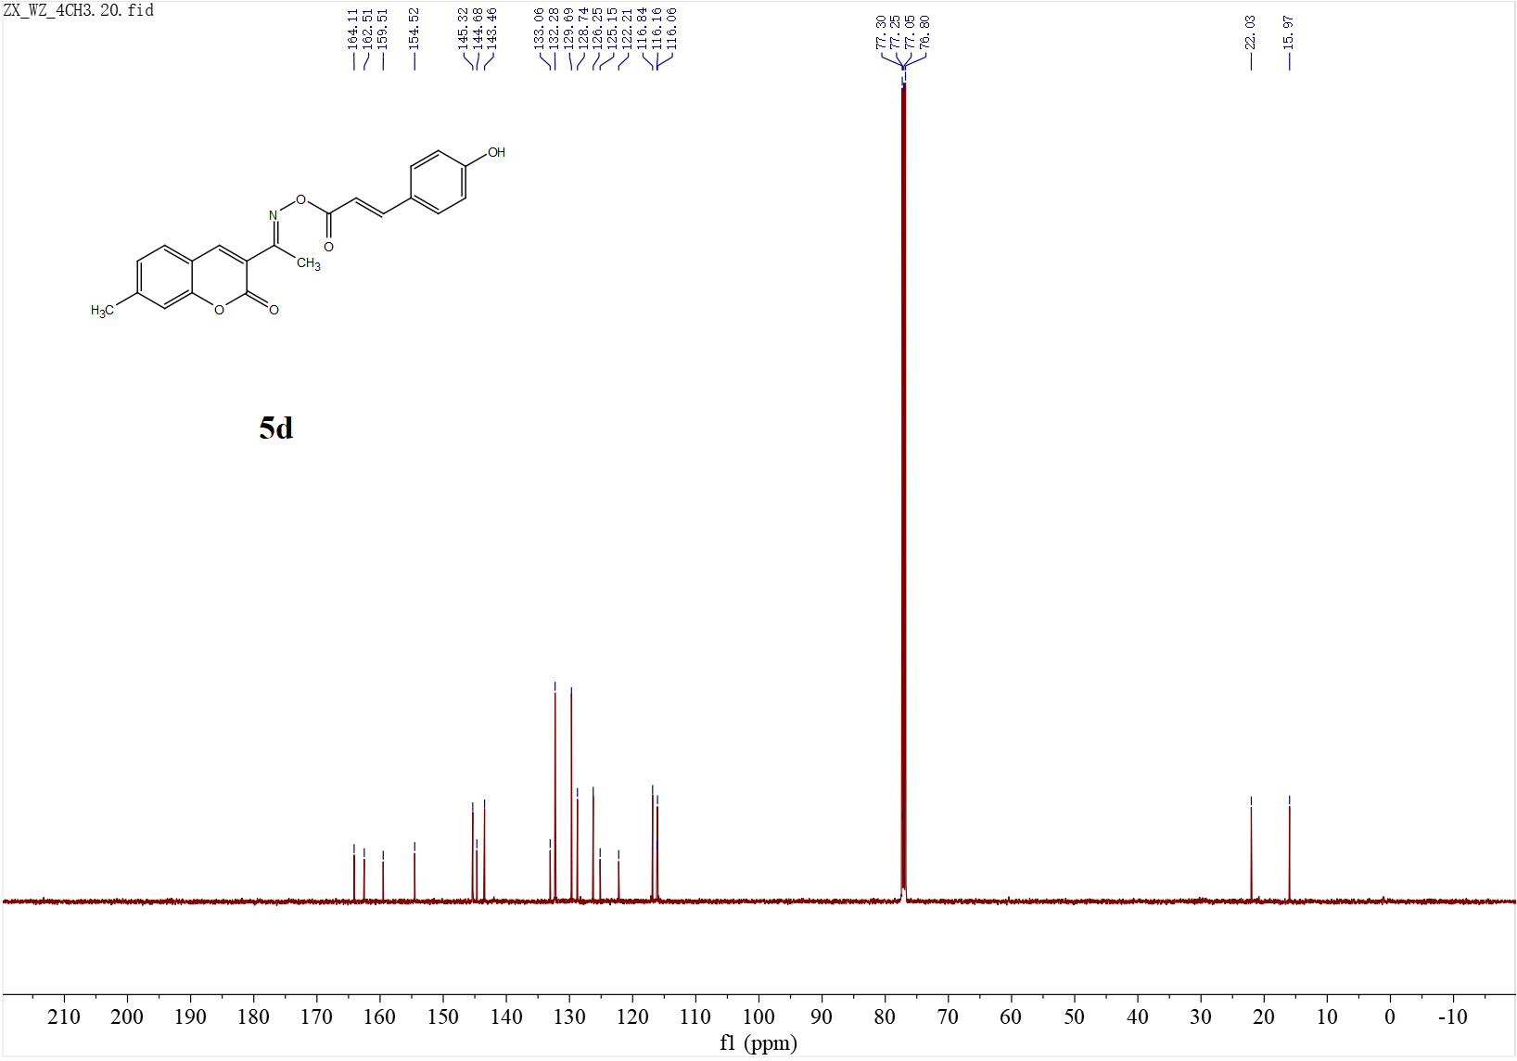

Fig.44 **5d** (13C NMR)

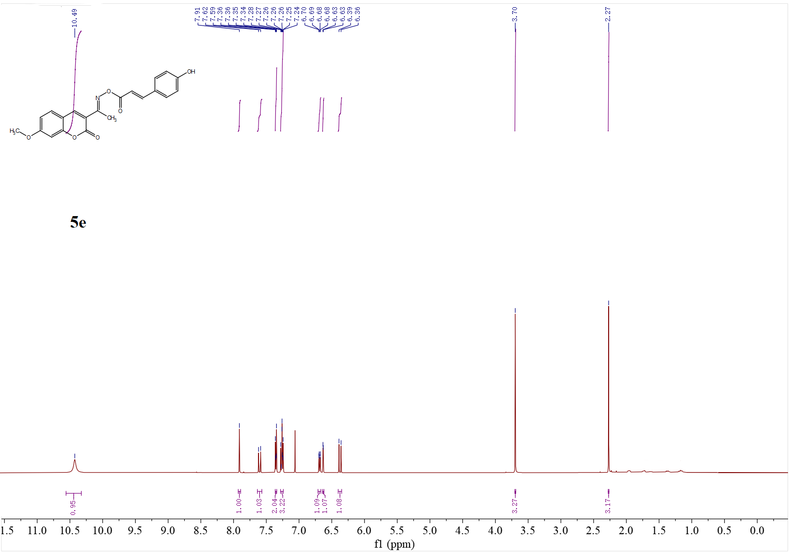

Fig.45 **5e** (1H NMR)

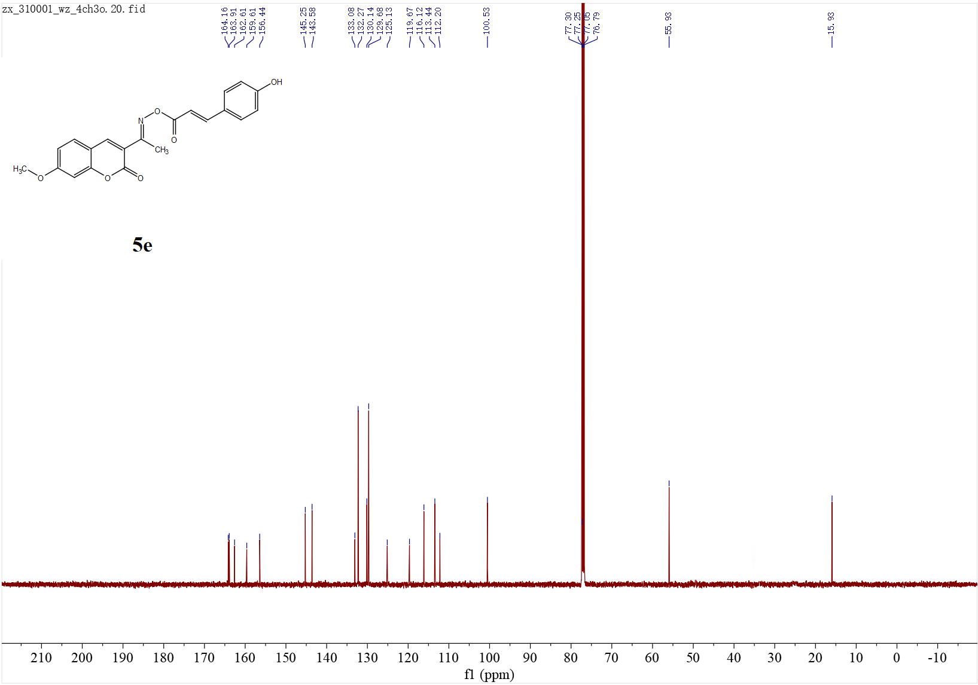

Fig.46 **5e** (13C NMR)

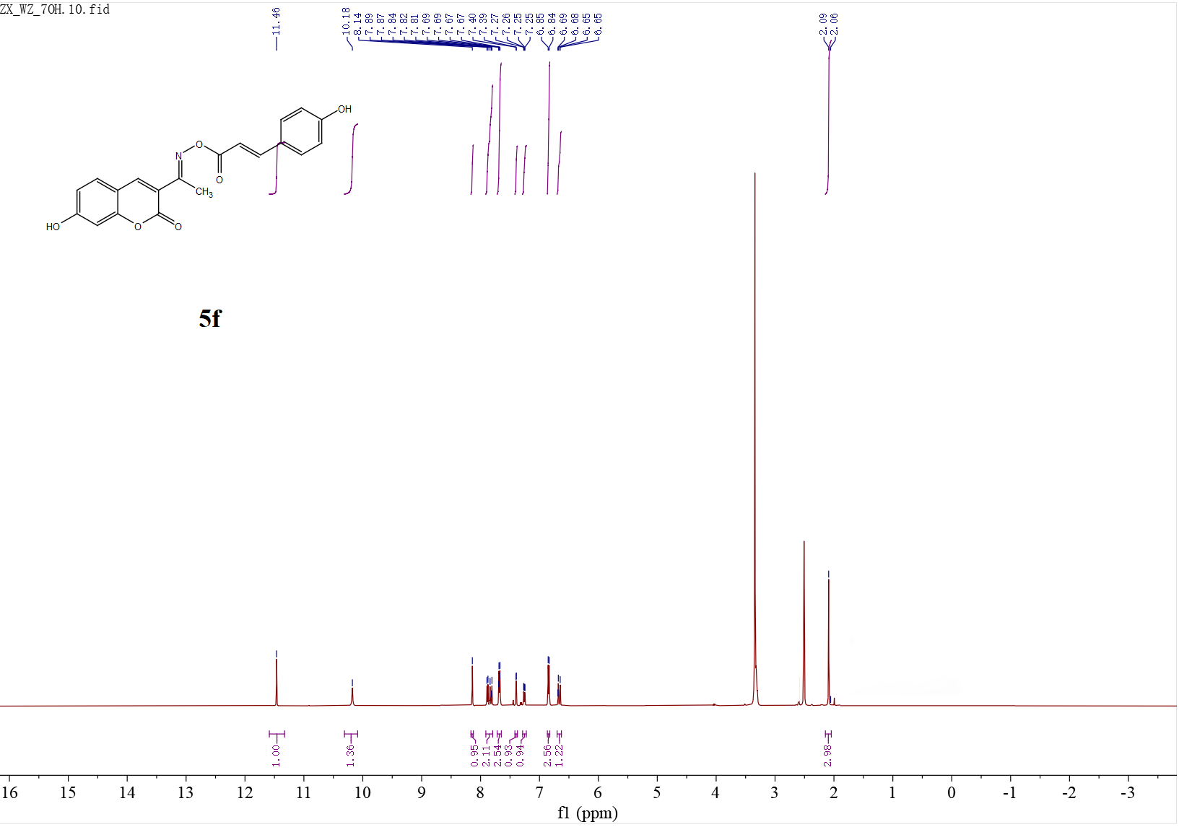

Fig.47 **5f** (1H NMR)

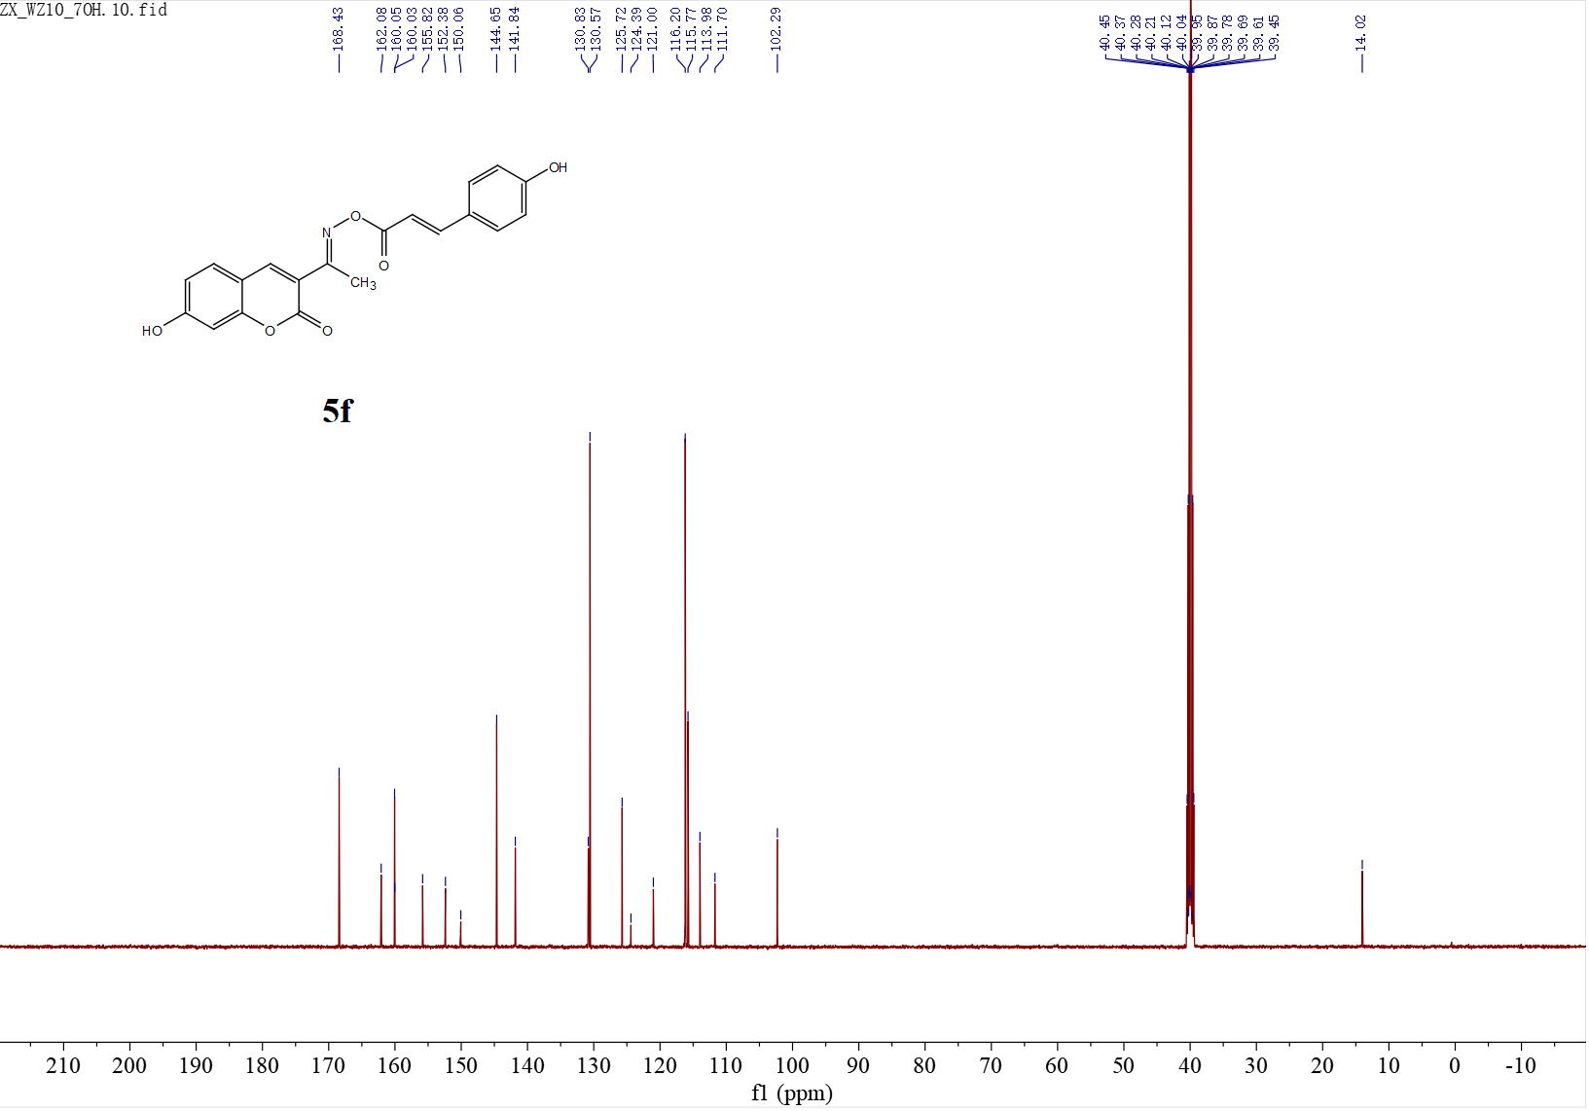 Fig.48 **5f** (13C NMR)

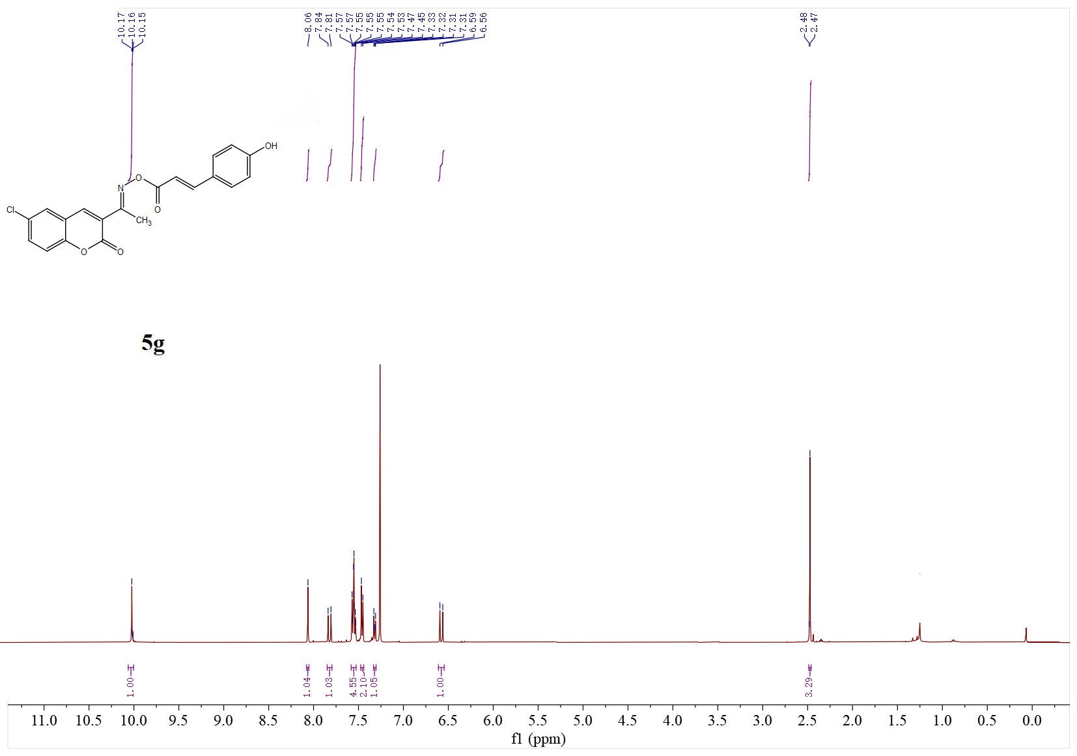

Fig.49 **5g** (1H NMR)

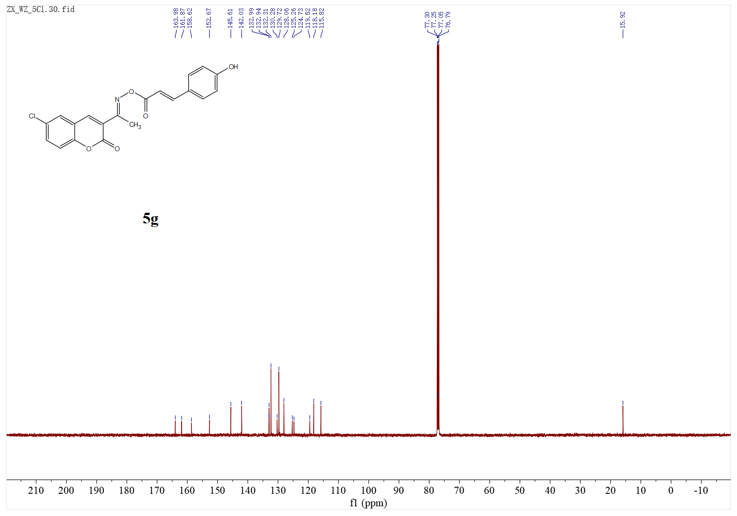

Fig.50 **5g** (13C NMR)

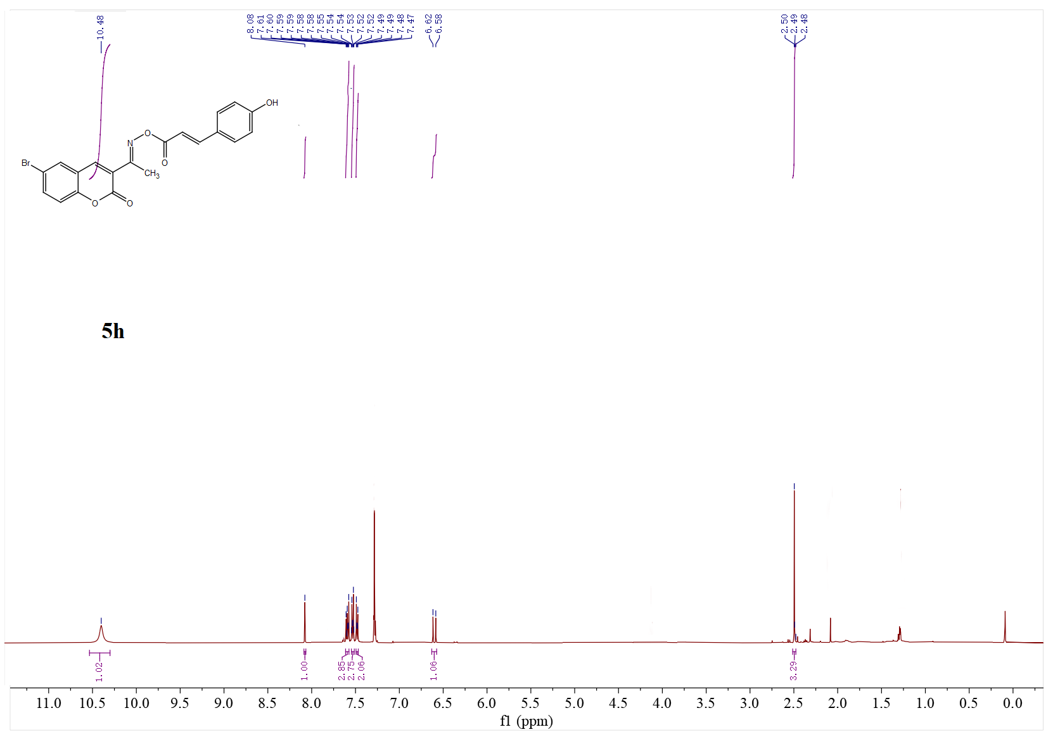

Fig.51 **5h** (1H NMR)

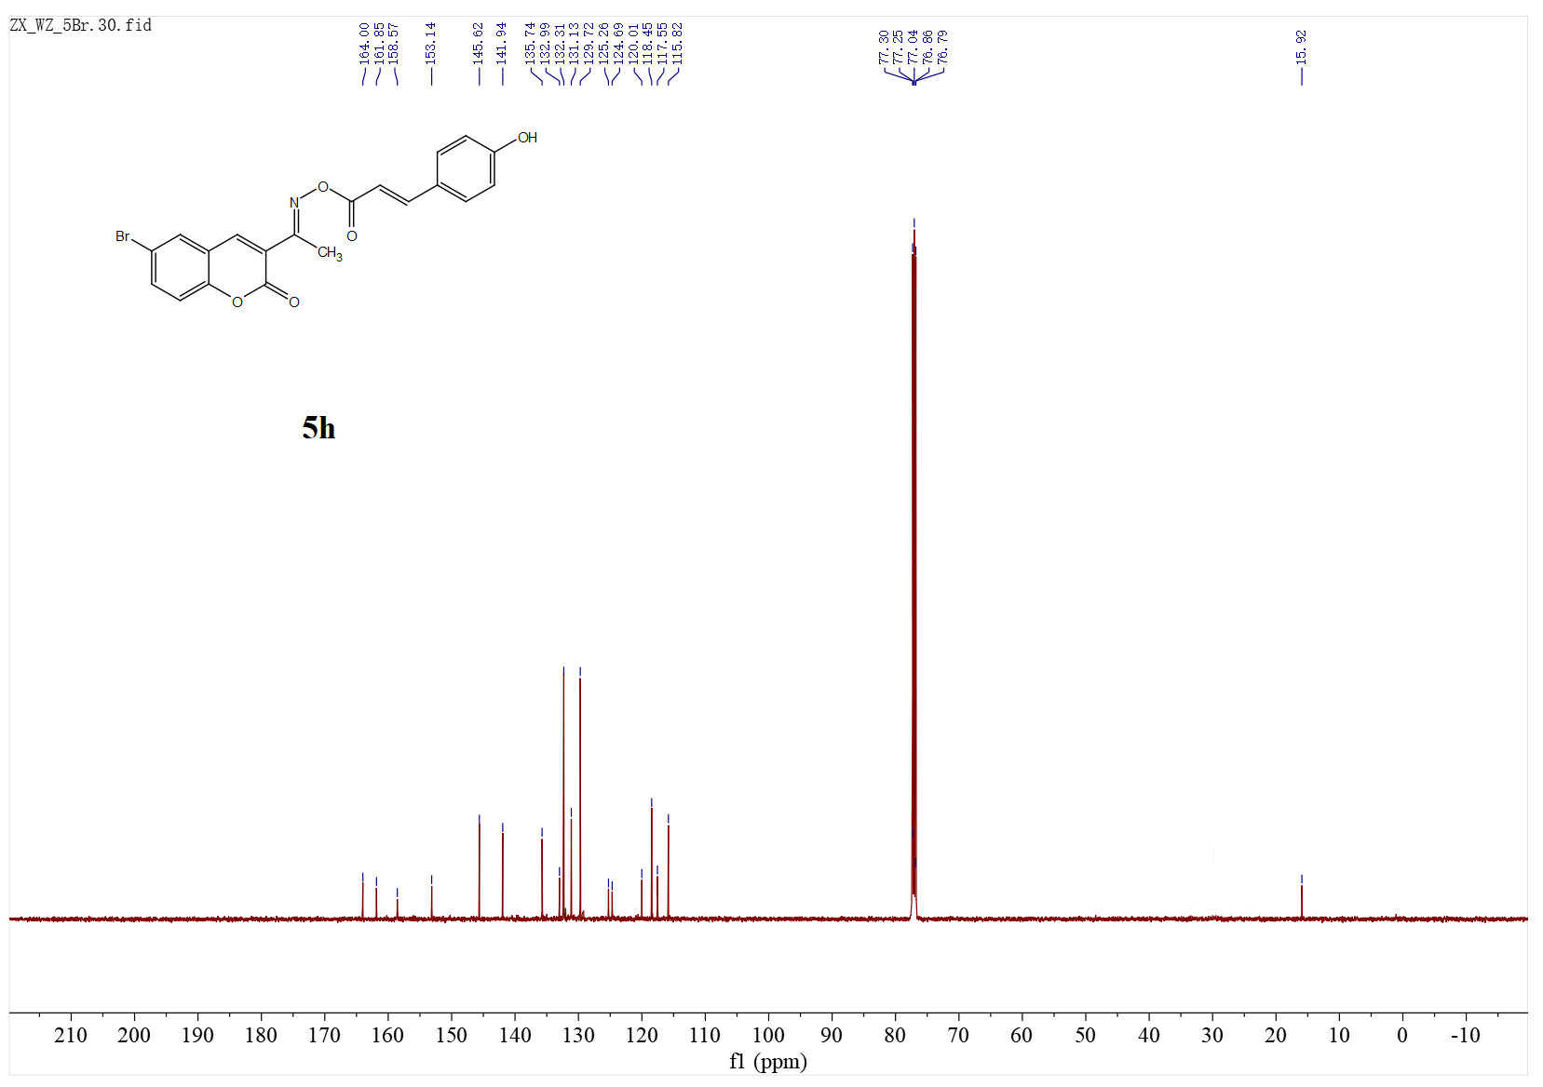

Fig.52 **5h** (13C NMR)

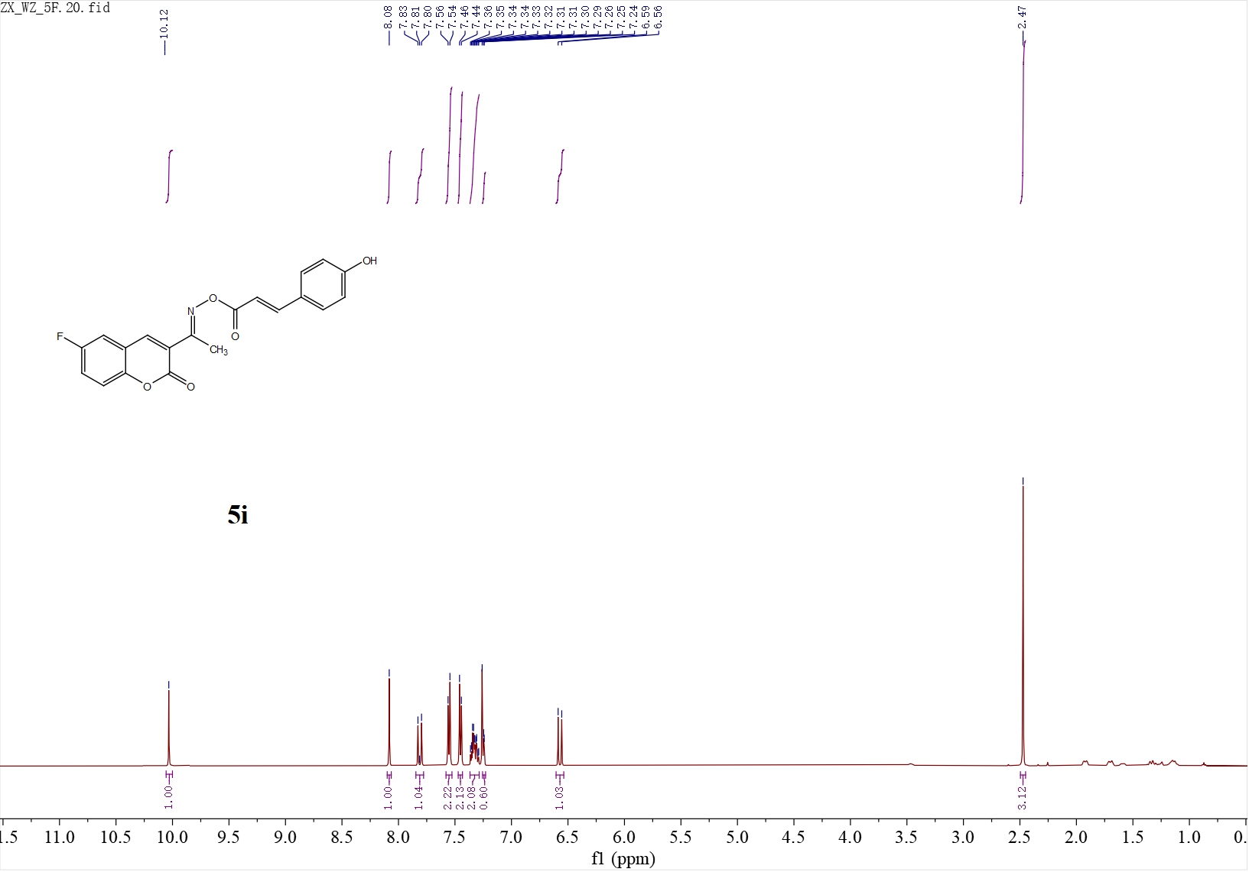

Fig.53 **5i** (1H NMR)



Fig.54 **5i** (13C NMR)

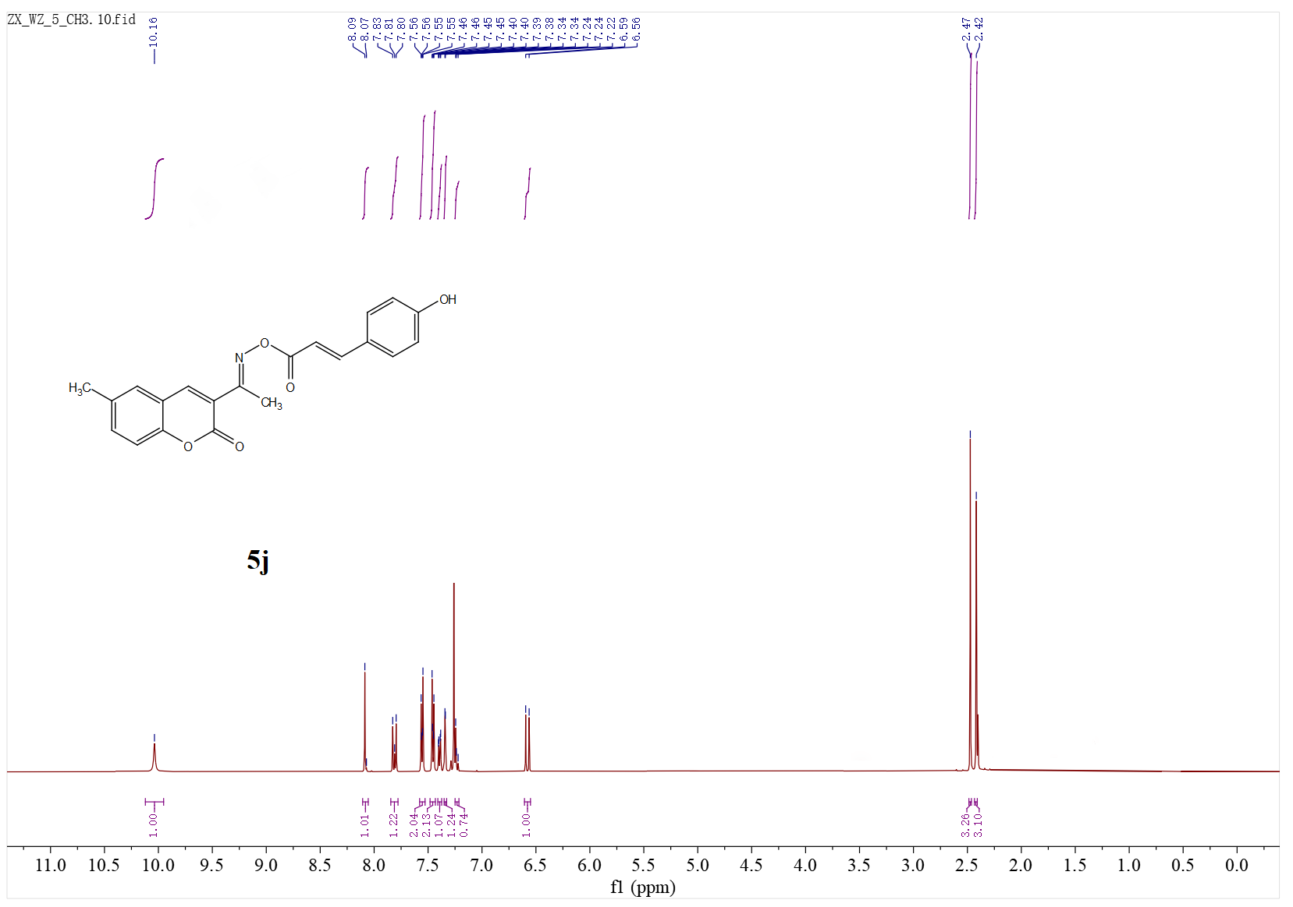

Fig.55 **5j** (1H NMR)

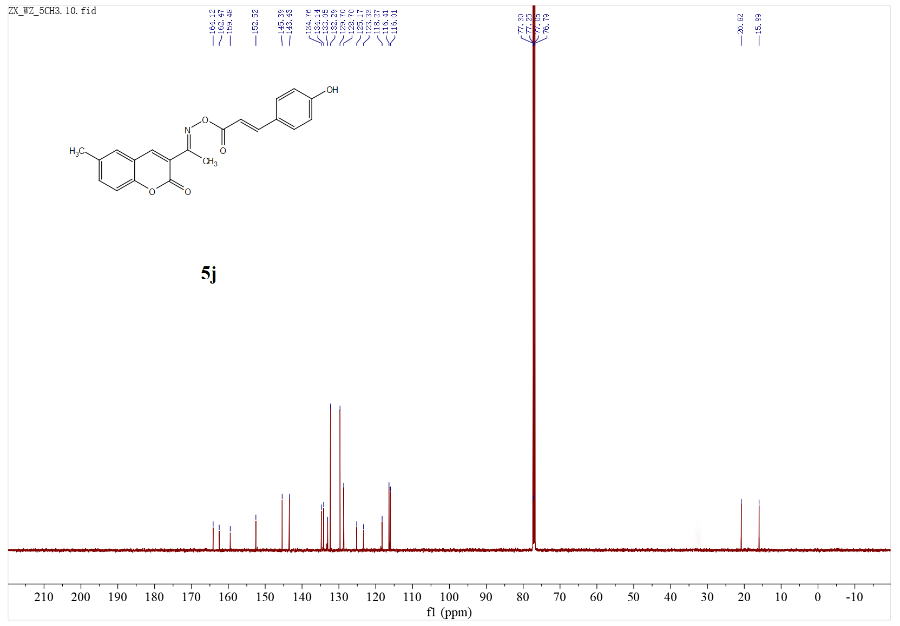

Fig.56 **5j** (13C NMR)

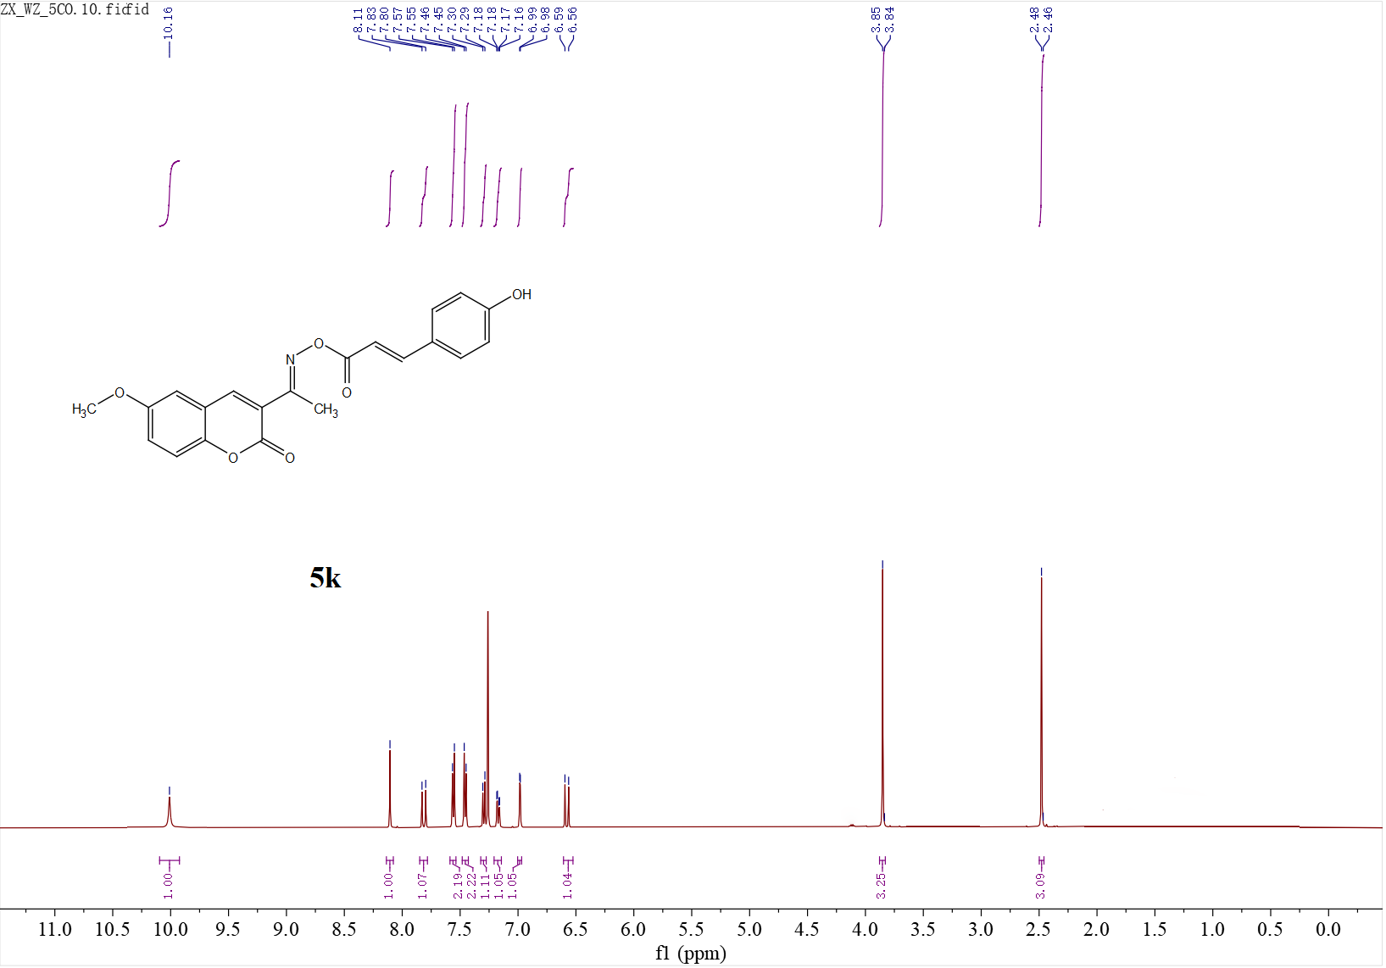

Fig.57 **5k** (1H NMR)

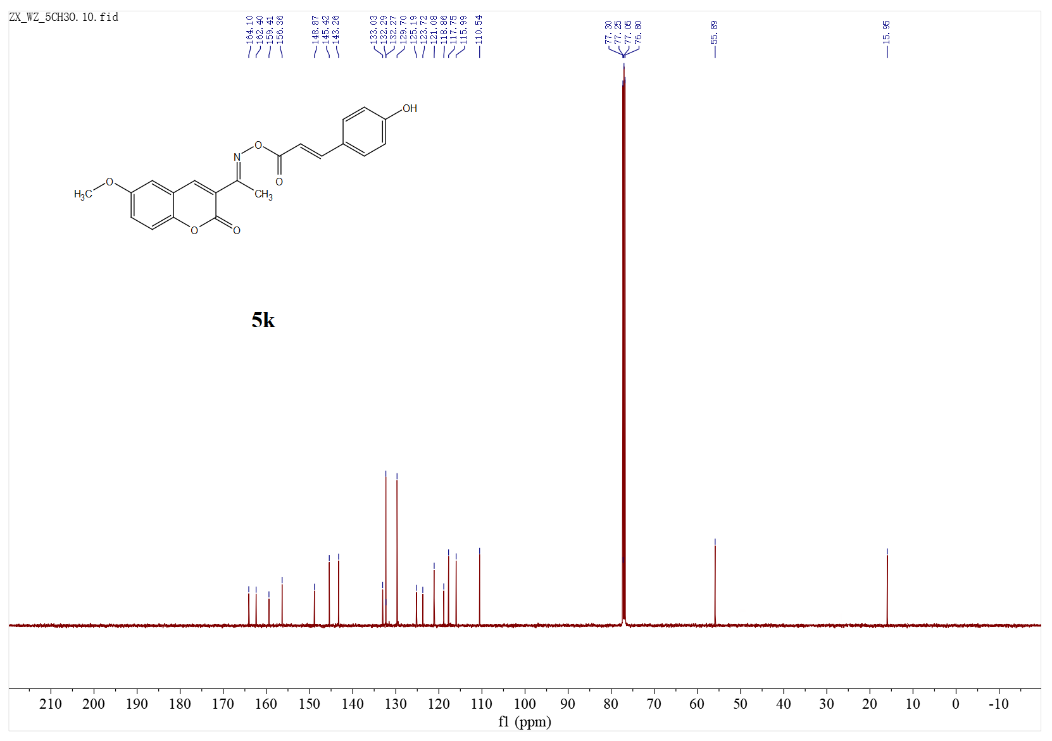

Fig.58 **5k** (13C NMR)

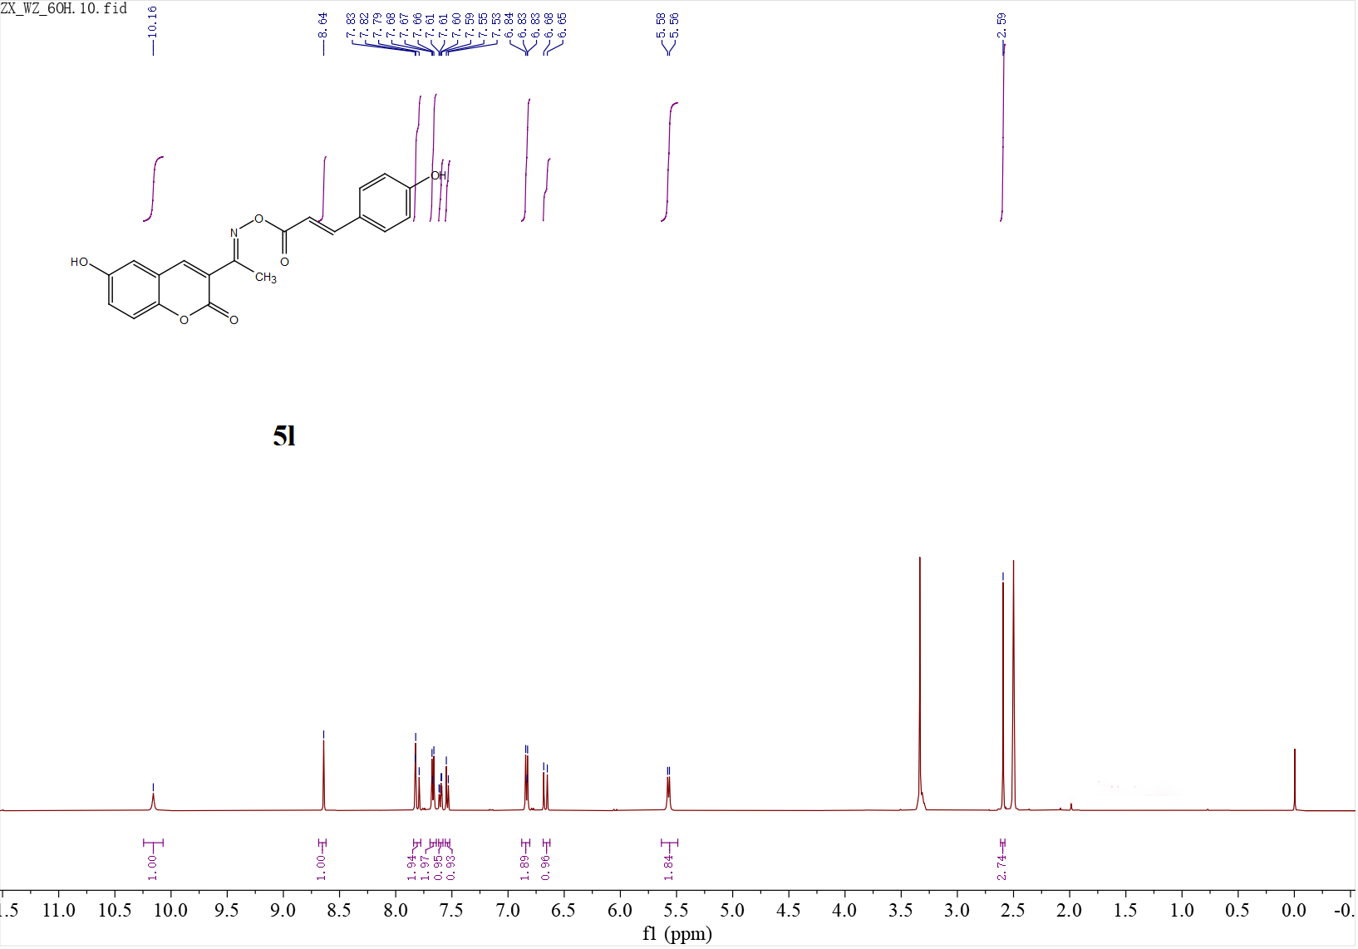

Fig.59 **5l** (1H NMR)

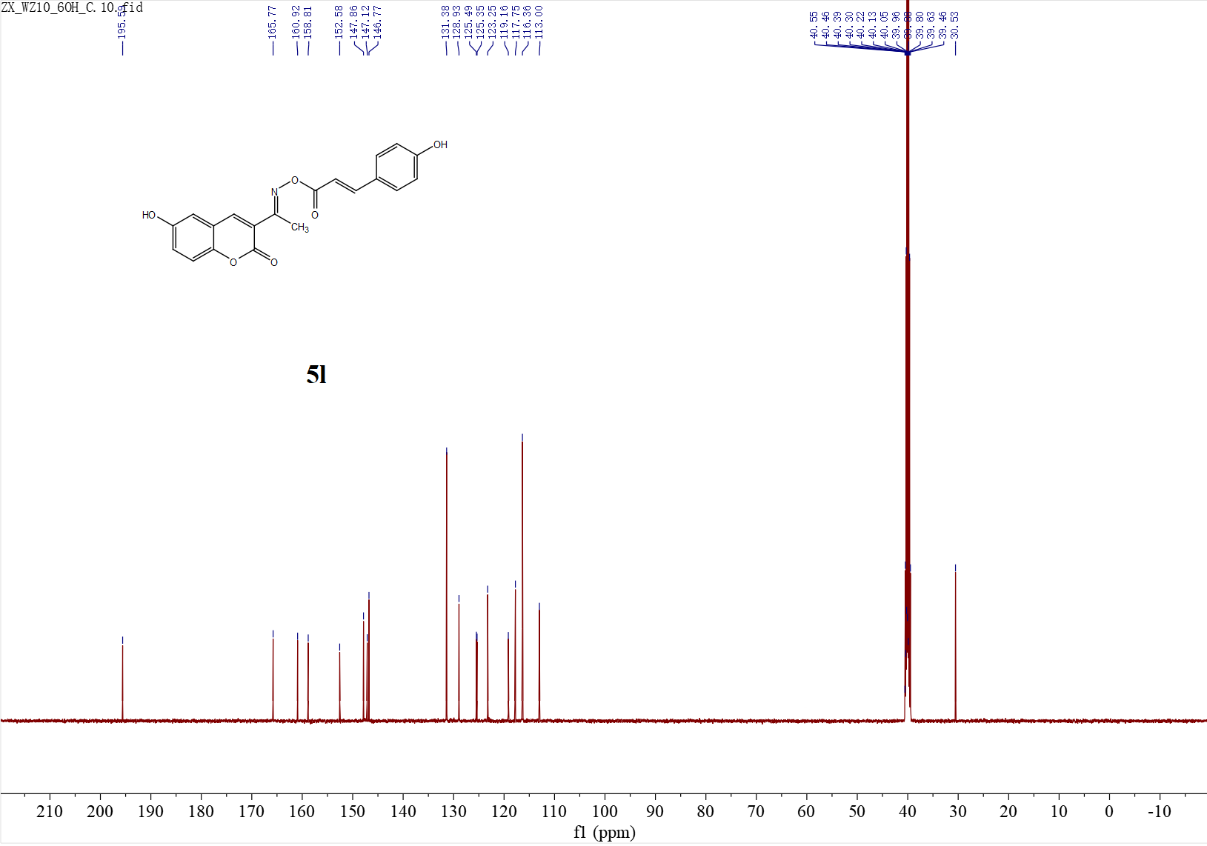

Fig.60 **5l** (13C NMR)