# Supporting Information

**(111)-Oriented Crystalline Plane MnO Loaded by Biomass Carbon Separator to Facilitate Sulfur Redox Kinetics in Lithium–Sulfur Batteries**

Xusheng Gong1+, Rong Li2+, Hongguo Chen1*, Chao He3*, Zi'ang Gao4, Haijiao Xie 5

1. School of Nuclear Technology and Chemistry & Biology, Hubei Key Laboratory of Radiation Chemistry and Functional Materials, Hubei Engineering Research Center for Fragrant Plants, Hubei University of Science and Technology, Xianning, Hubei 437100, China

2. Low-Carbon Technology and Chemical Reaction Engineering Laboratory, School of Chemical Engineering, Sichuan University, Chengdu 610065, China

3. Hubei Key Laboratory of Petroleum Geochemistry and Environment, College of Resources and Environment, Yangtze University, Wuhan 430100, China

4. Department of Naval Architecture, Ocean and Structural Engineering, School of Naval Architecture, Ocean and Energy Power Engineering, Wuhan University of Technology, Wuhan 430063, China

5. Hangzhou Yanqu Information Technology Co., Ltd， Y2， 2nd Floor, Building 2, Xixi Legu Creative Pioneering Park, No. 712 Wen’er West Road, Xihu District, Hangzhou City, Zhejiang Province, 310003, P.R.O.C

+These authors contributed to the work equally and should be regarded as co-first authors.

*These authors contributed to the work equally and should be regarded as corresponding authors.

**Experimental section**

The theoretical calculation:

First principle calculation was performed for the adsorption of Li2S6 molecule on three surfaces of MnO material, including {100}, {110} and {111}. The projector augmented wave (PAW) approach [1] implemented in the Vienna ab initio package (VASP) [2] was used to treat the valance electrons described by cut-off plane waves and core electrons described by pseudo wavefunctions. The Perdew-Burke-Ernzehof (PBE) functional based on generalized gradient approximation (GGA) was used to calculate the exchange-correlation interaction [3]. The plane wave basis set is limited by an imposed cut-off energy (Ecut) of 400 eV. Only gamma point in the Brillouin zone was chosen in the calculation of electronic energy during optimization. The energy between two consecutive self-consistent steps was less than 10−6 eV. The self-consistent force is less than 0.02 eV/Å. The DFT + U method with on-site Coulomb correction Ueff =3.9 eV was used on Mn 3d orbital electrons [4-7]. Grimme’s zero-damping DFT-D3 method was used to calculate the van der Waals correction [8-9]. The crystal orbital Hamilton population (COHP) was employed to study the Mn-S bond between Li2S6 and the substrate [10-11]. In order to simplify the calculation, ignore the solvation effect.

The slab models as {100}, {110} and {111} were constructed based on the optimized crystal of MnO. The surface energy (γ, in unit of J/m2) of three slab models were calculated with equation 1.

$γ=\frac{1}{2A}\left(E_{slab}^{unrelax}-nE_{bulk}\right)+\frac{1}{A}(E_{slab}^{relax}-E_{slab}^{urelax})$ (Equation 1)

Where the term A indicated the area of the exposed surface in the slab models, $E_{slab}^{unrelax}$ was the energy of the structure without optimization and $E_{slab}^{relax}$ was the energy of the optimized structure, $E_{bulk}$ was the energy of MnO crystal with one unit of (MnO) group, this energy was -15.91 eV, and n was the number of the (MnO) unit in the slab models.

The adsorption energy ($E_{ads}$) was calculated with equation 2.

$E_{ads}=E_{mol+slab}-E_{mol}-E_{slab}$ (Equation 2)

Where $E_{mol+slab}$ indicated the energy of the optimized adsorption models, $E_{mol}$ indicated the energy of Li2S6 molecule and $E_{slab}$ indicated the energy of the optimized slab models of MnO materials.

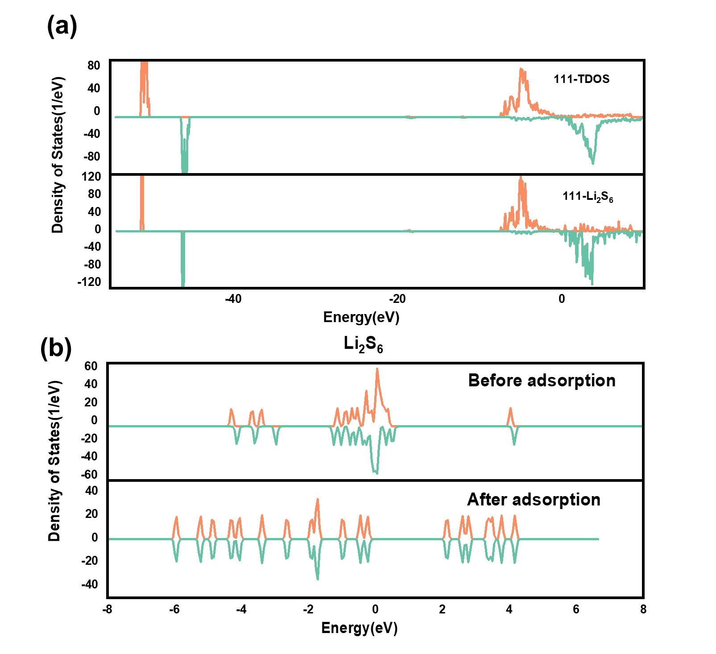

Figure S1. a) MnO(111) adsorbed Li2S6 structure and vacuum energy level, Fermi level and work function changes, b) MnO(111) system DOS and MnO(111) adsorbed Li2S6 system DOS.



Figure S2. DOS and COHP of the selected S-Mn bonds.

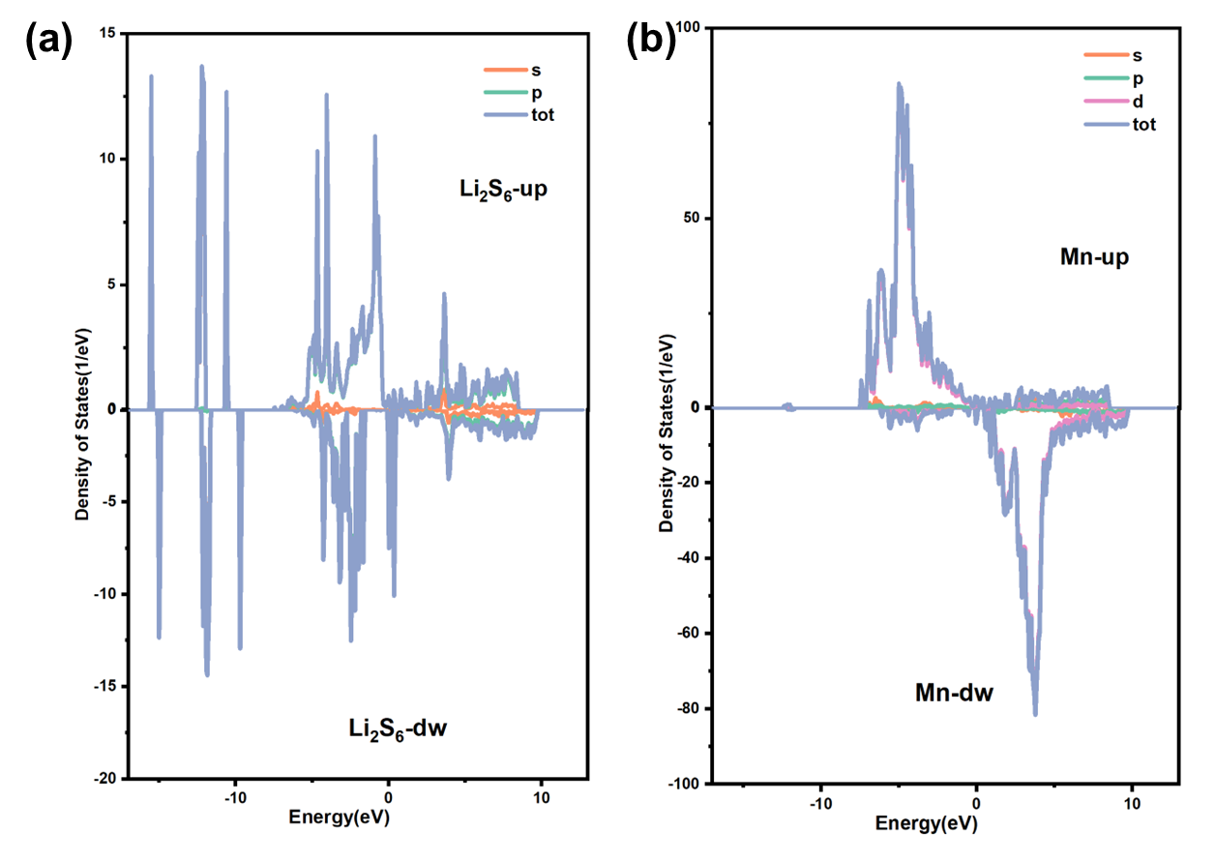

Figure S3. PDOS (projected density of states) orbital composition of a) Li2S6 and b) Mn after adsorption.

Figure S4. PDOS of the selected atoms of a) S atom in Li2S6 and b) Mn atom on MnO surface after adsorption

Figure S5. COHP analysis for the Mn-S bond in orbital resolution for spin-up interaction.

Figure S6. COHP analysis for the Mn-S bond in orbital resolution for spin-down interaction.

Figure S7. XRD of biochar-Mn2O3 after sintering.

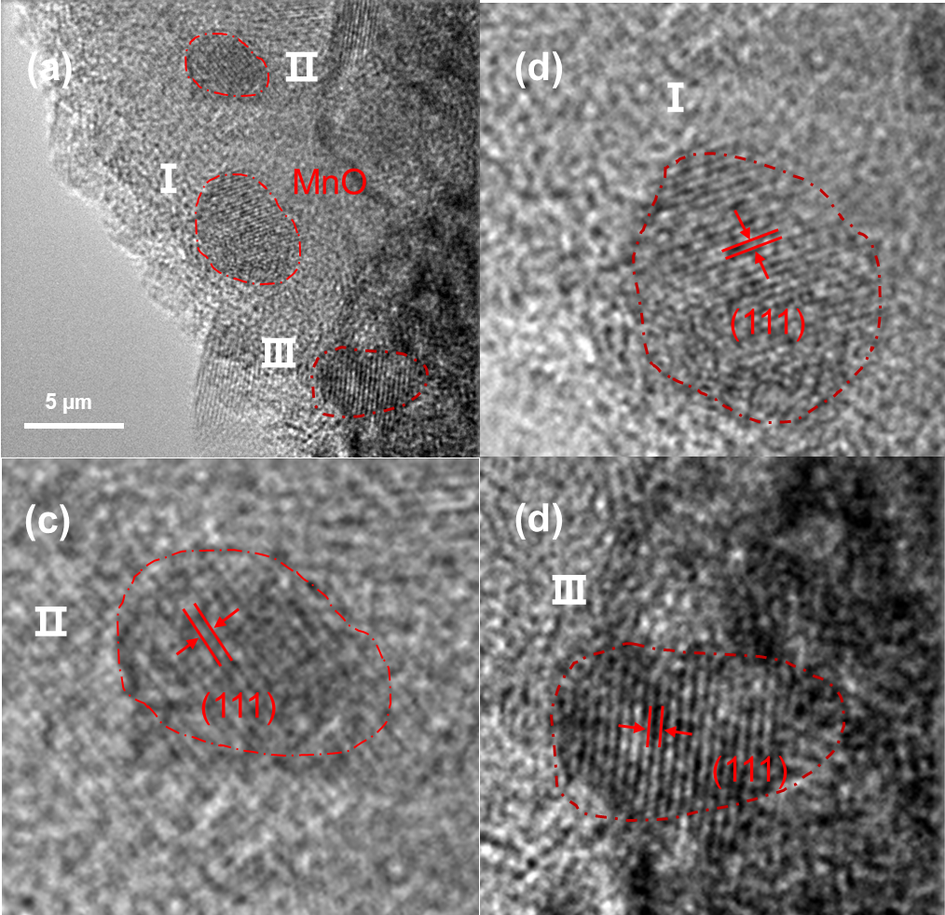

Figure S8. schematic diagram of (111) crystal plane in different regions.

Figure S9. XPS spectra K 2p for BYM.

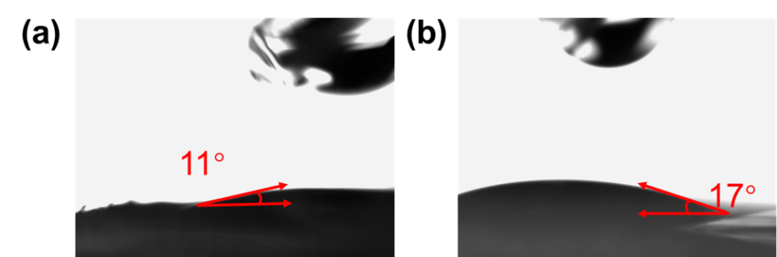

Figure S10. Contact angles of the a) BCM and b) PP separators.

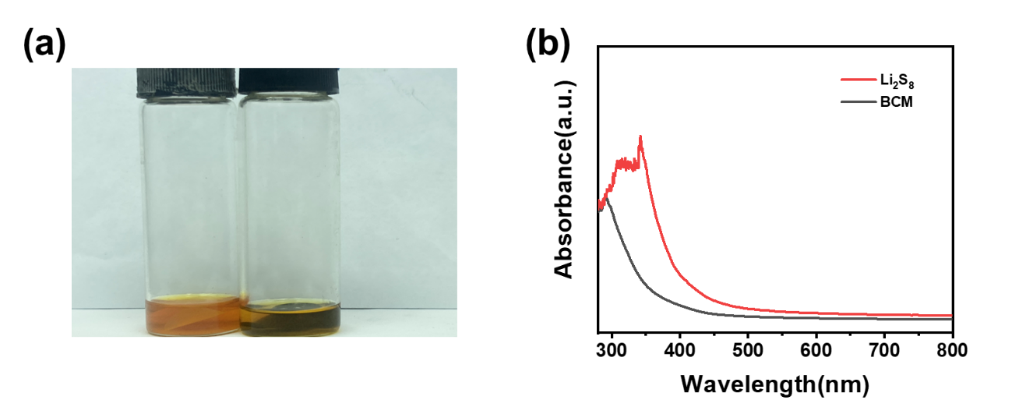

Figure S11. Adsorption after 24 h later a) tests for the BCM and PP separators. b) UV spectra of Li2S6 solution with PP and BCM separators after adsorption test.

Figure S12. CV profiles of a) BCM b) LiS at 50 mV/s.

Figure S13. The discharge curves for different numbers of cycles for BCM at a) 2 C and b) 4 C.

Table

**Table S1.** The lithium polysulfide bond lengths before and after adsorption.

|  |  |  |  |  |
| --- | --- | --- | --- | --- |
| **Bond** | **Li2S6** | **MnO(100)** | **MnO(110)** | **MnO(111)** |
| **I(S-Li)** | 2.39510(0) Å | 2.42974(0) Å | 3.77881(0) Å | 2.61763(0) Å |
| **I(S-S)** | 2.03807(0) Å | 2.03409(0) Å | 2.09709(0) Å | 3.77354(0) Å |

**References**

[1] Blöchl P E. Projector augmented-wave method[J]. Physical Review B, 1994, 50 (24): 17953-17979.

[2] Kresse G, Furthmüller J. Efficient iterative schemes for ab initio total-energy calculations using a plane-wave basis set[J]. Physical Review B, 1996, 54 (16): 11169-11186.

[3] Perdew J P, Burke K, Ernzerhof M. Generalized gradient approximation made simple[J]. Physical Review Letters, 1996, 77 (18): 3865-3868.

[4] Details available at: 〈https://www.materialsproject.org/〉.

[5] Jain, A., Hautier, G., Ong, S. P., Moore, C. J., Fischer, C. C. , & Persson, K. A. , et al. (2011). Formation enthalpies by mixing GGA and GGA+U calculations. Physical review, 84(4), p.045115.1-045115.10.

[6] Mueller T, Hautier G, Jain A, et al. Evaluation of Tavorite-Structured Cathode Materials for Lithium-Ion Batteries Using High-Throughput Computing[J]. Chemistry of Materials, 2011, 23(17):3854–3862.

[7] Hautier G, Ong S P, Jain A, et al. Accuracy of density functional theory in predicting formation energies of ternary oxides from binary oxides and its implication on phase stability[J]. Physical Review B Condensed Matter, 2012, 85(15):155208.

[8] Grimme, S., Antony, J., Ehrlich, S. & Krieg, H. A consistent and accurate ab initio parametrization of density functional dispersion correction (DFT-D) for the 94 elements H-Pu. J. Chem. Phys. 132, 154104 (2010).

[9] Grimme, S., Ehrlich, S. & Goerigk, L. Effect of the damping function in dispersion corrected density functional theory. J. Comput. Chem. 32, 1456–1465 (2011).

[10] R. Dronskowski, P.E. Bloechl, Crystal orbital Hamilton populations (COHP): energy-resolved visualization of chemical bonding in solids based on density functional calculations, J. Phys. Chem. 97 (1993) 8617–8624, https://doi.org/10.1021/j100135a014.

[11] S. Maintz, V.L. Deringer, A.L. Tchougreeff, et al., Lobster: a tool to extract chemical bonding from plane-wave based DFT, J. Comput. Chem. 37 (2016) 1030–1035, https://doi.org/10.1002/jcc.24300.