**The Supporting information**



Fig. 1 The model of Heterostructure







Fig. 2 DOS and PDOS diagram of ZnS and BWOZS heterojunction.

(DOS of ZnS(a), BWOZS(b) and PDOS of ZnS(c, d), PDOS of BWOZS(e-i))

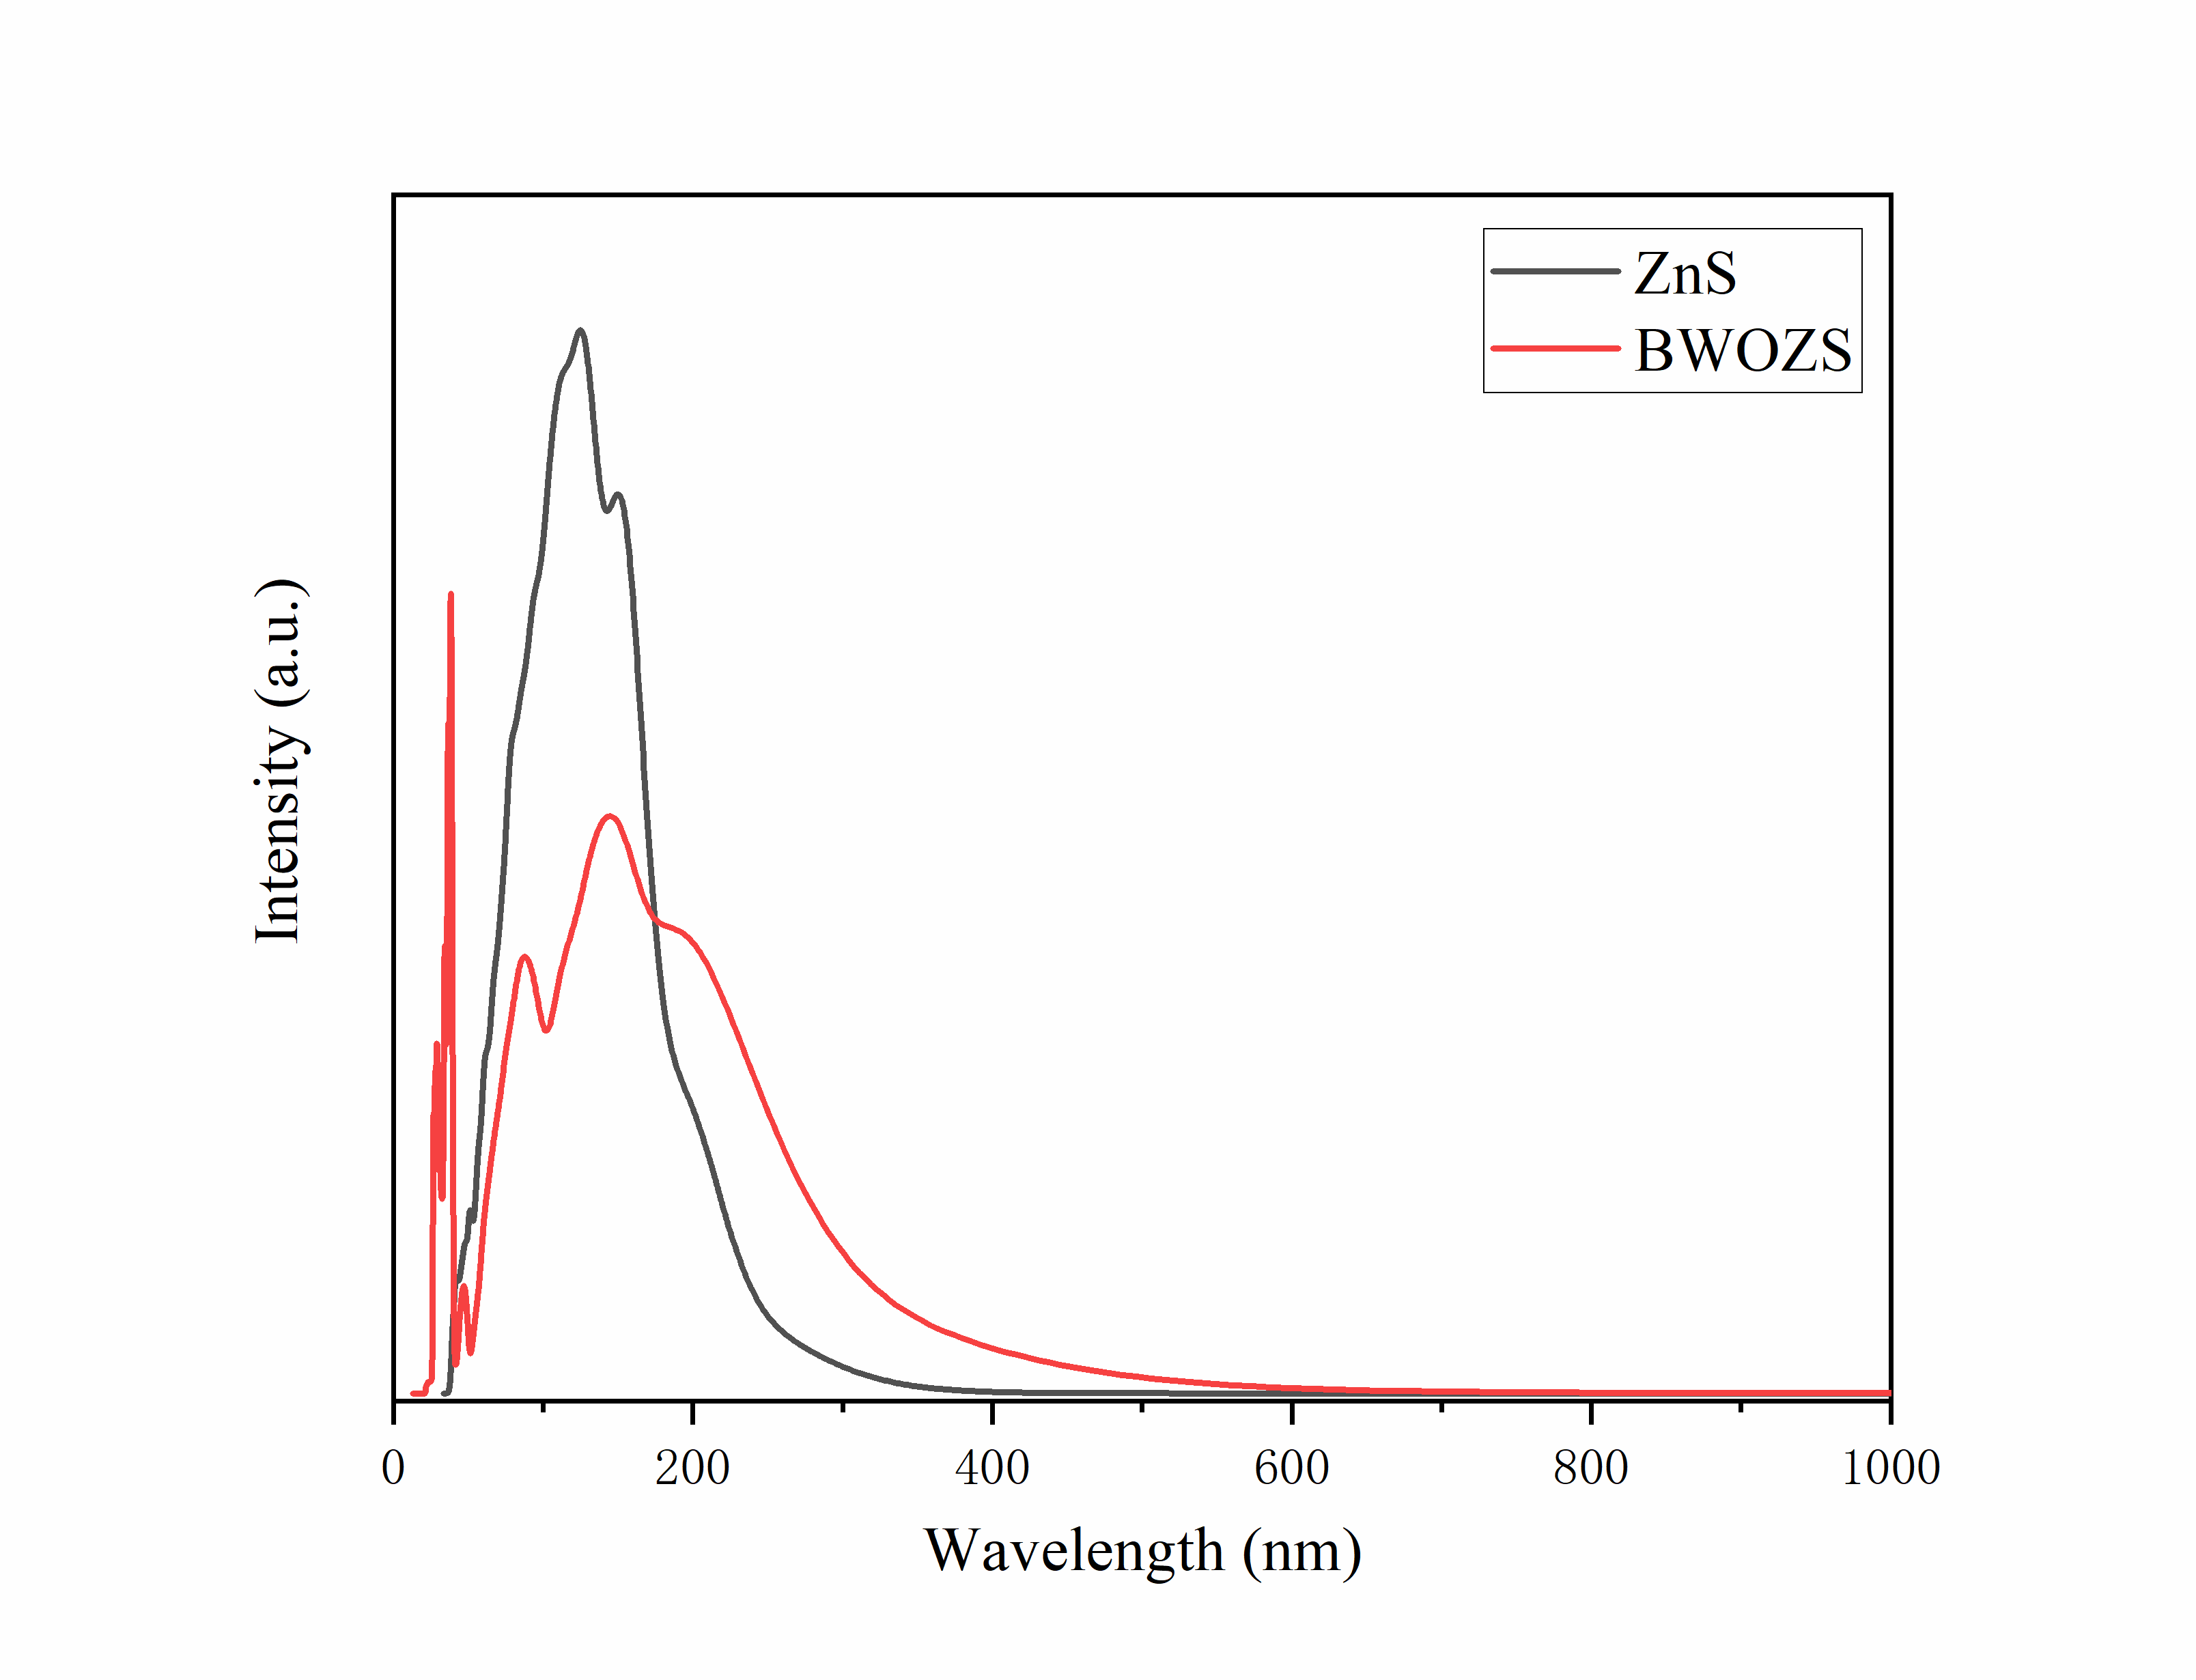

Fig.3 Optical property of ZnS and BWOZS.