Supporting Information
A novel NIR fluorescent probe for monitoring cysteine in
mitochondria of living cells
Jianning Dong, Guowei Lu, Bin He, Yayi Tu* and Congbin Fan*
Jiangxi Key Laboratory of Organic Chemistry, College of Chemistry and Chemical Engineering, Jiangxi Science and Technology Normal University, Nanchang 330013, P.R. China
*Corresponding authors: Yayi Tu, Congbin Fan

Contents

1. Experimental Section

1.1 Materials and Methods
1.2 Detection limit of Cys
Fig. S1: ¹H NMR spectrum of probe LAA in CD₂Cl₂-d₂.

Fig. S2: ¹³C NMR spectrum of probe LAA in CD₂Cl₂-d₂.
Fig. S3: ESI–MS spectrum of probe LAA.
Fig. S4: ESI–MS spectrum of probe LAA + Cys.
Fig. S5: MTT assay of Hela cells treated in the presence of probe LAA for 24 h incubation.

1. Experimental Section
1.1 Materials and instruments
All commercially available reagents and solvents were not further purified. ¹H NMR and ¹³C NMR spectra were recorded on a Bruker AV400 (400 MHz) NMR spectrometer using tetramethylsilane (TMS) as the internal standard. Fluorescence spectra were collected with a Hitachi F-4600 fluorescence spectrophotometer. Ultraviolet-visible (UV-Vis) spectra were recorded with an Agilent 8454 UV/vis spectrophotometer. Mass data was obtained by an Agilent 1100 ion trap MSD spectrometer. Cytotoxicity assay was measured by Multiskan FC microplate reader (Thermo Scientific). Cell imaging was performed with an Olympus FV1000 confocal laser-scanning microscope.
1.2 Detection limit of Cys
According to the equation：LOD = 3σ/k, we calculated the limit of detection（LOD）of LAA reacted with Cys. Using the concentration of Cys (μM) as the X-axis and the fluorescence intensity at the maximum emission wavelength as the Y-axis, the slope k was obtained by linear fitting. The value of σ was obtained from the standard deviation of 11 consecutive measurements of the blank group.

Fig. S1: ¹H NMR spectrum of probe LAA in CD₂Cl₂-d₂.

Fig. S2: ¹³C NMR spectrum of probe LAA in CD₂Cl₂-d₂.

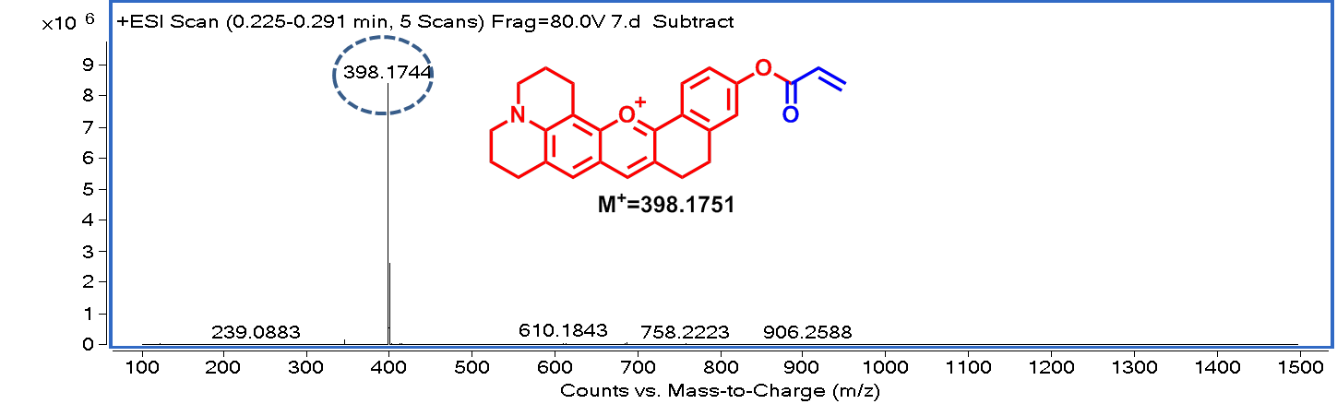
Fig. S3: ESI–MS spectrum of probe LAA.

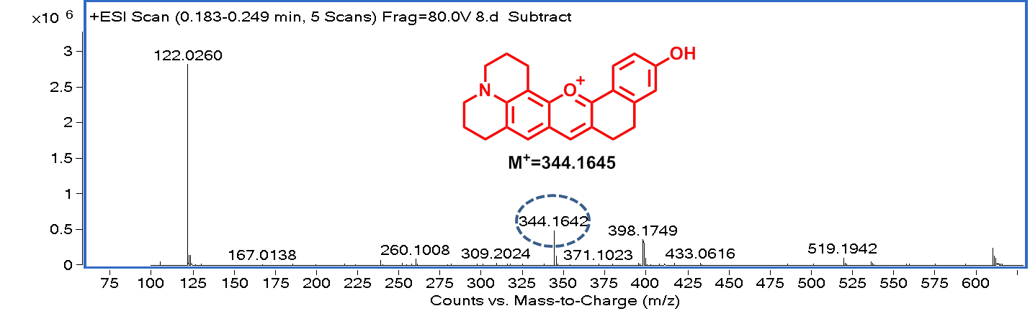
Fig. S4: ESI–MS spectrum of probe LAA +Cys.

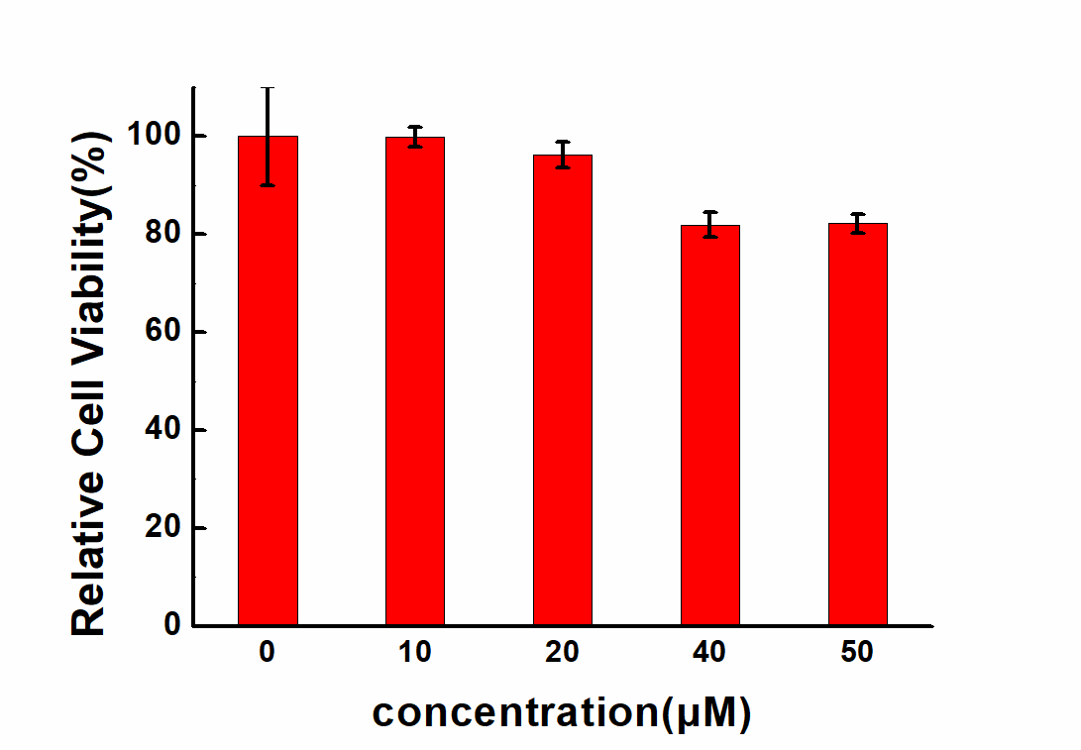
Fig. S5: MTT assay of HeLa cells treated in the presence of LAA for 24 h incubation.

