**18*β*-Glycyrrhetinic acid derivative-based metallo-hydrogels with highly selective and sensitive for histidine detection**

Kaize Su a, b, Jiahao Li a, b, Xiaoyu Guo a, b, Shengzhu Guo a, b, Wende Zheng a, b, Xiaowen Tang a, b, Duanyu Deng a, b, Huiji Yang c, Wing-Leung Wong d, Song Ang a, b *, Kun Zhang a, b * and Panpan Wu a, b *

a School of Biotechnology and Health Sciences, Wuyi University, Jiangmen, 529020, P. R. China

b International Healthcare Innovation Institute (Jiangmen), Jiangmen, 529040, P. R. China

c College of Chemistry, Beijing Normal University, Beijing, 100875, P. R. China

d The State Key Laboratory of Chemical Biology and Drug Discovery, Department of Applied Biology and Chemical Technology, The Hong Kong Polytechnic University, Hung Hom, Kowloon, Hong Kong, P. R. China

**\*Corresponding author**: Dr. Song Ang (jnuangsong@126.com), Prof. Kun Zhang (kzhang@gdut.edu.cn), and Dr. Panpan Wu (wyuchemwpp@126.com)



**Scheme S1** (a) acetone, Jones Reagents, 0 ℃, 2 h, 90%; (b) ethanol, KOH, 6-trifluoromethylpyridine-3-formaldehyde, r. t., 4 h, 76.8%.

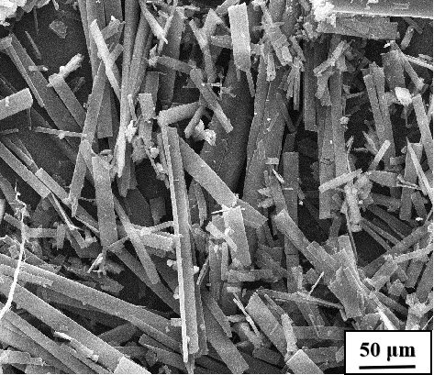

Fig. S1 The SEM image of GA-O-09 hydrogel.

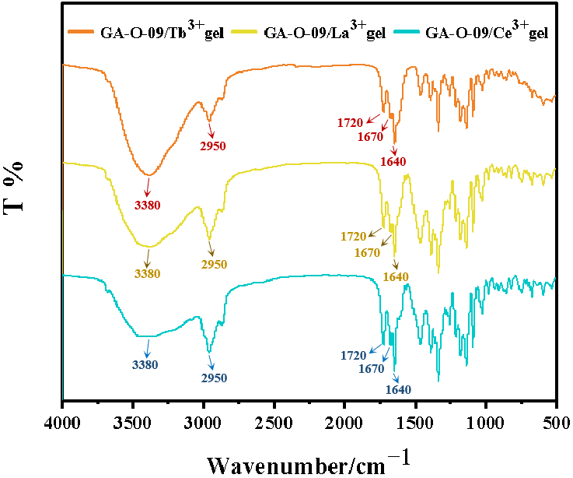

Fig. S2 The FT-IR spectra of GA-O-09/Tb3+ hydrogel, GA-O-09/La3+ hydrogel, and GA-O-09/Ce3+ hydrogel.

**Table S1** BET of (a) **GA-O-09** and (b) **GA-O-09/M3+ (M3+ = Eu3+, La3+)** hydrogels.

|  |  |  |  |
| --- | --- | --- | --- |
|  | **GA-O-09** | **GA-O-09/Eu3+** | **GA-O-09/La3+** |
| BET Surface Area | 14.57 m²/g | 17.68 m²/g | 17.81 m²/g |
| Langmuir Surface Area: | 121.30 m²/g | 142.5 m²/g | 135.6 m²/g |
| Adsorption average pore diameter (4V/A by BET): | 16.08 nm | 15.21 nm | 15.48 nm |
| Desorption average pore diameter (4V/A by BET): | 16.08 nm | 15.21 nm | 15.48 nm |



Fig. S3 Water contact angle of GA-O-09 and GA-O-09/M3+ (M3+ = Eu3+, La3+) hydrogels.

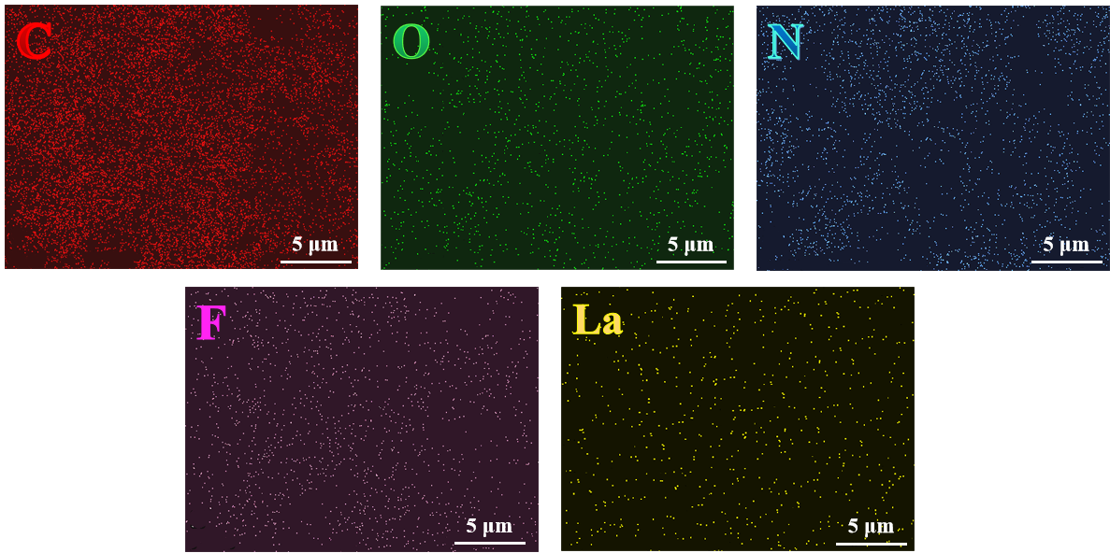

Fig. S4 The EDS elemental mapping of GA-O-09/La3+ hydrogel.

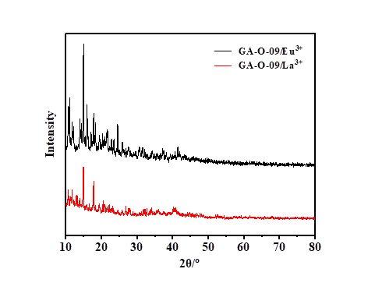

Fig. S5 The PXRD of xero-hydrogel of GA-O-09/Eu3+ and GA-O-09/La3+.

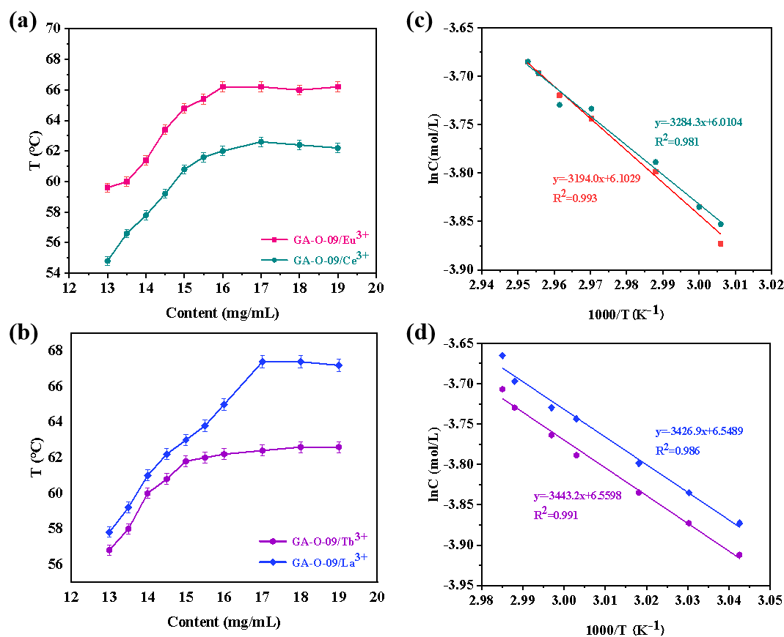

Fig. S6 (a), (b) Gel phase-solution phase transition diagram; (c), (d) A plot of lnC vs 1/T, green: *Δ*H=27.31 kJ·mol-1, *Δ*S=49.97 J·(mol·K)-1, *Δ*G=12.42 kJ·mol-1; red: *Δ*H=26.56 kJ·mol-1, *Δ*S=50.74 J·(mol·K)-1, *Δ*G=11.43 kJ·mol-1; blue: *Δ*H=28.49 kJ·mol-1, *Δ*S=54.45 J·(mol·K)-1, *Δ*G=12.27 kJ·mol-1; purple: *Δ*H=28.63 kJ·mol-1, *Δ*S=54.53 J·(mol·K)-1, *Δ*G=12.40 kJ·mol-1.

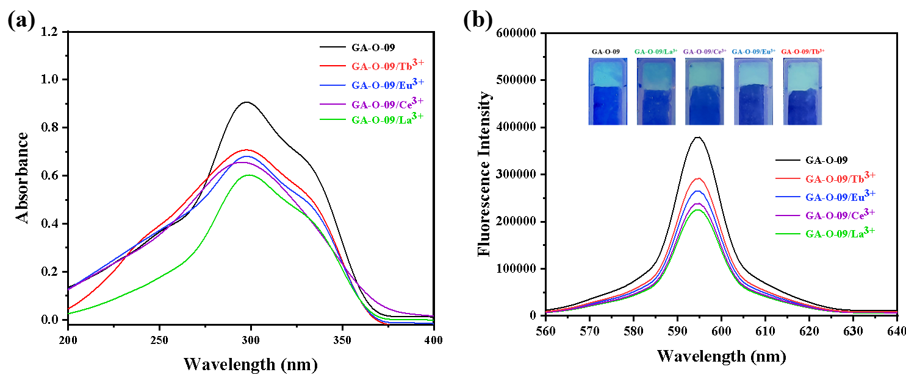

**Fig. S7** (a) The UV-vis spectra of **GA-O-09** hydrogel and **GA-O-09/M3+** (**M3+**=**La3+, Ce3+, Eu3+** and **Tb3+**) hydrogels. (b) the fluorescence spectra of **GA-O-09** hydrogel and **GA-O-09/M3+** (**M3+**=**La3+**, **Ce3+**, **Eu3+** and **Tb3+**) hydrogels upon excitation at 300 nm, respectively. Insets showed the corresponding photographs irradiation of hydrogels under 365 nm UV lamp irradiation.

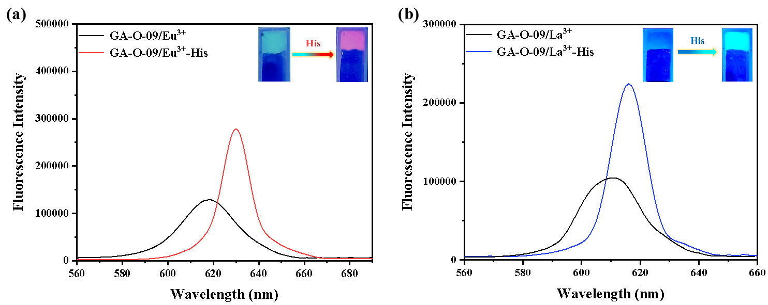

**Fig. S8** Comparison of fluorescence intensity between (a) **GA-O-09/Eu3+** and (b) **GA-O-09/La3+** hydrogels prepared with 1.0 **e**quiv**.** of His or without Hisupon excitation at **365** nm.

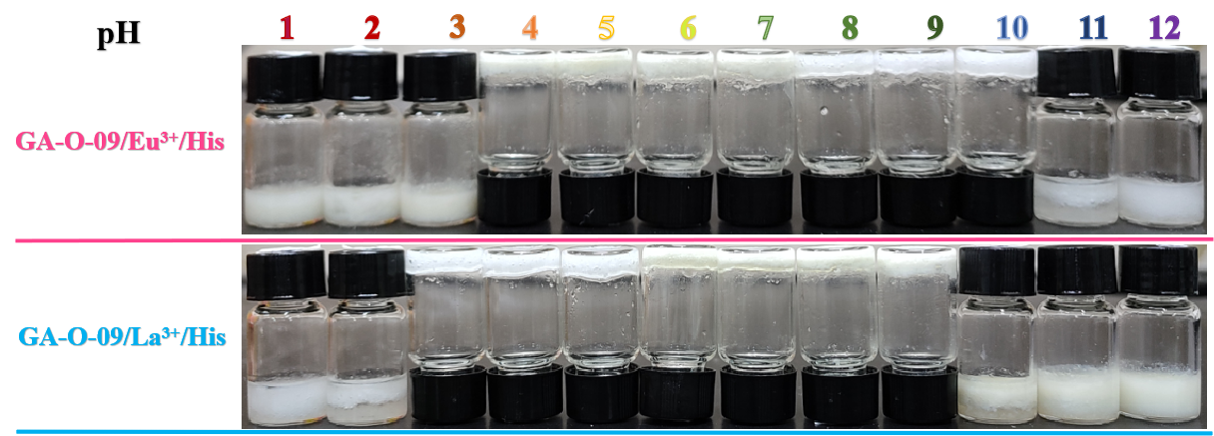

Fig. S9 The stability of the His-loaded GA-O-09/Eu3+ and GA-O-09/La3+ hydrogels at varied pH values.

**Table S2** Comparison of the T*gel* of **GA-O-09/Eu3+** and **GA-O-09/La3+** hydrogels which added with different equivalents of His.

|  |  |  |  |  |
| --- | --- | --- | --- | --- |
|  | **GA-O-09/Eu3+** | | **GA-O-09/La3+** | |
| run | Equivalent（nHis/nGA-O-09/Eu3+） | T*gel*/℃ | Equivalent（nHis/nGA-O-09/La3+） | T*gel*/℃ |
| 1 | 0 | 64.8±0.40 | 0 | 63.0±0.63 |
| 2 | 0.2 | 64.6±0.49 | 0.2 | 62.8±0.49 |
| 3 | 0.4 | 64.0±0.63 | 0.4 | 62.8±0.40 |
| 4 | 0.6 | 63.4±0.40 | 0.6 | 62.2±0.63 |
| 5 | 0.8 | 62.8±0.40 | 0.8 | 61.6±0.49 |
| 6 | 1.0 | 62.8±0.63 | 1.0 | 61.4±0.40 |
| 7 | 1.2 | 61.6±0.40 | 1.2 | 60.8±0.49 |
| 8 | 1.4 | 59.8±0.63 | 1.4 | 58.8±0.63 |
| 9 | 1.6 | 59.6±0.63 | 1.6 | ND |
| 10 | 1.8 | NDa | 1.8 | ND |
| aND: not detected. | | | | |

**Calculation formula of LOD:**

Linear Equation: y=Ax+B (S1)

$δ=\sqrt{\frac{\sum{{\left(F_{i}-F_{0}\right)}^{2}}}{N-1} }\left(N=20\right)$ (S2)

$S=A×{10}^{6}$ (S3)

$LOD=K×\frac{δ}{S} \left(K=3\right)$ (S4)

Where Fi: the fluorescence intensity of the GA-O-09/Eu3+ or GA-O-09/La3+ hydrogels at *λ*ex= 600 nm; F0: the average of 20 times fluorescence intensity of GA-O-09/Eu3+ hydrogel or GA-O-09/La3+ hydrogel at *λ*ex= 600 nm; A: Slope of linear fitting of fluorescence titration; B: intercept of linear fitting of fluorescence titration.