Synthesis, In Vitro Thymidine Phosphorylase Inhibitory Activity and Molecular Docking Study of Novel Pyridine-derived Bis-Oxadiazole Bearing Bis-Schiff Base Derivatives

Rafaqat Hussain1, Wajid Rehman*1, Fazal Rahim1,Shoaib Khan1, Ashwag S. Alanazi2, Mohammed M. Alanazi3, Liaqat Rasheed1, Yousaf Khan4, Syed A. A. Shah5, 6, Muhammad Taha7

1 Department of Chemistry, Hazara University Mansehra-21120, Pakistan.

2 Department of Pharmaceutical Sciences, College of Pharmacy, Princess Nourah bint Abdulrahman University, P.O. Box 84428, Riyadh 11671, Saudi Arabia.

3 Department of Pharmaceutical Chemistry, College of Pharmacy, King Saud University, Riyadh 11451, Saudi Arabia.

4 COMSATS Department of Chemistry, COMSATS University, Islamabad, Pakistan

5 Faculty of Pharmacy, Universiti Teknologi MARA Cawangan Selangor Kampus Puncak Alam, Bandar Puncak Alam 42300, Selangor, Malaysia

6 Atta-ur-Rahman Institute for Natural Product Discovery (AuRIns), Universiti Teknologi MARA Cawangan Selangor Kampus Puncak Alam, Bandar Puncak Alam 42300, Selangor, Malaysia.

7Department of Clinical Pharmacy, Institute for Research and Medical Consultations (IRMC), Imam Abdulrahman Bin Faisal University, P.O. Box 1982, Dammam 31441, Saudi Arabiac

*3.3. Spectral analysis*

**(2E,2'E)-2,2'-(pyridine-2,6-diylbis(methanylylidene))bis(hydrazine-1-carboxamide)** 2

Gray solidsolid; Yield: 87%; m.p. 58-59 °C; FT-IR (KBr, cm-1): 3350, 3050, 1745,1669, 1610; 1H-NMR (600 MHZ, DMSO-*d6*): *δ*10.13 (s, 2H, NH),7.80(d, *J* = 7.4 Hz, 2H, Pyridine-H), 7.75 (d, *J* = 8.0 Hz, 1H, Pyridine-H), 7.60(s, 2H, CH), 7.16(s, 2H, NH2), 13C-NMR (150 MHz, DMSO-d6): *δ*153.1, 153.1, 151.7, 151.7, 141.9, 141.9, 133.2, 120.3, 120.3.; Elem. Anal. C 43.35, H 4.42, N 39.33, O 12.82; HREI-MS: m/z calcd for C9H11N7O2 [M]+ 249.0974; Found; 249.0945.

**5,5'-(pyridine-2,6-diyl)bis(1,3,4-oxadiazol-2-amine)**3

White solid solid; Yield: 77%; m.p. 59-60 °C; FT-IR (KBr, cm-1): 3310, 3060, 1670;1H-NMR (600 MHZ, DMSO-*d6*): *δ*7.72 (d, *J* = 7.5 Hz, 2H, Pyridine-H), 7.65 (d, *J* = 8.3 Hz, 1H, Pyridine-H), 7.30 (s, 2H, NH2), 13C-NMR (150 MHz, DMSO-d6): *δ*168.3, 168.3, 161.5, 161.5, 154.6, 154.6, 120.1, 120.1, 140.0.; Elem. Anal. C 44.02, H 2.84, N 39.96, O 13.02; HREI-MS: m/z calcd for C9H7N7O2 [M]+ 245.061; Found; 245.0624.

**(1E, 1’E)-N-N-(pyridine-2,6-diylbis(1,3,4-oxadiazole-5,2-diyl))bis(1-(4-methyl-2-nitrophenyl)methanimine) (4a)**

Black solid; Yield: 82%; m.p. 125-126°C; FT-IR (KBr, cm-1):2966, 1675,1660, 1530, 1460;1H-NMR (600 MHZ, DMSO-*d6*): *δ* 9.88 (s, 2H,CH), 8.15 (s, 2H, Ar-H), 8.12 (d, *J* = 8.8 Hz, 2H, Pyridine-H), 8.10 (d, *J* = 7.3 Hz, 1H, Pyridine-H), 8.02 (d, *J* = 7.0 Hz, 2H, Ar-H), 7.66 (d, *J* = 6.9Hz, 2H, Ar-H), 3.30 (s, 6H, CH3), 13C-NMR (150 MHz, DMSO-d6): *δ* 164.5, 164.5, 160.0, 160.0, 157.6, 156.6, 147.7, 147.7, 142.0, 142.0, 141.6, 141.6, 139.4, 135.2, 135.2, 130.0, 130.0, 125.5, 125.5, 125.4, 125.4, 121.1, 121.1, 20.3, 20.3.; Elem. Anal. C 55.63, H 3.16, N 23.33, O 17.74; HREI-MS: m/z calcd for C25H17N9O6 [M]+ 539.1302; Found; 539.1298.

**(1E, 1’E)-N,N-(pyridine-2,6-diylbis(1,3,4-oxadiazole-5,2-diyl))bis(1-(4-chloro-2-nitrophenyl)methanimine) (4b)**

White solid; Yield: 66%; m.p. 135-136 °C; FT-IR (KBr, cm-1):1673, 1658, 1534,838;1H-NMR (600 MHZ, DMSO-*d6*): *δ* 8.99 (s, 2H, CH), 8.82 (s, 2H, Ar-H), 8.12 (s, 1H, Pyridine-H), 8.10 (d, *J* = 7.4 Hz, 2H, Pyridine-H), 8.01 (d, *J* = 7.2 Hz, 2H, Ar-H), 7.90 (d, *J* = 6.9 Hz, 2H, Ar-H), 13C-NMR (150 MHz, DMSO-*d6)*: *δ* 164.5, 164.5, 160.0, 160.0, 157.6, 157.6, 149.2, 149.2, 142.0, 135.9, 135.9, 135.O, 135.0, 131.5, 131.5, 130.4, 130.4, 126.5, 126.5, 124.3, 124.3, 121.1, 121.1; Elem. Anal. C 47.60, H 1.89, Cl 12.20, N 21.70, O 16.50; HREI-MS: m/z calcd C23H11Cl2N9O6 for [M]+ 579.0209; Found; 579.0205.

**(1E,1’E)-N,N’-(pyridine-2,6-diylbis(1,3,4-oxadiazole-5,2-diyl))bis(1-(2,4-dichlorophenyl)methanimine) (4c)**

Gray solid; Yield: 70%; m.p. 130-131 °C; FT-IR (KBr, cm-1): 1674, 1659, 1535, 846;1H-NMR (600 MHZ, DMSO-*d6*): *δ* 10.28 (s, 2H, CH), 8.66 (s, 2H, Ar-H), 8.33 (d, *J* = 9.0 Hz, 2H, Ar-H), 8.25 (d, *J* = 7.8 Hz, 2H, Pyridine-H), 7.89 (d, *J* = 8.4 Hz, 1H, Pyridine-H), 7.70 (d, *J* = 7.8 Hz, 2H, Ar-H), 13C-NMR (150 MHz, DMSO-*d6*): *δ* 164.5, 164.5, 160.0, 160.0, 157.6, 157.6, 142.0, 131.5, 131.5, 131.0, 131.0, 130.2, 130.2, 129.1, 129.1, 129.0, 129.0, 128.3, 128.3, 127.0, 127.0, 121.1, 121.1; Elem. Anal. C 49.38, H 1.88, Cl 25.33, N 17.50, O 5.70;HREI-MS: m/z calcd C23H11Cl4N7O2 for [M]+558.9699; Found; 558.9695.

**(1E,1’E)-N,N’-(pyridine-2,6-diylbis(1,3,4-oxadiazole-5,2-diyl))bis(1-(4-chloro-2-methylphenyl)methanimine) (4d)**

Gold solid; Yield: 72%; m.p. 120-121 °C; FT-IR (KBr, cm-1): 2980, 1680, 1666, 1540, 1480, 848;1H-NMR (600 MHZ, DMSO-*d6*): *δ* 10.27 (s, 2H, CH), 7.88 (d, *J* = 8.4 Hz, 2H, Pyridine-H), 7.84 (d, *J* = 1.8 Hz, 2H, Ar-H), 7.72 (d, *J* = 8.4 Hz, 2H, Ar-H) 7.64 (d, *J* = 6.8 Hz, 1H, Pyridine-H), 7.37 (d, *J* = 6.6Hz, 2H, Ar-H), 5.38 (s, 6H, CH3), 13C-NMR (150 MHz, DMSO-*d6*): *δ* 169.8, 169.8, 164.5, 164.5, 160.0, 160.0, 157.6, 157.6, 142.0, 140.3, 140.3, 136.5, 136.5, 133.3, 133.3, 130.5, 130.5, 128.9, 128.9, 125.9, 125.9, 121.1, 121.1, 18.4, 18.4.; Elem. Anal. C 57.90, H 3.30, Cl 13.67, N 18.91, O 6.15; HREI-MS: m/z calcd C25H17Cl2N7O2 for [M]+517.0821; Found; 517.0817.

**(1E,1’E)-N,N’-(pyridine-2,6-diylbis(1,3,4-oxadiazole-5,2-diyl))bis(1-(2,4-dimethylphenyl)methanimine) (4e)**

Yellow solid; Yield: 64%; m.p. 111-112 °C; FT-IR (KBr, cm-1): 2970, 1664, 1655, 1525, 1455; 1H-NMR (600 MHZ, DMSO-*d6*): *δ* 8.99 (s, 2H,CH), 8.11 (t, *J* = 6.8Hz, 1H, Pyridine-H), 8.10 (d, *J* = 7.3 Hz, 2H, Pyridine-H), 7.71 (d, *J* = 7.0 Hz, 2H, Ar-H), 7.17 (d, *J* = 7.0 Hz, 2H, Ar-H), 7.10 (s, 2H, Ar-H), 2.48 (s, 6H,CH3), 2.30 (s, 6H, CH3), 13C-NMR (150 MHz, DMSO-*d6*): *δ* 164.5, 164.5, 160.0, 160.0, 157.6, 157.6, 142.0, 138.8, 138.8, 136.9, 136.9, 134.7, 134.7, 132.2, 132.2, 131.0,131.0, 129.0, 129.0, `126.1, 126.1, 121.1, 121.1, 21.6, 21.6, 19.2, 19.2.; Elem. Anal. C 67.90, H 4.85, N 20.50, O 6.69; HREI-MS: m/z calcd C27H23N7O2 for [M]+477.1913; Found; 477.1909.

**(1E,1’E)-N,N’-(pyridine-2,6-diylbis(1,3,4-oxadiazole-5,2-diyl))bis(1-(3-nitro-5-(trifluoromethyl)phenyl)methanimine) (4f)**

Brown solid; Yield: 68%; m.p. 151-152 °C; FT-IR (KBr, cm-1):1677, 1666, 1540, 1370; 1H-NMR (600 MHZ, DMSO-*d6*): *δ* 9.00 (s, 2H, CH), 8.48 (s, 2H,Ar-H), 8.44 (s, 2H, Ar-H), 8.41 (s, 2H, Ar-H), 8.12 (t, *J*=6.4Hz, 1H, Pyridine-H),8.10 (d,*J*= 7.2Hz, 2H, Pyridine-H), 13C-NMR (150 MHz, DMSO-*d6*): *δ* 174.9, 174.9, 164.5, 164.5, 160.0, 160.0, 157.6, 157.6, 142.0, 134.9, 134.9, 132.9, 132.9, 132.0, 132.0, 131.6, 131.6, 124.9, 124.9, 123.8, 123.8, 123.1, 123.1, 121.1, 121.1; Elem. Anal. C 46.37, H 1.70, F 17.60, N 19.46, O 14.80; HREI-MS: m/z calcd C25H11F6N9O6 for [M]+647.0736; Found; 647.0732.

**(1E,1’E)-N,N’-(pyridine-2,6-diylbis(1,3,4-oxadiazole-5,2-diyl))bis(1-(2,4-dimethoxyphenyl)methanimine) (4g)**

Yellow solid; Yield: 75%; m.p. 126-127 °C; FT-IR (KBr, cm-1): 2981, 1685, 1665, 1458,1260;1H-NMR (600 MHZ, DMSO-*d6*): *δ* 10.26 (s, 2H,CH), 8.65 (s, 2H, Ar-H), 8.33 (d, *J* = 7.2 Hz, 2H, Pyridine-H), 8.25 (d, *J* = 7.8 Hz, 2H, Ar-H), 8.21 (d, *J* = 8.4 Hz, 2H, Ar-H), 7.68 (d, *J* = 8.4 Hz, 1H, Pyridine-H), 3.92 (s, 12H, (-OCH3)4), 13C-NMR (150 MHz, DMSO- *d6*): *δ* 164.5, 164.5, 163.9, 163.9, 160.0, 160.0, 159.5, 159.5, 157.6, 157.6, 142.0, 138.5, 138.5, 133.0, 133.0, 121.1, 121.1, 117.2, 117.2, 106.7, 106.7, 101.5, 101.5, 55.8, 55.8, 55.8, 55.8.; Elem. Anal. C 59.88, H 4.27, N 18.10, O 17.70; HREI-MS: m/z calcd C27H23N7O6 for [M]+541.1710; Found; 541.1706.

**4’-((1E, E’)-((pyridine-2,6-diylbis(1,3,4-oxadiazole-5,2-diyl))bis(azaneylylidene))bis (methaneylylidene))bis(3-methoxyphenol) (4h)**

White solid; Yield: 77%; m.p. 119-120 °C; FT-IR (KBr, cm-1): 3250, 2991, 1689, 1666, 1459, 1262;1H-NMR (600 MHZ, DMSO-*d6*): *δ* 9.98 (s,2H, OH), 8.99 (s, 2H, CH), 8.12 (t, *J* = 6.7 Hz, 1H, Pyridine-H), 8.10 (d, *J* = 7.2Hz, 2H, Pyridine-H), 7.71 (d, *J* = 7.0 Hz, 2H, Ar-H), 6.46 (s, 2H, Ar-H), 6.45 (d, *J* = 7.1Hz, 2H, Ar-H), 3.81 (s, 6H, -OCH3), 13C-NMR (150 MHz, DMSO-*d6*): *δ* 169.3, 169.3, 164.5, 164.5, 161.8, 161.8, 160.0, 160.0, 159.5, 159.5, 157.6, 157.6, 142.0, 133.4, 133.4, 121.1, 121.1, 117.5, 117.5, 108.3, 108.3, 102.1, 102.1, 55.8, 55.8.; Elem. Anal. C 58.48, H 3.70, N 19.09, O 18.69; HREI-MS: m/z calcd C25H19N7O6 for [M]+513.1397; Found; 513.1392.

**5,5'-((1E,1'E)-((pyridine-2,6-diylbis(1,3,4-oxadiazole-5,2-diyl))bis(azanylylidene))bis(methanylylidene))bis(3-nitrophenol)(4i)**

Brown solid; Yield: 80%; m.p. 126-127 °C; FT-IR (KBr, cm-1): 3280, 2994, 1690, 1667, 1464, 1320;1H-NMR (600 MHZ, DMSO-*d6*): *δ* 9.45 (s, 2H, OH), 8.99 (s, 2H, CH), 8.12 (t,*J*=6.8 Hz, 1H, Pyridine-H), 8.10 (d,*J* = 7.4 Hz, 2H, Pyridine-H), 8.04 (s, 2H, Ar-H), 7.64 (s, 2H, Ar-H), 7.55 (s, 2H, Ar-H), 13C-NMR (150 MHz, DMSO-*d6*): *δ* 175.3, 175.3, 164.5, 164.5, 160.0, 160.0, 159.5, 159.5, 157.6, 157.6, 149.4, 149.4, 142.0, 136.0, 136.0, 121.1, 121.1, 121.0, 121.0, 114.2, 114.2, 113.8, 113.8.; Elem. Anal. C 50.83, H 2.40, N 23.19, O 23.53; HREI-MS: m/z calcd C23H13N9O8 for [M]+543.0887; Found; 543.0882.

**(1E,1'E)-N,N'-(pyridine-2,6-diylbis(1,3,4-oxadiazole-5,2-diyl))bis(1-(2-methoxy-4-methylphenyl)methanimine)(4j)**

Light yellow solid; Yield: 69%; m.p. 118-119 °C; FT-IR (KBr, cm-1): 2991, 1689, 1666, 1459, 1262;1H-NMR (600 MHZ, DMSO-*d6*): *δ* 8.99 (s, 2H, CH), 8.12 (t, *J* = 6.8Hz, 1H, Pyridine-H), 8.10 (d, *J* = 7.4 Hz, 2H, Pyridine-H), 7.76 (d, *J* = 7.3 Hz, 2H, Ar-H), 6.95 (d, *J* = 7.5 Hz, 2H, Ar-H), 6.93 (s, 2H, Ar-H), 3.90 (s, 12H, -OCH3),13C-NMR (150 MHz, DMSO-*d6*): *δ* 166.4, 166.4, 164.5, 164.5, 160.3, 160.3, 160.0, 160.0, 157.6, 157.6, 146.8, 146.8, 142.0, 130.1, 130.1, 121.9, 121.9, 121.4, 121.4, 121.1, 121.1, 116.9, 116.9, 55.8, 55.8, 21.6, 21.6; Elem. Anal. C 63.64, H 4.53, N 19.23, O 12.53; HREI-MS: m/z calcd C27H23N7O4 for [M]+509.1812; Found; 509.1808.

**2,2'-((1E,1'E)-((pyridine-2,6-diylbis(1,3,4-oxadiazole-5,2-diyl))bis(azanylylidene))bis(methanylylidene))bis(4-nitrophenol) (4k)**

Light brown solid; Yield: 65%; m.p. 126-127 °C; FT-IR (KBr, cm-1): 3280, 2994, 1690, 1667, 1464, 1320;1H-NMR (600 MHZ, DMSO-*d6*): *δ* 13.31 (s, 2H, OH), 8.99 (s, 2H, CH), 8.44 (s, 2H, Ar-H), 8.12 (t, *J* = 6.7Hz, 1H, Pyridine-H), 8.10 (d, *J* = 7.3Hz, 2H, Pyridine-H), 8.05 (d, *J* = 7.1Hz, 2H, Ar-H), 7.05 (d, *J* = 7.2 Hz, 2H, Ar-H), 13C-NMR (150 MHz, DMSO-*d6*): *δ* 173.7, 173.7, 167.2, 167.2, 164.5, 164.5, 160.0, 160.0, 157.6, 157.6, 142.0, 140.6, 140.6, 128.6, 128.6, 128.3, 128.3, 121.1, 121.1, 118.0, 118.0, 116.9, 116.9.; Elem. Anal. C 50.82, H 2.40, N 23.19, O 23.53; HREI-MS: m/z calcd C23H13N9O8 for [M]+543.0887; Found; 543.0881.

**4,4'-((1E,1'E)-((pyridine-2,6-diylbis(1,3,4-oxadiazole-5,2-diyl))bis(azanylylidene))bis(methanylylidene))bis(N,N-dimethylaniline) (4l)**

White solid; Yield: 74%; m.p. 118-119 °C; FT-IR (KBr, cm-1):2977, 1695, 1659, 1474, 1320;1H-NMR (600 MHZ, DMSO-*d6*): *δ* 10.27 (s, 2H, CH), 7.85 (d, *J* = 7.3 Hz, 2H, Pyridine-H), 7.83 (d, *J* = 8.3 Hz, 1H, Pyridine-H), 7.75 (d, *J* = 7.4Hz, 4H, Ar-H), 7.25 (d, *J* = 9.0 Hz, 4H, Ar-H), 3.93 (s, 12H, -N(CH3)4), 13C-NMR (150 MHz, DMSO-*d6*): *δ* 167.8, 167.8, 164.5, 164.5, 160.0, 160.0, 157.6, 157.6, 153.4, 153.4, 142.0, 128.3, 128.3, 128.3, 128.3, 125.9, 125.9, 121.1, 121.1, 111.9, 111.9, 111.9, 111.9, 41.3, 41.3, 41.3, 41.3.; Elem. Anal. C 63.87, H 4.94, N 24.83, O 6.28; HREI-MS: m/z calcd C27H25N9O2 for [M]+507.2131; Found; 507.2127.

*3.4. Assay protocol for docking study*

Utilizing Discovery Studio Visualizer's (DSV) MGL tool 1.5.7 and Auto DockVina, a molecular docking study was carried out [1-3]. In this work, the synthetic chemicals were tested against the enzymes glucosidase and amylase. These enzymes' structures were found in the Protein Data Bank (PDB) by using the search criteria 1b2y & 3w37. The target protein and the prepared ligand were both saved in PDB format after the first step of protein preparation, which involved utilizing DSV to remove water molecules and existing ligands. The process was then continued in AutoDock, where protein was charged with polar hydrogen, kollman, and gasteiger charges. Additionally, the chosen ligand was constructed using a torsion tree to find the root. Additionally, a configuration file was created and saved in the same docking folder along with the X, Y, and Z axis for both the ligand and protein in PDBQT format. The ligand was then generated in various postures using a command line, yielding a total of 9 distinct poses in PDBQT format. The dock protein and ligand were then opened in DSV to determine the ligand-enzyme active site interaction. The given article summarizes the additional information [4].

*3.5. Assay protocol for thymidine phosphorylase inhibition*

Since human TP is not easy to obtain, we used commercially available recombinant E. coli TP. The primary sequence of TP is frequently preserved throughout evolution as mammalian TP is reported to share 39% sequence resemblance with the TP of E. coli. The mammalian enzyme also shared up to 70% resemblance with the active site residues, and three-dimensional structure of E. coli TP enzyme. The thymidine phosphorylase/PD-ECGF (E. coli) activity was determined by measuring the absorbance at 290 nm spectrophotometrically. The method was described in. In brief, the total reaction mixture of 200 µL contained 145 µL of potassium phosphate buffer (pH 7.4), 30 µL of enzyme (human and E. coli) at concentration 0.05 and 0.002 U, respectively, were incubated with 5 µL of test materials for 10 min at 25 °C in a microplate reader. After incubation, a pre-read at 290 nm was taken to deduce the absorbance of substrate particles. The substrate (20 µL, 1.5 mM), dissolved in potassium phosphate buffer, was immediately added to the plate and continuously read after 10, 20, and 30 min in a microplate reader (SpectraMax, Molecular Devices, CA, USA). All assays were performed in triplicate [5].

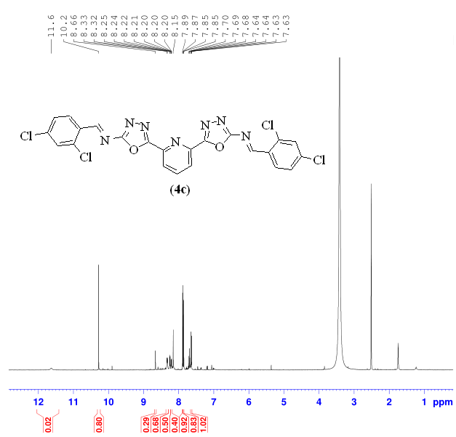

**Figure 1:** 1H-NMR of (1E, 1’E)-N,N’-(pyridine-2,6-diylbis(1,3,4-oxadiazole-5,2-diyl))bis(1-(2,4-dichlorophenyl)methanimine) (**4c**)

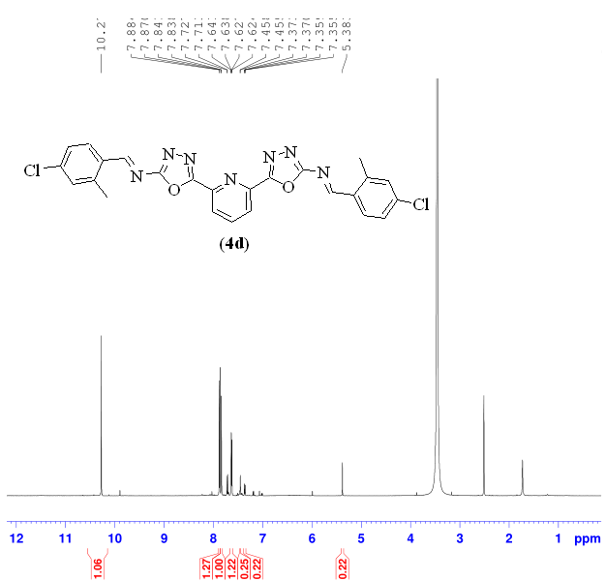

**Figure 2:**1H-NMR of (1E, 1’E)-N,N’-(pyridine-2,6-diylbis(1,3,4-oxadiazole-5,2-diyl))bis(1-(4-chloro-2-methylphenyl)methanimine) (4d)

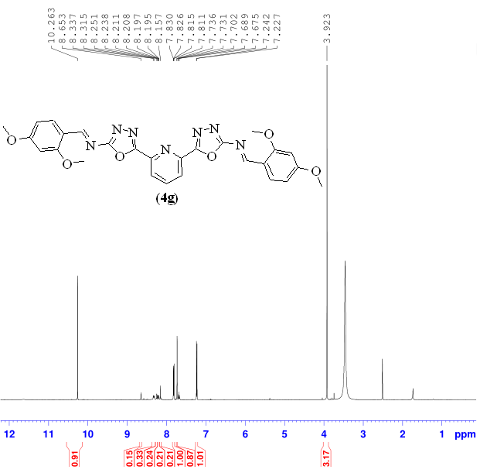

**Figure 3:**1H-NMR of (1E, 1’E)-N,N’-(pyridine-2,6-diylbis(1,3,4-oxadiazole-5,2-diyl))bis(1-(2,4-dimethoxyphenyl)methanimine) (4g)

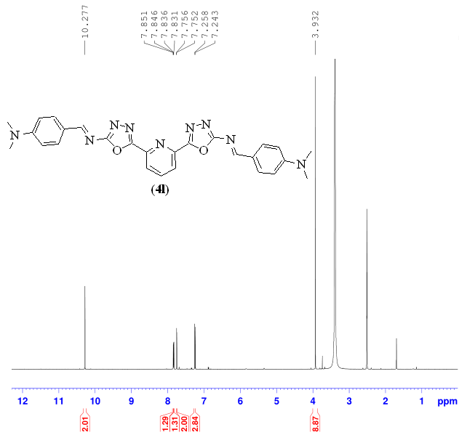

**Figure 4:**1H-NMR of 4,4'-((1E,1'E)-((pyridine-2,6-diylbis(1,3,4-oxadiazole-5,2-diyl))bis(azanylylidene))bis(methanylylidene))bis(N,N-dimethylaniline) (4l)

**Re-docking of co-crystallized ligand**

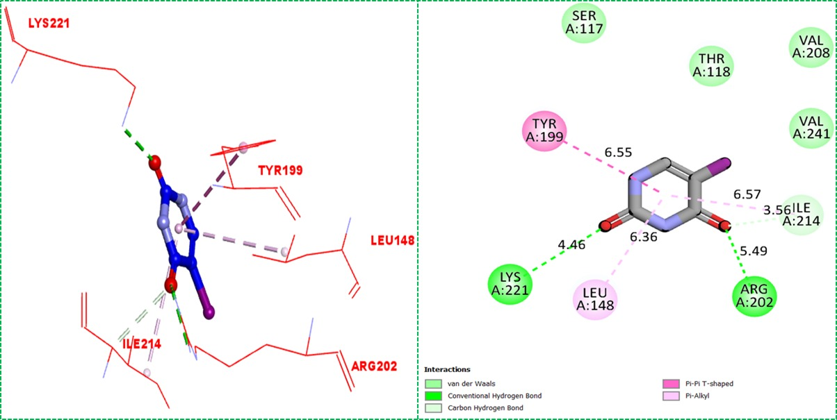

**Configuration file**

Receptor = protein.pdbqt

Ligand = ligand.pdbqt

Out = out.pdbqt

Center_x =21.807

Center_y = 17.01

Center_z = 42.393

Size_x = 40

Size_y = 40

Size_z = 40

Exhaustiveness = 8



**References**

1. Mrabti, N.N., 2018. QSAR study and molecular docking of benzimidazole derivatives inhibitors of p38 kinase. *Moroccan Journal of Chemistry*, *6*(3), pp.6-3.
2. Li, Z., Gu, J., Zhuang, H., Kang, L., Zhao, X. and Guo, Q., 2015. Adaptive molecular docking method based on information entropy genetic algorithm. *Applied Soft Computing*, *26*, pp.299-302.
3. Rao, C.M.M.P., Naidu, N., Priya, J., Rao, K.P.C., Ranjith, K., Shobha, S., Chowdary, B.S. and Siddiraju, S., 2021. Molecular docking and dynamic simulations of benzimidazoles with beta-tubulins. *Bioinformation*, *17*(3), p.404.
4. Khan, S., Ullah, H., Rahim, F., Nawaz, M., Hussain, R. and Rasheed, L., 2022. Synthesis, in vitro α-amylase, α-glucosidase activities and molecular docking study of new benzimidazole bearing thiazolidinone derivatives. *Journal of Molecular Structure*, *1269*, p.133812.
5. Almandil, N.B., Taha, M., Farooq, R.K., Alhibshi, A., Ibrahim, M., Anouar, E.H., Gollapalli, M., Rahim, F., Nawaz, M., Shah, S.A.A. and Ahmed, Q.U., 2019. Synthesis of thymidine phosphorylase inhibitor based on quinoxaline derivatives and their molecular docking study. *Molecules*, *24*(6), p.1002.