**Supplementary Figures**

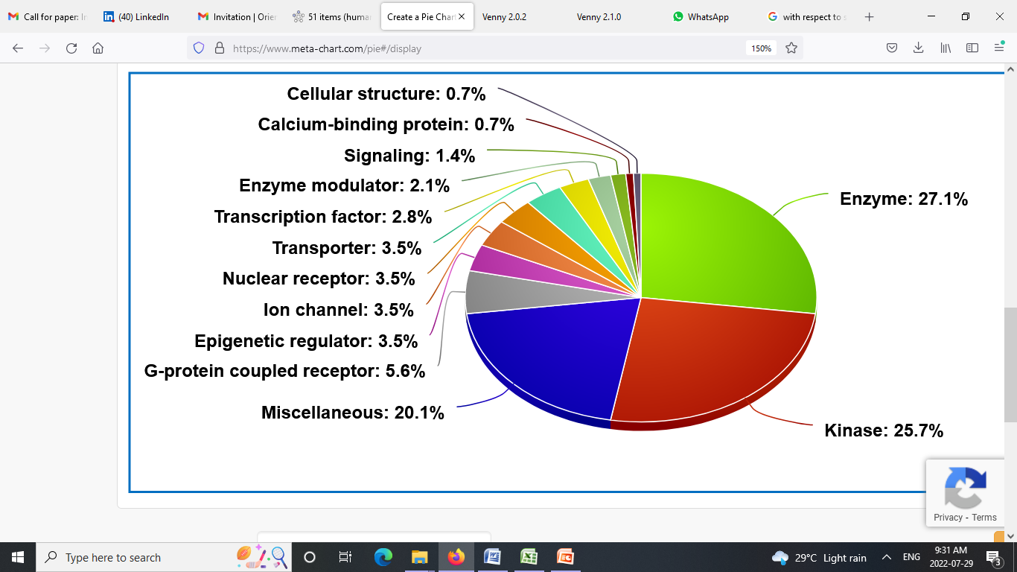

**Figure S1:** Categorical classification of matched targets regulated by karanjin.

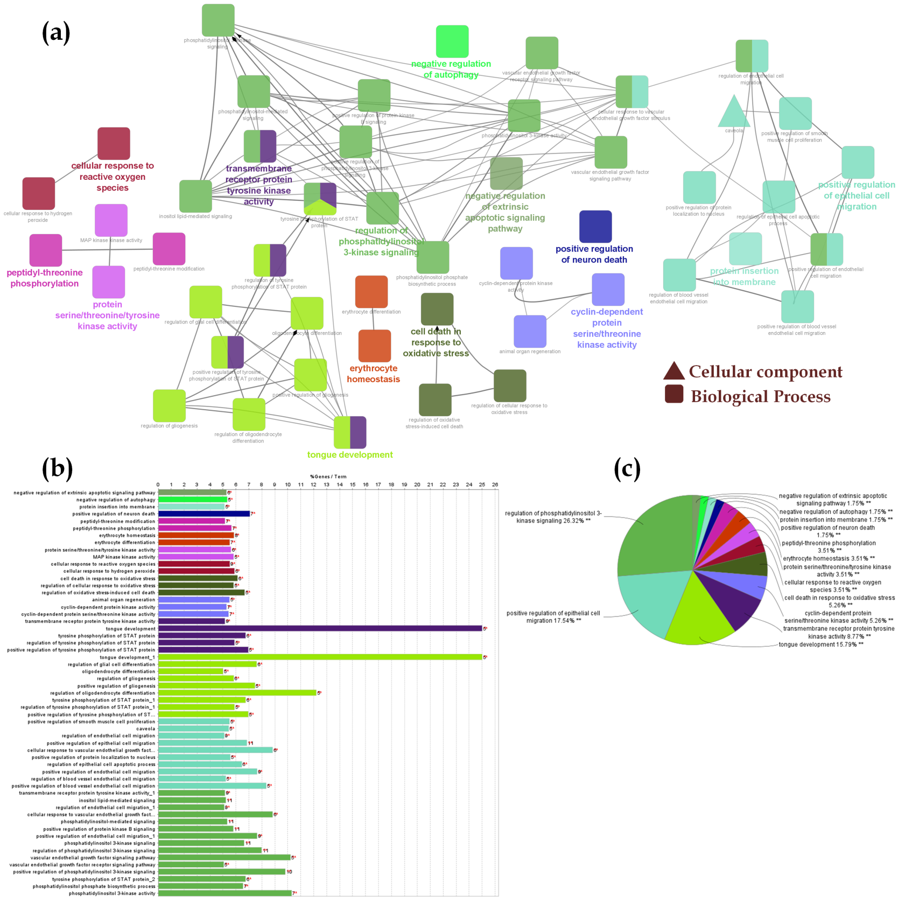

**Figure S2: (a)** Cluster analysis of GO terms (CC, MF, and BP); **(b)** GO enrichment analysis depicted as bar graph **(c)** GO enrichment represent as pie chart. Where, different colors represent different clusters.

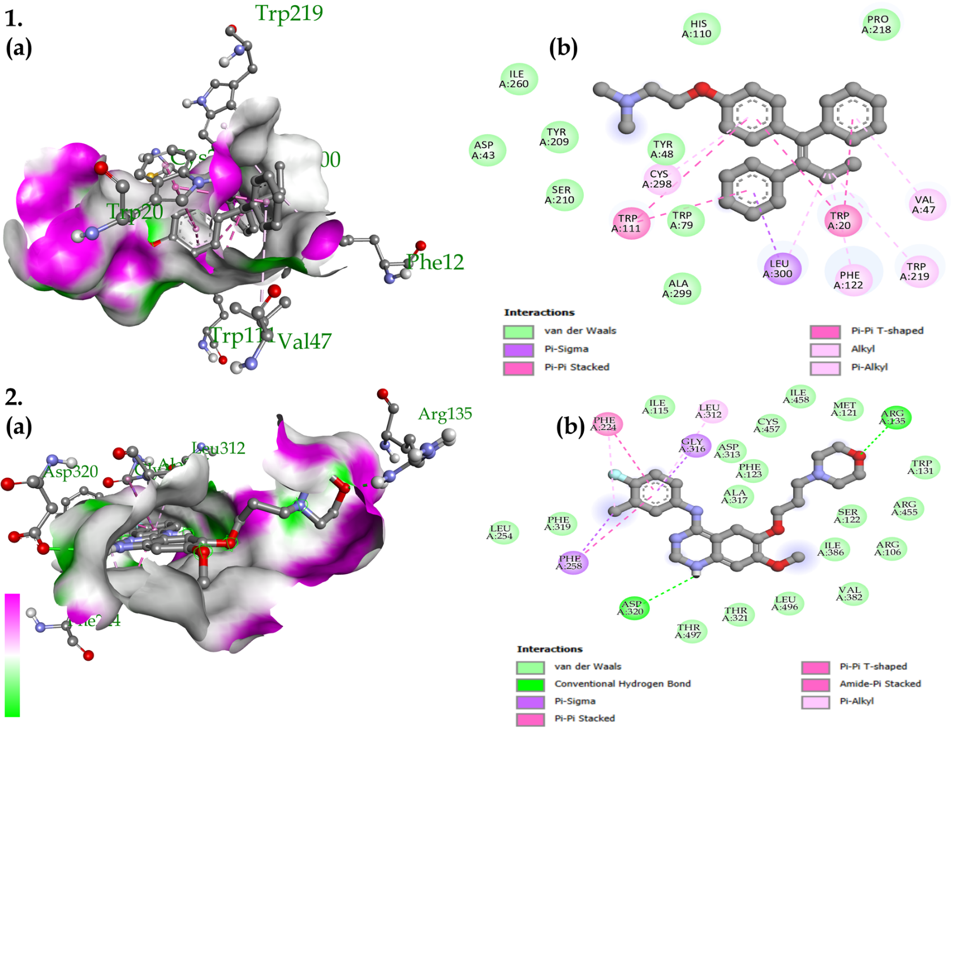

**Figure S3: a)** 3D and **b)** 2D interaction of top complex possessing highest binding affinity; **1.** Tamoxifen-*AKR1B1*, and **2.** Gefitinib-*CYP1A1*

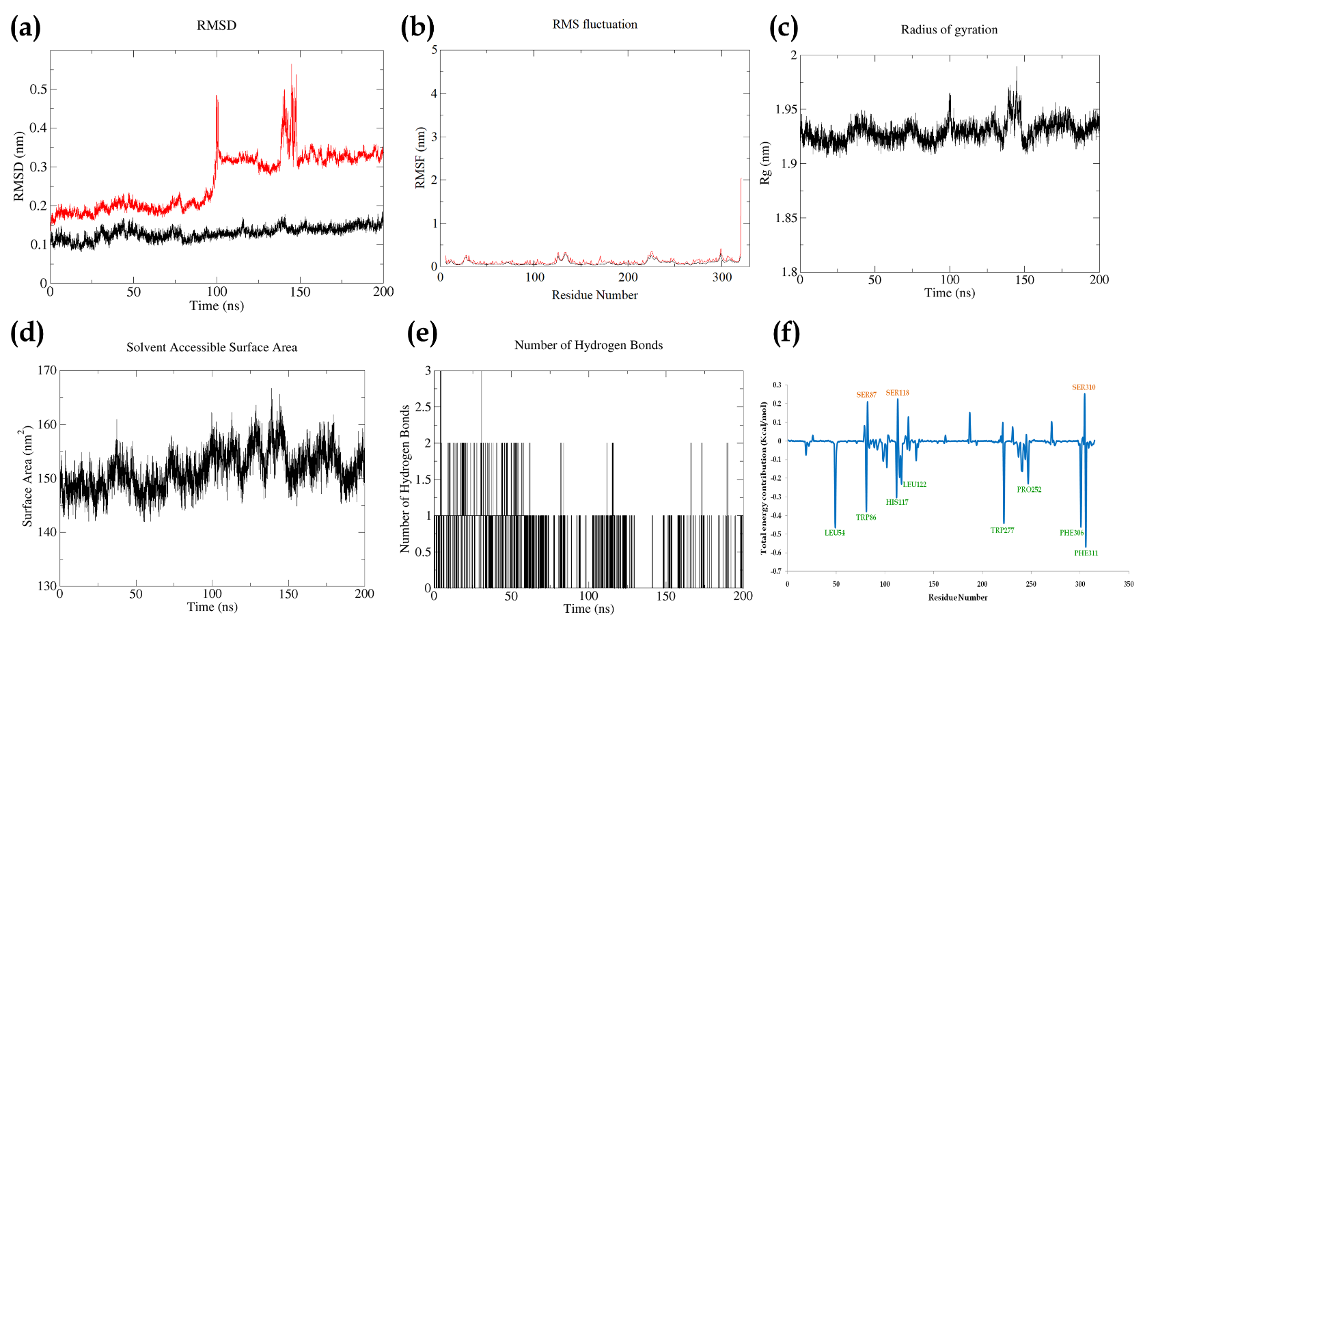

**Figure S4:** Parameters describing the stability of karanjin-*AKR1C3* complex. Where, **(a)** RMSD of backbone (black) and complex (red); **(b)** RMSF of complex (black) and RMSF of c-alpha atoms (red); **(c)**; Radius of gyration; **(d)** Solvent Assessable Surface Area (SASA); **(e)** Number of hydrogen bonds between protein and ligand; **(f)** Total energy contribution per residue.

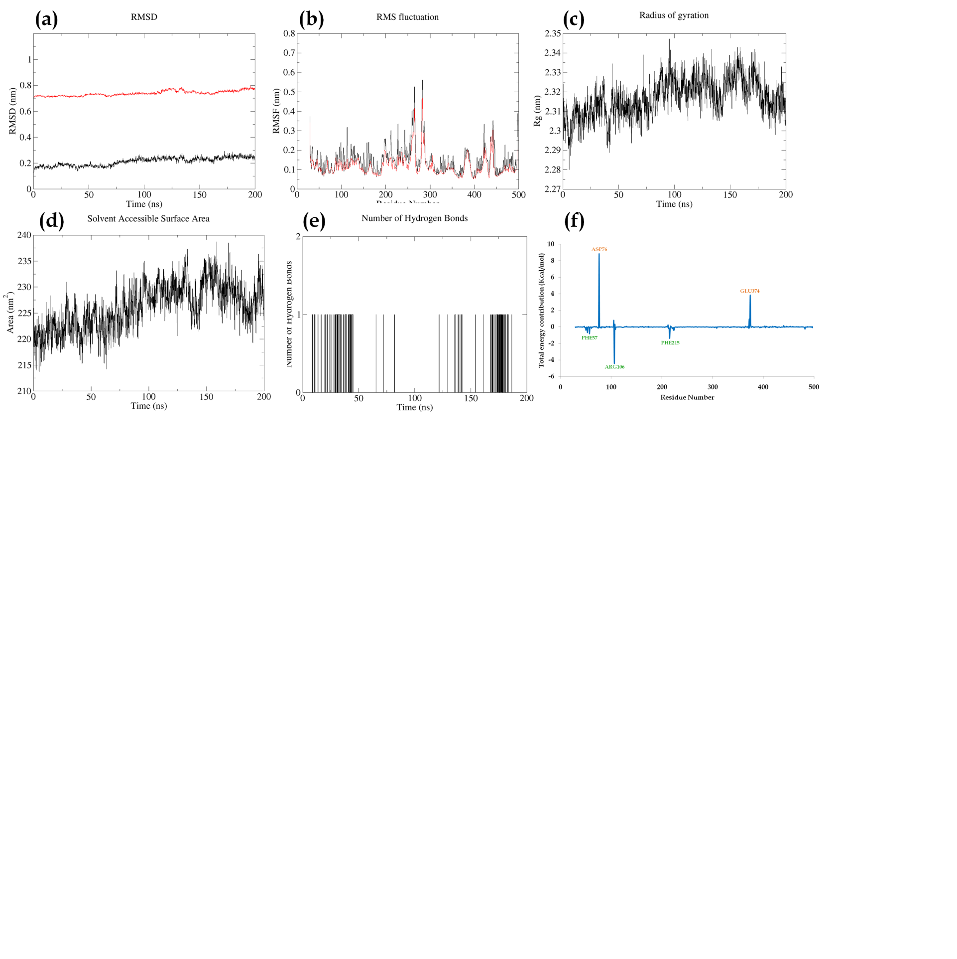

**Figure S5:** Parameters describing stability of karanjin-*CYP3A4* complex. Where, **(a)** RMSD of backbone (black) and complex (red); **(b)** RMSF of complex (black) and RMSF of c-alpha atoms (red); **(c)**; Radius of gyration; **(d)** Solvent Assessable Surface Area (SASA); **(e)** Number of hydrogen bonds between protein and ligand; **(f)** Total energy contribution per residue.

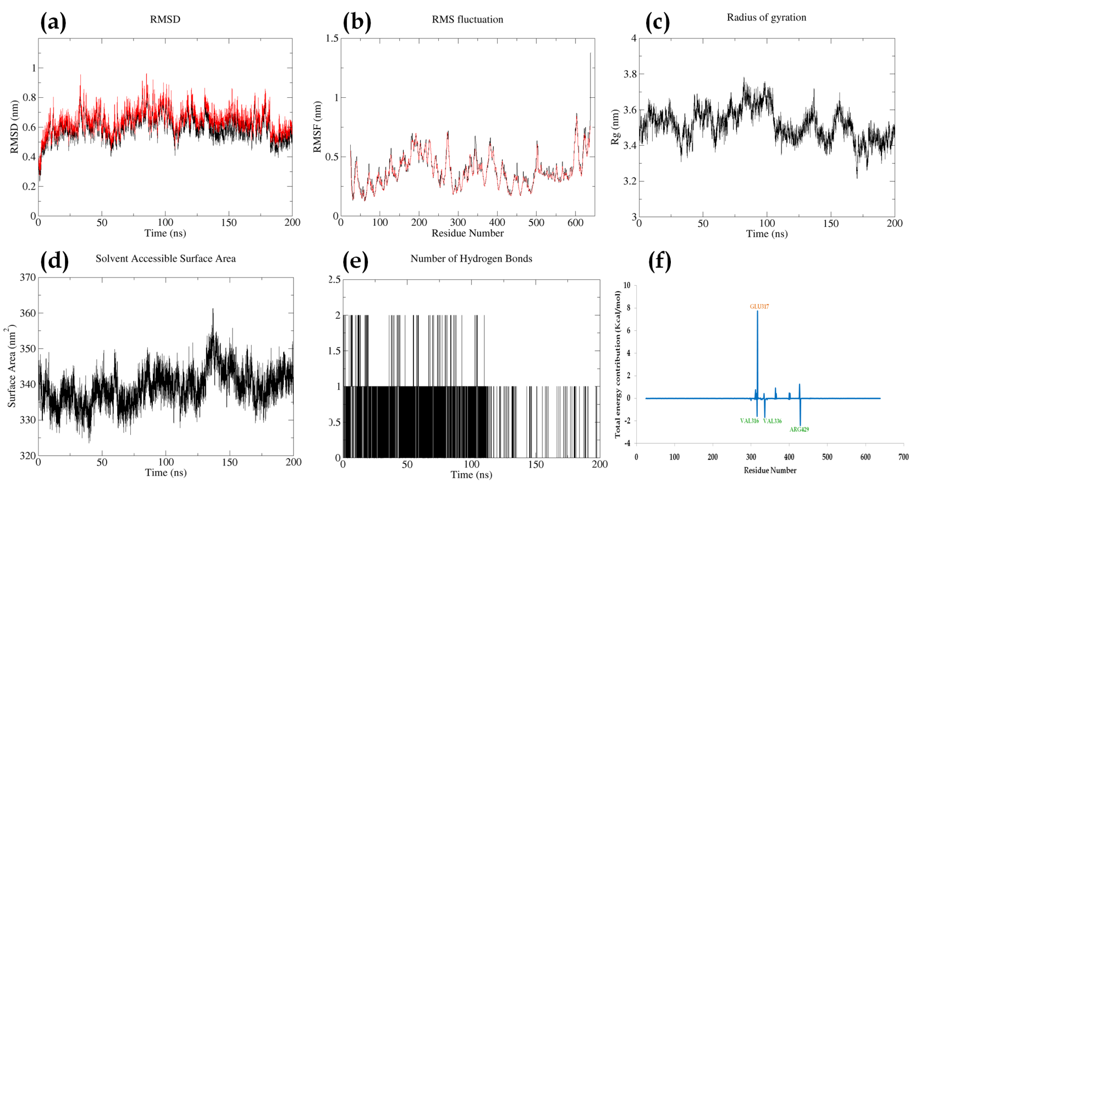

**Figure S6:** Parameters describing the stability of karanjin-*EGFR* complex. Where, **(a)** RMSD of backbone (black) and complex (red); **(b)** RMSF of complex (black) and RMSF of c-alpha atoms (red); **(c)**; Radius of gyration; **(d)** Solvent Assessable Surface Area (SASA); **(e)** Number of hydrogen bonds between protein and ligand; **(f)** Total energy contribution per residue.

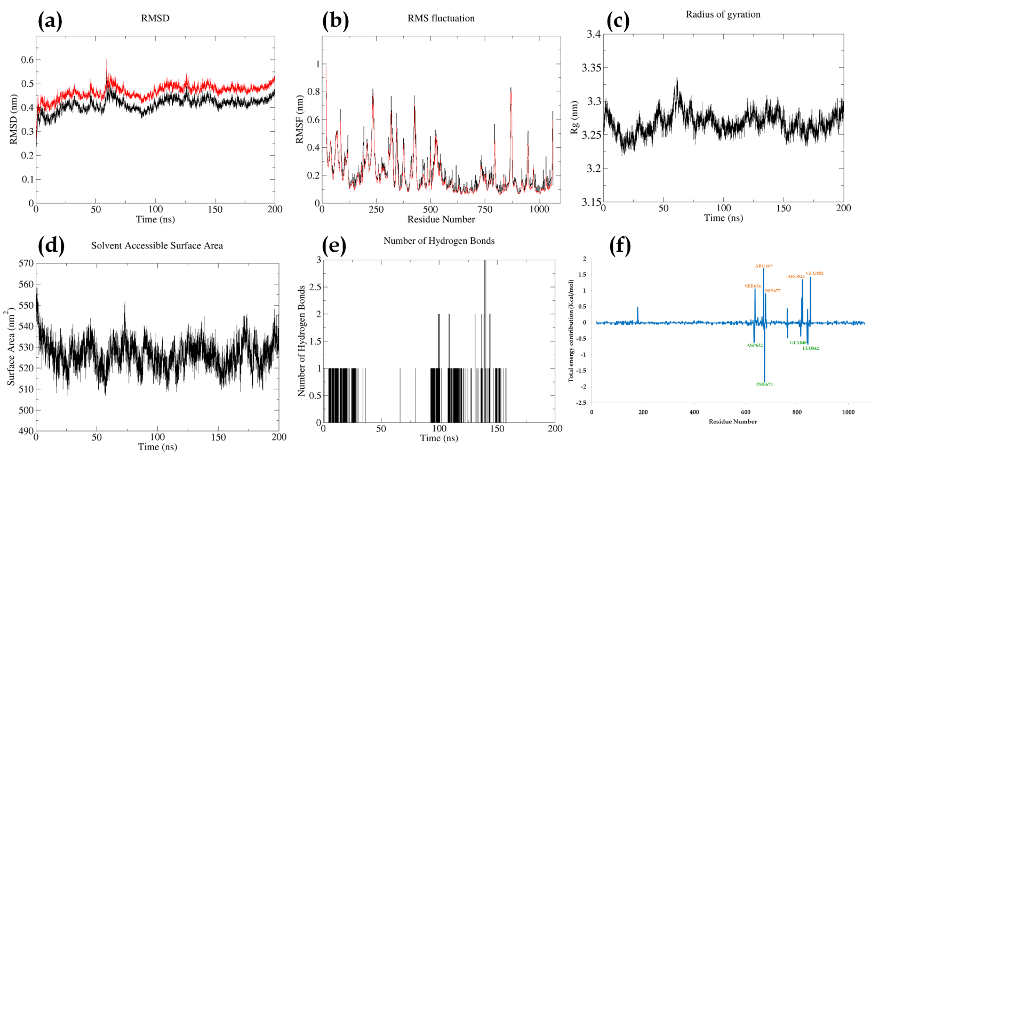

**Figure S7:** Parameters describing the stability of karanjin-*PI3KCB* complex. Where, **(a)** RMSD of backbone (black) and complex (red); **(b)** RMSF of complex (black) and RMSF of c-alpha atoms (red); **(c)**; Radius of gyration; **(d)** Solvent Assessable Surface Area (SASA); **(e)** Number of hydrogen bonds between protein and ligand; **(f)** Total energy contribution per residue.

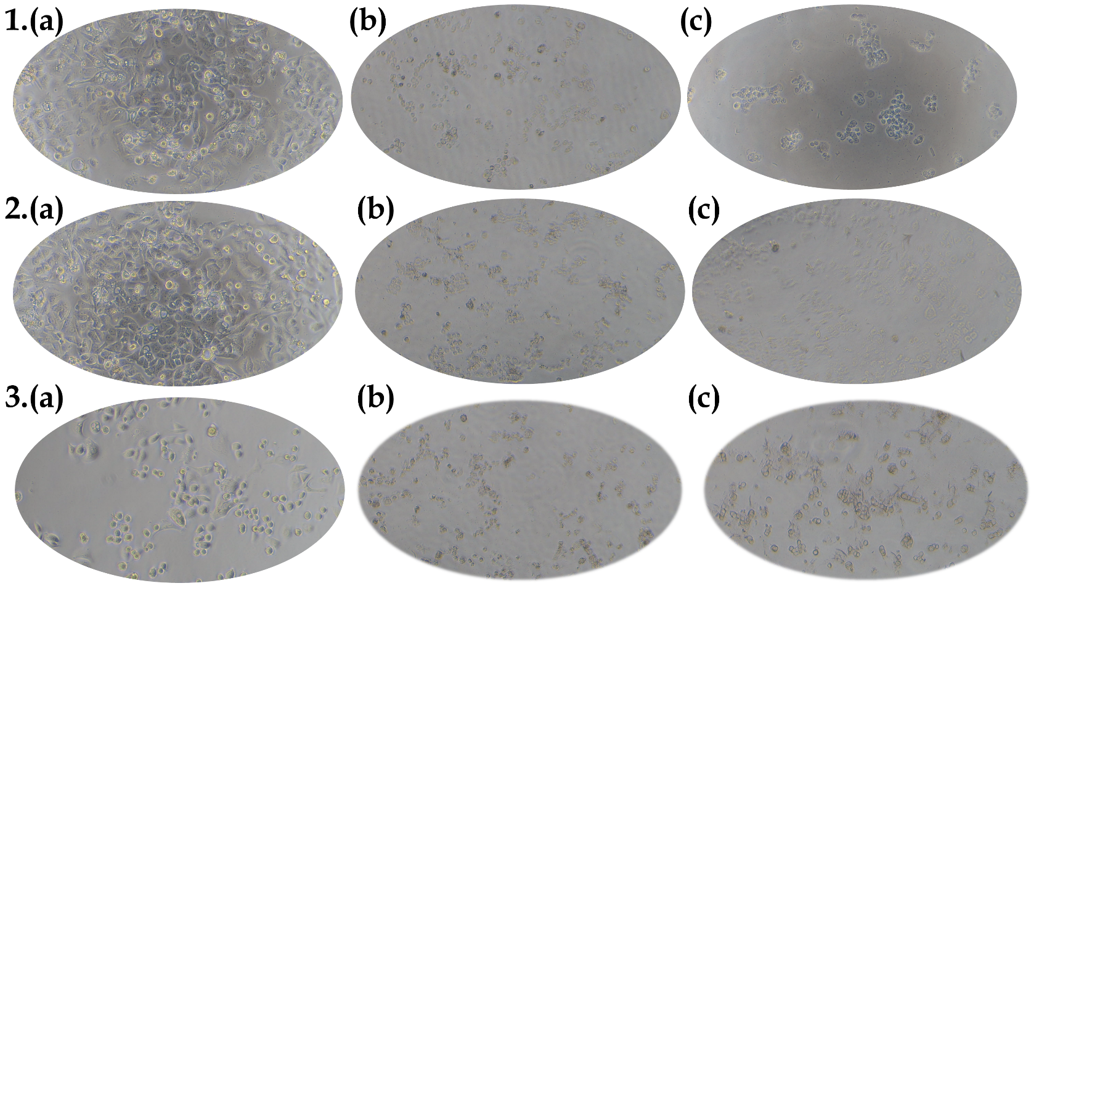

**Figure S8:** The cell line images of **1.** T47D**; 2.** MDA-MB-468; **3.** SKBR3on **(a)** normal**; (b)** Karanjin**; (c)** Karanjin + Standardtreated cells.

Where, Standard for **T47D:** Tamoxifen; **MDA-MB-468:** Tamoxifen; **SKBR3:** Gefitinib.

*The Images were taken after the completion of the treatment, before adding MTT reagent.