CO_{x} -free H₂ Production via Catalytic Decomposition of CH₄ over Fe Supported on Tungsten oxide-activated Carbon Catalyst: Effect of Tungsten Loading

Hossein Bayahia¹, Anis H. Fakeeha^{2,3}, Salma A. Al-Zahrani⁴, Salwa B. Alreshaidan⁵, Abdulrhman S. Al-Awadi^{2,3}, Mohammed F. Alotibi⁶, Rawesh Kumar⁷*, Ahmed S. Al-Fatesh²*

¹ Chemistry Department, Faculty of Science, Albaha University, Albaha, Saudi Arabia.
²Chemical Engineering Department, College of Engineering, King Saud University, P.O. Box 800, Riyadh 11421, Saudi Arabia.
³King Abdullah City for Atomic & Renewable Energy, Energy Research & Innovation Center (ERIC) in Riyadh, Riyadh 11451, Saudi Arabia.
⁴Department of Chemistry, College of Sciences, University of Hail, Hail, 2440, Saudi Arabia.
⁵Department of Chemistry, Faculty of Science, King Saud University, P.O. Box 800, Riyadh 11451, Saudi Arabia.
⁶Institute of Refining and Petrochemicals Technologies, King Abdulaziz City for Science and Technology (KACST), P.O. Box 6086, Riyadh 11442, Kingdom of Saudi Arabia
⁷Department of Chemistry, Indus University, Ahmedabad, Gujarat-382115 India.
*Correspondence: aalfatesh@ksu.edu.sa (A.S.A.-F.), kr.rawesh@gmail.com (R.K); mfalotaibi@ksacst.edu.sa

Table S1. A comparative table of literature report over supported catalyst system towards CH₄ decomposition reaction.
Catalysts | Method | Activity |  |  | Temp  (ºC) | TOS (minute) | Ref.
Catalysts | Method |  | % |  | Temp  (ºC) | TOS (minute) | Ref.
Ni/Activated carbon | Activated carbon is obtained from coconut shell and then Ni is impregnated over it. | - | 75 | - | 850 | 4h | Sarada Prasad et al., 2011
Ni/Activated carbon | Activated carbon is obtained from coal liquefaction residue then Ni is impregnated over it | - | 60 | - | 850 | 9h | hang et al., 2013
10Ni/SiO₂ | Impregnation | 10 | - | - | 500-800 | 300 | Dong et al., 2015
10Ni/SiO₂ | Impregnation | 35 | - | - | 650 | 60 | Dong et al., 2015
30Ni/SiO₂ | Impregnation | 10 | - | - | 600 | 500 | Venugopal et al., 2007
Ni/SiO₂ | Impregnation | 30 |  |  | 548 | 130 | Bonura et al., 2006
Ni/MgO | Impregnation | 30 |  |  | 548 | 210 | Bonura et al., 2006
Ni/ZSM-5 Si/Al = 300 | Nano nickel is prepared by sol-gel and then it is impregnated over ZSM-5 | 45 | - | - | 700 | 14 | Michalkiewicz and Majewska, 2014
Ni/LiAlO₂ | Impregnation | 27 | - | - | 548 | 60 | Bonura et al., 2006
Ni-MgO solid solution | Hydrothermal | - | - | 45% |  | 3h | Bonura et al., 2006
Ni/SiO₂.MgO | Co-precipitation | >50 | - | - | 575 | 600 min | Karimi et al., 2021
Ni/Hydrotalcite  Ni:Al:La: 2:0.7:0.3 | Co-precipitation | 30 | - | - | 550 | 24h | Anjaneyulu et al., 2015
65Ni-10Fe-25SiO₂ | Heterophase  sol-gel method | 20 | - | - | 550 | 440 | Wang et al., 2012
Co-Al | Co-precipitation | 75 |  |  | 750 | - | Zardin and Perez-Lopez, 2017
Co/Al₂O₃ coated silica | Silica fabric is wash-coated with dispersed alumina and then Co is impregnated over it. | 90 | - | - | 700 | 11.6 h | Italiano et al., 2010
70Ni-10Cu-10Fe/Al₂O₃ | Mechanochemical activation of metal oxide mixture |  | 77 hydrogens |  | 700 | 14 | Chesnokov and Chichkan, 2009
60Fe/Al₂O₃ | Co-precipitation |  |  | 77 | 700 | 4h | Ibrahim et al., 2015
Fe-Al/Activated carbon  Fe/Al = 24/16 | Impregnation | 35 | - | - | 850 | 100h | Jin et al., 2013
= Conversion of CH₄, = Mol % of CH₄, = Yield of H₂, TOS = Time on Stream, Temp.= Temperature, Ref. = Reference

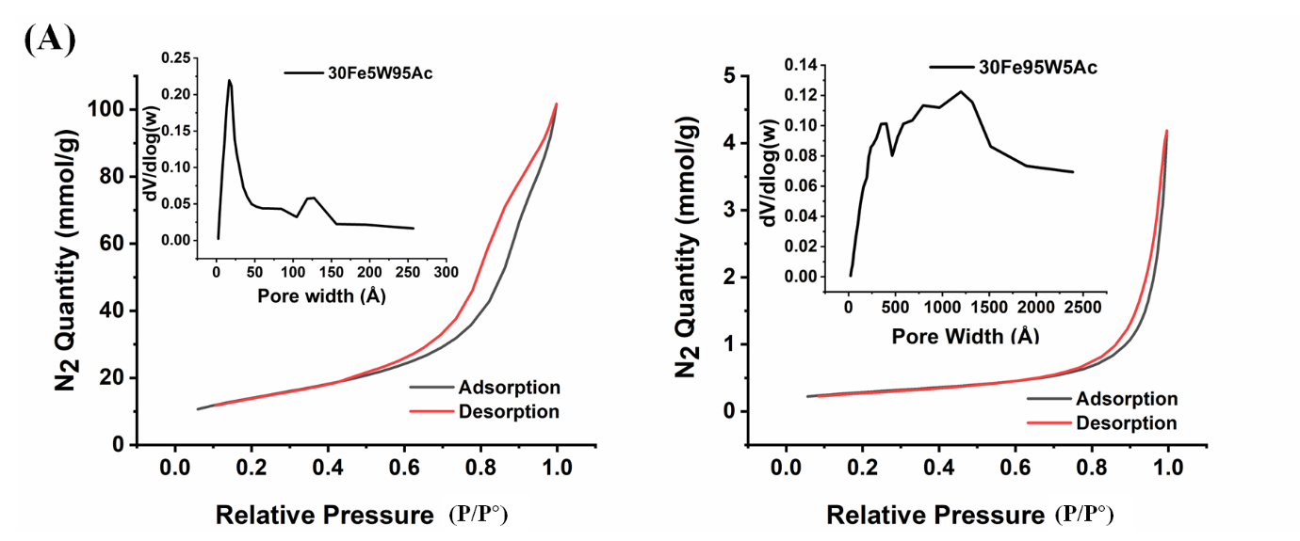
Fig. S2. N₂-adsorption isotherm and porosity distribution profile of (A) 30Fe5W95Ac catalyst (B) 30Fe95W5Ac catalyst

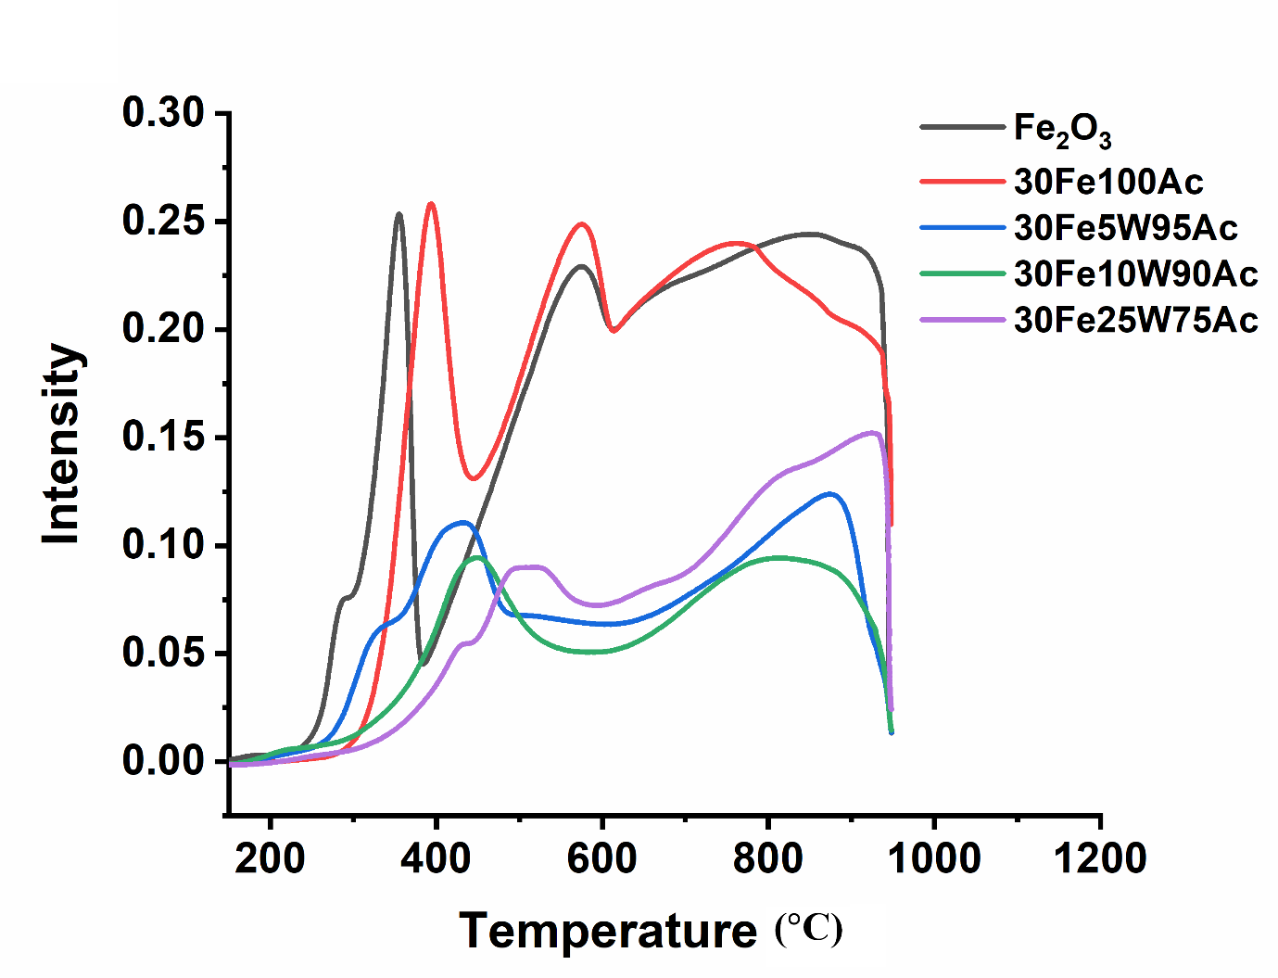
Fig. S3. H₂-TPR profile of Fe₂O₃, 30Fe100Ac, 30Fe5W95Ac, 30Fe10W90Ac and 30Fe25W75Ac
Table S4. H₂-consumption per gram catalyst form H₂-TPR profile
Catalyst | Total H₂- consumption  (cm³/g)
Fe₂O₃ | 417.24
30Fe100Ac | 240
30Fe5W95Ac | 169.24
30Fe10W90Ac | 137.44
30Fe25W75Ac | 183
30Fe50W50Ac | 174.2
30Fe90W10Ac | 72.28
30Fe95W5Ac | 68.24
30Fe100W | 46.32
Table S5. Carbon yield (%) of 30FexW100-xAc (x = 5, 25, 50, 90, 95) catalyst
Catalyst | W_{p} (g) | W_{cat} (g) | *Carbon yield (%)
30Fe5W95Ac | 0.17 | 0.15 | 13.3
30Fe25W75Ac | 0.36 | 0.15 | 140
30Fe50W50Ac | 0.31 | 0.15 | 107
30Fe75W25Ac | 0.16 | 0.15 | 6.7
30Fe90W10Ac | 0.25 | 0.15 | 66.6
30Fe95W5Ac | 0.29 | 0.15 | 93.3
*Carbon yield (%)= 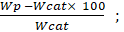𝑊_{𝑝} is the weight of the product after reaction and 𝑊_{𝑐𝑎𝑡} is the weight of the fresh catalyst.
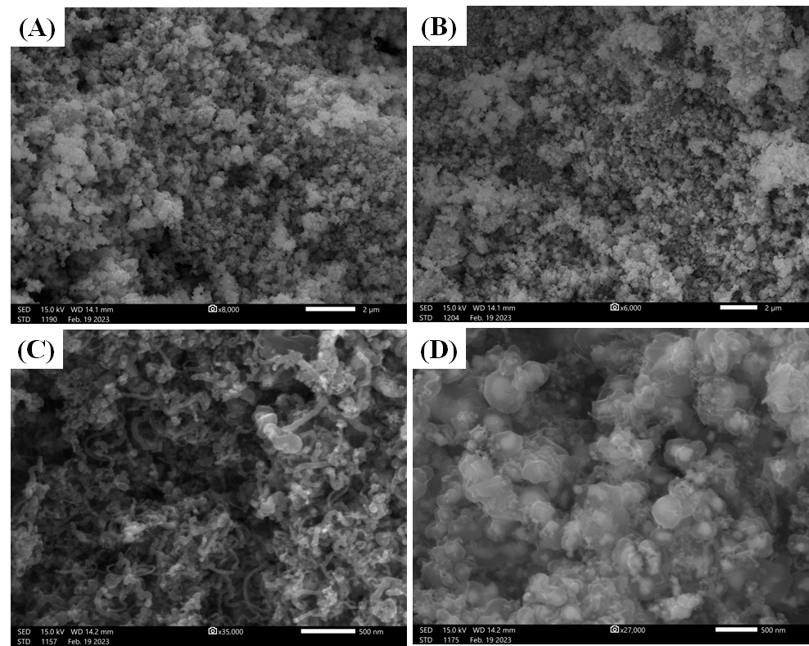
Fig S6. SEM image of (A) Fresh 30Fe10W90Ac (B) Fresh 30Fe90W10Ac (C) Spent 30Fe10W90Ac (D) Spent 30Fe90W10Ac

