**Supplementary data file**

**Antioxidant, Anti-inflammatory, Anti-nociceptive, Tyrosinase inhibitory potential and Toxicological evaluation of *Portulacaria afra* using in-vitro, In-*vivo* and *In-silico* studies**

**List of Figures**

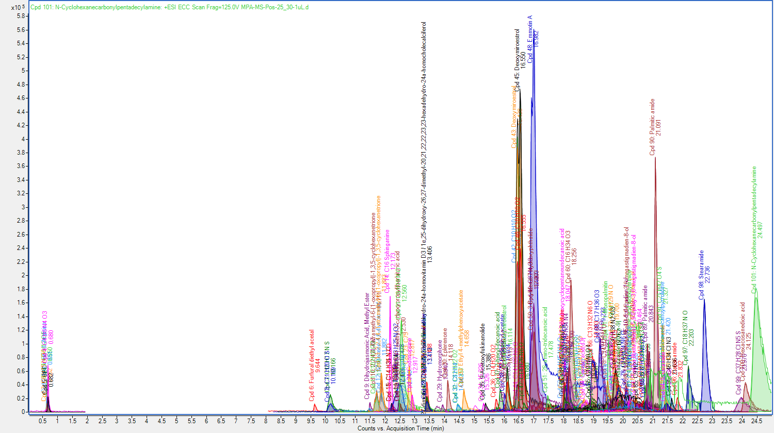

**Figure 1S:** RP-UHPLC-MS Chromatogram of RP-UHPLC-MS (Positive mode) analysis of PAME.

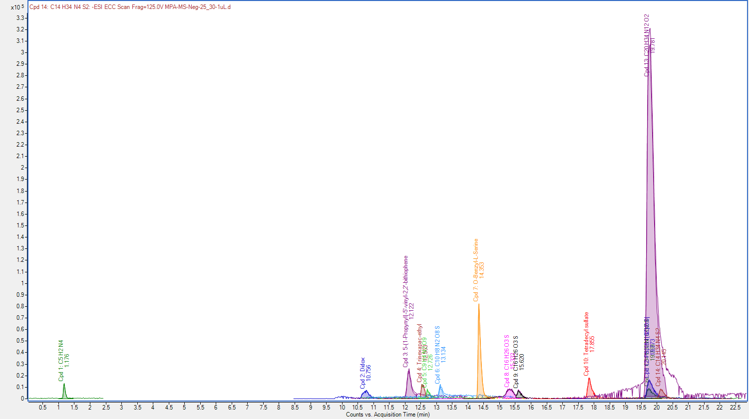**Figure 2S:** RP-UHPLC-MS Chromatogram of RP-UHPLC-MS (negative mode) analysis of PAME.

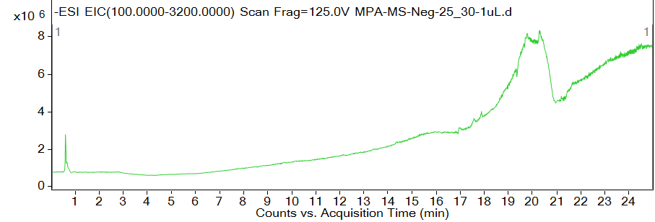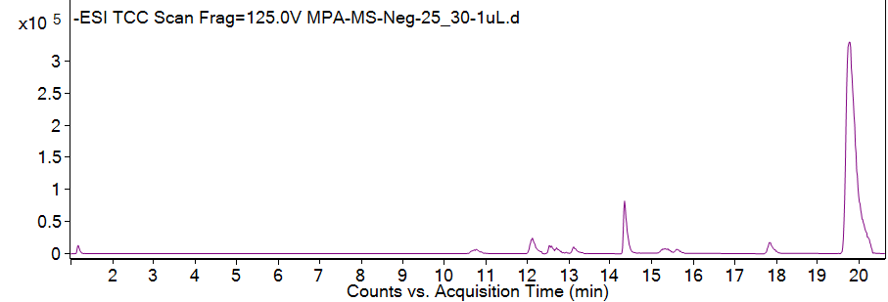

**Figure 3S:** RP-UHPLC-MS scan of PAME in negative mode of ionization

**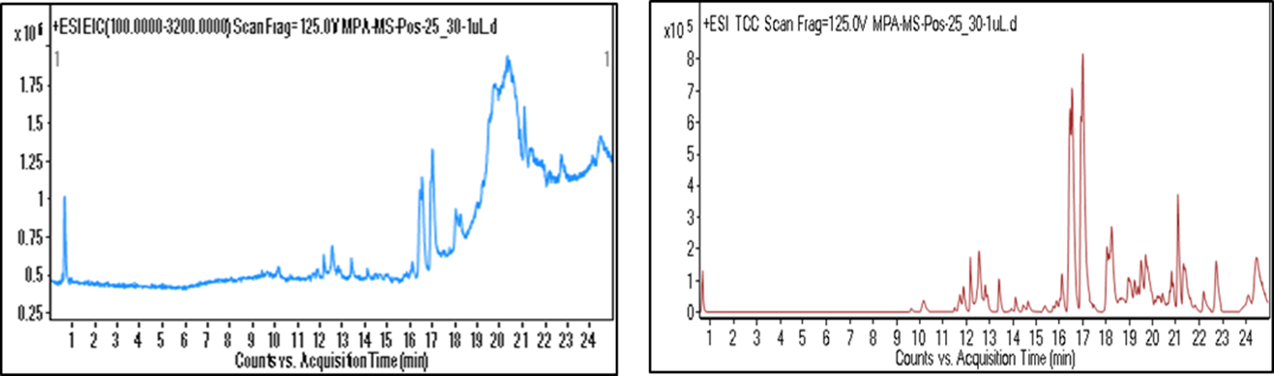****Figure 4S:** RP-UHPLC-MS scan of PAME in positive mode of ionization.