**An efficient two-step approach for the preparative separation and purification of eight polyphenols from *Hibiscus manihot* L. flower with** **high-speed countercurrent chromatography**

Ju-Zhao Liua,1, Le-Le Wena,1, Xiao-Li Tiana,1, Yu-Jie Fub, Qi Cuia,*

a College of Pharmaceutical Science, Zhejiang Chinese Medical University, Hangzhou 311402, PR China

b College of Biological Sciences and Technology, Beijing Forestry University, No. 35, Tsinghua East Road, Haidian District, Beijing 100083, PR China

* Corresponding author: E-mail address: [zcmucq@163.com](mailto:zcmucq@163.com)

1 These authors contributed equally to this work.

**Abbreviations:**

AChE: acetylcholinesterase; CAA: caffeic acid; CHA: chlorogenic acid; BuChE: butyrylcholinesterase; HI: hibifolin; HY: hyperin; ISQ: isoquercetin; QOG: quercetin-3'-O-glucoside; QOR: quercetin-3-O-robibioside; RU: rutin; TFC: total flavonoid content, UAE, ultrasonic-assisted extraction.

The detailed data of these eight compounds were as follows:

**Chlorogenic acid** (CHA, peak 1 in Fig. 6B, 3.2 mg): white needle crystal (Water), ESI-MS *m/z* 353.0 [M-H]−, 191.1 [M-H-161.9]−. 1H NMR spectra (500 MHz, MeOD): 7.50 (1H, d, *J* = 16.0 Hz, H-7′), 7.01 (1H, d, *J* = 2.0 Hz, H-2′), 6.92 (1H, dd, *J* = 8.4 Hz, *J* = 2.0 Hz, H-6′), 6.75 (1H, d, *J* = 8.4 Hz, H-5′), 6.23 (1H, d, *J* = 16.0 Hz, H-8′), 5.09 (1H, m, H-3), 4.81 (1H, m, H-5), 3.66 (1H, dd, *J* = 8.4 Hz, *J* = 5.0 Hz), 2.11~1.97 (4H, m, H-2, H-6); 13C NMR spectra (125 MHz, MeOD): 175.5 (C-7), 167.4 (C-9), 148.9 (C-4′), 145.6 (C-3′), 145.3 (C-7′), 126.3 (C-1′), 121.6 (C-6′), 115.1 (C-5′), 113.9 (C-8′), 113.6 (C-2′), 74.4 (C-1), 71.1 (C-4), 70.3 (C-5), 69.7 (C-3), 37.5 (C-2), 36.7 (C-6).

**Caffeic acid** (CAA, peak 2 in Fig. 6B, 2.1 mg): white powder (Water), ESI-MS *m/z* 179.0 [M-H]−, 135.0 [M-H-44.0]−. 1H NMR spectra (500 MHz, DMSO-d6): 7.47 (1H, d, *J* = 16.0 Hz, H-7), 7.11 (1H, d, *J* = 2.0 Hz, H-2), 6.97 (1H, d, *J* = 8.4 Hz, H-6), 6.80 (1H, d, *J* = 8.4 Hz, H-5), 6.23 (1H, d, *J* = 16.0 Hz, H-8); 13C NMR spectra (125 MHz, DMSO-d6): 167.8 (C-9), 148.0 (C-4), 145.4 (C-3), 144.5 (C-7), 125.6 (C-1), 121.1 (C-6), 115.6 (C-5), 115.0 (C-2), 114.4 (C-8).

**Quercetin-3-O-robibioside** (QOR, peak 3 in Fig. 6B, 1.7 mg): yellow powder (MeOH), ESI-MS *m/z* 609.1 [M-H]−, 300.0 [M-H-309.0]−. 1H NMR spectra (500 MHz, DMSO-d6): 7.64 (1H, d, *J* = 2.0 Hz, H-2′), 7.60 (1H, dd, *J* = 2.0 Hz, *J* = 9.0 Hz, H-6′), 6.84 (1H, d, *J* = 8.5 Hz, H-5′), 6.40 (1H, d, *J* = 2.0 Hz, H-8), 6.13 (1H, d, *J* = 2.0 Hz, H-6), 5.13 (1H, d, *J* = 8.0 Hz, H-1′′), 4.47 (1H, d, *J* = 1.5 Hz, H-1′′′), 1.25 (1H, d, *J* = 8.0 Hz, 5′′′-CH3); 13C NMR spectra (125 MHz, DMSO-d6): 178.1 (C-4), 166.4 (C-7), 162.5 (C-5), 157.7 (C-2), 156.9 (C-9), 148.2 (C-4′), 145.1 (C-3′), 134.6 (C-3), 123.4 (C-6′), 122.3 (C-1′), 115.9 (C-5′), 114.4 (C-2′), 104.2 (C-10), 104.0 (C-1′′), 102.0 (C-1′′′), 99.2 (C-6), 94.1 (C-8), 77.3 (C-3′′), 77.1 (C-2′′), 75.9 (C-5′′), 73.7 (C-4′′), 72.6 (C-6′′), 71.9 (C-4′′′), 71.5 (C-2′′′), 70.0 (C-3′′′), 68.8 (C-5′′′), 18.1 (C-6′′′).

**Rutin** (RU, peak 4 in Fig. 6B, 0.6 mg): yellow powder (MeOH), ESI-MS *m/z* 609.1 [M-H]−, 299.8 [M-H-309.3]−. 1H NMR spectra (500 MHz, MeOD): 7.67 (1H, d, *J* = 2.0 Hz, H-2′), 7.62 (1H, dd, *J* = 2.0 Hz, J = 9.0 Hz, H-6′), 6.87 (1H, d, *J* = 8.5 Hz, H-5′), 6.40 (1H, d, *J* = 2.0 Hz, H-8), 6.14 (1H, d, *J* = 2.0 Hz, H-6), 5.27 (1H, d, *J* = 8.0 Hz, H-1′′), 4.40 (1H, d, *J* = 1.5 Hz, H-1′′′), 1.05 (3H, d, *J* = 8.0 Hz, 5′′′-CH3); 13C NMR spectra (125 MHz, MeOD): 178.1 (C-4), 166.6 (C-7), 162.8 (C-5), 157.6 (C-2), 157.1 (C-9), 148.5 (C-4′), 145.3 (C-3′), 135.2 (C-3), 123.6 (C-6′), 122.6 (C-1′), 116.2 (C-5′), 114.7 (C-2′), 104.4 (C-10), 103.6 (C-1′′), 101.9~~4~~ (C-1′′′), 99.5 (C-6), 94.3 (C-8), 77.0 (C-3′′), 76.1 (C-2′′), 75.5 (C-5′′), 73.3 (C-4′′), 72.3 (C-6′′), 71.8 (C-4′′′), 71.4 (C-2′′′), 69.8 (C-3′′′), 68.7 (C-5′′′), 18.0 (C-6′′′).

**Hibifolin** (HI, peak 5 in Fig. 6B and peak 3 in Fig. 7B, 11.3 mg and 12.1 mg): yellow powder (MeOH), ESI-MS *m/z* 493.0 [M-H]−. 1H NMR spectra (500 MHz, MeOD): 6.25 (1H, s, H-6), 6.93 (1H, d, *J* = 8.5 Hz, H-5′), 7.87 (1H, dd, *J* = 8.0 Hz, H-6′), 7.98 (1H, d, *J* = 2.0 Hz, H-2′); 13C NMR spectra (125 MHz, MeOD): 175.9 (C-4), 157.2 (C-5), 156.6 (C-9), 147.5 (C-2), 147.2 (C-4′), 144.4 (C-3′), 125.2 (C-8), 122.7 (C-6′), 121.1 (C-1′), 115.3 (C-2′), 115.2 (C-5′), 106.7 (C-1′′), 103.1 (C-10), 98.0 (C-6), 76.0 (C-5′′), 75.9 (C-3′′), 73.8 (C-2′′), 71.7 (C-4′′).

**Hyperin** (HY, peak 1 in Fig. 7B, 10.4 mg): yellow needle crystal (MeOH), ESI-MS *m/z* 463.0 [M-H]−, 299.9 [M-H-163.1]−, 179.1 [M-H-283.9]−, 150.8 [M-H-312.2]−. 1H NMR spectra (500 MHz, MeOD): 6.20 (1H, d, *J* = 2.0 Hz, H-8), 6.39 (1H, d, *J* = 2.0 Hz, H-6), 6.87 (1H, d, *J* = 8.5 Hz, H-5′), 7.59 (1H, dd, *J* = 8.5 Hz, *J* = 2.0 Hz, H-6′), 7.71 (1H, d, *J* = 2.0 Hz, H-2′), 12.38 (1H, s, 5-OH); 13C NMR spectra (125 MHz, MeOD): 178.1 (C-4), 164.6 (C-7), 161.7 (C-5), 157.6 (C-9), 157.1 (C-2), 148.4 (C-4′), 144.5 (C-3′), 134.2 (C-3), 121.8 (C-6′), 121.7 (C-1′), 116.2 (C-2′), 114.6 (C-5′), 104.3 (C-10), 102.9 (C-1′′), 98.5 (C-6), 93.3 (C-8), 77.0 (C-5′′), 76.7 (C-3′′), 74.3 (C-2′′), 69.8 (C-4′′), 61.2 (C-6′′).

**Isoquercetin** (ISQ, peak 2 in Fig. 7B, 7.9 mg): yellow needle crystal (MeOH), ESI-MS *m/z* 463.0 [M-H]−, 300.0 [M-H-163.0]−, 178.8 [M-H-284.2]−, 150.8 [M-H-312.2]−. 1H NMR spectra (500 MHz, CD3OD): 7.59 (1H, d, *J* = 2.0 Hz, H-2′), 7.58 (1H, dd, *J* = 2.0 Hz, J = 8.4 Hz, H-6′), 6.88 (1H, d, *J* = 8.5 Hz, H-5′), 6.39 (1H, d, *J* = 2.0 Hz, H-8), 6.20 (1H, d, *J* = 2.0 Hz, H-6), 5.27 (1H, d, *J* = 7.7 Hz, H-1′′), 3.22~3.73 (6H, m, H-2′′-6′′); 13C NMR spectra (125 MHz, CD3OD): 178.3 (C-4), 164.6 (C-7), 161.7 (C-5), 156.5 (C-9), 156.4 (C-2), 148.5 (C-4′), 144.9 (C-3′), 134.3 (C-3), 122.1 (C-6′), 121.7 (C-1′), 116.2 (C-2′), 115.6 (C-5′), 105.1 (C-10), 102.9 (C-1′′), 99.2 (C-6), 93.3 (C-8), 78.3 (C-5′′), 76.8 (C-3′′), 74.5 (C-2′′), 70.4 (C-4′′), 61.2 (C-6′′).

**Quercetin-3'-O-glucoside** (QOG, peak 4 in Fig. 7B, 1.1 mg): yellow needle crystal (MeOH), ESI-MS *m/z* 463.0 [M-H]−, 300.8 [M-H-162.2]−, 178.7 [M-H-284.3]−, 150.8 [M-H-312.2]−. 1H NMR spectra (500 MHz, MeOD): 6.08 (1H, d, *J* = 2.0 Hz, H-8), 6.35 (1H, d, *J* = 2.0 Hz, H-6), 6.88 (1H, d, *J* = 8.5 Hz, H-5′), 7.79 (1H, dd, *J* = 8.5 Hz, *J* = 2.0 Hz, H-6′), 8.05 (1H, d, *J* = 2.0 Hz, H-2′); 13C NMR spectra (125 MHz, MeOD): 97.9 (C-6), 93.2 (C-8), 164.3 (C-7), 161.1 (C-5), 156.9 (C-9), 149.0 (C-2), 145.9 (C-4′), 145.3 (C-3′), 123.7 (C-6′), 123.0 (C-1′), 116.8 (C-2′), 115.7 (C-5′), 103.0 (C-1′′), 77.0 (C-5′′), 76.3 (C-3′′), 73.5 (C-2′′), 69.8 (C-4′′), 61.0 (C-6′′).

**Table S1** Physical properties of the macroporous resins used.

|  |  |  |  |  |
| --- | --- | --- | --- | --- |
| Trade name | Polarity | Surface area (m2/g) | Average pore diameter (mm) | Particle diameter (nm) |
| HPD-826 | Polar | 500-600 | 0.3-1.25 | 9.0-10.0 |
| AB-8 | Weak-polar | 480-520 | 0.3-1.25 | 13.0-14.0 |
| FL-2 | Polar | 300-350 | 0.3-1.25 | 12.0-16.0 |
| NKA-9 | Polar | 250-290 | 0.3-1.25 | 15.0-16.5 |
| SA-3 | Weak-polar | 500-600 | 0.3-1.20 | 15.0-25.0 |
| ME-2 | Weak-polar | 650-750 | 0.3-1.25 | 9.0-11.0 |
| D101 | Non-polar | 500-550 | 0.25-0.84 | 10.0-11.0 |
| FL-3 | Non-polar | 80-120 | 0.3-1.25 | 15.0-20.0 |
| HPD-100 | Non-polar | 450-550 | 0.3-1.25 | 8.5-9.0 |

**Table S2** Results of the docking experiments against AChE.

|  |  |  |  |  |  |
| --- | --- | --- | --- | --- | --- |
| Compound | AChE | | Compound | AChE | |
| Amino acid residue | Distance(Å) | Amino acid residue | Distance(Å) |
| CHA | Thr238 | 2.757 | QOR | Gln201 | 3.665 |
| Thr238 | 3.007 | Asn233 | 2.282 |
| His405 | 2.130 | Trp236 | 3.207 |
| Gln413 | 3.539 | Arg247 | 3.407 |
| CAA | Tyr133 | 2.957 | Phe297 | 3.184 |
| Glu202 | 2.282 | Gln369 | 2.257 |
| Tyr337 | 3.028 | His405 | 2.572 |
| RU | Thr238 | 3.280 | ISQ | Tyr124 | 1.889 |
| Arg296 | 3.798 | Tyr124 | 2.715 |
| Gln369 | 2.279 | Ser293 | 1.960 |
| Asn533 | 2.543 | Ser293 | 3.869 |
| Ser541 | 3.886 | Ser293 | 3.883 |
| HY | Asn233 | 3.542 | Phe295 | 2.764 |
| His405 | 3.195 | Tyr124 | 1.889 |
| Asn533 | 2.188 | QOG | Tyr124 | 2.875 |
| HI | Gly234 | 3.242 | Ser293 | 2.737 |
| Pro235 | 3.288 | Ser293 | 2.829 |
| Thr238 | 3.171 | Ser293 | 3.316 |
| Thr238 | 2.955 | Phe295 | 2.883 |
| Gln369 | 2.482 | Phe295 | 3.314 |
| His405 | 3.619 | Tyr337 | 3.748 |

**Table S3** Results of the docking experiments against BuChE.

|  |  |  |  |  |  |
| --- | --- | --- | --- | --- | --- |
| Compound | BuChE | | Compound | BuChE | |
| Amino acid residue | Distance(Å) | Amino acid residue | Distance(Å) |
| CHA | Gly115 | 3.832 | RU | Asn68 | 3.701 |
| Gly116 | 2.420 | Asp70 | 2.455 |
| Pro285 | 3.931 | Gly78 | 3.187 |
| Ala328 | 3.825 | Trp82 | 3.620 |
| His438 | 3.696 | Thr120 | 2.564 |
| CAA | His372 | 2.794 | Tyr128 | 1.955 |
| QOR | Thr120 | 2.523 | Tyr128 | 1.975 |
| Ser198 | 2.514 | Ser198 | 2.433 |
| Ser198 | 3.639 | Tyr332 | 1.933 |
| Asn289 | 2.191 | ISQ | Gln67 | 2.437 |
| Asn289 | 2.231 | Asp70 | 3.738 |
| HY | Ser79 | 3.146 | Trp82 | 3.794 |
| Ser198 | 3.280 | Asn83 | 2.674 |
| Ser287 | 2.051 | Gly115 | 2.282 |
| HI | Gln67 | 3.624 | Tyr128 | 2.356 |
| Asn68 | 2.898 | Ser198 | 2.141 |
| Trp82 | 2.022 | QOG | Gly117 | 2.259 |
| Thr120 | 3.263 | Thr120 | 3.56 |
| Tryr128 | 1.751 | Ser287 | 2.000 |
| Ser198 | 3.236 |  |  |  |

**Table S4** Comparison of the binding energy of isolated compounds and commercially available inhibitors against AChE and BuChE.

|  |  |  |
| --- | --- | --- |
| AChE inhibitor | Therapeutic effect | Ref. |
| RU | -8.7 kcal/mol | This study |
| HI | -8.7 kcal/mol | This study |
| Tacrine | IC50 = 205 nM | Alhumaydhi et al., 2021 |
| -7.6 kcal/mol | Dilshad et al., 2022 |
| -8.6 kcal/mol | Islam et al., 2013 |
| Galantamine | IC50 = 410 nM | Milojevic & Melacini, 2011 |
| -8.2 kcal/mol | Ghalloo et al., 2022 |
| -8.0 kcal/mol | Islam et al., 2013 |
| Donepezil | IC50 = 11.6 nM | Truong, Quiroz & Priefer, 2020 |
| -7.9 kcal/mol | Islam et al., 2013 |
| Rivastigmine | IC50 = ~4.3 nM | Zhang et al., 2021 |
| -8.6 kcal/mol | Islam et al., 2013 |
| BuChE inhibitor | Therapeutic effect | Ref. |
| ISQ | -10.1 kcal/mol | This study |
| Tacrine | -6.44 kcal/mol | Serdaroğlu, Uludag & Üstün, 2023 |
| Galantamine | -8.4 kcal/mol | Dilshad et al., 2022 |
| -8.8 kcal/mol | Ghalloo et al., 2022 |
| -7.1 kcal/mol | Serdaroğlu, Uludag & Üstün, 2023 |

**Fig. S1** Pareto chart for the extraction of TFC by UAE.



**Fig. S2** Negative ESI--MS and ESI--MS/MS spectra, FT-IR spectra, 1H and 13C NMR spectra of purified CHA.

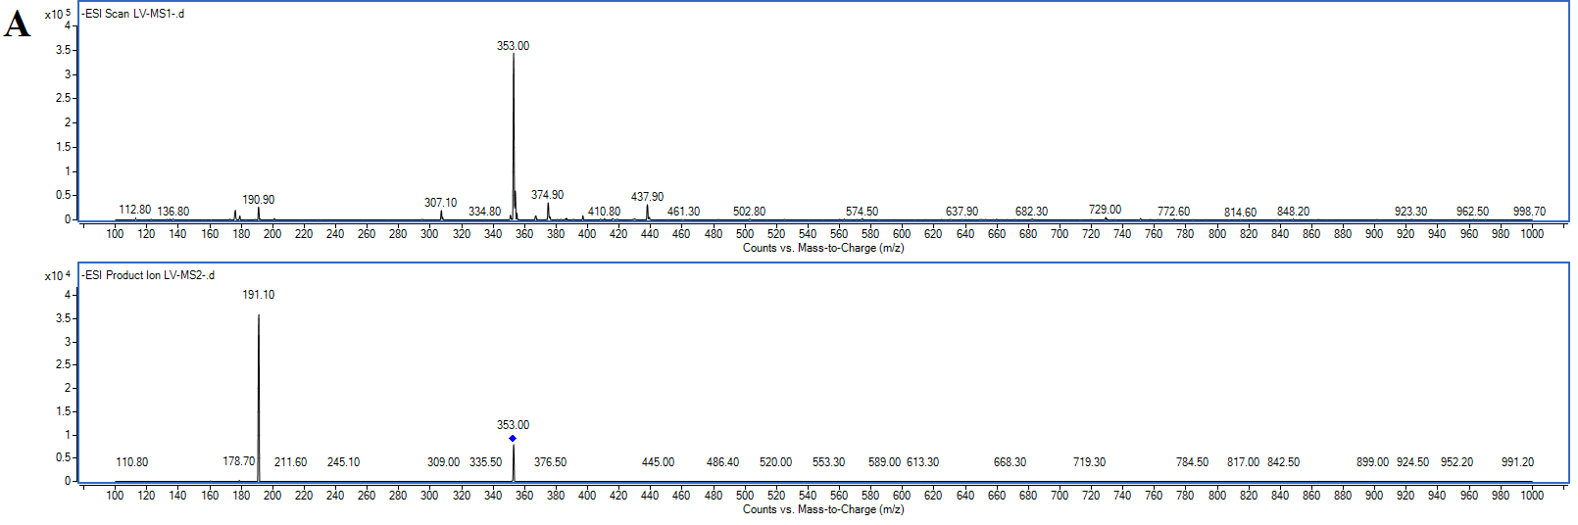



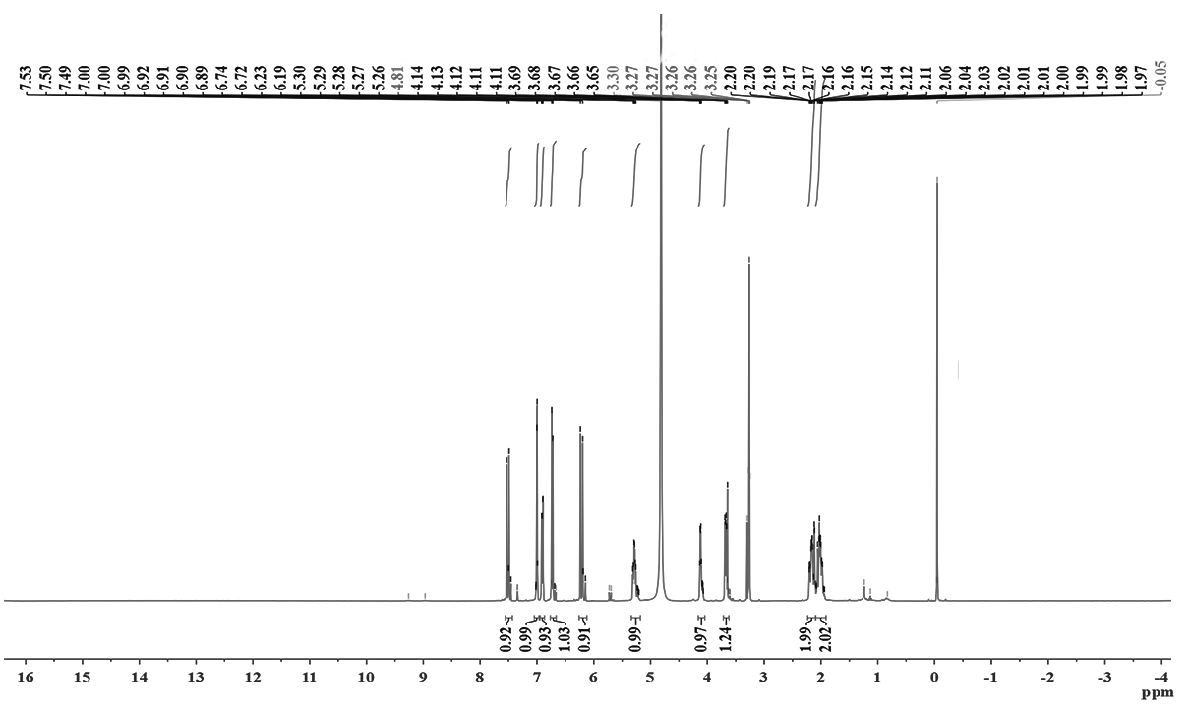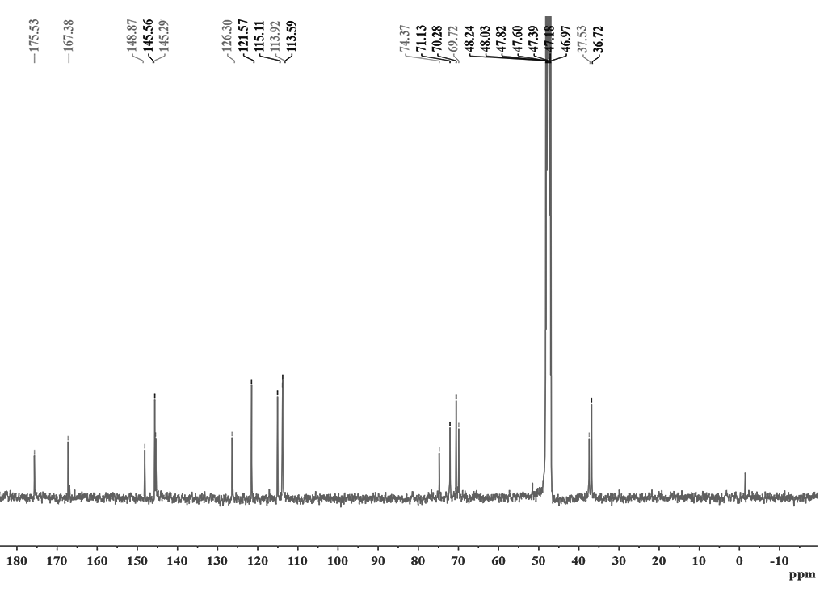



**Fig. S3** Negative ESI--MS and ESI--MS/MS spectra (A) and FT-IR spectra (B) of purified CAA.

**A**

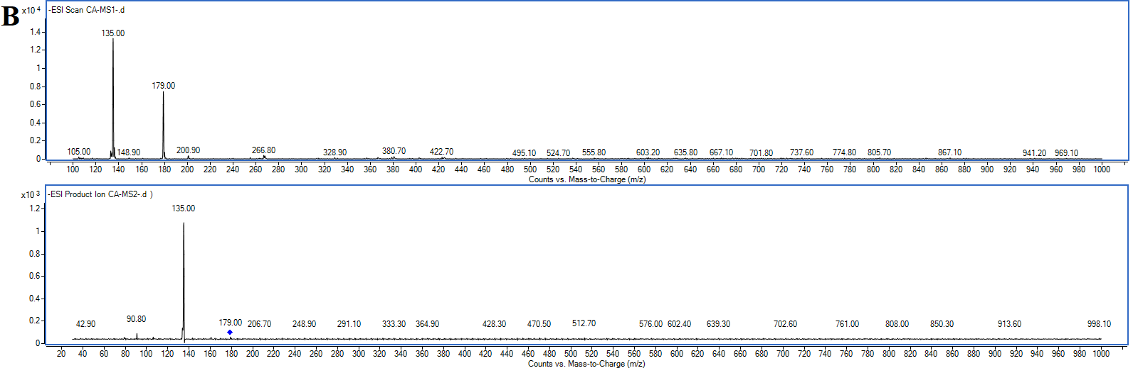

**B**



**Fig. S4** Negative ESI--MS and ESI--MS/MS spectra (A) and FT-IR spectra (B) of purified QOR.

**A**

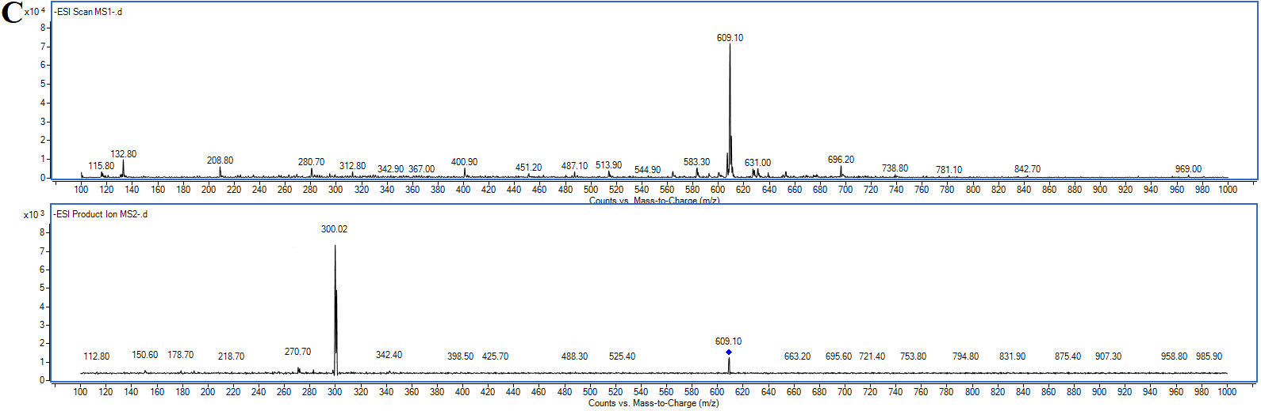

**B**



**Fig. S5** Negative ESI--MS and ESI--MS/MS spectra, FT-IR spectra, 1H and 13C NMR spectra of purified RU.

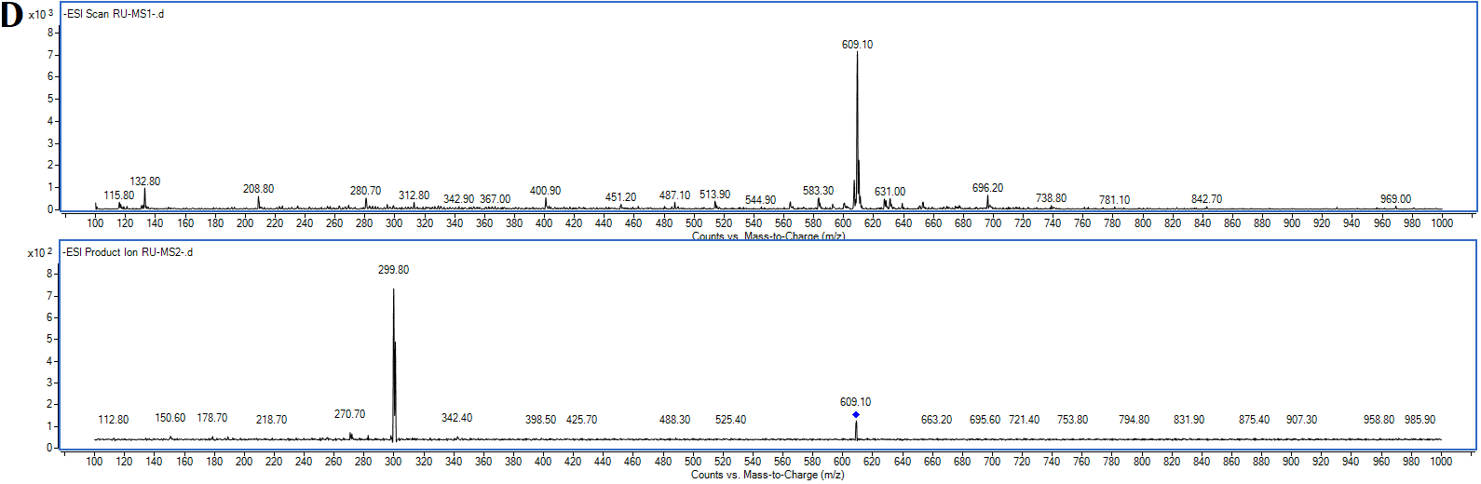



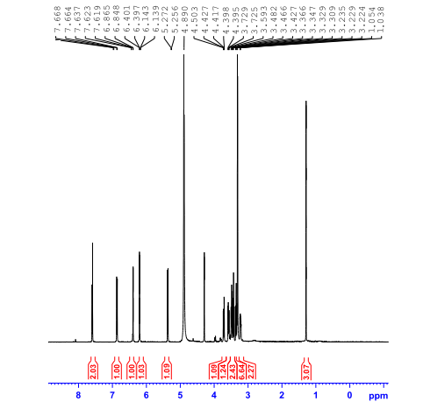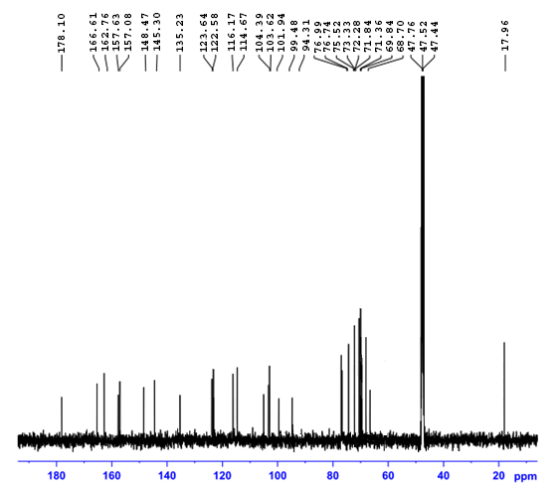



**Fig. S6** Negative ESI--MS and ESI--MS/MS spectra, FT-IR spectra, 1H and 13C NMR spectra of purified HY.

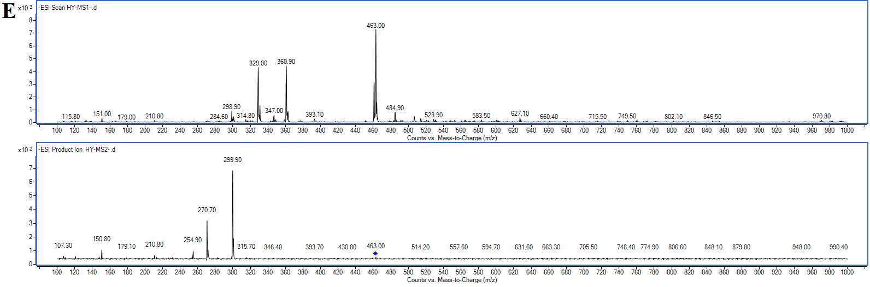



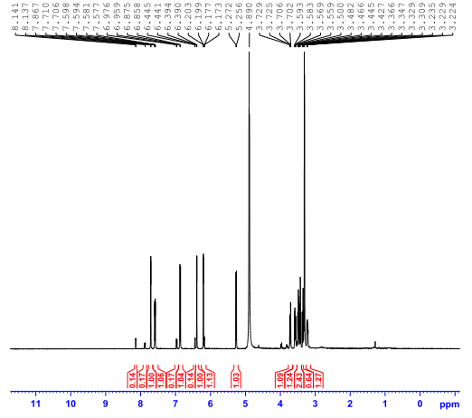



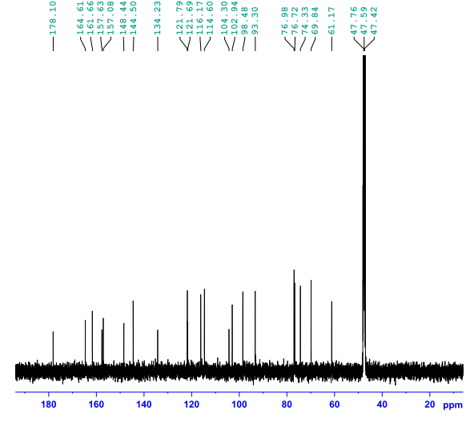

**Fig. S7** Negative ESI--MS and ESI--MS/MS spectra, FT-IR spectra, 1H and 13C NMR spectra of purified ISQ.

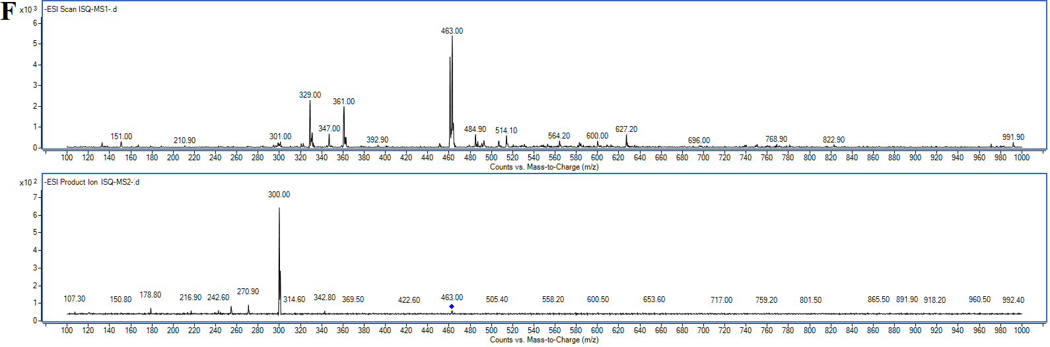



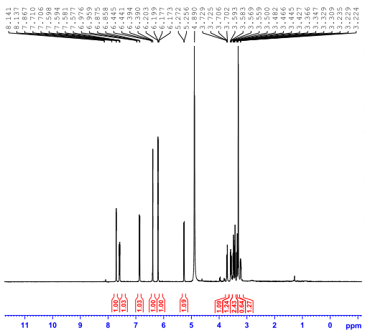

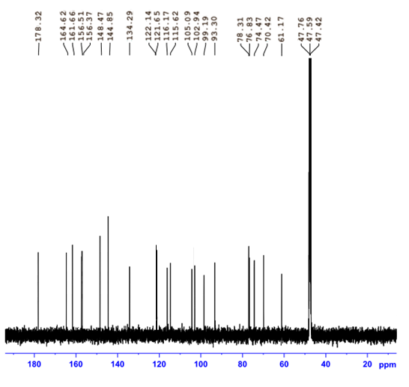

**Fig. S8** Negative ESI--MS and ESI--MS/MS spectra, FT-IR spectra, 1H and 13C NMR spectra of purified HI.

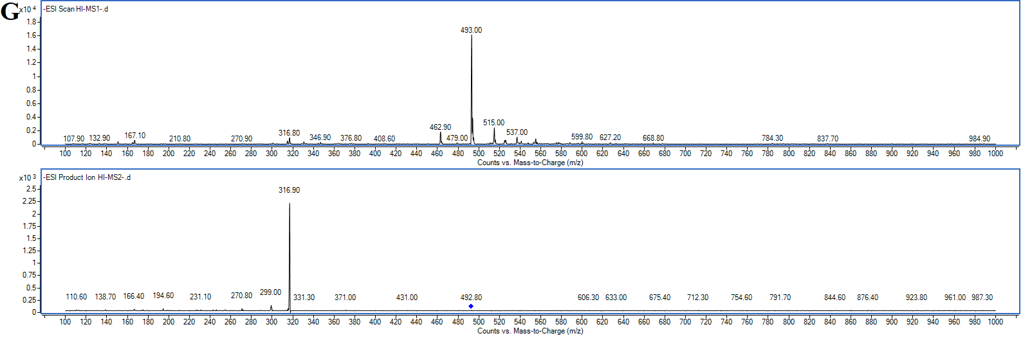



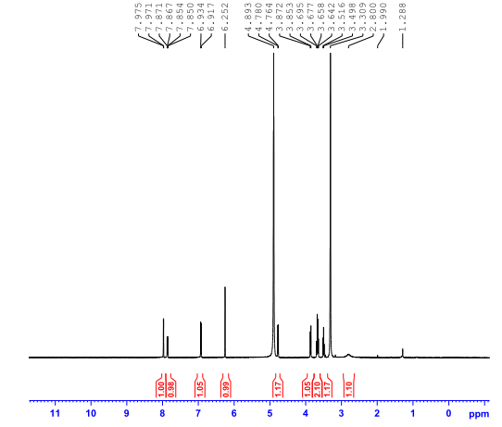

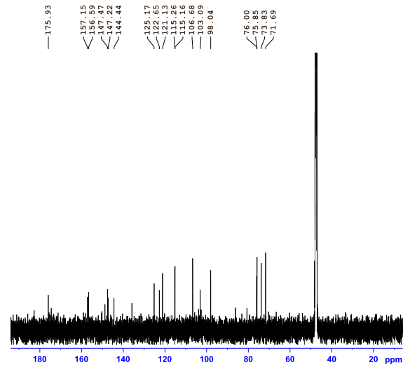

**Fig. S9** Negative ESI--MS and ESI--MS/MS spectra, FT-IR spectra, 1H and 13C NMR spectra of purified QOG.

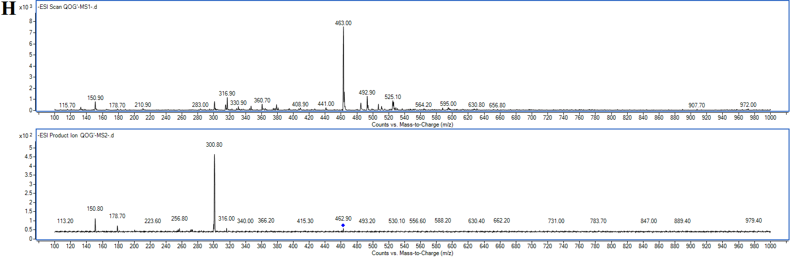



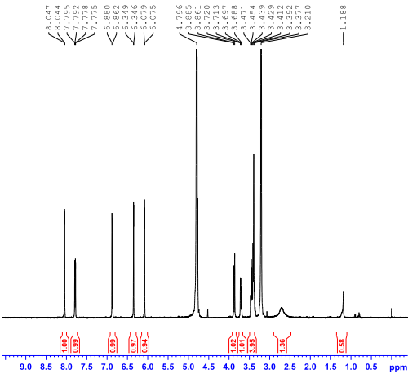

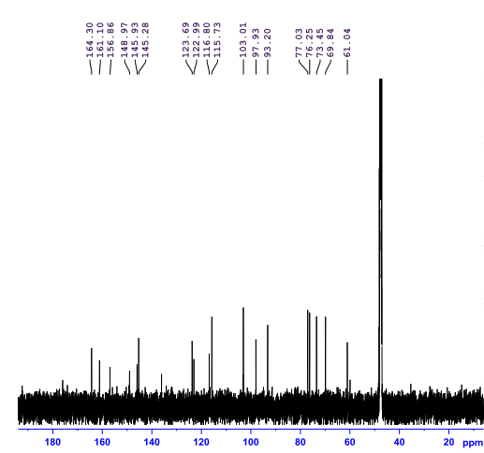

**Fig. S10** Docking pose of RU-AChE (A), HY-AChE (B), HI-AChE (C), QOR-BuChE (D), ISQ-BuChE (E) and QOG-BuChE (F) inside the active site in two dimensional space.

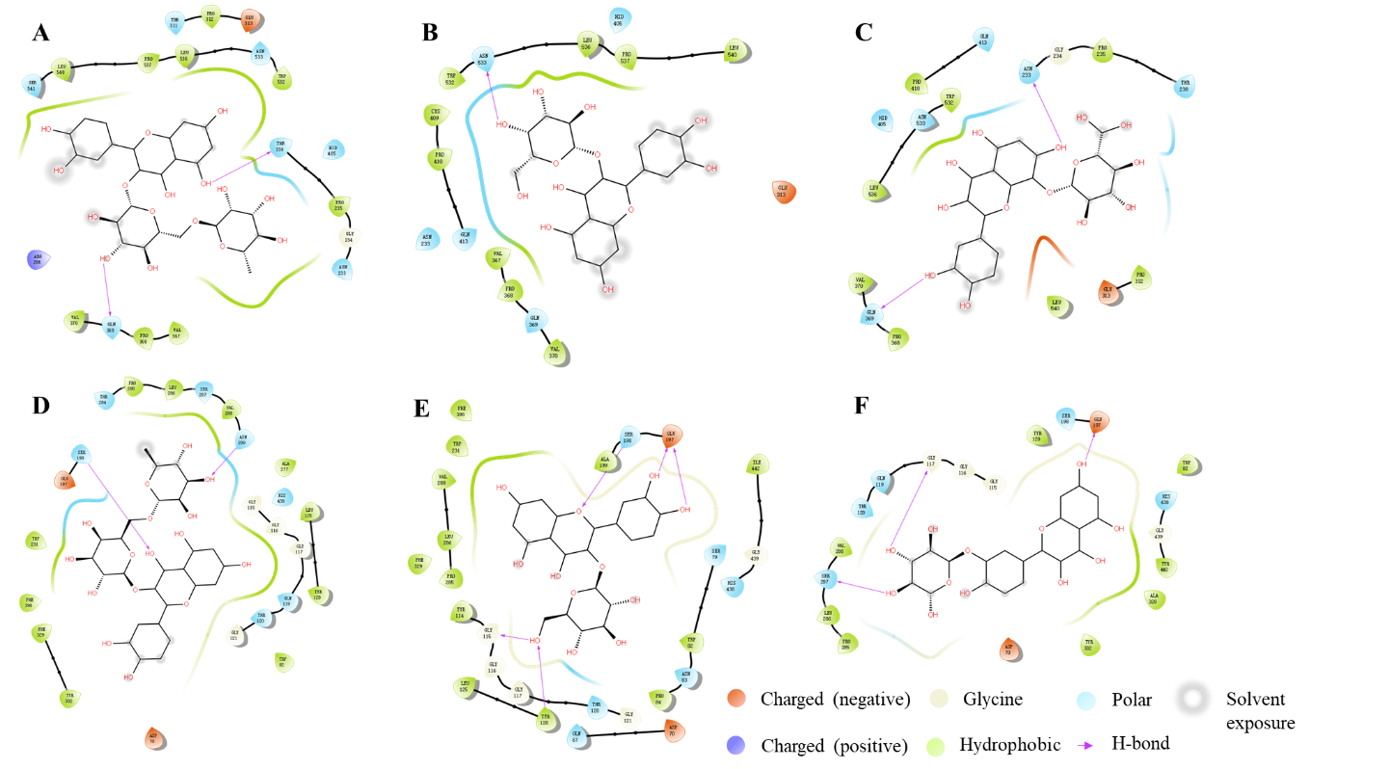

**References**

Alhumaydhi, F.A., Aljasir, M.A., Aljohani, A.S., et al., 2021. Probing the interaction of memantine, an important Alzheimer’s drug, with human serum albumin: *In silico* and *in vitro* approach. J. Mol. Liq. 340, 116888.

Dilshad, R., Khan, K.R., Ahmad, S., 2022. Phytochemical proﬁling, *in vitro* biological activities, and *in-silico* molecular docking studies of *Typha domingensis*. Arab. J. Chem. 15(10), 104133.

Ghalloo, B.A., Khan, K.U.R., Ahmad, S., et al., 2022. Phytochemical proﬁling, *in vitro* biological activities, and *in silico* molecular docking studies of *Dracaena reﬂexa*. Molecules 27(3), 913.

Islam, M.R., Zaman, A., Jahan, I., et al., 2013. *In silico* QSAR analysis of quercetin reveals its potential as therapeutic drug for Alzheimer's disease. J. Young Pharm. 5(4), 173-179.

Milojevic, J., Melacini, G., 2011. Stoichiometry and afﬁnity of the human serum

albumin-Alzheimer’s A*β* peptide interactions. Biophys. J. 100(1), 183-192.

Serdaroğlu, G., Uludag, N., Üstün, E., 2023. Efﬁcient synthesis of chromeno[2,3-*b*]pyridine derivatives using Zn(OTf)2 as a catalyst: DFT computations, molecular docking and ADME studies. J. Mol. Liq. 375, 121364.

Truong, B., Quiroz, J.P., Priefer, R., 2020. Acetylcholinesterase inhibitors for Alzheimer’s disease: past, present, and potential future. Med. Res. Arch. 8(12).

Zhang, F., Zhao, K., Tang, T., et al., 2021. Bisindole compound 4ae ameliorated cognitive impairment in rats with vascular dementia by anti-inﬂammation effect via microglia cells. Eur. J. Pharmacol. 908, 174357.