**Supporting Information**

Efficient one-pot synthesis of antimony-containing mesoporous tin dioxide nanostructures for gas-sensing applications

Tariq Aqeela*, Vardan Galstyanb,c, Elisabetta Cominib, and Ali Bumajdadd

a Department of Science, College of Basic Education, The Public Authority of Applied Education and Training (PAAET), P.O. Box 23167, Safat 13092, Kuwait

b Sensor Lab, Department of Information Engineering, University of Brescia and ISTM, Via Valotti 9, 25133 Brescia, Italy

c Department of Engineering "Enzo Ferrari”, University of Modena and Reggio Emilia, Via Vivarelli 10, 41125 Modena, Italy

d Department of Chemistry, Faculty of Science, Kuwait University, P.O. Box 5969, Safat 13060, Kuwait

*Corresponding author: tm.aqeel@paaet.edu.kw

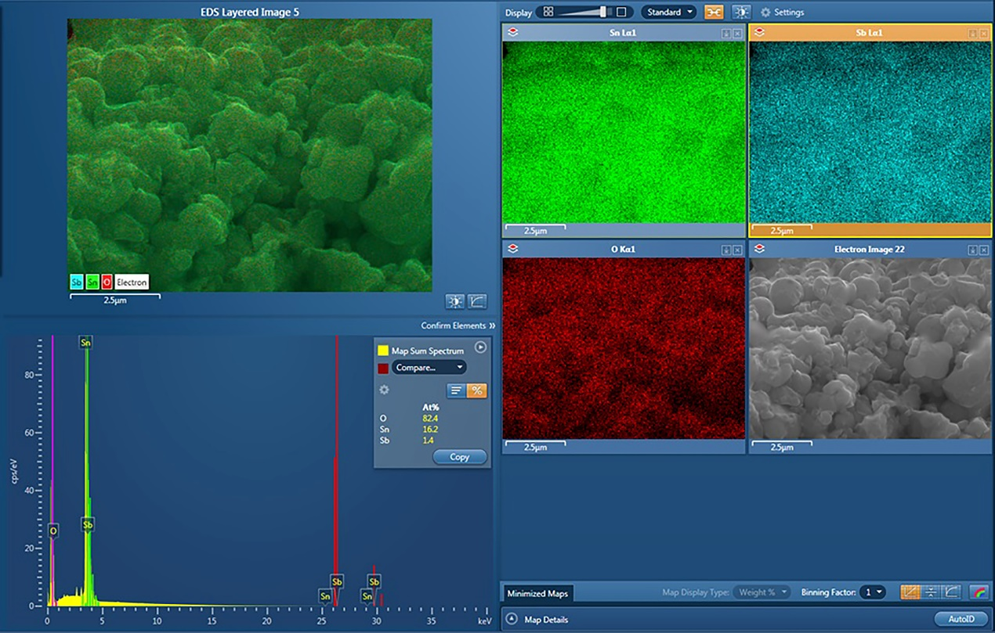

**Figure S1.** EDS/EDX images of a different section of Sb–SnO2 showing the atomic percentages of different elements contained in the sample and Sb distribution in the sample.

**Table 1** Gas sensing response of the Sb–SnO2 toward different concentrations of ethanol, acetone, NO2, and H2 at 300 °C.

|  |  |  |
| --- | --- | --- |
|  | Concentration  (ppm) | Response |
| Ethanol | 5 | 4.8 |
| 10 | 5.5 |
| 20 | 6.5 |
| 40 | 7 |
| Acetone | 1.5 | 3.6 |
| 2.5 | 4 |
| 5 | 5 |
| 10 | 5.7 |
| NO2 | 1 | 2.5 |
| 2 | 3 |
| 4 | 3.8 |
| 8 | 6.9 |
| H2 | 50 | 0.4 |
| 100 | 0.8 |
| 200 | 1 |
| 400 | 13 |

**Table 2**. Gas sensing response of the Sb–SnO2 toward different concentrations of ethanol, acetone, NO2, and H2 at 400 °C.

|  |  |  |
| --- | --- | --- |
|  | Concentration  (ppm) | Response |
| Ethanol | 5 | 5.8 |
| 10 | 7.3 |
| 20 | 8.7 |
| 40 | 11.4 |
| Acetone | 1.5 | 4 |
| 2.5 | 4.9 |
| 5 | 5.9 |
| 10 | 8 |
| NO2 | 1 | 0.4 |
| 2 | 0.8 |
| 4 | 1.2 |
| 8 | 1.5 |
| H2 | 50 | 6.1 |
| 100 | 6.6 |
| 200 | 6.8 |
| 400 | 7.6 |