**Supplementary materials**

**Figure captions**

**Figure S1** MS/MS spectrum and fragmentation pattern of cyclocarioside C of *C. paliurus* leaves in negative ion mode.

**Figure S2** MS/MS spectrum and fragmentation pattern of pterocaryoside A of *C. paliurus* leaves in negative ion mode.

**Figure S3** MS/MS spectrum and fragmentation pattern of cyclocrioside I of *C. paliurus* leaves in negative ion mode.

**Figure S4** MS/MS spectrum and fragmentation pattern of cypaliuruside J of *C. paliurus* leaves in negative ion mode.

**Figure S5** Molecular docking study of potential inhibitor cypaliuruside J interacting with amino acid residues in the active site of α-glucosidase.

**Figure S6** Molecular docking study of potential inhibitor cyclocarioside C interacting with amino acid residues in the active site of α-glucosidase.

**Figure S7** Molecular docking study of potential inhibitor cyclocarioside I interacting with amino acid residues in the active site of α-glucosidase.

**Figure S8** Molecular docking study of potential inhibitor pterocaryoside A interacting with amino acid residues in the active site of α-glucosidase.

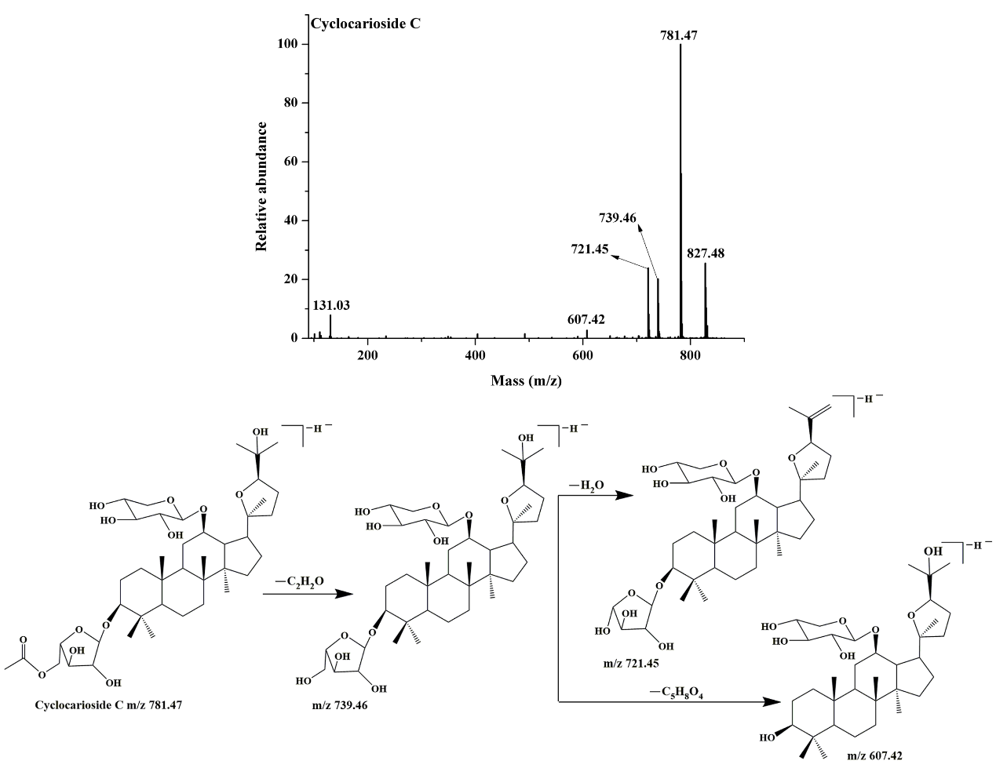

**Figure S1**

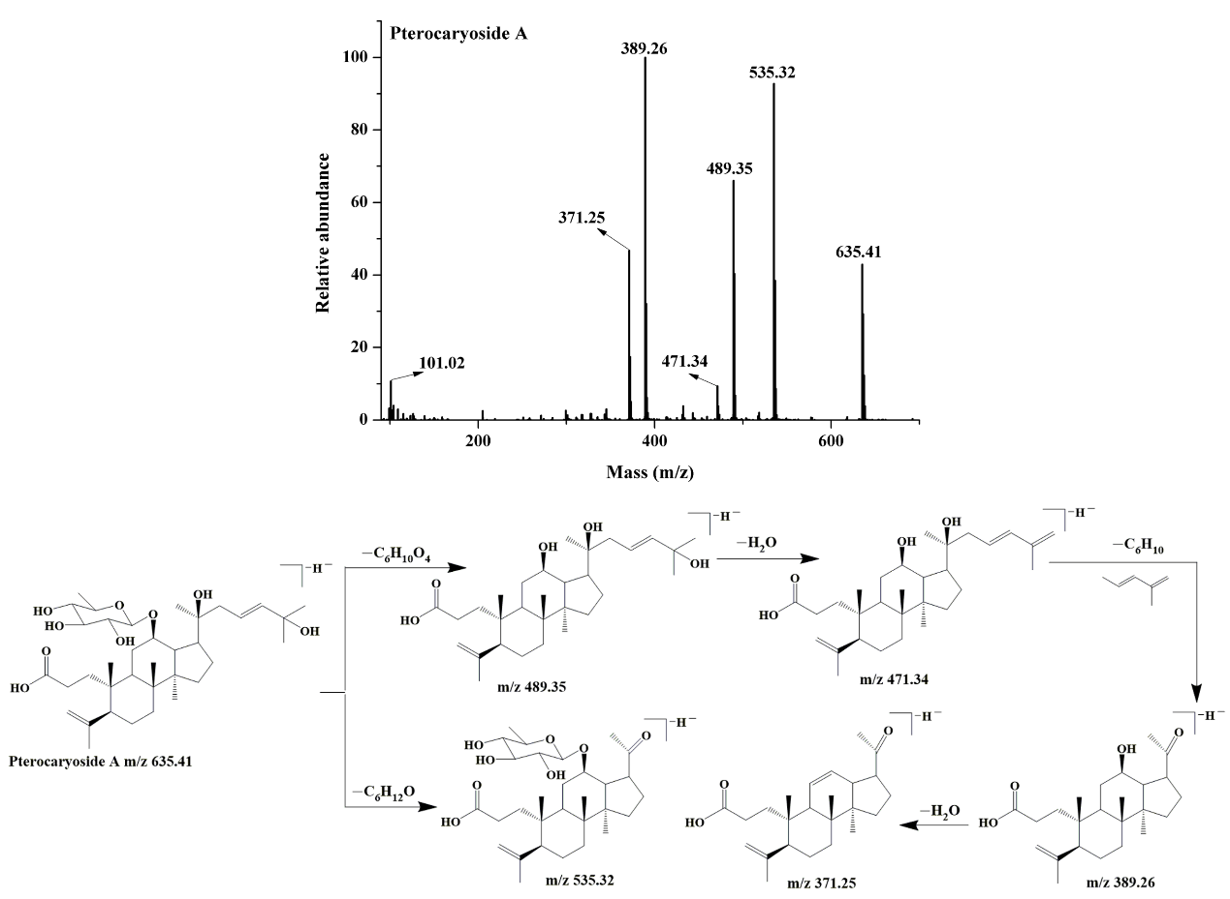

**Figure S2**

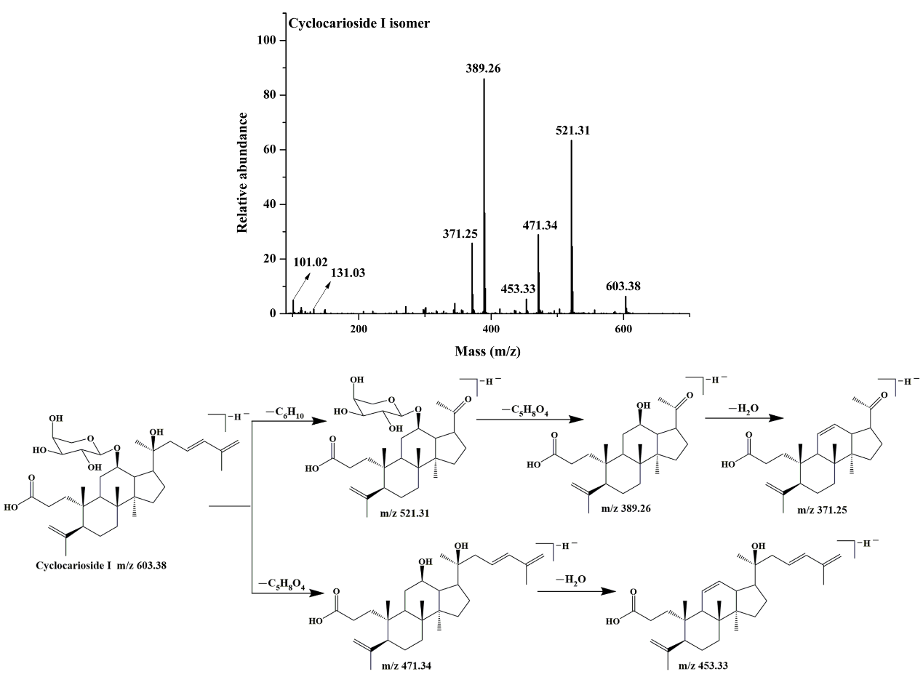

**Figure S3**

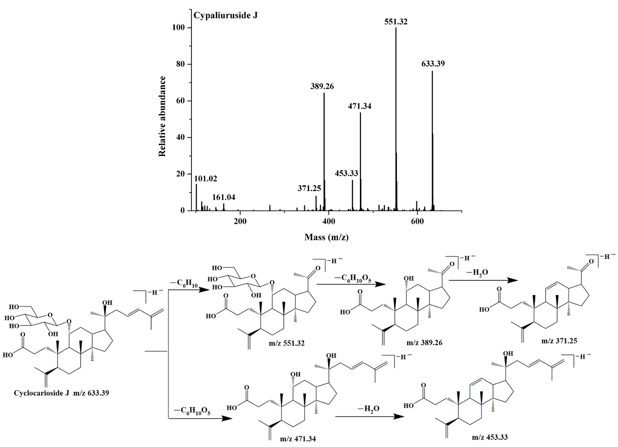

**Figure S4**

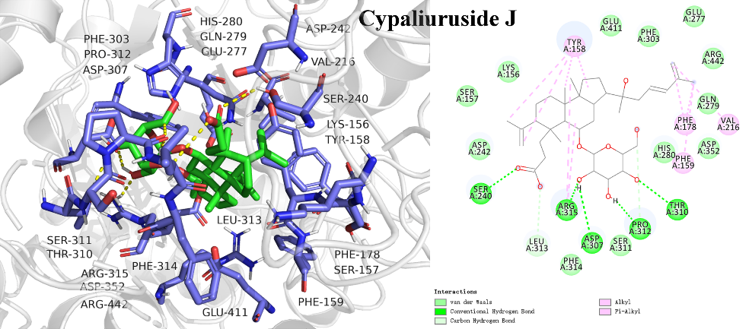

**Figure S5**

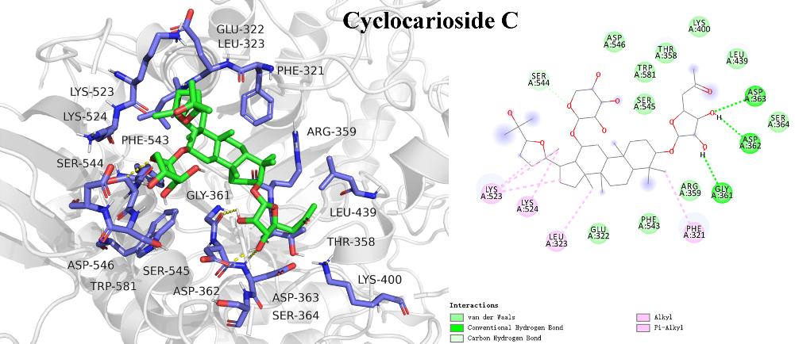

**Figure S6**

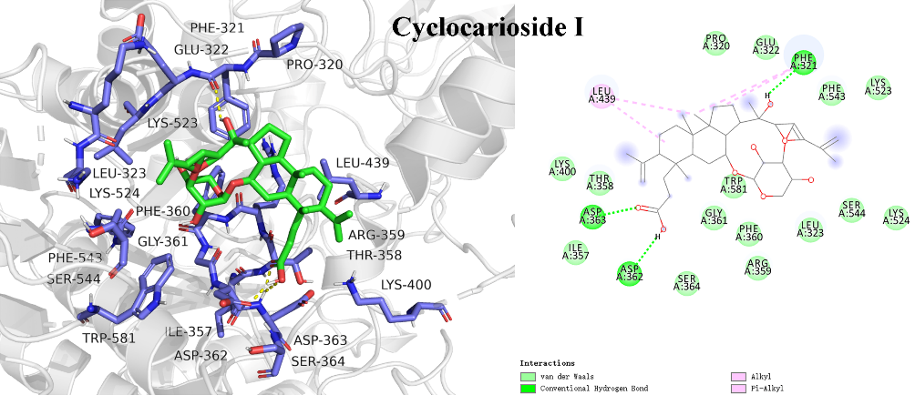

**Figure S7**

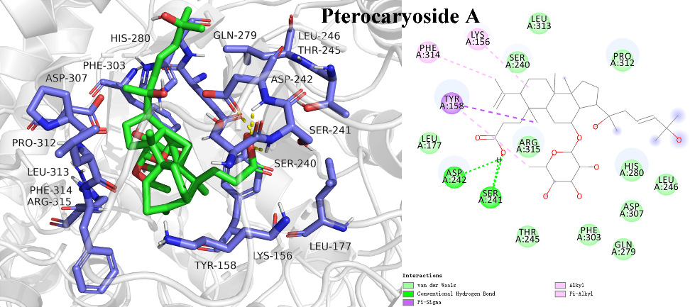

**Figure S8**