**Part A: Antimicrobial activity**

To evaluate the ligand and its corresponded complexes, certain strains of Gram positive (*S. aureus* & *B. subtilis*) and Gram negative (*E. coli* & *P. aeuroginosa*) bacteria as well as fungi were subjected to in vitro antimicrobial testing (*C. albicans* & *A. flavus*). The gar well diffusion technique was used to examine how well the ligand and its complexes inhibited bacteria growth. For HL and their complexes, DMSO was employed as a solvent, and two different concentrations (10 and 20 mg/mL) were used for each drug. To analyze the growth of the organisms on the agar, a cooled agar plate was prepared, and the holes were set up (1 cm) and then adding 100 μl of each substance with a varied concentration in the hole. These agar plates were incubated at 37°C for 24-72 hours. By using the serial dilution method [from 10 μg ml-1 to 0.5 μg ml-1], the activity was discovered with an inhibitory region that occurred in the zone containing concentration of HL ligand and their complexes, as well as other areas in the plates. It was possible to see how microorganisms developed. After that, the zones of inhibition were recorded and typical medications like Colitrimazole (an antifungal agent) and Ampicilline were compared for (antibacterial agent). Estimates were made for the (MIC) minimal inhibitory concentration ranges.

**Part B: Pharmacophore and Molecular docking study (MOE)**

The docking tool used in pharmacophore query was the Pharmit link (<http://pharmit.csb.edu>) towards DNA-polymerase 1bpy, 5szt, and 1zqa. This was performed regarding the HL ligand which exhibited the highest biological activity during in-vitro test, for confirmation. This was performed accordance to grid-based and ligand-based models [1] to search on drug analogues and assess the availability of interactions with protein receptors. The tested ligand must be modified as mol2 file format before using. The MolPort and Zn libraries were used to search on analogues drug within 112,939,594 and 123,399,574 compounds that found in the two libraries, respectively [1]. Additionally, the quantity and varieties of H-bonds made with protein receptors were identified.

On the other hand the molecular operating environmental module (MOE)(2018 version) was used to support biomedical research by demonstrating how the HL ligand interact with biological systems [2]. Before or after an in-vitro investigation, this silico screening is useful for evaluating the outcomes and monitoring the compound-protein interaction. This test was run to assess how new substance interacted with the co-crystal forms of DNA-polymerase 1bpy, 5szt, and 1zqa. Prior to docking, several configurations over the ligand and the target proteins must be carried out. To add the atomic charges and measure the potential energy values, the compound must be changed until it has the lowest energy. After that, create a database with the sole purpose of storing the compound as an MDB file, which is now prepared for docking. Each PDB protein was also orientated in the software. This is accomplished by choosing the receptors, utilizing an MMFF-force field to remove the solvent molecules and replace them with hydrogen atoms [2]. As a result, unnecessary helixes are cut, receptor types are connected, potential energy is calculated, and finally receptors and dummies are investigated. The final pose, which is the most stable of the 30 poses produced by the docking method, suggests a wide variety of allosteric interactions with protein pockets. To adapt these poses, the triangle-matcher was used three times, and once the London dG-scoring method. Finding the optimal docking pathways eliminated inappropriate collisions that led to deceptive postures. The length of interaction bonds (H-bonding), according to Van der Waals, never exceeds 3.5Å, and the inhibitory rank was determined using a conventional relationship [3].

**Part C: ADME parameters**

The HL ligand was commonly utilized in Swiss-link because to its small size. This tool is accurately predicts important pharmacokinetics, biophysical, lipophilic, and drug-like properties of potential medication (tested ligand). So, the Swiss-ADME program is endorsed by the pharmaceutical industry [4]. In this assay, ADME characteristics like molecular structure, solubility, absorption, excretion, and metabolism are being studied [5]. Lipid solubility, logical polarity of surface area (TPSA), solubility (log*S*), and unsaturation ratio based on sp3 hybridized carbon, and rotatable bonds were used in the sustainability radar calculation to measure drug-likeness. The effects on vital proteins (P-glycoprotein, P-gp, and cytochromes, CYP), which support living things and tissues, as well as the partition coefficient between n-octanol and water (log P*o/w*), were also of interest.

**Part D: Equations used for cyclic voltammetry calculations**

1- The current peak was estimated from Randles-Sevcik Equation [6]; Ip= (2.69x105) n3/2 A C ν1/2 D1/2 (1) in which the current (Ip, Ampere), diffusion coefficient (D, cm2/s), electrode surface area (A, cm2), molar concentration of the nickel (C, mol/cm3) and the scan rate (ν, volts/s) were the parameters used.

2- ΔEp is the potential gap determined by applying this equation; ΔEp= Epa-Epc (**2**) [7]. Where, Epa is the potential of anodic peak, while Epc is the potential of cathodic peak. Equation E˚ = (Epa+Epc)/2 (**3**), was used to estimate the formal potential (E˚) [8]. Where Epa is the anodic peak potential and Epc is the cathodic peak potential.

3- The stability constants (βMX) for metal complexes were derived from this equation (**4**) [9]; ΔE˚= E˚C- E˚M =2.303 (RT/nF)* (log βMX +j log Cx) (**4**). Where, E˚C is the formal potential peak of the complex after each addition of ligand, E˚M is the formal potential peak of the metal, Cx is the ligand concentration (mol/cm), j is the complex's coordination number, T and R are the absolute temperature and the gas constant (8.314 J.mol-1.K-1), respectively. Furthermore, the Gibbs free energy [6] was computed using the following equation; ΔG = -2.303 RT log βMX **(5**); where βMX is the stability constant.

|  |  |
| --- | --- |
| [1] | C.D. Willey, J.A. Bonner. Interaction of chemotherapy and radiation Gunderson LL, Tepper JEBT-CRO 65 (2012). |
| [2] | O. Alaysuy, H. M Abumelha, A. Alsoliemy, A. Alharbi, N. M Alatawi, H. EM Osman, R. Zaky, N. M El-Metwaly, [Elucidating of new hydrazide-based complexes derived from Pd (II), Cu (II) and Cd (II) ions: studies concerning spectral, DFT, Hirshfeld-crystal, biological screening beside Swiss-ADME verification](https://scholar.google.com/scholar?oi=bibs&cluster=13155106243412279406&btnI=1&hl=en), J. Mol. Struct. (2022) 132748 |
| [3] | S. Y Al-nami, E. Aljuhani, I. Althagafi, H. M Abumelha, T. M Bawazeer, A. M Al-Solimy, Z. A Al-Ahmed, F. Al-Zahrani, N. El-Metwaly, [Synthesis and Characterization for new nanometer Cu (II) complexes, conformational study and molecular docking approach compatible with promising in vitro screening](https://link.springer.com/article/10.1007/s13369-020-04814-x), Arab. J. Sci. Eng., 46 (2021)365–382. |
| [4] | [A. Daina](https://www.nature.com/articles/srep42717#auth-Antoine-Daina), [O. Michielin](https://www.nature.com/articles/srep42717#auth-Olivier-Michielin), [V. Zoete](https://www.nature.com/articles/srep42717#auth-Vincent-Zoete), SwissADME: a free web tool to evaluate pharmacokinetics, drug-likeness and medicinal chemistry friendliness of small molecules, [*Scientific Reports*](https://www.nature.com/srep), 7 (2017) 42717 |
| [5] | S. A Almalki, T. M Bawazeer, B. Asghar, A. Alharbi, M. M Aljohani, M. E Khalifa, N. El-Metwaly, [Synthesis and characterization of new thiazole-based Co (II) and Cu (II) complexes; therapeutic function of thiazole towards COVID-19 in comparing to current antivirals in treatment protocol](https://scholar.google.com/scholar?oi=bibs&cluster=7487319859276177671&btnI=1&hl=en), J. Mol. Struct. 1244(2021) 130961 |
| [6] | Matsuki, K., Endo, T., &Kamada, H. (1984). SEM studies of electrolytic manganese dioxide. *Electrochimicaacta*, *29*(7), 983-993. |
| [7] | El-Shereafy, S. E., Gomaa, E. A., Yousif, A.M., El-Yazed, A.S.A., 2017. Electrochemical and Thermodynamic Estimations of the Interaction Parameters for Bulk and Nano-Silver Nitrate (NSN) with Cefdinir Drug Using a Glassy Carbon Electrode. Iran. J. Mater. Sci. Eng. 14. |
| [8] | Bamford,C. H., Compton, R. G., Thomas, J. D. R.,1987. Electrode kinetics: principles and methodology (Comprehensive chemical kinetics, vol. 26): Elsevier, Amsterdam, 1986 (ISBN 0-444-42550-0). xviii+ 450 pp. Price US $172.00 (Dfl. 430.00). |
| [9] | Brownson, D. A. C., Banks, C. E., 2014. The Handbook of Graphene Electrochemistry, Springer |



**Scheme S1.** Ball milling technique applied for green synthesis approach



**Scheme S**2. Instruments applied in this study

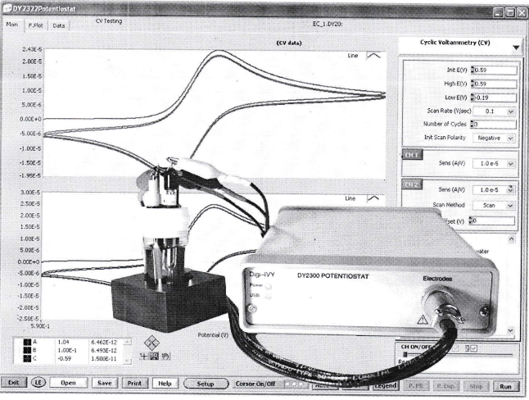

**Scheme S3** Cyclic Voltammetry equipment (DY 2000)



**Scheme S4.** The steps of colorimetric test for DNA binding efficiency of the tested compounds

|  |  |
| --- | --- |
| https://cdn.rcsb.org/images/structures/5szt_assembly-1.jpeg  5SZT; Crystal structure of the large fragment of DNA Polymerase I from Thermus aquaticus in a closed ternary complex with 7-(N-(10-hydroxydecanoyl)-aminopentenyl)-7-deaza-2'-dATP | https://cdn.rcsb.org/images/structures/1bpy_assembly-1.jpeg  1BPY; HUMAN DNA POLYMERASE BETA COMPLEXED WITH GAPPED DNA AND DDCTP |
| https://cdn.rcsb.org/images/structures/1zqa_assembly-1.jpeg  1ZQA; DNA POLYMERASE BETA (POL B) (E.C.2.7.7.7) COMPLEXED WITH SEVEN BASE PAIRS OF DNA; SOAKED IN THE PRESENCE OF KCL (150 MILLIMOLAR) AT PH 7.5 | |
| **Scheme S5.** The characterization of DNA-polymerase proteins | |

|  |
| --- |
| **HL Ligand** |
| **Ni(II) complex** |
| **Zn(II) complex** |
| **UO2(II) complex** |
| **Figure S1.** IR spectra of the HL ligand and its complexes |

|  |
| --- |
|  |
| **(A)** |
|  |
| **(B)** |

**Figure S2.**1H NMR spectra of (A) HL and (B) [Zn(HL)2(OAc)2] compounds

|  |
| --- |
|  |
| **(A)** |
|  |
| **(B)** |

**Figure S3.**13C NMR spectra of (A) HL and (B) [Zn(HL)2(OAc)2] compounds

|  |  |
| --- | --- |
| (A) | (B) |
| (C) |  |
| **Figure S4.** Scanning electron microscope analysis of (A) [Zn(HL)2(OAc)2], (B) Ni(L)2(H2O)2], and (C) [UO2(L)2].2H2O complexes | |

|  |
| --- |
| (A) |
| (B) |
| **Figure S5**. EDX analysis of (A) [Zn(HL)2(OAc)2], and (B) Ni(L)2(H2O)2] complexes |

|  |  |
| --- | --- |
| (A) | (B) |
| (C) |  |
| **Figure S6**. The optimized structures of (A)HL ligand, (B)Ni(II) and (C)Zn(II) complexes | |

|  |  |
| --- | --- |
| (A) | (B) |
| (C) |  |
| **Figure S7.** MEP maps of (A)HL ligand, (B)Ni(II) and (C)Zn(II) complexes | |

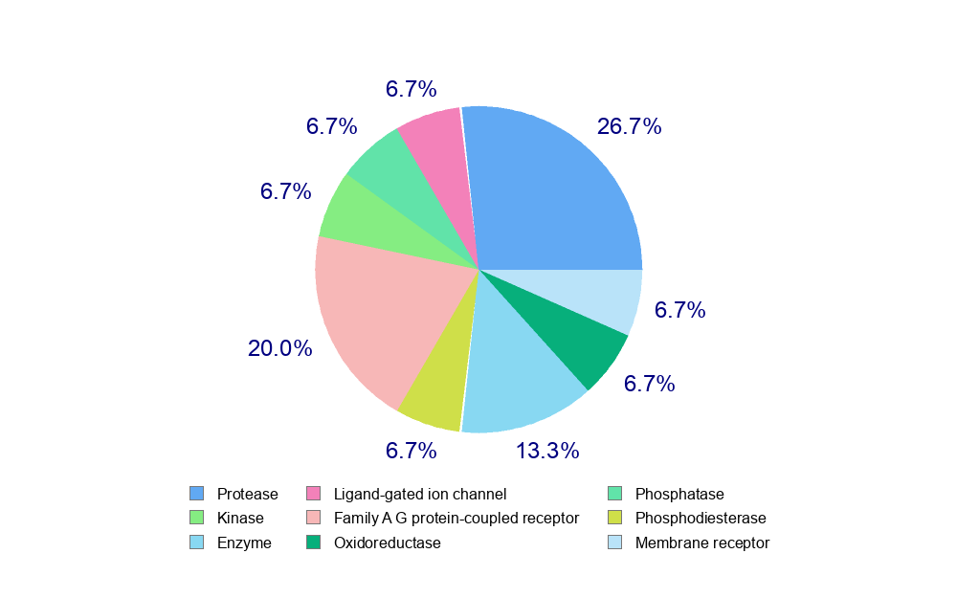

**Figure S8.** The biological targets for the HL ligand inside living cells

**Table S1.** The molecular parameters of ligand and its complexes

|  |  |  |  |
| --- | --- | --- | --- |
| **Theoretical data** | **Compounds** | | |
| **HL** | **Ni(II) complex** | **Zn(II) complex** |
| **Total energy (Ha)** | -1068.11336 | -2481.518210 | -2847.696304 |
| **Sum of atomic energies (Ha)** | -1062.6105618 | -2469.8665867 | -2834.5145320 |
| **Kinetic energy (Ha)** | -6.2159770 | -8.7245684 | -8.4185643 |
| **Electrostatic energy (Ha)** | -3.1076751 | -11.0873067 | -13.9255736 |
| **Exchange-correlation energy (Ha)** | 2.0166451 | 4.4669780 | 4.9973598 |
| **Spin polarization energy (Ha)** | 1.8042115 | 3.6932733 | 4.1650065 |
| **Binding energy (Ha)** | -5.5027956 | -11.6516237 | -13.1817715 |
| **Dipole moment (debye)** | 3.6579 | 3.3649 | 3.1438 |
| **HOMO (ev)** | -4.457 | -4.398 | -0.1493 |
| **LUMO (ev)** | -2.729 | -3.411 | -0.08258 |