**MXene Ti3C2Tx derived lamellar Ti3C2Tx-TiO2-CuO Heterojunction: Significantly Improved Ammonia Sensor Performance**

**Ming HOU1, Guoxin JIANG1, Shenghui GUO1, Jiyun GAO1, Zhigang SHEN4, Zhihang WANG6，Xiaolei YE 2*, Li YANG1, 3*, Qian DU1, Jianhong YI5, Hongbo ZENG3*, Pascal BRIOIS2**

1. State Key Laboratory of Complex Nonferrous Metal Resources Clean Utilization; Faculty of Metallurgical and Energy Engineering, Kunming University of Science and Technology, Kunming 650093, China

2. FEMTO-ST Institute (UMR CNRS 6174), UBFC/UTBM. Site de Montbéliard, F-90010 Belfort-France

3. Department of Chemical and Materials Engineering, University of Alberta, Edmonton T6G 2V4, Canada

4. SINOPEC Shanghai Research Institute of Petrochemical Technology, Shanghai 201208, China

5. Faculty of Materials Science and Engineering, Kunming University of Science and Technology, Kunming 650093, China

6. Sinochem International Corporation, Beijing 100045, China

**1. Measurement of gas sensing device.**

Gas sensing was completed in a four channel gas sensing measurement device (SD101，Huachuang Ruike Science and Technology Wuhan Co. Ltd). The electrode chip was fabricated on the basis of an alumina substrate (6*30 mm). The platinum sizing agent was printed on the alumina matrix by using screen printing. Then these alumina matrixes were dried at 70 °C for 40 min and calcined at 350 °C and 850 °C for 20 min. As shown in **Fig. S1**, the whole platinum electrode was consisted of heating electrode and measuring electrode. The gap between the gear shaping electrodes was 0.42 mm. As displayed in **Fig. S1**, the Ti3C2Tx pastes sensing materials were printed on the alumina matrix by using screen printing method. The thickness of Ti3C2Tx films were 5-10 μm, which is achieved by using the screen printing equipment. Then the samples were put in an oven to remove the organic solvent at 70 °C for 40 min. At last, the as-products were annealed at 400°C for 2 h under argon atmosphere to enhance the mechanical bond of particles in the films.

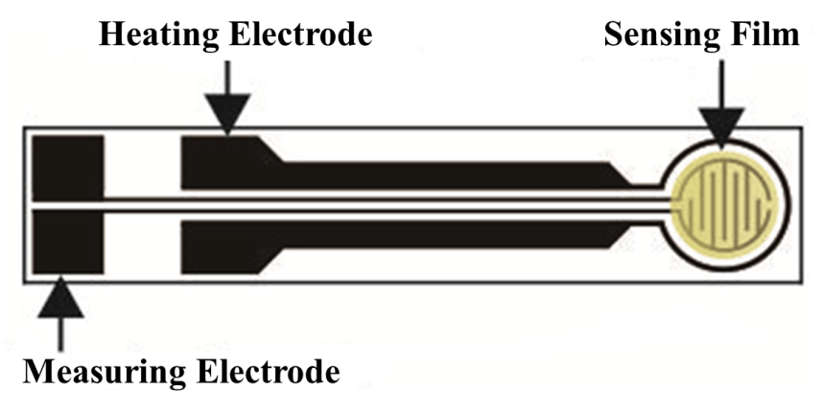

**Fig. S1**. Schematic of gas sensing material chip[35]

The gas sensing test platform used in this work is a four-channel gas sensing test system (self-developed). As shown in **Fig. S2(a)**, the gas sensing test system consists of a PC host, a gas sensing detection chamber and a gas flow control module. The system can be controlled by computer gas-sensing flow software and gas-sensing test software, and connected to the computer through USB to adjust the gas flow in real time and obtain real-time sample resistance data. It can realize normal temperature test and variable temperature test, and the heating or cooling rate can be adjusted. The resistance test range is 0-1012Ω, and the temperature control range is 25-500 ° C. The gas flow can be displayed and adjusted on the flow control interface (**Fig. S2 (c)** ), and the test temperature can be adjusted on the gas-sensing performance test interface ( **Fig. S2 (d)**). The gas sensing test platform can realize the photothermal combined excitation gas sensing test. The luminescence module can be added in the gas sensing detection cavity (**Fig.S2 (b)**), and the luminescence can be adjusted by the gas sensing performance test interface. In the test, only the chip with the sample needs to be inserted into the gas sensing detection chamber, and the external temperature control method is adopted, without the need to process the sensor or damage the material, so it is suitable for the test of various nanomaterial-based sensors.

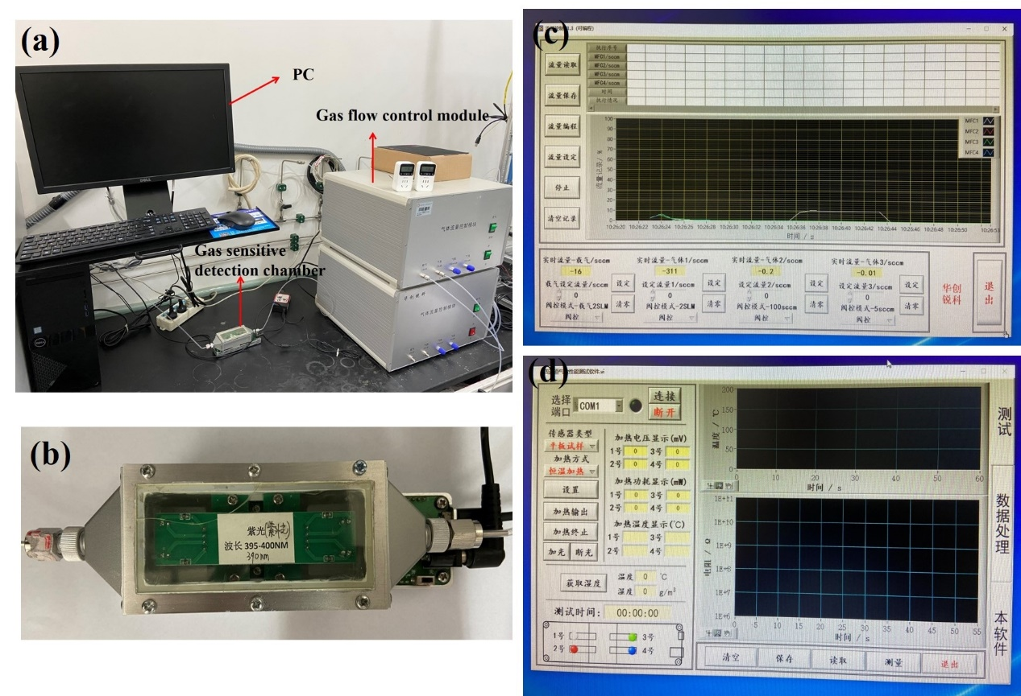

**Fig. S2.** Gas sensing test system (a) Gas sensitive test platform, (b) Gas sensitive test chamber, (c) Flow control interface, (d) Gas sensitivity test interface

**Table S1** The response-recovery time of different samples toward 100ppm NH3 with UV irradiation at room temperature

|  |  |  |  |  |  |  |
| --- | --- | --- | --- | --- | --- | --- |
| Time (s) | TTC-1 | TTC-2 | TTC-3 | TC | TT | Ti3C2Tx |
| Response | 75 | 99 | 102 | 137 | 83 | 184 |
| Recovery | 80 | 107 | 119 | 150 | 90 | 204 |

**Table S2** The resistance of TTC-1 toward different target gases with UV irradiation at room temperature

|  |  |  |  |  |  |  |  |
| --- | --- | --- | --- | --- | --- | --- | --- |
| Resistance(MΩ) | Air | NH3 | Methanol | NO2 | CO | Formaldehyde | Ethanol |
|  | 5.8 | 2.49 | 4.785 | 7.25 | 4.23 | 5.22 | 3.68 |

**Table S3** The resistance of TTC-1 toward different target gases without UV irradiation at room temperature

|  |  |  |  |  |  |  |  |
| --- | --- | --- | --- | --- | --- | --- | --- |
| Resistance(MΩ) | Air | NH3 | Methanol | NO2 | CO | Formaldehyde | Ethanol |
|  | 7.2 | 5.76 | 3.74 | 9.63 | 3.05 | 2.87 | 1.06 |