**SUPPLEMENTARY DATA**

**An environmentally safe approach for the facile synthesis of anti-mutagenic fluorescent quantum dots: property investigation and the development of novel antimicrobial applications**

Morteza Yazdani1, Fereshteh Jookar Kashi2*, Elahe Seyed Hosseini3

1 Department of Phytochemistry, Faculty of Chemistry, University of Kashan, Kashan, I.R. Iran; morteza.yazdani.hu@gmail.com (ORCID ID: 0000-0001-6569-5681)

2Department of Cell and Molecular Biology, Faculty of Chemistry, University of Kashan, Kashan, I.R. Iran; jookar@kashanu.ac.ir (ORCID ID: 0000-0002-8332-1269)

3Gametogenesis Research Center, Kashan University of Medical Science, Kashan, I.R. Iran; elaheir.66@gmail.com

**Table S01.** Synthesis condition for the preparation of AgQDs

|  |  |  |  |  |
| --- | --- | --- | --- | --- |
| Experiment | pH | C. AgNO3 | C. Extract | Temp |
| 1 | 11 | 1 | 1/200 | 30 |
| 2 | 9 | 1 | 1/50 | 50 |
| 3 | 11 | 2 | 1/100 | 30 |
| 4 | 11 | 2 | 1/50 | 40 |
| 5 | 11 | 4 | 1/20 | 40 |
| 6* | 7 | 3 | 1/50 | 60 |
| 7 | 5 | 1 | 1/200 | 60 |
| 8 | 7 | 3 | 1/20 | 30 |
| 9 | 5 | 3 | 1/200 | 40 |
| 10 | 5 | 2 | 1/50 | 40 |
| 11 | 11 | 3 | 1/20 | 60 |
| 12 | 11 | 3 | 1/200 | 50 |
| 13 | 5 | 3 | 1/100 | 50 |
| 14 | 9 | 1 | 1/100 | 60 |
| 15 | 11 | 4 | 1/100 | 60 |
| 16 | 5 | 2 | 1/100 | 30 |
| 17 | 9 | 2 | 1/20 | 60 |
| 18 | 9 | 3 | 1/50 | 30 |
| 19 | 9 | 3 | 1/100 | 40 |
| 20 | 5 | 4 | 1/50 | 60 |
| 21 | 7 | 4 | 1/50 | 30 |
| 22 | 11 | 1 | 1/50 | 50 |
| 23 | 7 | 1 | 1/20 | 40 |
| 24 | 7 | 2 | 1/200 | 50 |
| 25 | 5 | 1 | 1/20 | 30 |
| 26 | 7 | 1 | 1/100 | 40 |
| 27 | 9 | 4 | 1/200 | 30 |
| 28 | 7 | 4 | 1/100 | 50 |
| 29 | 7 | 2 | 1/200 | 60 |
| 30 | 9 | 2 | 1/20 | 50 |
| 31 | 9 | 4 | 1/200 | 40 |
| 32 | 5 | 4 | 1/20 | 50 |

* This experiment was selected to eco-friendly synthesis of AgQDs.

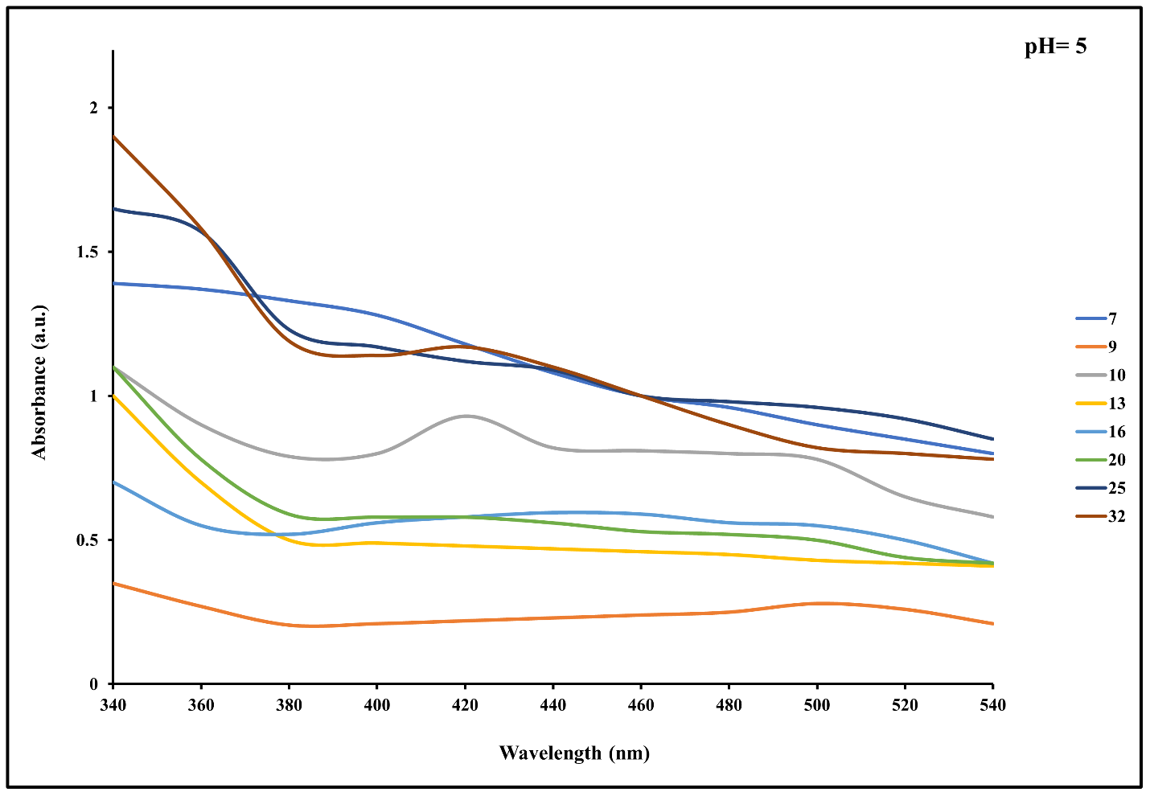

**Fig S01.** UV-Vis absorption spectra were obtained from experiments 7, 9, 10, 13, 16, 20, 25, and 32, which were conducted to synthesize AgQDs at pH 5.

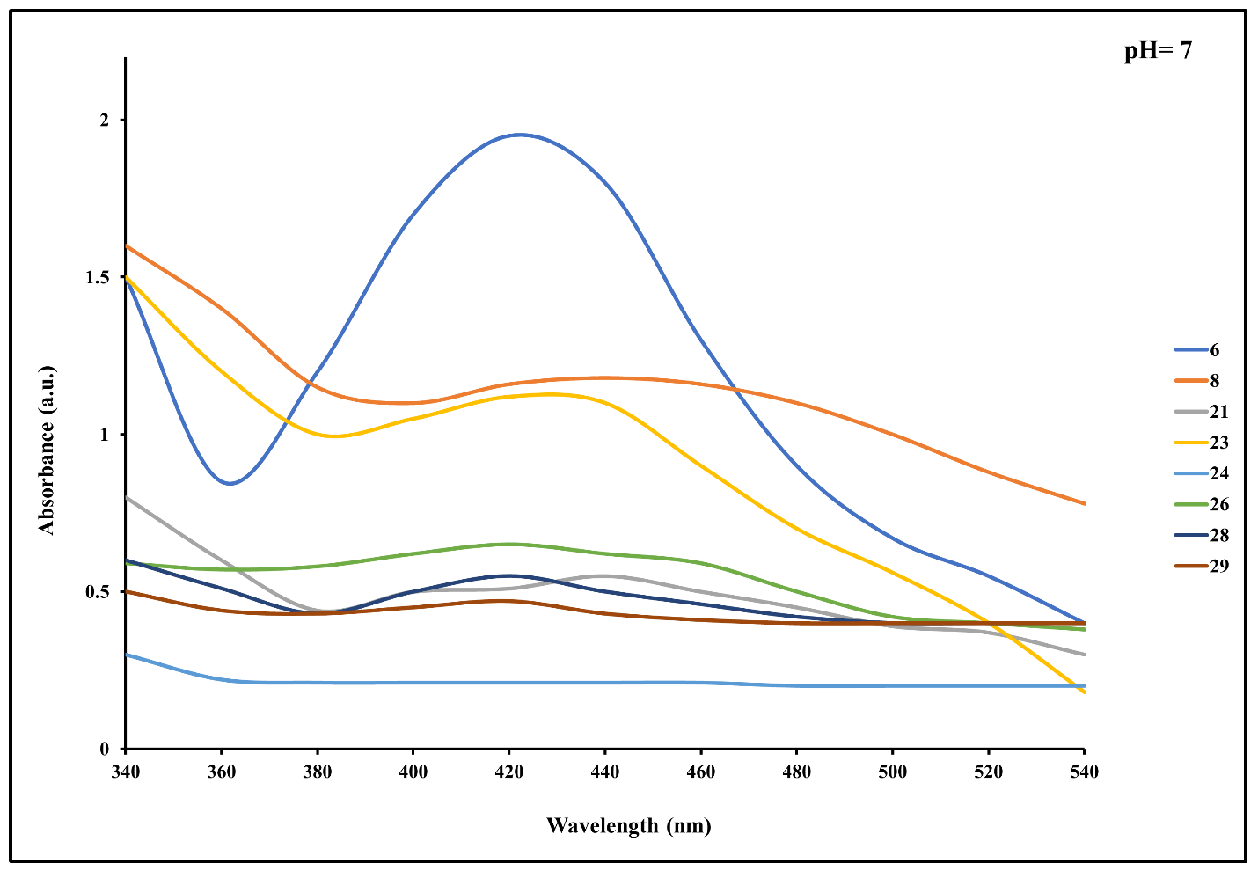

**Fig S02.** UV-Vis absorption spectra were obtained from experiments 6, 8, 21, 23, 24, 26, 28, and 29, which were conducted to synthesize AgQDs at pH 7. Based on the findings, the experimental conditions used in experiment 6 were identified as the most effective for synthesizing green AgQDs in a neutral environment (pH=7). Therefore, we chose these conditions for further analysis.

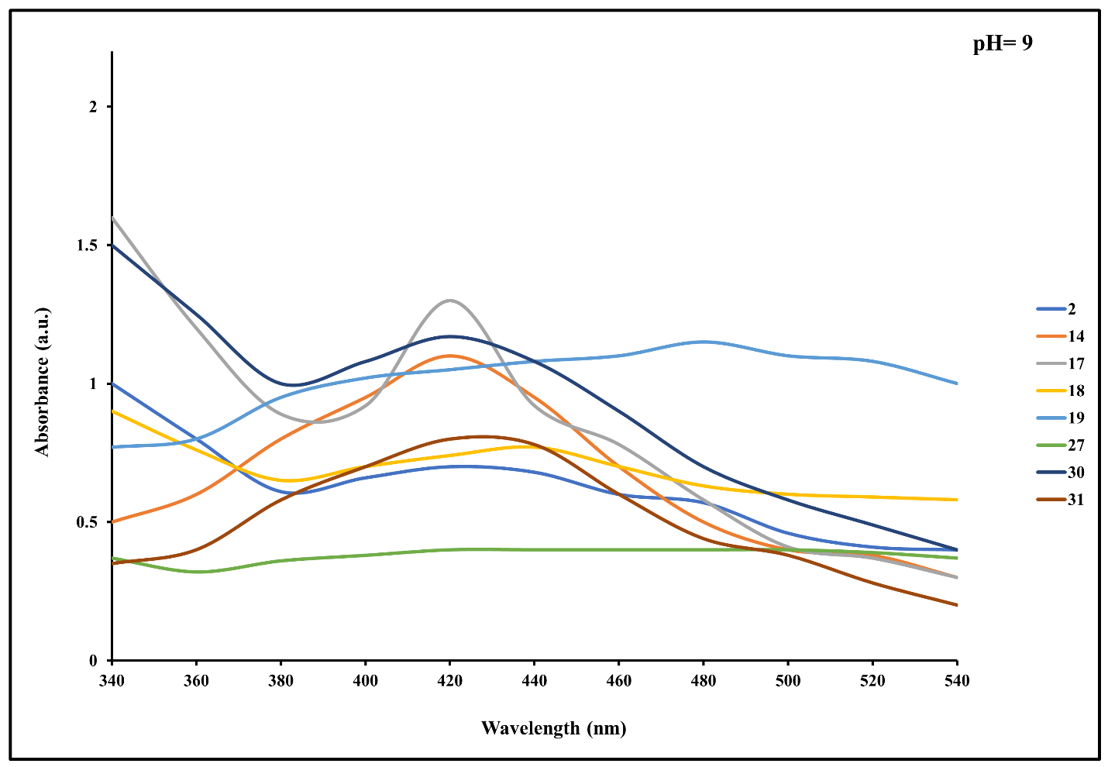

**Fig S03.** UV-Vis absorption spectra were obtained from experiments 2, 14, 17, 18, 19, 27, 30, and 31, which were conducted to synthesize AgQDs at pH 9.

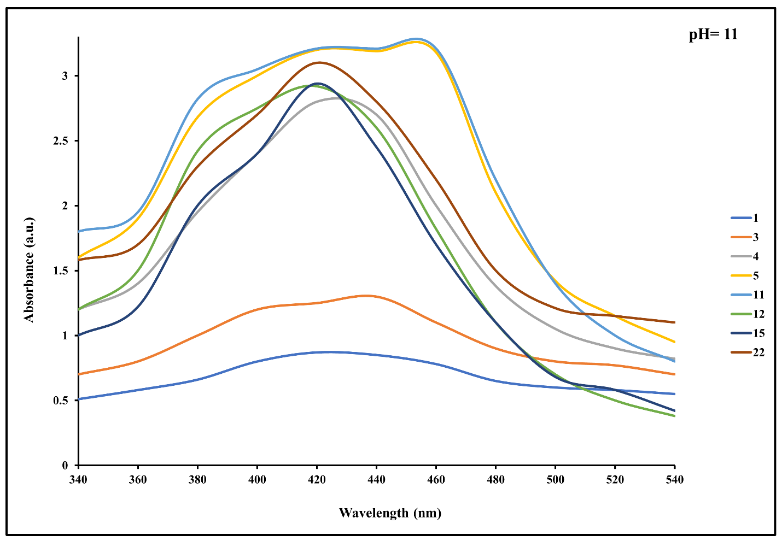

**Fig S04.** UV-Vis absorption spectra were obtained from experiments 1, 3, 4, 5, 11, 12, 15, and 22, which were conducted to synthesize AgQDs at pH 11.

**Table S02.** Images of the zone of inhibition of standard gram-positive bacteria

|  |  |  |
| --- | --- | --- |
| **Standard strain** | **Sample** | |
| **AgQDs** | **AgNO3** |
| **Gram-positive bacteria** | |
| ***B. subtilis*** |  | - |
| ***S. epidermidis*** |  |  |
| ***S. aureus*** |  |  |

**Table S03.** Images of the zone of inhibition of standard gram-negative bacteria

|  |  |  |
| --- | --- | --- |
| **Standard strain** | **Sample** | |
| **AgQDs** | **AgNO3** |
| **Gram-negative bacteria** | |
| ***E. coli*** |  |  |
| ***K. pneumonia*** | - |  |
| ***S. dysenteriae*** | - |  |
| ***P. vulgaris*** |  | - |
| ***S. paratyphi-A serotype*** | - |  |
| ***P. aeruginosa*** |  |  |

**Table S05.** Images of the zone of inhibition of standard fungi

|  |  |  |
| --- | --- | --- |
| **Standard strain** | **Sample** | |
| **AgQDs** | **AgNO3** |
| **Fungi** | |
| ***C. albicans*** |  |  |

**Table S06.** Images of the zone of inhibition of clinical microbial strains

|  |  |
| --- | --- |
| **Clinical strain** | **Sample** |
| **AgQDs** |
| ***S. epidermidis*** |  |
| ***C. albicans*** |  |
| ***P. vulgaris*** | E:\rahimi\revise yazdani\IMAG2855.jpg |
| ***S. saprophyticus*** |  |
| ***S. aureus*** |  |
| ***E. coli*** |  |