**SYNTHESIS, HEMOROHEOLOGICAL AND ANTIFIBROTIC ACTIVITY OF NEW**

**3-ACETYL-2,4,6-TRIMETHYLPYRIDINE DERIVATIVES**

**Zarina Shulgau1, Alena Stalinskaya2, Shynggys Sergazy1*, Aigerim Zhulikeyeva1, Yevgeniy Kamyshanskiy1,4, Alexandr Gulyayev1, Yerlan Ramankulov1 and Ivan Kulakov 1,3\*\***

*1 National Center for Biotechnology, 13/5 Kurgalzhynskoe Road, 010000 Nur-Sultan, Kazakhstan; e-mail: shulgau@biocenter.kz, shynggys.sergazy@gmail.com*

*2 Institute of Environmental and Agricultural Biology (X-Bio), University of Tyumen, 23 Lenina St., Tyumen, 625003, Russia*

*3 Center for Nature-Inspired Engineering, Tyumen State University, 15a Perekopskaya St., 625003 Tyumen, Russia; e-mail: i.v.kulakov@utmn.ru*

*4 Clinic of Medical University "MUK" NCJSC, Karaganda, Kazakhstan; e-mail: kamyshanskiy84@mail.ru*

Table of contents

**Experimental S2**

**General Information S2**

**Experimental Procedures S2**

**Copies of NMR Spectra of Products S3**

**Copies of MS Spectra of Products S3**

**Table 1. Effect of studied samples on blood viscosity (mPa*s) at different spindle speeds in an in vitro blood hyperviscosity model S12**

**Experimental**

General Information

1H and 13C NMR spectra were recorded on a Bruker DRX400 (400 and 101 MHz, respectively), Bruker AVANCE 500 (500 and 126 MHz, respectively) and Magritek spinsolve 80 carbon ultra (81 and 20 MHz, respectively) instruments using CDCl3 and DMSO-d*6* the internal standard was TMS or residual solvent signals (2.49 and 39.9 ppm for 1Н and 13C nuclei in DMSO-d*6*; 7.26 and 77.0 ppm for 1Н and 13C nuclei in CDCl3).

Chromato-mass spectrometric studies were carried out on a Trace GC Ultra chromatograph with a DSQ II mass-selective detector in the electron ionization mode (70 eV) on a Thermo TR-5 MS quartz capillary column, 15 m long, 0.25 mm inner diameter, with a film thickness of the stationary phase of 0.25 μm. Splitless input mode was used. Carrier gas discharge 20 ml/min. The velocity of the carrier gas (helium) is 1 ml/min. Evaporator temperature 200°C, transition chamber temperature 200°C, ion source temperature 200°C. The temperature of the column thermostat was changed according to the program: from 15 (5 min delay) to 220°C at a rate of 20°C per minute, to 290° at a rate of 15° per minute. The total analysis time was 30 min. The volume of the injected sample is 1 μl. Chromatograms were recorded in TIC mode. The range of mass scanning is 30 - 450 amu.

Elemental analysis was performed on a Carlo Erba 1106CHN instrument. Melting points were determined using a Stuart SMP10 hot bench. Monitoring of the reaction course and the purity of the products was carried out by TLC on Sorbfil plates and visualized using iodine vapor or UV light.

Experimental Procedures

**1-(2,4,6-trimethylpyridin-3-yl)ethan-1-one** **3** was synthesized according to published procedures [24]. A mixture of acetylacetone (50 g, 0.5 mol) and ammonium acetate (38.5 g, 0.5 mol) was heated at 80 °C on a water bath for 40 hours. The reaction mixture was neutralized with Na2CO3 and extracted with benzene (3 × 20 ml). The combined organic layers were dried over anhydrous Na2SO4 and then evaporated in vacuum. The resulting liquid is distilled at reduced pressure (bp. 159-160 °С / 30 mmHg). The output is a slightly yellowish liquid (yield: 25 g (31%)). 1H NMR (400 MHz, CDCl3) δ ppm 2.62 s (3H, -COCH3), 2.84 s (3H, 6-CH3), 2.88 (s, 3H, 2-CH3), 2.91 (s, 3H, 4-CH3), 7.26 (s, 1H, H-5). 13C NMR (101 MHz, CDCl3) δ ppm 18.1, 21.8, 23.5, 31.5, 121.7, 134.5, 142.0, 151.0, 157.1, 205.7. MS (EI) m/z (Irel, %): [M]+ 162.99 (43), 147.98 (100), 119.98 (56), 76.96 (16). Anal. calcd for C10H13NO: C, 73.70; H, 8.21; N, 8.43; found: C, 73.59; H, 8.03; N, 8.58.

**1-(2,4,6-trimethylpyridin-3-yl)ethan-1-ol 4**. To a solution of 3-acetyl-2,4,6-trimethylpyridine **3** (2.0 g, 12.0 mmol) in 8 ml of EtOH-water (5:3) was added with stirring in portions NaBH4 (0.9 g, 24.0 mmol). Stirring was maintained for 2 hours after NaBH4 was all added, then water (50 ml) was added, and the mixture extracted with EtOAc (3 x 20 ml). The combined organic layers were washed with saturated NaCl solution and dried over anhydrous Na2SO4. The solvent was evaporated under reduced pressure, and the residue was purified by recrystallization from hexane. Yield: 1.8 g (90%), white crystals, mp 94-95°С. 1H NMR (500 MHz, CDCl3) δ ppm 1.48 (d, *J* = 6.8 Hz, 3H, -CHCH3), 2.38 (2 s, 6H, 4-CH3, 6-CH3), 2.48 (s, 3H, 2-CH3), 5.28 (q, *J* = 6.7 Hz, 1H, -CH), 6.73 (s, 1H, H-5). 13C NMR (126 MHz, CDCl3) δ ppm 20.1, 21.8, 23.2, 23.7, 66.3, 124.3, 133.6, 145.7, 154.9, 155.5. MS (EI) m/z (Irel, %): [M]+ 165.00 (20), 150.04 (100), 122.11 (44). Anal. calcd for C10H15NO: C, 72.53; H, 9.37; N, 8.65; found: C, 72.69; H, 9.15; N, 8.48.

**(*E,Z*)-1-(2,4,6-trimethylpyridin-3-yl)ethan-1-one oxime 5.** A solution of 3-acetyl-2,4,6-trimethylpyridine **3** (1.0 g, 6.0 mmol), NH2OH*HCl (1.2 g, 18.0 mmol) and NaOH (0.7 g, 18.0 mmol) in 50% aqueous solution of EtOH (10 ml) was refluxed for 10 hours. At the end of the reaction (GC-MS control), the mixture was poured into water and extracted with EtOAc (3 x 10 ml). The combined organic layers were washed with saturated NaCl solution and dried over anhydrous Na2SO4. The solvent was evaporated under reduced pressure, and the residue was purified by recrystallization from a mixture of hexane: methylene chloride (2:1). Yield: 0.8 g (76%), white crystals, mp 163-165°С. 1H NMR (500 MHz, DMSO-d*6*) δ ppm 1.99 s (1.2 H, 6-CH3 (*Z*)), .2.00 s (1.8 H, 6-CH3 (*E*)), 2.06 s (1.2 H, 2-CH3 (*Z*)), .2.10 s (1.8 H, 2-CH3 (*E*)), 2.23 s (1.2 H, 4-CH3 (*Z*)), .2.27 s (1.8 H, 4-CH3 (*E*)), 2.35 s (1.2 H, N=C-CH3 (*Z*)), .2.36 s (1.8 H, N=C-CH3 (*E*)), 6.91 s (0.4 H, H-4 (*Z*)), 6.94 s (0.6H, H-4 (*E*)), 10.55 s (0.4H, =N-OH (*Z*)), 11.07 s (0.6H, =N-OH (*E*)). 13C NMR (126 MHz, DMSO-d*6*) δ ppm 15.4 (N=C-CH3 (*E-*), 18.4 (4-CH3 (*Z*)), 18.6 (4-CH3 (*E*)), 20.0 (N=C-CH3 (*Z-*)), 21.8 (2-CH3 (*Z*)) , 22.2 (2-CH3 (*E-*)), 23.5 (6-CH3 (*Z-*)), 23.6 (6-CH3 (*E-*)), 121.5 (C-5 (*Z-*)), 121.9 (C-5 (*E-*)), 128.9 (C-3 (*Z-*)), 130.4 (C-5 (*E-*)), 143.4 (C-4 (*Z-*)), 145.1 (C-4 (*E-*)), 152.0 (N=C(*Z-*), 152.3 (C-6(*Z-*)), 153.2 (N=C-CH3 (*E-*)), 154.4 (C-6 (*E-*)), 156.0 (C-2(*Z-*)), 156.1 (C-2(*E-*)). MS (EI) m/z (Irel, %): [M]+ 163.07 (100), 161.11 (59), 146.09 (32), 120.07 (31), 80.27 (27), 77.03 (39). Anal. calcd for C10H14N2O: C, 67.57; H, 7.73; N, 15.60; found: C, 67.39; H, 7.92; N, 15.72.

**3-acetyl-2,4,6-trimethylpyridine 1-oxide 6**. To a solution of 1.6 g (10.0 mmol) of 3-acetyl-2,4,6-trimethylpyridine **3** in AcOH (5 mL) was added 5 mL (50.0 mmol) of 30% aqueous solution of H2O2 solution. The reaction mixture was refluxed for 5 hours. At the end of the reaction (GC-MS control), the mixture was poured into water, neutralized with NaHCO3 (to pH 6-7) and extracted with EtOAc (3 x 20 ml). The combined organic layers were washed with saturated NaCl solution and dried over anhydrous Na2SO4. Concentrating in vacuum gave product as a yellow oily substance. Yield: 1.2 g (70%). 1H NMR (500 MHz, CDCl3) δ ppm 2.20 (s, 3H, -COCH3), 2.43 (s, 3H, 4-CH3), 2.47 (s, 3H, 6-CH3), 2.50 (s, 3H, 2-CH3), 7.03 (s, 1H, H-5). 13C NMR (20 MHz, CDCl3) δ ppm 15.5, 18.2, 20.9, 31.9, 125.8, 133.2, 137.8, 144.6, 149.2, 202.1. MS (EI) m/z (Irel, %): [M]+ 178.96 (29), 161.98 (100), 134.03 (18).Anal. calcd for C10H13NO2: C, 67.19; H, 7.15; N, 7.71; found: C, 67.02; H, 7.31; N, 7.82.

**3-acetyl-2,4,6-trimethylpyridin-1-ium chloride 7** was obtained by treating at room temperature 3-acetyl-2,4,6-trimethylpyridine **3** (0.50 g, 3.05 mmol) with conc. HCl solution (5 ml). The reaction mixture was stirring at room temperature for 2 hours. After evaporation of water under vacuum, hydroscopic colorless crystals were obtained. Yield: 0.6 g (90%). 1H NMR (80 MHz, D2O) δ ppm. 2.47 (s, 3H, -COCH3), 2.61 (s, 3H, 4-CH3), 2.67 (s, 3H, 6-CH3), 2.69 (s, 3H, 2-CH3), 7.59 (s, 1H, H-5). 13C NMR (20 MHz, D2O) δ ppm 17.1, 18.6, 19.5, 31.5, 127.0, 137.1, 147.9, 153.0, 155.2, 206.2. Anal. calcd for C10H14NOCl: C, 73.14; H, 8.59; N, 8.53; found: C, 73.01; H, 8.76; N, 8.40.

**Copies of NMR Spectra of Products**





1H (400 MHz, CDCl3) and 13C (101 MHz, CDCl3) NMR Spectra of **3**



1H (500 MHz, CDCl3) and 13C (126 MHz, CDCl3) NMR Spectra of **4**





1H (500 MHz, DMSO-d*6*) and 13C (126 MHz, DMSO-d*6*) NMR Spectra of **5**





1H (500 MHz, CDCl3) and 13C (20 MHz, CDCl3) NMR Spectra of **6**

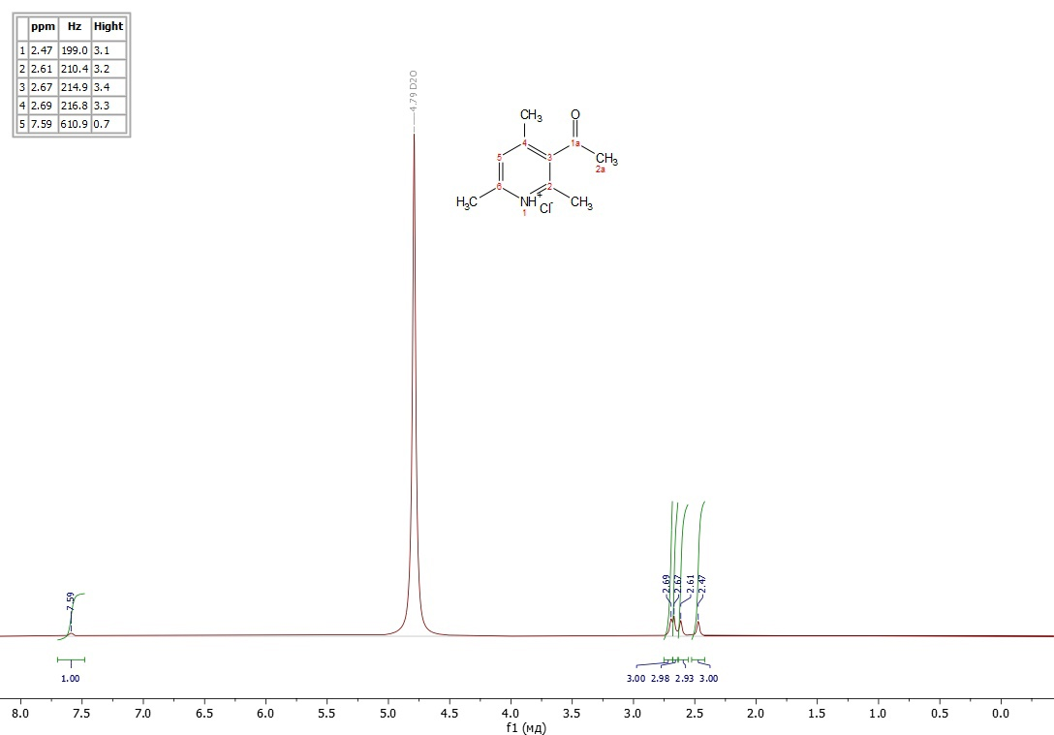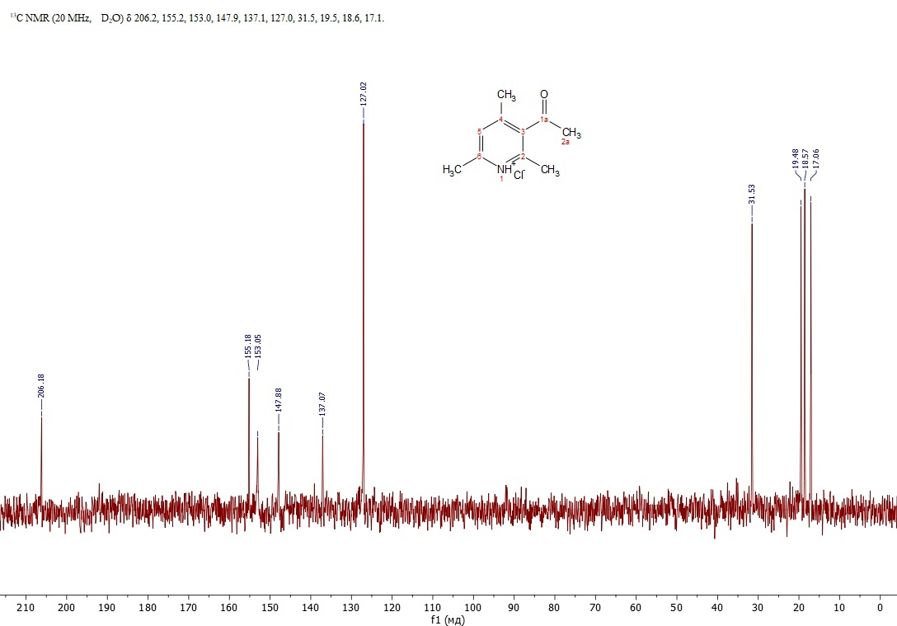

1H (80 MHz, D2O) and 13C (20 MHz, D2O) NMR Spectra of **7**

Copies of MS Spectra of Products





Mass spectrum of **3**





Mass spectrum of **4**





Mass spectrum of **5**





Mass spectrum of **6**

**Table 1.** Effect of studied samples on blood viscosity (mPa*s) at different spindle speeds in an in vitro blood hyperviscosity model

|  |  |  |  |  |  |  |  |  |  |
| --- | --- | --- | --- | --- | --- | --- | --- | --- | --- |
| **Researched indicator** | | **Blood viscosity (mPa*s) at various spindle speeds, revolutions per minute** | | | | | | | |
|  | | **2** | **4** | **6** | **8** | **12** | **20** | **40** | **60** |
| **3** | | | | | | | | | |
| Initial viscosity, n=3 | | 3.45±0.07 | 3.35±0.07 | 3.14±0.07 | 2.98±0.11 | 2.36±0.03 | 2.15±0.03 | 2.10±0.01 | 2.06±0.02 |
| Blood viscosity after incubation, n=6 | | 7.12±0.16  p1=0.000001 | 6.05±0.31  p1=0.0005 | 5.08±0.12  p1=0.00002 | 4.54±0.12  p1=0.0001 | 4.26±0.05  p1=0.00000004 | 3.48±0.04  p1=0.0000001 | 3.35±0.02  p1=0.000000001 | 3.25±0.02  p1=0.000000003 |
| Blood viscosity after incubation with **3**, n=6 | | 6.38±0.13  p1=0.000001  p2=0.0050 | 5.32±0.03  p1=0.00000001  p2=0.0387 | 4.72±0.17  p1=0.0005  p2=0.1184 | 4.25±0.05  p1=0.000004  p2=0.0411 | 4.08±0.02  p1=0.000000001  p2=0.0070 | 3.38±0.01  p1=0.0000000004  p2=0.0248 | 3.27±0.01  p1=0.0000000001  p2=0.0107 | 3.18±0.01  p1=0.0000000002  p2=0.0075 |
| **4** | | | | | | | | | |
| Initial viscosity, n=3 | | 3.33±0.04 | 3.19±0.04 | 3.12±0.01 | 3.04±0.03 | 2.51±0.03 | 2.28±0.04 | 2.20±0.02 | 2.17±0.02 |
| Blood viscosity after incubation, n=6 | | 6.08±0.25  p1=0.0001 | 5.81±0.23  p1=0.0001 | 5.40±0.28  p1=0.0008 | 5.17±0.28  p1=0.0012 | 4.96±0.29  p1=0.0007 | 3.69±0.07  p1=0.000005 | 3.37±0.04  p1=0.0000001 | 3.27±0.02  p1=0.000000003 |
| Blood viscosity after incubation with **4**, n=6 | | 4.99±0.26  p1=0.0032  p2=0.0126 | 4.67±0.19  p1=0.0010  p2=0.0032 | 4.46±0.17  p1=0.0010  p2=0.0155 | 4.19±0.10  p1=0.0001  p2=0.0080 | 3.94±0.15  p1=0.0003  p2=0.0105 | 3.48±0.06  p1=0.000003  p2=0.0490 | 3.27±0.05  p1=0.000002  p2=0.1124 | 3.17±0.04  p1=0.000001  p2=0.0666 |
| **5** | | | | | | | | | |
| Initial viscosity, n=3 | 5.10±0.88 | 4.41±0.66 | 3.85±0.35 | 3.58±0.24 | 2.79±0.01 | 2.50±0.13 | 2.36±0.09 | 2.31±0.08 |
| Blood viscosity after incubation, n=6 | 8.23±0.34  p1=0.0045 | 7.45±0.52  p1=0.0105 | 6.76±0.56  p1=0.0115 | 6.08±0.46  p1=0.0090 | 4.94±0.24  p1=0.0005 | 4.48±0.14  p1=0.0001 | 3.76±0.08  p1=0.00001 | 3.32±0.05  p1=0.00002 |
| Blood viscosity after incubation with **5**, n=6 | 6.25±0.06  p1=0.0906  p2=0.0002 | 5.75±0.15  p1=0.0272  p2=0.0107 | 4.85±0.20  p1=0.0304  p2=0.0096 | 4.38±0.11  p1=0.0099  p2=0.0053 | 4.14±0.05  p1=0.0000005  p2=0.0079 | 3.76±0.13  p1=0.0005  p2=0.0042 | 3.60±0.09  p1=0.0001  p2=0.2138 | 3.24±0.01  p1=0.0000004  p2=0.1196 |
| **6** | | | | | | | | |
| Initial viscosity, n=3 | 3.88±0.24 | 3.41±0.03 | 3.29±0.04 | 3.13±0.03 | 2.41±0.08 | 2.27±0.04 | 2.18±0.03 | 2.14±0.01 |
| Blood viscosity after incubation, n=6 | 12.69±1.04  p1=0.0007 | 8.75±0.32  p1=0.00001 | 7.03±0.44  p1=0.0006 | 6.17±0.31  p1=0.0003 | 4.19±0.04  p1=0.0000001 | 3.63±0.08  p1=0.00001 | 3.47±0.04  p1=0.0000003 | 3.34±0.02  p1=0.00000001 |
| Blood viscosity after incubation with **6**, n=6 | 11.32±1.23  p1=0.0046  p2=0.4138 | 8.46±0.37  p1=0.00003  p2=0.5632 | 6.93±0.41  p1=0.0005  p2=0.8603 | 5.38±0.16  p1=0.00002  p2=0.0477 | 3.90±0.16  p1=0.0005  p2=0.1179 | 3.54±0.11  p1=0.0001  p2=0.5662 | 3.37±0.06  p1=0.000004  p2=0.2414 | 3.27±0.05  p1=0.000002  p2=0.2230 |
| **7** | | | | | | | | |
| Initial viscosity, n=3 | 3.69±0.30 | 3.52±0.27 | 3.17±0.09 | 2.86±0.22 | 2.30±0.05 | 2.17±0.04 | 2.12±0.03 | 2.07±0.03 |
| Blood viscosity after incubation, n=6 | 5.06±0.23  p1=0.0088 | 4.55±0.19  p1=0.0151 | 4.27±0.07  p1=0.00003 | 3.86±0.17  p1=0.0114 | 3.60±0.13  p1=0.0003 | 3.32±0.04  p1=0.0000002 | 3.25±0.02  p1=0.00000003 | 3.20±0.02  p1=0.00000001 |
| Blood viscosity after incubation with **7**, n=6 | 4.64±0.19  p1=0.0276  p2=0.1899 | 4.53±0.22  p1=0.0273  p2=0.9413 | 4.17±0.06  p1=0.00004  p2=0.2973 | 3.70±0.18  p1=0.0253  p2=0.5469 | 3.53±0.15  p1=0.0010  p2=0.7318 | 3.28±0.05  p1=0.000001  p2=0.5182 | 3.21±0.03  p1=0.0000001  p2=0.3757 | 3.16±0.02  p1=0.000000005  p2=0.1575 |
| Note:  n is the number of samples in a group; p is the significance level;  p1<0.05 - statistically significant differences compared to baseline;  p2<0.05 - statistically significant differences compared to the corresponding values in control samples | | | | | | | | |