**Supplementary Information**

### Unveiling the anticancer, antimicrobial, antioxidative properties, and UPLC-ESI-QTOF-MS/ GC-MS metabolite profile of the lipophilic extract of Siam weed (*Chromolaena odorata*)

**Jun Hu1, Qinghua Qi1, Yibao Zhu1, Chaoling Wen2, Opeyemi Joshua Olatunji3, Titilope John Jayeoye4, Fredrick Nwude Eze5\***

1Second People’s Hospital of Wuhu City, 241001 Anhui, China

2Anhui Traditional Chinese Medicine College, Wuhu City 241001, Anhui China

3African Genome Center, Mohammed VI Polytechnic University (UM6P), Lot 660, Hay Moulay Rachid, Ben Guerir, 43150, Morocco.

4Department of Chemistry, Faculty of Science, Chulalongkorn University, Bangkok 10330, Thailand.

5Faculty of Pharmaceutical Sciences, Prince of Songkla University, Hat Yai, Songkhla 90112, 6 Thailand.

*Corresponding author

**Supplementary Figure captions**

**Figure S1.** (A) Base peak chromatogram, (B) extracted ion chromatogram (C) UV/Vis DAD signals obtained at λ210 nm, (D) at λ280 nm, (E) at λ320 nm, (F) at λ360 nm, and (G) at λ520 nm obtained from compounds detected during UPLC-MS analysis of *Chromolaena odorata* aerial part lipophilic extract.

**Figure S2.** UPLC-MS and MS/MS spectra of various metabolites identified in *Chromolaena odorata* aerial part lipophilic extract including (A) gallic acid, (B) chlorogenic acid, (C) phloridzin, (D) rutin, (E) (±)-catechin, (F) apigenin, (G) (±)-naringenin, (H) eriodictyol, and (I) luteolin.



**A**



**B**



**C**



**D**



**E**



**F**



**G**

**Figure S1**

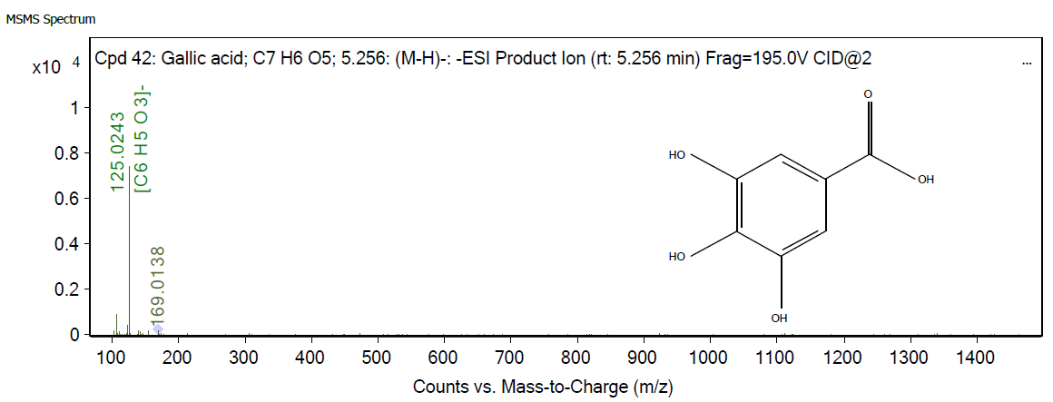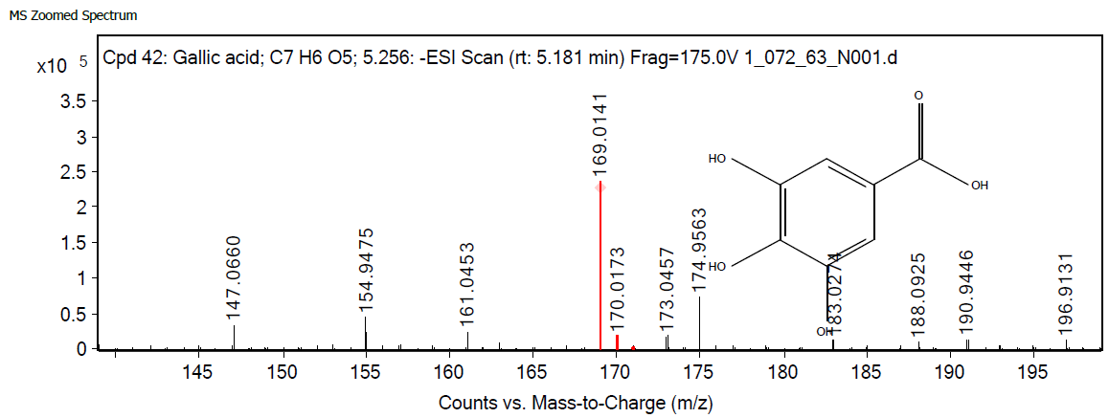

**A**

**Gallic acid**

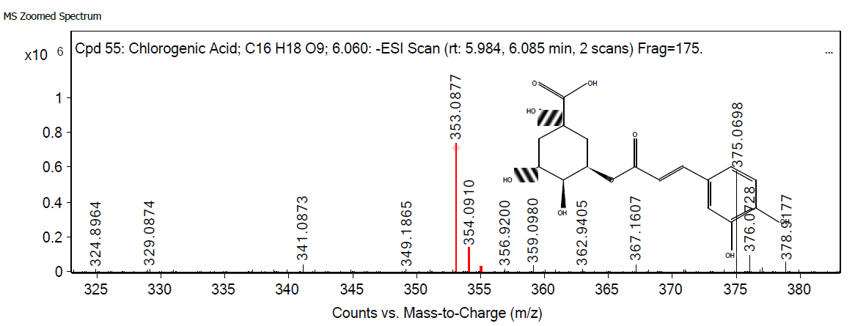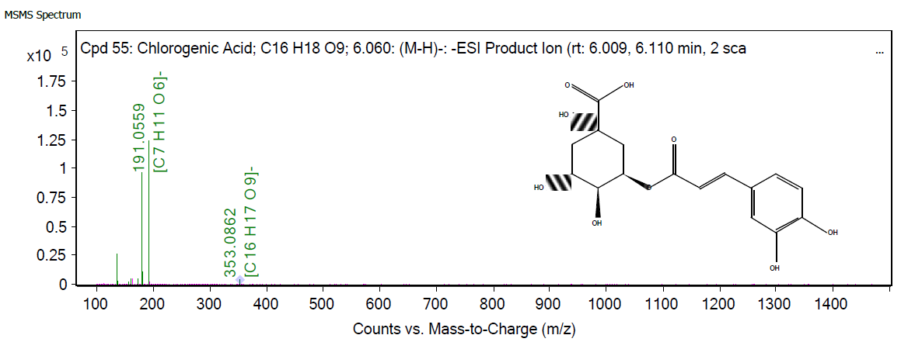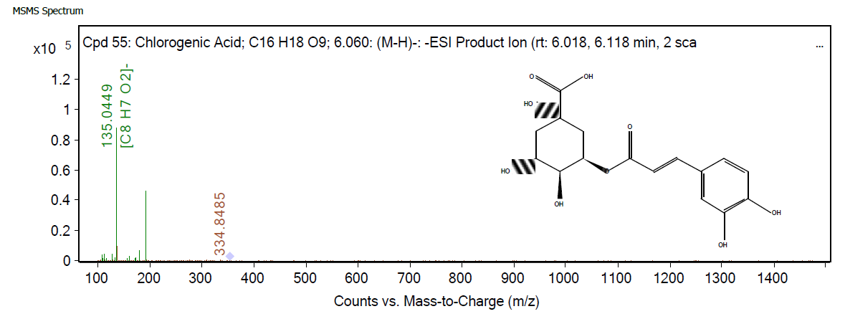

**B**

**Chlorogenic acid**

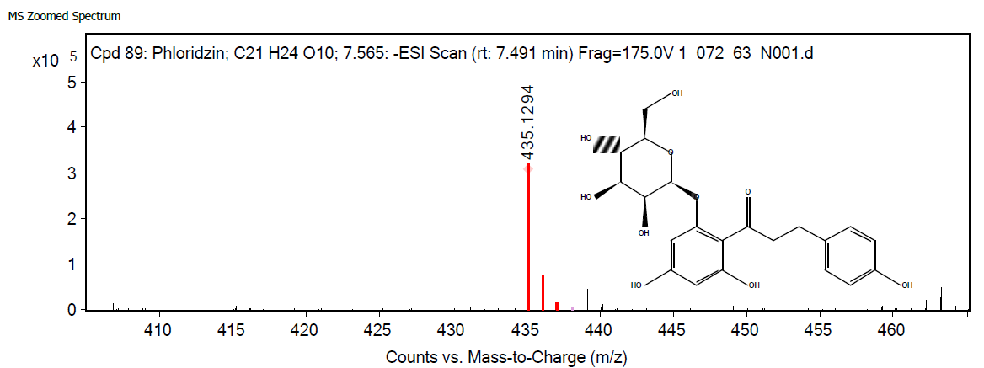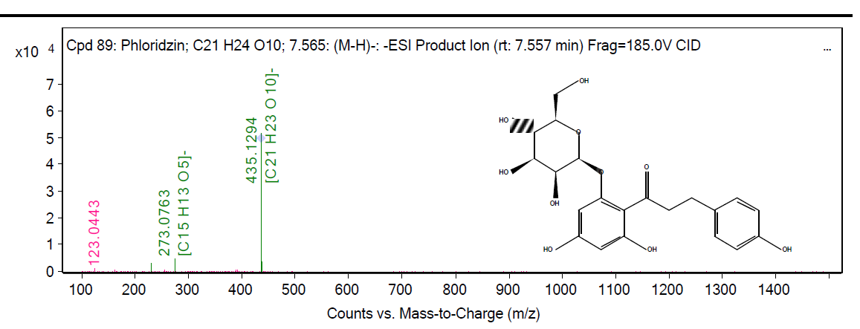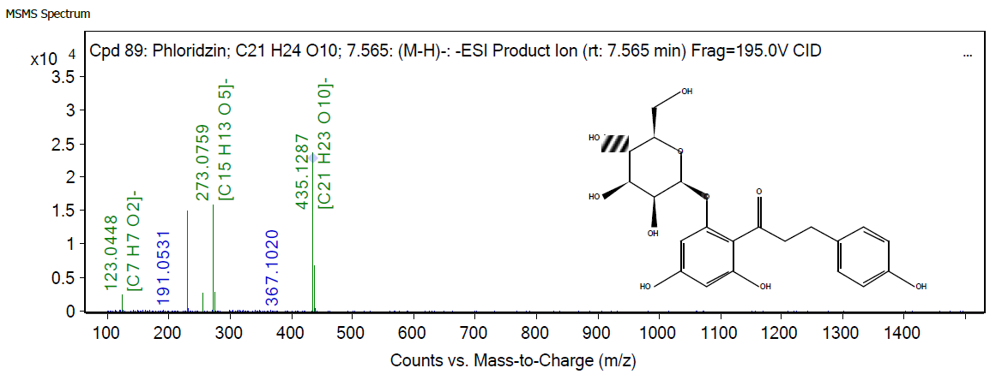

**C**

**Phloridzin**

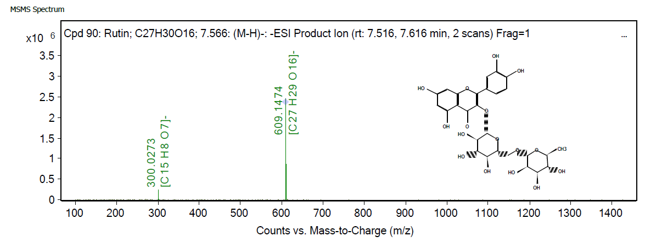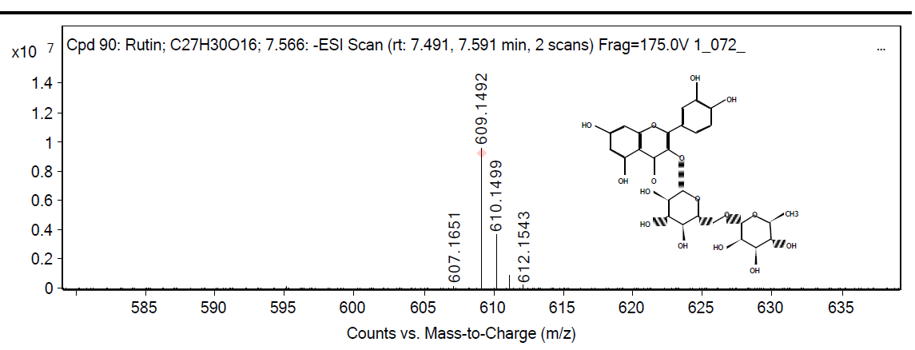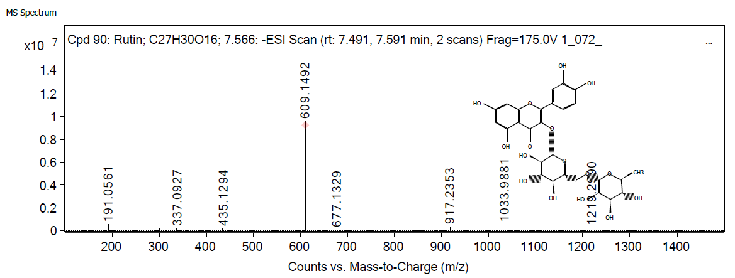

**D**

**Rutin**

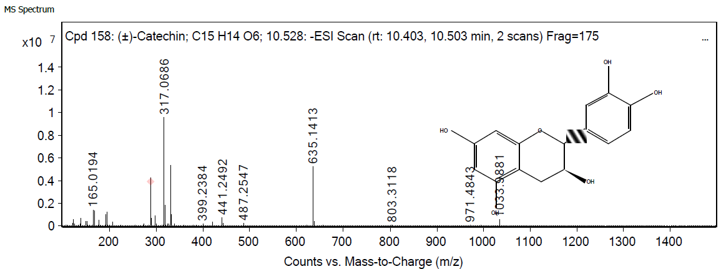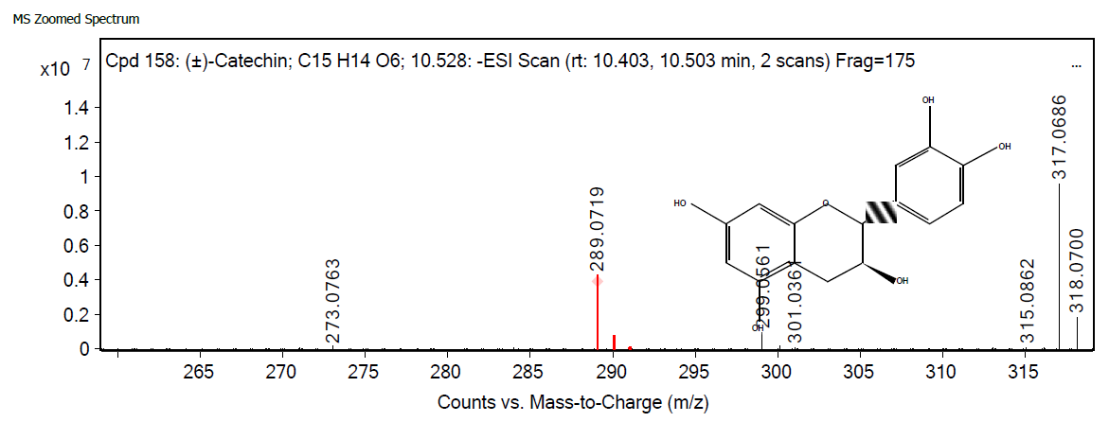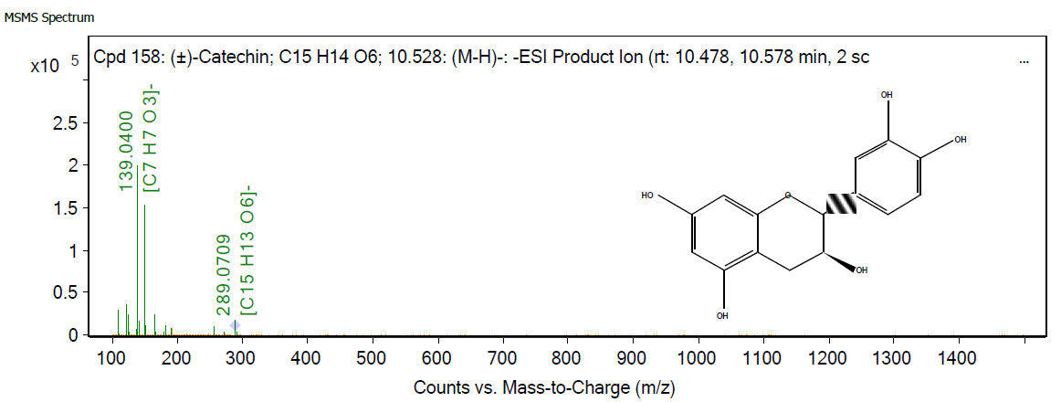

**E**

**(±)-Catechin**

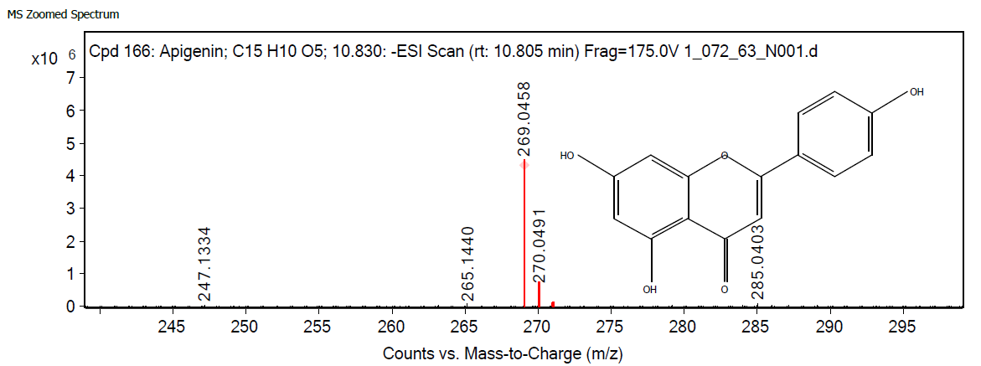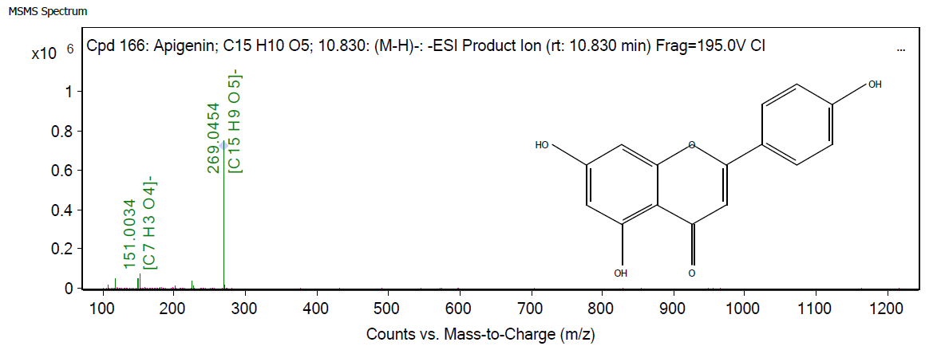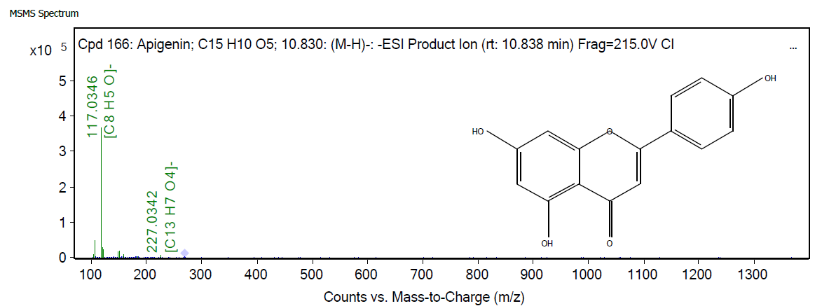

**F**

**Apigenin**

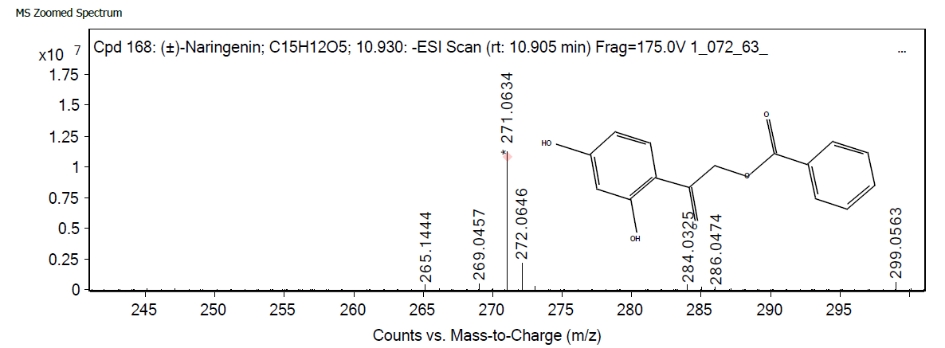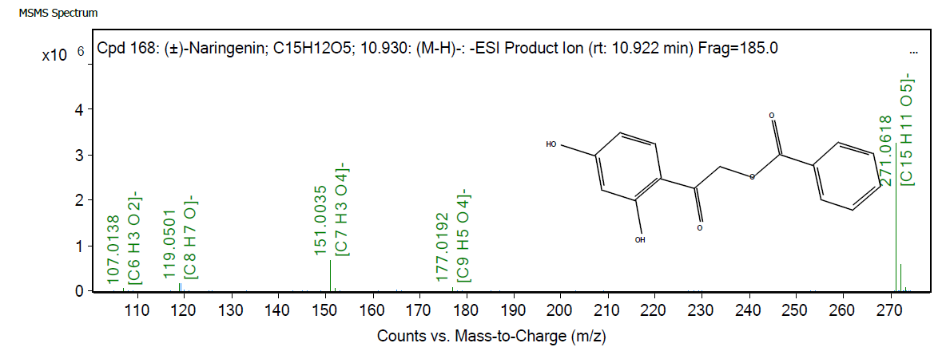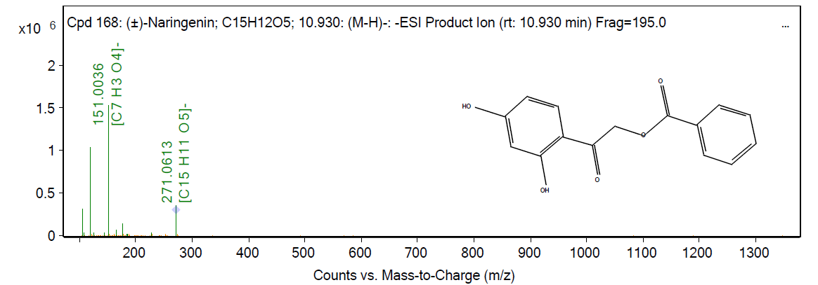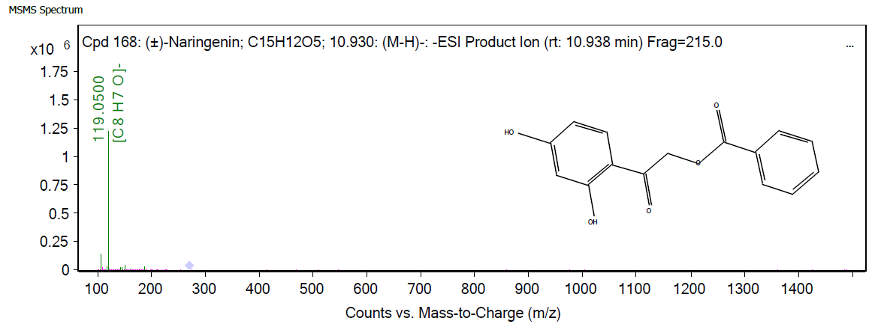

**G**

**(±)-Naringenin**

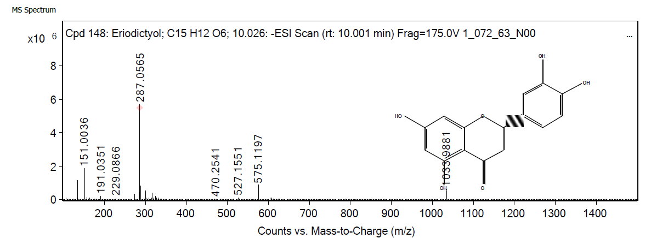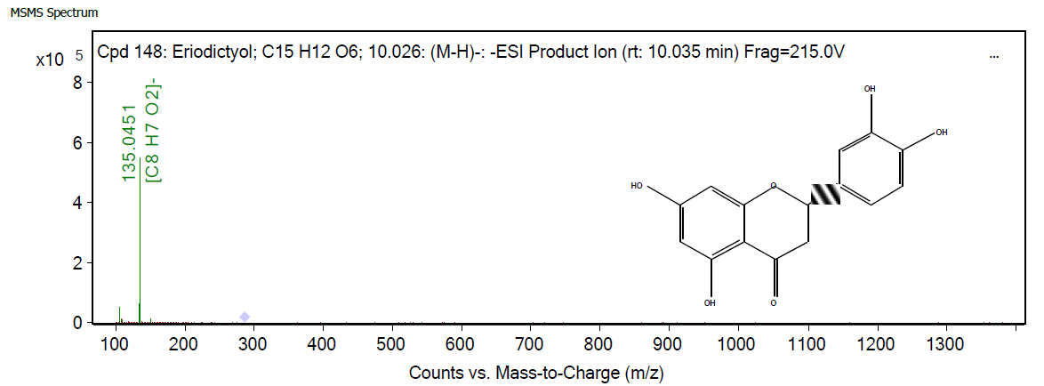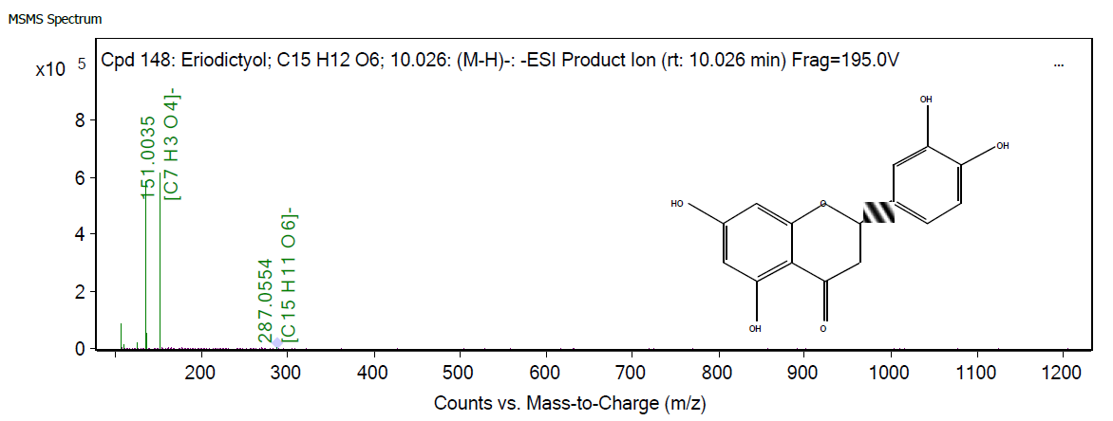

**H**

**Eriodictyol**

c

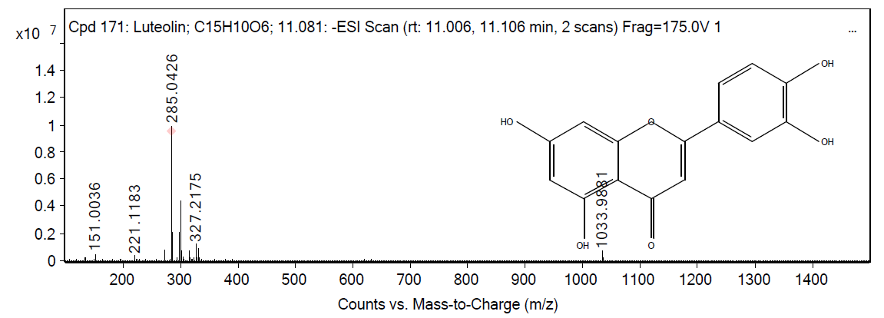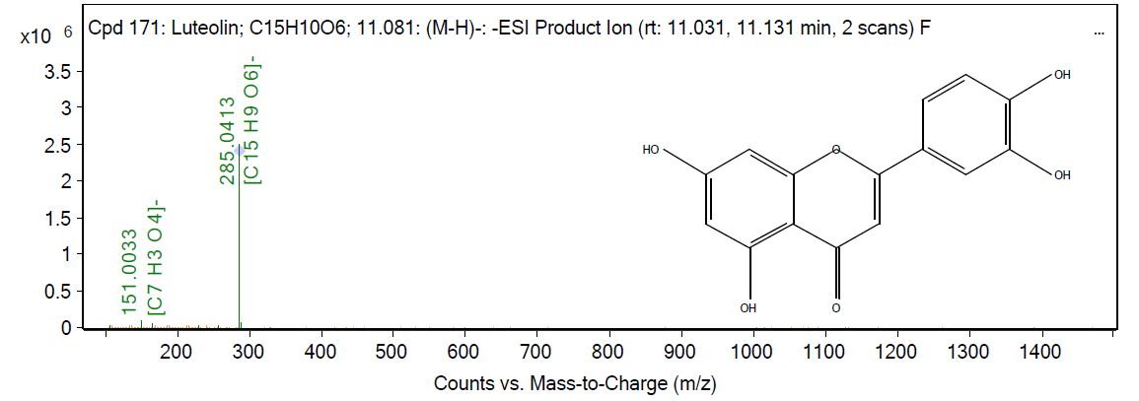

**I**

**Luteolin**

**Figure S2**