Supporting Information

**Synthesis, molecular modelling and docking studies of new thieno[2,3-*b*:4,5-*b*'] dipyridine compounds as antimicrobial agents**

**Noof A. Alenazi1, Ahmad Fawzi Qarah2, Mansoor Alsahag3, Haifa Alharbi4, Abrar Bayazeed****5, Salhah D. Al-Qahtani6, Nashwa M. El-Metwaly5,7\***

*1Department of Chemistry, College of Science and Humanities in Al-Kharj, Prince Sattam bin Abdulaziz University, Al-Kharj 11942, Saudi Arabia*

*2Department of Chemistry, College of Science, Taibah University, Madinah, P. O. Box 344, Saudi Arabia*

*3Department of laboratory Medicine, Faculty of Applied Medical Sciences, Albaha University, Saudi Arabia*

*4Department of Chemistry, College of Science, Northern Border University, Saudi Arabia*

*5Department of Chemistry, Faculty of Applied Sciences, Umm Al-Qura University, Makkah, Saudi Arabia*

*6Department of Chemistry, College of Science, Princess Nourah bint Abdulrahman University, P.O. Box 84428, Riyadh 11671, Saudi Arabia*

*7Department of Chemistry, Faculty of Science, Mansoura University, El-Gomhoria Street 35516, Egypt*

**DFT studies**

**Table S1**. The DFT dihedral angle data of the investigated compounds.

|  |  |  |  |  |  |
| --- | --- | --- | --- | --- | --- |
|  | **2** |  | **3** |  | **4** |
| C(13)-C(14)-N(17)-H(30) | 180.0 | C(13)-C(17)-N(19)-H(33) | 178.7 | C(13)-C(14)-N(15)-C(9) | 1.5 |
| C(13)-C(14)-N(17)-H(31) | 0.0 | C(13)-C(17)-N(19)-H(34) | 6.5 | C(18)-C(14)-N(15)-C(9) | -179.2 |
| N(15)-C(14)-N(17)-H(30) | 0.0 | O(20)-C(17)-N(19)-H(33) | 0.9 | C(12)-C(13)-C(17)-C(19) | 39.1 |
| N(15)-C(14)-N(17)-H(31) | 180.0 | O(20)-C(17)-N(19)-H(34) | -171.3 | C(12)-C(13)-C(17)-O(20) | -145.1 |
| C(13)-C(14)-N(15)-C(9) | 0.0 | C(13)-C(14)-N(18)-H(31) | 178.1 | C(14)-C(13)-C(17)-C(19) | -140.2 |
| N(17)-C(14)-N(15)-C(9) | 180.0 | C(13)-C(14)-N(18)-H(32) | -4.9 | C(14)-C(13)-C(17)-O(20) | 35.6 |
| C(12)-C(13)-C(18)-N(19) | 180.0 | N(15)-C(14)-N(18)-H(31) | -1.8 | C(12)-C(13)-C(14)-N(15) | -2.1 |
| C(14)-C(13)-C(18)-N(19) | 0.0 | N(15)-C(14)-N(18)-H(32) | 175.2 | C(12)-C(13)-C(14)-C(18) | 178.6 |
| C(12)-C(13)-C(14)-N(15) | 0.0 | C(13)-C(14)-N(15)-C(9) | 2.7 | C(17)-C(13)-C(14)-N(15) | 177.1 |
| C(12)-C(13)-C(14)-N(17) | -180.0 | N(18)-C(14)-N(15)-C(9) | -177.4 | C(17)-C(13)-C(14)-C(18) | -2.2 |
| C(18)-C(13)-C(14)-N(15) | 180.0 | C(12)-C(13)-C(17)-N(19) | 20.5 | C(8)-C(12)-C(13)-C(14) | 1.2 |
| C(18)-C(13)-C(14)-N(17) | 0.0 | C(12)-C(13)-C(17)-O(20) | -161.9 | C(8)-C(12)-C(13)-C(17) | -178.0 |
| C(8)-C(12)-C(13)-C(14) | 0.0 | C(14)-C(13)-C(17)-N(19) | -157.8 | C(16)-C(12)-C(13)-C(14) | -176.2 |
| C(8)-C(12)-C(13)-C(18) | 180.0 | C(14)-C(13)-C(17)-O(20) | 19.8 | C(16)-C(12)-C(13)-C(17) | 4.6 |
| C(16)-C(12)-C(13)-C(14) | 180.0 | C(12)-C(13)-C(14)-N(15) | -5.6 | C(5)-C(9)-N(15)-C(14) | 178.9 |
| C(16)-C(12)-C(13)-C(18) | 0.0 | C(12)-C(13)-C(14)-N(18) | 174.5 | C(8)-C(9)-N(15)-C(14) | 0.0 |
| C(5)-C(9)-N(15)-C(14) | 180.0 | C(17)-C(13)-C(14)-N(15) | 172.8 | S(7)-C(8)-C(12)-C(13) | -179.8 |
| C(8)-C(9)-N(15)-C(14) | 0.0 | C(17)-C(13)-C(14)-N(18) | -7.1 | S(7)-C(8)-C(12)-C(16) | -2.2 |
| S(7)-C(8)-C(12)-C(13) | 180.0 | C(8)-C(12)-C(13)-C(14) | 3.9 | C(9)-C(8)-C(12)-C(13) | 0.3 |
| S(7)-C(8)-C(12)-C(16) | 0.0 | C(8)-C(12)-C(13)-C(17) | -174.4 | C(9)-C(8)-C(12)-C(16) | 177.8 |
| C(9)-C(8)-C(12)-C(13) | 0.0 | C(16)-C(12)-C(13)-C(14) | -173.6 | S(7)-C(8)-C(9)-C(5) | 0.1 |
| C(9)-C(8)-C(12)-C(16) | 180.0 | C(16)-C(12)-C(13)-C(17) | 8.2 | S(7)-C(8)-C(9)-N(15) | 179.1 |
| S(7)-C(8)-C(9)-C(5) | 0.0 | C(5)-C(9)-N(15)-C(14) | 179.8 | C(12)-C(8)-C(9)-C(5) | -179.9 |
| S(7)-C(8)-C(9)-N(15) | 180.0 | C(8)-C(9)-N(15)-C(14) | 1.7 | C(12)-C(8)-C(9)-N(15) | -0.9 |
| C(12)-C(8)-C(9)-C(5) | 180.0 | S(7)-C(8)-C(12)-C(13) | 178.9 | C(4)-S(7)-C(8)-C(9) | 0.0 |
| C(12)-C(8)-C(9)-N(15) | 0.0 | S(7)-C(8)-C(12)-C(16) | -3.4 | C(4)-S(7)-C(8)-C(12) | -179.9 |
| C(4)-S(7)-C(8)-C(9) | 0.0 | C(9)-C(8)-C(12)-C(13) | 0.1 | C(4)-C(5)-C(9)-C(8) | -0.2 |
| C(4)-S(7)-C(8)-C(12) | -180.0 | C(9)-C(8)-C(12)-C(16) | 177.8 | C(4)-C(5)-C(9)-N(15) | -179.2 |
| C(4)-C(5)-C(9)-C(8) | 0.0 | S(7)-C(8)-C(9)-C(5) | -0.4 | C(6)-C(5)-C(9)-C(8) | 179.8 |
| C(4)-C(5)-C(9)-N(15) | 180.0 | S(7)-C(8)-C(9)-N(15) | 177.9 | C(6)-C(5)-C(9)-N(15) | 0.8 |
| C(6)-C(5)-C(9)-C(8) | 180.0 | C(12)-C(8)-C(9)-C(5) | 178.5 | C(4)-C(5)-C(6)-C(1) | -0.3 |
| C(6)-C(5)-C(9)-N(15) | 0.0 | C(12)-C(8)-C(9)-N(15) | -3.2 | C(4)-C(5)-C(6)-C(11) | 179.7 |
| C(4)-C(5)-C(6)-C(1) | 0.0 | C(4)-S(7)-C(8)-C(9) | 0.3 | C(9)-C(5)-C(6)-C(1) | 179.7 |
| C(4)-C(5)-C(6)-C(11) | -180.0 | C(4)-S(7)-C(8)-C(12) | -178.5 | C(9)-C(5)-C(6)-C(11) | -0.3 |
| C(9)-C(5)-C(6)-C(1) | 180.0 | C(4)-C(5)-C(9)-C(8) | 0.2 | N(3)-C(4)-S(7)-C(8) | 179.7 |
| C(9)-C(5)-C(6)-C(11) | 0.0 | C(4)-C(5)-C(9)-N(15) | -178.0 | C(5)-C(4)-S(7)-C(8) | -0.2 |
| N(3)-C(4)-S(7)-C(8) | -179.993 | C(6)-C(5)-C(9)-C(8) | 179.8 | N(3)-C(4)-C(5)-C(6) | 0.4 |
| C(5)-C(4)-S(7)-C(8) | -0.006 | C(6)-C(5)-C(9)-N(15) | 1.6 | N(3)-C(4)-C(5)-C(9) | -179.6 |
| N(3)-C(4)-C(5)-C(6) | -0.01 | C(4)-C(5)-C(6)-C(1) | -0.2 | S(7)-C(4)-C(5)-C(6) | -179.8 |
| N(3)-C(4)-C(5)-C(9) | 179.993 | C(4)-C(5)-C(6)-C(11) | 179.9 | S(7)-C(4)-C(5)-C(9) | 0.3 |
| S(7)-C(4)-C(5)-C(6) | -179.997 | C(9)-C(5)-C(6)-C(1) | -179.8 | C(2)-N(3)-C(4)-C(5) | -0.2 |
| S(7)-C(4)-C(5)-C(9) | 0.007 | C(9)-C(5)-C(6)-C(11) | 0.3 | C(2)-N(3)-C(4)-S(7) | 179.9 |
| C(2)-N(3)-C(4)-C(5) | 0.01 | N(3)-C(4)-S(7)-C(8) | 179.8 | C(1)-C(2)-N(3)-C(4) | 0.0 |
| C(2)-N(3)-C(4)-S(7) | 179.996 | C(5)-C(4)-S(7)-C(8) | -0.2 | C(10)-C(2)-N(3)-C(4) | -180.0 |
| C(1)-C(2)-N(3)-C(4) | -0.005 | N(3)-C(4)-C(5)-C(6) | 0.4 | C(2)-C(1)-C(6)-C(5) | 0.1 |
| C(10)-C(2)-N(3)-C(4) | 179.995 | N(3)-C(4)-C(5)-C(9) | -179.9 | C(2)-C(1)-C(6)-C(11) | -179.9 |
| C(2)-C(1)-C(6)-C(5) | 0 | S(7)-C(4)-C(5)-C(6) | -179.7 | C(6)-C(1)-C(2)-N(3) | 0.1 |
| C(2)-C(1)-C(6)-C(11) | 180 | S(7)-C(4)-C(5)-C(9) | 0.0 | C(6)-C(1)-C(2)-C(10) | 180.0 |
| C(6)-C(1)-C(2)-N(3) | 0 | C(2)-N(3)-C(4)-C(5) | -0.267 |  |  |
| C(6)-C(1)-C(2)-C(10) | 180 | C(2)-N(3)-C(4)-S(7) | 179.807 |  |  |
|  |  | C(1)-C(2)-N(3)-C(4) | -0.036 |  |  |
|  |  | C(10)-C(2)-N(3)-C(4) | -179.993 |  |  |
|  |  | C(2)-C(1)-C(6)-C(5) | -0.039 |  |  |
|  |  | C(2)-C(1)-C(6)-C(11) | 179.833 |  |  |
|  |  | C(6)-C(1)-C(2)-N(3) | 0.185 |  |  |
|  |  | C(6)-C(1)-C(2)-C(10) | -179.86 |  |  |
|  | **5** |  | **6** |  | **8** |
| C(17)-O(19)-C(21)-C(22) | -179.9 | C(13)-C(14)-N(15)-C(9) | 0.0 | C(17)-O(18)-C(20)-C(21) | -179.9 |
| C(13)-C(17)-O(19)-C(21) | 180.0 | C(12)-C(13)-C(14)-N(15) | 0.0 | C(13)-C(17)-O(18)-C(20) | 180.0 |
| O(20)-C(17)-O(19)-C(21) | 0.0 | C(8)-C(12)-O(16)-H(26) | -180.0 | O(19)-C(17)-O(18)-C(20) | 0.0 |
| C(13)-C(14)-N(15)-C(9) | 0.0 | C(13)-C(12)-O(16)-H(26) | 0.0 | C(13)-C(14)-N(15)-C(9) | 0.0 |
| C(18)-C(14)-N(15)-C(9) | -180.0 | C(8)-C(12)-C(13)-C(14) | 0.0 | C(12)-C(13)-C(17)-O(18) | 0.0 |
| C(12)-C(13)-C(17)-O(19) | 0.2 | O(16)-C(12)-C(13)-C(14) | -180.0 | C(12)-C(13)-C(17)-O(19) | -180.0 |
| C(12)-C(13)-C(17)-O(20) | -179.9 | C(5)-C(9)-N(15)-C(14) | 180.0 | C(14)-C(13)-C(17)-O(18) | -180.0 |
| C(14)-C(13)-C(17)-O(19) | -179.8 | C(8)-C(9)-N(15)-C(14) | 0.0 | C(14)-C(13)-C(17)-O(19) | 0.0 |
| C(14)-C(13)-C(17)-O(20) | 0.1 | S(7)-C(8)-C(12)-C(13) | -180.0 | C(12)-C(13)-C(14)-N(15) | 0.0 |
| C(12)-C(13)-C(14)-N(15) | 0.0 | S(7)-C(8)-C(12)-O(16) | 0.0 | C(17)-C(13)-C(14)-N(15) | 180.0 |
| C(12)-C(13)-C(14)-C(18) | 180.0 | C(9)-C(8)-C(12)-C(13) | 0.0 | C(8)-C(12)-O(16)-H(30) | -180.0 |
| C(17)-C(13)-C(14)-N(15) | 180.0 | C(9)-C(8)-C(12)-O(16) | 180.0 | C(13)-C(12)-O(16)-H(30) | 0.0 |
| C(17)-C(13)-C(14)-C(18) | 0.0 | S(7)-C(8)-C(9)-C(5) | 0.0 | C(8)-C(12)-C(13)-C(14) | 0.0 |
| C(8)-C(12)-C(13)-C(14) | 0.0 | S(7)-C(8)-C(9)-N(15) | 180.0 | C(8)-C(12)-C(13)-C(17) | -180.0 |
| C(8)-C(12)-C(13)-C(17) | -180.0 | C(12)-C(8)-C(9)-C(5) | -180.0 | O(16)-C(12)-C(13)-C(14) | -180.0 |
| C(16)-C(12)-C(13)-C(14) | -180.0 | C(12)-C(8)-C(9)-N(15) | 0.0 | O(16)-C(12)-C(13)-C(17) | 0.0 |
| C(16)-C(12)-C(13)-C(17) | 0.0 | C(4)-S(7)-C(8)-C(9) | 0.0 | C(5)-C(9)-N(15)-C(14) | -180.0 |
| C(5)-C(9)-N(15)-C(14) | 180.0 | C(4)-S(7)-C(8)-C(12) | 180.0 | C(8)-C(9)-N(15)-C(14) | 0.0 |
| C(8)-C(9)-N(15)-C(14) | 0.0 | C(4)-C(5)-C(9)-C(8) | 0.0 | S(7)-C(8)-C(12)-C(13) | -180.0 |
| S(7)-C(8)-C(12)-C(13) | -180.0 | C(4)-C(5)-C(9)-N(15) | -180.0 | S(7)-C(8)-C(12)-O(16) | 0.0 |
| S(7)-C(8)-C(12)-C(16) | 0.0 | C(6)-C(5)-C(9)-C(8) | -180.0 | C(9)-C(8)-C(12)-C(13) | 0.0 |
| C(9)-C(8)-C(12)-C(13) | 0.0 | C(6)-C(5)-C(9)-N(15) | 0.0 | C(9)-C(8)-C(12)-O(16) | 180.0 |
| C(9)-C(8)-C(12)-C(16) | 180.0 | C(4)-C(5)-C(6)-C(1) | 0.0 | S(7)-C(8)-C(9)-C(5) | 0.0 |
| S(7)-C(8)-C(9)-C(5) | 0.0 | C(4)-C(5)-C(6)-C(11) | -180.0 | S(7)-C(8)-C(9)-N(15) | 180.0 |
| S(7)-C(8)-C(9)-N(15) | 180.0 | C(9)-C(5)-C(6)-C(1) | 180.0 | C(12)-C(8)-C(9)-C(5) | 180.0 |
| C(12)-C(8)-C(9)-C(5) | 180.0 | C(9)-C(5)-C(6)-C(11) | 0.0 | C(12)-C(8)-C(9)-N(15) | 0.0 |
| C(12)-C(8)-C(9)-N(15) | 0.0 | N(3)-C(4)-S(7)-C(8) | 180.0 | C(4)-S(7)-C(8)-C(9) | 0.0 |
| C(4)-S(7)-C(8)-C(9) | 0.0 | C(5)-C(4)-S(7)-C(8) | 0.0 | C(4)-S(7)-C(8)-C(12) | -180.0 |
| C(4)-S(7)-C(8)-C(12) | -180.0 | N(3)-C(4)-C(5)-C(6) | 0.0 | C(4)-C(5)-C(9)-C(8) | 0.0 |
| C(4)-C(5)-C(9)-C(8) | 0.0 | N(3)-C(4)-C(5)-C(9) | -180.0 | C(4)-C(5)-C(9)-N(15) | -180.0 |
| C(4)-C(5)-C(9)-N(15) | -180.0 | S(7)-C(4)-C(5)-C(6) | 180.0 | C(6)-C(5)-C(9)-C(8) | -180.0 |
| C(6)-C(5)-C(9)-C(8) | -180.0 | S(7)-C(4)-C(5)-C(9) | 0.0 | C(6)-C(5)-C(9)-N(15) | 0.0 |
| C(6)-C(5)-C(9)-N(15) | 0.0 | C(2)-N(3)-C(4)-C(5) | 0.0 | C(4)-C(5)-C(6)-C(1) | 0.0 |
| C(4)-C(5)-C(6)-C(1) | 0.0 | C(2)-N(3)-C(4)-S(7) | -180.0 | C(4)-C(5)-C(6)-C(11) | -180.0 |
| C(4)-C(5)-C(6)-C(11) | -180.0 | C(1)-C(2)-N(3)-C(4) | 0.0 | C(9)-C(5)-C(6)-C(1) | 180.0 |
| C(9)-C(5)-C(6)-C(1) | 180.0 | C(10)-C(2)-N(3)-C(4) | -179.9 | C(9)-C(5)-C(6)-C(11) | 0.0 |
| C(9)-C(5)-C(6)-C(11) | 0.0 | C(2)-C(1)-C(6)-C(5) | 0.0 | N(3)-C(4)-S(7)-C(8) | 180.0 |
| N(3)-C(4)-S(7)-C(8) | 180.0 | C(2)-C(1)-C(6)-C(11) | -180.0 | C(5)-C(4)-S(7)-C(8) | 0.0 |
| C(5)-C(4)-S(7)-C(8) | 0.0 | C(6)-C(1)-C(2)-N(3) | 0.0 | N(3)-C(4)-C(5)-C(6) | 0.0 |
| N(3)-C(4)-C(5)-C(6) | 0.0 | C(6)-C(1)-C(2)-C(10) | 179.9 | N(3)-C(4)-C(5)-C(9) | -180.0 |
| N(3)-C(4)-C(5)-C(9) | -180.0 |  |  | S(7)-C(4)-C(5)-C(6) | 180.0 |
| S(7)-C(4)-C(5)-C(6) | 180.0 |  |  | S(7)-C(4)-C(5)-C(9) | 0.0 |
| S(7)-C(4)-C(5)-C(9) | 0.0 |  |  | C(2)-N(3)-C(4)-C(5) | 0.0 |
| C(2)-N(3)-C(4)-C(5) | 0.0 |  |  | C(2)-N(3)-C(4)-S(7) | -180.0 |
| C(2)-N(3)-C(4)-S(7) | -180.0 |  |  | C(1)-C(2)-N(3)-C(4) | 0.0 |
| C(1)-C(2)-N(3)-C(4) | 0.0 |  |  | C(10)-C(2)-N(3)-C(4) | -180.0 |
| C(10)-C(2)-N(3)-C(4) | -180.0 |  |  | C(2)-C(1)-C(6)-C(5) | 0.0 |
| C(2)-C(1)-C(6)-C(5) | 0.0 |  |  | C(2)-C(1)-C(6)-C(11) | -180.0 |
| C(2)-C(1)-C(6)-C(11) | 180.0 |  |  | C(6)-C(1)-C(2)-N(3) | 0.0 |
| C(6)-C(1)-C(2)-N(3) | 0.0 |  |  | C(6)-C(1)-C(2)-C(10) | 180.0 |
| C(6)-C(1)-C(2)-C(10) | 180.0 |  |  |  |  |

**Table S2**. The DFT bond angle data of the investigated compounds.

|  |  |  |  |  |  |  |  |  |
| --- | --- | --- | --- | --- | --- | --- | --- | --- |
|  | **2** |  |  | **3** |  |  | **4** |  |
| **Angle** | **(°)** | **Std.** | **Angle** | **(°)** | **Std.** | **Angle** | **(°)** | **Std.** |
| N(19)-C(18)-C(13) | 176.395 | 180 | H(34)-N(19)-H(33) | 119.655 | 119 | O(20)-C(17)-C(19) | 118.992 | 123 |
| H(31)-N(17)-H(30) | 120.167 | 119 | H(34)-N(19)-C(17) | 123.415 | 120 | O(20)-C(17)-C(13) | 120.446 | 123 |
| H(31)-N(17)-C(14) | 121.752 | 120 | H(33)-N(19)-C(17) | 116.47 | 120 | C(19)-C(17)-C(13) | 120.43 | 115 |
| H(30)-N(17)-C(14) | 118.081 | 120 | H(32)-N(18)-H(31) | 124.958 | 119 | C(14)-N(15)-C(9) | 119.224 | 115 |
| C(14)-N(15)-C(9) | 118.34 | 115 | H(32)-N(18)-C(14) | 117.248 | 119 | C(18)-C(14)-N(15) | 115.378 | 115 |
| N(17)-C(14)-N(15) | 117.421 | 126 | H(31)-N(18)-C(14) | 117.72 | 119 | C(18)-C(14)-C(13) | 123.067 | 121 |
| N(17)-C(14)-C(13) | 120.583 | 120 | O(20)-C(17)-N(19) | 118.099 | 123 | N(15)-C(14)-C(13) | 121.551 | 120 |
| N(15)-C(14)-C(13) | 121.996 | 120 | O(20)-C(17)-C(13) | 122.116 | 123 | C(17)-C(13)-C(14) | 118.495 | 118 |
| C(18)-C(13)-C(14) | 118.414 | 120 | N(19)-C(17)-C(13) | 119.746 | 113 | C(17)-C(13)-C(12) | 121.597 | 118 |
| C(18)-C(13)-C(12) | 121.566 | 120 | C(14)-N(15)-C(9) | 118.614 | 115 | C(14)-C(13)-C(12) | 119.904 | 120 |
| C(14)-C(13)-C(12) | 120.02 | 120 | N(18)-C(14)-N(15) | 116.242 | 126 | C(16)-C(12)-C(13) | 124.607 | 121 |
| C(16)-C(12)-C(13) | 122.09 | 121 | N(18)-C(14)-C(13) | 121.344 | 120 | C(16)-C(12)-C(8) | 118.871 | 121 |
| C(16)-C(12)-C(8) | 121.546 | 121 | N(15)-C(14)-C(13) | 122.414 | 120 | C(13)-C(12)-C(8) | 116.47 | 120 |
| C(13)-C(12)-C(8) | 116.365 | 120 | C(17)-C(13)-C(14) | 117.602 | 118 | N(15)-C(9)-C(8) | 121.541 | 120 |
| N(15)-C(9)-C(8) | 122.147 | 120 | C(17)-C(13)-C(12) | 124.095 | 118 | N(15)-C(9)-C(5) | 125.206 | 120 |
| N(15)-C(9)-C(5) | 125.055 | 120 | C(14)-C(13)-C(12) | 118.283 | 120 | C(8)-C(9)-C(5) | 113.245 | 120 |
| C(8)-C(9)-C(5) | 112.798 | 120 | C(16)-C(12)-C(13) | 124.785 | 121 | C(12)-C(8)-C(9) | 121.279 | 120 |
| C(12)-C(8)-C(9) | 121.133 | 120 | C(16)-C(12)-C(8) | 117.907 | 121 | C(12)-C(8)-S(7) | 125.862 | 119 |
| C(12)-C(8)-S(7) | 125.655 | 119 | C(13)-C(12)-C(8) | 117.262 | 120 | C(9)-C(8)-S(7) | 112.86 | 119 |
| C(9)-C(8)-S(7) | 113.212 | 119 | N(15)-C(9)-C(8) | 121.83 | 120 | C(8)-S(7)-C(4) | 88.672 | 98.5 |
| C(8)-S(7)-C(4) | 88.52 | 98.5 | N(15)-C(9)-C(5) | 125.115 | 120 | C(11)-C(6)-C(5) | 121.709 | 121 |
| C(11)-C(6)-C(5) | 121.759 | 121 | C(8)-C(9)-C(5) | 113.031 | 120 | C(11)-C(6)-C(1) | 121.676 | 121 |
| C(11)-C(6)-C(1) | 121.508 | 121 | C(12)-C(8)-C(9) | 121.359 | 120 | C(5)-C(6)-C(1) | 116.615 | 120 |
| C(5)-C(6)-C(1) | 116.733 | 120 | C(12)-C(8)-S(7) | 125.827 | 119 | C(9)-C(5)-C(6) | 129.927 | 120 |
| C(9)-C(5)-C(6) | 129.924 | 120 | C(9)-C(8)-S(7) | 112.804 | 119 | C(9)-C(5)-C(4) | 112.694 | 120 |
| C(9)-C(5)-C(4) | 112.754 | 120 | C(8)-S(7)-C(4) | 88.638 | 98.5 | C(6)-C(5)-C(4) | 117.379 | 120 |
| C(6)-C(5)-C(4) | 117.323 | 120 | C(11)-C(6)-C(5) | 121.715 | 121 | S(7)-C(4)-C(5) | 112.528 | 119 |
| S(7)-C(4)-C(5) | 112.716 | 119 | C(11)-C(6)-C(1) | 121.555 | 121 | S(7)-C(4)-N(3) | 121.545 | 126 |
| S(7)-C(4)-N(3) | 121.488 | 126 | C(5)-C(6)-C(1) | 116.729 | 120 | C(5)-C(4)-N(3) | 125.927 | 120 |
| C(5)-C(4)-N(3) | 125.796 | 120 | C(9)-C(5)-C(6) | 129.813 | 120 | C(4)-N(3)-C(2) | 117.241 | 115 |
| C(4)-N(3)-C(2) | 117.368 | 115 | C(9)-C(5)-C(4) | 112.807 | 120 | C(10)-C(2)-N(3) | 116.661 | 115 |
| C(10)-C(2)-N(3) | 116.684 | 115 | C(6)-C(5)-C(4) | 117.378 | 120 | C(10)-C(2)-C(1) | 122.358 | 121 |
| C(10)-C(2)-C(1) | 122.348 | 121 | S(7)-C(4)-C(5) | 112.718 | 119 | N(3)-C(2)-C(1) | 120.98 | 120 |
| N(3)-C(2)-C(1) | 120.968 | 120 | S(7)-C(4)-N(3) | 121.484 | 126 | C(6)-C(1)-C(2) | 121.857 | 120 |
| C(6)-C(1)-C(2) | 121.812 | 120 | C(5)-C(4)-N(3) | 125.798 | 120 | RSMD | 2.14E+01 |  |
| RSMD | 3.56E+01 |  | C(4)-N(3)-C(2) | 117.315 | 115 |  |  |  |
|  |  |  | C(10)-C(2)-N(3) | 116.643 | 115 |  |  |  |
|  |  |  | C(10)-C(2)-C(1) | 122.348 | 121 |  |  |  |
|  |  |  | N(3)-C(2)-C(1) | 121.008 | 120 |  |  |  |
|  |  |  | C(6)-C(1)-C(2) | 121.769 | 120 |  |  |  |
|  |  |  | RSMD | 4.24E+01 | max |  |  |  |
|  | **5** |  |  | **6** |  |  | **8** |  |
| **Angle** | **(°)** | **Std.** | **Angle** | **(°)** | **Std.** | **Angle** | **(°)** | **Std.** |
| C(22)-C(21)-O(19) | 106.959 | 107 | H(26)-O(16)-C(12) | 113.325 | 108 | C(21)-C(20)-O(18) | 107.288 | 107 |
| C(21)-O(19)-C(17) | 115.301 | 110 | C(14)-N(15)-C(9) | 117.341 | 115 | C(20)-O(18)-C(17) | 116.48 | 110 |
| O(20)-C(17)-O(19) | 120.077 | 122 | N(15)-C(14)-C(13) | 123.63 | 124 | O(19)-C(17)-O(18) | 120.53 | 122 |
| O(20)-C(17)-C(13) | 125.633 | 123 | C(14)-C(13)-C(12) | 119.219 | 120 | O(19)-C(17)-C(13) | 127.221 | 123 |
| O(19)-C(17)-C(13) | 114.291 | 124 | O(16)-C(12)-C(13) | 124.595 | 124 | O(18)-C(17)-C(13) | 112.249 | 124 |
| C(14)-N(15)-C(9) | 119.294 | 115 | O(16)-C(12)-C(8) | 117.6 | 124 | H(30)-O(16)-C(12) | 108.685 | 108 |
| C(18)-C(14)-N(15) | 114.404 | 115 | C(13)-C(12)-C(8) | 117.804 | 120 | C(14)-N(15)-C(9) | 117.274 | 115 |
| C(18)-C(14)-C(13) | 123.933 | 121 | N(15)-C(9)-C(8) | 122.268 | 120 | N(15)-C(14)-C(13) | 124.051 | 124 |
| N(15)-C(14)-C(13) | 121.663 | 120 | N(15)-C(9)-C(5) | 125.463 | 120 | C(17)-C(13)-C(14) | 117.903 | 118 |
| C(17)-C(13)-C(14) | 117.629 | 118 | C(8)-C(9)-C(5) | 112.27 | 120 | C(17)-C(13)-C(12) | 123.208 | 118 |
| C(17)-C(13)-C(12) | 122.617 | 118 | C(12)-C(8)-C(9) | 119.738 | 120 | C(14)-C(13)-C(12) | 118.889 | 120 |
| C(14)-C(13)-C(12) | 119.754 | 120 | C(12)-C(8)-S(7) | 126.292 | 119 | O(16)-C(12)-C(13) | 123.924 | 124 |
| C(16)-C(12)-C(13) | 125.46 | 121 | C(9)-C(8)-S(7) | 113.97 | 119 | O(16)-C(12)-C(8) | 119.122 | 124 |
| C(16)-C(12)-C(8) | 118.421 | 121 | C(8)-S(7)-C(4) | 88.221 | 98.5 | C(13)-C(12)-C(8) | 116.954 | 120 |
| C(13)-C(12)-C(8) | 116.119 | 120 | C(11)-C(6)-C(5) | 121.603 | 121 | N(15)-C(9)-C(8) | 122.361 | 120 |
| N(15)-C(9)-C(8) | 121.549 | 120 | C(11)-C(6)-C(1) | 121.81 | 121 | N(15)-C(9)-C(5) | 125.233 | 120 |
| N(15)-C(9)-C(5) | 124.927 | 120 | C(5)-C(6)-C(1) | 116.587 | 120 | C(8)-C(9)-C(5) | 112.406 | 120 |
| C(8)-C(9)-C(5) | 113.524 | 120 | C(9)-C(5)-C(6) | 129.814 | 120 | C(12)-C(8)-C(9) | 120.471 | 120 |
| C(12)-C(8)-C(9) | 121.621 | 120 | C(9)-C(5)-C(4) | 112.725 | 120 | C(12)-C(8)-S(7) | 125.539 | 119 |
| C(12)-C(8)-S(7) | 125.941 | 119 | C(6)-C(5)-C(4) | 117.462 | 120 | C(9)-C(8)-S(7) | 113.99 | 119 |
| C(9)-C(8)-S(7) | 112.438 | 119 | S(7)-C(4)-C(5) | 112.815 | 119 | C(8)-S(7)-C(4) | 88.201 | 98.5 |
| C(8)-S(7)-C(4) | 88.809 | 98.5 | S(7)-C(4)-N(3) | 121.34 | 126 | C(11)-C(6)-C(5) | 121.729 | 121 |
| C(11)-C(6)-C(5) | 121.716 | 121 | C(5)-C(4)-N(3) | 125.845 | 120 | C(11)-C(6)-C(1) | 121.792 | 121 |
| C(11)-C(6)-C(1) | 121.782 | 121 | C(4)-N(3)-C(2) | 117.22 | 115 | C(5)-C(6)-C(1) | 116.479 | 120 |
| C(5)-C(6)-C(1) | 116.502 | 120 | C(10)-C(2)-N(3) | 117.251 | 115 | C(9)-C(5)-C(6) | 129.872 | 120 |
| C(9)-C(5)-C(6) | 129.859 | 120 | C(10)-C(2)-C(1) | 121.753 | 121 | C(9)-C(5)-C(4) | 112.613 | 120 |
| C(9)-C(5)-C(4) | 112.604 | 120 | N(3)-C(2)-C(1) | 120.996 | 120 | C(6)-C(5)-C(4) | 117.516 | 120 |
| C(6)-C(5)-C(4) | 117.536 | 120 | C(6)-C(1)-C(2) | 121.89 | 120 | S(7)-C(4)-C(5) | 112.791 | 119 |
| S(7)-C(4)-C(5) | 112.625 | 119 | RSMD | 3.26E+01 |  | S(7)-C(4)-N(3) | 121.396 | 126 |
| S(7)-C(4)-N(3) | 121.53 | 126 |  |  |  | C(5)-C(4)-N(3) | 125.814 | 120 |
| C(5)-C(4)-N(3) | 125.845 | 120 |  |  |  | C(4)-N(3)-C(2) | 117.167 | 115 |
| C(4)-N(3)-C(2) | 117.139 | 115 |  |  |  | C(10)-C(2)-N(3) | 117.251 | 115 |
| C(10)-C(2)-N(3) | 117.227 | 115 |  |  |  | C(10)-C(2)-C(1) | 121.686 | 121 |
| C(10)-C(2)-C(1) | 121.691 | 121 |  |  |  | N(3)-C(2)-C(1) | 121.064 | 120 |
| N(3)-C(2)-C(1) | 121.082 | 120 |  |  |  | C(6)-C(1)-C(2) | 121.961 | 120 |
| C(6)-C(1)-C(2) | 121.895 | 120 |  |  |  | RSMD | 2.12E+01 |  |
| RSMD | 2.08E+01 |  |  |  |  |  |  |  |

**Table S3.** The DFT bond length data of the investigated compounds.

|  |  |  |  |  |  |  |  |  |  |
| --- | --- | --- | --- | --- | --- | --- | --- | --- | --- |
|  | **2** |  |  | **3** | |  |  | **4** |  |
| **Bond** | **Å** | **Std.** | **Bond** | **Å** | | **Std.** | **Bond** | **Å** | **Std.** |
| C(18)-N(19) | 1.18 | 1.16 | N(19)-H(34) | 1.01 | | 1.01 | C(17)-O(20) | 1.25 | 1.21 |
| N(17)-H(31) | 1.02 | 1.05 | N(19)-H(33) | 1.02 | | 1.01 | C(17)-C(19) | 1.50 | 1.51 |
| N(17)-H(30) | 1.02 | 1.05 | N(18)-H(32) | 1.03 | | 1.05 | C(14)-C(18) | 1.49 | 1.50 |
| C(14)-N(17) | 1.35 | 1.46 | N(18)-H(31) | 1.02 | | 1.05 | C(14)-N(15) | 1.34 | 1.36 |
| C(14)-N(15) | 1.34 | 1.36 | C(17)-O(20) | 1.27 | | 1.21 | C(13)-C(17) | 1.47 | 1.52 |
| C(13)-C(18) | 1.40 | 1.47 | C(17)-N(19) | 1.36 | | 1.37 | C(13)-C(14) | 1.42 | 1.42 |
| C(13)-C(14) | 1.43 | 1.42 | C(14)-N(18) | 1.35 | | 1.46 | C(12)-C(16) | 1.49 | 1.50 |
| C(12)-C(16) | 1.48 | 1.50 | C(14)-N(15) | 1.35 | | 1.36 | C(12)-C(13) | 1.41 | 1.42 |
| C(12)-C(13) | 1.40 | 1.42 | C(13)-C(17) | 1.46 | | 1.52 | C(9)-N(15) | 1.35 | 1.36 |
| C(9)-N(15) | 1.35 | 1.36 | C(13)-C(14) | 1.44 | | 1.42 | C(8)-C(12) | 1.39 | 1.42 |
| C(8)-C(12) | 1.39 | 1.42 | C(12)-C(16) | 1.49 | | 1.50 | C(8)-C(9) | 1.40 | 1.42 |
| C(8)-C(9) | 1.41 | 1.42 | C(12)-C(13) | 1.41 | | 1.42 | S(7)-C(8) | 1.80 | 1.66 |
| S(7)-C(8) | 1.80 | 1.66 | C(9)-N(15) | 1.34 | | 1.36 | C(6)-C(11) | 1.48 | 1.50 |
| C(6)-C(11) | 1.48 | 1.50 | C(8)-C(12) | 1.39 | | 1.42 | C(5)-C(9) | 1.43 | 1.42 |
| C(5)-C(9) | 1.43 | 1.42 | C(8)-C(9) | 1.41 | | 1.42 | C(5)-C(6) | 1.41 | 1.42 |
| C(5)-C(6) | 1.41 | 1.42 | S(7)-C(8) | 1.81 | | 1.66 | C(4)-S(7) | 1.82 | 1.66 |
| C(4)-S(7) | 1.82 | 1.66 | C(6)-C(11) | 1.48 | | 1.50 | C(4)-C(5) | 1.40 | 1.42 |
| C(4)-C(5) | 1.41 | 1.42 | C(5)-C(9) | 1.44 | | 1.42 | N(3)-C(4) | 1.32 | 1.36 |
| N(3)-C(4) | 1.32 | 1.36 | C(5)-C(6) | 1.40 | | 1.42 | C(2)-C(10) | 1.48 | 1.50 |
| C(2)-C(10) | 1.48 | 1.50 | C(4)-S(7) | 1.82 | | 1.66 | C(2)-N(3) | 1.35 | 1.36 |
| C(2)-N(3) | 1.35 | 1.36 | C(4)-C(5) | 1.41 | | 1.42 | C(1)-C(6) | 1.39 | 1.42 |
| C(1)-C(6) | 1.39 | 1.42 | N(3)-C(4) | 1.32 | | 1.36 | C(1)-C(2) | 1.40 | 1.42 |
| C(1)-C(2) | 1.40 | 1.42 | C(2)-C(10) | 1.48 | | 1.50 | RSMD | 5.02E-02 |  |
| RSMD | 5.49E-02 |  | C(2)-N(3) | 1.35 | | 1.36 |  |  |  |
|  |  |  | C(1)-C(6) | 1.39 | | 1.42 |  |  |  |
|  |  |  | C(1)-C(2) | 1.40 | | 1.42 |  |  |  |
|  |  |  | RSMD | 5.36E-02 | |  |  |  |  |
|  | **5** |  |  | **6** | |  |  | **8** |  |
| **Bond** | **Å** | **Std.** | **Bond** | **Å** | | **Std.** | **Bond** | **Å** | **Std.** |
| C(21)-C(22) | 1.50 | 1.51 | O(16)-H(26) | | 0.98 | 0.97 | C(20)-C(21) | 1.50 | 1.51 |
| O(19)-C(21) | 1.46 | 1.39 | C(14)-N(15) | | 1.34 | 1.36 | O(18)-C(20) | 1.46 | 1.39 |
| C(17)-O(20) | 1.24 | 1.21 | C(13)-C(14) | | 1.39 | 1.42 | C(17)-O(19) | 1.23 | 1.21 |
| C(17)-O(19) | 1.37 | 1.34 | C(12)-O(16) | | 1.37 | 1.36 | C(17)-O(18) | 1.40 | 1.34 |
| C(14)-C(18) | 1.49 | 1.50 | C(12)-C(13) | | 1.39 | 1.42 | O(16)-H(30) | 1.02 | 0.97 |
| C(14)-N(15) | 1.34 | 1.36 | C(9)-N(15) | | 1.35 | 1.36 | C(14)-N(15) | 1.33 | 1.36 |
| C(13)-C(17) | 1.46 | 1.52 | C(8)-C(12) | | 1.39 | 1.42 | C(13)-C(17) | 1.45 | 1.52 |
| C(13)-C(14) | 1.43 | 1.42 | C(8)-C(9) | | 1.41 | 1.42 | C(13)-C(14) | 1.41 | 1.42 |
| C(12)-C(16) | 1.49 | 1.50 | S(7)-C(8) | | 1.79 | 1.66 | C(12)-O(16) | 1.35 | 1.36 |
| C(12)-C(13) | 1.42 | 1.42 | C(6)-C(11) | | 1.48 | 1.50 | C(12)-C(13) | 1.41 | 1.42 |
| C(9)-N(15) | 1.34 | 1.36 | C(5)-C(9) | | 1.44 | 1.42 | C(9)-N(15) | 1.36 | 1.36 |
| C(8)-C(12) | 1.39 | 1.42 | C(5)-C(6) | | 1.41 | 1.42 | C(8)-C(12) | 1.39 | 1.42 |
| C(8)-C(9) | 1.40 | 1.42 | C(4)-S(7) | | 1.82 | 1.66 | C(8)-C(9) | 1.40 | 1.42 |
| S(7)-C(8) | 1.80 | 1.66 | C(4)-C(5) | | 1.40 | 1.42 | S(7)-C(8) | 1.78 | 1.66 |
| C(6)-C(11) | 1.48 | 1.50 | N(3)-C(4) | | 1.32 | 1.36 | C(6)-C(11) | 1.48 | 1.50 |
| C(5)-C(9) | 1.43 | 1.42 | C(2)-C(10) | | 1.49 | 1.50 | C(5)-C(9) | 1.43 | 1.42 |
| C(5)-C(6) | 1.41 | 1.42 | C(2)-N(3) | | 1.35 | 1.36 | C(5)-C(6) | 1.41 | 1.42 |
| C(4)-S(7) | 1.82 | 1.66 | C(1)-C(6) | | 1.39 | 1.42 | C(4)-S(7) | 1.82 | 1.66 |
| C(4)-C(5) | 1.40 | 1.42 | C(1)-C(2) | | 1.40 | 1.42 | C(4)-C(5) | 1.40 | 1.42 |
| N(3)-C(4) | 1.32 | 1.36 | RSMD | | 5.12E-02 | max | N(3)-C(4) | 1.32 | 1.36 |
| C(2)-C(10) | 1.48 | 1.50 |  | |  | min | C(2)-C(10) | 1.48 | 1.50 |
| C(2)-N(3) | 1.35 | 1.36 |  | |  |  | C(2)-N(3) | 1.35 | 1.36 |
| C(1)-C(6) | 1.39 | 1.42 |  | |  |  | C(1)-C(6) | 1.39 | 1.42 |
| C(1)-C(2) | 1.40 | 1.42 |  | |  |  | C(1)-C(2) | 1.40 | 1.42 |
| RSMD | 5.06E-02 | max |  | |  |  | RSMD | 5.16E-02 | max |

**Antibacterial activity**

*Minimum inhibitory concentration (MIC)*

Minimal inhibition concentration (MIC) values of thieno[2,3-b:4,5-b'] dipyridine hybrids were identified using agar dilution bacterial cultures were grown in nutrient broth medium at 30°C. After 16 h of growth, each microorganism, at a concentration of 108cells/mL, was inoculated on the surface of Mueller–Hinton agar plates using sterile cotton swab. Then, uniform size filter paper disks (6 mm in diameter) were impregnated by equal volume (10 μL) from the specific concentration of dissolved compounds and carefully placed on surface of each inoculated plate. The plates were incubated in the upright position at 36°C for 24 h. After incubation, the diameters of the growth inhibition zones formed around the disc were measured with translucent ruler in millimeter, averaged and the mean values were documented.

**Molecular docking Studies**

|  |  |
| --- | --- |
|  |  |
| **2D** | **3D** |

**Figure S1.** Docking interactions over analogue **2** with 1AJ6.

|  |  |
| --- | --- |
|  |  |
| **2D** | **3D** |

**Figure S2.** Docking interactions over analogue **3** with 1AJ6.

|  |  |
| --- | --- |
|  |  |
| **2D** | **3D** |

**Figure S3.** Docking interactions over analogue **4** with 1AJ6.

|  |  |
| --- | --- |
|  |  |
| **2D** | **3D** |

**Figure S4.** Docking interactions over analogue **6** with 1AJ6.

|  |  |
| --- | --- |
| **C:\Users\Dream\Desktop\Ampicilin\2d.png** | **C:\Users\Dream\Desktop\Ampicilin\3d.png** |
| **2D** | **3D** |

**Figure S5.** Docking interactions over ampicillinwith 1AJ6.

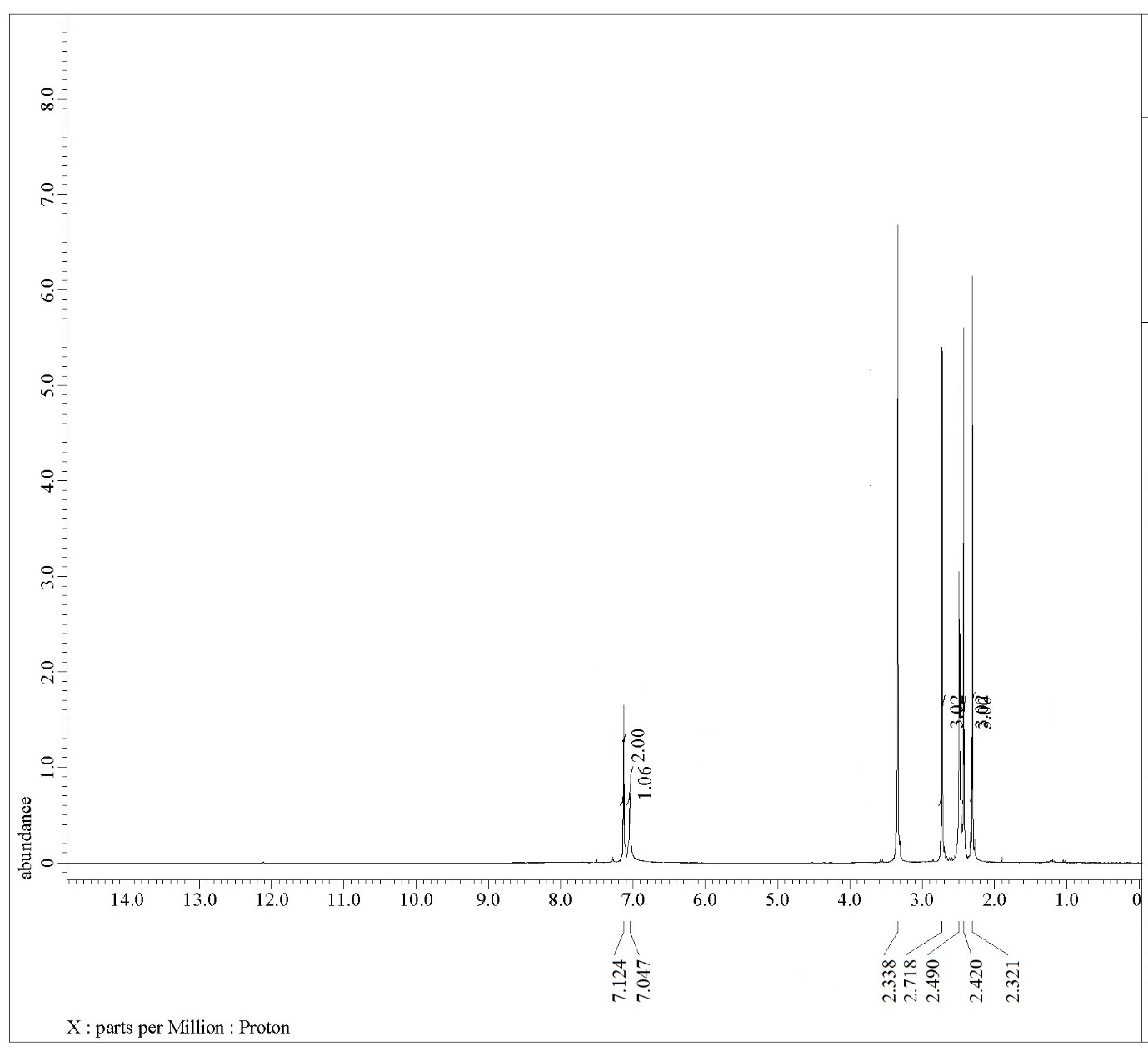



**Figure S6.** 1H NMR spectrum of compound **2**.

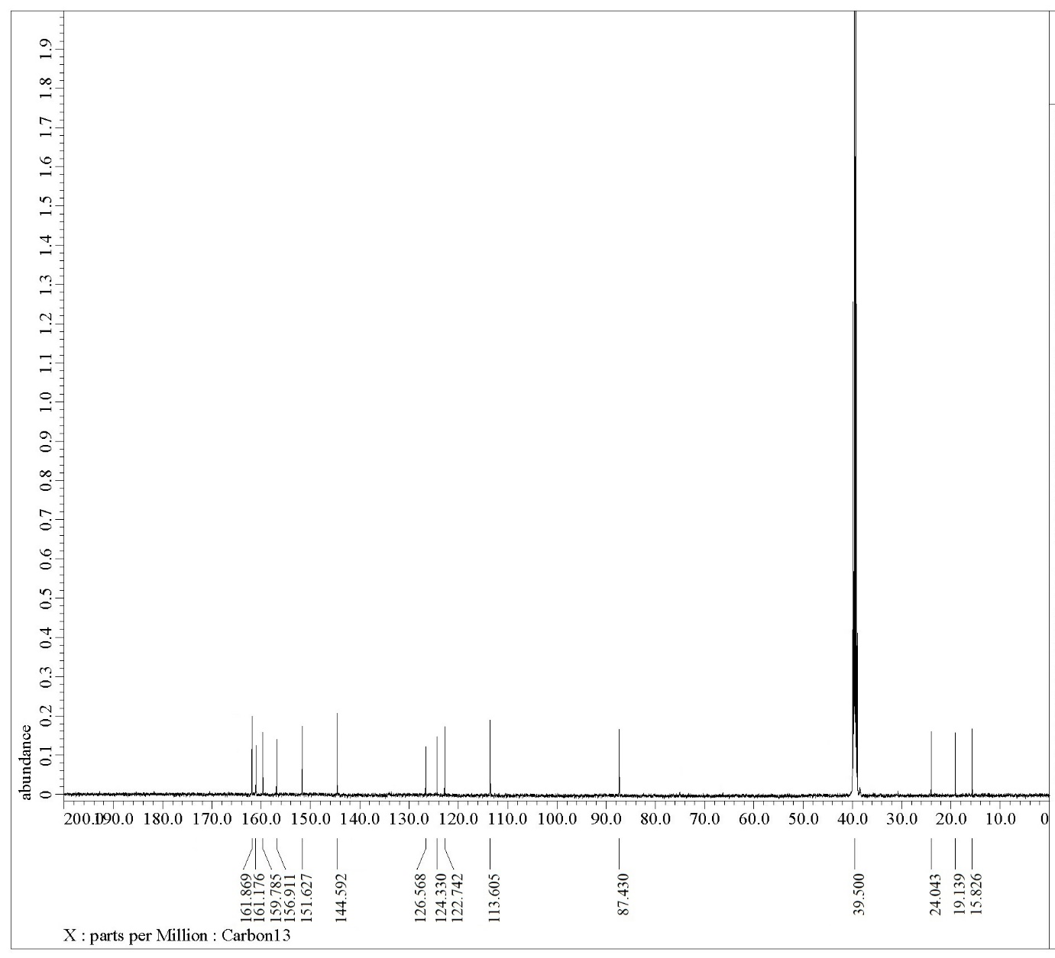



**Figure S7.** 13C NMR spectrum of compound **2**.

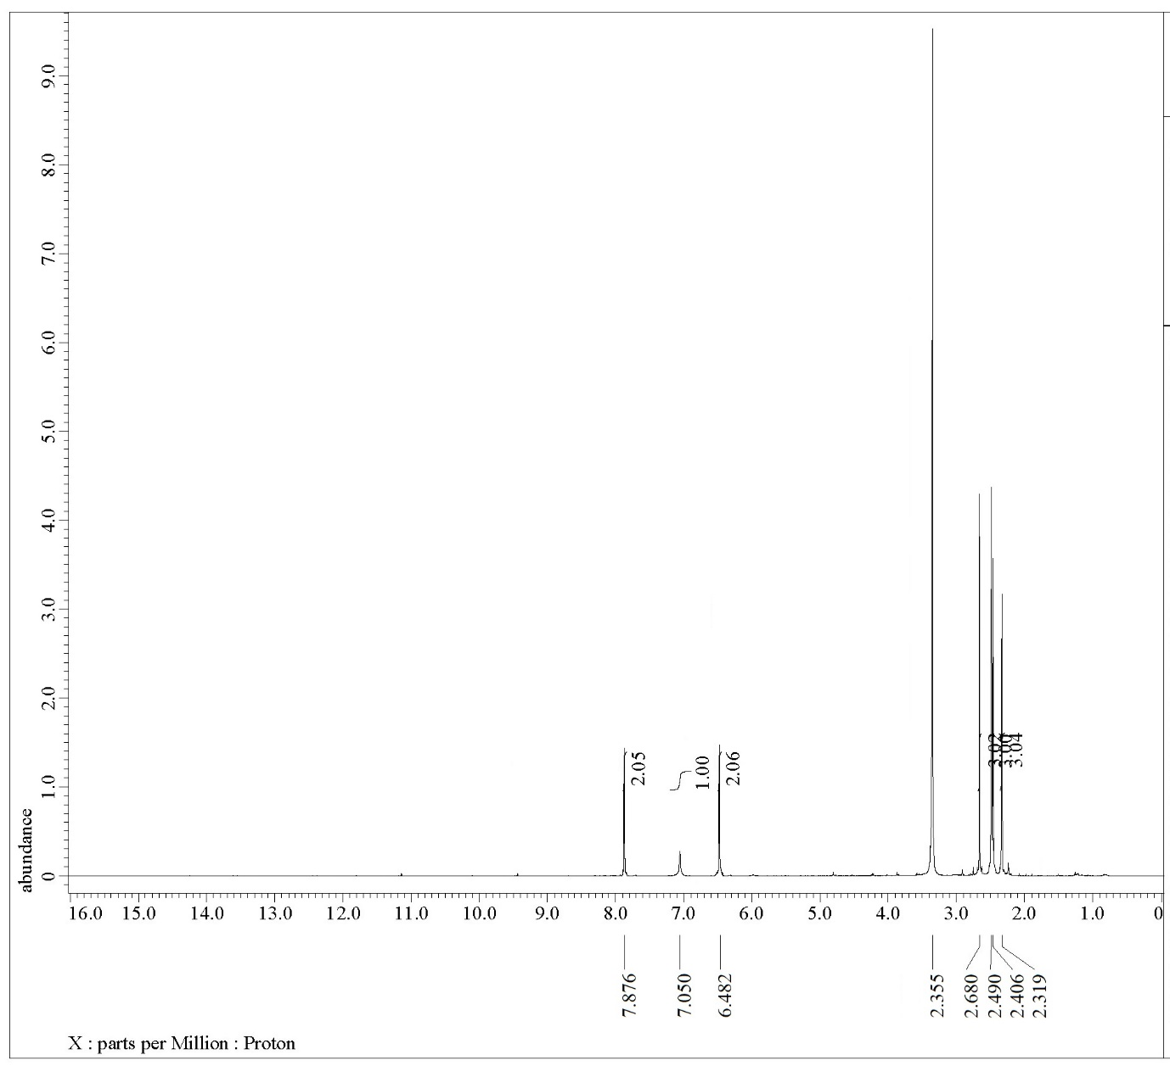



**Figure S8.** 1H NMR spectrum of compound **3**.

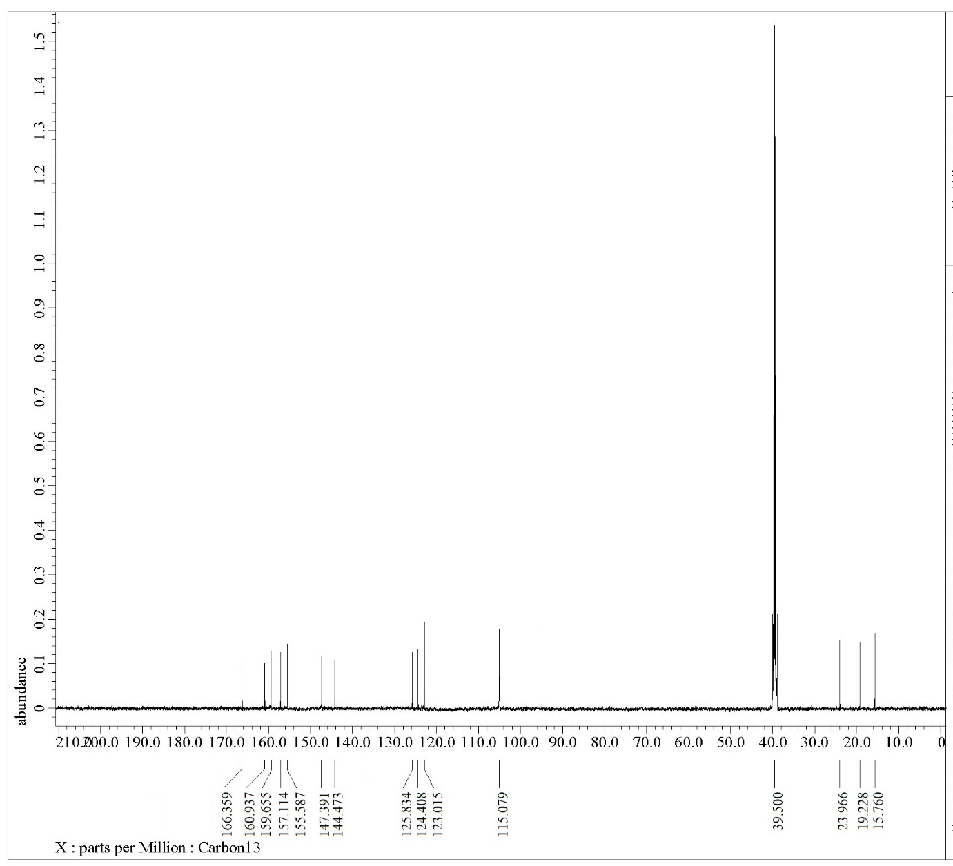



**Figure S9.** 13C NMR spectrum of compound **3**.

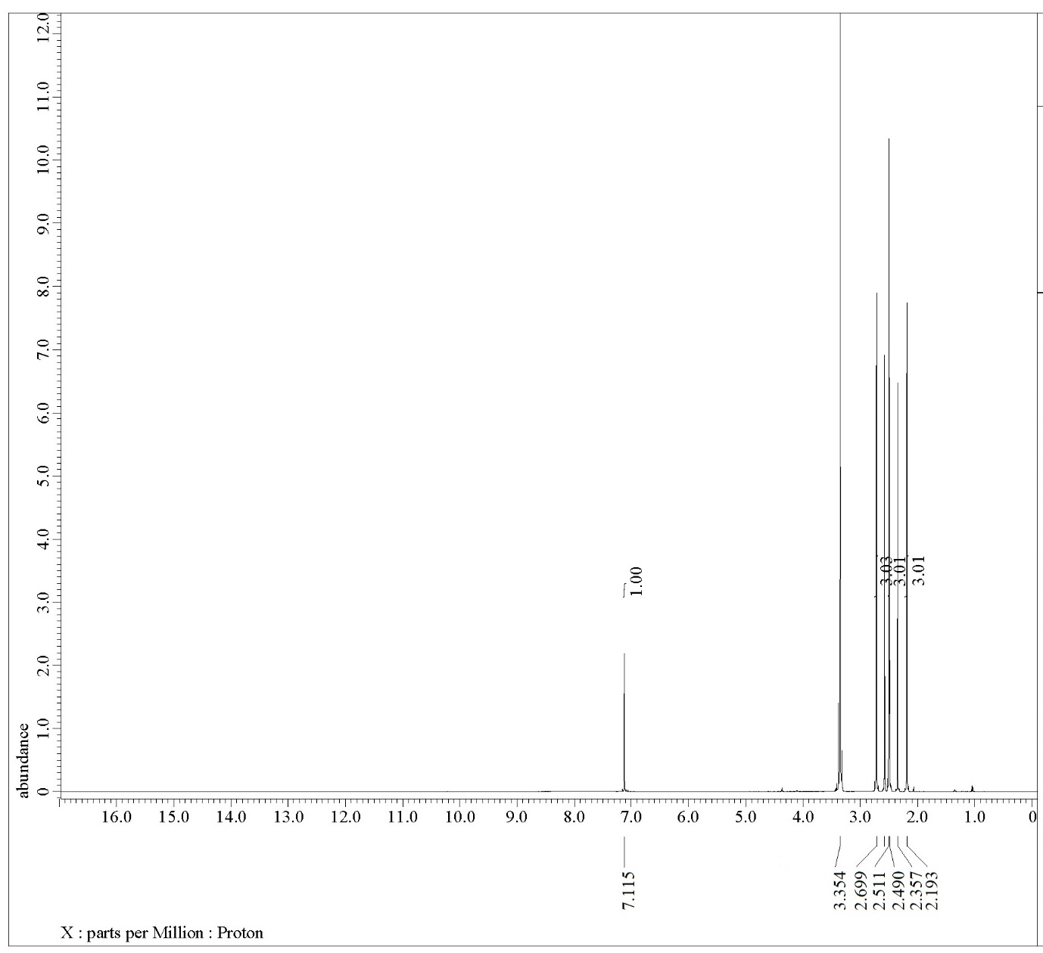



**Figure S10.** 1H NMR spectrum of compound **4**.

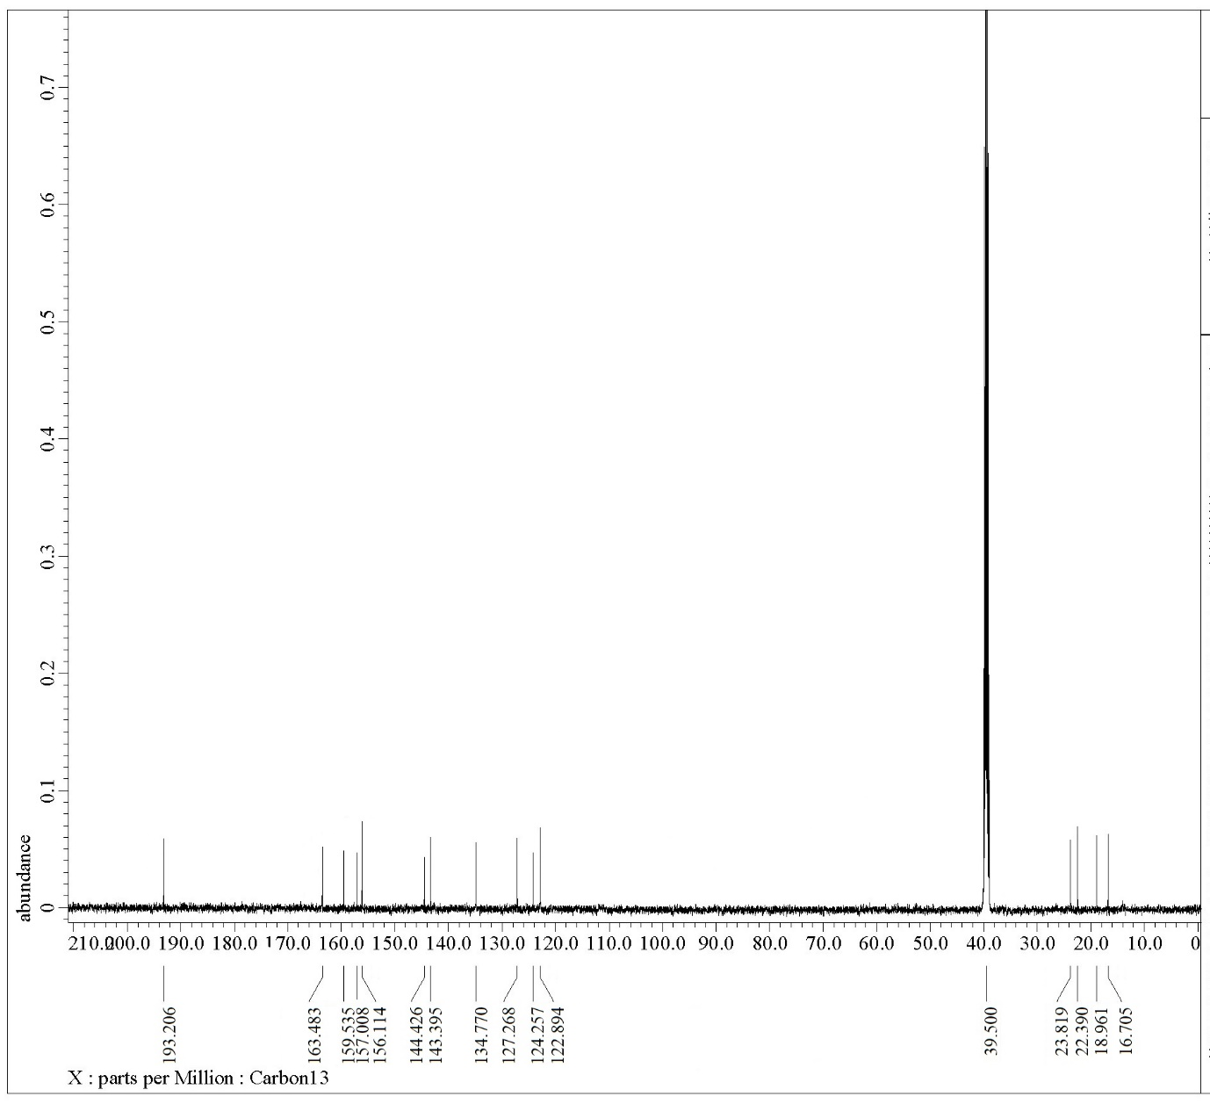



**Figure S11.** 13C NMR spectrum of compound **4**.

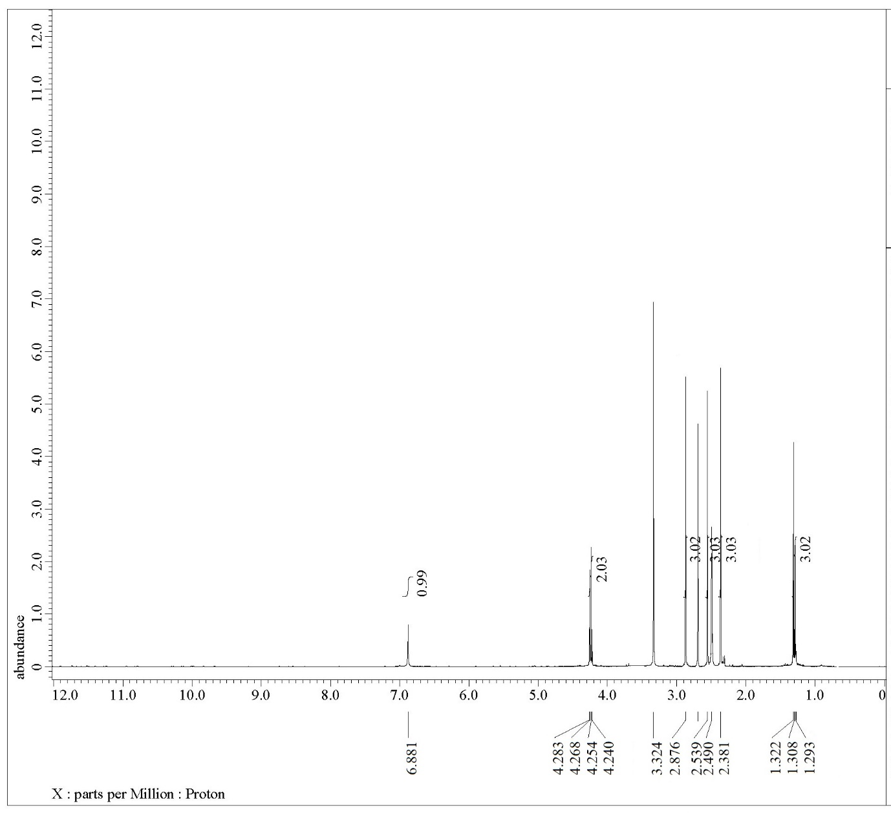



**Figure S12.** 1H NMR spectrum of compound **5**.

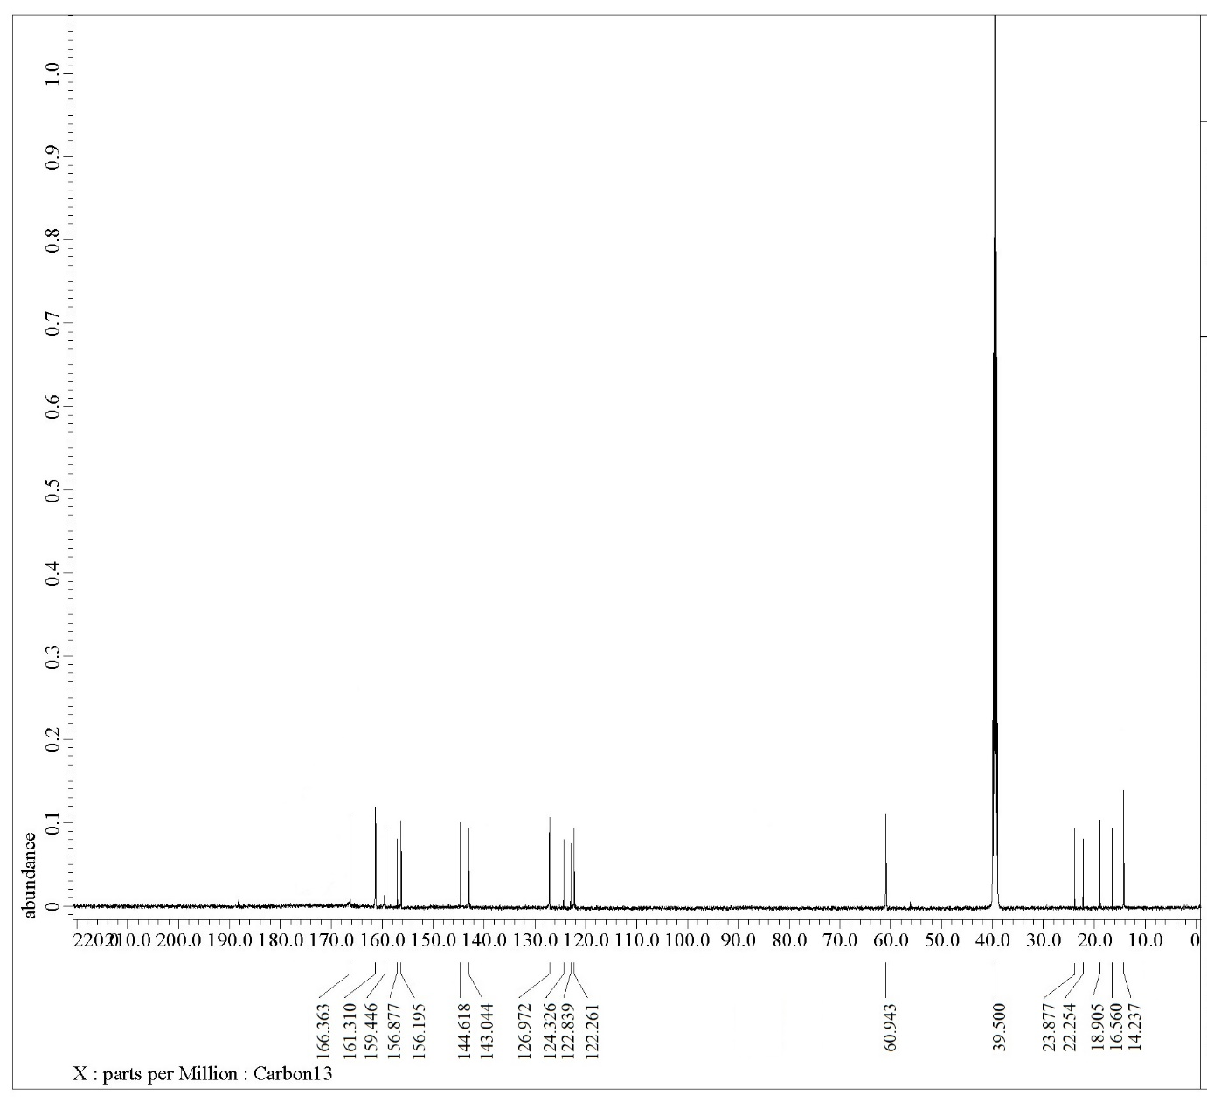



**Figure S13.** 13C NMR spectrum of compound **5**.

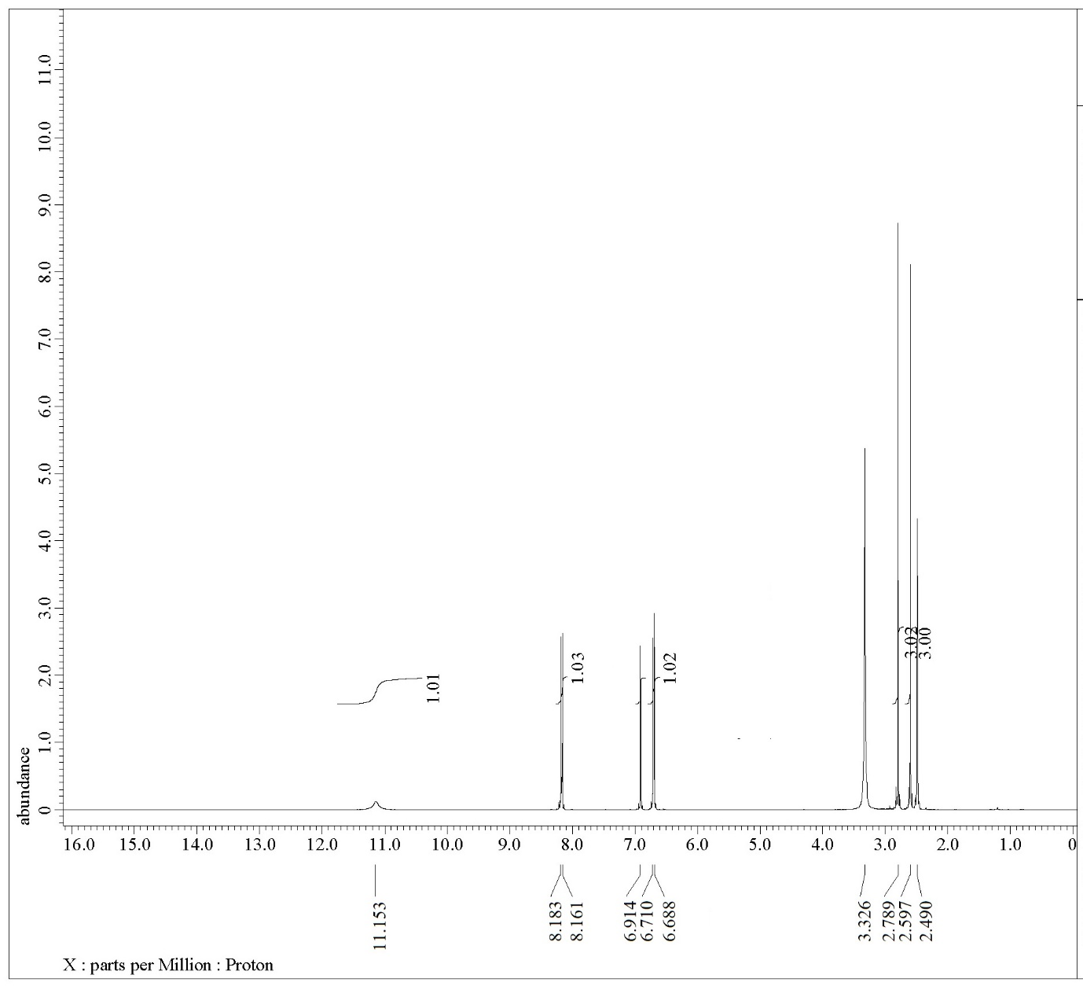



**Figure S14.** 1H NMR spectrum of compound **6**.

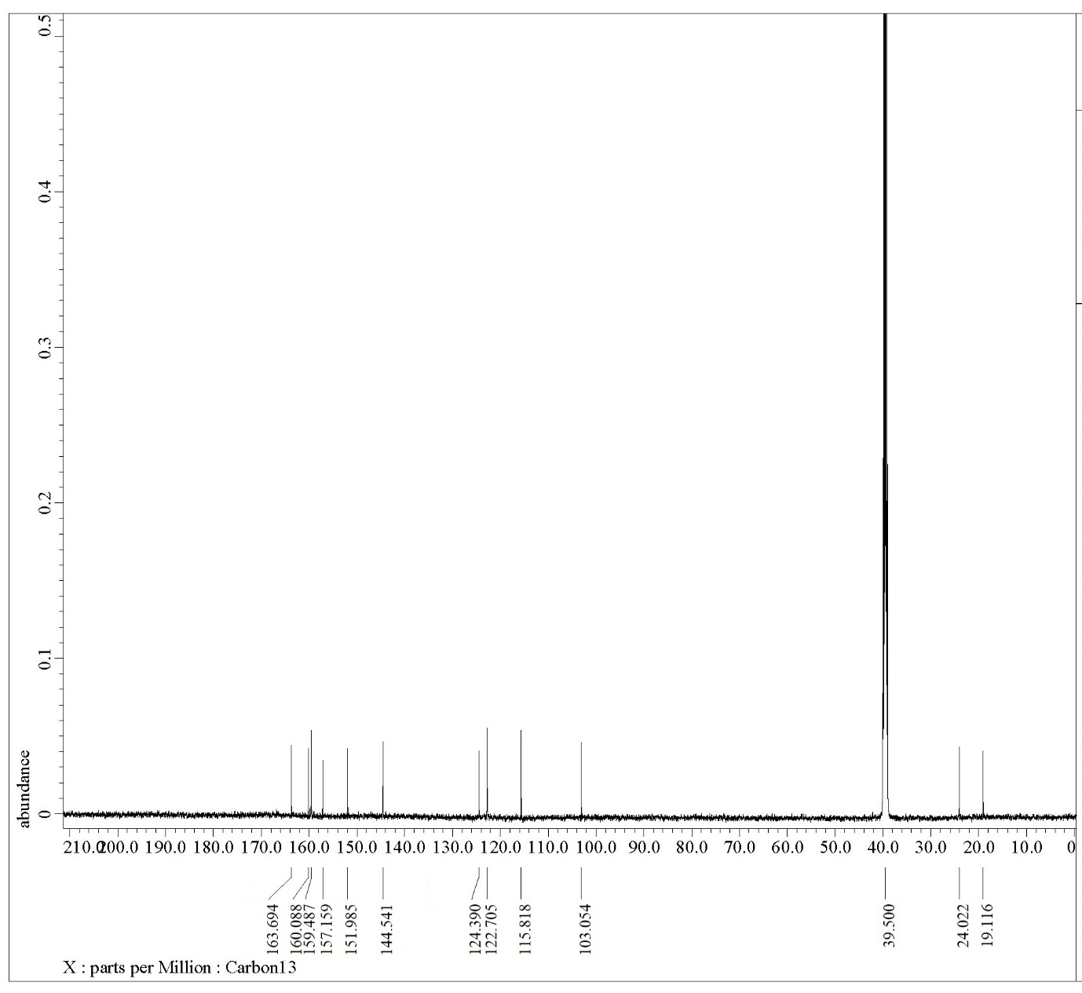



**Figure S15.** 13C NMR spectrum of compound **6**.

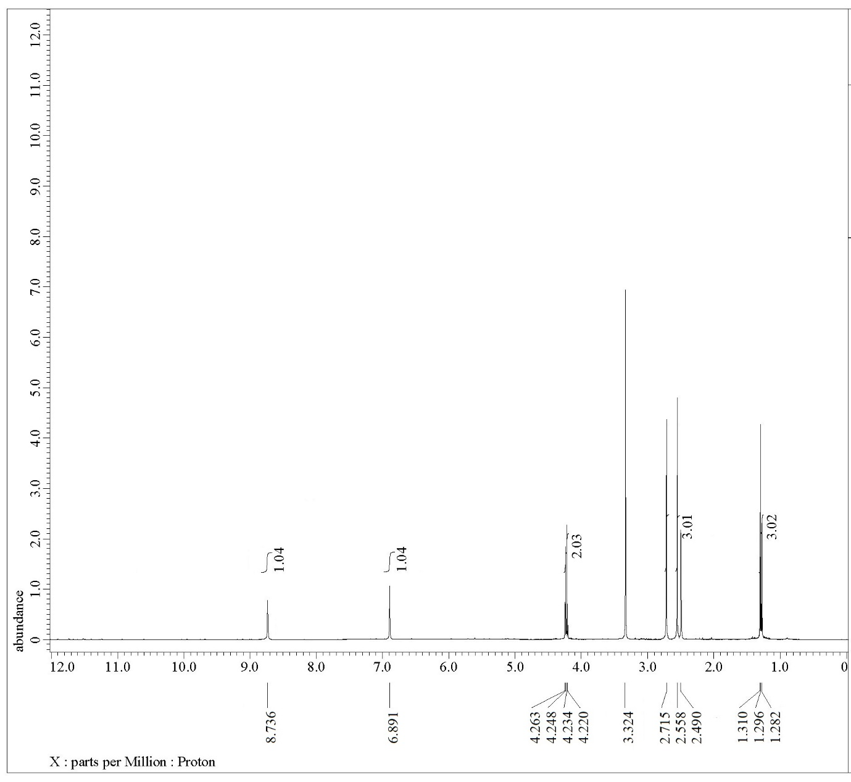



**Figure S16.** 1H NMR spectrum of compound **8**.

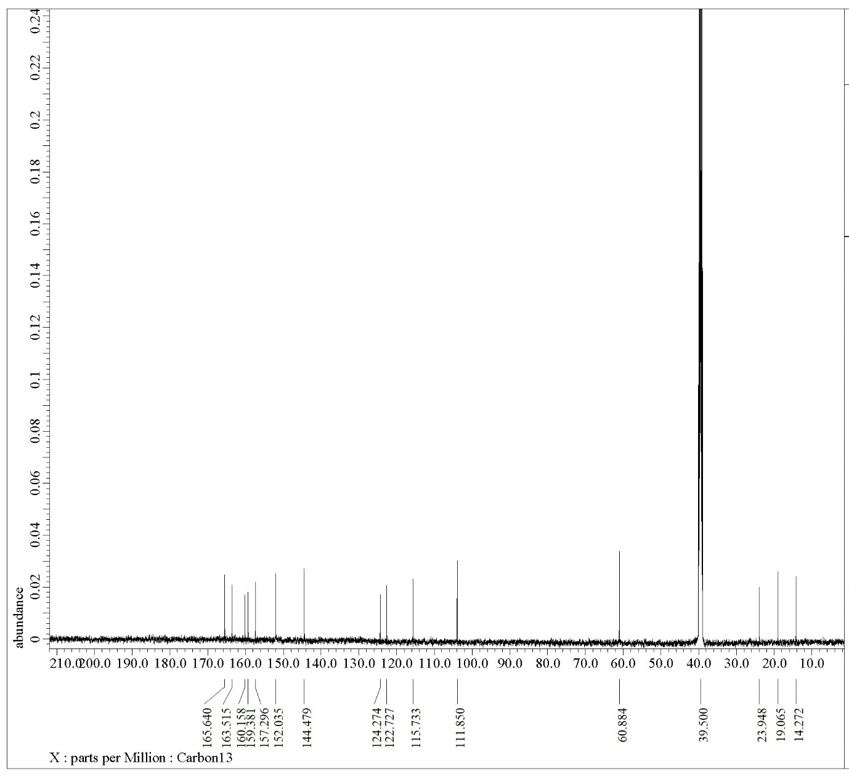



**Figure S17.** 13C NMR spectrum of compound **8**.