A small library of C–H⋯O hydrogen bonds based on supramolecular architectures of 1,5-diketone malonates in the solid state

Domingo Salazar-Mendoza*, 1 José Luis García-Gutiérrez 2 and Federico Jiménez-Cruz* 2

**SUPPLEMENTARY INFORMATION**

Table S1. X-ray selected geometric parameters for 1,5-diketones **1a-g**.

|  |  |  |  |  |  |  |  |  |
| --- | --- | --- | --- | --- | --- | --- | --- | --- |
| Parameter | **1a** | **1b** | **1c** | **1c´** | **1d** | **1e** | **1f** | **1g** |
| Distance (Å) |  |  |  |  |  |  |  |  |
| CRC1 | 1.494 | 1.500 | 1.486 | 1.479 | 1.486 | 1.490 | 1.488 | 1.534 |
| C1C2 | 1.561 | 1.551 | 1.557 | 1.555 | 1.558 | 1.564 | 1.567 | 1.570 |
| C2C3 | 1.551 | 1.558 | 1.559 | 1.557 | 1.555 | 1.557 | 1.559 | 1.561 |
| C3C4 | 1.515 | 1.517 | 1.518 | 1.517 | 1.516 | 1.519 | 1.525 | 1.542 |
| C4C5 | 1.501 | 1.497 | 1.503 | 1.503 | 1.499 | 1.508 | 1.496 | 1.514 |
| C5C6 | 1.494 | 1.492 | 1.495 | 1.500 | 1.490 | 1.502 | 1.509 | 1.491 |
| C1O1 | 1.206 | 1.201 | 1.208 | 1.208 | 1.214 | 1.211 | 1.202 | 1.216 |
| C5O5 | 1.201 | 1.196 | 1.193 | 1.199 | 1.210 | 1.199 | 1.198 | 1.197 |
| C7O7 | 1.187 | 1.187 | 1.195 | 1.183 | 1.187 | 1.194 | 1.196 | 1.194 |
| C8O8 | 1.190 | 1.189 | 1.186 | 1.190 | 1.182 | 1.202 | 1.188 | 1.182 |
| C7O(ester) | 1.326 | 1.325 | 1.338 | 1.326 | 1.319 | 1.323 | 1.326 | 1.344 |
| C8O(ester) | 1.314 | 1.354 | 1.320 | 1.336 | 1.317 | 1.330 | 1.313 | 1.328 |
| Bond angle (°) |  |  |  |  |  |  |  |  |
| CRC1C2 | 119.6 | 120.6 | 118.3 | 119.6 | 120.0 | 120.3 | 120.7 | 122.3 |
| C1C2C3 | 109.0 | 108.8 | 108.8 | 108.9 | 108.2 | 107.7 | 107.1 | 108.5 |
| C2C3C4 | 113.9 | 115.4 | 114.0 | 114.2 | 115.9 | 114.9 | 116.4 | 114.9 |
| C3C4C5 | 113.5 | 112.1 | 113.6 | 114.0 | 112.7 | 113.2 | 112.1 | 114.5 |
| C4C5C6 | 116.8 | 115.6 | 116.4 | 116.1 | 117.2 | 116.0 | 116.2 | 115.0 |
| CRC1O1 | 121.1 | 119.9 | 121.5 | 121.2 | 120.7 | 121.7 | 120.7 | 119.6 |
| O1C1C2 | 119.3 | 119.5 | 120.1 | 119.2 | 119.4 | 118.0 | 118.6 | 118.1 |
| C4C5O5 | 122.6 | 121.5 | 122.1 | 122.2 | 121.4 | 122.4 | 122.8 | 122.2 |
| O5C5C6 | 120.6 | 122.8 | 121.5 | 121.7 | 121.3 | 121.7 | 121.0 | 123.1 |
| Dihedral angle (°) |  |  |  |  |  |  |  |  |
| O1C1C2C3 | -0.1 | 3.7 | 0.9 | -8.9 | 5.9 | 23.6 | 1.8 | 1.5 |
| C3C4C5O5 | -3.1 | -5.9 | 7.1 | -8.6 | 20.9 | 7.1 | 4.4 | 15.6 |
| O1C1C5O5 | -1.7 | -11.8 | 1.2 | -17.1 | 37.6 | 26.8 | 4.8 | -64.4 |

**NMR results and spectra 1e-g.**

Dimethyl 2-(2-adamantyl)-2-(3-oxobutyl) malonate **1e**: 1H NMR  (ppm): 3.78 (s, 6H), 2.53 (t, 2H, *J*=7.2 Hz), 2.41 (t, 2H, *J*=7.2 Hz), 2.14 (s, 3H), 2.00 (bs, 3H), 1.80-1.95 (m, 6H), 1.60-1.75 (m, 6H). 13C NMR  (ppm): 206.7, 205.4, 167.2 (2C), 67.4, 52.5 (2C), 48.9, 39.1 (3C), 38.9, 36.3 (3C), 29.8, 28.0 (3C), 27.7.

Dimethyl 2-(2-naphthoyl)-2-(3-oxobutyl) malonate **1e**: 1H NMR  (ppm): 8.37 (1H, s), 7.94 (d, 1H, *J*=7.8 Hz), 7.86 (d, 2H, *J*=0.9 Hz), 7.85 (d, 1H, *J*=7.8 Hz), 7.60 (td, 1H, *J*=8.1, 1.5 Hz), 7.53 (td, 1H, *J*=8.1, 1.5 Hz), 3.74 (6H, s), 2.6-2.7 (4H, m), 2.12 (3H, s). 13C NMR  (ppm): 206.7, 191.6, 168.3 (2C), 135.2, 132.5, 132.1, 130.4, 129.7, 128.7, 128.2, 127.5, 126.8, 124.1, 67.6, 53.0 (2C), 38.9, 29.8, 27.7.

Dimethyl 2-(1-naphthoyl)-2-(3-oxobutyl) malonate **1f**: 1H NMR  (ppm) : 8.17 (d, 1H, *J*=8.1 Hz), 7.94 (d, 1H, *J*=8.1 Hz), 7.85 (d, 1H, *J*=7.8 Hz), 7.65 (d, 1H, *J*=7.0 Hz), 7.57 (t, 1H, *J*=7.0 Hz), 7.51 (t, 1H, *J*=7.0 Hz), 7.43 (t, 1H, *J*=7.8 Hz), 3.66 (6H, s), 2.73 (t, 2H, *J*=7.2 Hz), 2.59 (t, 2H, *J*=7.2 Hz), 2.10 (3H, s). 13C NMR  (ppm): 206.6, 196.6, 168.3 (2C), 134.8, 133.7, 131.9, 130.0, 128.3, 127.8, 126.5, 125.0, 124.9, 123.8, 70.2, 52.9 (2C), 39.0, 29.8, 27.9.

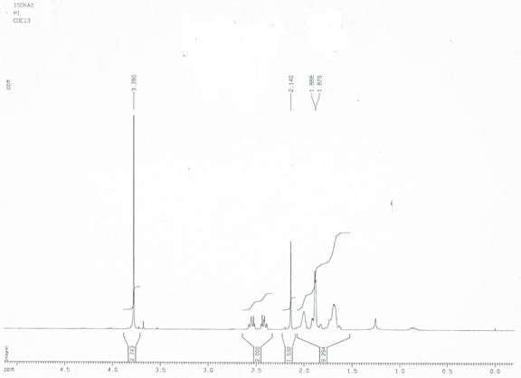

**Figure S1.** 1H NMR spectrum for 1,5diketone **1e**.

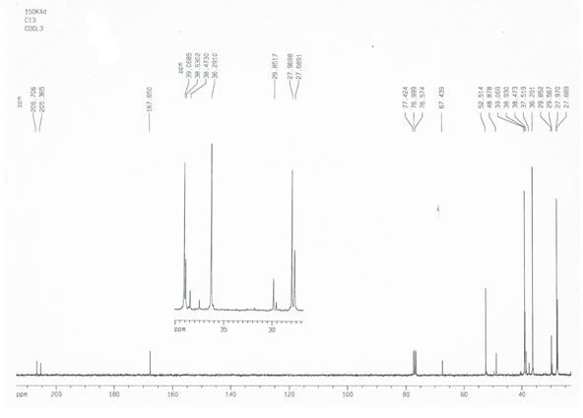

**Figure S2.** 13C NMR spectrum for 1,5diketone **1e**.

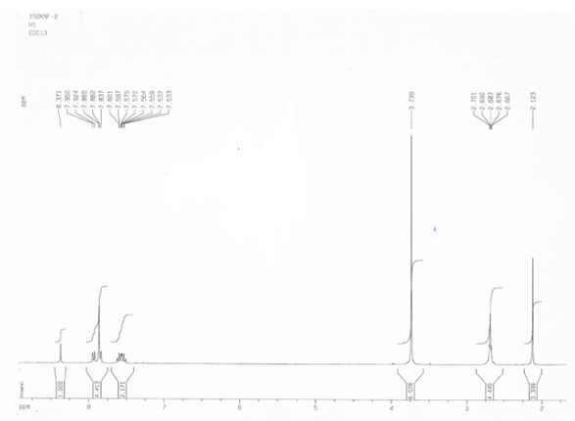

**Figure S3.** 1H NMR spectrum for 1,5-diketone **1f**.

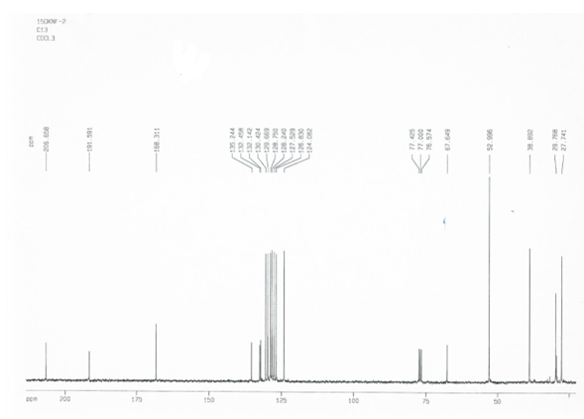

**Figure S4.** 13C NMR spectrum for 1,5-diketone **1f**.

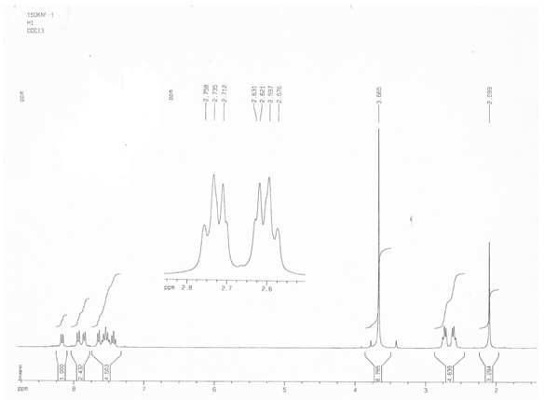

**Figure S5.** 1H NMR spectrum for 1,5-diketone **1g**.

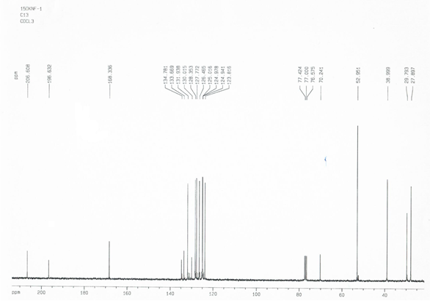

**Figure S6.** 13C NMR spectrum for 1,5-diketone **1g**.