**Supporting Information**

**Synthesis, Molecular docking and ADMET studies of bis-benzimidazole-based thiadiazole derivatives as potent inhibitors, *in vitro* α-amylase and α-glucosidase**

Shoaib Khan1, Shahid Iqbal2*, Wajid Rehman1, Nadia Hussain4,5, Rafaqat Hussain1, Mazloom Shah3, Farhan Ali1, Ahmed M. Fouda6, Yousaf Khan7, Ayed A. Dera8, Mohammed Issa Alahmdi9, Ali Bahadur10*, Hanan A. Al-ghulikah11, Eslam B. Elkaeed12*

*1Department of Chemistry, Hazara University, Mansehra-21120, Pakistan.*

*2Department of Chemistry, School of Natural Sciences (SNS), National University of Science and Technology (NUST), H-12, Islamabad, 46000, Pakistan.*

*3Department of Chemistry, Abbottabad University of Science and Technology (AUST) Abbottabad, Pakistan.*

*4Department of Pharmaceutical Sciences, College of Pharmacy, Al Ain University, Al Ain.*

*5AAU Health and Biomedical Research center, Al Ain University, Abu Dhabi, UAE.*

*6Chemistry Department, Faculty of Science, King Khalid University, Abha 61413, Saudi Arabia.*

*7Department of Chemistry, COMSATS University Islamabad campus-45550, Islamabad, Pakistan.*

*8Department of Clinical Laboratory Sciences, College of Applied Medical Sciences, King Khalid University, Abha, Saudi Arabia.*

*9Department of Chemistry, Faculty of Science, University of Tabuk, Tabuk- 71491, Saudi Arabia.*

*10Department of Chemistry, College of Science and Technology, Wenzhou-Kean University, Wenzhou 325060, China.*

*11Department of Chemistry, College of Science, Princess Nourah bint Abdulrahman University, P.O. Box 84428, Riyadh 11671, Saudi Arabia.*

*12Department of Pharmaceutical Sciences, College of Pharmacy, AlMaarefa University, Riyadh 13713, Saudi Arabia.*

**\**To whom corresponding should be addressed***

abahadur@wku.edu.cn (A.B.), [shahidiqbal@hzu.edu.cn](mailto:shahidiqbal@hzu.edu.cn) (S. Iqbal) and [ikaeed@mcst.edu.sa](mailto:ikaeed@mcst.edu.sa) (E. B. Elkaeed)

### *2.2 Spectra analysis*

**Spectral analysis for intermediates compounds II and III**

**2.2 a *(E)-2-((1H-benzo[d]imidazol-4-yl)methylene)hydrazine-1-carbothioamide (II)***

1H-NMR (600 MHz, DMSO-*d6*): *δ* 12.32 (s, 1H, NH), 11.58 (s, 1H, NH), 8.28 (s, 1H, CH), 8.14 (s, 1H, Benzimidazole-H), 7.77 (dd, *J =* 7.5, 1.9Hz, Benzimidazole-H), 7.59 (dd, *J =* 8.0, 2.4Hz, Benzimidazole-H), 7.65 (s, 2H, NH), 7.40 (t, *J =* 7.1Hz, Benzimidazole-H), 13C-NMR (150 MHz, DMSO-*d6*): *δ* 177.9, 142.7, 141.6, 138.3, 127.5, 124.1, 122.8, 117.1, 116.3. HR EI-MS: *m/z* calcd for C9H9N5S[M]+ 219.4277; Found: 219.4182.

**2.2 b *5-(1H-benzo[d]imidazol-4-yl)-1,3,4-thiadiazol-2-amine (III)***

1H-NMR (600 MHz, DMSO-*d6*): *δ* 12.30 (s, 1H, NH), 8.15 (s, 1H, Benzimidazole-H), 8.11 (dd, *J =* 7.4, 1.8Hz, 1H, Benzimidazole-H), 7.60 (dd, *J =* 7.8, 2.3Hz, Benzimidazole-H), 7.55 (t, *J =* 7.2Hz, Benzimidazole-H), 7.18 (s, 2H, NH), 13C-NMR (150 MHz, DMSO-*d6*): *δ* 174.0, 161.4, 141.5, 139.6, 138.4, 123.2, 122.8, 121.6, 114.0. HR EI-MS: *m/z* calcd for C9H7N5S[M]+ 217.3201; Found: 217.3162.

### *2.2.1 (E)-3-(1-((5-(1H-benzo[d]imidazol-4-yl)-1,3,4-thiadiazol-2-yl)imino)-2-((6-nitro-1H-benzo[d]imidazol-2-yl)thio)ethyl)-5-nitrophenol (1)*

1H-NMR (600 MHz, DMSO-*d6*): *δ* 13.38 (s, 1H, NH), 11.27 (s, 1H, NH), 10.04 (s, 1H, OH), 8.28 (d, *J* = 1.5Hz, 1H, Ar-H), 8.16 (d, *J* = 1.9Hz, 1H, Ar-H), 7.99 (s, 1H, Ar-H), 7.63 (s, 1H, Benzimidazole-H), 7.55 (d, *J* = 7.6Hz, 1H, Benzimidazole-H), 7.34 (s, 1H, Benzimidazole-H), 7.11 (d, *J* = 7.0Hz, 1H, Benzimidazole-H), 7.04 (d, *J* = 7.3Hz, 2H, Benzimidazole-H), 6.91 (d, *J* = 7.2Hz, 1H, Benzimidazole-H), 2.50 (s, 2H, -SCH2), 13C-NMR (150 MHz, DMSO-*d6*): *δ* 163.1, 153.0, 150.9, 146.7, 141.2, 138.8, 136.4, 131.8, 130.3, 127.4, 126.0, 125.5, 122.8, 122.3, 119.7, 114.0, 113.9, 112.8, 111.8, 111.6, 111.0, 119.5, 114.4, 55.8. HR EI-MS: *m/z* calcd for C24H15N9O5S2 [M]+ 573.0937; Found: 573.0830.

### *2.2.2 (E)-N-(5-(1H-benzo[d]imidazol-4-yl)-1,3,4-thiadiazol-2-yl)-2-((6-nitro-1H-benzo[d]imidazol-2-yl)thio)-1-(p-tolyl)ethan-1-imine (2)*

1H-NMR (600 MHz, DMSO-*d6*): *δ* 13.69 (s, 1H, NH), 11.51 (s, 1H, NH), 8.37 (d, *J* = 7.6Hz, 1H, Benzimidazole-H), 8.23 (d, *J* = 7.3Hz, 1H, Benzimidazole-H), 8.14 (s, 1H, Benzimidazole-H), 7.27 (d, *J* = 8.1Hz, 2H, Ar-H), 7.11 (d, *J* = 7.5Hz, 2H, Ar-H), 7.02 (s, 1H, Benzimidazole-H), 6.48 (d, *J* = 6.8Hz, 1H, Benzimidazole-H), 6.39 (d, *J* = 7.2Hz, 1H, Benzimidazole-H), 3.51 (s, 2H, -SCH2), 2.15 (s, 3H, CH3), 13C-NMR (150 MHz, DMSO-*d6*): *δ* 156.3, 144.2, 143.5, 137.3, 131.4, 124.1, 123.9, 118.8, 116.5, 114.8, 112.6, 110.4, 109.8, 108.7, 107.4, 106.3, 105.3, 104.8, 103.6, 102.3, 101.7, 100.6, 100.4, 51.4, 21.3. HR EI-MS: *m/z* calcd for C25H18N8O2S2 [M]+ 526.8571; Found: 526.7265.

### *2.2.3 (E)-N-(5-(1H-benzo[d]imidazol-4-yl)-1,3,4-thiadiazol-2-yl)-1-(3-chlorophenyl)-2-((6-nitro-1H-benzo[d]imidazol-2-yl)thio)ethan-1-imine (3)*

1H-NMR (600 MHz, DMSO-*d6*): *δ* 13.76 (s, 1H, NH), 11.69 (s, 1H, NH), 8.39 (d, *J* = 7.1Hz, 1H, Benzimidazole-H), 8.26 (d, *J* = 7.5Hz, 1H, Benzimidazole-H), 8.17 (s, 1H, Benzimidazole-H), 7.33 (dd, *J* = 8.4, 1.8Hz, 1H, Ar-H), 7.28 (s, 1H, Ar-H), 7.16 (dd, *J* = 7.4, 2.9Hz, 1H, Ar-H), 7.06 (t, *J* = 7.9Hz, 1H, Ar-H), 7.14 (s, 2H, Benzimidazole-H), 6.87 (d, *J* = 7.8Hz, 1H, Benzimidazole-H), 6.51 (d, *J* = 7.8Hz, 1H, Benzimidazole-H), 3.40 (s, 2H, -SCH2), 13C-NMR (150 MHz, DMSO-*d6*): *δ* 167.0, 164.0, 149.4, 137.1, 131.0, 124.2, 123.8, 118.4, 116.1, 114.0, 112.3, 110.2, 109.3, 108.0, 107.0, 106.2, 105.1, 104.5, 103.2, 102.0, 101.9, 100.3, 100.2, 51.2. HR EI-MS: *m/z* calcd for C24H15ClN8O2S2 [M]+ 546.3271; Found: 546.1165.

### *2.2.4 (E)-N-(5-(1H-benzo[d]imidazol-4-yl)-1,3,4-thiadiazol-2-yl)-1-(3-chloro-5-(trifluoromethyl)phenyl)-2-((6-nitro-1H-benzo[d]imidazol-2-yl)thio)ethan-1-imine (4)*

1H-NMR (600 MHz, DMSO-*d6*): *δ* 13.84 (s, 1H, NH), 11.67 (s, 1H, NH), 8.30 (d, *J* = 2.5Hz, 1H, Ar-H), 8.53 (d, *J* = 2.0Hz, 1H, Ar-H), 8.49 (s, 1H, Ar-H), 8.45 (s, 1H, Benzimidazole-H), 7.77 (d, *J* = 7.7Hz, 1H, Benzimidazole-H), 7.40 (s, 2H, Benzimidazole-H), 7.31 (d, *J* = 7.6Hz, 1H, Benzimidazole-H), 6.99 (d, *J* = 8.2Hz, 2H, Benzimidazole-H), 6.73 (d, *J* = 7.8Hz, 1H, Benzimidazole-H), 3.77 (s, 2H, -SCH2), 13C-NMR (150 MHz, DMSO-*d6*): *δ* 169.5, 163.2, 160.9, 150.6, 149.9, 148.7, 148.1, 146.0, 145.3, 143.0, 141.9, 140.8, 139.8, 135.1, 129.7, 129.4, 128.6, 126.9, 124.4, 122.5, 119.6, 116.5, 111.4, 110.9, 56.6. HR EI-MS: *m/z* calcd for C25H14ClF3N8O2S2 [M]+ 614.0471; Found: 614.0265.

### *2.2.5 (E)-N-(5-(1H-benzo[d]imidazol-4-yl)-1,3,4-thiadiazol-2-yl)-1-(3-bromo-5-methoxyphenyl)-2-((6-nitro-1H-benzo[d]imidazol-2-yl)thio)ethan-1-imine (5)*

1H-NMR (600 MHz, DMSO-*d6*): *δ* 13.33 (s, 1H, NH), 11.25 (s, 1H, NH), 7.84 (d, *J* = 2.0Hz, 1H, Ar-H), 7.78 (d, *J* = 6.9Hz, 1H, Ar-H), 7.55 (s, 1H, Ar-H), 7.45 (s, 1H, Benzimidazole-H), 7.36 (d, *J* = 7.1Hz, 1H, Benzimidazole-H), 7.11 (s, 2H, Benzimidazole-H), 7.08 (d, *J* = 8.4Hz, 1H, Benzimidazole-H), 7.02 (d, *J* = 6.8Hz, 2H, Benzimidazole-H), 6.99 (d, *J* = 8.1Hz, 1H, Benzimidazole-H), 3.81 (s, 2H, -SCH2), 3.51 (s, 3H, -OCH3), 13C-NMR (150 MHz, DMSO-*d6*): *δ* 163.1, 159.0, 157.9, 152.6, 150.9, 149.7, 149.1, 141.2, 140.3, 131.9, 130.4, 127.0, 126.9, 122.3, 120.6, 119.8, 119.7, 114.1, 114.0, 112.4, 111.0, 107.5, 104.6, 57.2, 25.5. HR EI-MS: *m/z* calcd for C25H17BrN8O3S2 [M]+ 620.0571; Found: 620.0365.

### *2.2.6 (E)-3-(1-((5-(1H-benzo[d]imidazol-4-yl)-1,3,4-thiadiazol-2-yl)imino)-2-((6-nitro-1H-benzo[d]imidazol-2-yl)thio)ethyl)benzonitrile (6)*

1H-NMR (600 MHz, DMSO-*d6*): *δ* 13.77 (s, 1H, NH), 11.58 (s, 1H, NH), 8.36 (d, *J* = 7.3Hz, 1H, Benzimidazole-H), 8.29 (d, *J* = 7.9Hz, 1H, Benzimidazole-H), 8.22 (s, 1H, Benzimidazole-H), 7.37 (dd, *J* = 7.4, 1.9Hz, 1H, Ar-H), 7.25 (s, 1H, Ar-H), 7.19 (dd, *J* = 7.7, 2.6Hz, 1H, Ar-H), 7.04 (t, *J* = 7.4Hz, 1H, Ar-H), 7.18 (s, 1H, Benzimidazole-H), 6.77 (d, *J* = 7.5Hz, 1H, Benzimidazole-H), 6.51 (d, *J* = 7.0Hz, 1H, Benzimidazole-H), 3.41 (s, 2H, -SCH2), 13C-NMR (150 MHz, DMSO-*d6*): *δ* 169.5, 167.2, 158.4, 146.3, 139.9, 137.4, 131.2, 129.7, 125.4, 124.1, 123.0, 122.3, 121.2, 117.3, 115.0, 114.0, 111.2, 109.1, 108.5, 106.2, 104.0, 103.9, 102.3, 101.2, 54.2. HR EI-MS: *m/z* calcd for C25H15N9O2S2 [M]+ 537.3371; Found: 537.3065.

### *2.2.7 (E)-4-(1-((5-(1H-benzo[d]imidazol-4-yl)-1,3,4-thiadiazol-2-yl)imino)-2-((6-nitro-1H-benzo[d]imidazol-2-yl)thio)ethyl)-N,N-dimethylaniline (7)*

1H-NMR (600 MHz, DMSO-*d6*): *δ* 13.73 (s, 1H, NH), 11.55 (s, 1H, NH), 8.34 (d, *J* = 7.6Hz, 1H, Benzimidazole-H), 8.18 (d, *J* = 7.3Hz, 1H, Benzimidazole-H), 8.07 (s, 1H, Benzimidazole-H), 7.29 (d, *J* = 7.1Hz, 2H, Ar-H), 7.19 (d, *J* = 7.3Hz, 2H, Ar-H), 7.06 (s, 2H, Benzimidazole-H), 6.52 (d, *J* = 6.5Hz, 1H, Benzimidazole-H), 6.22 (d, *J* = 7.1Hz, 1H, Benzimidazole-H), 3.40 (s, 2H, -SCH2), 13C-NMR (150 MHz, DMSO-*d6*): *δ* 165.1, 163.0, 152.2, 149.8, 133.4, 122.1, 121.8, 121.7, 115.5, 114.3, 112.3, 110.2, 109.7, 108.3, 107.0, 106.2, 105., 103.8, 102.6, 101.9, 101.4, 100.9, 100.6, 53.1. HR EI-MS: *m/z* calcd for C26H21N9O2S2 [M]+ 555.2371; Found: 555.2063.

### *2.2.8 (E)-N-(5-(1H-benzo[d]imidazol-4-yl)-1,3,4-thiadiazol-2-yl)-2-((6-nitro-1H-benzo[d]imidazol-2-yl)thio)-1-(o-tolyl)ethan-1-imine (8)*

1H-NMR (600 MHz, DMSO-*d6*): *δ* 13.34 (s, 1H, NH), 11.25 (s, 1H, NH), 7.79 (d, *J* = 7.3Hz, 1H, Benzimidazole-H), 7.72 (d, *J* = 7.2Hz, 1H, Benzimidazole-H), 7.54 (s, 1H, Benzimidazole-H), 7.36 (dd, *J* = 8.1, 2.3Hz, 1H, Ar-H), 7.33 (dd, *J* = 7.0, 1.9Hz, 1H, Ar-H), 7.29-7.23 (m, 1H, Ar-H), 7.22-7.17 (m, 1H, Ar-H), 7.11 (s, 2H, Benzimidazole-H), 7.08 (d, *J* = 7.8Hz, 1H, Benzimidazole-H), 6.98 (d, *J* = 7.1Hz, 1H, Benzimidazole-H), 3.35 (s, 2H, -SCH2), 2.33 (s, 3H, CH3), 13C-NMR (150 MHz, DMSO-*d6*): *δ* 165.8, 163.1, 151.1, 141.2, 137.2, 131.9, 131.2, 130.4, 129.3, 129.2, 125.6, 125.6, 125.4, 122.3, 119.8, 119.7, 111.0, 105.8, 103.3, 102.8, 101.3, 100.9, 100.3, 51.2, 30.6. HR EI-MS: *m/z* calcd for C25H18N8O2S2 [M]+ 526.1371; Found: 526.0163.

### *2.2.9 (E)-N-(5-(1H-benzo[d]imidazol-4-yl)-1,3,4-thiadiazol-2-yl)-2-((6-nitro-1H-benzo[d]imidazol-2-yl)thio)-1-(3-nitro-5-(trifluoromethyl)phenyl)ethan-1-imine (9)*

1H-NMR (600 MHz, DMSO-*d6*): *δ* 13.38 (s, 1H, NH), 11.30 (s, 1H, NH), 8.50 (dd, *J* = 7.3, 2.3Hz, 1H, Benzimidazole-H), 8.20 (dd, *J* = 8.5, 2.2Hz, 1H, Benzimidazole-H), 8.15 (d, *J* = 2.2Hz, 1H, Ar-H), 8.10 (d, *J* = 2.1Hz, 1H, Ar-H), 7.74 (s, 1H, Benzimidazole-H), 7.70 (d, *J* = 2.6Hz, 1H, Benzimidazole-H), 7.66 (d, *J* = 2.6Hz, 1H, Ar-H), 7.55 (d, *J* = 6.6Hz, 1H, Benzimidazole-H), 7.01 (d, *J* = 8.5Hz, 1H, Benzimidazole-H), 7.08 (t, *J* = 8.6Hz, 1H, Benzimidazole-H), 3.02 (s, 2H, -SCH2), 13C-NMR (150 MHz, DMSO-*d6*): *δ* 168.5, 167.2, 151.5, 148.4, 146.1, 141.9, 141.5, 133.9, 133.4, 131.3, 130.8, 129.6, 127.8, 126.8, 126.5, 125.3, 125.2, 124.7, 123.7, 123.3, 122.9, 122.6, 121.1, 117.9, 43.7. HR EI-MS: *m/z* calcd for C25H14F3N9O4S2 [M]+ 625.4134; Found: 625.4020.

### *2.2.10 (E)-2-(1-((5-(1H-benzo[d]imidazol-4-yl)-1,3,4-thiadiazol-2-yl)imino)-2-((6-nitro-1H-benzo[d]imidazol-2-yl)thio)ethyl)-4,6-dichlorophenol (10)*

1H-NMR (600 MHz, DMSO-*d6*): *δ* 13.87 (s, 1H, NH), 11.62 (s, 1H, NH), 9.57 (s, 1H, OH), 8.78 (d, *J* = 7.1Hz, 1H, Ar-H), 8.51 (d, *J* = 6.8Hz, 1H, Ar-H), 8.36 (s, 1H, Benzimidazole-H), 7.57 (d, *J* = 6.7Hz, 1H, Benzimidazole-H), 7.33 (s, 1H, Benzimidazole-H), 7.10 (d, *J* = 8.1Hz, 1H, Benzimidazole-H), 6.86 (d, *J* = 8.1Hz, 2H, Benzimidazole-H), 6.59 (d, *J* = 7.1Hz, 1H, Benzimidazole-H), 3.83 (s, 2H, -SCH2), 13C-NMR (150 MHz, DMSO-*d6*): *δ* 162.2, 159.9, 149.6, 148.9, 148.0, 147.1, 145.0, 144.3, 142.0, 140.9, 139.8, 139.4, 134.1, 128.7, 128.4, 127.6, 125.9, 123.4, 121.5, 118.6, 115.5, 109.4, 100.9, 55.6. HR EI-MS: *m/z* calcd for C24H14Cl2N8O3S2 [M]+ 596.0630; Found: 596.0518.

### *2.2.11 (E)-N-(5-(1H-benzo[d]imidazol-4-yl)-1,3,4-thiadiazol-2-yl)-1-(2-methyl-5-nitrophenyl)-2-((6-nitro-1H-benzo[d]imidazol-2-yl)thio)ethan-1-imine (11)*

1H-NMR (600 MHz, DMSO-*d6*): *δ* 13.34 (s, 1H, NH), 11.25 (s, 1H, NH), 7.86 (d, *J* = 7.3Hz, 1H, Benzimidazole-H), 7.69 (d, *J* = 7.8Hz, 1H, Benzimidazole-H), 7.66 (s, 2H, Benzimidazole-H), 7.54 (d, *J* = 7.7Hz, 1H, Ar-H), 7.35 (d, *J* = 7.2Hz, 1H, Ar-H), 7.10 (s, 1H, Benzimidazole-H), 7.08 (s, 1H, Ar-H), 6.97 (d, *J* = 6.8Hz, 2H, Benzimidazole-H), 6.63 (d, *J* = 6.7Hz, 1H, Benzimidazole-H), 3.57 (s, 2H, -SCH2), 2.51 (s, 3H, Ar-CH3); 13C-NMR (150 MHz, DMSO-*d6*): *δ* 166.1, 163.1, 149.8, 141.2, 133.1, 132.2, 131.6, 131.5, 131.4, 130.5, 127.6, 127.5, 127.2, 122.4, 122.3, 121.3, 120.9, 119.8, 119.6, 111.0, 107.5, 104.8, 101.9, 56.1, 40.1. HR EI-MS: *m/z* calcd for C25H17N9O4S2 [M]+ 571.4104; Found: 571.4520.

### *2.2.12 (E)-N-(5-(1H-benzo[d]imidazol-4-yl)-1,3,4-thiadiazol-2-yl)-1-(3,4-dichlorophenyl)-2-((6-nitro-1H-benzo[d]imidazol-2-yl)thio)ethan-1-imine (12)*

1H-NMR (600 MHz, DMSO-*d6*): *δ* 13.74 (s, 1H, NH), 11.62 (s, 1H, NH), 8.58 (d, *J* = 7.4Hz, 1H, Benzimidazole-H), 8.46 (d, *J* = 7.5Hz, 1H, Benzimidazole-H), 8.38 (s, 1H, Benzimidazole-H), 7.85 (d, *J* = 7.3Hz, 1H, Ar-H), 7.43 (d, *J* = 8.2Hz, 1H, Ar-H), 7.30 (s, 1H, Benzimidazole-H), 7.24 (s, 1H, Ar-H), 6.83 (d, *J* = 7.8Hz, 2H, Benzimidazole-H), 6.60 (d, *J* = 7.3Hz, 1H, Benzimidazole-H), 3.53 (s, 2H, -SCH2), 13C-NMR (150 MHz, DMSO-*d6*): *δ* 168.1, 164.2, 159.9, 153.0, 146.4, 140.4, 128.2, 122.1, 120.7, 119.3, 117.8, 115.2, 113.4, 112.6, 111.3, 110.1, 109.7, 108.2, 107.4, 108.5, 104.8, 104.5, 101.7, 56.4, 23.3. HR EI-MS: *m/z* calcd for C24H14Cl2N8O2S2 [M]+ 580.0709; Found: 571.0070.

### *2.2.13 (E)-N-(5-(1H-benzo[d]imidazol-4-yl)-1,3,4-thiadiazol-2-yl)-1-(3-bromophenyl)-2-((6-nitro-1H-benzo[d]imidazol-2-yl)thio)ethan-1-imine (13)*

1H-NMR (600 MHz, DMSO-*d6*): *δ* 13.10 (s, 1H, NH), 11.80 (s, 1H, NH), 8.79 (d, *J* = 7.1Hz, 1H, Benzimidazole-H), 8.52 (d, *J* = 7.0Hz, 1H, Benzimidazole-H), 8.45 (s, 2H, Benzimidazole-H), 7.58 (dd, *J* = 6.7, 2.8Hz, 1H, Ar-H), 7.38 (t, *J* = 1.9Hz, 1H, Ar-H), 7.29 (s, 1H, Benzimidazole-H), 7.02-7.00 (m, 1H, Ar-H), 6.55 (d, *J* = 6.9Hz, 2H, Benzimidazole-H), 6.55 (d, *J* = 6.9Hz, 2H, Benzimidazole-H), 6.49 (d, *J* = 7.1Hz, 1H, Ar-H), 3.81 (s, 2H, -SCH2), 13C-NMR (150 MHz, DMSO-*d6*): *δ* 169.6, 163.6, 157.3, 152.7, 145.8, 139.8, 127.6, 121.2, 119.9, 118.7, 116.0, 114.3, 112.6, 111.3, 110.5, 109.4, 108.8, 107.3, 106.5, 105.9, 105.0, 103.8, 100.9, 55.1. HR EI-MS: *m/z* calcd for C24H15BrN8O2S2 [M]+ 589.5271; Found: 589.4165.

### *2.2.14 (E)-5-(1-((5-(1H-benzo[d]imidazol-4-yl)-1,3,4-thiadiazol-2-yl)imino)-2-((6-nitro-1H-benzo[d]imidazol-2-yl)thio)ethyl)benzene-1,3-diol (14)*

1H-NMR (600 MHz, DMSO-*d6*): *δ* 13.81 (s, 1H, NH), 11.76 (s, 1H, NH), 9.58 (s, 2H, OH), 8.41 (d, *J* = 2.5Hz, 1H, Ar-H), 8.59 (d, *J* = 1.8Hz, 1H, Ar-H), 8.53 (s, 1H, Ar-H), 8.43 (s, 1H, Benzimidazole-H), 7.85 (d, *J* = 7.4Hz, 1H, Benzimidazole-H), 7.52 (s, 1H, Benzimidazole-H), 7.41 (d, *J* = 7.9Hz, 1H, Benzimidazole-H), 7.13 (d, *J* = 7.5Hz, 2H, Benzimidazole-H), 6.92 (d, *J* = 7.3Hz, 1H, Benzimidazole-H), 3.85 (s, 2H, -SCH2), 13C-NMR (150 MHz, DMSO-*d6*): *δ* 172.5, 165.2, 162.9, 152.6, 151.9, 150.7, 150.1, 148.0, 147.3, 145.0, 143.9, 142.8, 140.8, 137.1, 130.7, 130.4, 130.2, 128.9, 126.4, 124.5, 121.6, 118.5, 115.4, 112.9, 58.3. HR EI-MS: *m/z* calcd for C24H16N8O4S2 [M]+ 544.1709; Found: 544.1270.

### *2.2.15 (E)-N-(5-(1H-benzo[d]imidazol-4-yl)-1,3,4-thiadiazol-2-yl)-1-([1,1'-biphenyl]-4-yl)-2-((6-nitro-1H-benzo[d]imidazol-2-yl)thio)ethan-1-imine (15)*

1H-NMR (600 MHz, DMSO-*d6*): *δ* 13.60 (s, 1H, NH), 11.52 (s, 1H, NH), 8.31 (s, 1H, Benzimidazole-H), 8.15 (d, *J* = 7.2Hz, 1H, Benzimidazole-H), 8.10 (s, 1H, Benzimidazole-H), 8.06 (d, *J* = 7.1Hz, 1H, Benzimidazole-H), 7.45 (d, *J* = 7.2Hz, 2H, Ar-H), 7.37 (d, *J* = 7.8Hz, 2H, Ar-H), 7.25 (dd, *J* = 7.4, 1.9Hz, 1H, Ar-H), 7.22-7.19 (m, 1H, Ar-H), 7.13 (t, *J* = 7.7Hz, 1H, Ar-H), 6.99 (d, *J* = 7.0Hz, 2H, Benzimidazole-H), 6.70 (d, *J* = 7.3Hz, 1H, Benzimidazole-H), 3.85 (s, 2H, -SCH2), 13C-NMR (150 MHz, DMSO-*d6*): *δ* 168.4, 164.2, 161.9, 151.6, 151.9, 150.7, 150.1, 148.0, 147.3, 146.7, 145.0, 144.3, 143.9, 142.8, 141.9, 140.8, 139.6, 137.1, 134.7, 130.7, 130.4, 129.2, 127.9, 126.4, 124.5, 120.6, 119.5, 115.4, 112.9, 56.3. HR EI-MS: *m/z* calcd for C30H20N8O2S2 [M]+ 588.1769; Found: 588.1670.

### *2.2.16 (E)-3-(1-((5-(1H-benzo[d]imidazol-4-yl)-1,3,4-thiadiazol-2-yl)imino)-2-((6-nitro-1H-benzo[d]imidazol-2-yl)thio)ethyl)phenolimine (16)*

1H-NMR (600 MHz, DMSO-*d6*): *δ* 13.84 (s, 1H, NH), 11.74 (s, 1H, NH), 9.52 (s, 1H, OH), 8.79 (d, *J* = 7.0Hz, 1H, Benzimidazole-H), 8.51 (d, *J* = 6.9Hz, 1H, Benzimidazole-H), 8.38 (s, 1H, Benzimidazole-H), 7.58 (dd, *J* = 7.0, 2.4Hz, 1H, Ar-H), 7.26 (d, *J* = 1.7Hz, 1H, Ar-H), 7.17 (t, *J* = 7.7Hz, 1H, Ar-H), 7.11 (s, 1H, Benzimidazole-H), 6.84-6.83 (m, 1H, Ar-H), 6.60 (d, *J* = 7.2Hz, 1H, Benzimidazole-H), 6.54 (d, *J* = 7.3Hz, 1H, Benzimidazole-H), 3.70 (s, 2H, -SCH2), 13C-NMR (150 MHz, DMSO-*d6*): *δ* 169.3, 167.2, 157.7, 152.4, 145.5, 139.4, 127.3, 121.0, 119.6, 118.3, 116.2, 114.1, 112.3, 111.0, 110.2, 109.1, 108.4, 107.0, 106.7, 105.6, 105.8, 103.7, 100.5, 55.3. HR EI-MS: *m/z* calcd for C24H16N8O3S2 [M]+ 528.5271; Found: 528.4165.

### *2.2.17 (E)-N-(5-(1H-benzo[d]imidazol-4-yl)-1,3,4-thiadiazol-2-yl)-1-(4-chlorophenyl)-2-((6-nitro-1H-benzo[d]imidazol-2-yl)thio)ethan-1-imine (17)*

1H-NMR (600 MHz, DMSO-*d6*): *δ* 13.74 (s, 1H, NH), 11.63 (s, 1H, NH), 8.50 (d, *J* = 7.2Hz, 1H, Benzimidazole-H), 8.32 (d, *J* = 7.9Hz, 1H, Benzimidazole-H), 8.23 (s, 1H, Benzimidazole-H), 7.43 (d, *J* = 7.3Hz, 2H, Ar-H), 7.22 (d, *J* = 6.7Hz, 2H, Ar-H), 7.07 (s, 2H, Benzimidazole-H), 6.55 (d, *J* = 7.6Hz, 1H, Benzimidazole-H), 6.43 (d, *J* = 7.4Hz, 1H, Benzimidazole-H), 3.61 (s, 2H, -SCH2), 13C-NMR (150 MHz, DMSO-*d6*): *δ* 167.3, 166.2, 154.7, 148.4, 142.5, 135.4, 124.3, 119.0, 117.6, 115.3, 113.2, 111.1, 110.3, 109.0, 108.2, 107.1, 106.4, 105.0, 104.7, 103.6, 102.8, 102.7, 101.5, 52.3. HR EI-MS: *m/z* calcd for C24H25ClN8O2S2 [M]+ 546.1709; Found: 546.1570.

### *2.2.18 (E)-N-(5-(1H-benzo[d]imidazol-4-yl)-1,3,4-thiadiazol-2-yl)-1-(4-bromophenyl)-2-((6-nitro-1H-benzo[d]imidazol-2-yl)thio)ethan-1-imine (18)*

1H-NMR (600 MHz, DMSO-*d6*): *δ* 13.71 (s, 1H, NH), 11.61 (s, 1H, NH), 8.46 (d, *J* = 7.1Hz, 1H, Benzimidazole-H), 8.30 (d, *J* = 7.0Hz, 1H, Benzimidazole-H), 8.21 (s, 1H, Benzimidazole-H), 7.41 (d, *J* = 8.3Hz, 2H, Ar-H), 7.17 (d, *J* = 7.7Hz, 2H, Ar-H), 7.05 (s, 2H, Benzimidazole-H), 6.53 (d, *J* = 6.6Hz, 1H, Benzimidazole-H), 6.41 (d, *J* = 7.4Hz, 1H, Benzimidazole-H), 3.59 (s, 2H, -SCH2), 13C-NMR (150 MHz, DMSO-*d6*): *δ* 167.3, 165.2, 153.7, 147.4, 141.5, 134.4, 127.3, 118.0, 116.6, 114.3, 112.2, 110.1, 109.3, 108.0, 107.2, 106.1, 105.4, 104.0, 103.7, 102.6, 101.8, 100.7, 100.5, 51.3. HR EI-MS: *m/z* calcd for C24H25BrN8O2S2 [M]+ 589.9201; Found: 589.7032.

***4.1 Molecular docking protocol***

Discovery Studio Visualizer (DSV) MGL tool 1.5.7 and Auto Dock Vina were used to conduct a molecular docking investigation. In this study the synthesized moieties were analyzed against α-glucosidase and α-amylase enzyme. The structure of these enzymes was retrieve from protein data bank (PDB) with searching code 1b2y & 3w37. In the first step, protein was prepared by using DSV in which water molecules and already present ligand were removed, save both target protein as well as prepared ligand in PDB format. The process was further carried out in auto dock in which polar hydrogen and gasteiger charges were added to protein. Moreover, dock protein and ligand were then open in DSV to identify the binding interaction of ligand with active sites of enzyme [27].

***4.1 Alpha-amylase inhibition protocol***

Kwon and Apostolidis method were for the determination of α-amylase inhibition [28]. 500 µL (0.5 mg/mL) of α-amylase was prepared in phosphate buffer and 500 µL of sample (100, 200, 400, 800, 1000 *μ*g/mL) were also prepared. Both solutions were incubated at 25oC for 10 minutes. 1% Starch solution (500 µL) and 0.02 M sodium phosphate buffer was added and incubated for 10 minutes. Dinitrosalisylic acid was added as color agent, incubated in boiling water for 5 minutes, cooled and diluted using distilled water. The percentage inhibition was recorded from the absorbance using the formula

%inhibition = (Absorbance control —Absorbance sample)/Absorbance control × 100

***4.3 Alpha-glucosidase inhibition protocol***

*α*-Glucosidase inhibitory activities was determined as per reported methods [29]. 10 μL of test samples (5 mg/mL DMSO solution) were altered in 100 *μ*L of 100 mM-phosphate buffer (pH 6.8) in 96-well microplate and incubated with 50 *μ*L of crude intestinal *α*-glucosidase for 5 min before 50*μ*L substrate (5 mM, *p*-nitrophenyl-*α*-D-glucopyranoside prepared in same buffer) was added. Release of *p*-nitrophenol was measured at 405nm spectrophotometrically (Spectra Max® plus384) for 5 min after incubation with substrate. Individual blanks for test samples were prepared to correct background absorbance where substrate was replaced with 50*μ*L of buffer. Control sample contained 10 *μ*L DMSO in place of test samples. Percentage of enzyme inhibition was calculated as (1-B/A) x 100 where A represents absorbance of control without test samples, and B represents absorbance in presence of test samples.

***Spectral analysis***

Spectra’s of representative compounds (5, 8 and 11) for both 1HNMR and 13CNMR are given below.

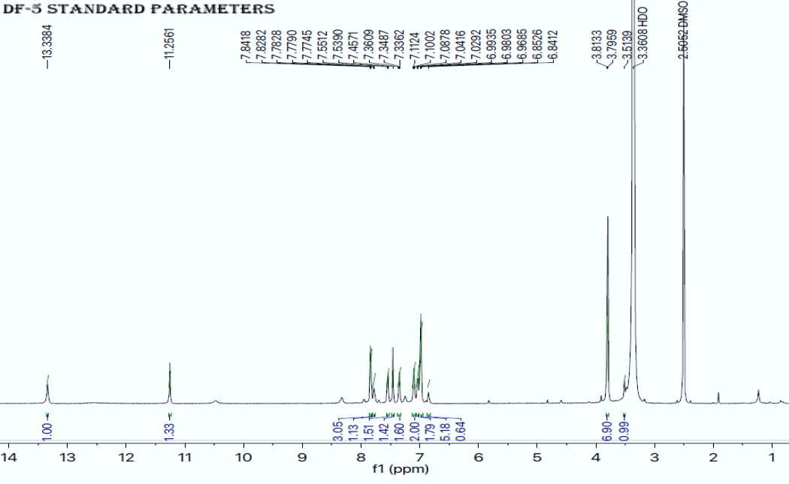

**Figure-S1:** Represents 1HNMR of analog-5

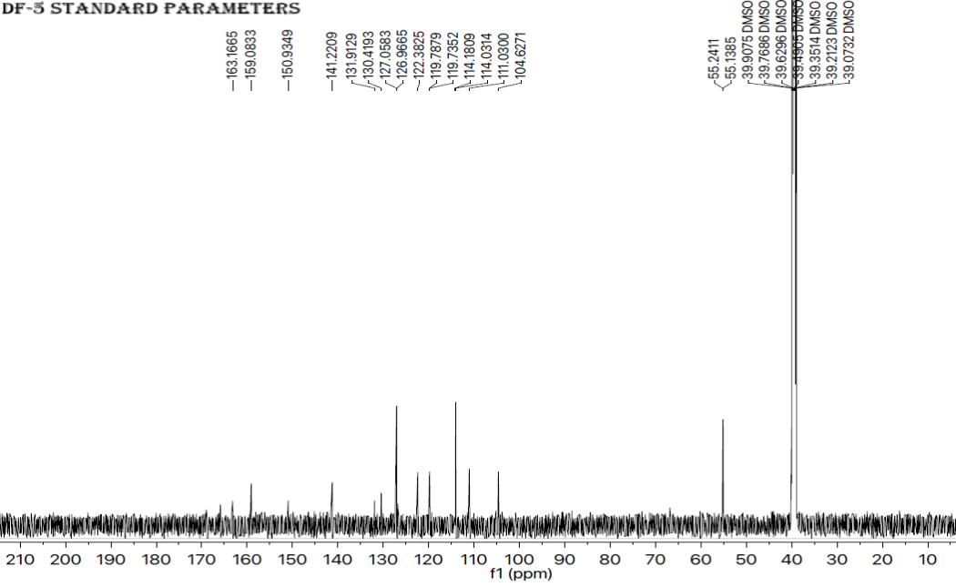

**Figure-S2:** Represents 13CNMR of analog-5

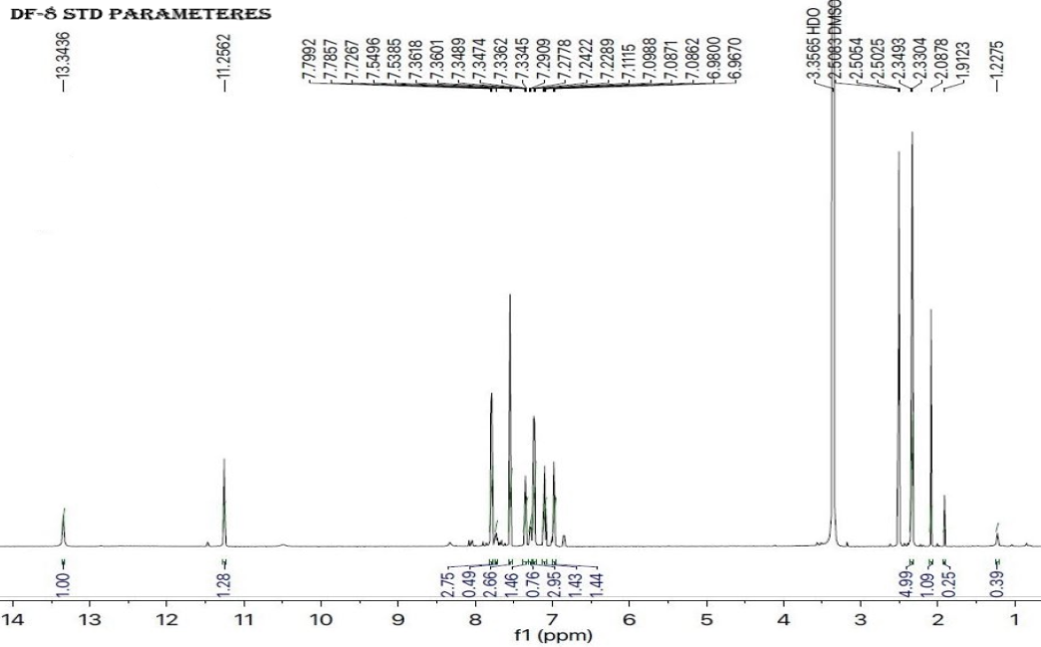

**Figure-S3:** Represents 1HNMR of analog-8

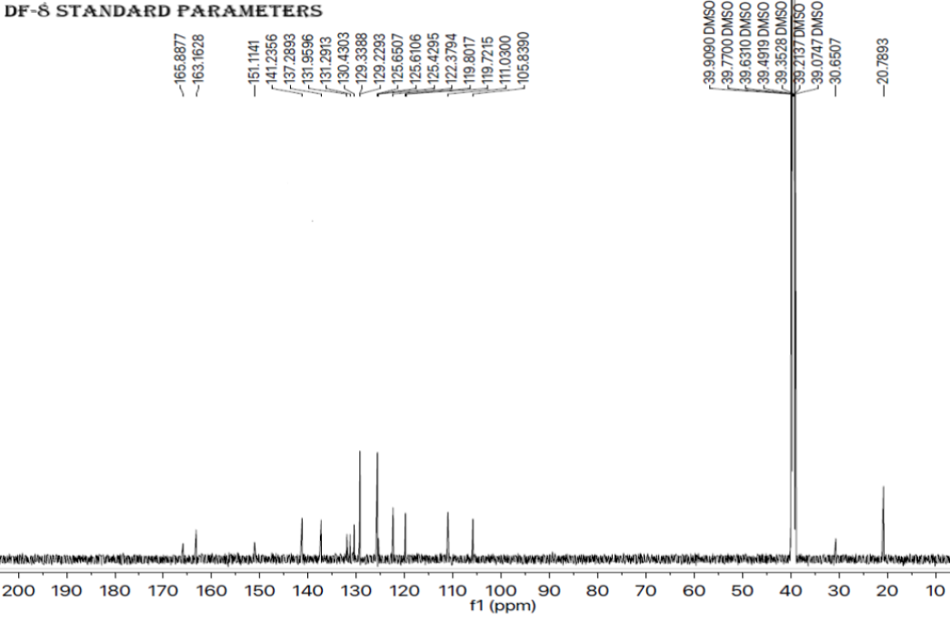

**Figure-S4:** Represents 13CNMR of analog-8

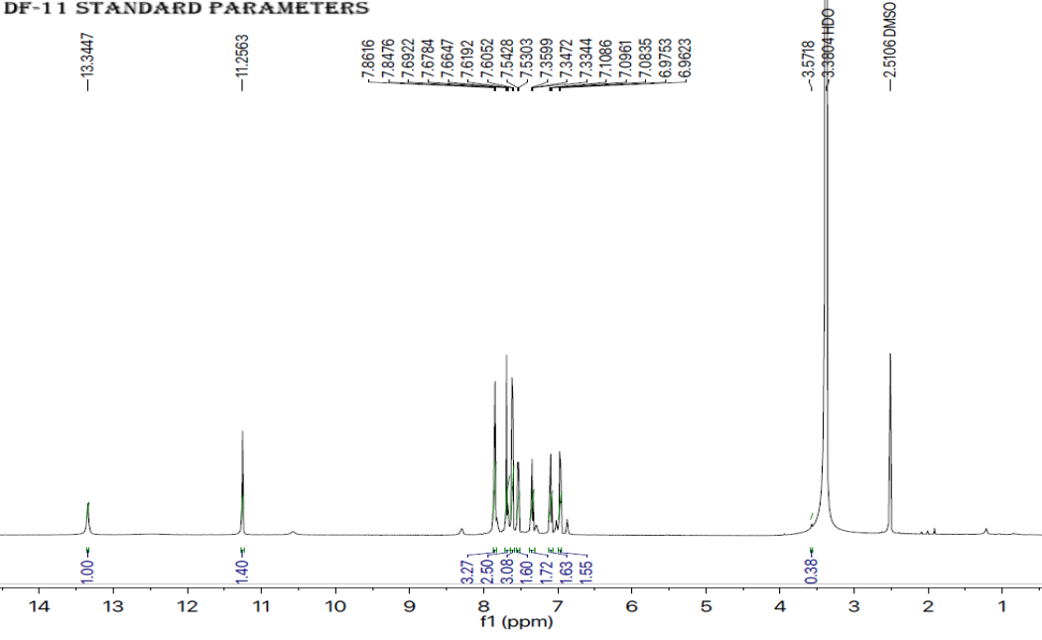

**Figure-S5:** Represents 1HNMR of analog-11

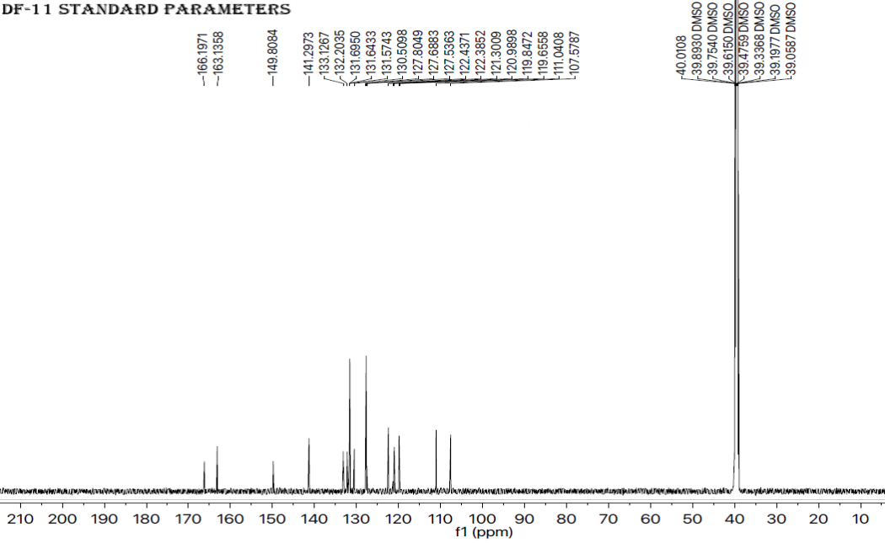**Figure-S6:** Represents 13CNMR of analog-11