**Supporting Information**

**Design, synthesis and biological activity of chalcone derivatives containing pyridazine**

Shuai Chen1, Miaohe Zhang1, Shuang Feng1，Chenyu Gong1, Yuanxiang Zhou1, Li Xing1, Bangcan He1, Yongjun Wu2,*, Wei Xue1,*

1 State Key Laboratory Breeding Base of Green Pesticide and Agricultural Bioengineering; Key Laboratory of Green Pesticide and Agricultural Bioengineering, Ministry of Education; Research and Development Center for Fine Chemicals, Guizhou University, Guiyang 550025, P.R. China.

2 Key laboratory of Plant Resource Conservation and Germplasm Innovation in Mountainous Region (Ministry of Education), College of Life Sciences, Guizhou University, Guiyang 550025, Guizhou Province, China.

*Corresponding author: Tel.: 0086-851-88292090, Fax: 0086-851-88292090, E-mail: wyjbio@163.com, wxue@gzu.edu.cn (Wei Xue)

Abbreviation

|  |  |  |
| --- | --- | --- |
|  | abbreviation | full name |
| 1 | 1H NMR | 1H nuclear magnetic resonance |
| 2 | 13C NMR | 13C nuclear magnetic resonance |
| 3 | 19F NMR | 19F nuclear magnetic resonance |
| 4 | HRMS | High-resolution mass spectroscopy |
| 5 | *Xoo* | *Xanthomonas oryzaepv.oryzae* |
| 6 | *Xac* | *Xanthomonas axonopodispv. Citri* |
| 7 | *Psa* | *Pseudomonas syringaepv. actinidiae* |
| 8 | *RS* | *Rhizoctonia solani* |
| 9 | *FG* | *Fusarium graminearum* |
| 10 | *SS* | *Sclerotinia sclerotiorum* |
| 11 | *BD* | *Botryosphaeria dothidea* |
| 12 | *CG* | *Colletotrichum gloeosporioides* |
| 13 | *PS* | *Phomopsissp* |
| 14 | *BC* | *Botrytis cinerea* |
| 15 | *PC* | *Phytophthora Capsici* |
| 16 | *CC* | *Colletotrichum capsici* |
| 17 | *CA* | *Colletotrichum acutatum* |
| 18 | DMSO | Dimethylsulfoxide |
| 19 | DMF | *N*,*N*-dimethylformamide |
| 20 | TLC | Thin Layer Chromatography |
| 21 | m.p. | Melting point |
| 22 | EC50 | 50% effective concentration |
| 23 | NB | Nutrient broth |
| 24 | OD | Optical density |
| 25 | PDA | Potato dextrose agar |
| 26 | TC | Thiodiazole-copper |
| 27 | BT | Bismerthiazol |
| 28 | SEM | Scanning electron microscope |
| 29 | AZ | Azoxystrobin |
| 30 | MDA | Malondialdehyde |

**1H NMR, 13C NMR, 19F NMR and HRMS spectrum of the title compounds**

|  |  |
| --- | --- |
|  | **Physical and chemical data** |
|  | **1H NMR (400 MHz, DMSO-*d*6)** δ 8.29 (d, *J* = 8.8 Hz, 2H), 8.12 (d, *J* = 9.2 Hz, 1H), 8.03 (d, *J* = 15.6 Hz, 1H), 7.97 (d, *J* = 8.5 Hz, 2H), 7.77 (d, *J* = 15.6 Hz, 1H), 7.61 (d, *J* = 9.2 Hz, 1H), 7.55 (d, *J* = 8.5 Hz, 2H), 7.50 – 7.42 (m, 2H);  **13C NMR (101 MHz, DMSO-*d*6)**δ 188.30 (s), 165.63 (s), 157.55 (s), 144.00 (s), 143.09 (s), 136.37 (s), 135.62 (s), 135.01 (s), 134.14 (s), 131.36 (s), 131.08(s), 129.45 (s), 123.12 (s), 122.11 (s), 121.59 (s);  **HRMS** (ESI) [M+H]+ calcd for C19H13O2N2BrCl: 414.98434, found:414.98373; Gary solid; m.p.: 200-202. oC; yield, 88%. |
|  | **1H NMR (500 MHz, DMSO-*d*6)**δ 8.08 (d, *J* = 8.6 Hz, 2H), 7.74 (d, *J* = 15.7 Hz, 1H), 7.66 (d, *J* = 9.1 Hz, 1H), 7.55 (d, *J* = 8.5 Hz, 2H), 7.52 – 7.45 (m, 3H), 7.36 – 7.30 (m, 2H), 7.13 (d, *J* = 9.2 Hz, 1H);  **13C NMR (126 MHz, DMSO-*d*6)**δ 189.00 (s), 164.89 (s), 156.73 (s), 143.74 (s), 143.34 (s), 135.34 (s), 135.09 (s), 133.78 (s), 132.34 (s), 130.66 (s), 129.94 (s), 125.02 (s), 122.33 (s), 121.16 (s), 120.36 (s);  **HRMS** (ESI) [M+H]+ calcd for C19H13O2N2Br2: 458.93383, found:458.93304; White solid; m.p. 203-204 oC; yield, 57%. |
|  | **1H NMR (500 MHz, DMSO-*d*6)**δ 8.23 (d, *J* = 8.6 Hz, 2H), 8.06 (d, *J* = 9.2 Hz, 1H), 7.95 (s, 1H), 7.86 (dd, *J* = 6.6, 3.0 Hz, 2H), 7.73 (d, *J* = 15.7 Hz, 1H), 7.54 (d, *J* = 9.2 Hz, 1H), 7.44 – 7.41 (m, 3H), 7.40 (d, *J* = 8.6 Hz, 2H);  **13C NMR (126 MHz, DMSO-*d*6)**δ 188.52 (s), 165.67 (s), 157.52 (s), 144.64 (s), 144.03 (s), 136.40 (s), 135.17 (s), 131.28 (s), 131.22 (s), 129.47 (s), 122.45 (s), 122.12 (s), 121.61 (s);  **HRMS** (ESI) [M] calcd for calcd for C19H12O2N2Br: 379.00767, found:379.00845; Yellow solid; m.p.:135-136oC; yield, 83%. |
|  | **1H NMR (400 MHz, DMSO-*d*6)**δ 8.27 (d, *J* = 8.8 Hz, 2H), 8.12 (d, *J* = 9.2 Hz, 1H), 7.87 (s, 3H, Ph-CH), 7.76 (d, *J* = 15.5 Hz, 1H), 7.60 (d, *J* = 9.2 Hz, 1H), 7.44 (d, *J* = 8.8 Hz, 2H), 7.04 (d, *J* = 8.8 Hz, 2H), 3.83 (s, 3H);  **13C NMR (101 MHz, DMSO-*d*6)**δ 188.24 (s), 165.64 (s), 161.88 (s), 157.28 (s), 144.59 (s), 143.95 (s), 136.34 (s), 135.41 (s), 131.36 (s), 131.08 (s), 127.78 (s), 122.06 (s), 121.51 (s), 119.83 (s), 114.89 (s), 55.87 (s);  **HRMS** (ESI) [M+H]+C20H16 O3N2Br: 411.03388, found: 411.03311;Yellow solid; m.p.: 153-154oC; yield, 53%. |
|  | **1H NMR (400 MHz, DMSO-*d*6)**δ 8.33 – 8.17 (m, 2H), 8.12 (d, *J* = 9.2 Hz, 1H), 7.95 (d, *J* = 15.3 Hz, 1H), 7.81 (d, *J* = 5.0 Hz, 1H), 7.73 (d, *J* = 3.5 Hz, 1H), 7.66 – 7.56 (m, 2H), 7.51 – 7.38 (m, 2H), 7.21 (dd, *J* = 5.0, 3.6 Hz, 1H);  **13C NMR (101 MHz, DMSO-*d*6)**δ 187.91 (s), 165.62 (s), 157.38 (s), 143.98 (s), 140.18 (s), 137.31 (s), 136.35 (s), 135.05 (s), 133.48 (s), 131.30 (s), 131.21 (s), 129.23 (s), 122.08 (s), 121.57 (s), 120.67 (s);  **HRMS** (ESI) [M+H]+ calcd for C17H12O2N2BrS: 386.97974, found: 386.97882; Yellow solid; m.p.:182-184oC; yield, 68%. |
|  | **1H NMR (500 MHz, DMSO-*d*6)**δ 8.24 (d, *J* = 8.6 Hz, 2H), 7.99 (d, *J* = 2.8 Hz, 1H), 7.97 (d, *J* = 9.1 Hz, 1H), 7.92 (d, *J* = 8.5 Hz, 2H), 7.72 (d, *J* = 15.6 Hz, 1H), 7.68 (s, 1H), 7.50 (d, *J* = 8.6 Hz, 2H), 7.41 (d, *J* = 8.6 Hz, 2H);  **13C NMR (126 MHz, CDCl3)**δ 189.09 (s), 164.19 (d, J = 252.0 Hz), 163.19 (s), 156.73 (s), 152.82 (s), 143.88 (s), 135.43 (s), 131.95 (s), 131.13 (s), 130.65(s), 130.56(s), 130.49(s), 121.50 (s), 121.13 (s), 120.58 (s), 116.38 (s), 116.36 (s), 116.19 (s).  **19F NMR (476 MHz, CDCl3)** δ -109.41(s);  **HRMS** (ESI) [M+H]+ calcd for C19H13 O2N2ClF: 355.06411, found:355.06412; White solid; m.p.: 189-190oC; yield, 76%. |
|  | **1H NMR (500 MHz, CDCl3)**δ 8.08 (d, *J* = 6.7 Hz, 2H), 7.76 (d, *J* = 15.5 Hz, H), 7.55 (t, *J* = 11.3 Hz, 3H), 7.47 (d, *J* = 15.5 Hz, H), 7.38 (d, *J* = 6.6 Hz, 2H), 7.33 (d, *J* = 6.8 Hz, 2H), 7.22(d, *J* = 7.3 Hz, 2H);  **13C NMR (126 MHz, CDCl3)**δ 189.00 (s), 164.58 (s), 156.81 (s), 152.83 (s), 143.65 (s), 136.62 (s), 135.36 (s), 133.38 (s), 131.91 (s), 130.65 (s), 129.72 (s), 129.37 (s), 122.27 (s), 121.12 (s), 120.54 (s);  **HRMS** (ESI) [M+H]+ calcd for C19H13 O2N2Cl2: 371.03486, found:371.03448; Yellow solid; m.p.: 193-194oC; yield, 60%. |
|  | **1H NMR (500 MHz, DMSO-*d*6)**δ 8.24 (d, *J* = 8.6 Hz, 2H), 8.01 – 7.97 (m, 1H), 7.94 (d, *J* = 15.8 Hz, 1H), 7.87 (dd, *J* = 6.7, 3.1 Hz, 2H), 7.74 (d, *J* = 15.5 Hz, 1H), 7.67 (d, *J* = 10.1 Hz, 1H), 7.42 (ddd, *J* = 8.6, 5.5, 1.7 Hz, 5H);  **13C NMR (126 MHz, DMSO-*d*6)**δ 188.51 (s), 165.45 (s), 157.61 (s), 152.90 (s), 144.64 (s), 135.20 (s), 133.38 (s), 131.30 (s), 131.21 (s), 129.48 (s), 122.48 (s), 122.42 (s), 121.60 (s);  **HRMS** (ESI) [M+H]+calcd for C19H14O2N2Cl: 337.07383, found:337.07266; Yellow solid; m.p.: 137–139oC; yield, 81%. |
|  | **1H NMR (500 MHz, DMSO-*d*6)**δ 8.23 (d, *J* = 8.6 Hz, 2H), 7.98 (d, *J* = 9.5 Hz, 1H), 7.89 (d, *J* = 15.4 Hz, 1H), 7.76 (d, *J* = 8.0 Hz, 2H), 7.72 – 7.65 (m, 2H), 7.40 (d, *J* = 9.0 Hz, 2H), 7.24 (d, *J* = 7.9 Hz, 2H), 2.31 (s, 3H);  **13C NMR (126 MHz, DMSO-*d*6)**δ 188.46(s), 157.52(s), 152.89(s), 144.72(s), 141.32(s), 135.29(s), 133.37(s), 132.48(s), 131.23(s), 130.10(s), 129.53(s), 122.41(s), 121.58(s), 121.38(s), 21.63(s)  **HRMS** (ESI) [M+H]+calcd for C20H16O2N2Cl: 351.08948, found:351.08893; Yellow solid; m.p.:181-183oC; yield, 65%; |
|  | **1H NMR (000 MHz, DMSO-*d*6)**δ 8.29 – 8.22 (m, 2H, Ph-H), 8.02 (d, *J* = 9.2 Hz, 1H), 7.89 (s, 1H), 7.85 (d, *J* = 14.5 Hz, 2H), 7.75 (d, *J* = 15.5 Hz, 1H), 7.70 (d, *J* = 9.2 Hz, 1H,), 7.46 – 7.42 (m, 2H), 7.03 (d, *J* = 8.8 Hz, 2H), 3.83 (s, 3H);  **13C NMR (101 MHz, DMSO-*d*6)**δ 188.28 (s), 165.39 (s), 161.90 (s), 157.35 (s), 152.81 (s), 144.58 (s), 135.42 (s), 133.30 (s), 131.35 (s), 131.08 (s), 127.78 (s), 122.33 (s), 121.48 (s), 119.87 (s), 114.90 (s), 55.87 (s);  **HRMS** (ESI) [M+H]+calcd for C21H18 O2N2Cl: 367.08440, found:367.08392; Yellow solid; m.p.:141-143oC; yield, 65%; |
|  | **1H NMR (500 MHz, CDCl3)**δ 8.14 – 8.03 (m, 2H), 7.74 (d, *J* = 15.7 Hz, 1H), 7.58 – 7.52 (m, 3H), 7.52 – 7.46 (m, 3H), 7.36 – 7.31 (m, 2H), 7.23 (d, *J* = 9.1 Hz, 1H);  **13C NMR (126 MHz, CDCl3)**δ 189.00 (s), 164.58 (s), 156.81 (s), 152.84 (s), 143.74 (s), 135.33 (s), 133.79 (s), 132.34 (s), 131.94 (s), 130.67 (s), 129.94 (s), 125.02 (s), 122.32 (s), 121.15 (s), 120.56 (s);  **HRMS** (ESI) [M+H]+ calcd for C19H13O2N2BrCl: 414.98434, found: 414.98370;Yellow solid; m.p.: 187-189oC; yield, 80%. |
|  | **1H NMR (500 MHz, CDCl3)**δ 8.87δ 8.06 (d, *J* = 7.1 Hz, 2H), 7.74 (t, *J* = 14.3 Hz, H), 7.53 (d, *J* = 8.8 Hz, H), 7.33 (t, *J* = 14.1 Hz, 3H), 7.18 (d, *J* = 34.2 Hz, 2H), 6.89 (d, *J* = 7.3 Hz, H), 3.92 (d, *J* = 10.5 Hz, 6H);  **13C NMR (126 MHz, CDCl3)**δ 189.49 (s), 156.52 (s), 151.59 (s), 149.34 (s), 145.39 (s), 135.86 (s), 131.88 (s), 130.56 (s), 127.85 (s), 123.33 (s), 121.02 (s), 120.52 (s), 119.94 (s), 111.22 (s), 110.18 (s), 56.11 (s), 56.07(s);  **HRMS** (ESI) [M+H]+C21H18O4N2Cl: 397.09496, found:397.09421; Yellow solid; m.p.: 175-177oC; yield, 73%.. |
|  | **1H NMR (500 MHz, DMSO-*d*6)**δ 8.08 (dd, *J* = 17.4, 8.7 Hz, 2H), 7.78 (t, *J* = 14.4 Hz, 1H), 7.55 – 7.51 (m, 1H), 7.45 (dd, *J* = 19.9, 11.5 Hz, 3H), 7.31 (ddd, *J* = 13.8, 10.6, 6.1 Hz, 4H), 7.23 (d, *J* = 9.0 Hz, 1H), 2.38 (d, *J* = 5.0 Hz, 3H);  **13C NMR (126 MHz, DMSO-*d*6)** δ 189.41(s), 164.62 (s), 162.93 (s), 157.17 (s), 156.66 (s), 152.79 (s), 145.46 (s), 145.34 (s), 138.77 (s), 135.59 (s), 135.22 (s), 134.79 (s), 131.94 (s), 131.65(s), 130.68 (s), 129.21 (s), 128.99 (s), 125.87(s), 122.60 (s), 121.69(s), 121.08 (s), 120.56 (s), 21.48 (s);  **HRMS**(ESI) [M+Na]+calcd for C20H15O2N2ClNa: 351.08948, found:351.08890; Yellow solid; m.p.: 159-160oC; yield, 56%. |
|  | **1H NMR (500 MHz, DMSO-*d*6)**δ 8.23 (dt, *J* = 8.2, 3.2 Hz, 2H), 7.97 (dt, *J* = 11.6, 3.0 Hz, 3H), 7.82 (dt, *J* = 15.6, 2.9 Hz, 1H), 7.66 (dt, *J* = 9.3, 3.0 Hz, 1H), 7.40 (dd, *J* = 7.6, 4.5 Hz, 2H), 7.30 (t, *J* = 6.6 Hz, 1H), 7.25 (dd, *J* = 7.4, 3.8 Hz, 2H), 2.41 (d, *J* = 4.0 Hz, 3H);  **13C NMR (126 MHz, DMSO-*d*6)**δ 188.49 (s), 165.44 (s), 157.60 (s), 152.90 (s), 141.65 (s), 138.64 (s), 135.19 (s), 133.78 (s), 133.38 (s), 131.36 (s), 131.31 (s), 131.01 (s), 127.47 (s), 126.93 (s), 123.25 (s), 122.43 (s), 121.62 (s), 19.88 (s);  **HRMS** (ESI) [M+H]+ calcd for C23H16O2N2Cl: 351.08948, found:351.08896; Yellow solid; m.p.: >200oC; yield, 31%. |
|  | **1H NMR (500 MHz, DMSO-*d*6)**δ 8.45 – 8.38 (m, 1H), 8.29 – 8.22 (m, 3H), 8.22 – 8.15 (m, 2H), 7.97 (d, *J* = 15.5 Hz, 1H), 7.90 – 7.85 (m, 2H), 7.78 – 7.72 (m, 1H), 7.59 – 7.49 (m, 2H), 7.44 – 7.41 (m, 3H);  **13C NMR (126 MHz, DMSO-*d*6)**δ 188.56 (s), 161.38 (s), 157.46 (s), 151.27 (s), 144.64 (s), 135.47 (s), 135.40 (s), 135.20 (s), 135.06 (s), 131.20 (s), 131.12 (s), 129.48 (s), 129.46 (s), 128.00 (s), 125.56 (s), 124.11 (s), 122.50 (s), 122.41 (s), 122.06 (s), 121.46 (s);  **HRMS** (ESI) [M+H]+calcd for C23H16O2N2Cl: 387.08948, found:387.08871; White solid; m.p.: 109-110oC; yield, 62%. |
|  | **1H NMR (500 MHz, DMSO-*d*6)**δ 12.43 (s, 1H), 8.19 (d, *J* = 8.7 Hz, 2H), 7.97 – 7.92 (m, 2H), 7.89 (d, *J* = 15.5 Hz, 1H), 7.71 (d, *J* = 15.6 Hz, 1H), 7.42 (d, *J* = 10.0 Hz, 1H), 7.32 (d, *J* = 8.7 Hz, 2H), 7.27 (t, *J* = 8.8 Hz, 2H), 7.01 (d, *J* = 9.9 Hz, 1H);  **13C NMR (126 MHz, DMSO-*d*6)**δ 188.27 (s), 163.96 (d, J = 249.1 Hz), 162.88(s), 160.41 (s), 158.14 (s), 152.41 (s), 143.31 (s), 134.55(s), 134.50(s), 131.89(s), 131.82(s), 131.31(s), 131.31 (s), 128.76 (s), 122.27 (s), 120.64 (s), 116.58(s), 116.41(s);  **19F NMR (476 MHz, CDCl3)** δ -109.43 (s);  **HRMS** (ESI) [M]calcd for C19H14O3N2F: 337.09830, found:337.09769;Gray solid; m.p.: 186-187oC; yield, 59%. |
|  | **1H NMR (500 MHz, DMSO-*d*6)**δ 8.24 – 8.17 (m, 2H), 7.96 (d, *J* = 15.6 Hz, 1H), 7.90 (d, *J* = 8.5 Hz, 2H), 7.70 (d, *J* = 15.5 Hz, 1H), 7.49 (d, *J* = 8.5 Hz, 2H), 7.43 (d, *J* = 10.0 Hz, 1H), 7.34 – 7.30 (m, 2H), 7.01 (d, *J* = 9.9 Hz, 1H);  **13C NMR (126 MHz, DMSO-*d*6)**δ 188.21 (s), 172.68 (s), 160.38 (s), 158.19 (s), 152.36 (s), 143.03 (s), 135.65 (s), 134.50 (s), 134.45 (s), 134.18 (s), 131.37 (s), 131.35 (s), 131.18 (s), 129.49 (s), 128.74 (s), 123.12 (s), 120.63 (s);  **HRMS** (ESI) [M] calcd for C20H14O3N2Cl: 353.06875, found:353.06790; Yellow solid; m.p.: 191-192oC; yield, 82%. |
|  | **1H NMR (500 MHz, DMSO-*d*6)** δ 12.43 (s, 1H), 8.20 (d, *J* = 8.4 Hz, 2H), 7.91 (s, 1H), 7.89 – 7.83 (m, 2H), 7.74 – 7.69 (m, 1H), 7.46 – 7.40 (m, 4H), 7.32 (d, *J* = 8.5 Hz, 2H), 7.04 – 6.98 (m, 1H);  **13C NMR (126 MHz, DMSO-*d*6)**δ 188.36 (s), 160.39 (s), 158.14 (s), 152.40 (s), 144.54 (s), 135.20 (s), 134.58 (s), 134.51 (s), 131.31 (s), 131.21 (s), 129.48 (s), 129.10 (s), 128.75 (s), 122.41 (s), 120.65 (s);  **HRMS** (ESI) [M+H]+ calcd for C19H14O3N2: 319.10772, found:319.10699; Yellow solid; m.p.: 188-189oC; yield, 54%. |
|  | **1H NMR (500 MHz, DMSO-*d*6)**δ 12.42 (s, 1H), 8.20 – 8.17 (m, 2H), 7.87 (d, *J* = 15.6 Hz, 1H), 7.75 (d, *J* = 8.0 Hz, 2H), 7.69 (d, *J* = 15.5 Hz, 1H), 7.43 (d, *J* = 9.9 Hz, 1H), 7.33 – 7.30 (m, 2H), 7.24 (d, *J* = 8.0 Hz, 2H), 7.01 (d, *J* = 10.0 Hz, 1H), 2.31 (s, 3H);  **13C NMR (126 MHz, DMSO-*d*6)**δ 188.30 (s), 160.39 (s), 158.05 (s), 152.41 (s), 144.62 (s), 141.30 (s), 134.60 (d, *J* = 22.4 Hz), 132.49 (s), 131.24 (s), 130.10 (s), 129.53 (s), 128.75 (s), 121.33 (s), 120.63 (s), 21.64 (s);  **HRMS** (ESI) [M] calcd for C20H17O3N2: 333.12337, found:333.12259; Yellow solid; m.p.: 183-185oC; yield, 81%. |
|  | **1H NMR (500 MHz, DMSO-*d*6)**δ 8.17 (d, *J* = 8.7 Hz, 2H), 7.84 – 7.81 (m, 2H), 7.79 (d, *J* = 15.4 Hz, 1H), 7.69 (d, *J* = 15.6 Hz, 1H), 7.43 (d, *J* = 10.0 Hz, 1H), 7.33 – 7.29 (m, 2H), 7.01 (d, *J* = 10.0 Hz, 1H), 6.99 – 6.97 (m, 2H), 3.78 (s, 3H).  **13C NMR (126 MHz, DMSO-*d*6)** δ 188.18 (s), 161.93 (s), 160.39 (s), 157.94 (s), 152.43 (s), 144.55 (s), 134.87 (s), 134.50 (s), 131.41 (s), 131.15 (s), 128.74 (s), 127.84 (s), 120.60 (s), 119.85 (s), 114.95 (s), 55.92 (s).  **HRMS** (ESI) [M] calcd for C20H17O4N2: 349.11828, found:349.11746; Gray solid; m.p.: 143-144oC; yield, 62%. |

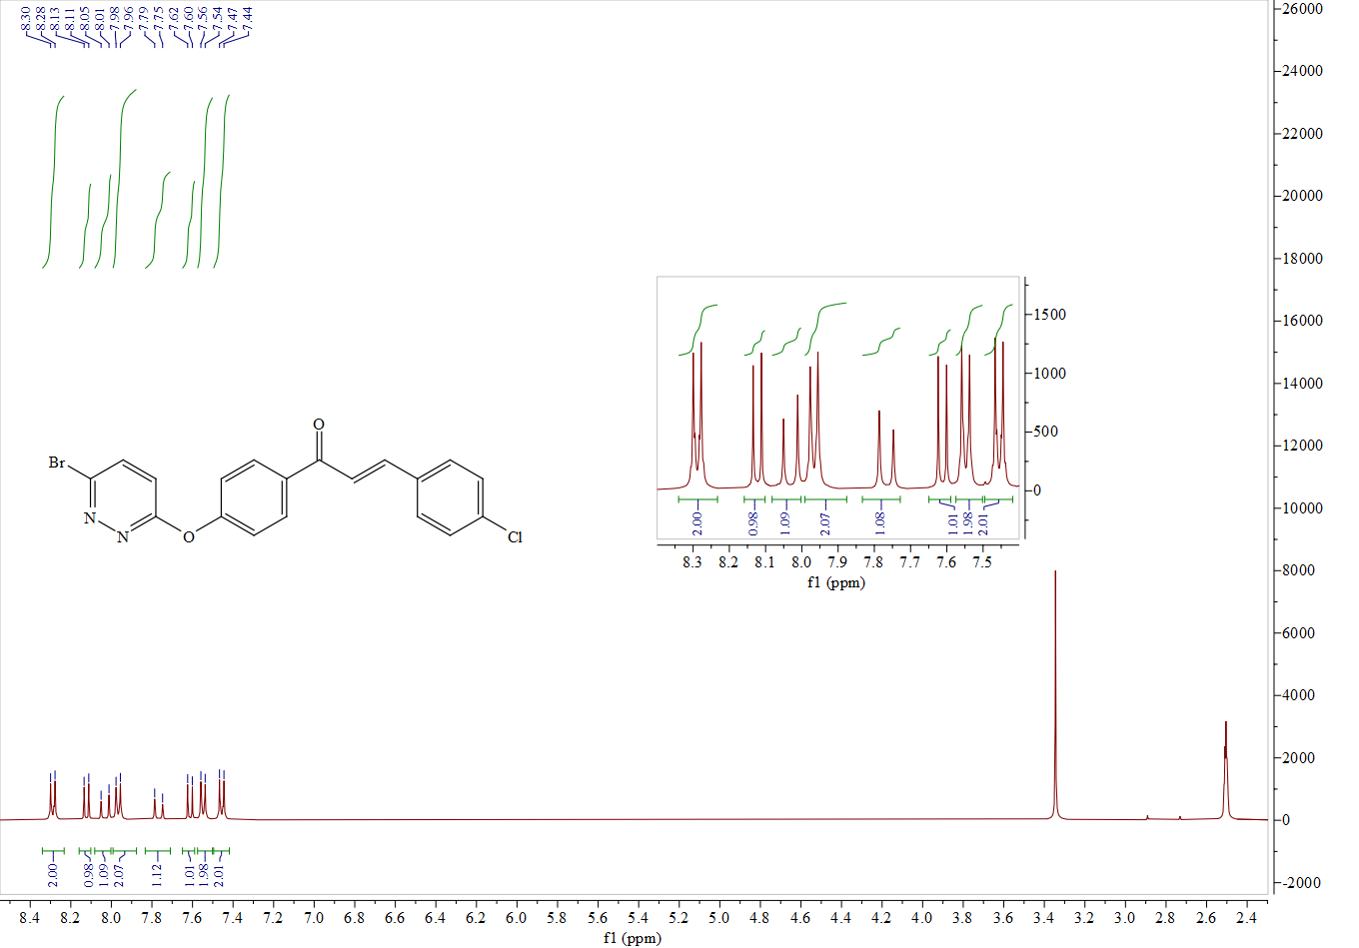

1H NMR spectrum of compound **A1**

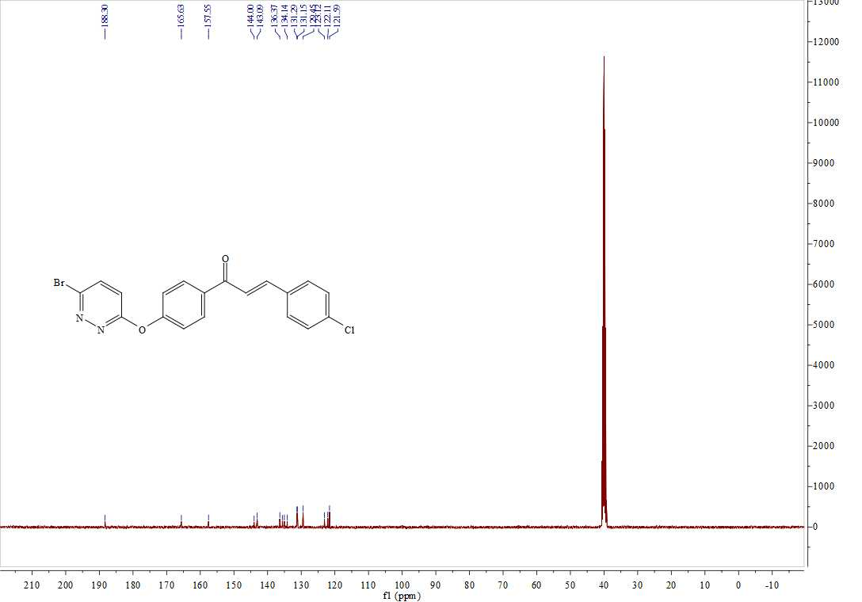

13C NMR spectrum of compound **A1**



HRMS (ESI)spectrum of compound **A1**

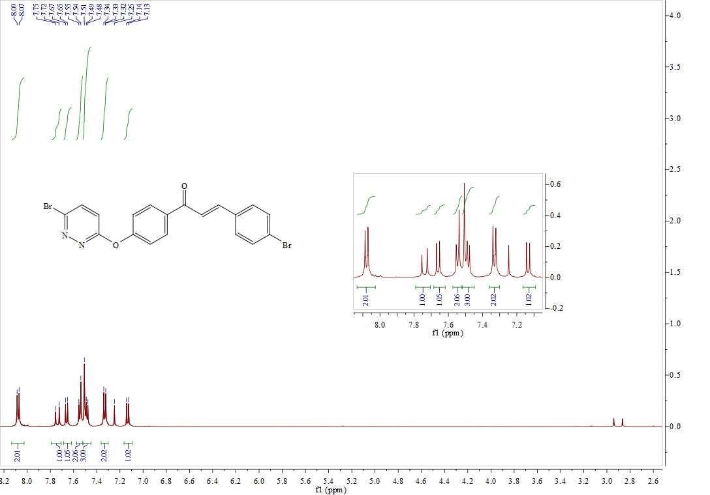

1H NMR spectrum of **A2**

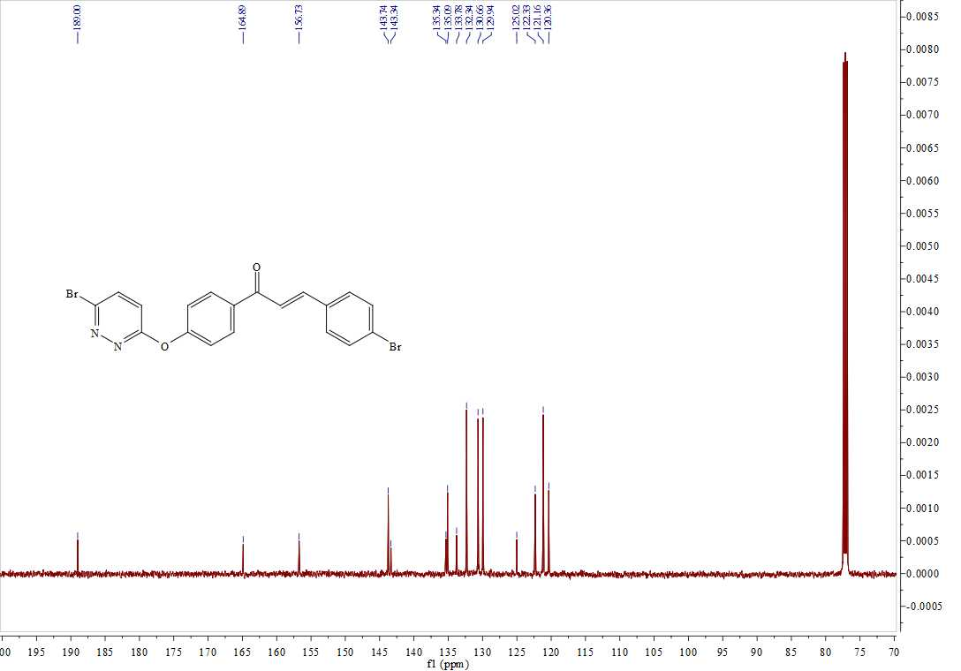

13C NMR spectrum of compound **A2**

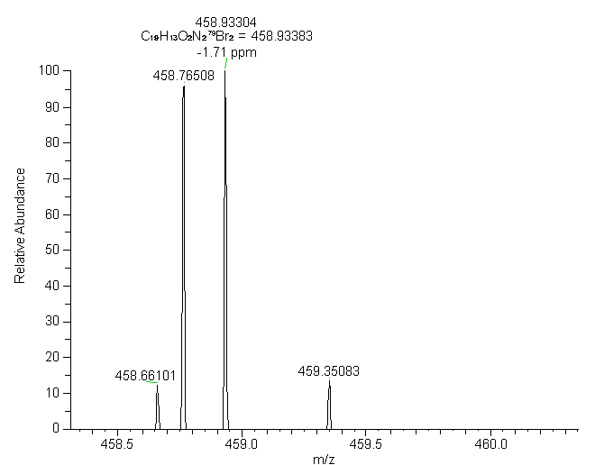

HRMS (ESI)spectrum of compound **A2**

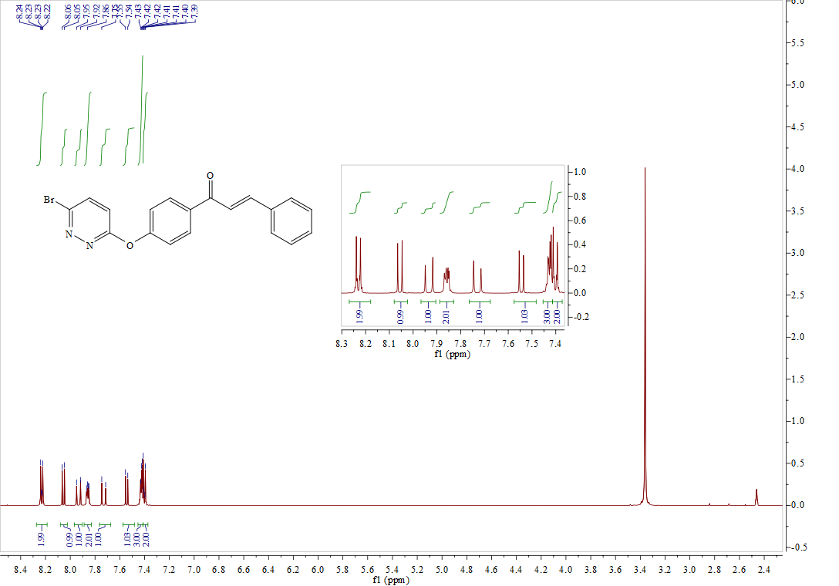

1H NMR spectrum of compound **A3**

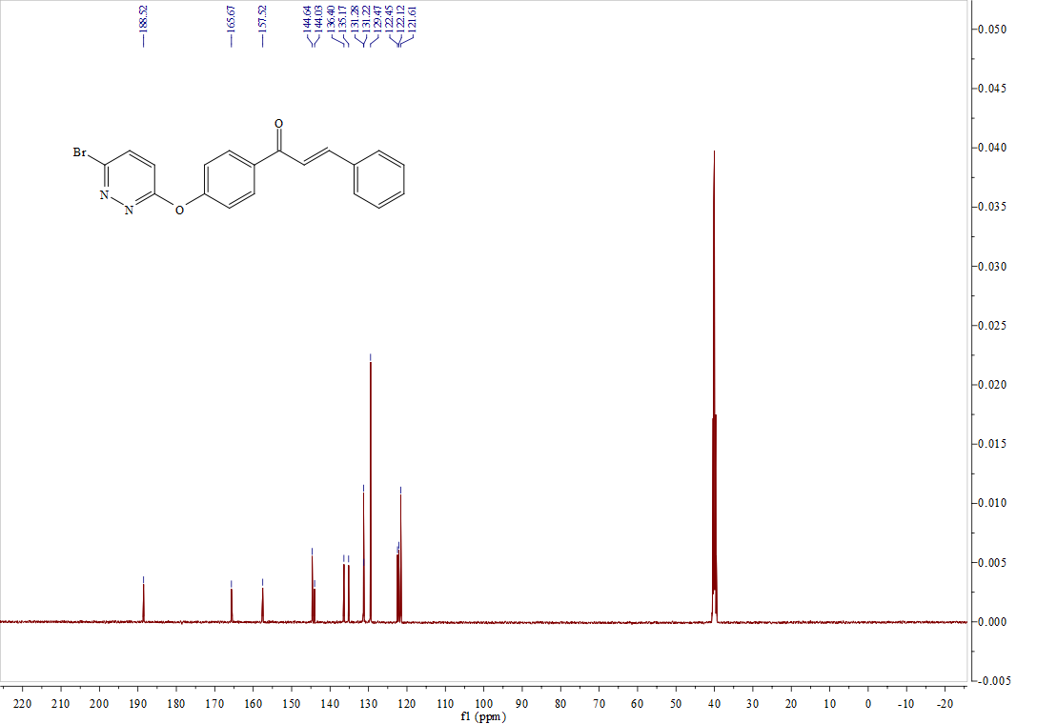

13C NMR spectrum of compound**A3**

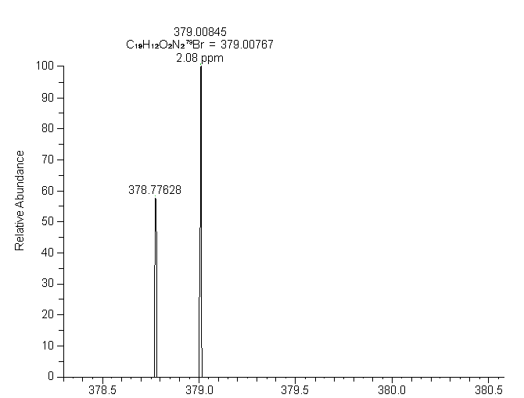

HRMS (ESI)spectrum of compound **A3**

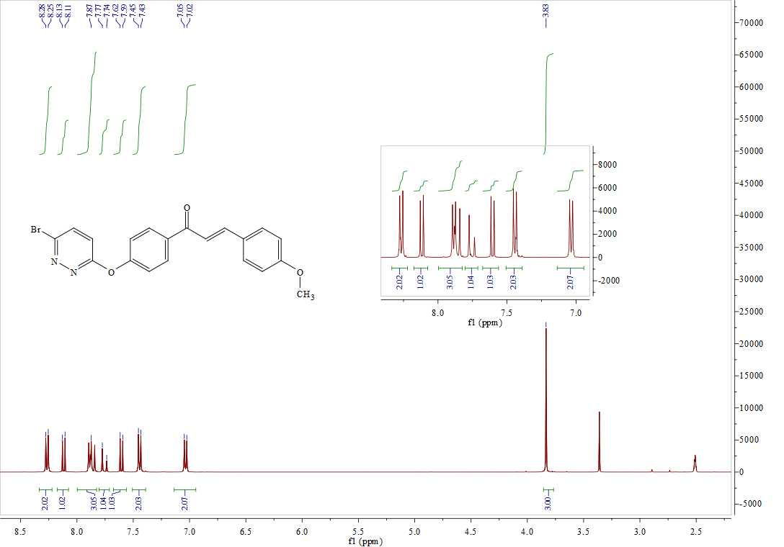

1H NMR spectrum of compound **A4**

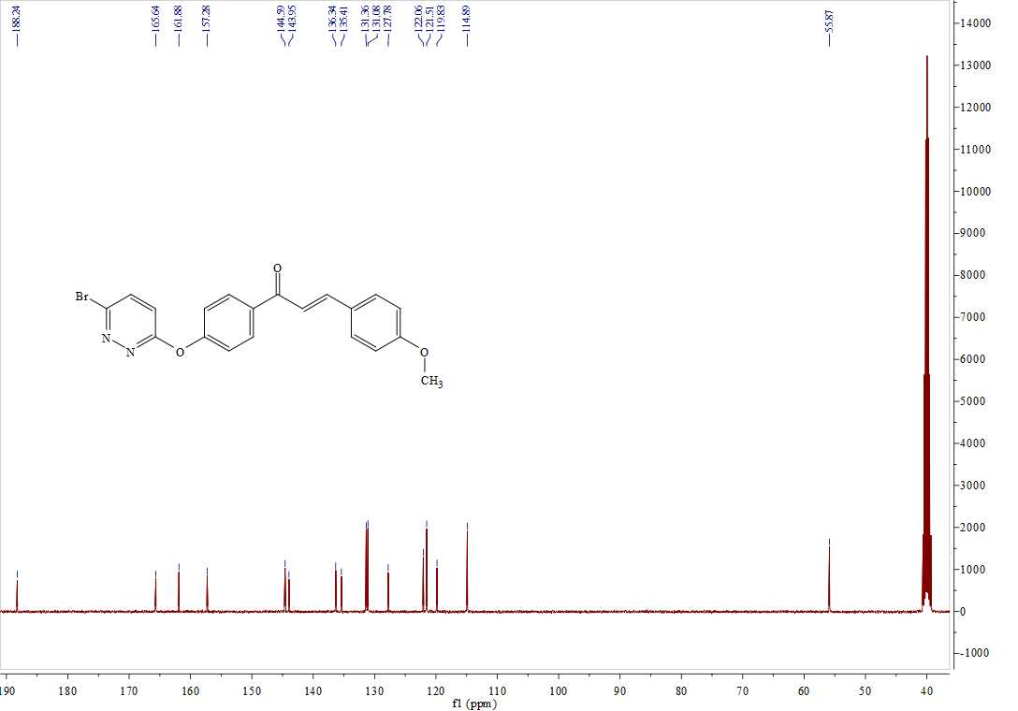

13C NMR spectrum of compound **A4**

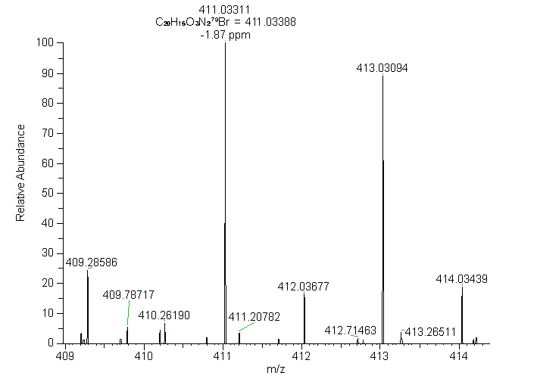

HRMS (ESI)spectrum of compound **A4**

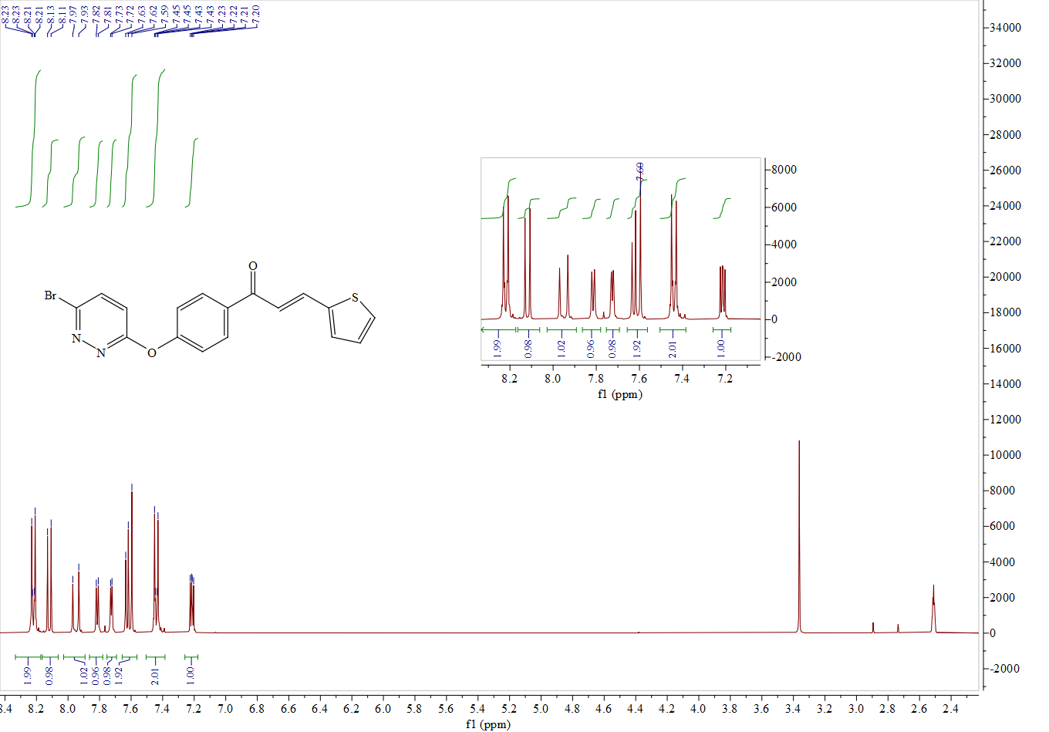

1H NMR spectrum of compound **A5**

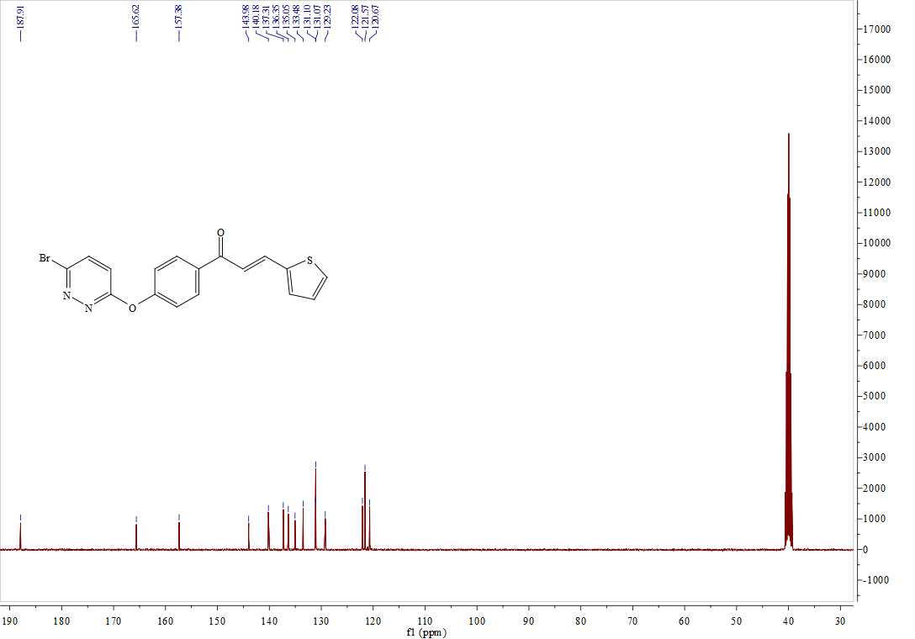

13C NMR spectrum of compound **A5**

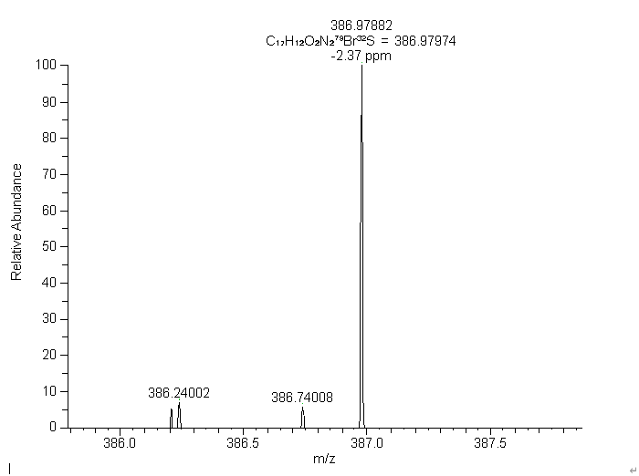

HRMS (ESI)spectrum of compound **A5**

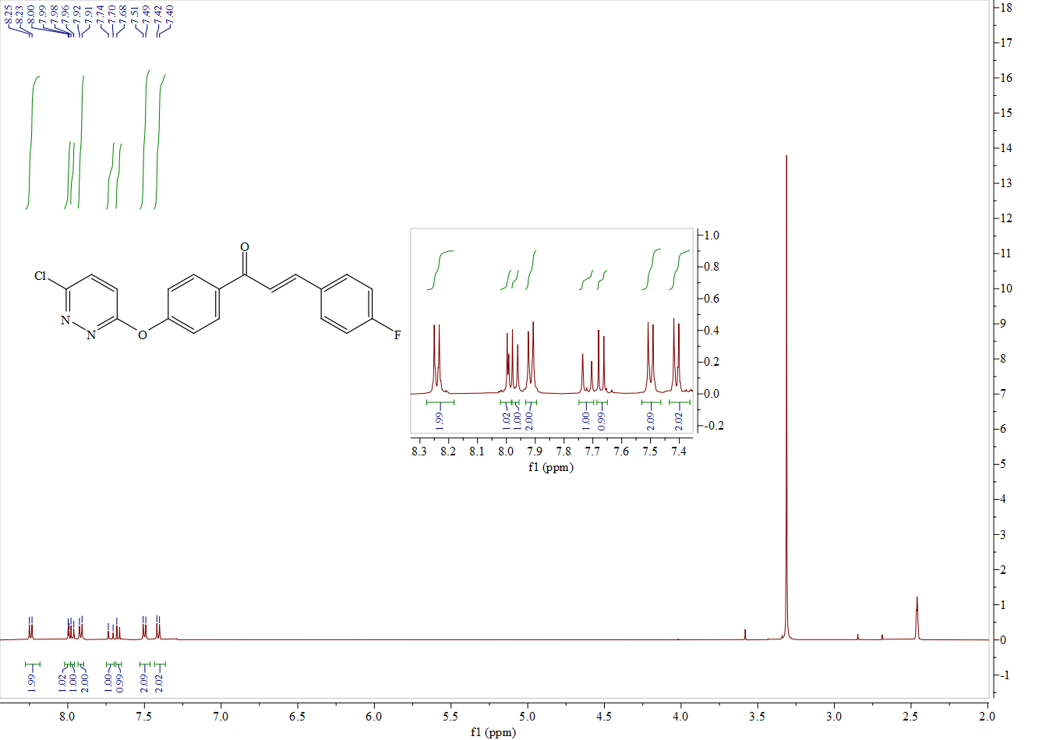1H NMR spectrum of compound **B1**

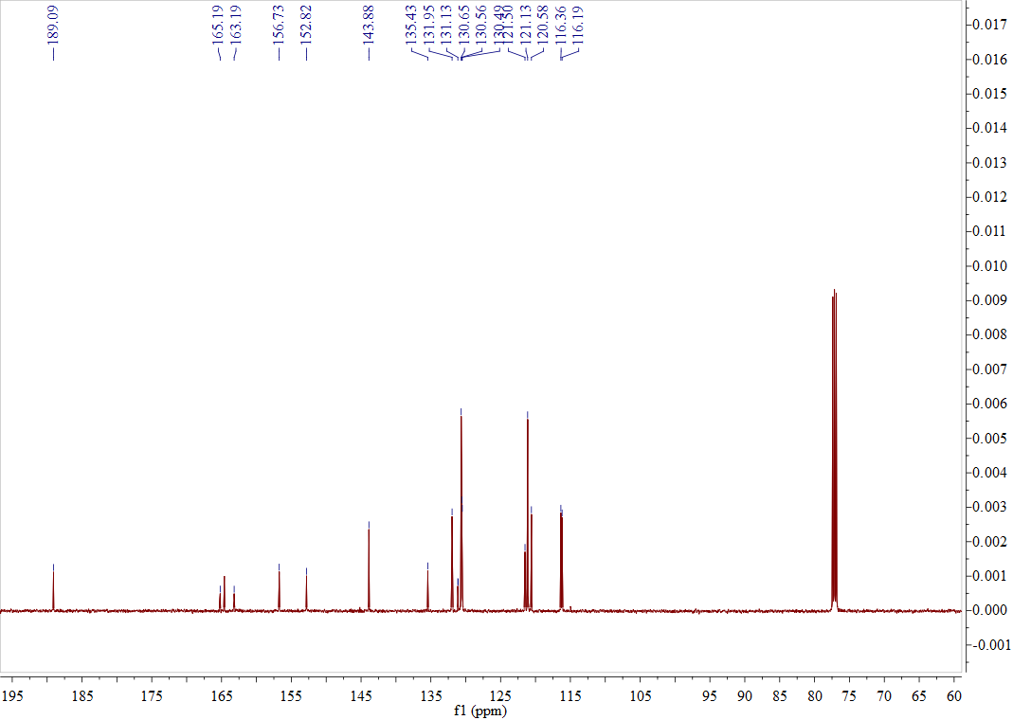

13C NMR spectrum of compound **B1**

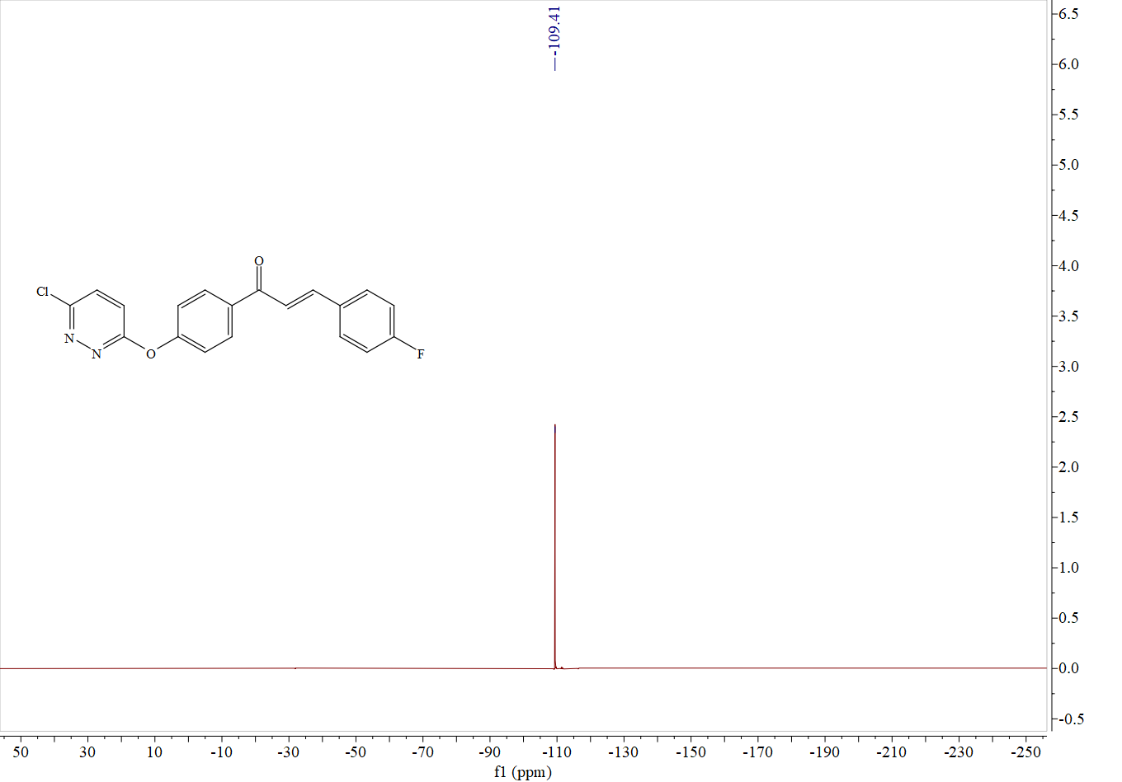

19F NMR spectrum of compound**B1**



HRMS (ESI)spectrum of compound **B1**

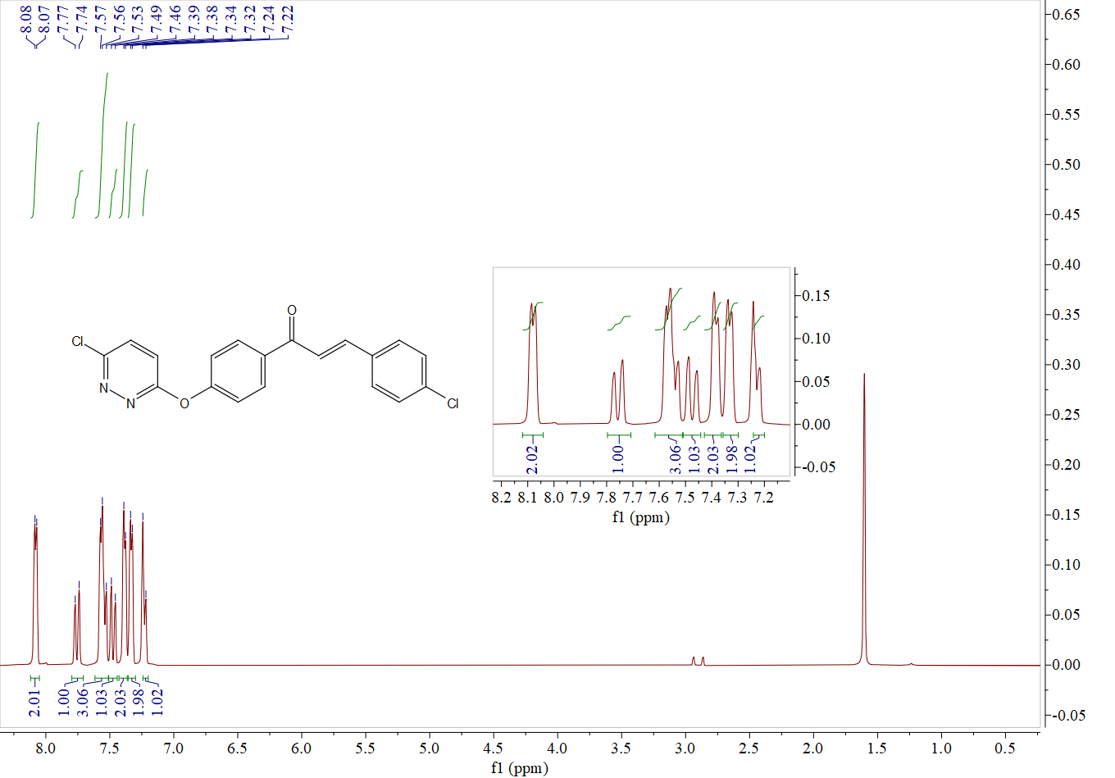1H NMR spectrum of compound **B2**

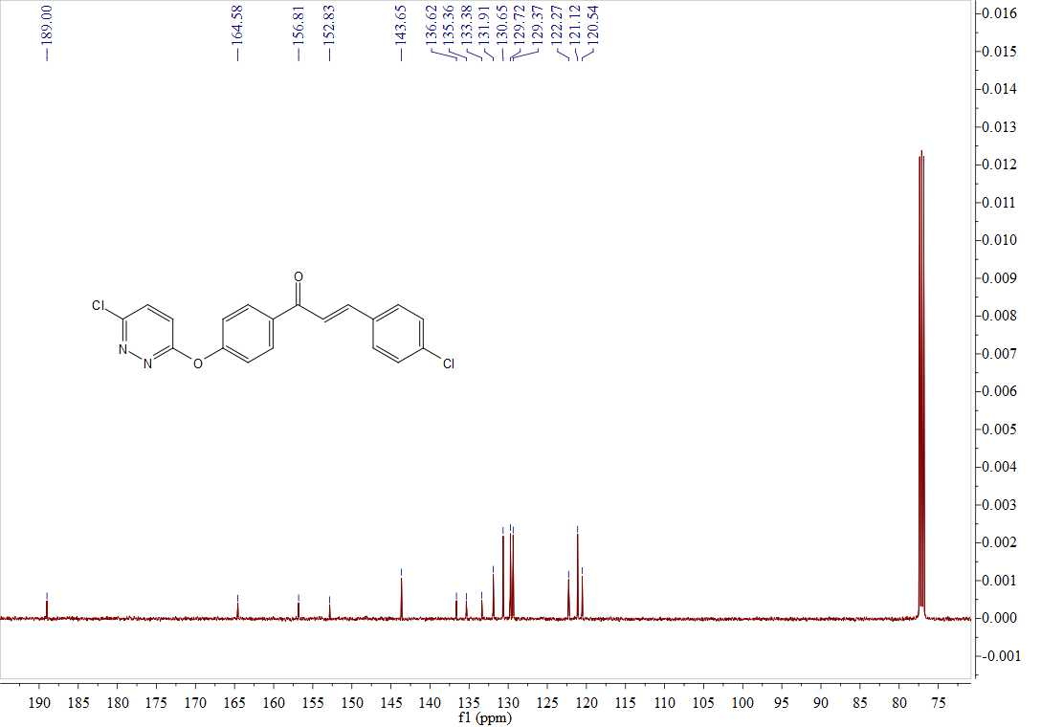13C NMR spectrum of compound **B2**



HRMS (ESI)spectrum of compound **B2**

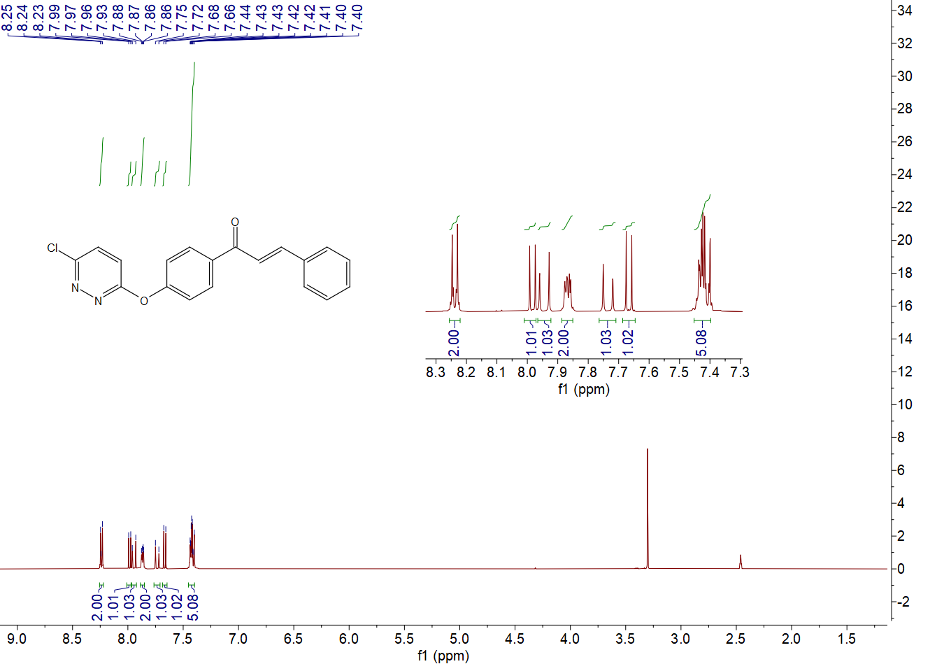

1H NMR spectrum of compound **B3**

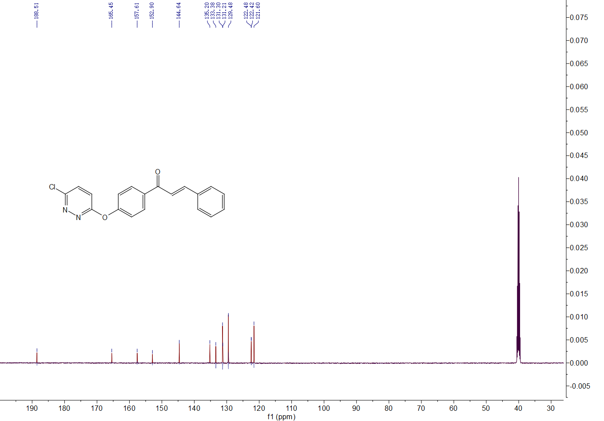

13C NMR spectrum of compound **B3**

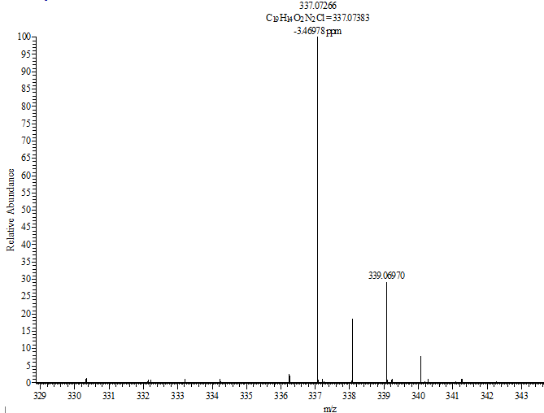

HRMS (ESI)spectrum of compound **B3**

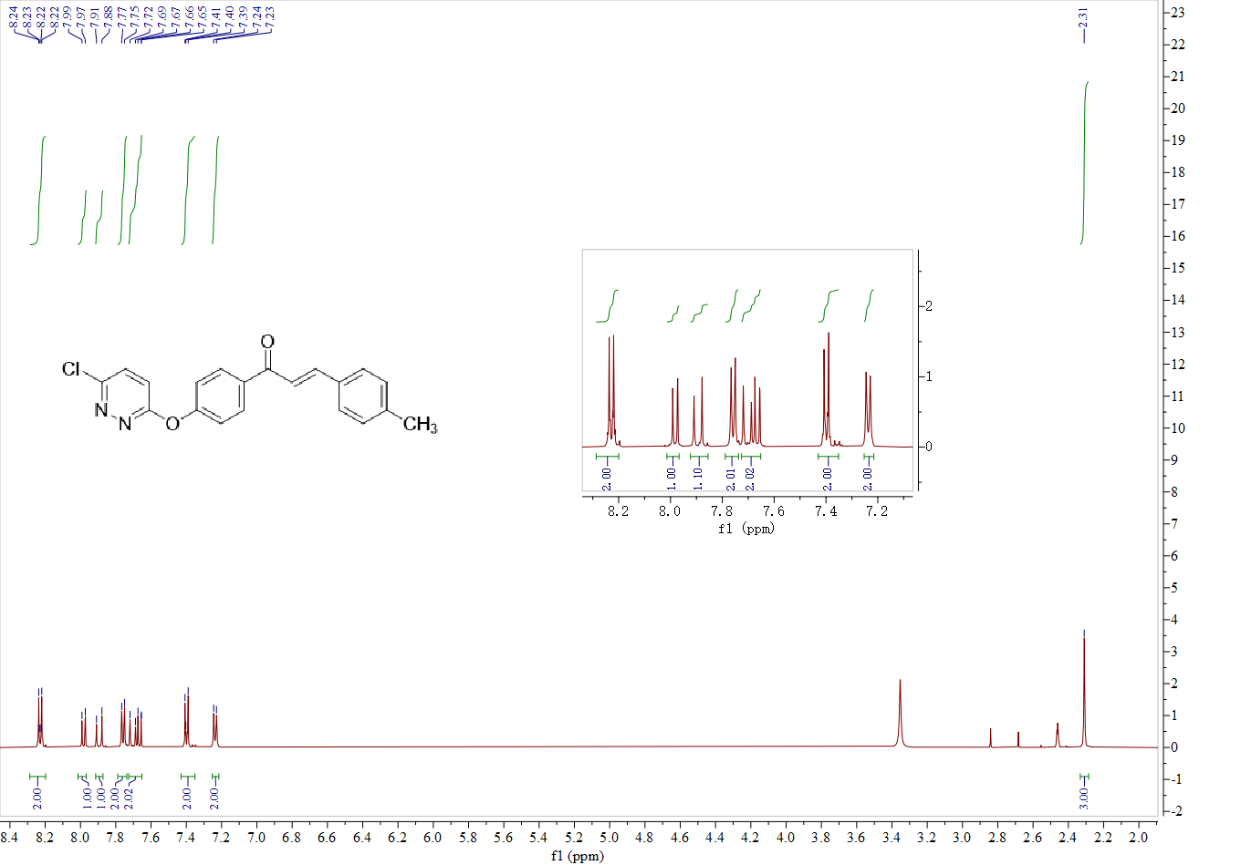1H NMR spectrum of compound **B4**

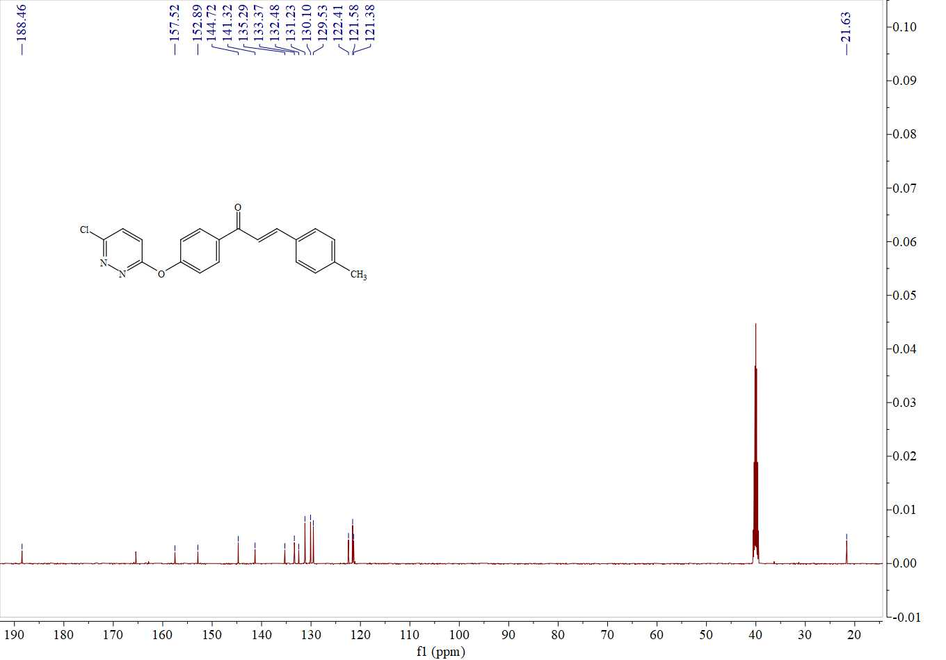13C NMR spectrum of compound **B4**

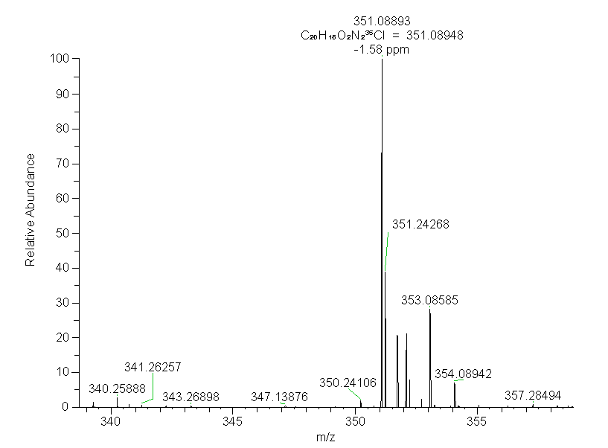

HRMS (ESI)spectrum of compound **B4**

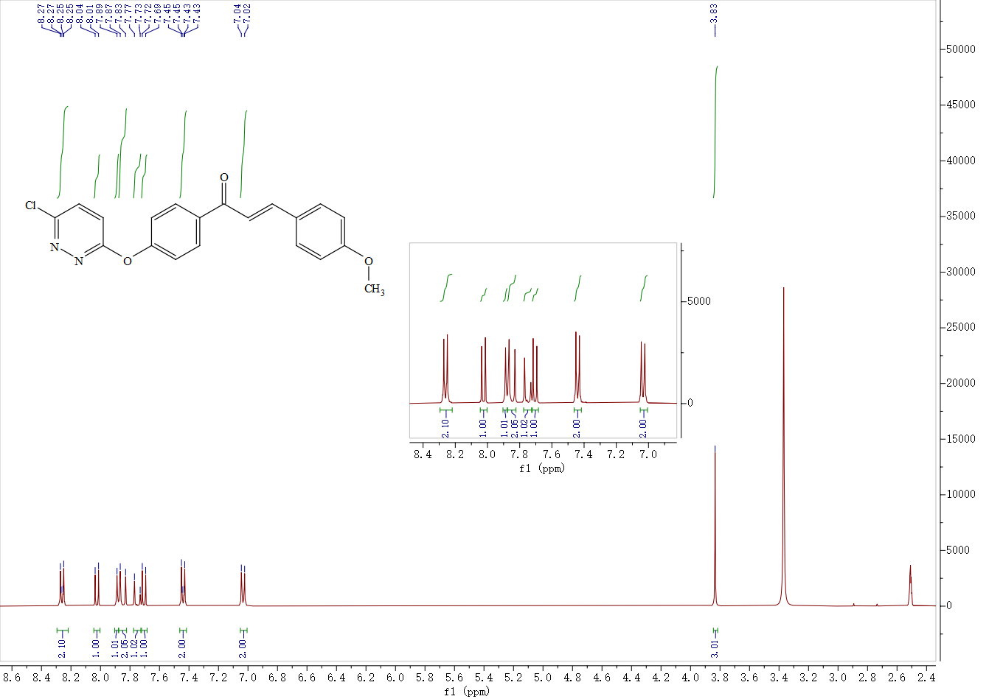

1H NMR spectrum of compound **B5**

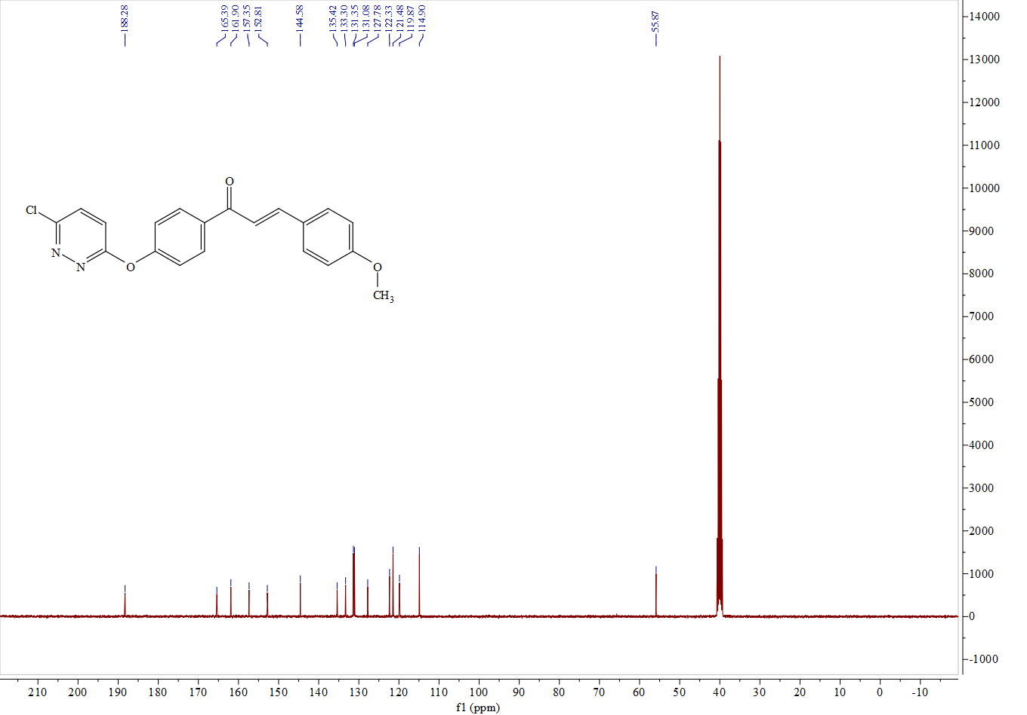

13C NMR spectrum of compound **B5**

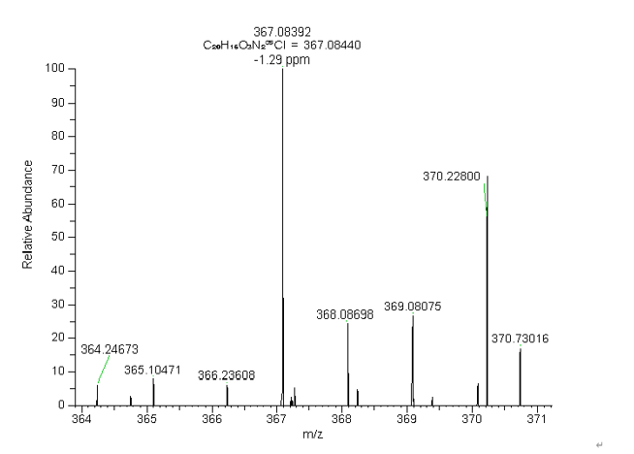

HRMS (ESI)spectrum of compound **B5**

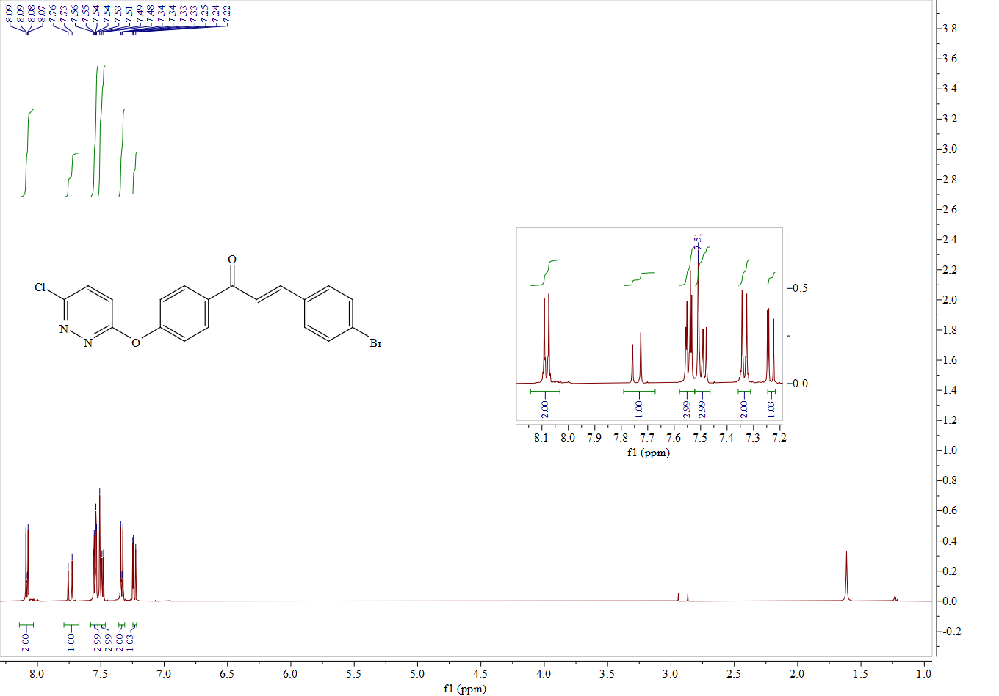

1H NMR spectrum of compound **B6**

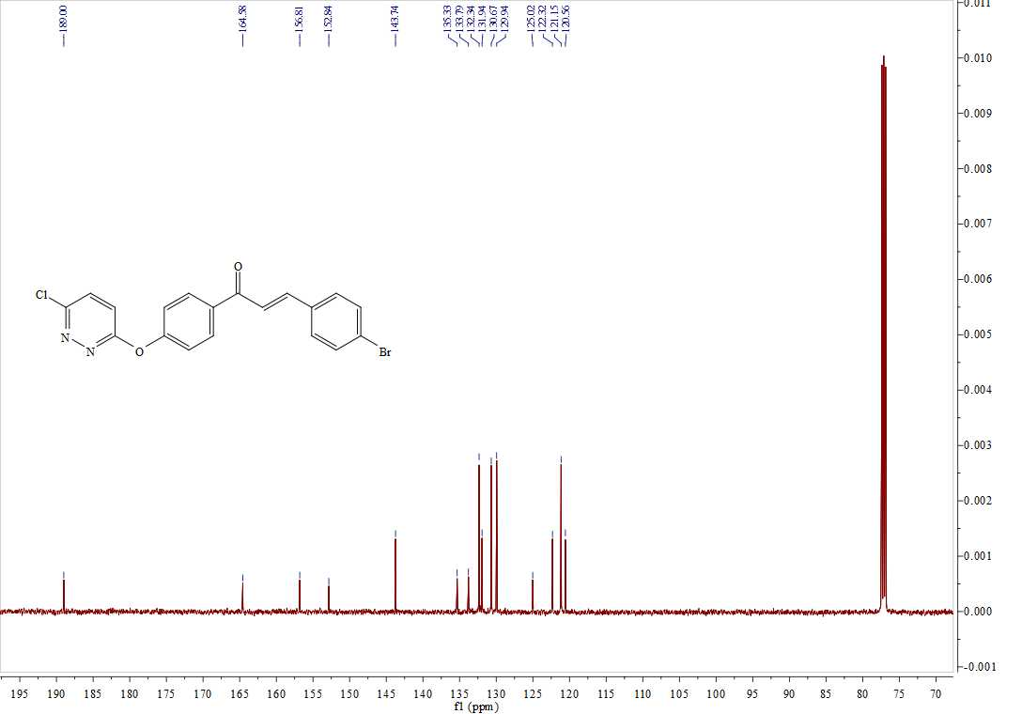

13C NMR spectrum of compound **B6**

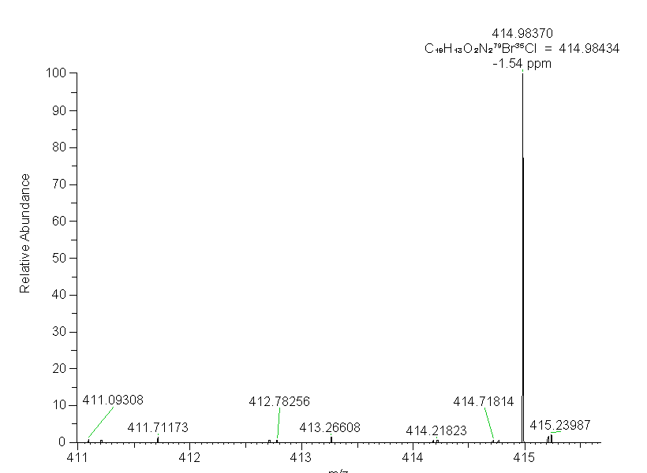

HRMS (ESI)spectrum of compound **B6**

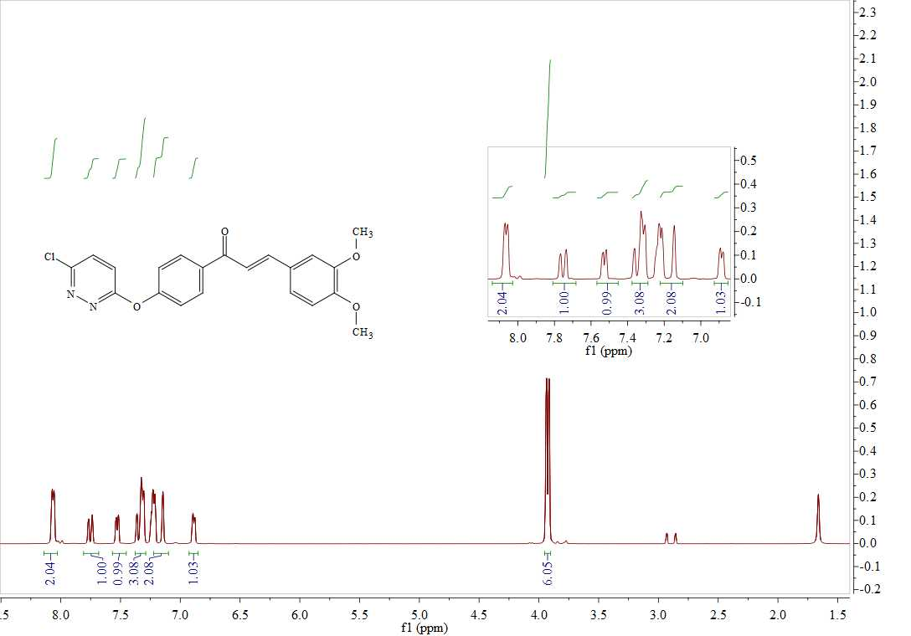

1H NMR spectrum of compound **B7**

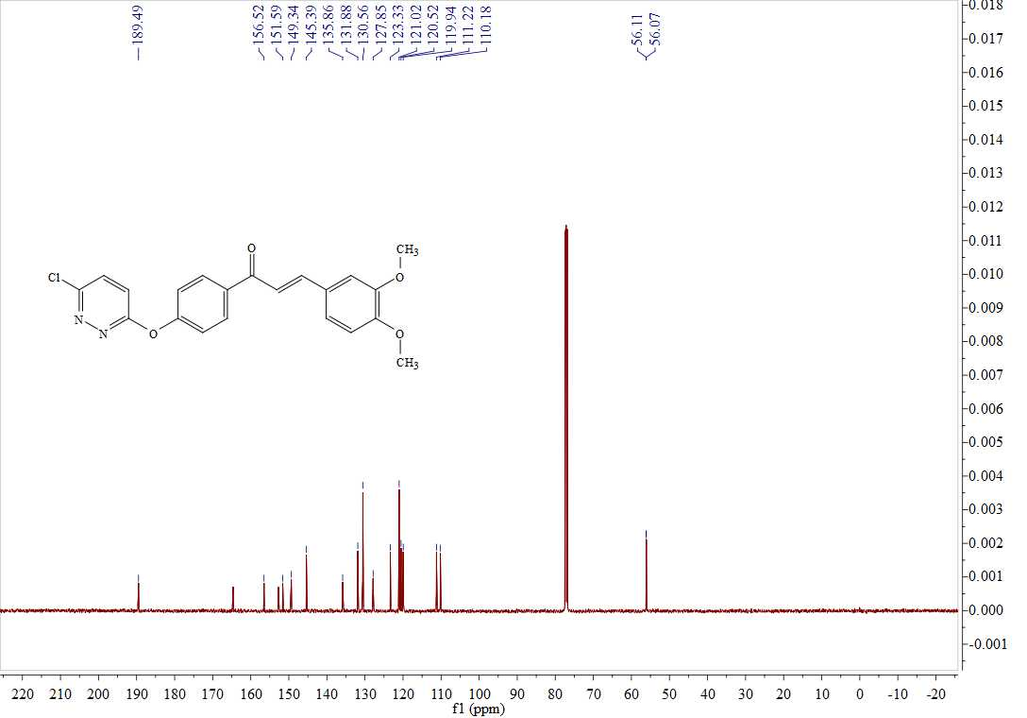

13C NMR spectrum of compound **B7**

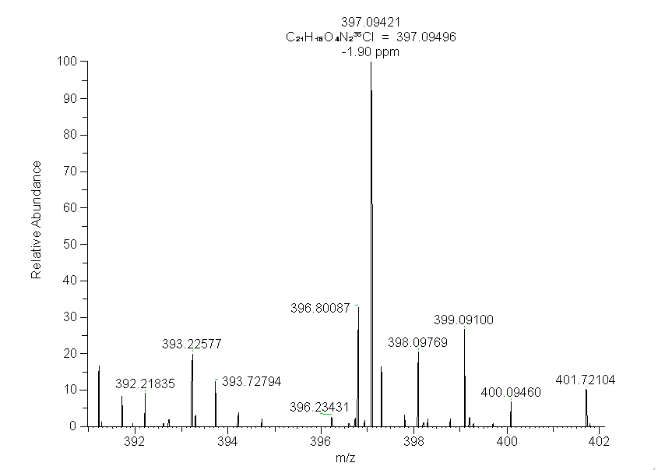

HRMS (ESI)spectrum of compound **B7**

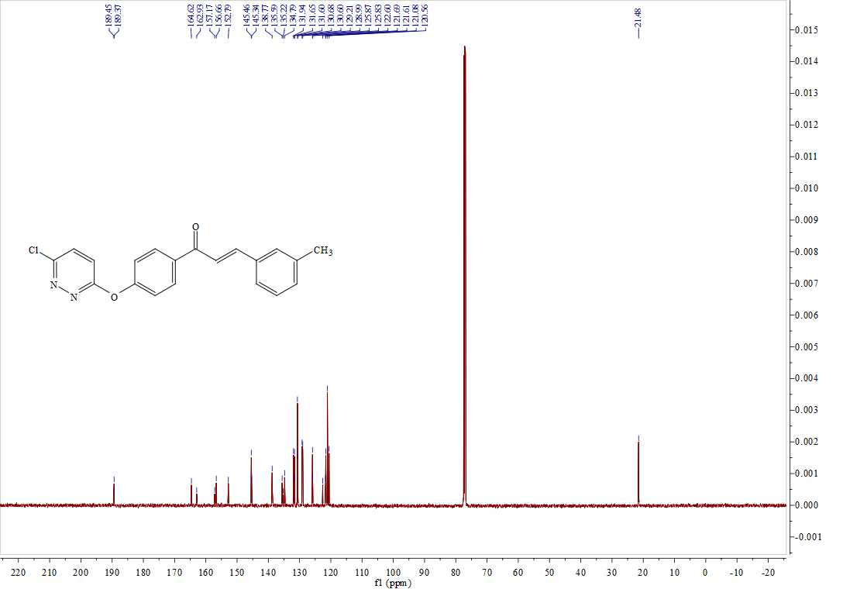

1H NMR spectrum of compound **B8**

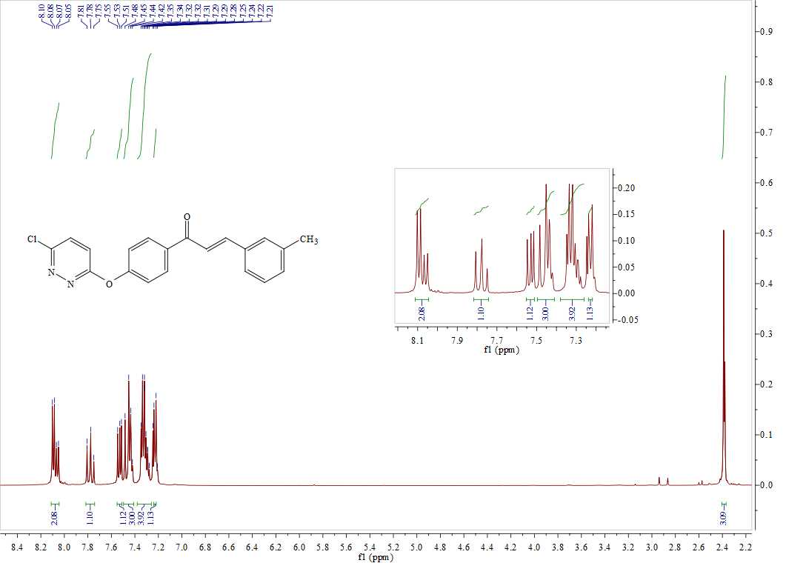

13C NMR spectrum of compound **B8**

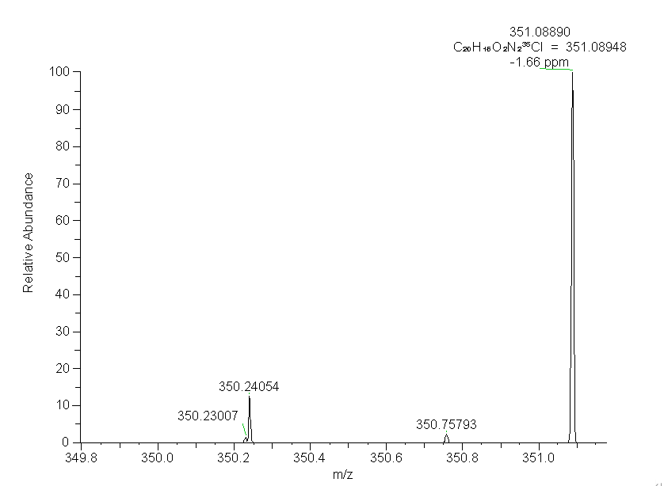

HRMS (ESI)spectrum of compound **B8**

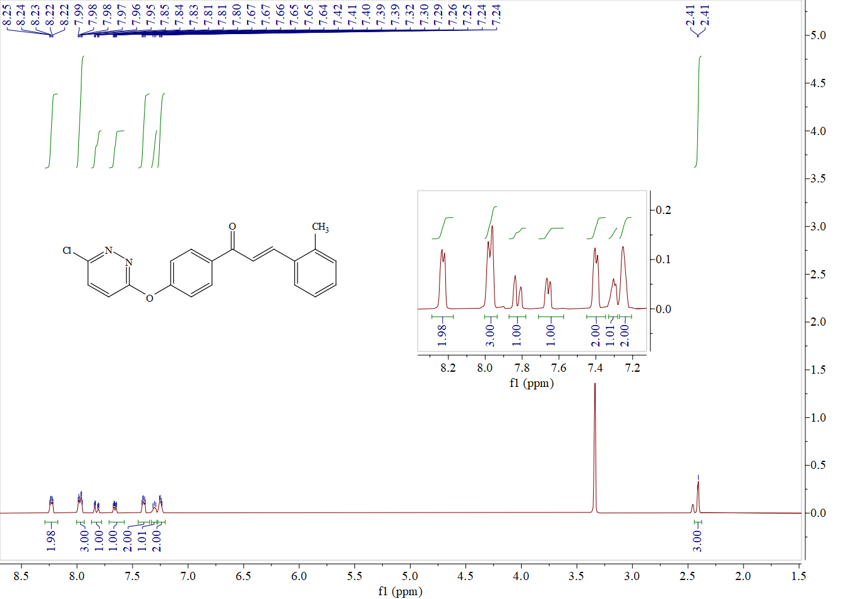

1H NMR spectrum of compound **B9**

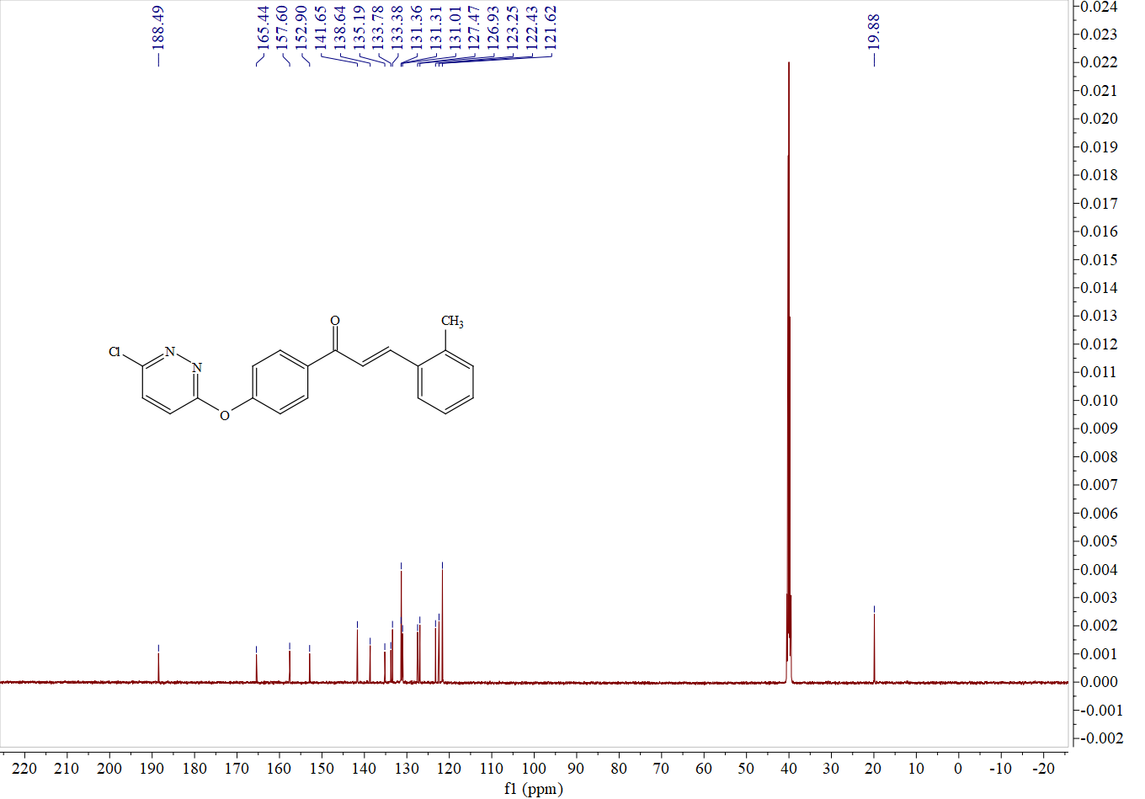

13C NMR spectrum of compound **B9**

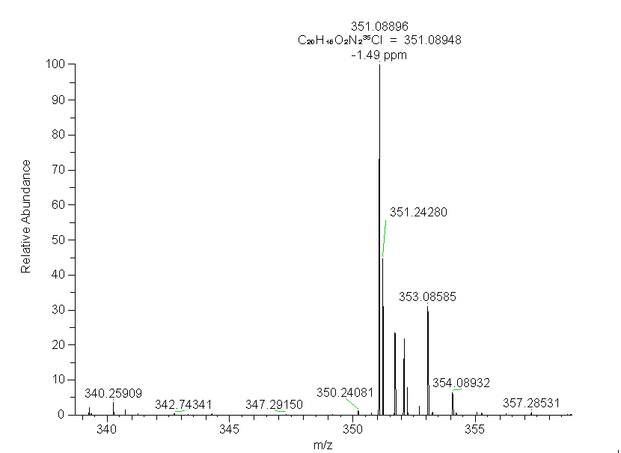

HRMS (ESI)spectrum of compound **B9**

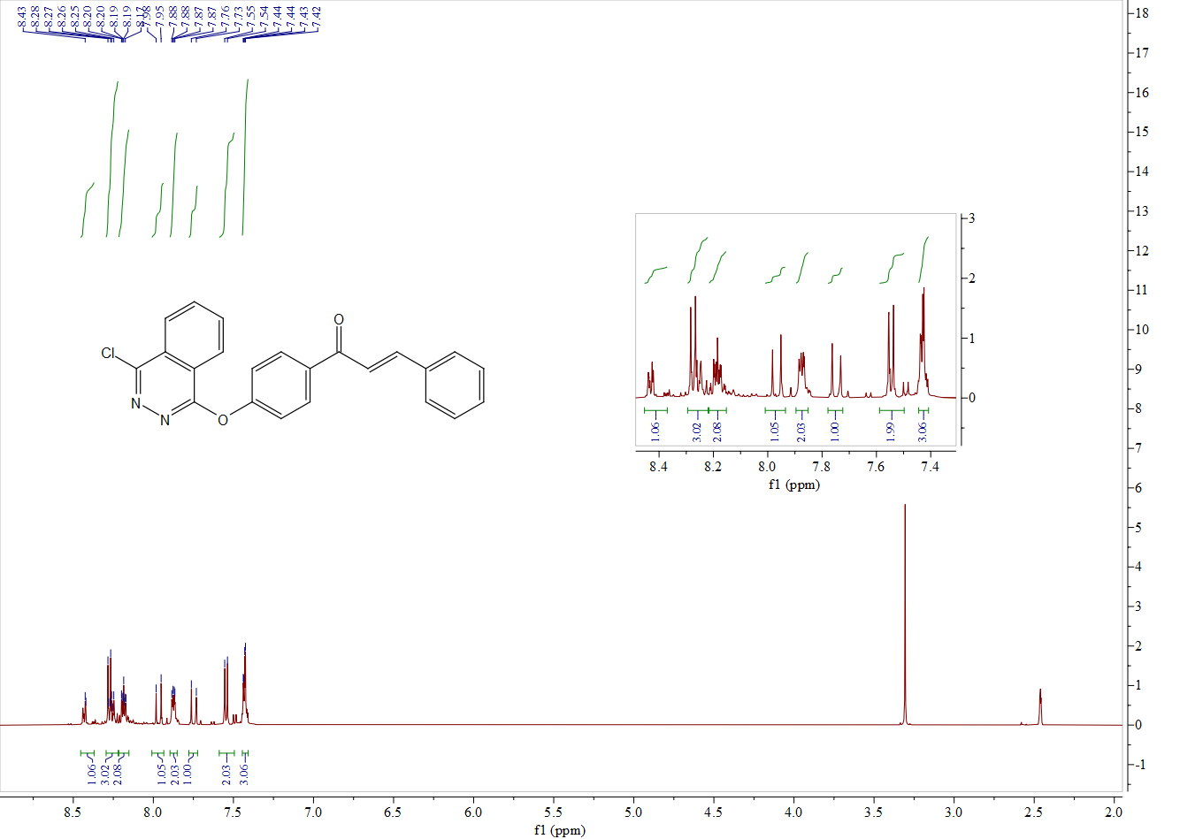

1H NMR spectrum of compound **C1**

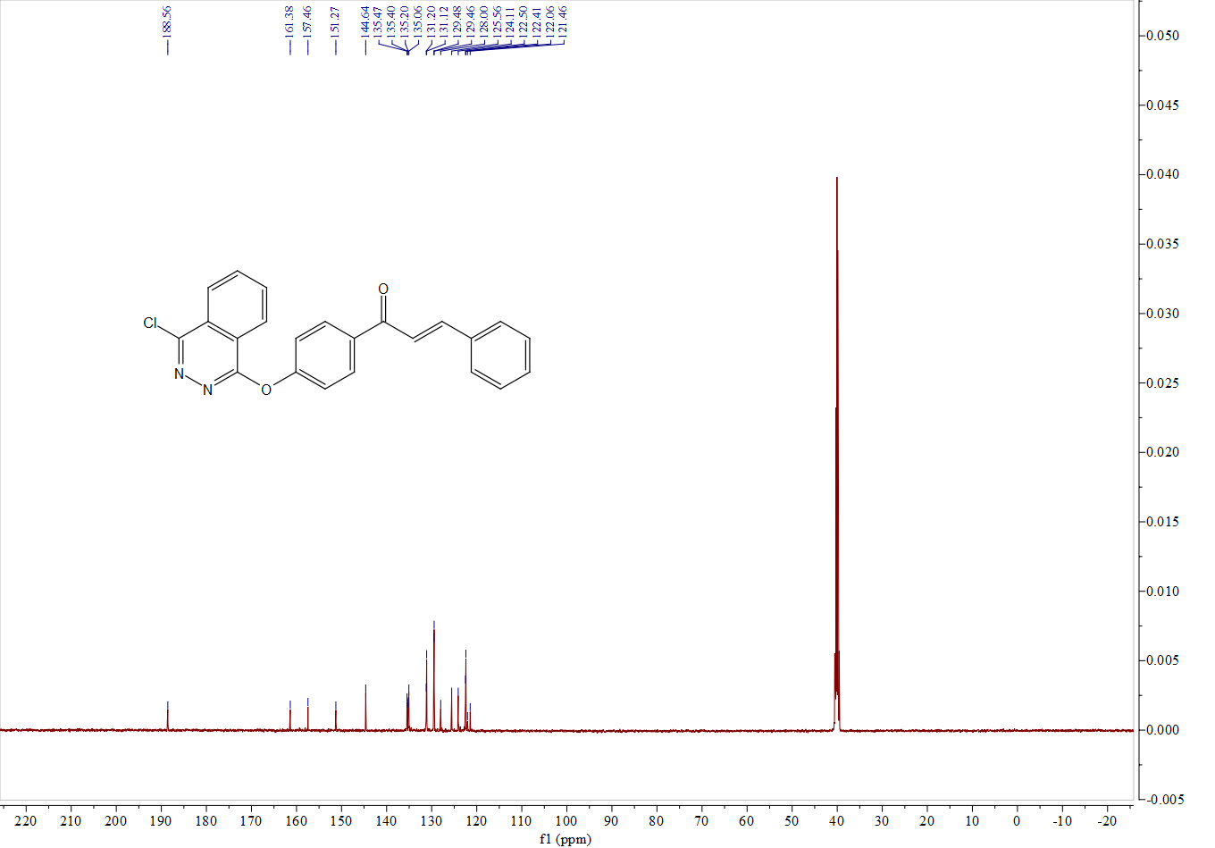

13C NMR spectrum of compound **C1**

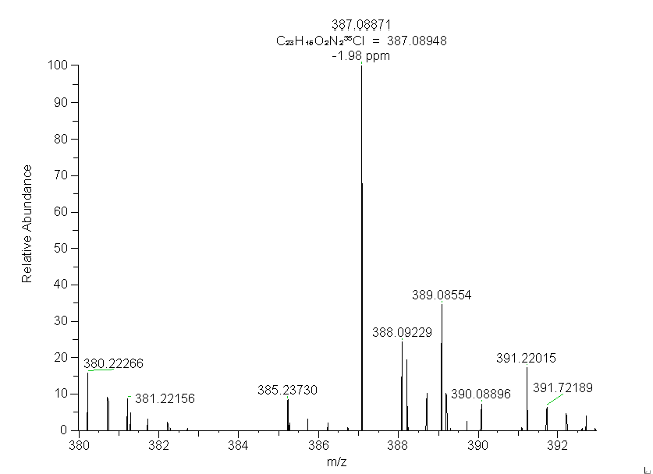

HRMS (ESI)spectrum of compound **C1**

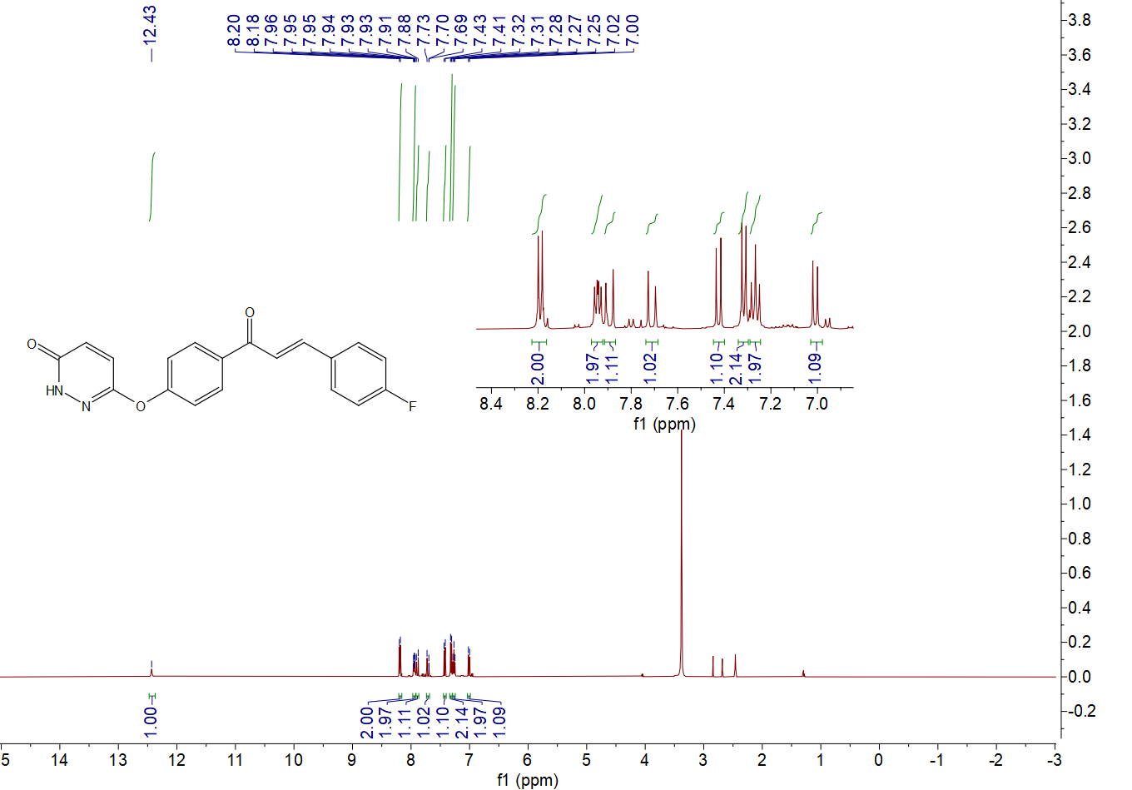

1H NMR spectrum of compound **D1**

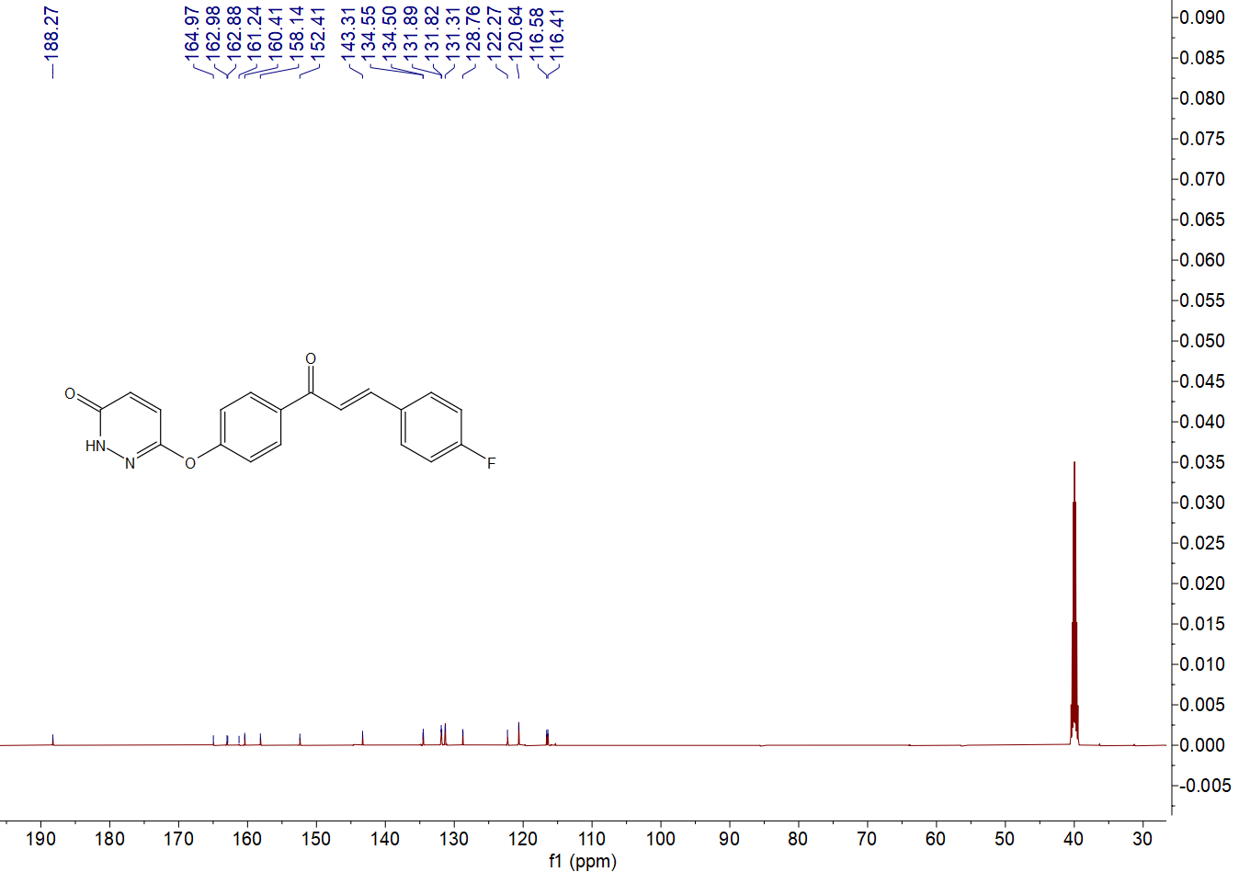

13C NMR spectrum of compound **D1**

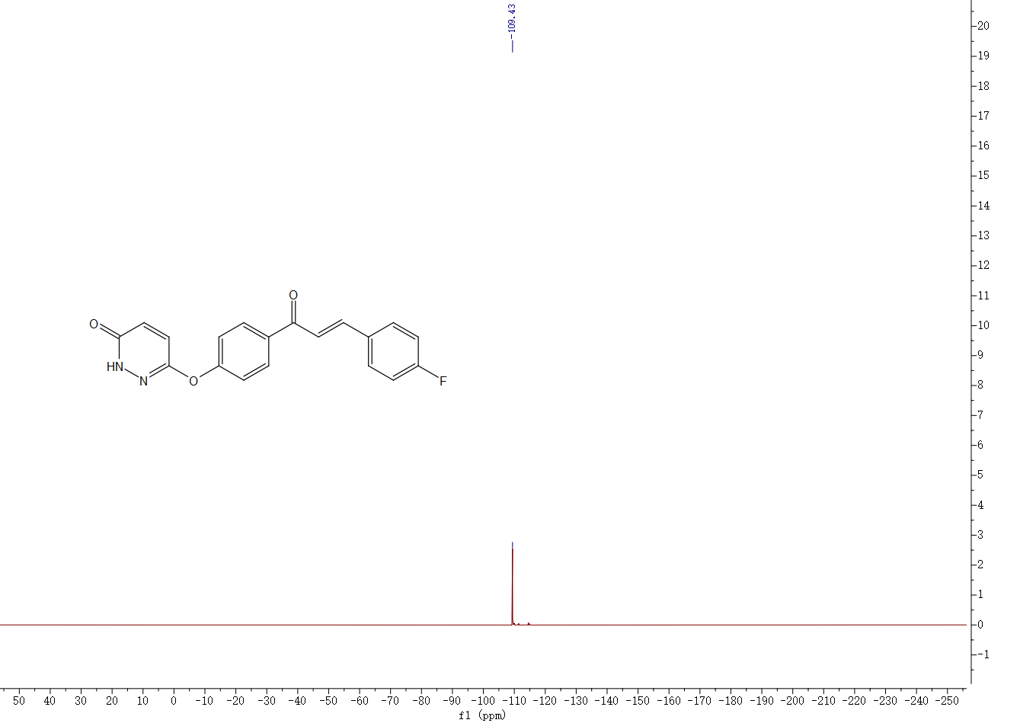

19F NMR spectrum of compound **D1**



HRMS (ESI)spectrum of compound **D1**

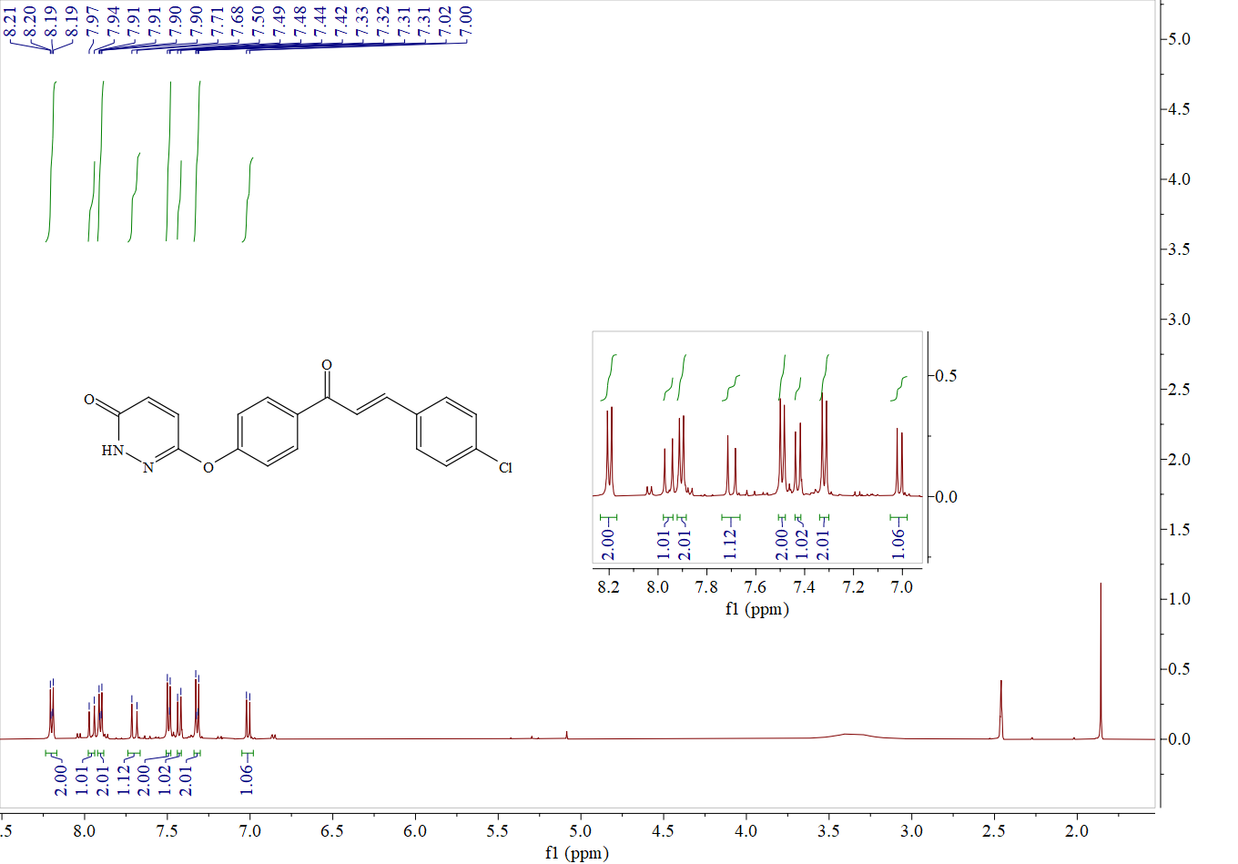

1H NMR spectrum of compound **D2**

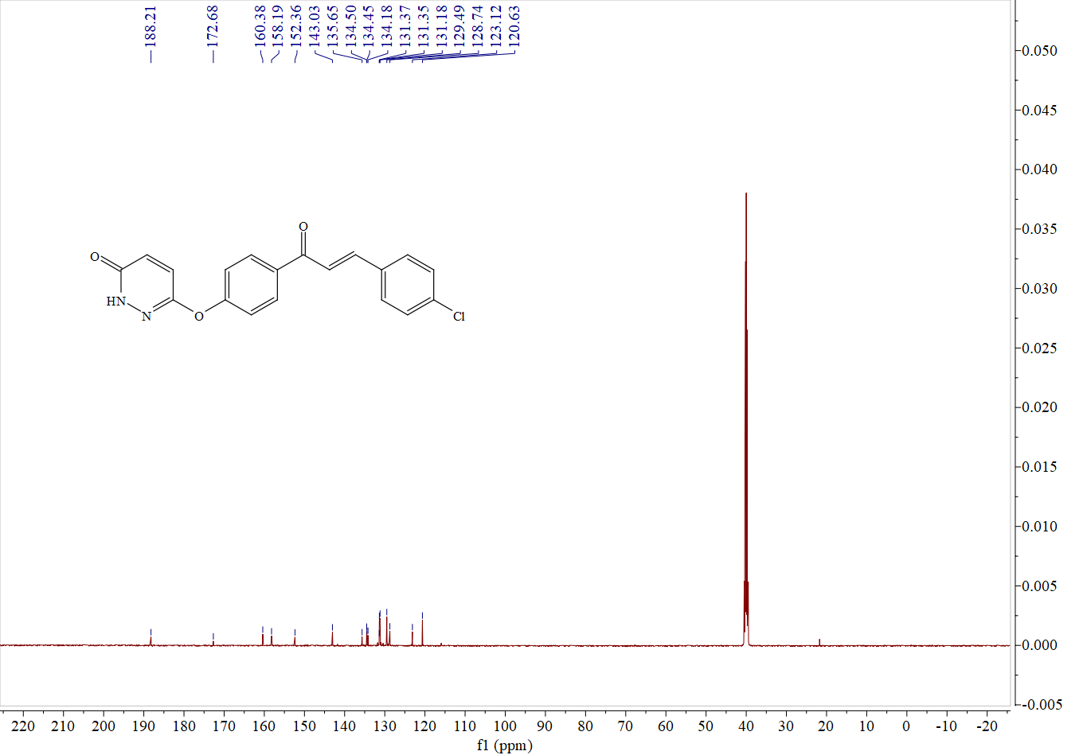

13C NMR spectrum of compound **D2**

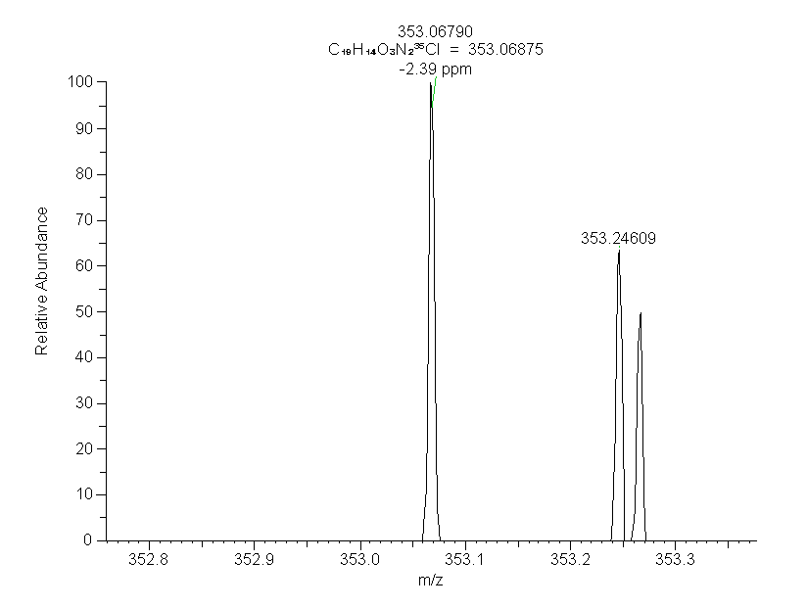HRMS (ESI)spectrum of compound **D2**

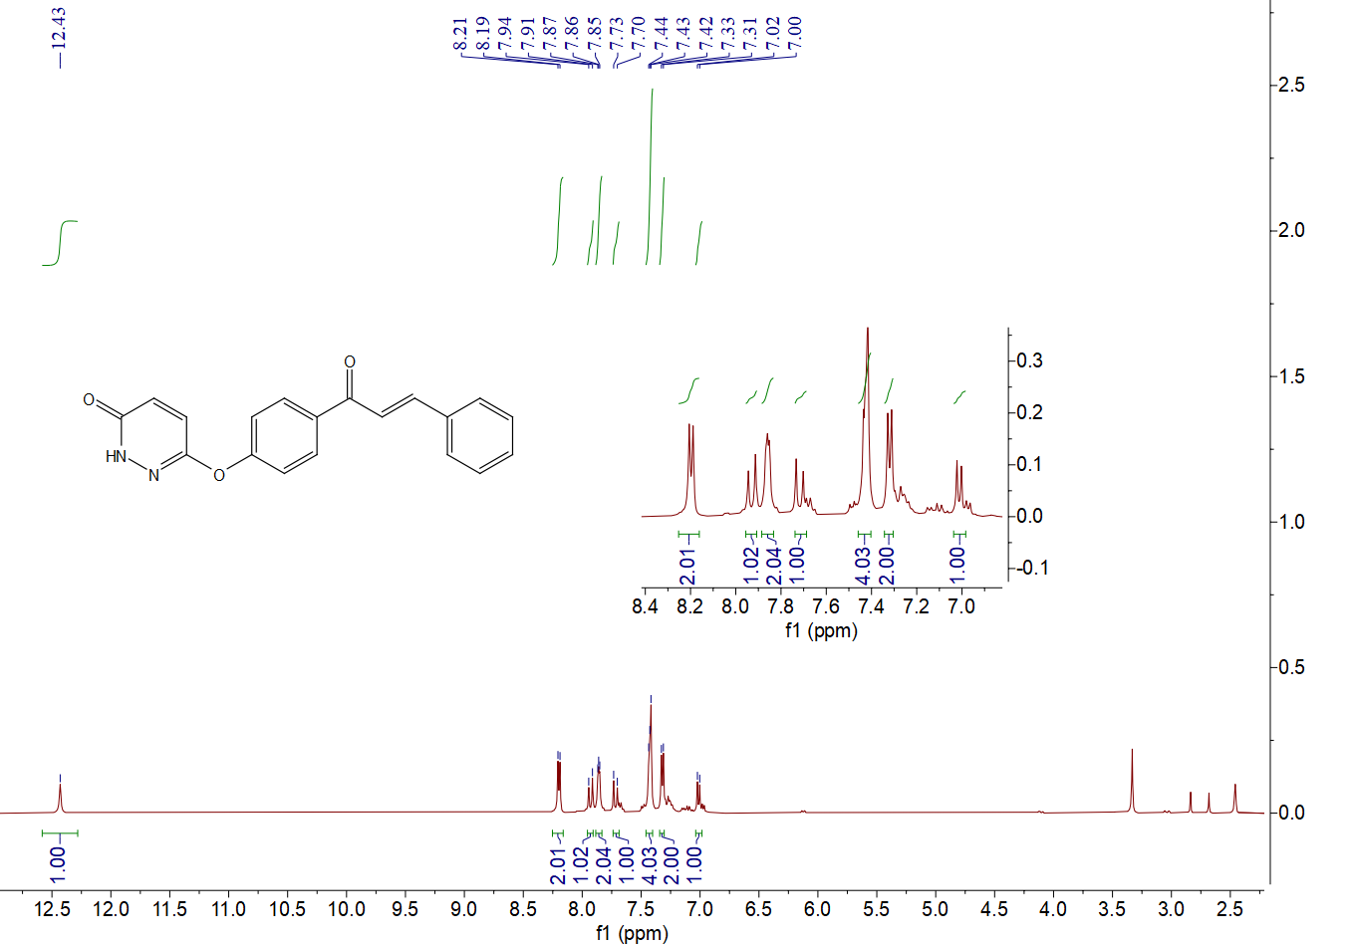

1H NMR spectrum of compound **D3**

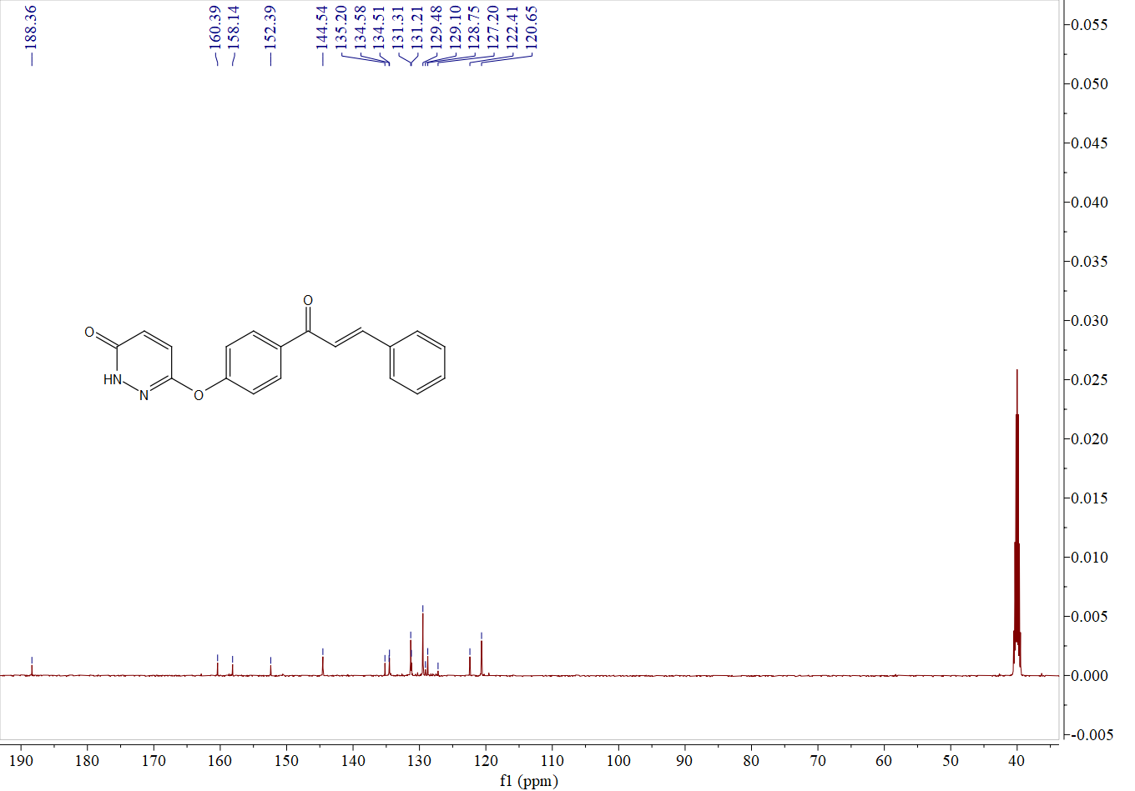

13C NMR spectrum of compound **D3**

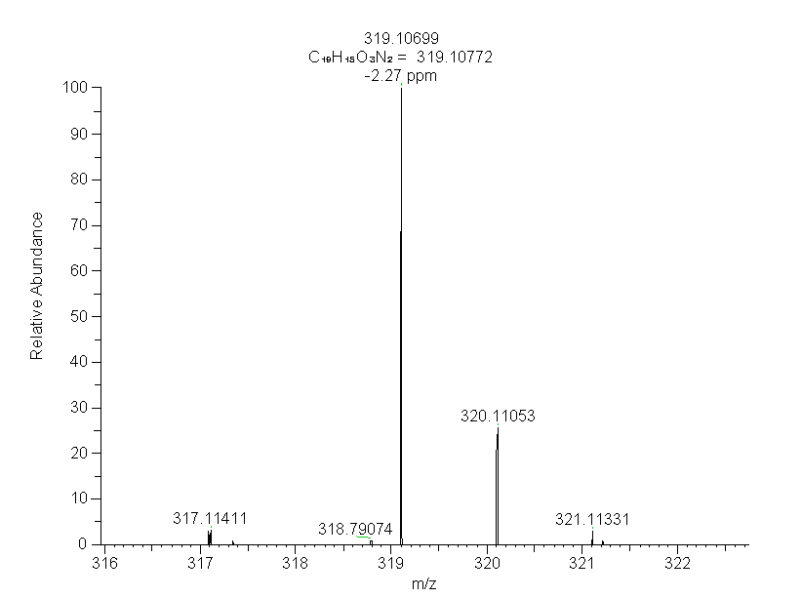

HRMS (ESI)spectrum of compound **D3**

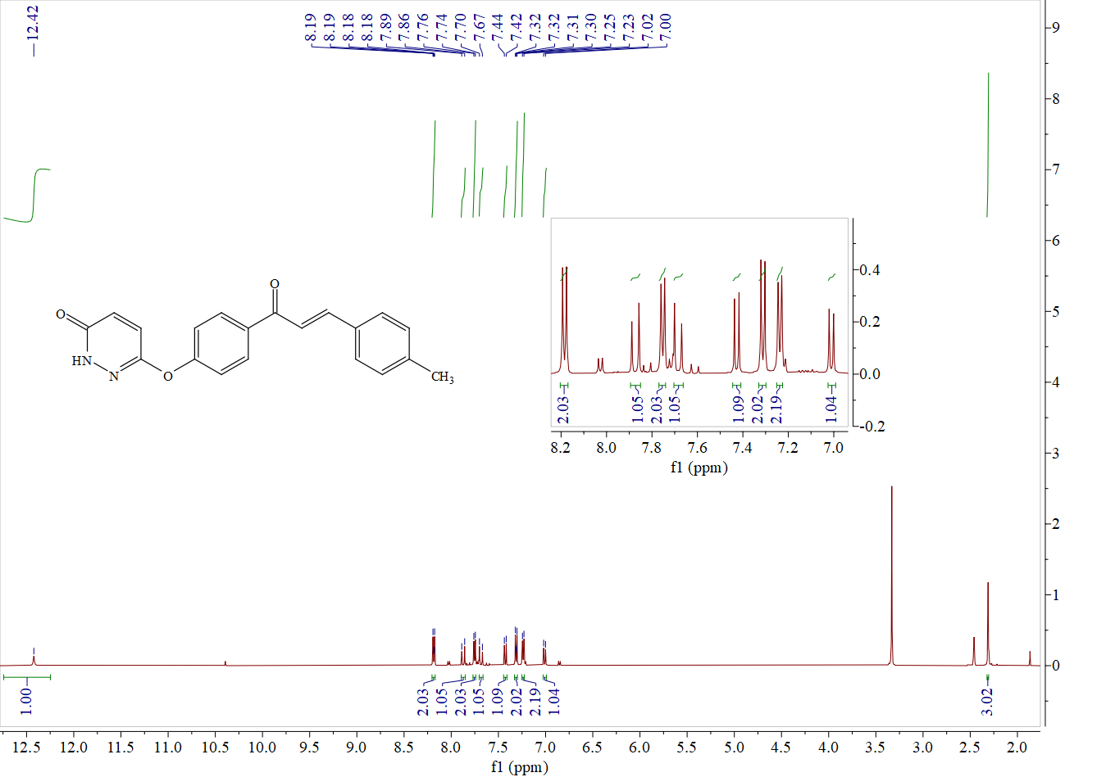

1H NMR spectrum of compound **D4**

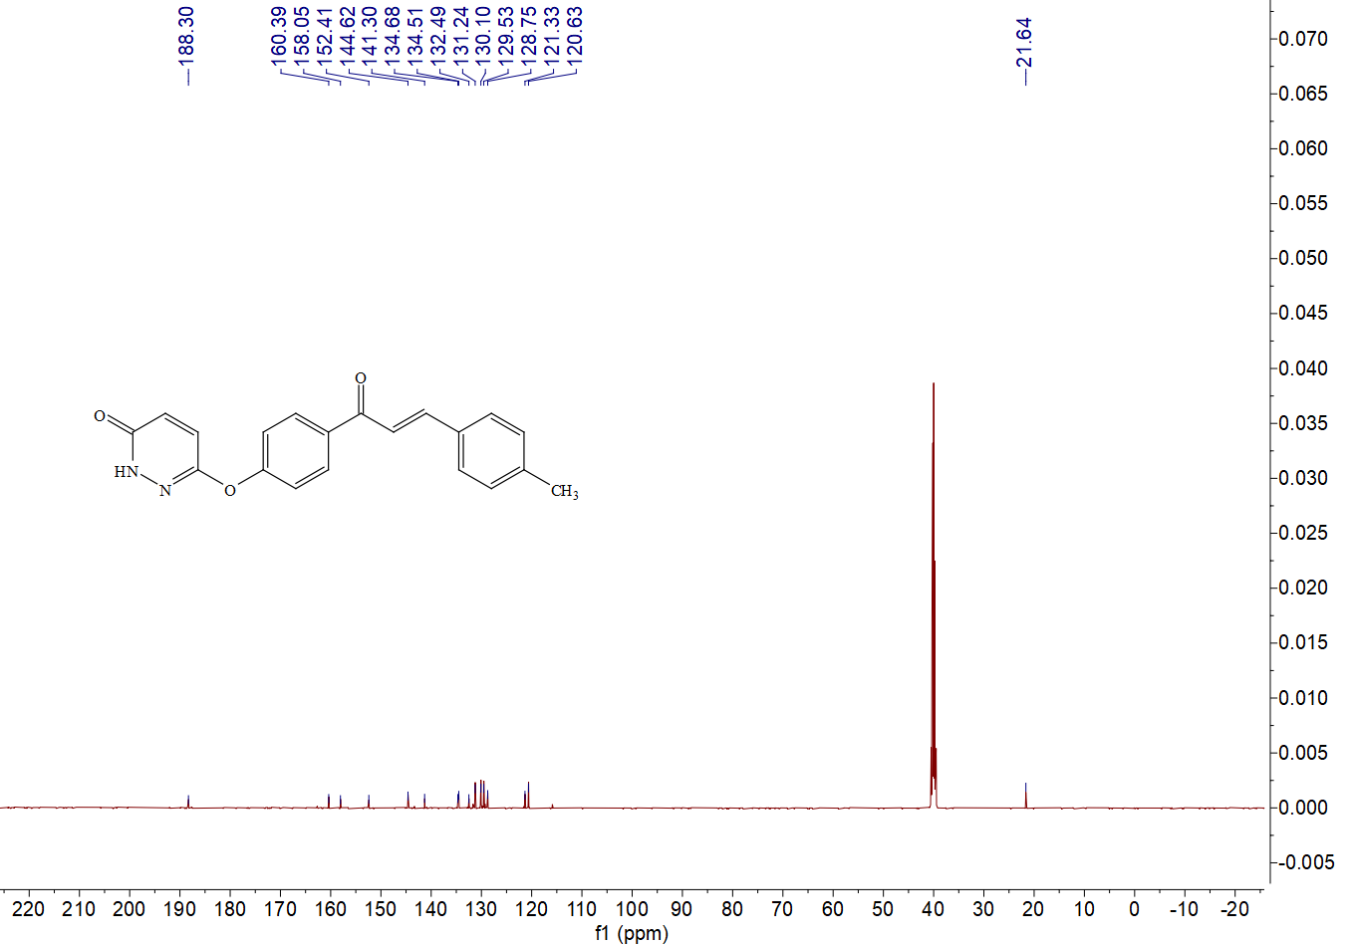

13C NMR spectrum of compound**D4**

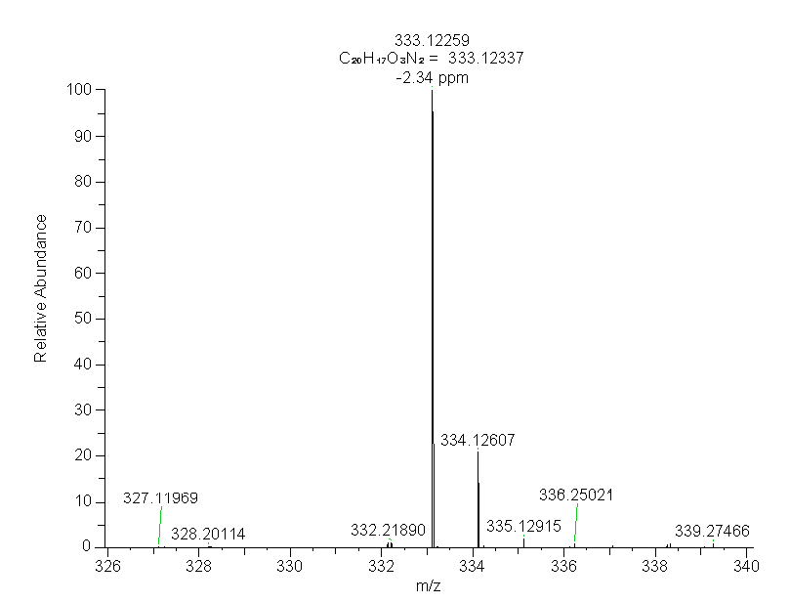

HRMS (ESI)spectrum of compound **D4**

.

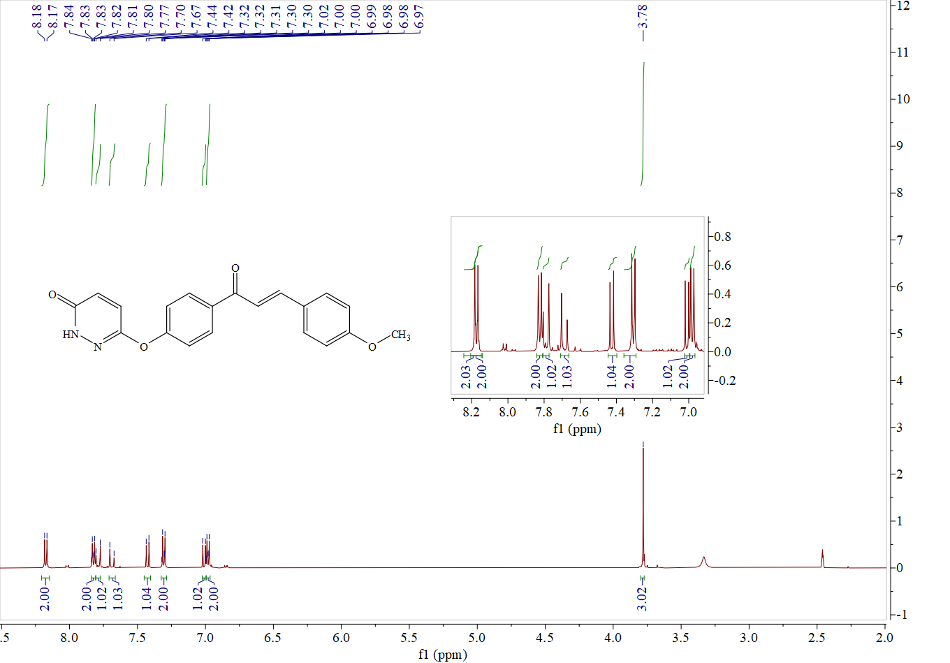

1H NMR spectrum of compound **D5**

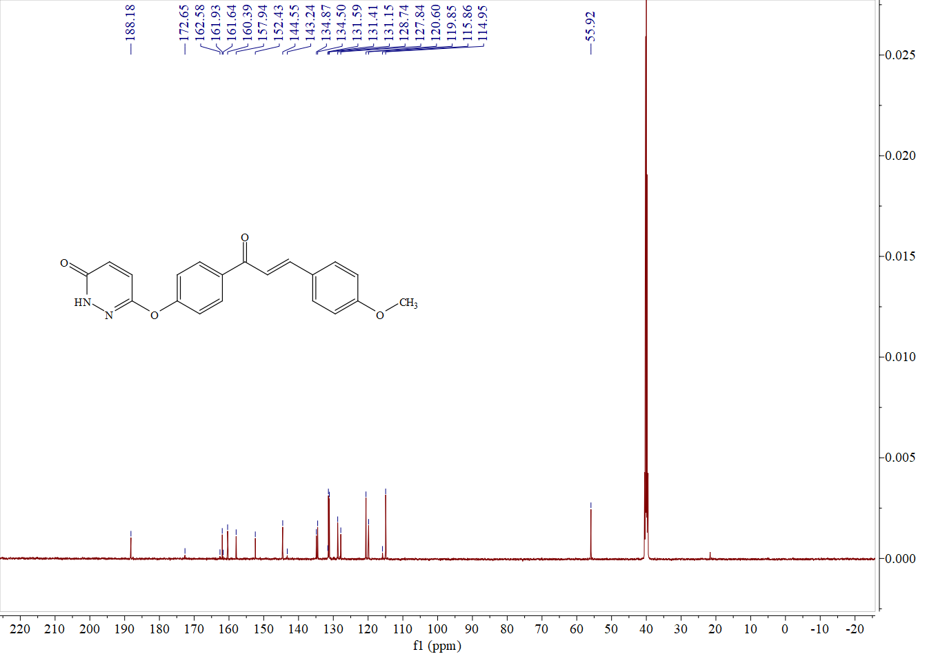

13C NMR spectrum of compound **D5**

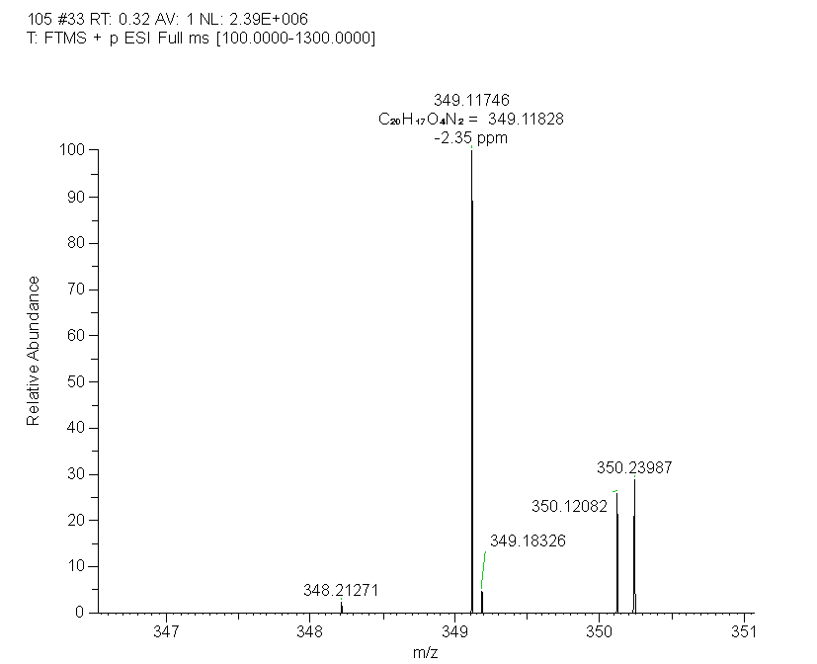

HRMS (ESI)spectrum of compound **D5**