**Supplementary Material for: Slow release fertilizers based on polyphosphate/montmorillonite nanocomposites for improving crop yield**

Guiting Yanga, Hongmeng Zhaob, Yanli Liuc,Zeli Lic, Feng Gaoc, Qiang Zhangd, Peng Zoue, Zhiguang Liuc*, Min Zhangc*

*a Institute of Agricultural Resources and Environment, Jiangsu Academy of Agricultural Sciences, Nanjing 210014, China.*

*b State Key Laboratory of Soil and Sustainable Agriculture, Key Laboratory of Soil Environment and Pollution Remediation, Institute of Soil Science, Chinese Academy of Sciences, Nanjing, 210008, China.*

*c**National Engineering Laboratory for Efficient Utilization of Soil and Fertilizer Resources, National Engineering & Technology Center for Slow and Controlled Release Fertilizers, College of Resources and Environment, Shandong Agricultural University, Tai’an, Shandong 271018, China.*

*d**State Key Laboratory for the Integrated Use of Nutritional Resources, Kingenta Ecological Engineering Group Ltd., Linshu, Shandong, 276700, China.*

*e Shandong wanhao fertilizer Co. Ltd., Jinan, 251600, China.*

✳Corresponding Author

(Z. L.) E-mail: [liuzhiguang8235126@126.com](mailto:liuzhiguang8235126@126.com). Phone: 86-538-824 1531. Fax: 86-538-824 2500.

(M.Z.) E-mail: [minzhang-2002@163.com](mailto:minzhang-2002@163.com). Phone: 86-538-824 1531. Fax: 86-538-824 2500.

**Table S1.** Recent advancement in nanocarrier as fertilizer for slow nutrient release.

|  |  |  |  |  |  |
| --- | --- | --- | --- | --- | --- |
| No | Nanomaterials | Preparation method | Fertilizer particle shape | Nutrient element | Reference |
| 1 | Urea-Montmorillonite Nanocomposites | Extrusion processing | Cylindrical | N | (Pereira et al., 2012) |
| 2 | Polymer (polyacrylamide hydrogen or polycaprolactone) /montmorillonite/urea composite | Extrusion processing | Cylindrical | N | (Pereira et al., 2015) |
| 3 | Montmorillonite-urea nanocomposites | Aqueous suspension technique | Powder | N | (Golbashy et al., 2017) |
| 4 | Carboxymethyl cellulose-g-poly (acrylamide)/montmorillonite superabsorbent composite | Free-radical graft copolymerization | Powder | N | (Kenawy et al., 2018) |
| 5 | Chrysotile-K2HPO4 mixtures | Mechanical grinding | Powder | P+K | (Borges et al., 2018) |
| 6 | Lignin/montmorillonite/urea composite | Extrusion processing | Cylindrical | N | (Gu et al., 2019) |
| 7 | Urea-hydroxyapatite-montmorillonite nanohybrid composites | Solvent assisted grinding techniques | Powder | N | (Madusanka et al., 2019) |
| 8 | Urea/urea-formaldehyde polymer nanocomposites | Extrusion processing | Cylindrical | N | (Yamamoto et al., 2019) |
| 9 | Zeolite/Fe2O3 nanocomposites | Quick green precipitation method | Powder | Zn+Fe | (Hossein et al., 2020) |
| 10 | Sodium alginate-g-poly (acrylate-co-acrylamide) /montmorillonite superabsorbent nanocomposite | Dissolution reaction | Powder | B | (Helmiyati et al., 2020) |

**Table S2.** The central composite design matrix employed for two independent variables.

|  |  |  |  |  |
| --- | --- | --- | --- | --- |
|  | UP | K | Angle of response (°) | Particle hardness (N) |
| 1 | 1 | 0.5 | 35.39 | 85.50 |
| 2 | 0.5 | 1 | 30.70 | 24.94 |
| 3 | 0.75 | 0.40 | 35.39 | 60.60 |
| 4 | 0.75 | 0.75 | 31.82 | 42.30 |
| 5 | 0.75 | 0.75 | 31.64 | 41.02 |
| 6 | 1.10 | 0.75 | 33.04 | 70.10 |
| 7 | 1 | 1 | 30.98 | 59.36 |
| 8 | 0.5 | 0.5 | 31.82 | 19.72 |
| 9 | 0.75 | 1.10 | 32.64 | 38.92 |
| 10 | 0.75 | 0.75 | 31.45 | 44.88 |
| 11 | 0.40 | 0.75 | 30.56 | 18.57 |
| 12 | 0.75 | 0.75 | 31.09 | 48.90 |
| 13 | 0.75 | 0.75 | 31.54 | 44.66 |

**Table S3.** The central composite design matrix employed for two independent variables

|  |  |  |  |  |
| --- | --- | --- | --- | --- |
|  | Time (min) | Temperature (℃) | Particle hardness(N) | Angle of response (°) |
| 1 | 300 | 120 | 43.41 | 35.1 |
| 2 | 300 | 80 | 14.6 | 35.4 |
| 3 | 210 | 100 | 55.15 | 30.98 |
| 4 | 337.279 | 100 | 55.5 | 31.07 |
| 5 | 210 | 100 | 59.74 | 31.93 |
| 6 | 210 | 100 | 62.54 | 31.16 |
| 7 | 210 | 100 | 61.23 | 31.02 |
| 8 | 210 | 100 | 62.14 | 31.02 |
| 9 | 120 | 120 | 47.01 | 35.1 |
| 10 | 210 | 71.7157 | 0.56 | 37.5 |
| 11 | 120 | 80 | 2.7 | 36.7 |
| 12 | 210 | 128.284 | 42 | 39.42 |
| 13 | 82.7208 | 100 | 34.44 | 33.14 |

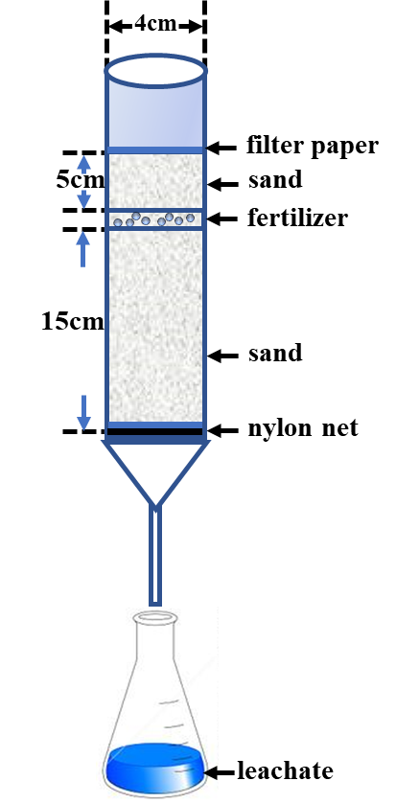

**Figure S1.** Schematic diagram showing column packing and leachate collection of the leaching experiment.



**Fig. S2**. TGA and DTG curves for thermogram of for the prepared fertilizers

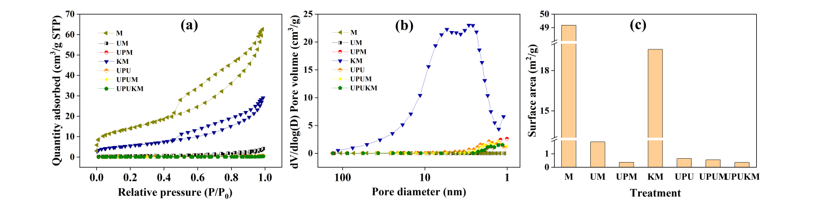

**Fig. S3.** Nitrogen gas adsorption-desorption isotherms and surface area of the prepared fertilizers.

**Reference**

Borges, R., Baika, L. M., Grassi, M. T. and Wypych, F., 2018. Mechanochemical conversion of chrysotile/K2HPO4 mixtures into potential sustainable and environmentally friendly slow-release fertilizers. J. Environ. Manage. 206, 962-970. http://doi.org/10.1016/j.jenvman.2017.11.082.

Gu, H., Zhang, Y., Li, X., Li, W., Huang, S., 2019. Lignin improves release behavior of slow-release fertilizers with high content of urea. J. Appl. Polym. Sci. 136, 48238. http://doi.org/10.1002/app.48238.

Helmiyati, H. and Nugraha, D., 2020. Superabsorbent nanocomposite as micronutrient slow-release fertilizer. IOP Conf. Ser.: Mater. Sci. Eng. http://doi.org/10.1088/1757-899X/763/1/012050.

Jahangirian, H., Rafiee-Moghaddam, R., Jahangirian, N., Nikpey, B., Jahangirian, S., Bassous, N., Saleh, B., Kalantari, K. and Webster, T. J., 2020. Green synthesis of zeolite/Fe2O3 nanocomposites: toxicity & cell proliferation assays and application as a smart iron nanofertilizer. Int. J. Nanomed. 1005-1020. http://doi.org/10.2147/IJN.S231679.

Kenawy, E. R., Azaam, M. M. and El-nshar, E. M., 2018. Preparation of carboxymethyl cellulose-g-poly (acrylamide)/montmorillonite superabsorbent composite as a slow-release urea fertilizer. Polym for Advan Technol. 29, 2072-2079. <http://doi.org/10.1002/pat.4315.>

Madusanka, N., Sandaruwan, C., Kottegoda, N., Sirisena, D., Munaweera, I., De Alwis, A., Karunaratne, V. and Amaratunga, G. A., 2017. Urea–hydroxyapatite-montmorillonite nanohybrid composites as slow release nitrogen compositions. Appl. Clay. Sci. 150, 303-308. http://doi.org/10.1016/j.clay.2017.09.039.

Pereira, E. I., da Cruz,C. C., Solomon, A., Le, A., Cavigelli, M. A., and Ribeiro, C., 2015. Novel slow-release nanocomposite nitrogen fertilizers: the impact of polymers on nanocomposite properties and function. Ind. Eng. Chem. Res. 54, 3717-3725. https://doi.org/10.1021/acs.iecr.5b00176.

Pereira, E. I., Minussi, F. B., da Cruz, C. C., Bernardi, A. C. and Ribeiro, C., 2012. Urea–montmorillonite-extruded nanocomposites: a novel slow-release material. J. Agric. Food. Chem. 60, 5267-5272. <http://doi.org/10.1021/jf3001229>.

Yamamoto, C. F., Pereira, E. I., Mattoso, L. H., Matsunaka, T. and Ribeiro, C., 2016. Slow release fertilizers based on urea/urea–formaldehyde polymer nanocomposites. Chem. Eng. J. 287, 390-397. http://doi.org/10.1016/j.cej.2015.11.023.