Supplementary Information

**Acid assisted-hydrothermal carbonization of solid waste from essential oils industry: optimization using *I*-optimal experimental design and removal dye application**

Faiçal El Ouadrhiri1*, Ebraheem Abdu Musad Saleh2, Kakul Husain2, Abderrazzak Adachi1, Anouar Hmamou1, Ismail Hassan2, Marwa Mostafa Moharam2,3, Amal Lahkimi1

*1 Laboratory of Engineering, Molecular Organometallic Materials and Environment, Faculty of Sciences Dhar El Mehraz, Sidi Mohamed Ben Abdellah University, Fez, Morocco.*

*2 Chemistry Department, College of Arts & Science,* *Prince Sattam Bin Abdulaziz University, Wadi Al-Dawaser, Alkharj, Saudi Arabia.*

*3 Chemical and Electrochemical Processing Department, Central Metallurgical Research and Development Institute (CMRDI), P.O. Box 87, Helwan 11421, Egypt.* *Corresponding author Email: [Faical.elouadrhiri@usmba.ac.ma](mailto:Faical.elouadrhiri@usmba.ac.ma)

**MATERIAL AND METHOD:**

**Optimal design of experimental**

Tableau S1 : Facteur de severite en fonction de la temperature et le temps

|  |  |  |  |  |  |  |
| --- | --- | --- | --- | --- | --- | --- |
| Niveau | 1 | 2 | 3 | 4 | 5 | 6 |
| ${HTC}_{T}$ (°C) | 180 | 195 | 210 | 210 | 210 | 210 |
| ${HTC}_{t}$ (min) | 180 | 180 | 180 | 60 | 120 | 240 |
| SF | 4.61 | 5.05 | 5.49 | 5.02 | 5.32 | 5.62 |

**Adsorption study**

Table S2:isotherm and kinetic equations used in the adsorption of HCop and AHCop

|  |  |  |
| --- | --- | --- |
| Utility | Equation | reference |
| Pseudo-First Order | $$ln⁡(Q_{e}-Q_{t}) = ln {(Q}_{e}) - K_{1}.t$$ | [1] |
| Pseudo-Second Order | $$t.Q_{t} =\frac{ t}{Q_{e}}+\frac{1}{K^{2}.Q_{e}^{2}}$$ | [2] |
| Modele de Langmuir | $$\frac{1}{Q_{e}}=\frac{1}{\left(K_{L}Q_{max}\right).C_{e}}+\frac{1}{Q_{max}}$$ | [3] |
| Modele de Freundlich | $$ln{ (Q}_{e})= \frac{1}{n_{F}}\ln{(C_{e})}+\ln{{(K}_{F})}$$ | [4] |
| Arrhenius équation |  | [5] |

C0 (mg.L-1) and Ce,t (mg.L-1) are the initial and equilibrium concentrations respectively. m (g) is the mass of carbocatalyst V (L) is the volume of Dye. Qe is the equilibrium quantity. KL (L.mg-1) is a direct measure of the adsorption intensity.Qmax is the maximum adsorption capacity. KF ((mg.g-1)(L.mg-1)1/n) is the adsorption capacity. (1/nF): is the intensity of adsorption for 1/nF=0 irreversible, 1/nF>1 unfavorable and for 0<1/nF<1 the adsorption is favorable.

**RESULT AND DISCUSSION:**

**Numerical Optimization of MY and CRR model**

Table S3 : Optimization constraints for factors and responses

|  |  |  |  |
| --- | --- | --- | --- |
| Name | Goal | Importance | Graph |
| X1 : HTCcat | minimize | 3 |  |
| X2 : SF | minimize | 1 |  |
| MY (%) | None | 1 |  |
| CRR (%) | maximize | 3 |  |

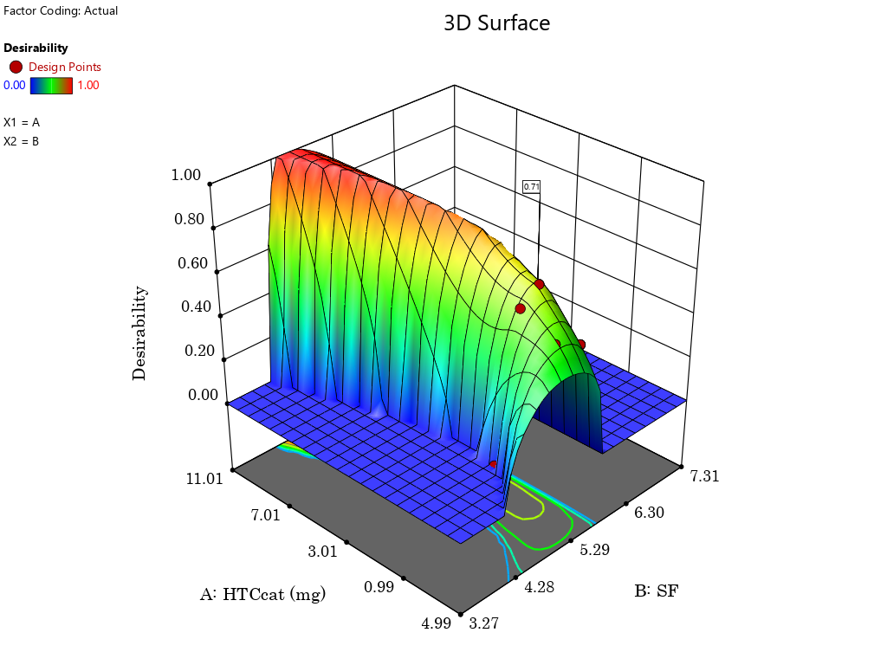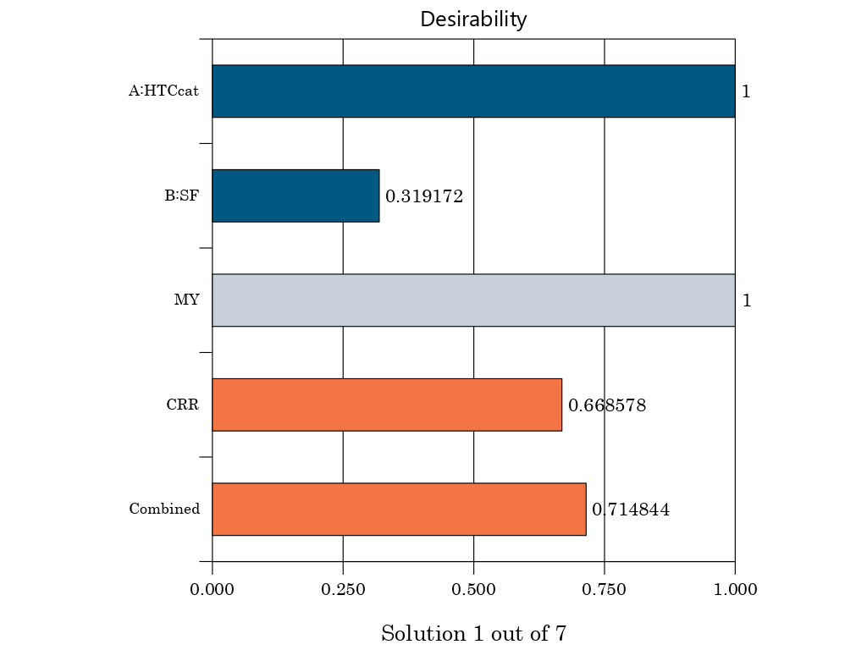

Figure S1 : (a) bar histogram (b) graphical representation of the desirability function for the optimal solution (D=0,739).



Figure S2 : N2 Adsorption-desorption and PSD profil of HCop

Table S4:  Maximum adsorption capacity of MB dye by various low-cost adsorbents.

|  |  |  |  |
| --- | --- | --- | --- |
| Adsorbent | SBET (m2.g-1) | Qm (mg.g-1) | reference |
| Activated-hydrochar from *surgane bagasse* | 15.34 | 357.14 | [6] |
| Treated *sugarcane bagasse* | 1.018 | 58.9 | [7] |
| Activated hydrochar from *loblolly pine* | 1703 | 719.4 | [8] |
| Hydrochar from *orange peel* | 46.16 | 66.23 | [9] |
| Hydrochar from *orange peel* | 34.08 | 36.63 |
| Activated-hydrochar from solid waste (essential oil industry) | 989.81 | 588.24 | **This study** |

**REFERENCE**

[1] Y. S. Ho and G. McKay, “Pseudo-second order model for sorption processes,” *Process Biochem.*, vol. 34, no. 5, pp. 451–465, Jul. 1999, doi: 10.1016/S0032-9592(98)00112-5.

[2] J. P. Simonin, “On the comparison of pseudo-first order and pseudo-second order rate laws in the modeling of adsorption kinetics,” *Chem. Eng. J.*, vol. 300, pp. 254–263, 2016, doi: 10.1016/j.cej.2016.04.079.

[3] I. Langmuir, “The constitution and fundamental properties of solids and liquids. Part I. Solids,” *J. Am. Chem. Soc.*, vol. 38, no. 11, pp. 2221–2295, Nov. 1916, doi: 10.1021/ja02268a002.

[4] L. Liu, X. B. Luo, L. Ding, and S. L. Luo, “Application of Nanotechnology in the Removal of Heavy Metal From Water,” *Nanomater. Remov. Pollut. Resour. Reutil.*, pp. 83–147, Jan. 2019, doi: 10.1016/B978-0-12-814837-2.00004-4.

[5] R. Tomer and P. Biswas, “Dehydration of glucose/fructose to 5-hydroxymethylfurfural (5-HMF) over an easily recyclable sulfated titania (SO42-/TiO2) catalyst,” *New J. Chem.*, vol. 44, no. 47, pp. 20734–20750, Dec. 2020, doi: 10.1039/d0nj04151c.

[6] F. Zhou *et al.*, “Efficient removal of methylene blue by activated hydrochar prepared by hydrothermal carbonization and NaOH activation of sugarcane bagasse and phosphoric acid,” *RSC Adv.*, vol. 12, no. 3, pp. 1885–1896, Jan. 2022, doi: 10.1039/d1ra08325b.

[7] A. salah omer *et al.*, “Adsorption of crystal violet and methylene blue dyes using a cellulose-based adsorbent from sugercane bagasse: characterization, kinetic and isotherm studies,” *J. Mater. Res. Technol.*, vol. 19, pp. 3241–3254, Jul. 2022, doi: 10.1016/j.jmrt.2022.06.045.

[8] A. I. Sultana, C. Chambers, M. M. N. Ahmed, P. Pathirathna, and T. Reza, “Multifunctional Loblolly Pine-Derived Superactivated Hydrochar: Effect of Hydrothermal Carbonization on Hydrogen and Electron Storage with Carbon Dioxide and Dye Removal,” *Nanomaterials*, vol. 12, no. 20, p. 3575, Oct. 2022, doi: 10.3390/nano12203575.

[9] N. Saha, M. Volpe, L. Fiori, R. Volpe, A. Messineo, and M. T. Reza, “Cationic Dye Adsorption on Hydrochars of Winery and Citrus Juice Industries Residues: Performance, Mechanism, and Thermodynamics,” *Energies*, vol. 13, no. 18, p. 4686, 2020, doi: 10.3390/en13184686.