Supporting Information

A stable N-containing heterocyclic carboxylic acid ligand Co-MOF for photoelectric performance and anionic dyes adsorption
Ying Zhao ^{a, *}, Yin- Hang Chai ^{a,b}, Ling Ding, Shuang Wangª, Yi-ni Wang, Lu-Fang Ma ^{a,b, *}, Bang-Tun Zhao ª

Table S1. Crystallographic data
Samples | [Co₂(L₁)₂(L₂)]
Chemical formula | C₃₆H₂₂Co₂N₆O₈
Formula weight | 784.478
CCDC number  Crystal system | 2172898  monoclinic
Space group | P2₁/n
a (Å) | 11.3586(4)
b (Å) | 13.9256(4)
c (Å) | 11.4919(4)
α (°) | 90
β (°) | 114.984(4)
γ (°) | 90
V (Å³) | 1647.64(11)
Z | 2
D (g cm^{–3}) | 1.581
μ (mm⁻¹) | 1.071
T (K) | 293(2)
Rint | 0.0258
R₁ (I>2σ (I )) | 0.0366
wR₂ (I>2σ(I )) | 0.0874

Table S2. Selected bond lengths [Å] and angles [º] for Co-MOF
Atoms | Lengths(Å) | Atoms | Lengths(Å)
Co (1)-O (2)A | 2.0179(17) | Co (1)-O (3) | 1.9288(15)
Co (1)-N (1)C | 2.0353(18) | Co (1)-N (2) | 2.0709(17)
Atoms | Angles(º) | Atoms | Angles(º)
N (1)-Co (1)-N (2) | 109.98(7) | N (2)-Co (1)-O (2) | 113.26(7)
N (1)-Co (1)-O (2) | 116.15(7) | N (2)-Co (1)-O (3) | 95.08(7)
N (1)-Co (1)-O (3) | 108.62(7) | O (3)-Co (1)-O (2) | 111.72(9)
Table S3. Comparison of Co-MOF in the removal of MO with other materials reported in the literature
Materials | Q₀ (mg g⁻¹) | Initial maximum concentration (mg L⁻¹) | Ref.
MIL-68(Al) | 341.3 | 100 | (Wu, et all 2017).
TMU-16 | 350 | 200 | (Roushani, et all 2016).
MIL-101 | 140 | 200 | (Haque, et all 2010).
[Cu(bipy)(SO₄)]_{n} | 1521 | 2000 | (Xiao, et all 2015).
MOF-235 | 501 | 50 | (Chakraborty, et all 2018).
Ce(III)-doped UiO-66 | 639.6 | 500 | (Yang, et all 2018).
Co-MOF | 440.5 | 60 | This work

Figure S1. The FT-IR spectra of Co-MOF for the as-synthesized.

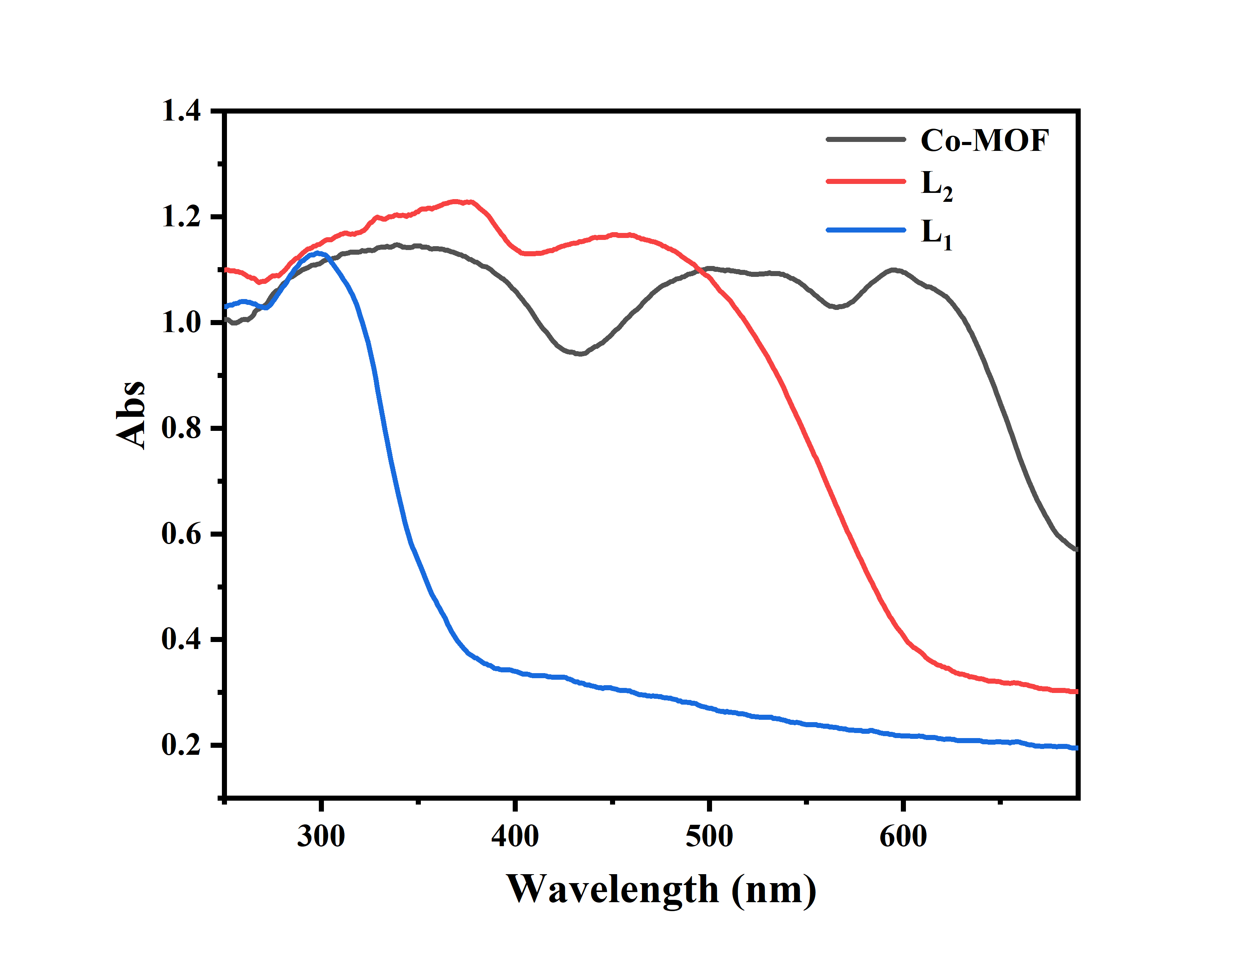
Figure S2. The solid-state UV-vis spectra of L₁, L₂ and Co-MOF
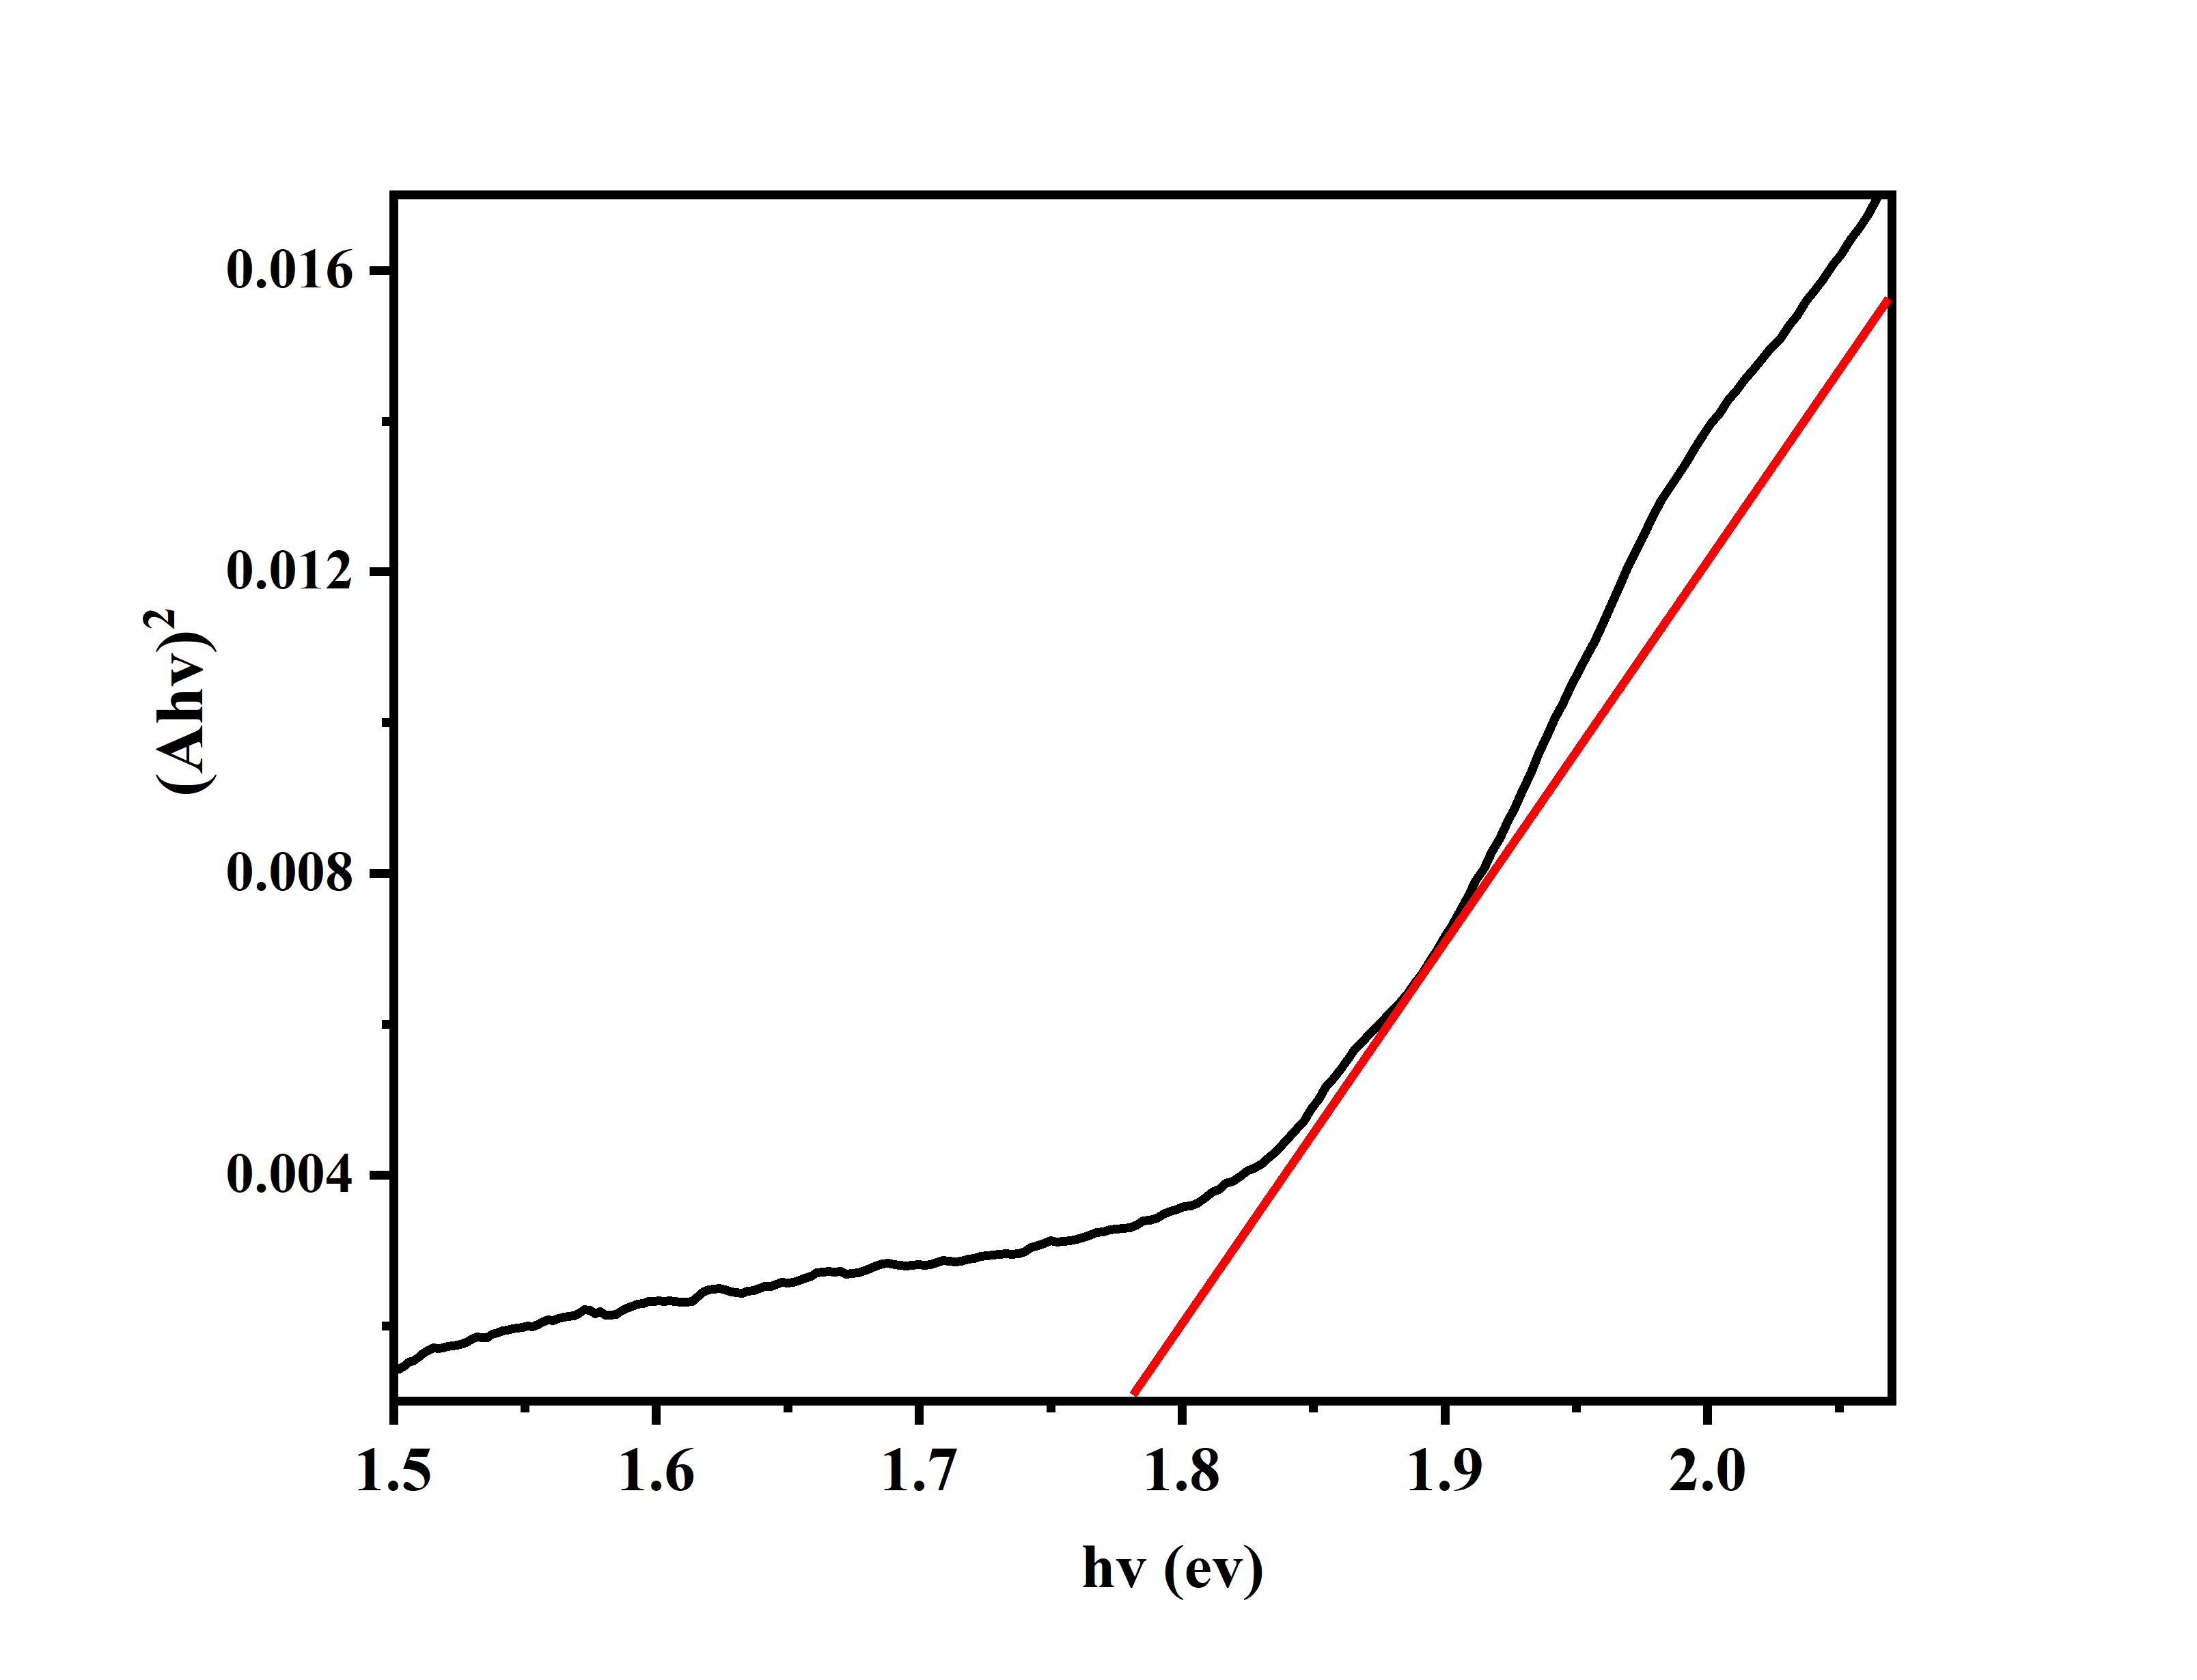
Figure S3. (Ahν)² versus photon energy (hν).

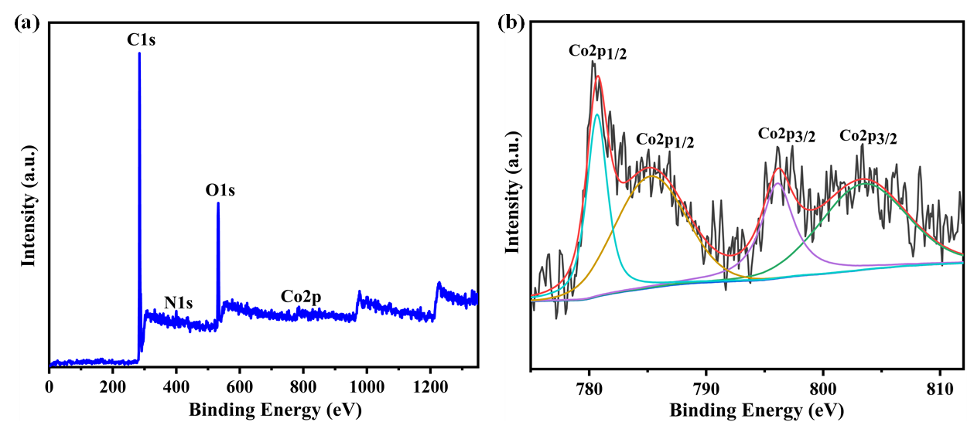
Figure S4. XPS (a) survey and (b) Co 2p spectra of the synthesized Co-MOF

Figure S5. The TGA curves of Co-MOF for the as-synthesized.

Figure S6. The PXRD patterns of simulated and after being immersed samples under different pH conditions of Co-MOF

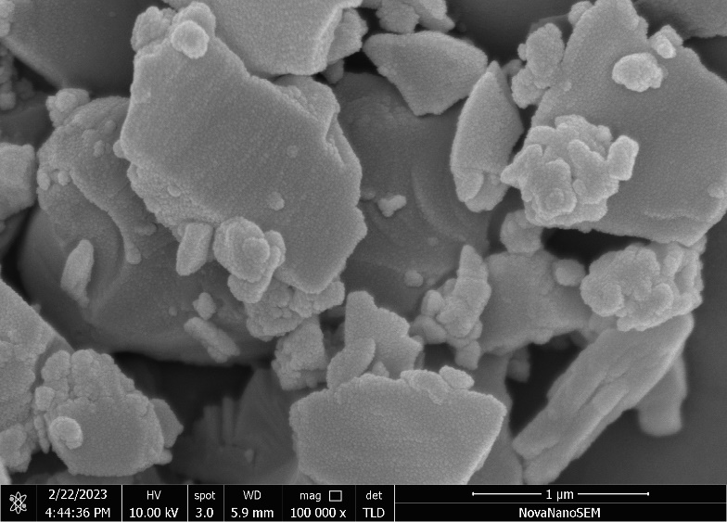
Figure S7. SEM images of Co-MOF

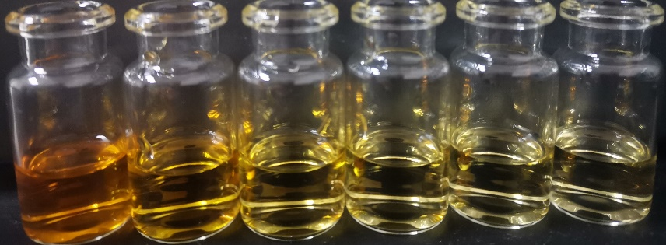
Figure S8. The color degree of methyl orange varied from 0-30min.

Figure S9. Uv-vis absorption spectra of methyl orange solution with adsorption concentration of 30 mg/g at different times.
Figure S10. Uv-vis absorption spectra of methyl orange solution with adsorption concentration of 40 mg/g at different times.
Figure S11. Uv-vis absorption spectra of methyl orange solution with adsorption concentration of 50 mg/g at different times.
Figure S12. Uv-vis absorption spectra of methyl orange solution with adsorption concentration of 60 mg/g at different times.

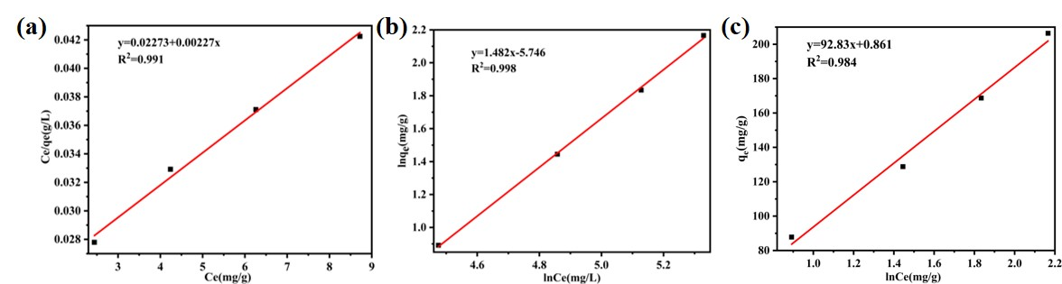
Figure S13. Plots of the fitting of the MO adsorption on Co-MOF experimental data with (a) Langmuir isotherm, (b) Freundlich and (c) Themkin isotherm models

Figure S14. Removal behavior of methyl orange by Co-MOF at different pH values

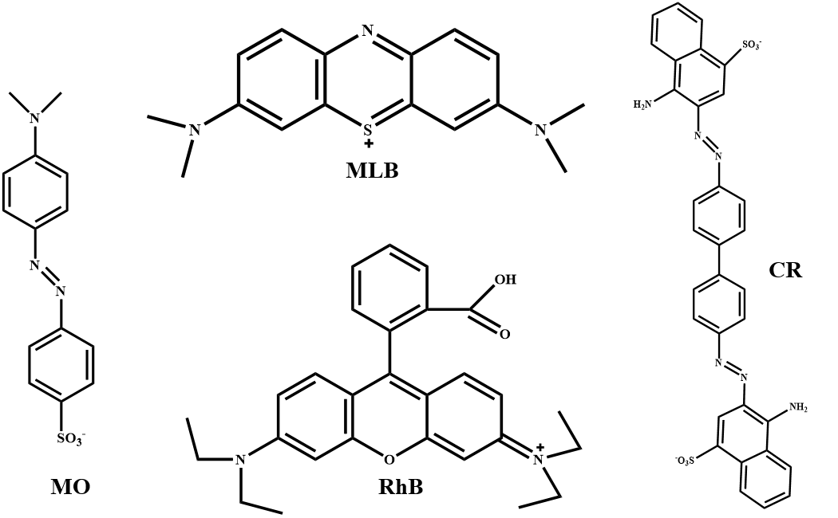
Figure S15.The structures of the selected dye molecules.
Table S4. The analog size of part of the dye (Konno, et al. 2022).
Type of dye | Length (nm) | Width (nm) | Height (nm)
MO | 1.67 | 0.58 | 0.67
MLB | 1.57 | 0.42 | 0.78
RhB | 1.69 | 0.86 | 1.37

Figure S16. Solid-state UV-vis spectra of Co-MOF before and after dye adsorption.

Figure S17. The zeta potentials of MO, Co-MOF and MO@Co-MOF.

Figure S18.The N₂ adsorption isotherms for Co-MOF at 77 K.

Figure S19. pore-size distribution curve for Co-MOF

References
Wu, S.C., You, X., Yang, C., and Cheng, J.H., 2017. Adsorption behavior of methyl orange onto an
aluminumbased metal organic framework, MIL-68(Al), Water. Sci. Technol, 75, 2800–2810.
Roushani, M., Saedi, Z., and Beygi, T.M., 2016. Anionic dyes removal from aqueous solution using TMU-16 and TMU-16-NH₂ as isoreticular nanoporous metal organic frameworks, J. Taiwan. Inst. Chem. Eng, 66, 164–171.
Haque, E., Lee, J.E., Jang, I.T., Hwang, Y.K., Chang, J.S., Jegal, J., and Jhung, S.H., 2010. Adsorptive removal of methyl orange from aqueous solution with metal-organic frameworks, porous chromium-benzenedicarboxylates, J. Hazard. Mater, 181, 535–542.
Xiao, L., Xiong, Y., Wen, Z.,and Tian, S., 2015. Adsorption behavior of one-dimensional coordination polymers [Cu(bipy)X]_{n} (X =2Cl⁻ and SO₄²⁻) toward acid orange 7 and methyl orange, RSC. Adv. 5, 61593–61600.
Chakraborty, A., and Acharya, H., 2018. Facile Synthesis of MgAl Layered Double Hydroxide Supported Metal Organic Framework Nanocomposite for Adsorptive Removal of Methyl Orange Dye, Colloid. Interface. Sci. Commun. 24, 35–39.
Yang, J.M., Ying, R.J., Han, C.X., Hu, Q.T., Xu, H.M., Li, J.H., Wang, Q. and Zhang, W., 2018. Adsorptive removal of organic dyes from aqueous solution by a Zr-based metal-organic framework: Effects of Ce(III) doping, Dalton. Trans., 47, 3913–3920.
Konno, H., Tsukada, A., 2022. Size- and ion-selective adsorption of organic dyes from aqueous solutions using functionalized UiO-66 frameworks. Colloids and Surfaces A: Physicochemical and Engineering Aspects, 651, 129749.

