Supporting Information for
Metal ion/Metal Hydroxide loaded Resin for Ammonia Removal from Solutions Containing High Salinity by Ligand Exchange: Stability of Metal Ions during Decomplexation of Ammonia Ligand
Chen Liu, Tingsheng Qiu, Yunnen Chen*
Jiangxi Key Laboratory of Mining & Metallurgy Environmental Pollution Control, Jiangxi University of Science & Technology, Ganzhou 341000, PR China
*Corresponding author. E-mail address: cyn70yellow@126.com (Y. Chen); Tel. +86-13879730457

1. Selection of optimum loading metal salt concentrations for preparation of metal(ion)-loaded resins
The influence of different loading metal salt concentrations (0, 0.001, 0.005, 0.01, 0.03, 0.05 and 0.07 mol/L) on D751 resin for ammonia removal from solutions containing high salinity was investigated. The results show that for D751 resin loaded with single metal ion, Cu²⁺-D751 resin has the optimum ammonia adsorption capacity, and its ammonia adsorption capacity increases gradually with the increase of metal salt concentration (from 0 to 0.005 mol/L). When the metal salt concentration exceeds 0.005 mol/L, the ammonia adsorption capacity no longer increase. For D751 resin loaded with double metal ion, ammonia adsorption capacity of Cu²⁺/Ni²⁺-D751 and Cu²⁺/Zn²⁺-D751 resin increases gradually with the increase of metal salt concentration (from 0 to 0.05 mol/L). When the double metal salt concentration exceeds 0.05 mol/L, the ammonia adsorption capacity no longer increase.
On the basis of the above experimental results, the metal salt concentration is selected as 0.005 mol/L of Cu²⁺ concentration for Cu²⁺-D751 resin, 0.05 mol/L of Cu²⁺ and Ni²⁺ concentration for Cu²⁺/Ni²⁺-D751 resin and 0.05 mol/L of Cu²⁺ and Zn²⁺ concentration for Cu²⁺/Zn²⁺-D751 resin.

2. This supplementary document consists of including 3 Figures and 4 Table.

Figure captions
Fig. S1 N₂ adsorption and desorption isotherms of virgin D751, Cu²⁺-D751, Cu²⁺/Ni²⁺-D751, Cu²⁺/Zn²⁺-D751, ammonia saturated Cu²⁺-D751, ammonia saturated Cu²⁺/Ni²⁺-D751, ammonia saturated Cu²⁺/Zn²⁺-D751.

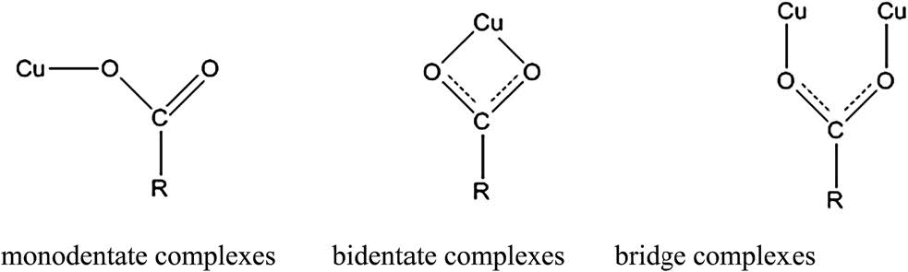
Fig. S2 Schema of metal–carboxylate complexes (Chen et al., 2017).

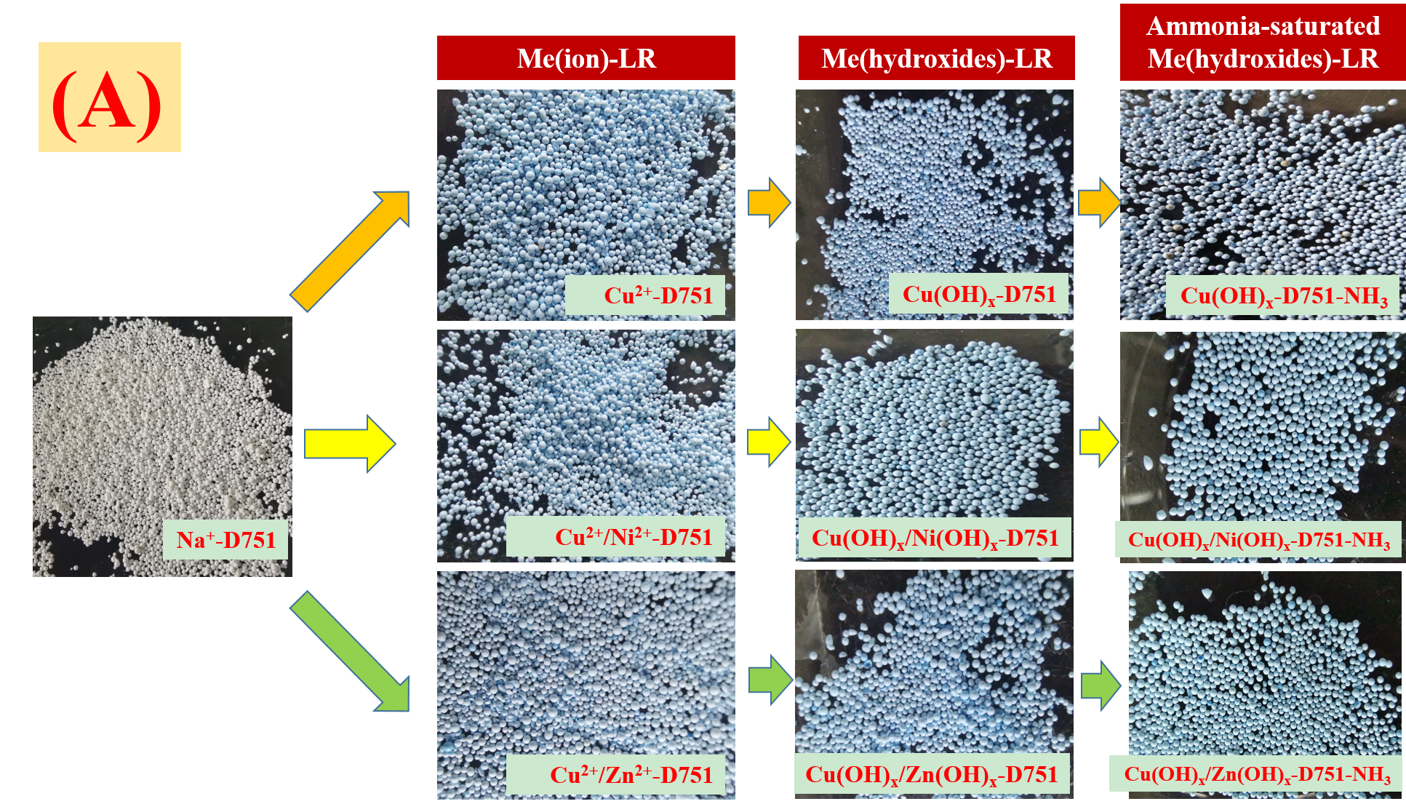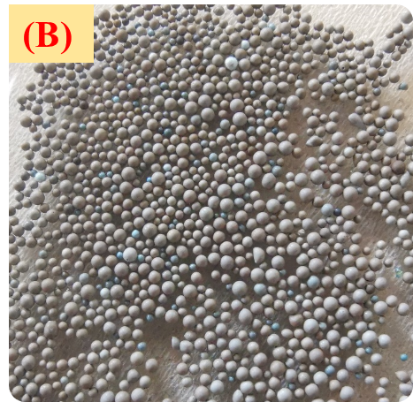
Fig.S3 The change in surface colour of resins by naked eye observation.
(A) Na⁺-D751, Me(ion)-LR, Me(hydroxides)-LR, ammonia-saturated Me(hydroxides)-LR; (B) Resin obtained by desorbing Cu(OH)_{x}-D751-NH₃ resin with 1 mol/L NaOH solution

Table captions
Table S1. Physical properties and specifications of virgin resin (D751)
Item | Property
Matrix | Styrene-divinylbenzene
Functional group | Iminodiacetate
Appearance | Beige grey opaque spherical beads
Ion type | Na⁺ form
Particle size (0.3-1.2 mm) | ≥95%
Volume total exchange capacity | ≥1.80 mmol/mL
Copper ion exchange capacity | ≥0.65 mol/L
Moisture retention | 55-65%
Wet superficial density | 1.10-1.2 g/mL
True wet density | 0.7-0.8 g/mL

Table S2 Background information on D751 chelating resin (Sengupta et al., 1991).
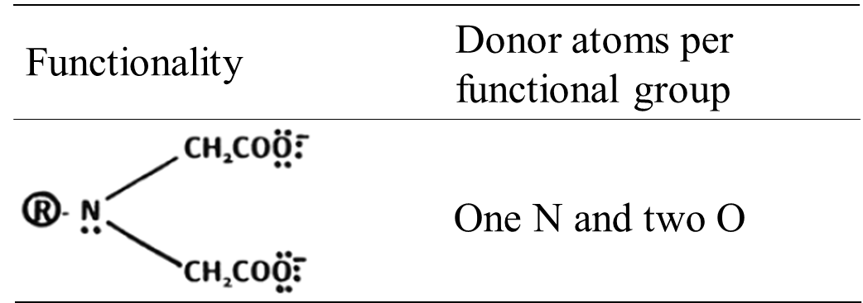

TableS3 Changes of water quality parameters before and after the first adsorption of ammonia by metal ion/metal hydroxide loaded resin.
Adsorbents | Water quality parameters
 | NH₄⁺ concentration (g/L) |  | Na⁺ concentration (g/L) |  | Cu²⁺ concentration (mg/L) |  | Ni²⁺ concentration (mg/L) |  | Zn²⁺ concentration (g/L)
 | Before | After | Before | After | Before | After | Before | After | Before | After
Cu²⁺-D751 | 0.1 | 0.068 | 4 | - | ND | 0.13 | ND | ND | ND | ND
Cu²⁺/Ni²⁺-D751 | 0.1 | 0.065 | 4 | - | ND | ND | ND | 0.54 | ND | ND
Cu²⁺/Zn²⁺-D751 | 0.1 | 0.066 | 4 | - | ND | 0.15 | ND | ND | ND | 0.66
Cu(OH)₂-D751 | 0.1 | 0.065 | 4 | - | ND | 0.16 | ND | ND | ND | ND
Cu(OH)₂/Ni(OH)₂-D751 | 0.1 | 0.051 | 4 | - | ND | 0.17 | ND | 0.95 | ND | ND
Cu(OH)₂/Zn(OH)₂-D751 | 0.1 | 0.052 | 4 | - | ND | ND | ND | ND | ND | ND
ND: the concentration of metal ions was not detected by the atomic absorption spectroscopy.
“-”: the concentration of Na⁺ after adsorption was not measured.

Table S4 The experimental conditions in this paper.
Experiment Title | Experimental conditions
Ammonia adsorption experiment by Me(ion)-LR and Me(hydroxides)-LR in three rounds of adsorption-desorption process | Adsorption process: Initial NH₃-N solution concentration, 0.1g/L; NaCl concentration, 4 g/L; original solution pH, 11; dosage of adsorbent, 6 g/L; stirring speed, 120 r/min; reaction temperature, 25 ℃；reaction time, 90 min.
Ammonia desorption experiment by Me(ion)-LR and Me(hydroxides)-LR in three rounds of adsorption-desorption process | Desorption process: desorbents, NaCl; concentration of desorbents, 1 mol/L; dosage of ammonia-saturated resin, 4g/L; stirring speed, 120 r/min; reaction temperature, 25 ℃；reaction time, 60 min.
Effect of NaOH concentration on ammonia removal by Me(hydroxides)-LR | Me(hydroxides)-LR preparation condition: ratio of Me(ion)-LR mass and NaOH solution volume, 1g/100mL; NaOH concentration, 0, 0.001, 0.005, 0.0075, 0.01, 0.02 mol/L; stirring speed, 120 r/min; reaction temperature, 25 ℃; reaction time, 30 min.
Effect of modification time on ammonia removal by Me(hydroxides)-LR | Me(hydroxides)-LR preparation condition: ratio of Me(ion)-LR mass and NaOH solution volume, 1g/100mL; NaOH concentration, 0.005, 0.01, 0.01 mol/L; stirring speed, 120 r/min; reaction temperature, 25 ℃；reaction time, 0, 5, 15, 30 and 45 min.
Effect of different desorbents on ammonia desorption of Me(hydroxides)-LR | Desorption process: desorbents, HCl, NaCl, NaOH; concentration of desorbents, 0.01, 1 mol/L; dosage of ammonia-saturated resin, 4 g/L; stirring speed, 120 r/min; reaction temperature, 25 ℃; reaction time, 60 min.
Effect of NaCl concentration on ammonia desorption of Me(hydroxides)-LR | Desorption process: desorbents, NaCl; concentration of desorbents, 0.01, 0.05, 0.1, 0.5, 1.0, 1.5, 2.0 and 2.5 mol/L; dosage of ammonia-saturated resin, 4 g/L; stirring speed, 120 r/min; reaction temperature, 25 ℃; reaction time, 60 min.
Effect of desorption time on ammonia desorption of Me(hydroxides)-LR | Desorption process: desorbents, NaCl; concentration of desorbents, 1.5 and 2 mol/L; dosage of ammonia-saturated resin, 4 g/L; stirring speed, 120 r/min; reaction temperature, 25 ℃; reaction time, 30, 60, 90 min.

