***Supporting Information***

**Controlled synthesis of 3D marigold-like ZnIn2S4/Ti3C2 for rapid and efficient removal of****antibiotics**

Ping Mao1\*, Kun Liu1, Aiwu Sun1\*, Xin Yang1, Xiaowu Ping1, Jing Zhang1, Jinyou Shen2, Yuting Li1, Jianfeng Teng1, Yong Yang3\*

1 National & Local Joint Engineering Research Center for Mineral Salt Deep Utilization, Key Laboratory for Palygorskite Science and Applied Technology of Jiangsu Province, School of Chemical Engineering, Huaiyin Institute of Technology, Huaian 223003, China

2 Jiangsu Key Laboratory of Chemical Pollution Control and Resources Reuse, School of Environmental and Biological Engineering, Nanjing University of Science and Technology, Nanjing 210094, China

3 Key Laboratory of Soft Chemistry and Functional Materials, Ministry of Education, School of Chemistry and Chemical Engineering, Nanjing University of Science and Technology, Nanjing 210094, China

\* E-mail address of the corresponding author: pingmao@hyit.edu.cn (P. M.); sunaiwu@hyit.edu.cn (A. S.); yychem@njust.edu.cn (Y. Y.)

**Experimental Section**

**Materials**

Zinc chloride (ZnCl2), indium chloride tetrahydrate (InCl3·4H2O), thioacetaMide (CH3CSNH2, TAA), L-Cysteine (C3H7NO2S) were purchased from Sinopharm Chemical Reagent Co., Ltd. Titanium aluminum carbide powder (Ti3AlC2), hydrofluoric acid (HF, content≥40.0%), tetracycline (TC) and 7-Aminocephalosporanic acid (7-ACA) were purchased from Macklin Co., Ltd. All of above reagents are analytical grade reagents and used without further purification. Deionized water (DI water) was used in the whole experiment.

**Characterization**

The phases of the samples were examined by Brucker-D8 Advanced X-ray diffraction (XRD) equipped with Cu-Ka radiation source. The morphological structures were observed by field mission scanning electron microscope (FESEM) (Hitachi, S-4800) and transmission electron microscopy (TEM) (JEOL, JEM-2100F). Energy dispersive X-ray spectroscopy (EDX) was collected by FESEM (Hitachi, S-4800). The surface chemical states of all elements were acquired using an X-ray photoelectron spectrometer (XPS) (Thermo, EScal AB 250). The binding energy of C1s (284.6 eV) was used to calibrate the other binding energies. The specific surface area was determined by Brunauer-Emmett-Teller (BET) method on a chemisorption analyzer (Micromeritics, ASAP 2020). The UV-vis diffuse-reflectance spectra (DRS) were obtained on a UV–Vis spectrophotometer (Varian, Cary 300). The Kubelka-Munk formula and Tauc plot were used to calculate the band gap and absorption edge of the spectrophotometer (Hitachi, F-4600) with an excitation wavelength of 360 nm at room temperature.

Additionally, electrochemical and photoelectrochemical measurements of as-prepared samples were performed with a CHI660D electrochemical workstation in a standard three-electrode system (Pt plate as a counter electrode; Ag/AgCl as reference electrodes; sample/FTO as a working electrode). 0.5 M Na2SO4 aqueous solution was regarded as the electrolyte solution. Working electrodes were made on fluorine doped tin oxide (FTO) conductive glass. The slurry mixture was obtained by ultrasonic dispersion of 5 mg samples in 0.5 mL DMF, and then the slurry was rotated and coated on FTO and dried in a drying box. A 300 W Xe lamp was used as the light source.



**Fig. S1.** The XRD patterns of Ti3AlC2 and Ti3C2.



**Fig. S2** Mott Schottky plots of ZnIn2S4 (V *vs*. E Ag/AgCl)

 

(b)

(a)

**Fig. S3.** The adsorption capacities of (a) TC and (b) 7-ACA on the samples.

 

(a)

(b)

**Fig. S4.** (a) Kinetic curves for the degradation of TC. (b) Kinetic curves for the degradation of 7-ACA.



**Fig. S5.** The analysis of XRD patterns of MZ-6 before and after photocatalytic degradation.

D:\光催化\刘坤\MZ-6-HF-少层-SEM\MZ-6-HF-少层-SEM\3-08.tif D:\光催化\刘坤\MZ-6-HF-少层-TEM\MZ-6-HF-少层-TEM\1_0011.tif

Fig. S6. FE-SEM (a) and TEM (b) images of MZ-6 after photocatalytic degradation.



**Fig. S7.** pH change during the trapping agent experiment.

C:\Users\Lenovo\Desktop\液质图谱.tif

**Fig. S8.** Ion chromatographs and mass spectra of 7-ACA at different degradation time, (a) 1.107 min and (b), (c) 1.217 min.



**Fig. S9.** The intermediate products and degradation path of 7-ACA

 



Fig. S10. HPLC-MS of the TC intermediates in the degradation process by MZ-6.

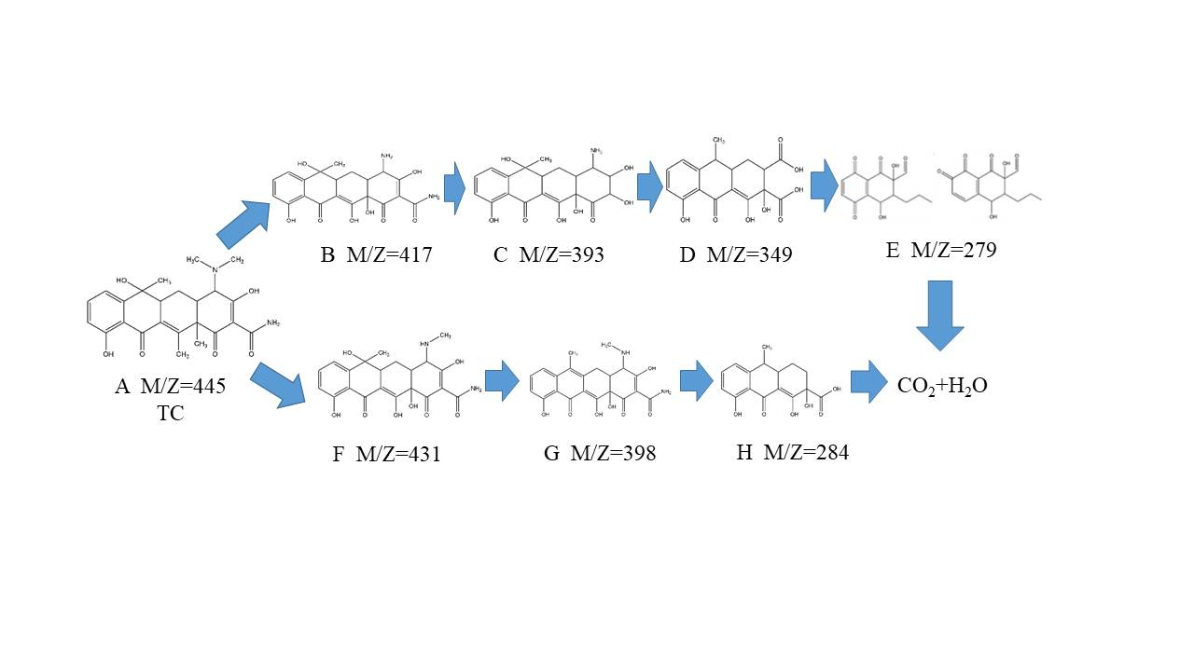

Fig. S11. The intermediate products and degradation path of TC