***In vitro*/*vivo* antifungal activity study of novel mandelic acid derivatives as potential fungicides against *Thanatephorus cucumeris***

Huabin Shi, Longju Li, Dandan Song, Ya Zheng, Zhibing Wu *

National Key Laboratory of Green Pesticide, Key Laboratory of Green Pesticide and Agricultural Bioengineering, Ministry of Education, Center for R&D of Fine Chemicals of Guizhou University, Guiyang, 550025, China.

E-mail: zbwu@gzu.edu.cn (Z.B. Wu).

**Contents**

1. The infection process of plants with *T. cucumeris* 2

2. 1H NMR, 13C NMR and HRMS data of the key intermediates 2

3. 1H NMR, 13C NMR, 19F NMR and HRMS data of the target compounds4

4. Copies of intermediates13

5. 1H NMR, 13C NMR, 19F NMR and HRMS of the target compounds 17

6. Crystallographic data of target compound **F16**67

7. Structures and inhibition rates target compounds against pathogenic fungi 69

8. The EC50 values and regression equations of the target compounds 74

**1. The infection process of plants with *T. cucumeris***



**Figure S1.** The infection process of sclerotia and mycelia infection of plants.

**2. 1H NMR, 13C NMR and HRMS data of the key** **intermediates**



*Date for* **B**. A white solid, yield 98%, m.p. 54-56 oC. 1H NMR (400 MHz, CDCl3) *δ* 7.43-7.41 (m, 2H, phenyl H), 7.40-7.31 (m, 3H, phenyl H), 5.18 (d, *J* = 4.0 Hz, 1H, CHOH), 3.76 (s, 3H, OCH3), 3.55 (d, *J* = 4.0 Hz, 1H, CHOH); 13C NMR (101 MHz, CDCl3) *δ* 174.25, 138.32, 128.74, 128.63, 126.71, 72.98, 53.18.



*Date for* **C**. A white solid, yield 93%, m.p. 131-132 oC. 1H NMR (400 MHz, DMSO-*d*6) *δ* 9.18 (s, 1H, CONH), 7.44-7.39 (m, 2H, phenyl H), 7.34-7.29 (m, 2H, phenyl H), 7.28-7.23 (m, 1H, phenyl H), 5.99 (d, *J* = 8.0 Hz, 1H, CHOH), 4.93 (d, *J* = 8.0 Hz, 1H, CHOH), 4.23 (s, 2H, NHNH2); 13C NMR (101 MHz, DMSO-*d*6) *δ* 171.12, 141.35, 127.95, 127.42, 126.55, 72.84.



*Date for* **D**. A yellow solid, yield 28%, m.p. 194-195 oC. 1H NMR (500 MHz, CDCl3) *δ* 11.53 (s, 1H, SH), 8.27 (d, *J* = 5.0 Hz, 2H, phenyl H), 7.69 (t, *J* = 5.0 Hz, 1H, phenyl H), 7.54 (t, *J* = 5.0 Hz, 2H, phenyl H); 13C NMR (126 MHz, CDCl3) *δ* 191.30, 181.18, 160.81, 134.88, 133.71, 130.74, 128.93.



*Date for* **E**. A yellow solid, yield 92%, m.p. 116-118oC. 1H NMR (400 MHz, DMSO-*d*6) *δ* 14.39 (s, 1H, SH), 7.44-7.37 (m, 4H, phenyl H), 7.35-7.30 (m, 1H, phenyl H), 6.98 (d, *J* = 4.0 Hz, 1H, CHOH), 5.85 (d, *J* = 4.0 Hz, 1H, CHOH); 13C NMR (101 MHz, DMSO-*d*6) *δ* 188.34, 168.78, 140.84, 128.52, 128.16, 126.22, 70.18.

**3.** **1H NMR, 13C NMR, 19F NMR and HRMS data of the target compounds**



*Date for* **F1**. A yellow oil, yield 93%. 1H NMR (400 MHz, CDCl3) *δ* 7.46 (d, *J* = 8.0 Hz, 2H, phenyl H), 7.33-7.30 (m, 3H, phenyl H), 6.17 (s, 1H, CHOH), 4.38 (d, *J* = 12.0 Hz, 1H, CHOH), 2.71 (s, 3H, SCH3); 13C NMR (101 MHz, CDCl3) *δ* 174.35, 168.54, 140.59, 128.95, 128.76, 126.23, 71.79, 16.62; HRMS (ESI): m/z calcd for C10H11N2OS2 [M+H]+ 239.0307, found 239.0307.



*Date for* **F2**. A yellow solid, yield 90%, m.p. 61-63oC. 1H NMR (400 MHz, CDCl3) *δ* 7.48-7.46 (m, 2H, phenyl H), 7.39-7.30 (m, 3H, phenyl H), 6.18 (s, 1H, CHOH), 4.13 (s, 1H, CHOH), 3.26 (q, *J* = 8.0Hz, 2H, SCH2), 1.42 (t, *J* = 8.0 Hz, 3H, SCH2CH3); 13C NMR (101 MHz, CDCl3) *δ* 174.20, 167.57, 140.60, 128.98, 128.80, 126.26, 71.89, 28.75, 14.55; HRMS (ESI): m/z calcd for C11H13N2OS2 [M+H]+ 253.0464, found 253.0464.



*Date for* **F3**. A yellow oil, yield 91%. 1H NMR (400 MHz, CDCl3) *δ* 7.47 (d, *J* = 4.0 Hz, 2H, phenyl H), 7.39-7.30 (m, 3H, phenyl H), 6.17 (s, 1H, CHOH), 4.20 (s, 1H, CHOH), 3.22 (t, *J* = 7.2 Hz, 2H, SCH2), 1.83-1.74 (m, 2H, SCH2CH2), 1.03 (t, *J* = 8.0 Hz, 3H, CH3); 13C NMR (101 MHz, CDCl3) *δ* 174.13, 167.85, 140.61, 128.96, 128.78, 126.26, 71.88, 36.29, 22.63, 13.39; HRMS (ESI): m/z calcd for C12H15N2OS2 [M+H]+ 267.0620, found 267.0620.



*Date for* **F4**. A yellow solid, yield 88%, m.p. 54-56oC. 1H NMR (400 MHz, CDCl3) *δ* 7.47 (d, *J* = 8.0 Hz, 2H, phenyl H), 7.39-7.30 (m, 3H, phenyl H), 6.17 (s, 1H, CHOH), 4.08 (s, 1H, CHOH), 3.25 (t, *J* = 8.0 Hz, 2H, SCH2), 1.78-1.70 (m, 2H, SCH2CH2), 1.45 (m, 2H, CH2CH3), 0.93 (t, *J* = 8.0 Hz, 3H, CH2CH3); 13C NMR (101 MHz, CDCl3) *δ* 174.04, 167.92, 140.61, 128.98, 128.80, 126.27, 71.92, 34.12, 31.16, 21.96, 13.65; HRMS (ESI): m/z calcd for C13H17N2OS2[M+H]+ 281.0777, found 281.0777.



*Date for* **F5**. A yellow oil, yield 83%. 1H NMR (400 MHz, CDCl3) *δ* 7.48-7.46 (2H, phenyl H), 7.39-7.30 (m, 3H, phenyl H), 6.17 (s, 1H, CHOH), 4.16 (s, 1H, CHOH), 3.24 (t, *J* = 8.0 Hz, 2H, SCH2), 1.79-1.72 (m, 2H, SCH2CH2), 1.44-1.28 (m, 4H, SCH2CH2CH2CH2), 0.89 (t, *J* = 8.0 Hz, 3H, CH2CH3); 13C NMR (101 MHz, CDCl3) *δ* 174.10, 167.91, 140.63, 128.97, 126.26, 71.89, 34.41, 30.93, 28.84, 22.24, 14.02; HRMS (ESI): m/z calcd for C14H19N2OS2 [M+H]+ 295.0933, found 295.0933.



*Date for* **F6**. A yellow liquid, yield 76%. 1H NMR (400 MHz, CDCl3) *δ* 7.47 (d, *J* = 8.0 Hz, 2H, phenyl H), 7.39-7.32 (m, 3H, phenyl H), 6.17 (s, 1H, CHOH), 3.92 (s, 1H, CHOH), 3.25 (t, *J* = 8.0 Hz, 2H, SCH2), 1.79-1.71 (m, 2H, SCH2CH2), 1.44-1.37 (m, 2H SCH2CH2CH2), 1.31-1.25 (m, 14H SCH2CH2CH2(CH2)7), 0.88 (t, *J* = 8.0 Hz, 3H, CH3); 13C NMR (101 MHz, CDCl3) *δ* 173.90 , 167.92, 140.61, 129.00, 128.83, 126.27, 71.97, 34.45, 32.02, 29.70 29.68, 29.58, 29.44, 29.17, 28.83, 26.21, 22.81, 14.25; HRMS (ESI): m/z calcd for C20H31N2OS2[M+H]+ 379.1872, found 379.1873.



*Date for* **F7**. A yellow oil, yield 82%. 1H NMR (400 MHz, CDCl3) *δ* 7.48-7.45 (m, 2H, phenyl H), 7.39-7.30 (m, 3H, phenyl H), 6.16 (s, 1H, CHOH), 4.21 (s, 1H, CHOH), 3.15 (d, *J* = 8.0 Hz, 2H, SCH2), 2.02 (m, 1H, SCH2CH), 1.03 (d, *J* =8.0 Hz, 6H, SCH2CH(CH3)2); 13C NMR (101 MHz, CDCl3) *δ* 174.09, 168.17, 140.62, 128.96, 128.77, 126.26, 71.86, 42.87, 28.50, 21.92; HRMS (ESI): m/z calcd for C13H17N2OS2 [M+H]+ 281.0777, found 281.0777.



*Date for* **F8**. A yellow oil, yield 90%. 1H NMR (400 MHz, CDCl3) *δ* 7.48-7.46 (m, 2H, phenyl H), 7.39-7.30 (m, 3H, phenyl H), 6.17 (s, 1H, CHOH), 4.11 (s, 1H, CHOH), 3.28-3.24 (m, 2H, SCH2), 1.76-1.68 (m, 1H, SCH2CH2CH), 1.67-1.61 (m, 2H, SCH2CH2), 0.92 (d, *J* = 4.0 Hz, 6H, CH(CH3)2); 13C NMR (101 MHz, CDCl3) *δ* 174.06, 167.88, 140.61, 128.97, 128.79, 126.26, 71.91, 37.87, 32.55, 27.58, 22.27; HRMS (ESI): m/z calcd for C14H19N2OS2 [M+H]+ 295.0933, found 295.0934.



*Date for* **F9**. A yellow solid, yield 91 %, m.p. 70-72oC. 1H NMR (400 MHz, CDCl3) *δ* 7.47-7.44 (m, 2H, phenyl H), 7.39-7.24 (m, 8H, phenyl H), 6.17 (d, *J* = 3.4 Hz, 1H, CHOH), 4.48 (q, *J* = 12.0 Hz, 2H, SCH2), 4.07 (d, *J* = 4.0 Hz, 1H, CHOH); 13C NMR (101 MHz, CDCl3) *δ* 174.60, 166.73, 140.55, 135.72, 129.33, 128.99, 128.86, 128.84, 128.05, 126.28, 71.94, 38.46; HRMS (ESI): m/z calcd for C16H15N2OS2 [M+H]+ 315.0620, found 315.0620.



*Date for* **F10**. A yellow liquid, yield 88%. 1H NMR (400 MHz, CDCl3) *δ* 7.47 (m, 2H, phenyl H), 7.40-7.30 (m, 4H, phenyl H), 7.23-7.11 (m, 3H, phenyl H), 6.19 (s, 1H, CHOH), 4.53 (t, *J* = 12.0 Hz, 2H, SCH2), 4.13 (s, 1H, CHOH), 2.39 (s, 3H, phenyl-CH3); 13C NMR (101 MHz, CDCl3) *δ* 174.58, 166.92, 140.57, 137.29, 133.22, 130.80, 130.45, 128.99, 128.83 128.49, 126.44, 126.27, 71.93, 36.75, 19.31; HRMS (ESI): m/z calcd for C17H17N2OS2 [M+H]+ 329.0777, found 329.0777.



*Date for* **F11**. A yellow solid, yield 90%, m.p. 52-54oC. 1H NMR (400 MHz, CDCl3) *δ* 7.48-7.45(m, 2H, phenyl H), 7.40-7.31 (m, 3H, phenyl H), 7.22-7.16 (m, 3H, phenyl H), 7.12-7.08 (m, 1H, phenyl H), 6.18 (s, 1H, CHOH), 4.46 (q, *J* = 12.0 Hz, 2H, SCH2), 3.75 (s, 1H, CHOH), 2.32 (s, 3H, phenyl-CH3); 13C NMR (101 MHz, CDCl3) *δ* 174.27, 166.90, 140.54, 138.63, 135.54, 130.02, 129.03, 128.90, 128.87, 128.77, 126.38, 126.29, 72.05, 38.49, 21.45; HRMS (ESI): m/z calcd for C17H17N2OS2 [M+H]+ 329.0777, found 329.0777.



*Date for* **F12**. A white solid, yield 87%, m.p. 113-115 oC. 1H NMR (400 MHz, CDCl3) *δ* 7.47-7.44 (m, 2H, phenyl H), 7.39-7.31 (m, 3H, phenyl H), 7.26 (d, *J* = 8.0 Hz, 2H, phenyl H), 7.11 (d, *J* = 8.0 Hz, 2H, phenyl H), 6.17 (s, 1H, CHOH), 4.45 (q, *J* = 12.0 Hz, 2H, SCH2), 3.93 (s, 1H, CHOH), 2.32 (s, 3H, phenyl-CH3); 13C NMR (101 MHz, CDCl3) *δ* 174.38, 166.93, 140.55, 137.88, 132.59, 129.55, 129.24, 129.00, 128.85, 126.29, 71.98, 38.29, 21.28; HRMS (ESI): m/z calcd for C17H17N2OS2 [M+H]+ 329.0777, found 329.0777.



*Date for* **F13**. A colorless oil, yield 94%. 1H NMR (500 MHz, CDCl3) *δ* 7.70 (d, *J* = 10.0 Hz, 1H, phenyl H), 7.65 (d, *J* = 10.0 Hz, 1H, phenyl H), 7.50-7.46 (m, 3H, phenyl H), 7.41-7.33 (m, 4H, phenyl H), 6.20 (d, *J* = 5.0 Hz, 1H, CHOH), 4.73 (q, *J* = 10.0 Hz, 2H, SCH2), 3.50 (d, *J* = 5.0 Hz, 1H, CHOH); 13C NMR (126 MHz, CDCl3) *δ* 174.45, 165.48, 140.41, 134.73, 132.42, 132.26, 129.11, 128.22, 126.44(q, *J* = 4.0 Hz), 125.72(q, *J* = 274.7 Hz), 72.16, 34.36, 29.85; 19F NMR (471 MHz, CDCl3) *δ* -59.21; HRMS (ESI): m/z calcd for C17H14F3N2OS2[M+H]+ 383.0494, found 383.0496.



*Date for* **F14**. A colorless oil, yield 93%. 1H NMR (500 MHz, CDCl3) *δ* 7.64 (s, 1H, phenyl H), 7.60 (d, *J* = 10.0 Hz, 1H, phenyl H), 7.53 (d, *J* = 5.0 Hz, 1H, phenyl H), 7.47-7.33 (m, 6H, phenyl H), 6.17 (d, *J* = 5.0 Hz, 1H, CHOH), 4.55 (q, *J* = 15.0 Hz, 2H, SCH2), 3.72 (d, *J* = 5.0 Hz, 1H, CHOH); 13C NMR (126 MHz, CDCl3) *δ* 174.70, 165.84, 140.40, 137.13, 132.78, 131.16 (q, *J* = 31.5 Hz), 129.34, 129.07, 128.98, 126.26, 126.02 (d, *J* = 2.5 Hz), 124.86 (d, *J* = 3.8 Hz), 123.98(q, *J* = 272.2 Hz), 72.04, 37.50; 19F NMR (471 MHz, CDCl3) *δ* -62.53; HRMS (ESI): m/z calcd for C17H14F3N2OS2 [M+H]+ 383.0494, found 383.0495.



*Date for* **F15**. A white solid, yield 93%, m.p. 59-61 oC. 1H NMR (500 MHz, CDCl3) *δ* 7.55 (d, *J* = 10.0 Hz, 2H, phenyl H), 7.51 (d, *J* = 10.0 Hz, 2H, phenyl H), 7.46-7.44 (m, 2H, phenyl H), 7.39-7.32 (m, 3H, phenyl H), 6.18 (d, *J* = 5.0 Hz, 1H, CHOH), 4.52 (q, *J* = 10.0 Hz, 2H, SCH2), 3.79 (d, *J* = 5.0 Hz, 1H, CHOH); 13C NMR (126 MHz, CDCl3) *δ* 174.77, 165.81, 140.39, 140.24, 130.26, 130.01, 129.68, 129.07, 128.98, 126.25, 125.77 (q, *J* = 3.0 Hz), 124.08 (q, *J* = 272.2 Hz), 72.02, 37.35; 19F NMR (471 MHz, CDCl3) *δ* -62.47; HRMS (ESI): m/z calcd for C17H14F3N2OS2 [M+H]+ 383.0494, found 383.0494.



*Date for* **F16**. A yellow solid, yield 93%. 1H NMR (400 MHz, CDCl3) *δ* 7.47-7.44 (m, 2H, phenyl H), 7.39-7.30 (m, 4H, phenyl H), 7.28-7.23 (m, 1H, phenyl H), 6.89-6.84 m, 2H, phenyl H), 6.17 (s, 1H, CHOH), 4.51 (s, 2H, SCH2), 4.09 (s, 1H, CHOH), 3.81 (s, 3H, OCH3); 13C NMR (101 MHz, CDCl3) *δ* 174.37, 167.70, 157.65, 140.64, 131.02, 129.56, 128.96, 128.78, 126.28, 124.2, 120.65, 110.72, 71.94, 55.56, 33.52; HRMS (ESI): m/z calcd for C17H17N2O2S2 [M+H]+ 345.0726, found 345.0726.



*Date for* **F17**. A yellow oil, yield 82%. 1H NMR (400 MHz, CDCl3) *δ* 7.47-7.45 (m, 2H, phenyl H), 7.39-7.31 (m, 3H, phenyl H), 7.21 (t, *J* = 8.0 Hz, 1H, phenyl H), 6.96-6.92 (m, 2H, phenyl H), 6.82-6.80 (m, 1H, phenyl H), 6.17 (s, 1H, CHOH), 4.45 (q, *J* =12.0 Hz, 2H, SCH2), 3.93 (s, 1H, CHOH), 3.77 (s, 3H, OCH3); 13C NMR (101 MHz, CDCl3) *δ* 174.53, 166.71, 159.89, 140.54, 137.18, 129.89, 129.01, 128.89, 126.28, 121.63, 114.71, 113.78, 71.99, 55.38, 38.4; HRMS (ESI): m/z calcd for C17H17N2O2S2 [M+H]+ 345.0726, found 345.0726.



*Date for* **F18**. A yellow solid, yield 81%, m.p. 99-101oC. 1H NMR (400 MHz, CDCl3) *δ* 7.47-7.45 (m, 2H, phenyl H), 7.39-7.28 (m, 5H, phenyl H), 6.84-6.81 (m, 2H, phenyl H), 6.17 (s, 1H, CHOH), 4.45 (q, *J* = 12.0 Hz, 2H, SCH2), 3.95 (s, 1H, CHOH), 3.78 (s, 3H, OCH3); 13C NMR (101 MHz, CDCl3) *δ* 174.40, 166.90, 159.40, 140.56, 130.58, 129.00, 128.85, 127.61, 126.29, 114.26, 71.98, 55.41, 38.10, 29.83; HRMS (ESI): m/z calcd for C17H17N2O2S2 [M+H]+ 345.0726, found 345.0726.



*Date for* **F19**. A yellow oil, yield 91%. 1H NMR (400 MHz, CDCl3) *δ* 7.56-7.54 (m, 1H, phenyl H), 7.47-7.45 (m, 2H, phenyl H), 7.40-7.29 (m, 4H, phenyl H), 7.26-7.18(m, 2H, phenyl H), 6.18 (s, 1H, CHOH), 4.57 (q, *J* = 12.0 Hz, 2H, SCH2), 3.74 (s, 1H, CHOH); 13C NMR (101 MHz, CDCl3) *δ* 174.64, 166.32, 147.77, 140.48, 131.88, 129.63, 129.06, 128.95, 128.62, 126.95, 126.29, 120.64(q, *J* = 259.6 Hz), 120.28(q, *J* = 8.1 Hz), 119.35, 72.08, 32.29; 19F NMR (376 MHz, CDCl3) *δ* -56.88 (d, *J* = 4.0 Hz); HRMS (ESI): m/z calcd for C17H14F3N2O2S2 [M+H]+ 399.0443, found 399.0443.



*Date for* **F20**. A yellow oil, yield 92%. 1H NMR (400 MHz, CDCl3) *δ* 7.47-7.44 (m, 2H, phenyl H), 7.40-7.32 (m, 5H, phenyl H), 7.25 (s, 1H, phenyl H), 7.14-7.12 (m, 1H, phenyl H), 6.17 (s, 1H, CHOH), 4.49 (q, *J* = 12.0 Hz, 2H, SCH2), 3.69 (s, 1H, CHOH); 13C NMR (101 MHz, CDCl3) *δ* 174.67, 165.91, 149.47, 140.44, 138.37, 130.20, 129.07, 128.97, 127.74, 126.27, 121.81, 120.53(q, *J* = 258.6 Hz), 120.45, 72.07, 37.51; 19F NMR (376 MHz, CDCl3) *δ* -57.76; HRMS (ESI): m/z calcd for C17H14F3N2O2S2 [M+H]+ 399.0443, found 399.0444.



*Date for* **F21**. A yellow oil, yield 91%. 1H NMR (400 MHz, CDCl3) *δ* 7.47-7.31 (m, 7H, phenyl H), 7.14 (d, *J* = 8.0 Hz, 2H, phenyl H), 6.18 (s, 1H, CHOH), 4.49 (q, *J* = 12.0 Hz, 2H, SCH2), 3.73 (s, 1H, CHOH); 13C NMR (126 MHz, CDCl3) *δ* 174.65, 166.10, 148.87, 140.44, 134.79, 130.82, 129.06, 128.97, 126.26, 121.27, 120.52(q, *J* = 257.0 Hz), 72.04, 37.24; 19F NMR (471 MHz, CDCl3) *δ* -57.72; HRMS (ESI): m/z calcd for C17H14F3N2O2S2[M+H]+ 399.0443, found 399.0443.



*Date for* **F22**. A colourless oil, yield 94%. 1H NMR (500 MHz, CDCl3) *δ* 7.47-7.43 (m, 3H, phenyl H), 7.39-7.32 (m, 3H, phenyl H), 7.2-7.23 (m, 1H, phenyl H), 7.08-7.02 (m, 2H, phenyl H), 6.18 (d, *J* = 5.0 Hz, 1H, CHOH), 4.54 (d, *J* = 15.0 Hz, 2H, SCH2), 3.78 (d, *J* = 5.0 Hz, 1H, CHOH); 13C NMR (126 MHz, CDCl3) δ 174.56, 166.39, 161.12(d, *J* = 249.5 Hz), 140.46, 131.60 (d, *J* = 3.8 Hz), 130.00 (d, *J* = 7.6 Hz), 129.05, 128.93, 126.28, 124.39 (d, *J* = 3.8 Hz), 123.28 (d, *J* = 15.1 Hz), 115.72 (d, *J* =21.4 Hz), 72.04, 31.47 (d, *J* = 3.8 Hz); 19F NMR (471 MHz, CDCl3) *δ* -116.58 (q, *J* = 9.4 Hz); HRMS (ESI): m/z calcd for C16H14FN2OS2 [M+H]+ 333.0526, found 333.0526.



*Date for* **F23**. A white solid, yield 91%, m.p. 50-52 oC. 1H NMR (500 MHz, CDCl3) *δ* 7.46 (m, 2H, phenyl H), 7.40-7.33 (m, 3H, phenyl H), 7.26 (m, 1H, phenyl H), 7.16 (d, *J* = 10.0 Hz, 1H, phenyl H), 7.13-7.08 (m, 1H, phenyl H), 6.96 (m, 1H, phenyl H), 6.18 (d, *J* = 5.0 Hz, 1H, CHOH), 4.48 (q, *J* = 15.0 Hz, 2H, SCH2), 3.74 (d, *J* = 5.0 Hz, 1H, CHOH); 13C NMR (126 MHz, CDCl3) *δ* 174.57, 166.15, 162.87(d, *J* = 247.0 Hz), 140.43, 138.38 (d, *J* = 7.6 Hz), 130.35 (d, *J* = 8.8 Hz), 129.06, 128.95, 126.27, 125.02 (d, *J* = 2.5 Hz), 116.25 (d, *J* = 21.4 Hz), 115.06 (d, *J* = 20.2 Hz), 72.04, 37.62; 19F NMR (471 MHz, CDCl3) *δ* -112.34 (q, *J* = 4.7 Hz); HRMS (ESI): m/z calcd for C16H14FN2OS2[M+H]+333.0526, found 333.0526.



*Date for* **F24**. A yellow solid, yield 89%, m.p. 63-65 oC. 1H NMR (400 MHz, CDCl3) *δ* 7.45 (m, 2H, phenyl H), 7.40-7.33 (m, 5H, phenyl H), 6.98 (m, 2H, phenyl H), 6.17 (s, 1H, CHOH), 4.46 (q, *J* = 12.0 Hz, 2H, SCH2), 3.74 (s, 1H, CHOH); 13C NMR (101 MHz, CDCl3) *δ* 174.53, 166.33, 162.48(d, *J* = 247.5 Hz), 140.48, 131.70 (d, *J* = 3.0 Hz), 131.06 (d, *J* = 8.1 Hz), 129.06, 128.95, 126.28, 115.88(d, *J* = 21.2.0 Hz), 72.05, 37.54; 19F NMR (376 MHz, CDCl3) *δ* -113.90--113.97 (m); HRMS (ESI): m/z calcd for C16H14FN2OS2 [M+H]+ 333.0526, found 333.0526.



*Date for* **F25**. A yellow oil, yield 94%. 1H NMR (400 MHz, CDCl3) *δ* 7.53-7.51(m, 1H, phenyl H), 7.48-7.45 (m, 2H, phenyl H), 7.40- 7.31 (m, 4H, phenyl H), 7.24-7.16 (m, 2H, phenyl H), 6.18 (d, *J* = 4.0 Hz, 1H, CHOH), 4.63 (q, *J* = 12.0 Hz, 2H, SCH2), 3.61 (d, *J* = 4.0 Hz, 1H, CHOH); 13C NMR (101 MHz, CDCl3) *δ* 174.45, 166.47, 140.48, 134.54, 133.95, 131.69, 129.88, 129.54, 129.07, 128.96, 127.15, 126.31, 72.13, 35.92; HRMS (ESI): m/z calcd for C16H14ClN2OS2 [M+H]+ 349.0231, found 349.0230.



*Date for* **F26**. A colorless oil, yield 92%. 1H NMR (500 MHz, CDCl3) *δ* 7.52-7.50 (m, 2H, phenyl H), 7.44-7.37 (m, 4H, phenyl H), 7.33-7.28 (m, 3H, phenyl H), 6.23 (d, *J* = 5.0 Hz, 1H, CHOH), 4.49 (q, *J* = 15.0 Hz, 2H, SCH2), 4.08 (d, *J* = 5.0 Hz, 1H, CHOH); 13C NMR (126 MHz, CDCl3) *δ* 174.80, 166.09, 140.43, 137.93, 134.56, 130.07, 129.34, 129.03, 128.90, 128.24, 127.53, 126.26, 71.94, 37.51; HRMS (ESI): m/z calcd for C16H14ClN2OS2 [M+H]+ 349.0231, found 349.0231.



*Date for* **F27**. A white solid, yield 91%, m.p. 94-96 oC. 1H NMR (400 MHz, CDCl3) *δ* 7.46-7.44 (m, 2H, phenyl H), 7.40-7.30 (m, 5H, phenyl H), 7.27-7.25 (m, 2H, phenyl H), 6.17 (d, *J* = 4.0 Hz, 1H, CHOH), 4.44 (q, *J* = 16.0 Hz, 2H, SCH2), 3.85 (d, *J* = 4.0 Hz, 1H, CHOH); 13C NMR (101 MHz, CDCl3) *δ* 174.69, 166.14, 140.46, 134.53, 133.90, 130.69, 129.05, 129.00, 128.93, 126.27, 72.01, 37.50; HRMS (ESI): m/z calcd for C16H14ClN2OS2 [M+H]+ 349.0231, found 349.0230.



*Date for* **F28**. A yellow oil, yield 91%. 1H NMR (400 MHz, CDCl3) *δ* 7.57-7.52 (m, 2H, phenyl H), 7.47-7.44 (m, 2H, phenyl H), 7.40-7.31 (m, 3H, phenyl H), 7.25-7.21 (m, 1H, phenyl H), 7.15-7.11 (m, 1H, phenyl H), 6.17 (s, 1H, CHOH), 4.63 (q, *J* = 12.0 Hz, 2H, SCH2), 3.70 (s, 1H, CHOH); 13C NMR (101 MHz, CDCl3) *δ* 174.53, 166.41, 140.48, 135.66, 133.19, 131.75, 129.71, 129.05, 128.94, 127.80, 126.30, 124.92, 72.10, 38.55; HRMS (ESI): m/z calcd for C16H14BrN2OS2 [M+H]+ 392.9725, found 392.9725.



*Date for* **F29**. A yellow solid, yield 87 %, m.p. 64-65oC. 1H NMR (400 MHz, CDCl3) *δ* 7.53 (s, 1H, phenyl H), 7.47-7.45 (m, 2H, phenyl H), 7.41-7.31 (m, 5H, phenyl H), 7.16 (t, *J* = 8.0 Hz, 1H, phenyl H), 6.17 (s, 1H, CHOH), 4.44(q, *J* = 12.0 Hz, 2H, SCH2), 3.89 (s, 1H, CHOH); 13C NMR (101 MHz, CDCl3) *δ* 174.74, 166.04, 140.45, 138.26, 132.24, 131.16, 130.35, 129.05, 128.92, 128.01, 126.28, 122.73, 72.00, 37.48; HRMS (ESI): m/z calcd for C16H14BrN2OS2 [M+H]+ 392.9725, found 392.9725.



*Date for* **F30**. A white solid, yield 92%, m.p. 112-113 oC. 1H NMR (400 MHz, CDCl3) *δ* 7.41-7.25 (m, 7H, phenyl H), 7.21-7.17 (m, 2H, phenyl H), 6.10 (s, 1H, CHOH), 4.41-4.31 (m, 2H, SCH2), 3.65 (s, 1H, CHOH); 13C NMR (101 MHz, CDCl3) *δ* 174.60, 166.09, 140.45, 135.09, 131.96, 131.03, 129.07, 128.96, 126.28, 122.03, 72.06, 37.53; HRMS (ESI): m/z calcd for C16H14BrN2OS2 [M+H]+ 392.9725, found 392.9725.

**4. Copies of intermediates**

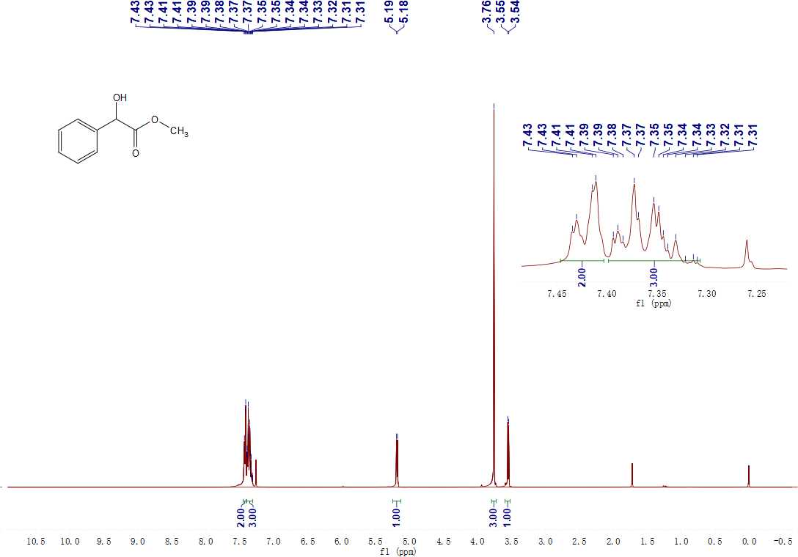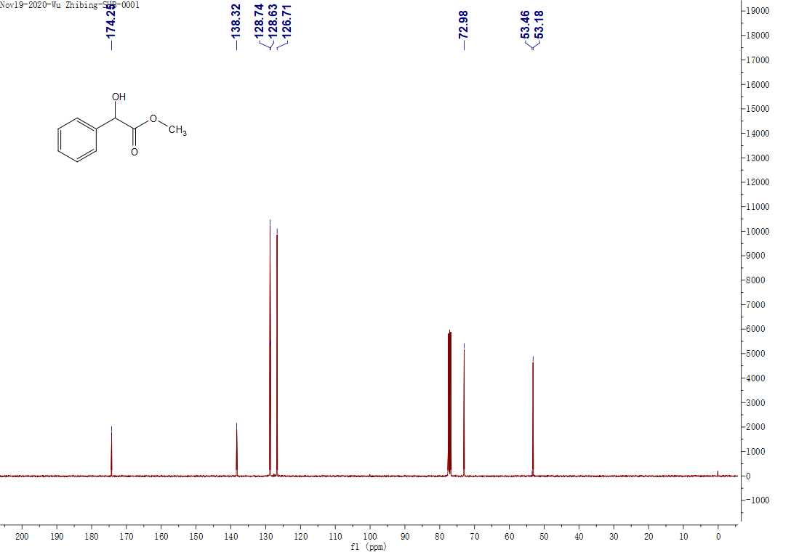

**Figure S2.** 1H NMR and 13C NMR for **B**.

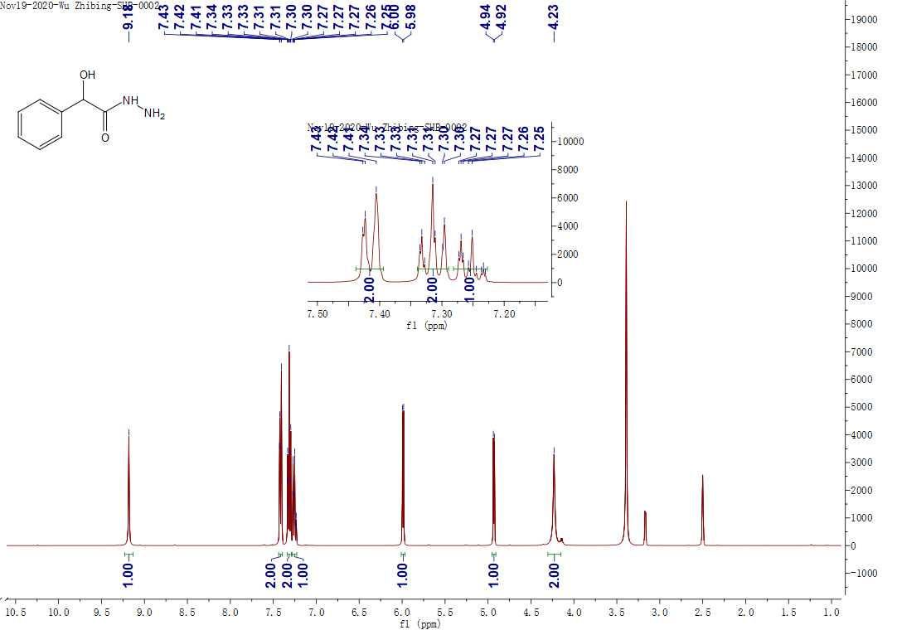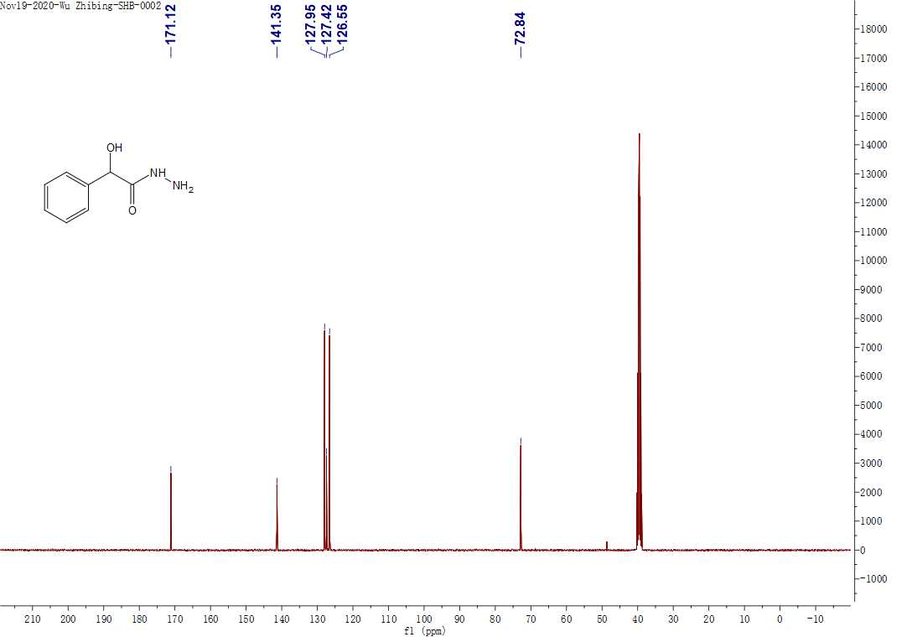

**Figure S3.** 1H NMR and 13C NMR for **C**.

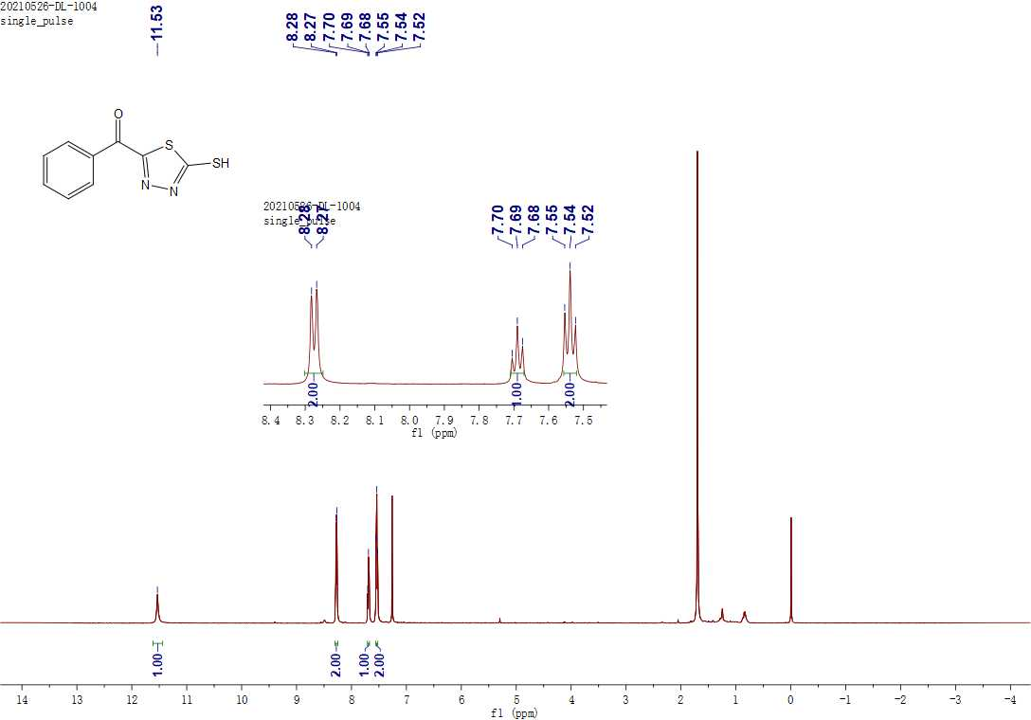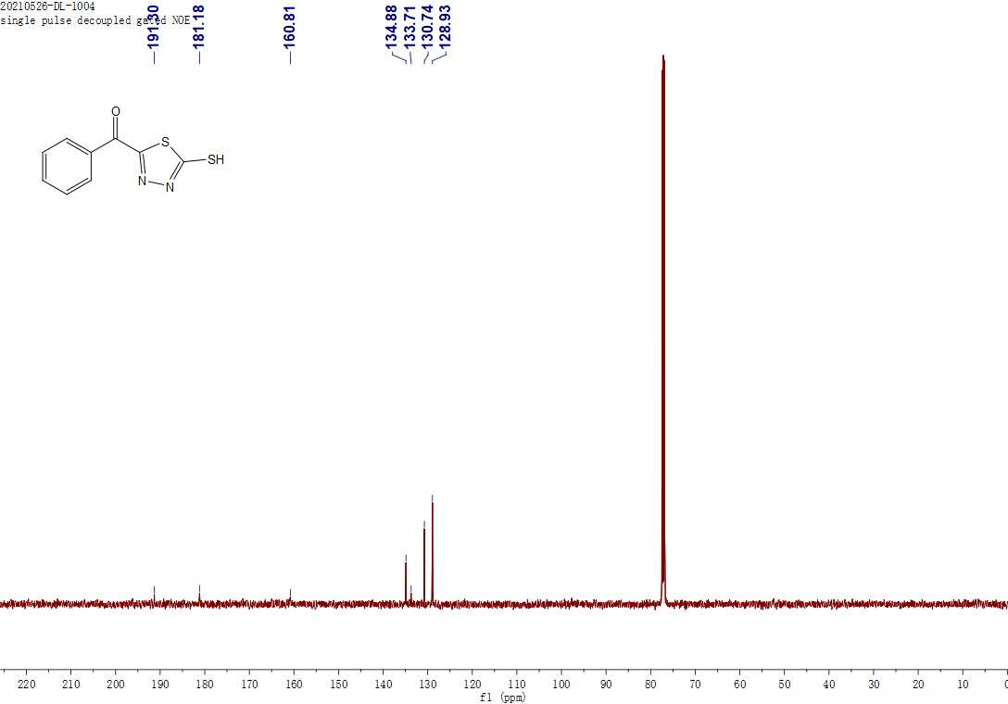**Figure S4.** 1H NMR and 13C NMR for **D**.

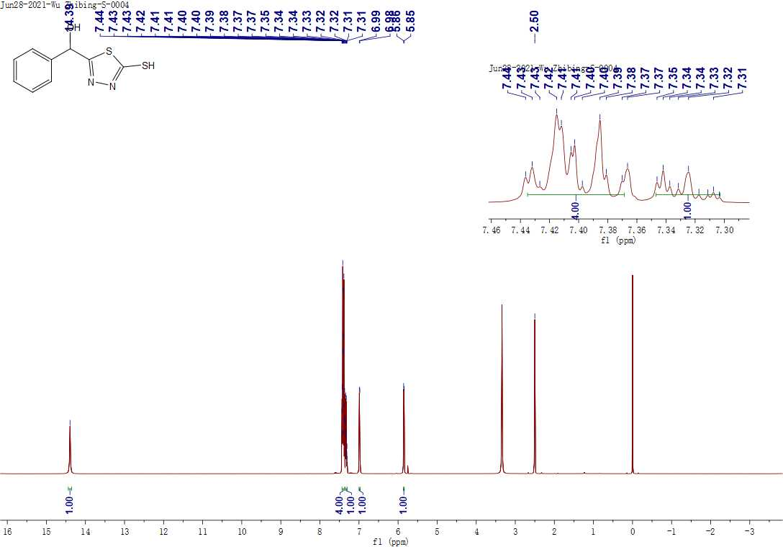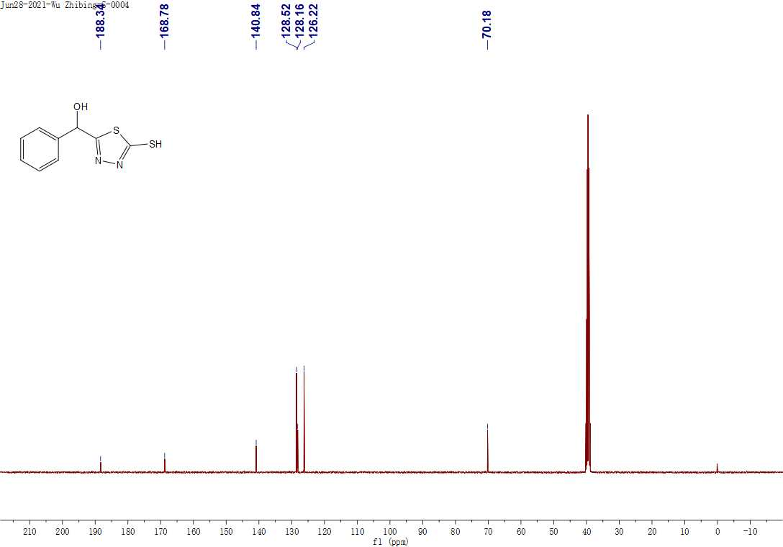**Figure S5.** 1H NMR, 13C NMR and HRMS for **E**.

**5. 1H NMR, 13C NMR, 19F NMR and HRMS of the target compounds**

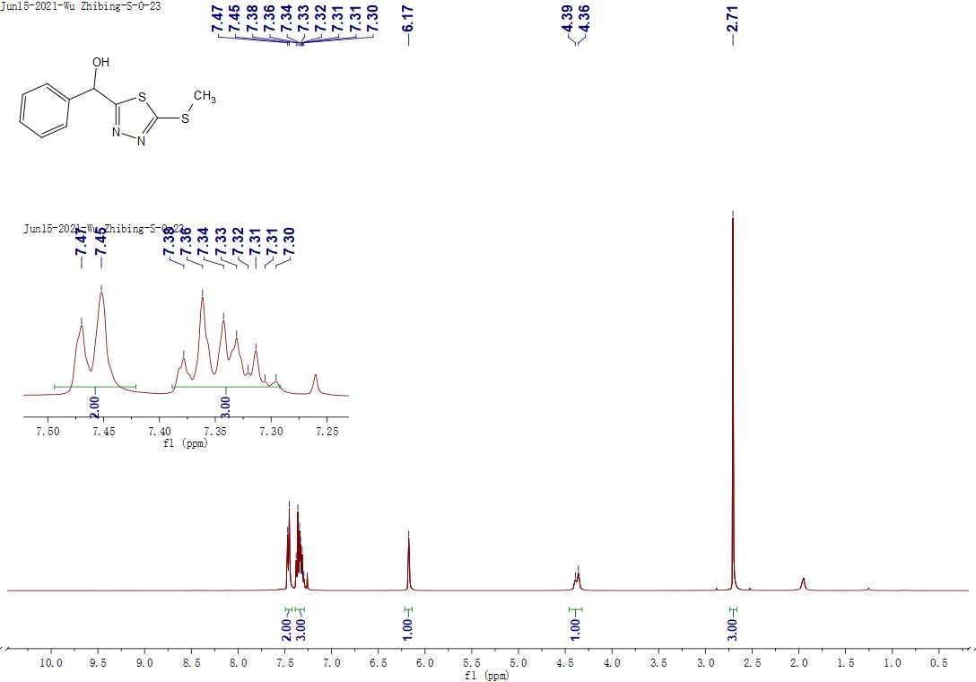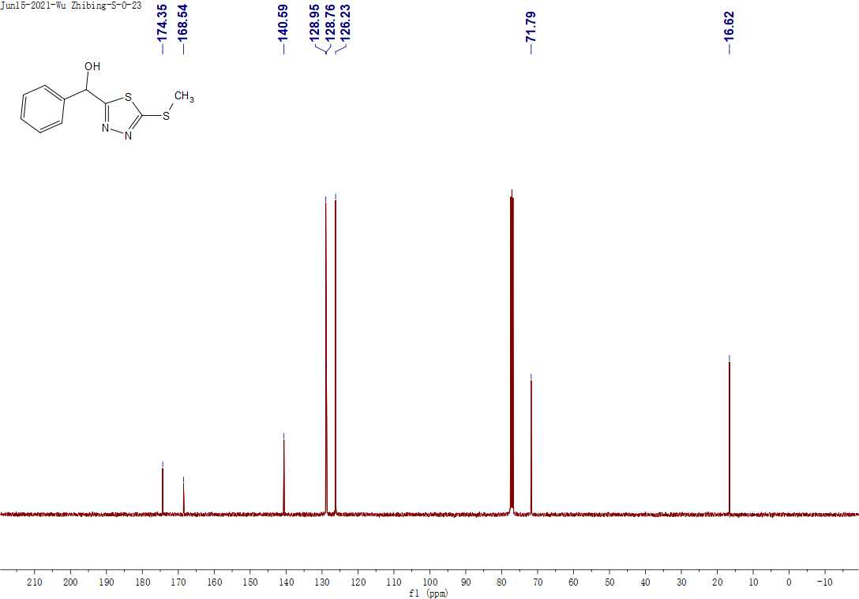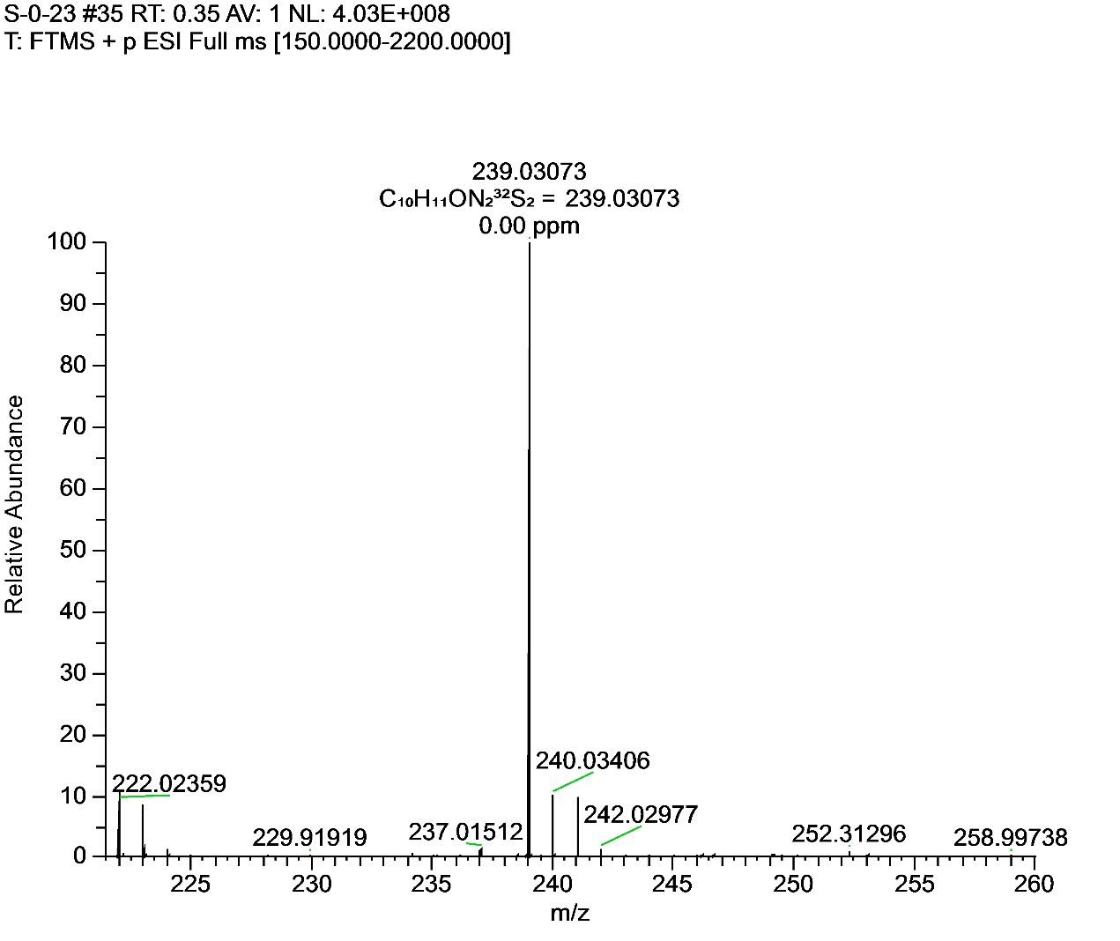**Figure S6.** 1H NMR, 13C NMR and HRMS for **F1**.

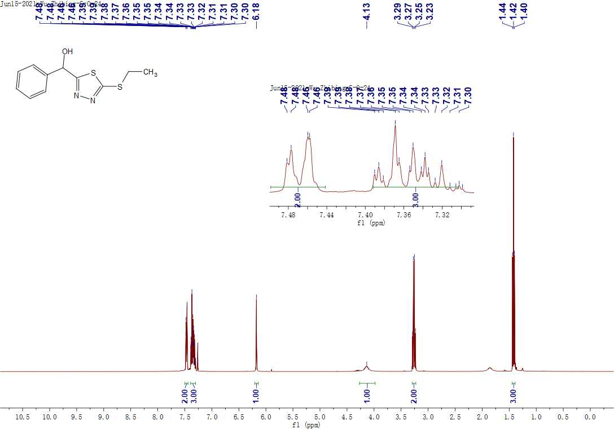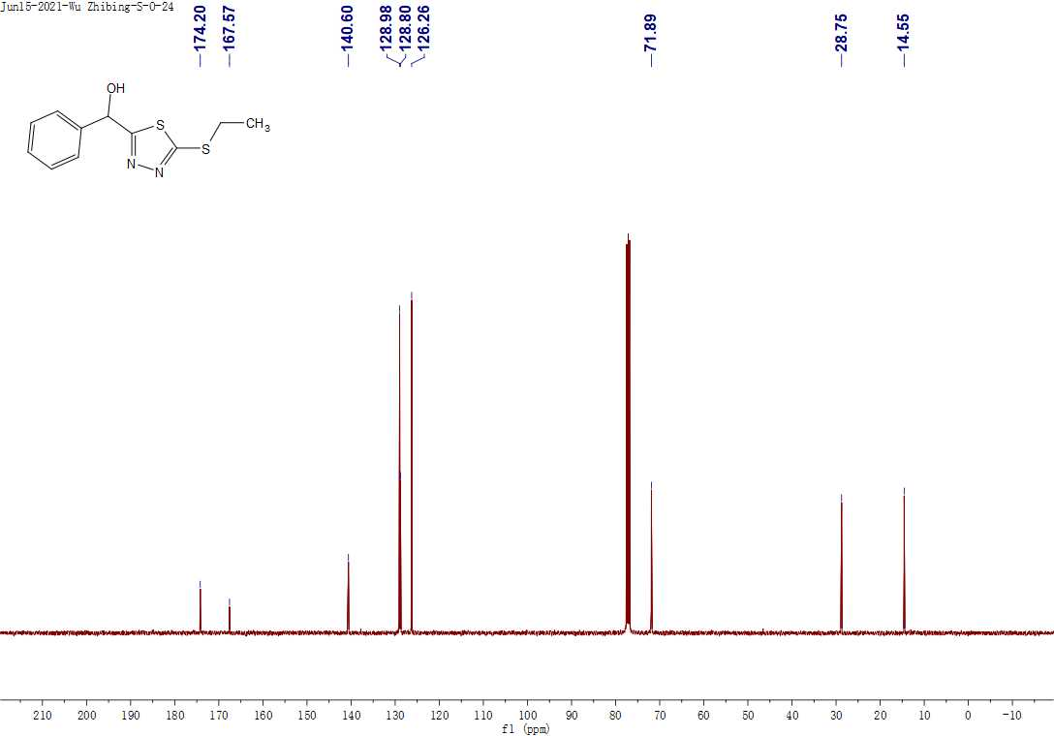 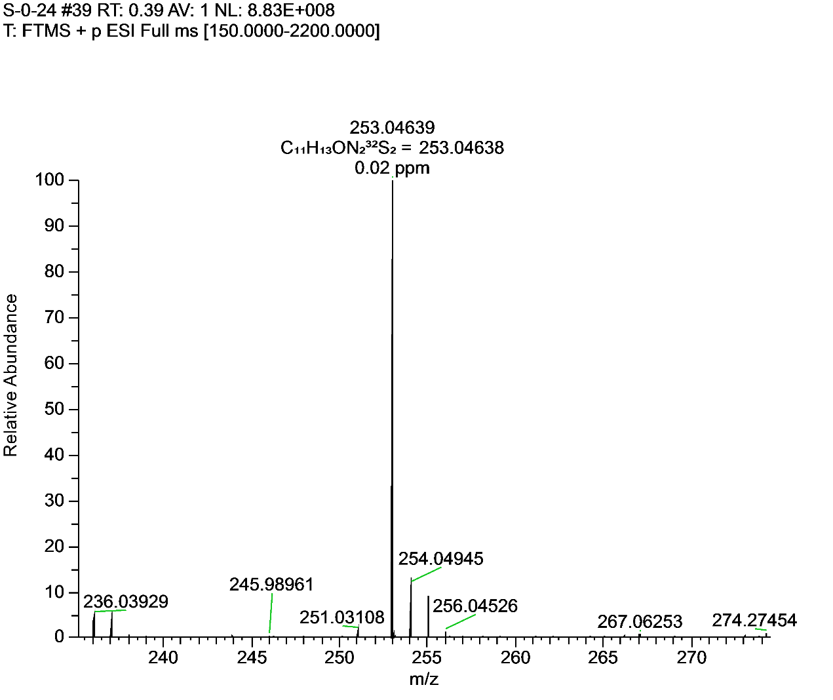**Figure S7.** 1H NMR, 13C NMR and HRMS for **F2**.

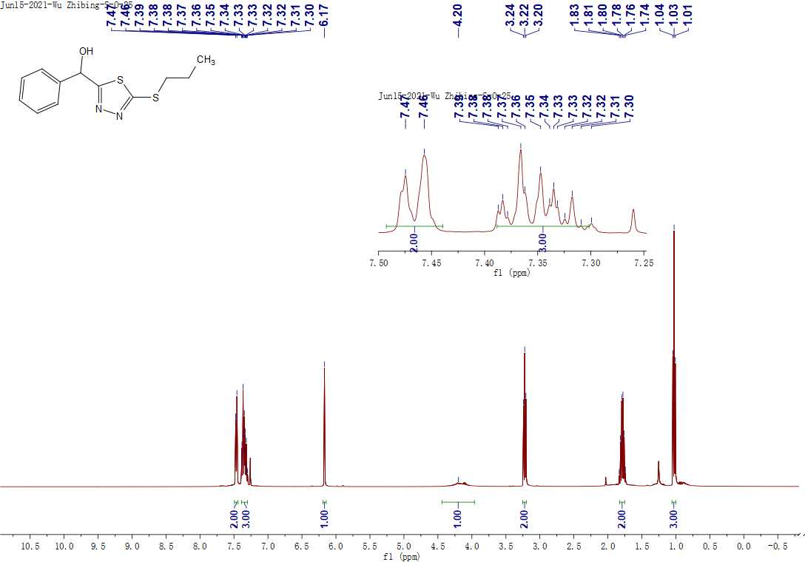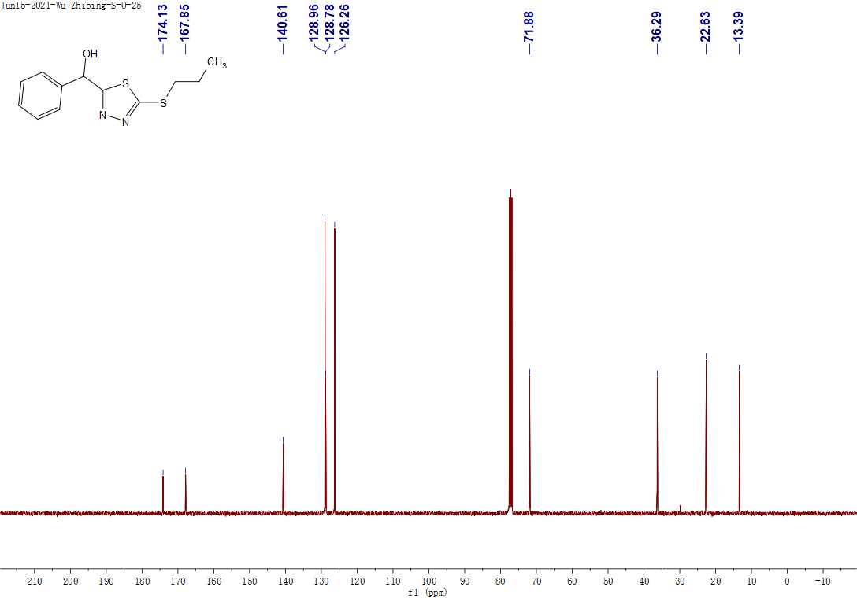 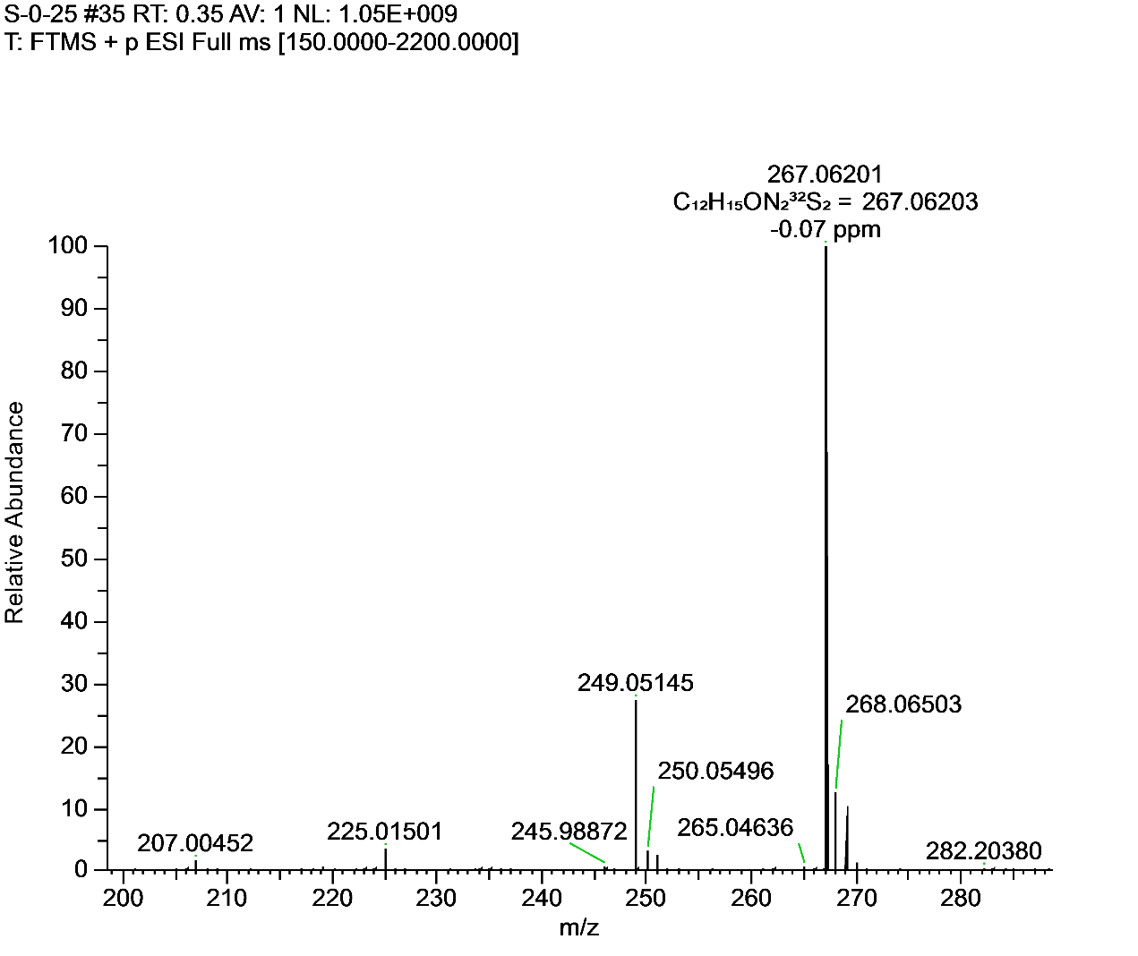**Figure S8.** 1H NMR, 13C NMR and HRMS for **F3**.

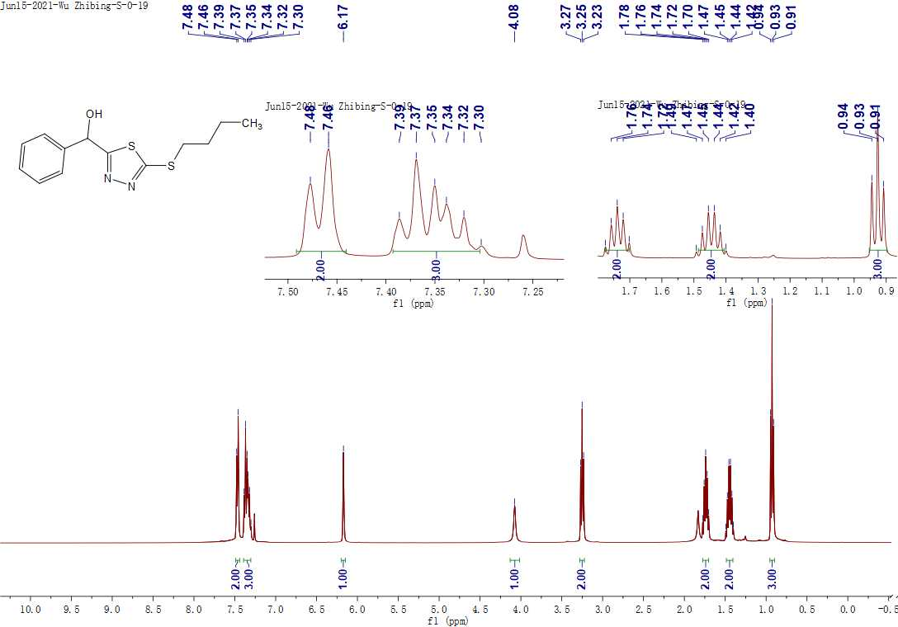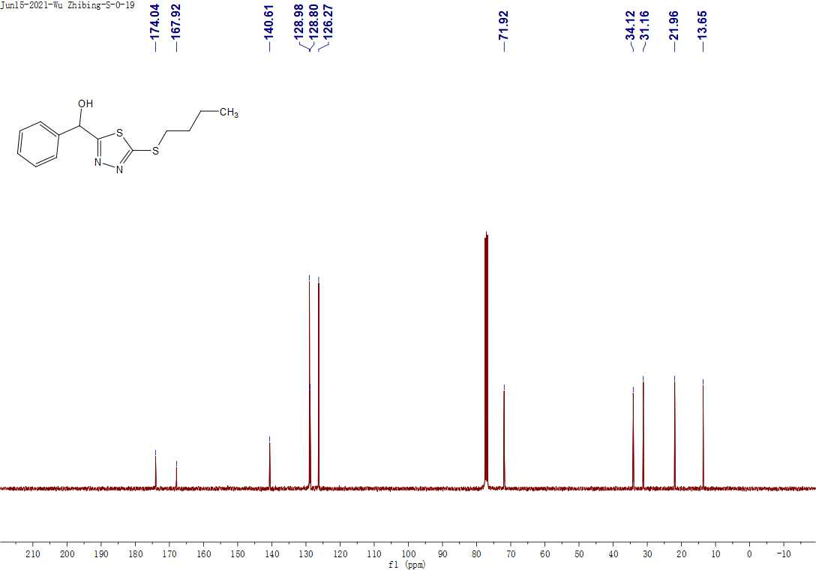 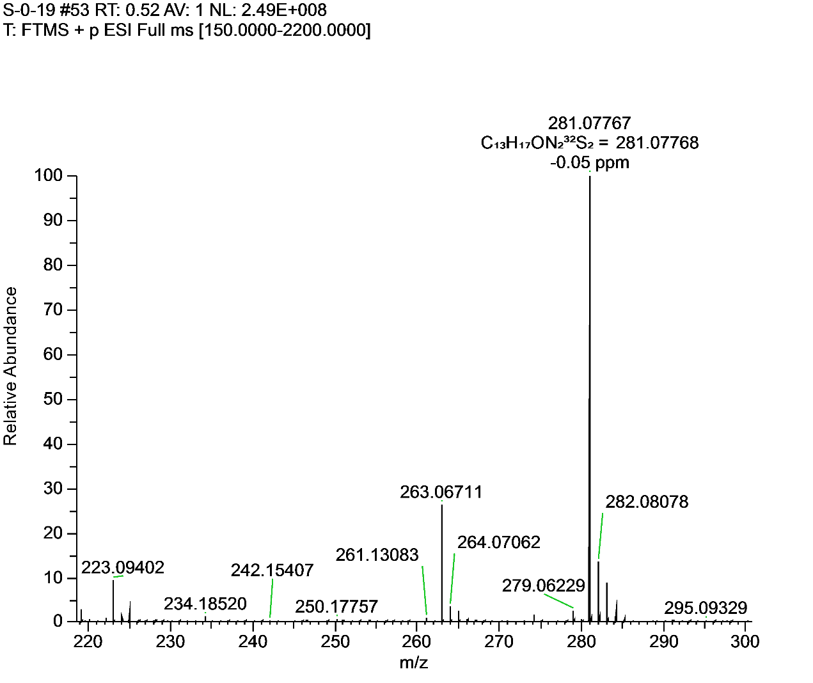**Figure S9.** 1H NMR, 13C NMR and HRMS for **F4**.

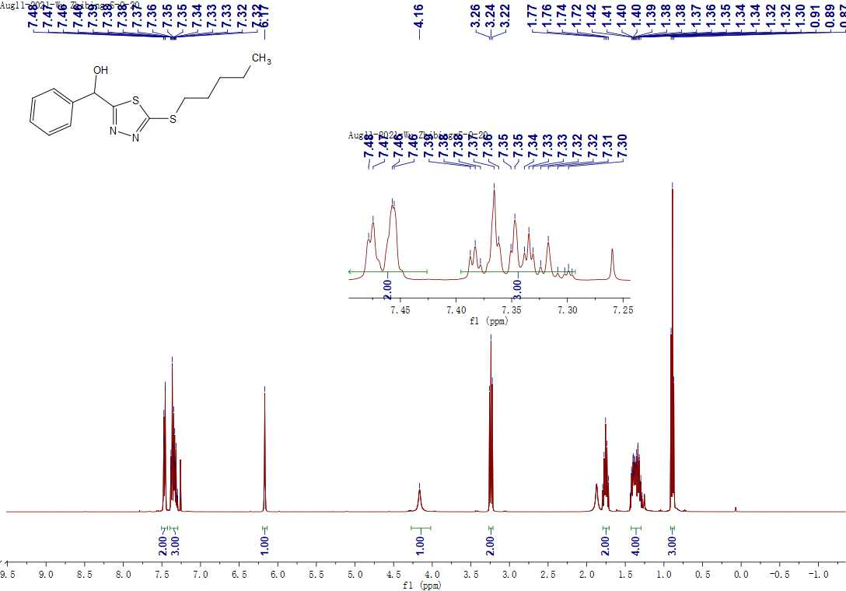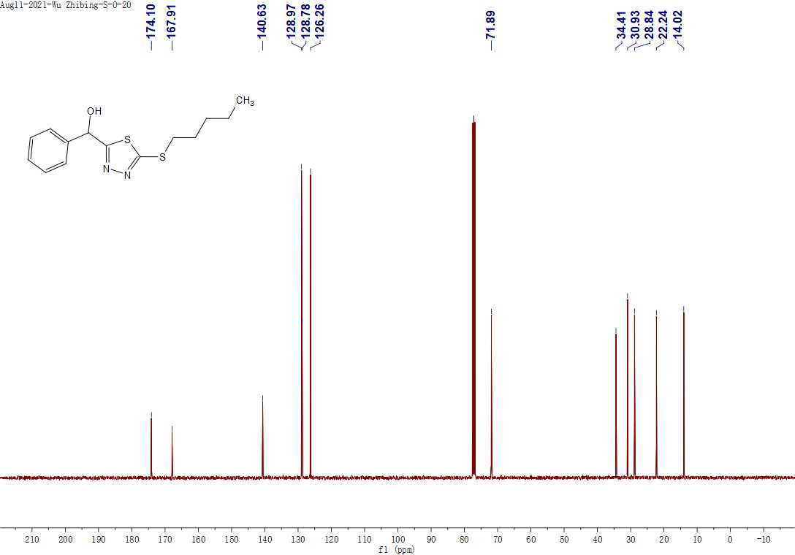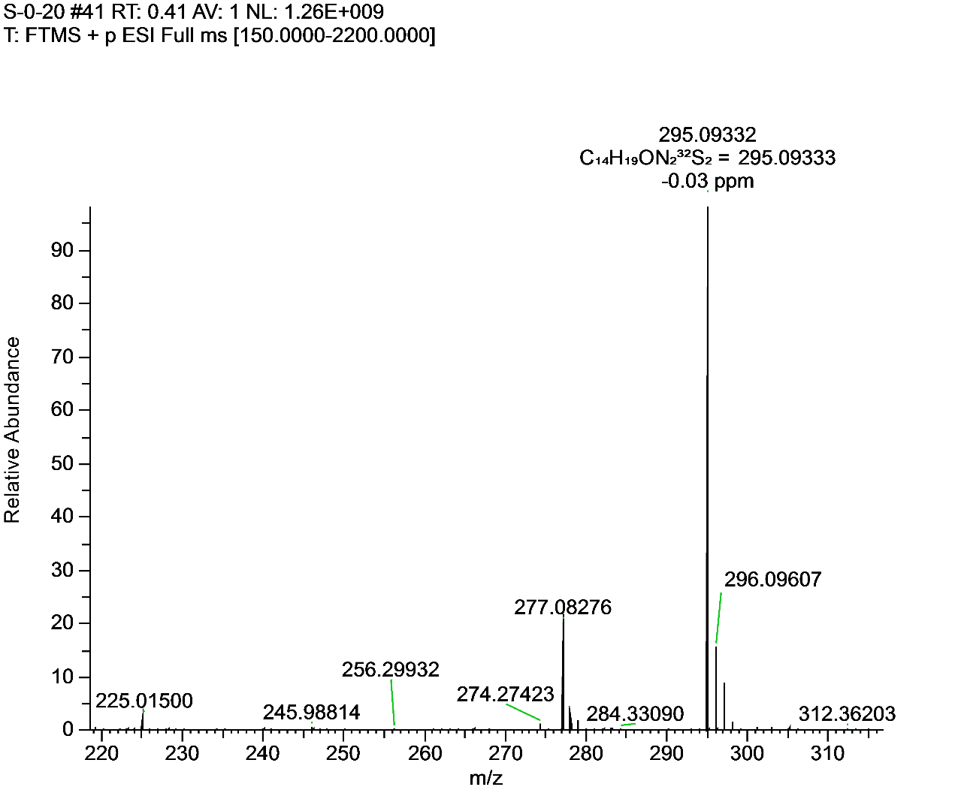**Figure S10.** 1H NMR, 13C NMR and HRMS for **F5**.

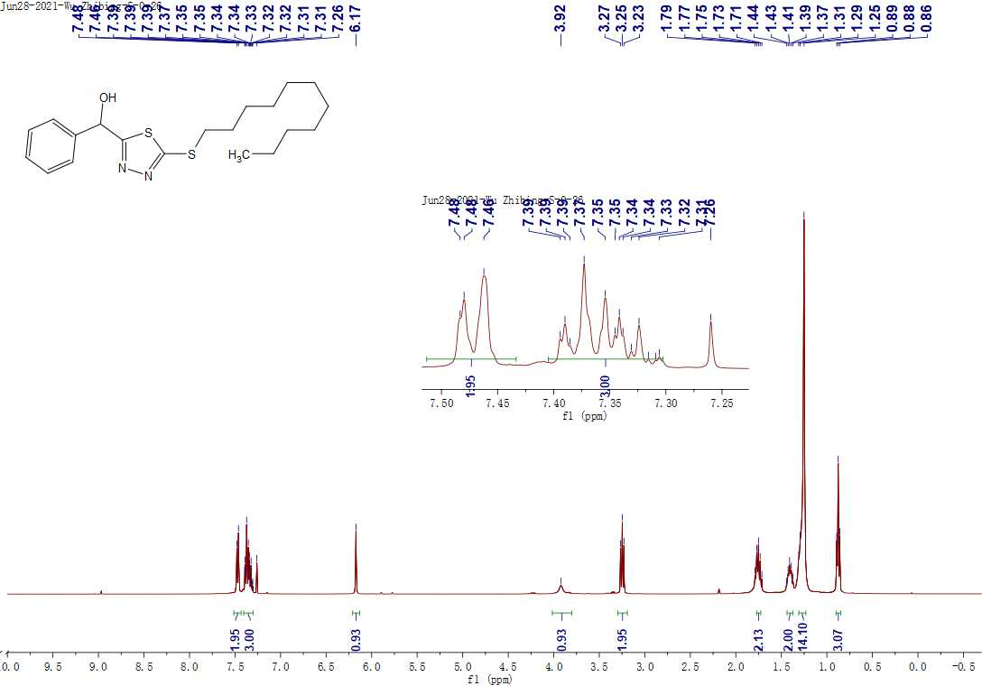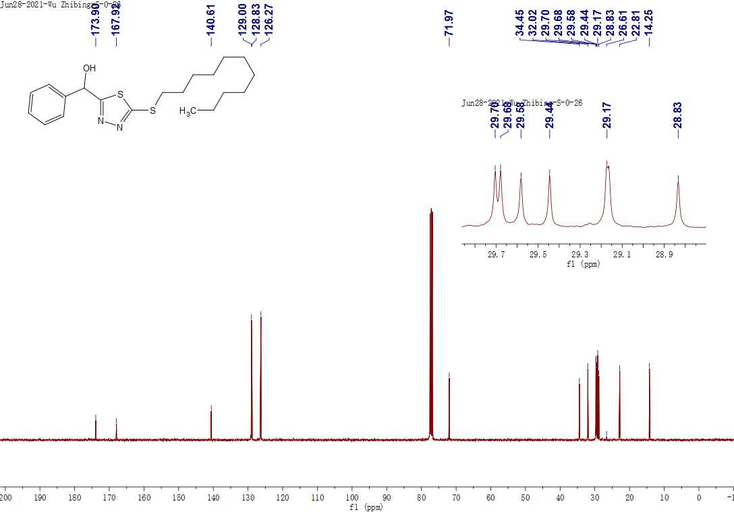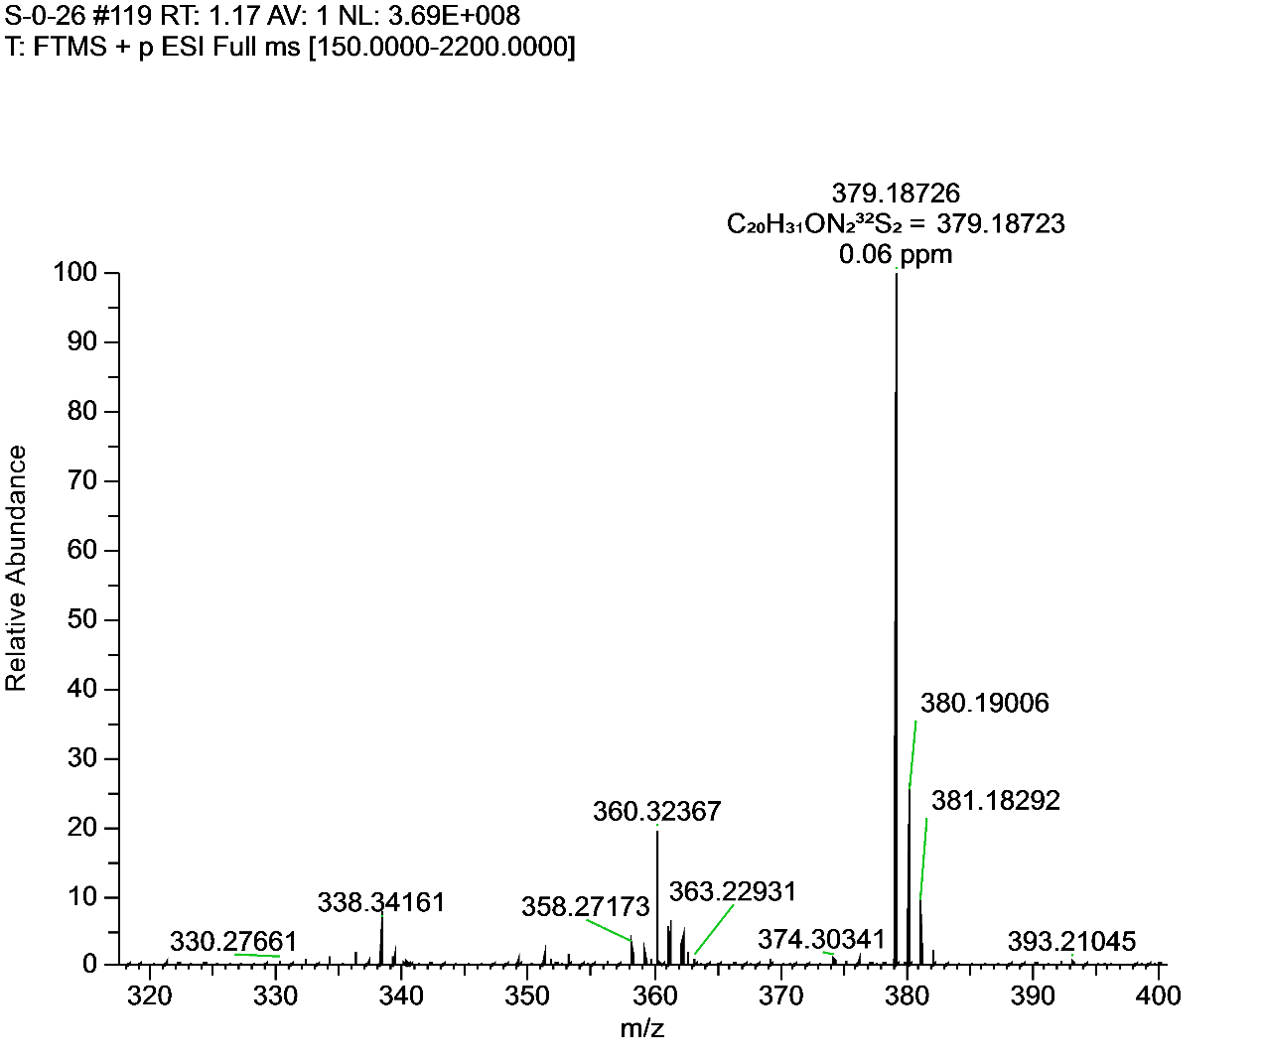**Figure S11.** 1H NMR, 13C NMR and HRMS for **F6**.

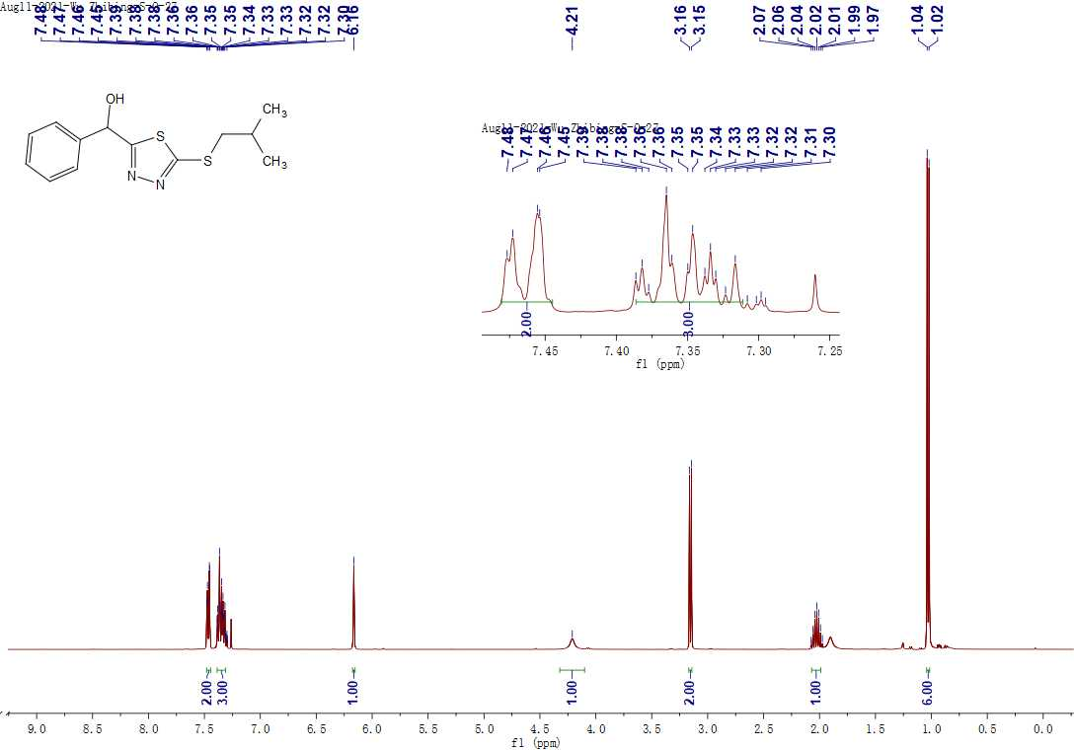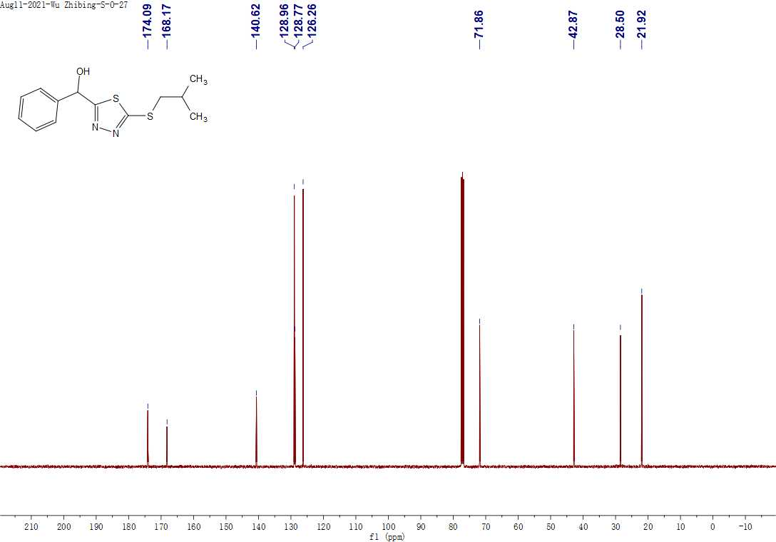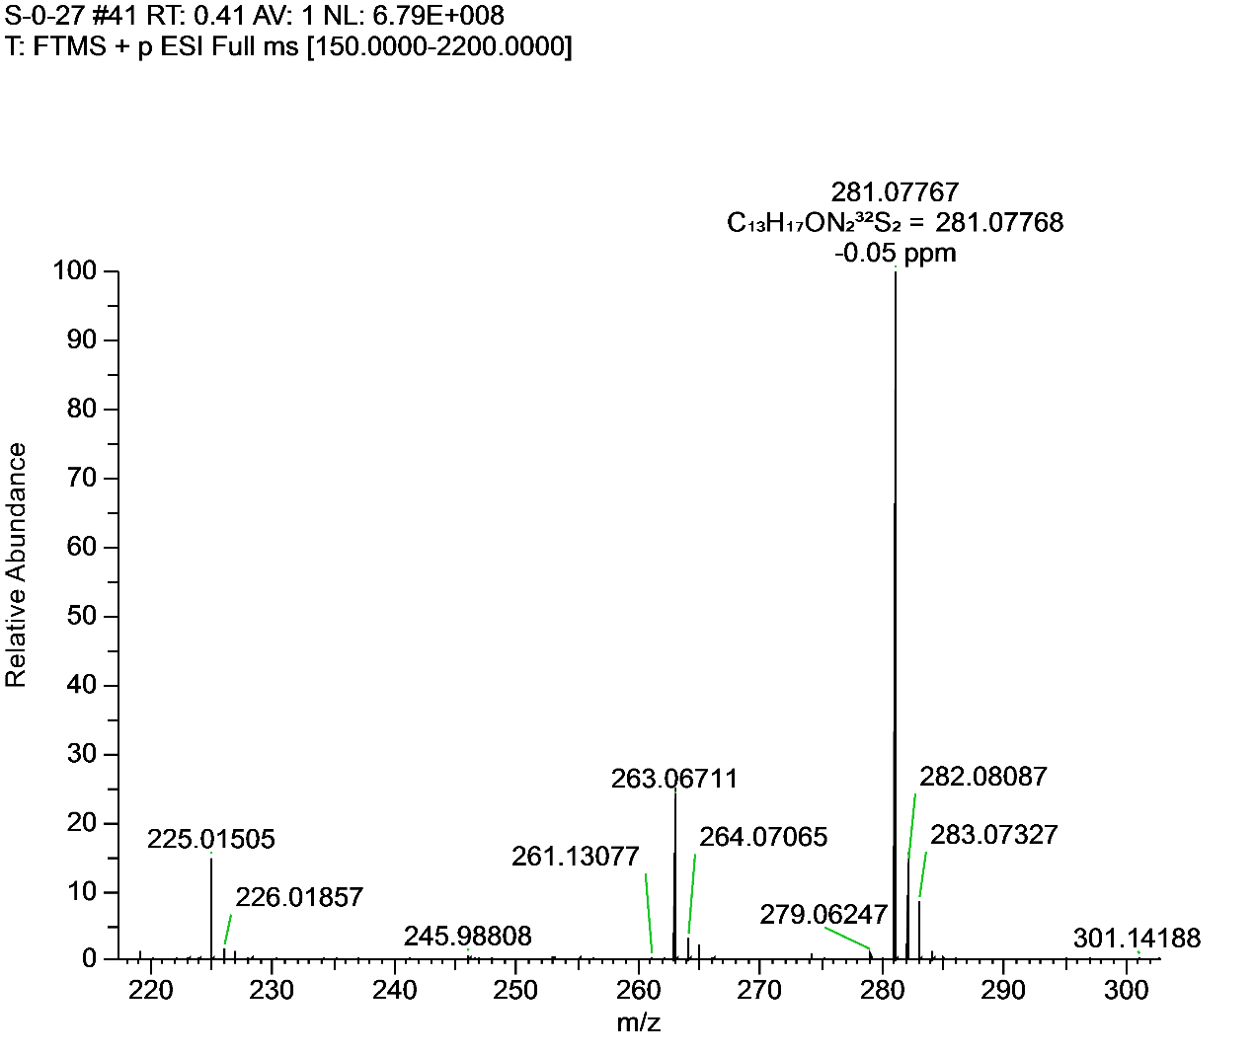**Figure S12.** 1H NMR, 13C NMR and HRMS for **F7**

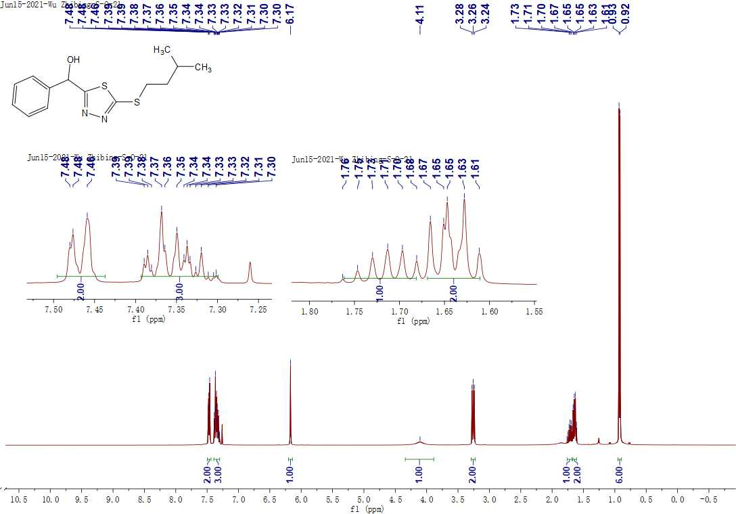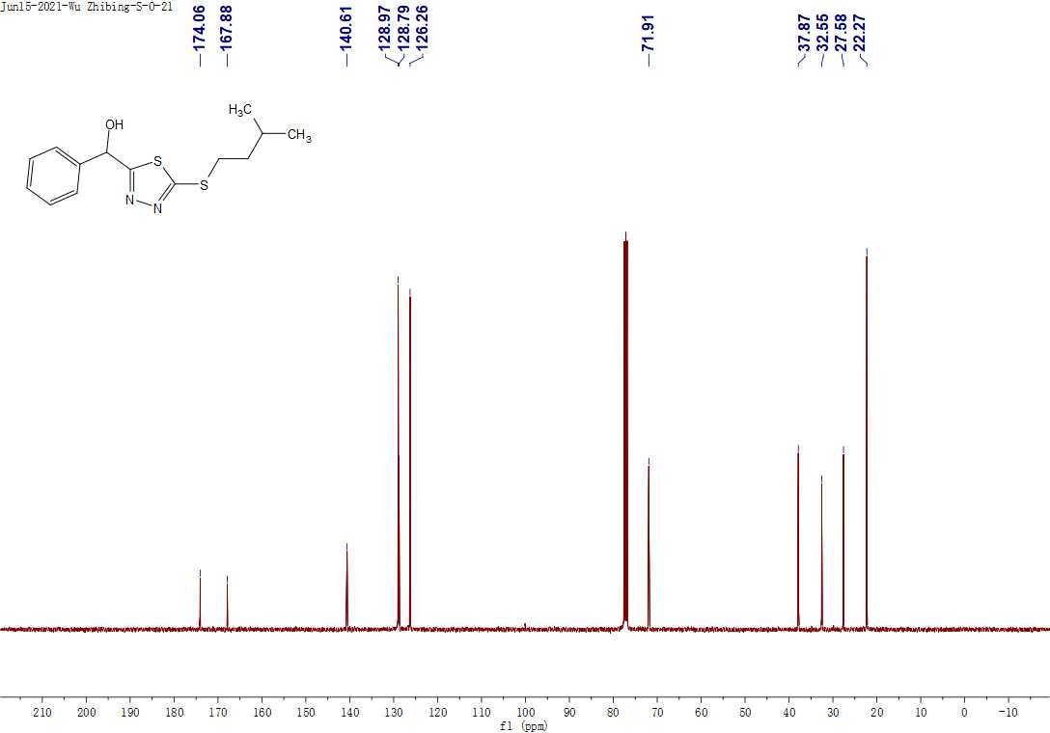 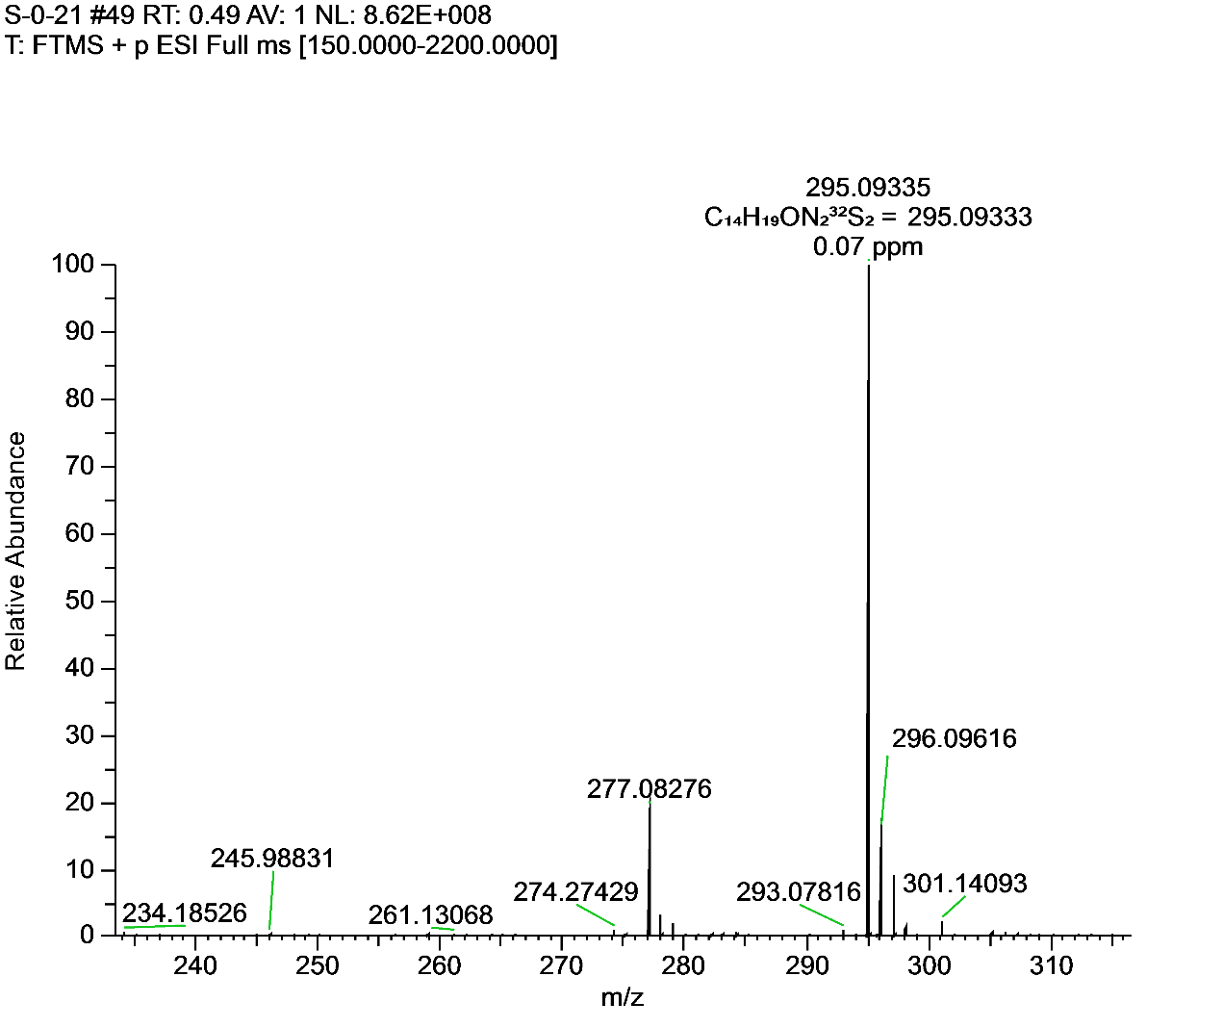**Figure S13.** 1H NMR, 13C NMR and HRMS for **F8**

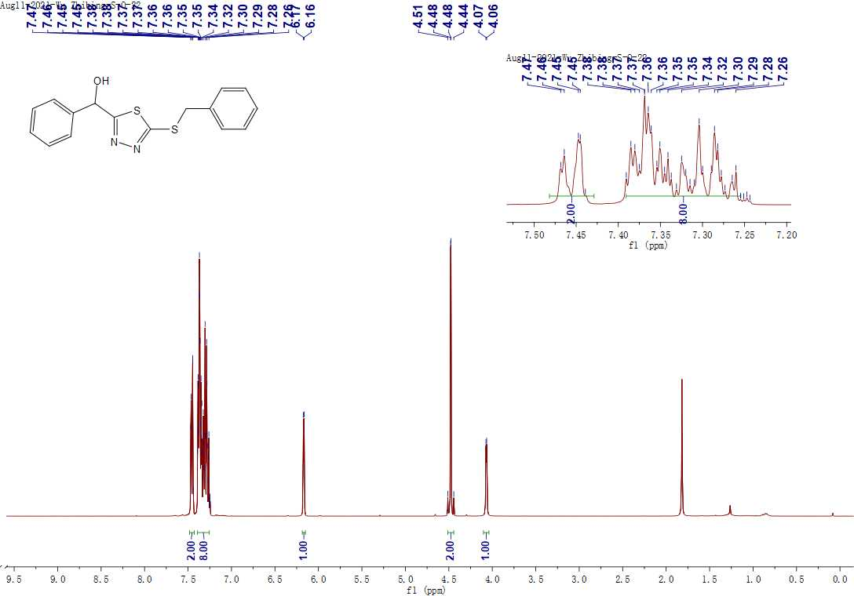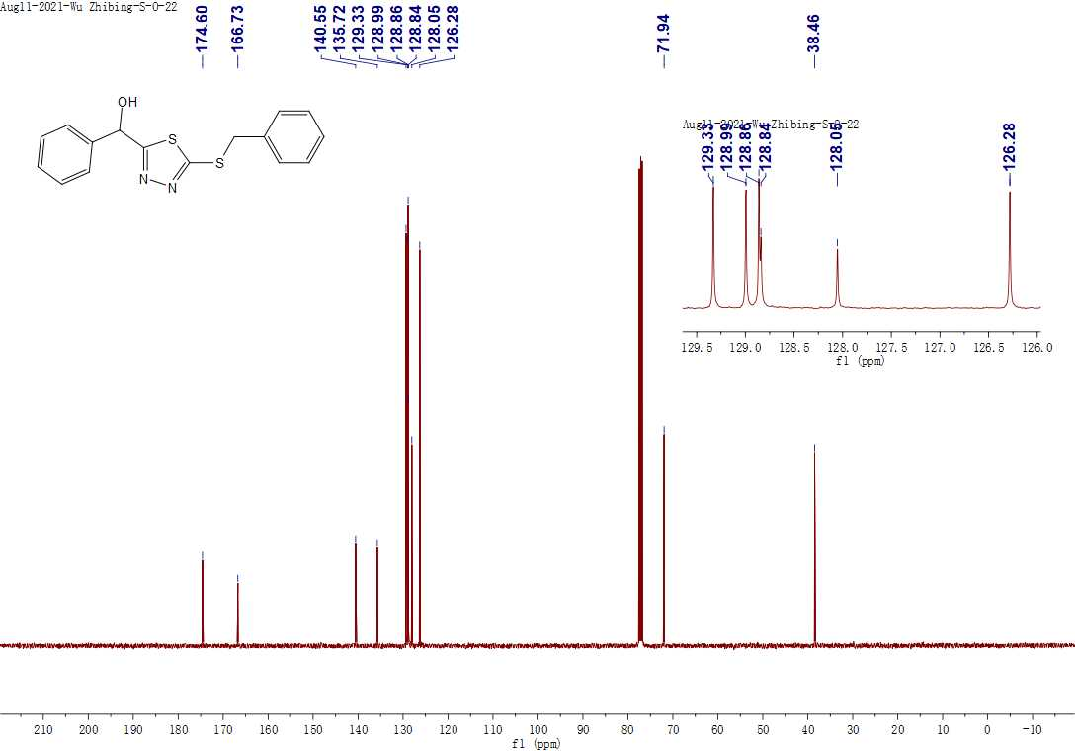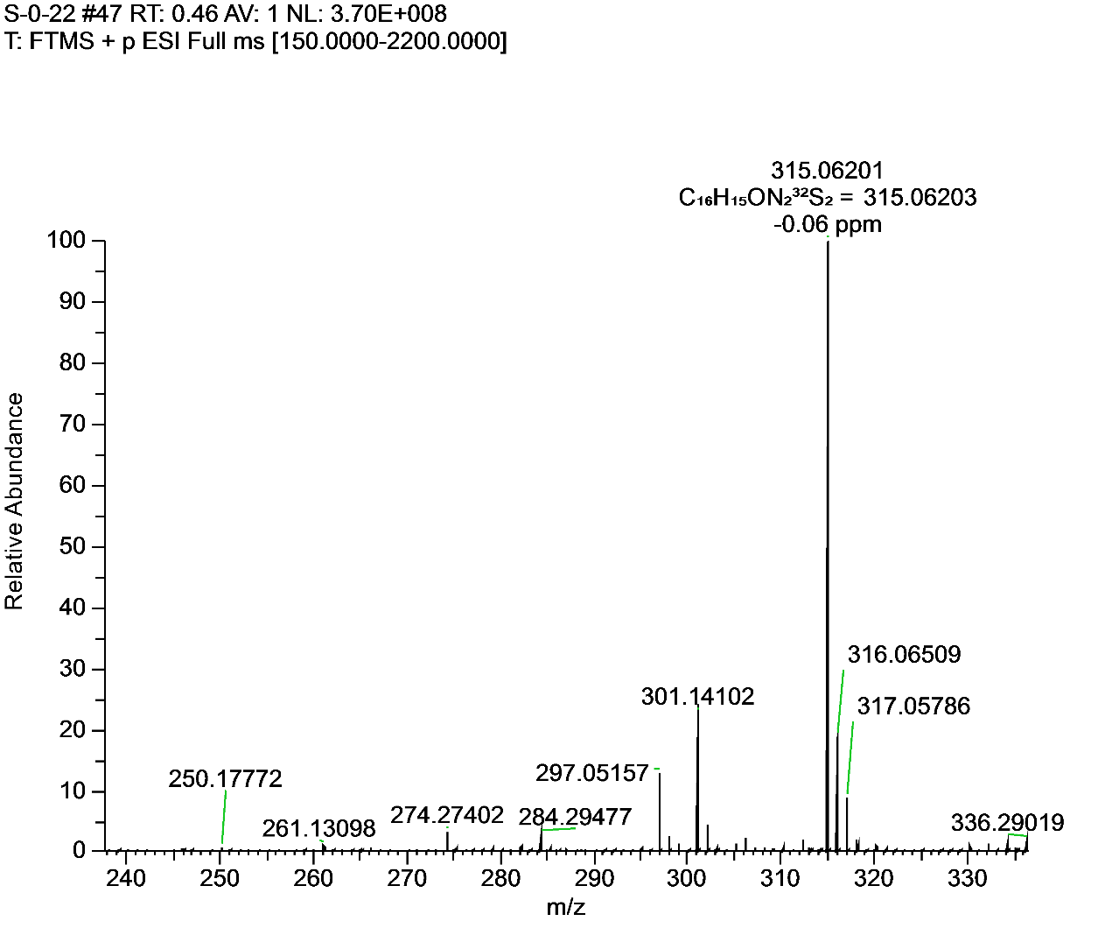**Figure S14.** 1H NMR, 13C NMR and HRMS for **F9**.

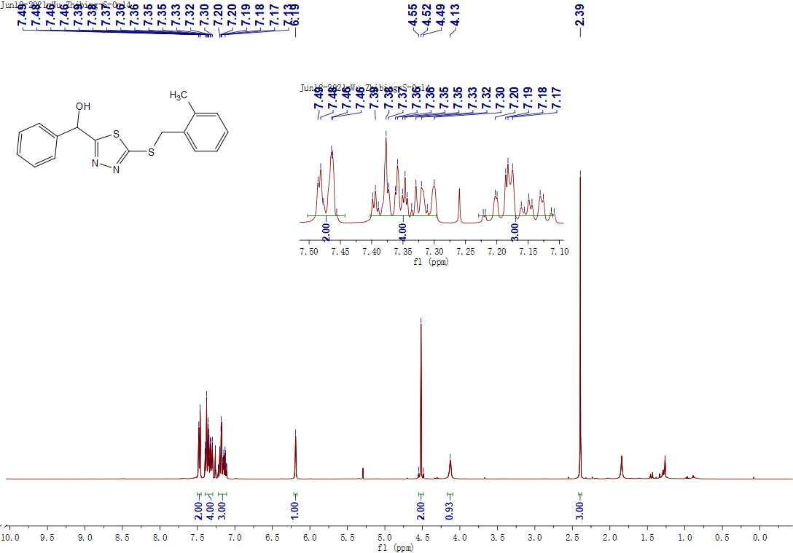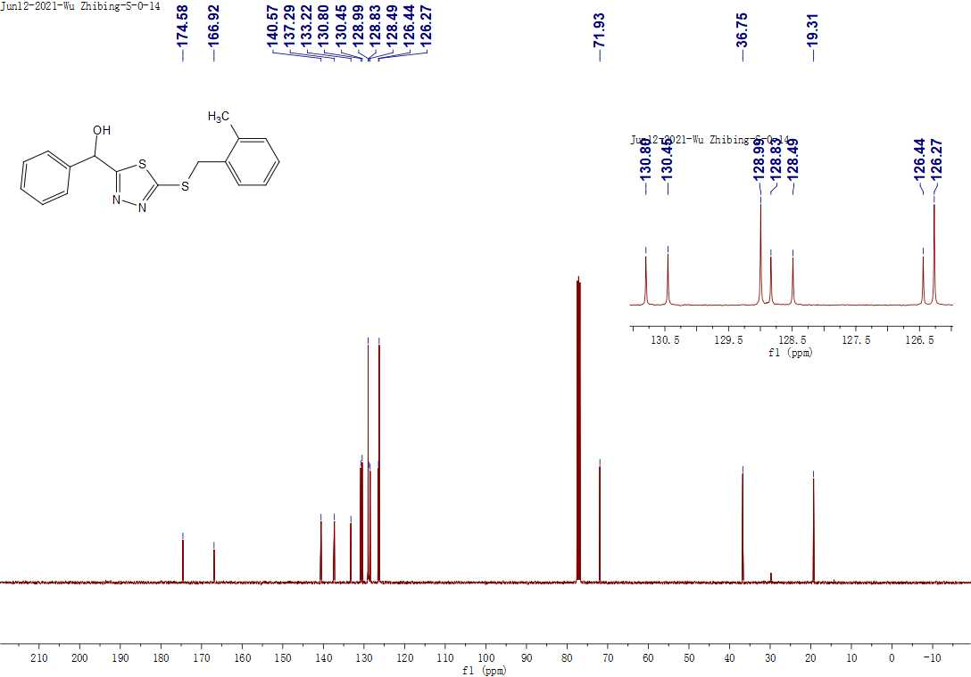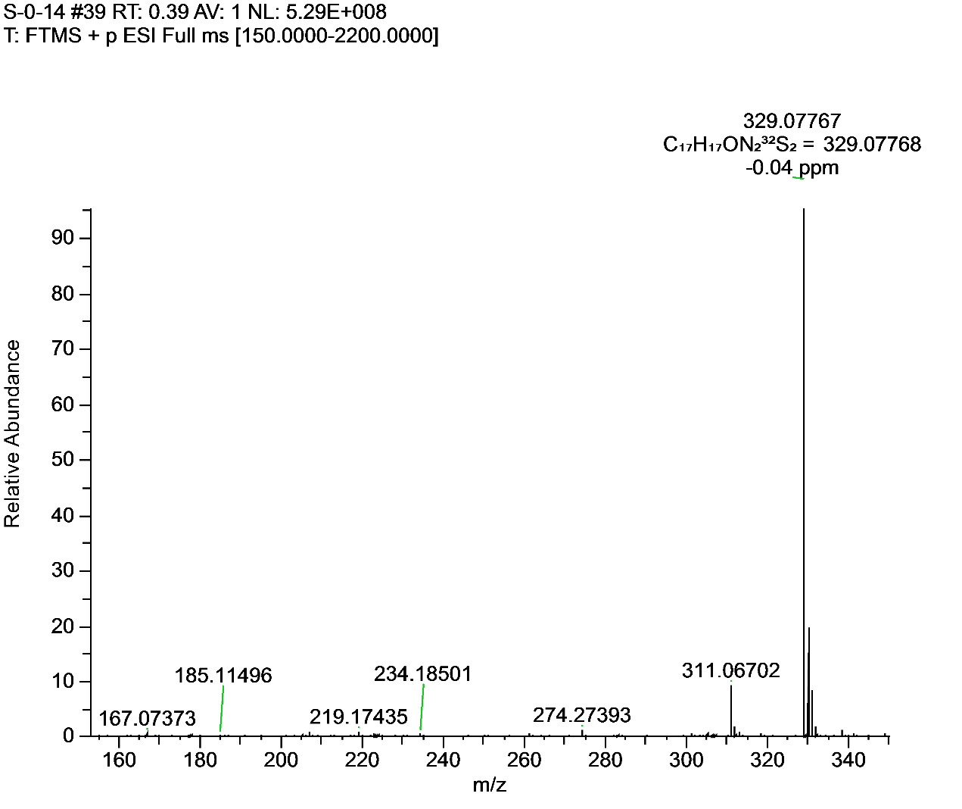**Figure S15.** 1H NMR, 13C NMR and HRMS for **F10**.

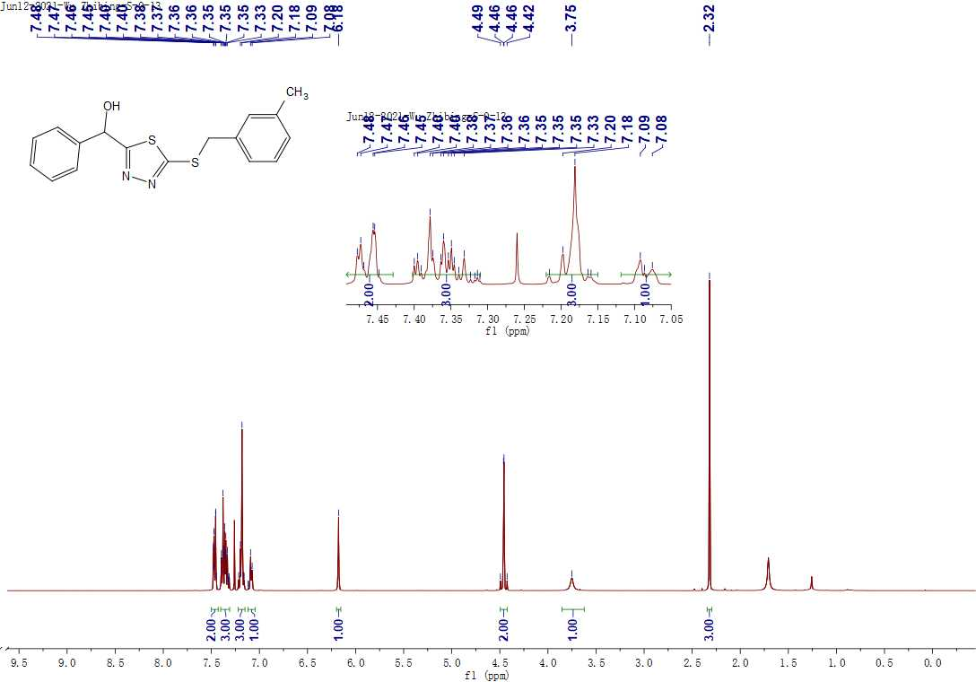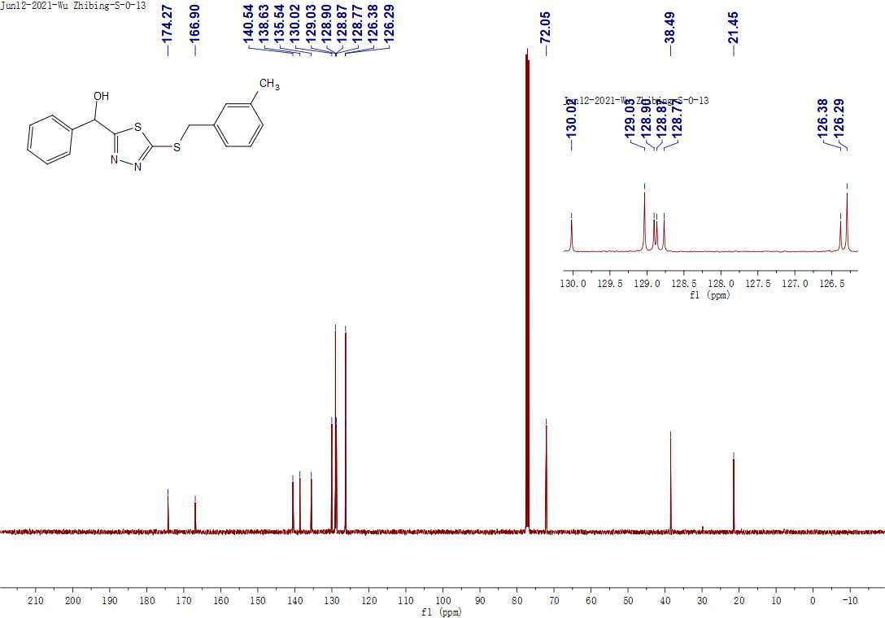 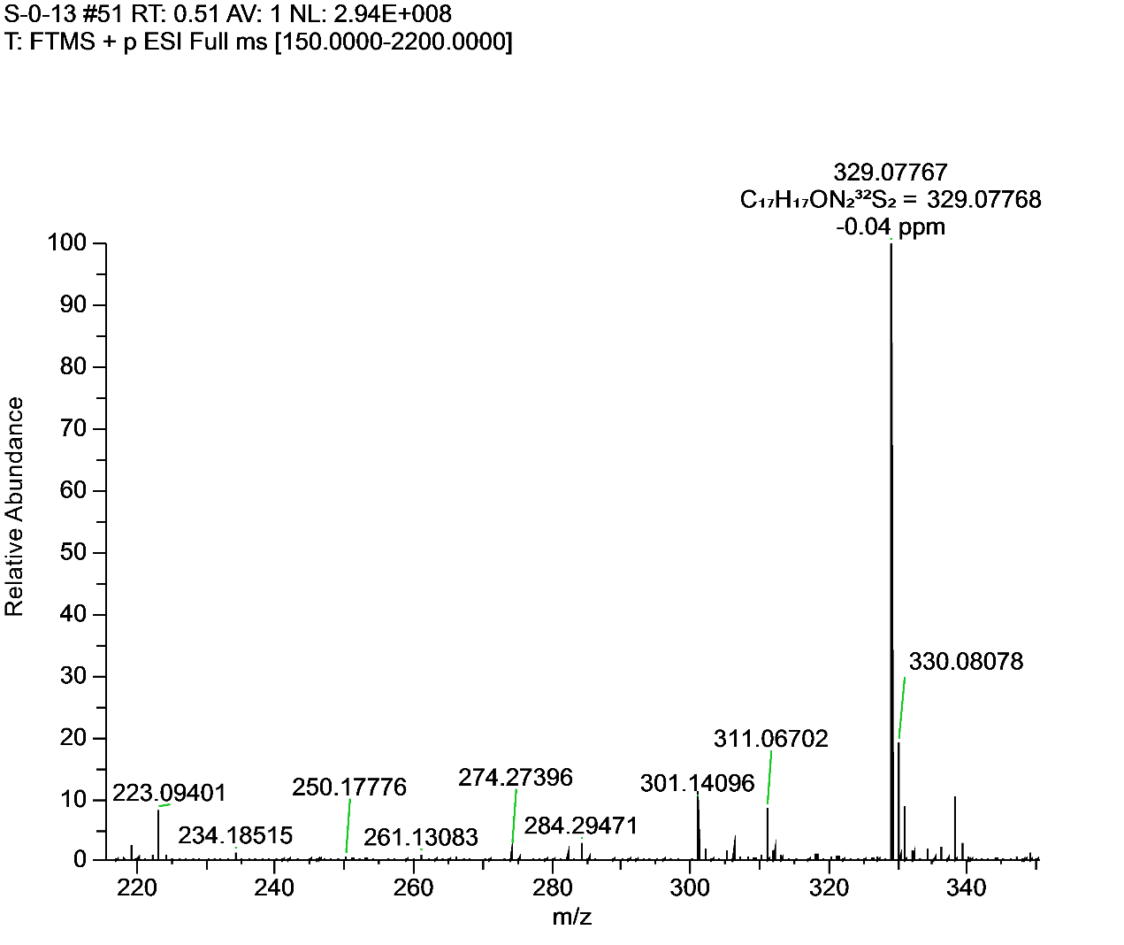**Figure S16.** 1H NMR, 13C NMR and HRMS for **F11**.

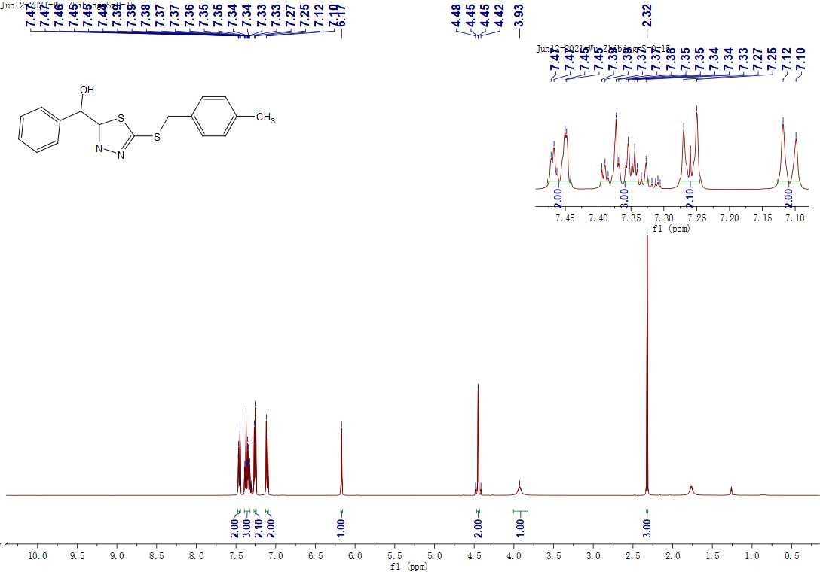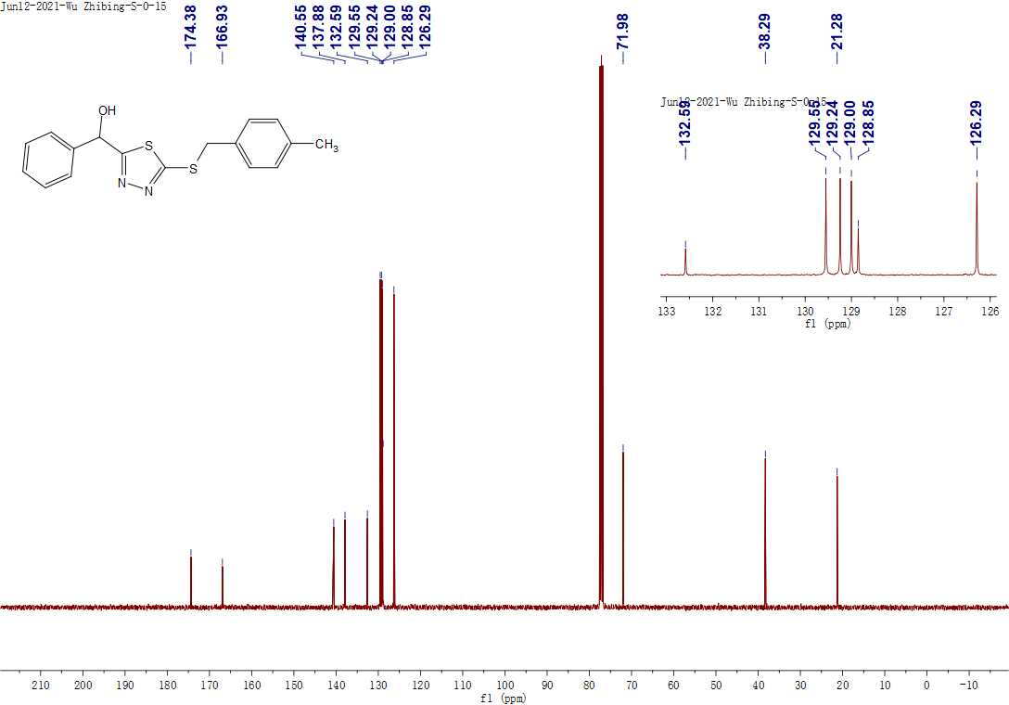 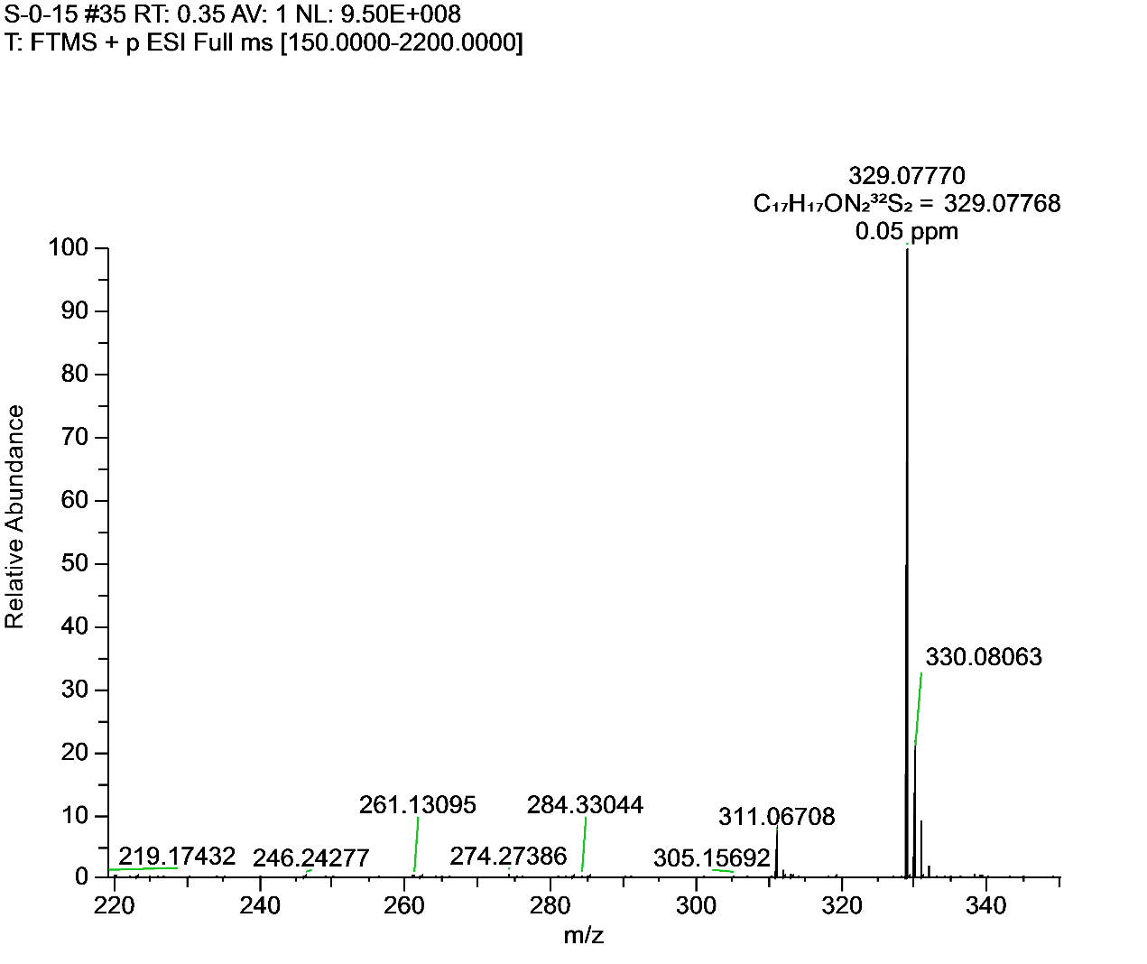**Figure S17.** 1H NMR, 13C NMR and HRMS for **F12**.

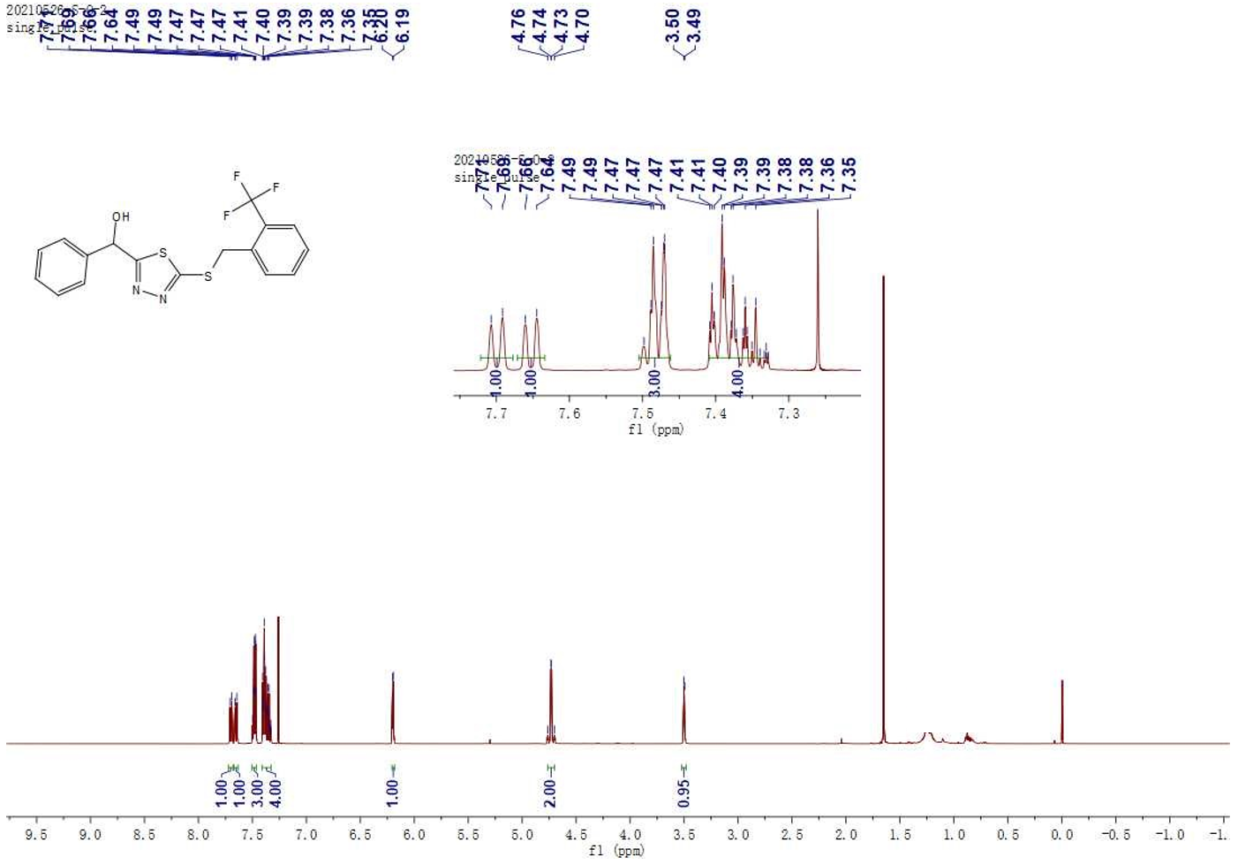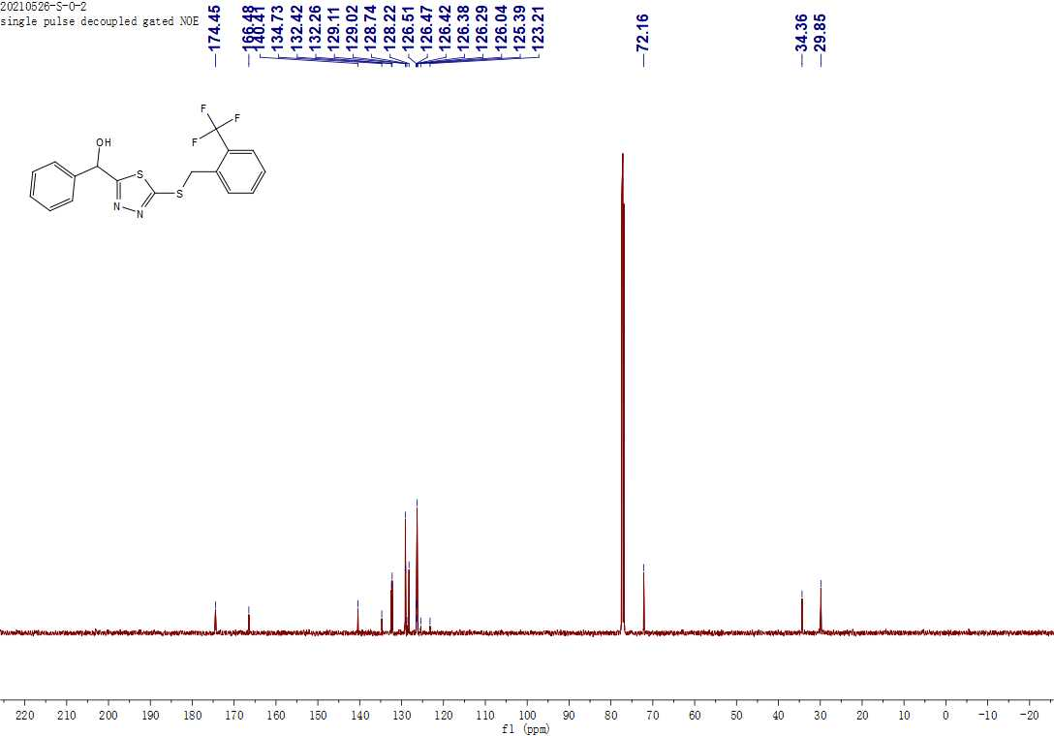 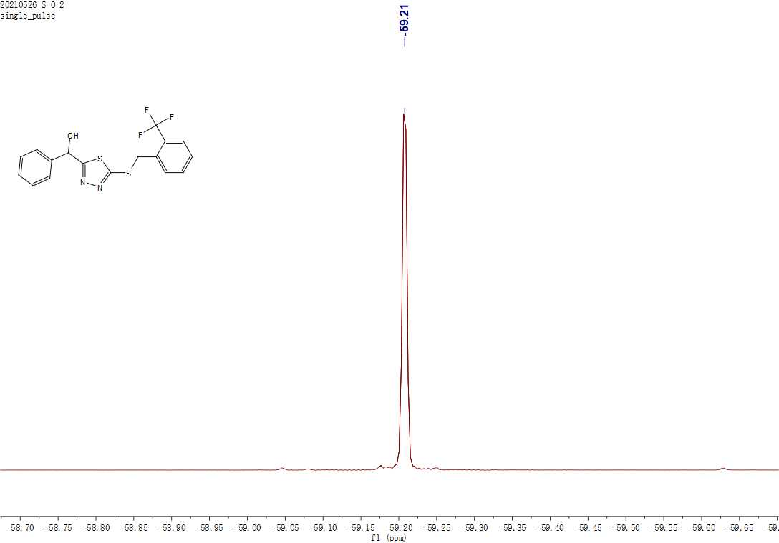 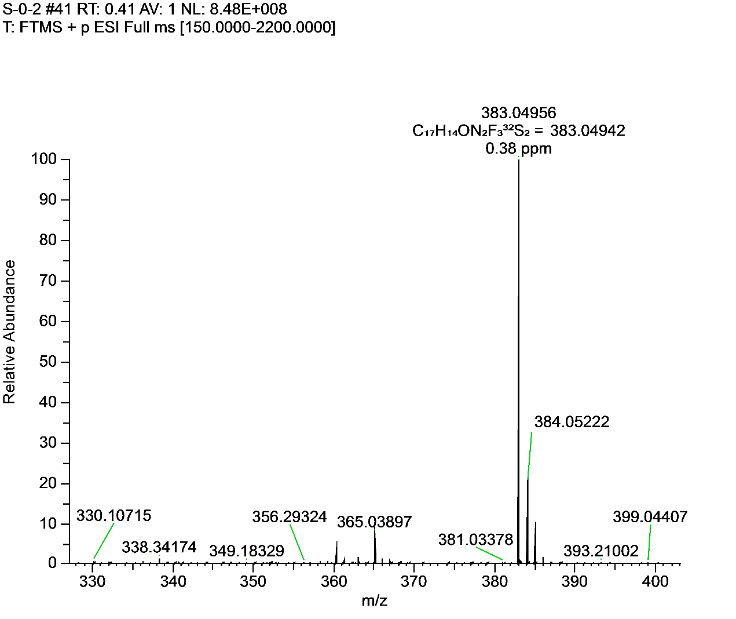**Figure S18.** 1H NMR, 13C NMR, 19FNMR and HRMS for **F13**.

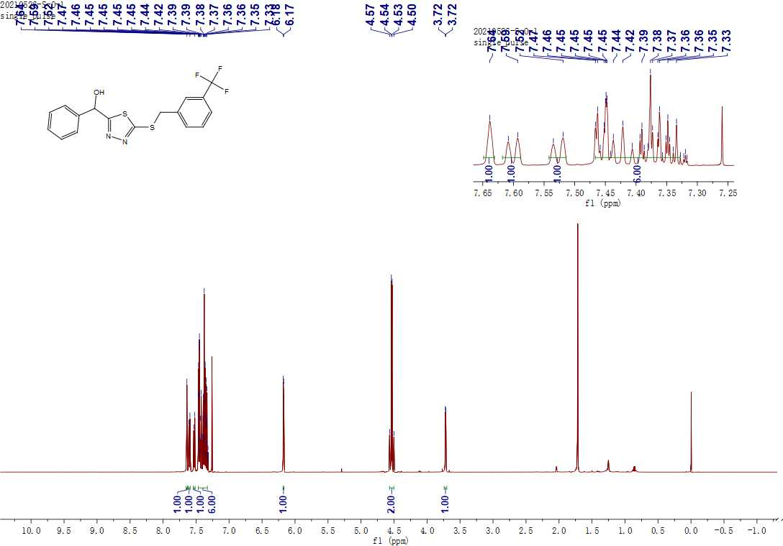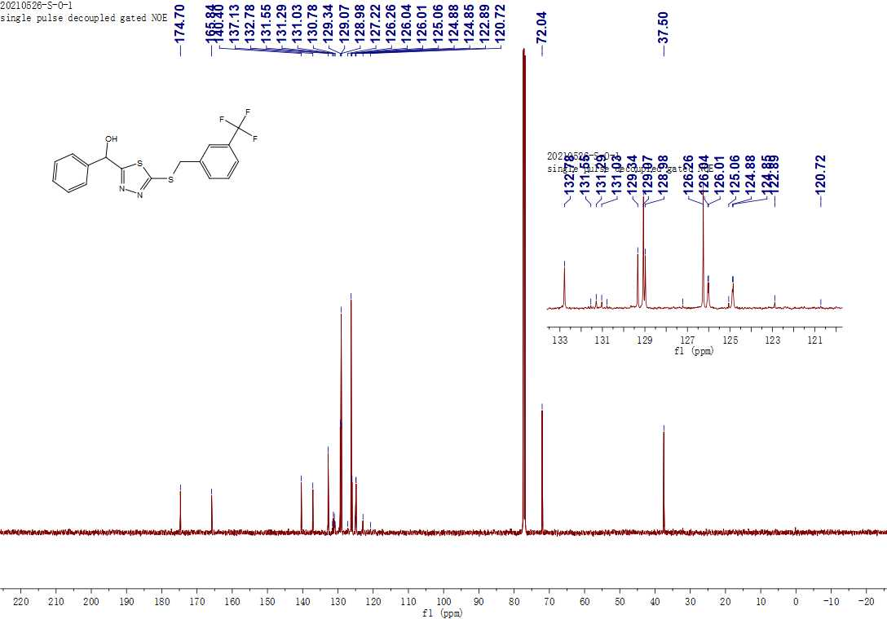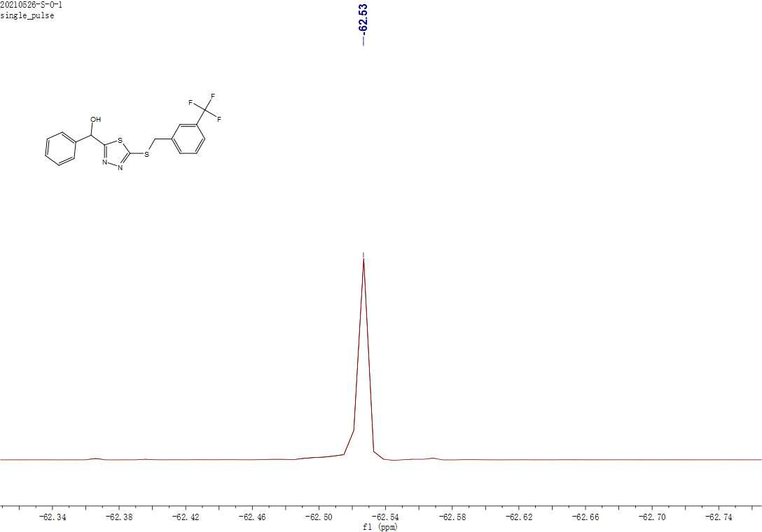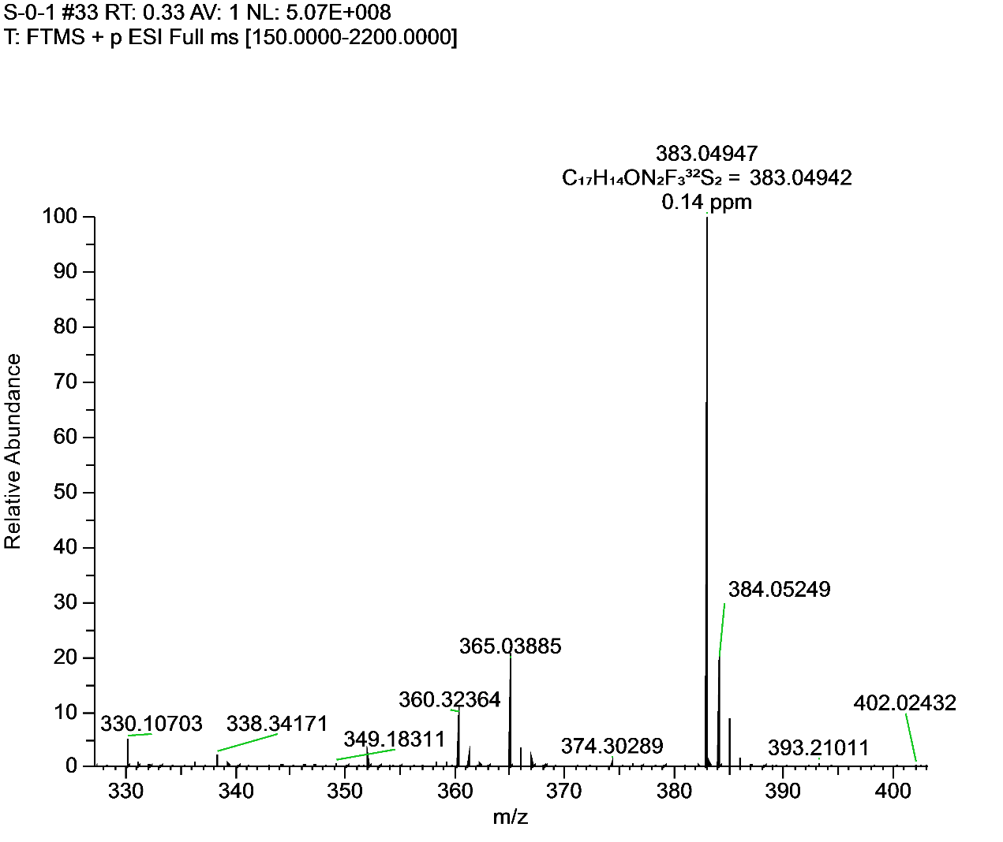**Figure S19.** 1H NMR, 13C NMR, 19FNMR and HRMS for **F14**.

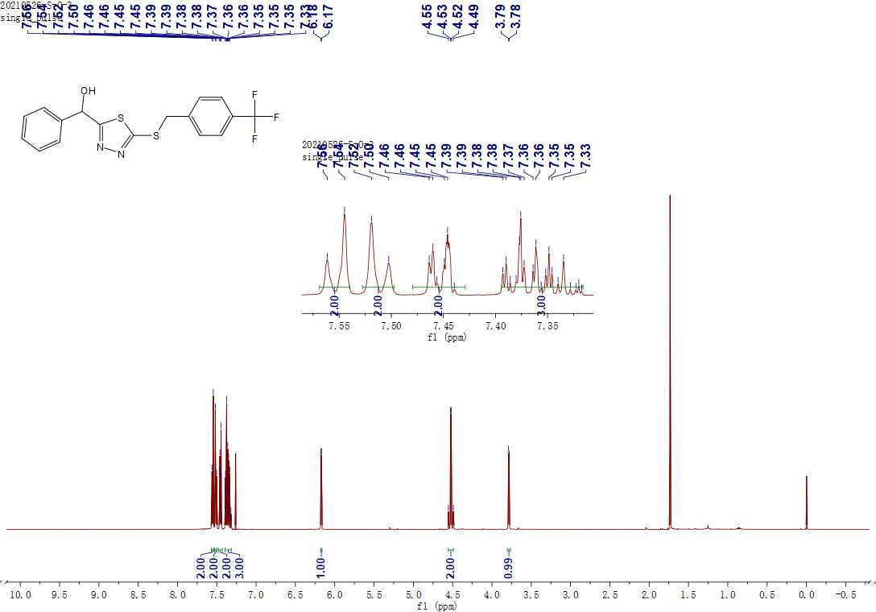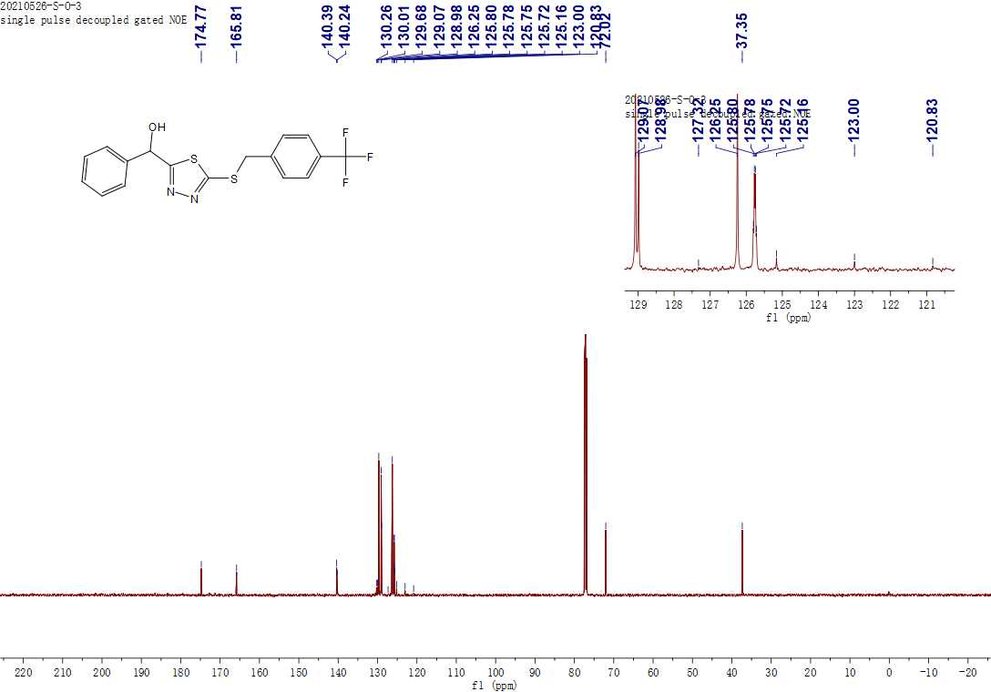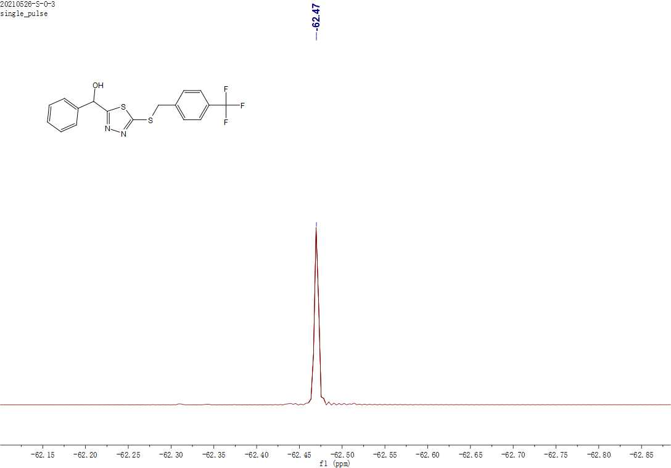**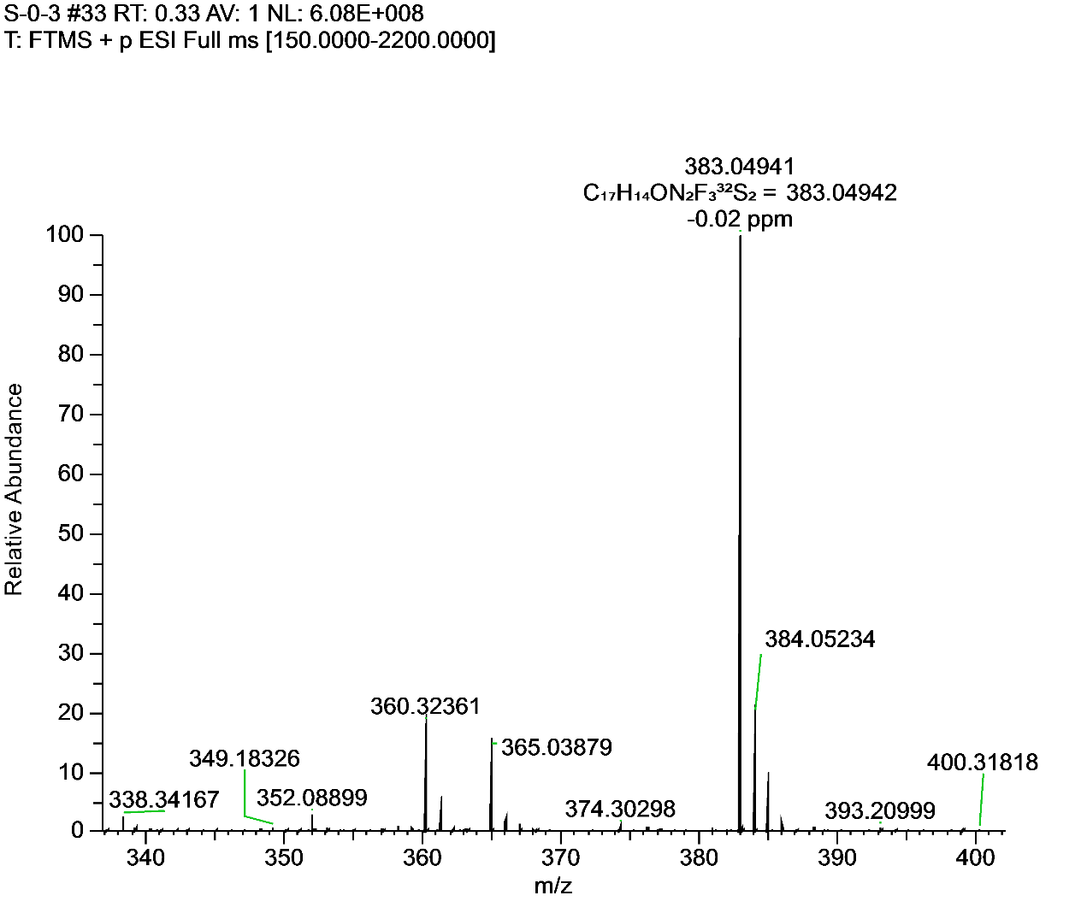Figure S20.** 1H NMR, 13C NMR, 19FNMR and HRMS for **F15**.

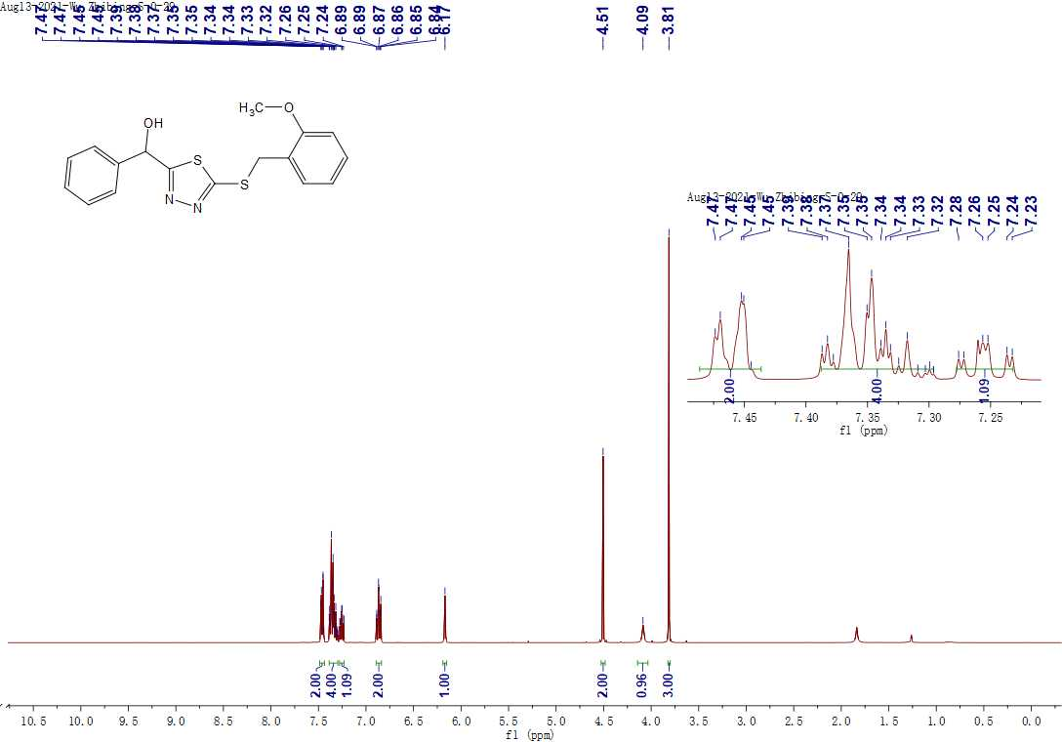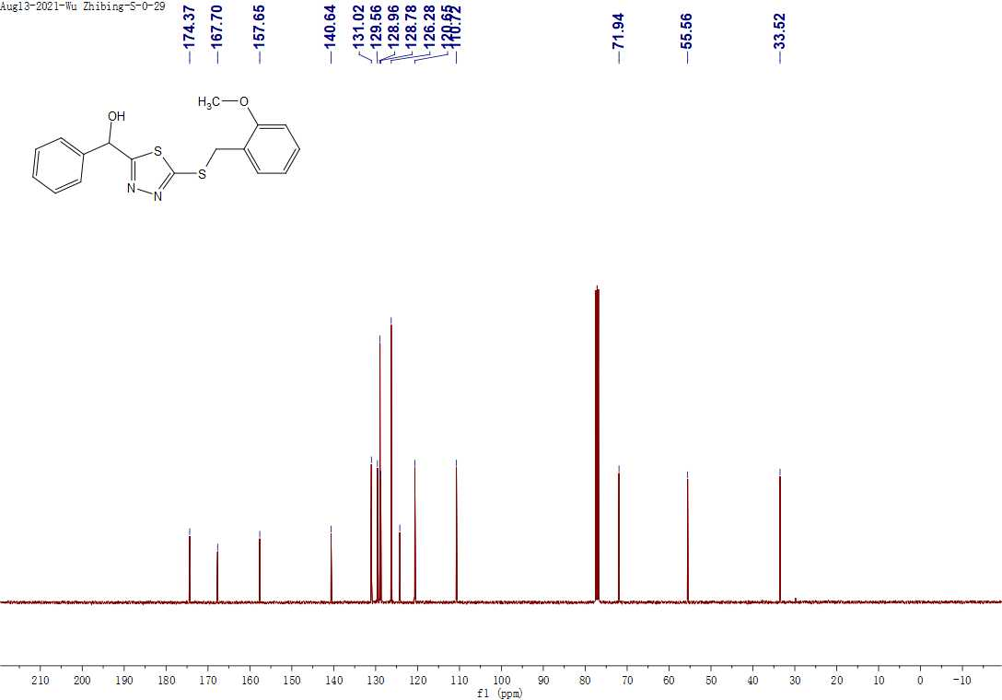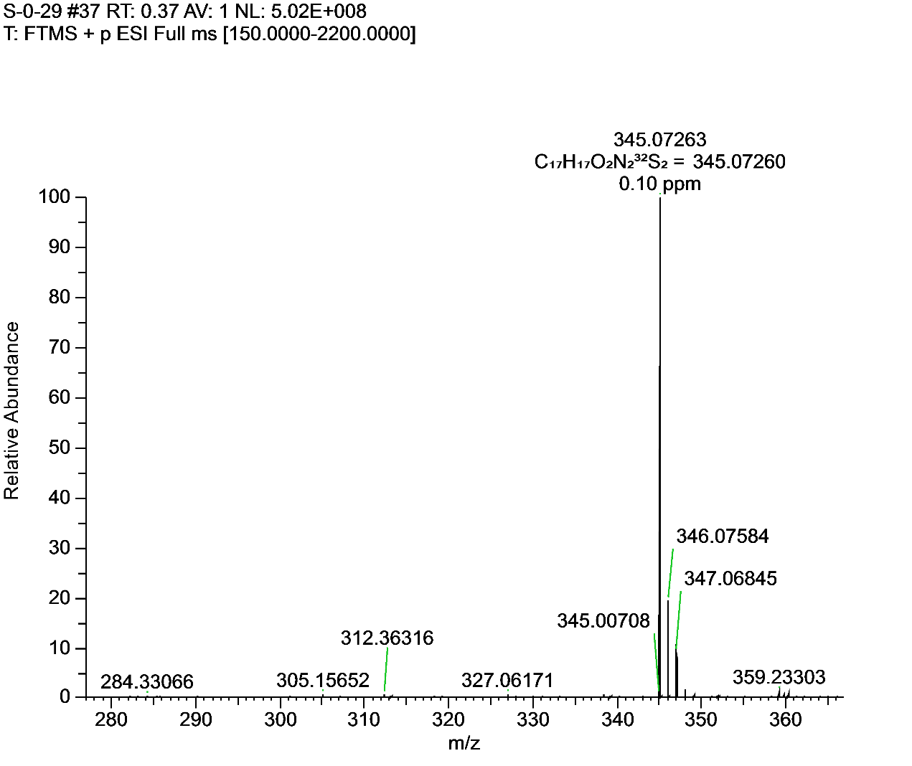

**Figure S21.** 1H NMR, 13C NMR and HRMS for **F16**.

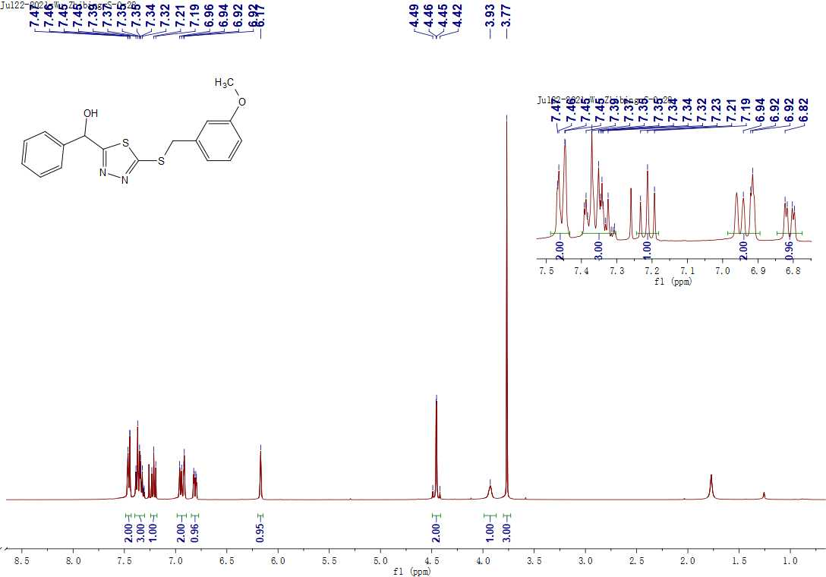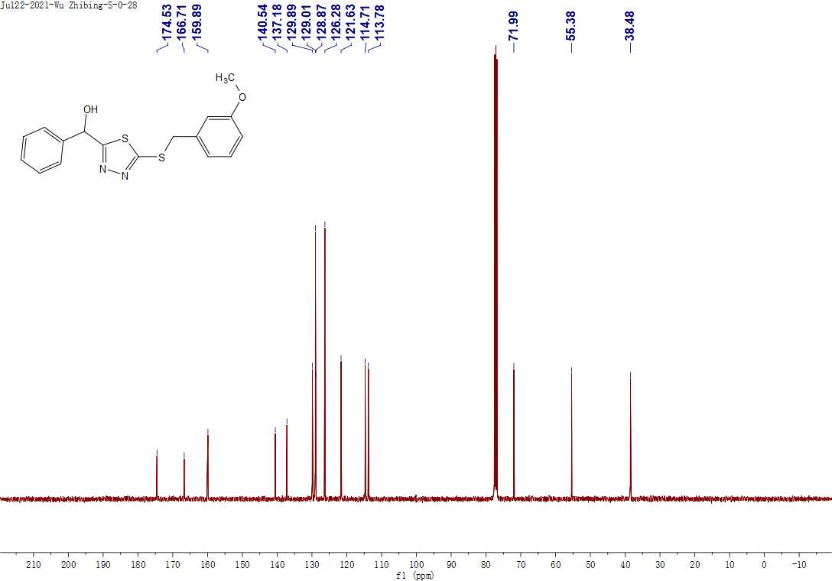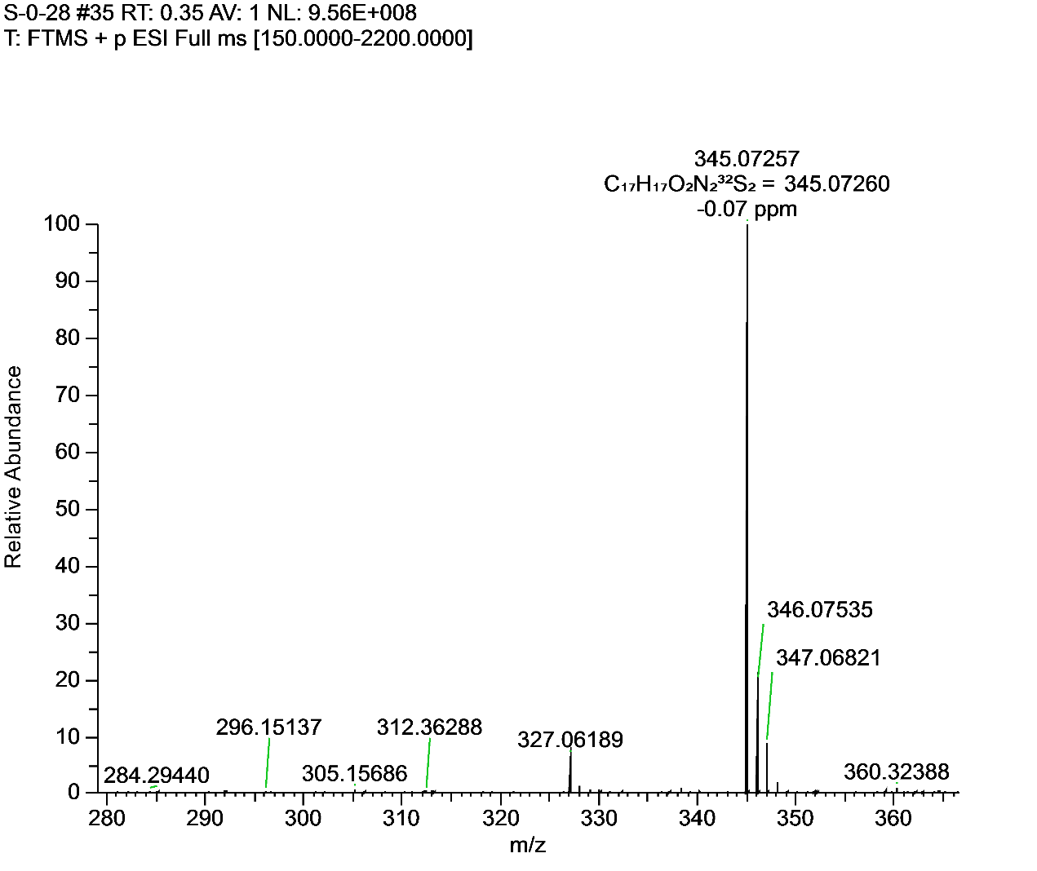

**Figure S22.** 1H NMR, 13C NMR and HRMS for **F17**.

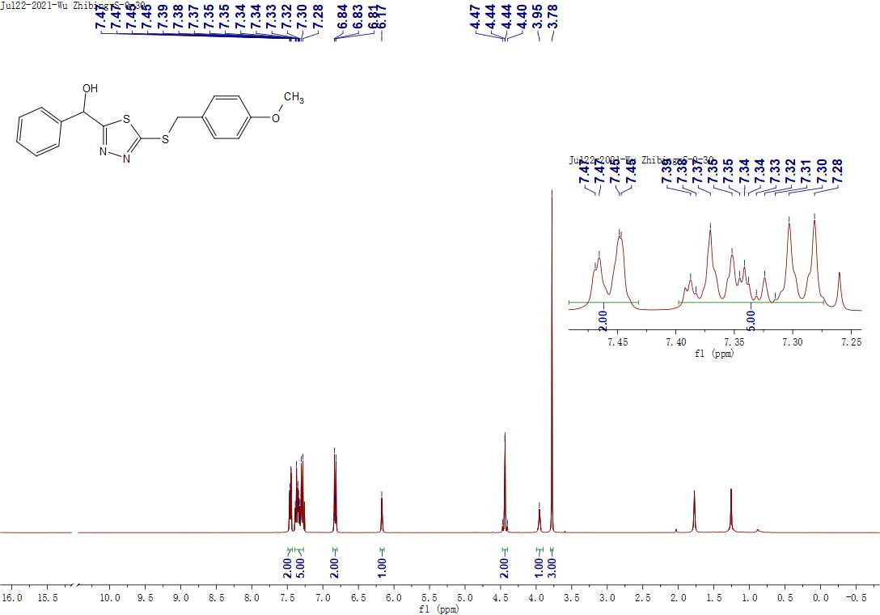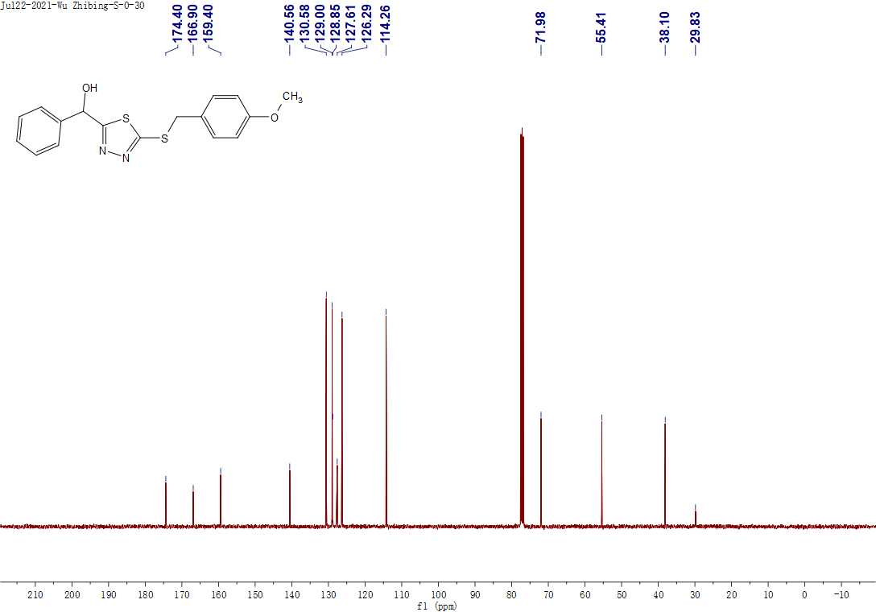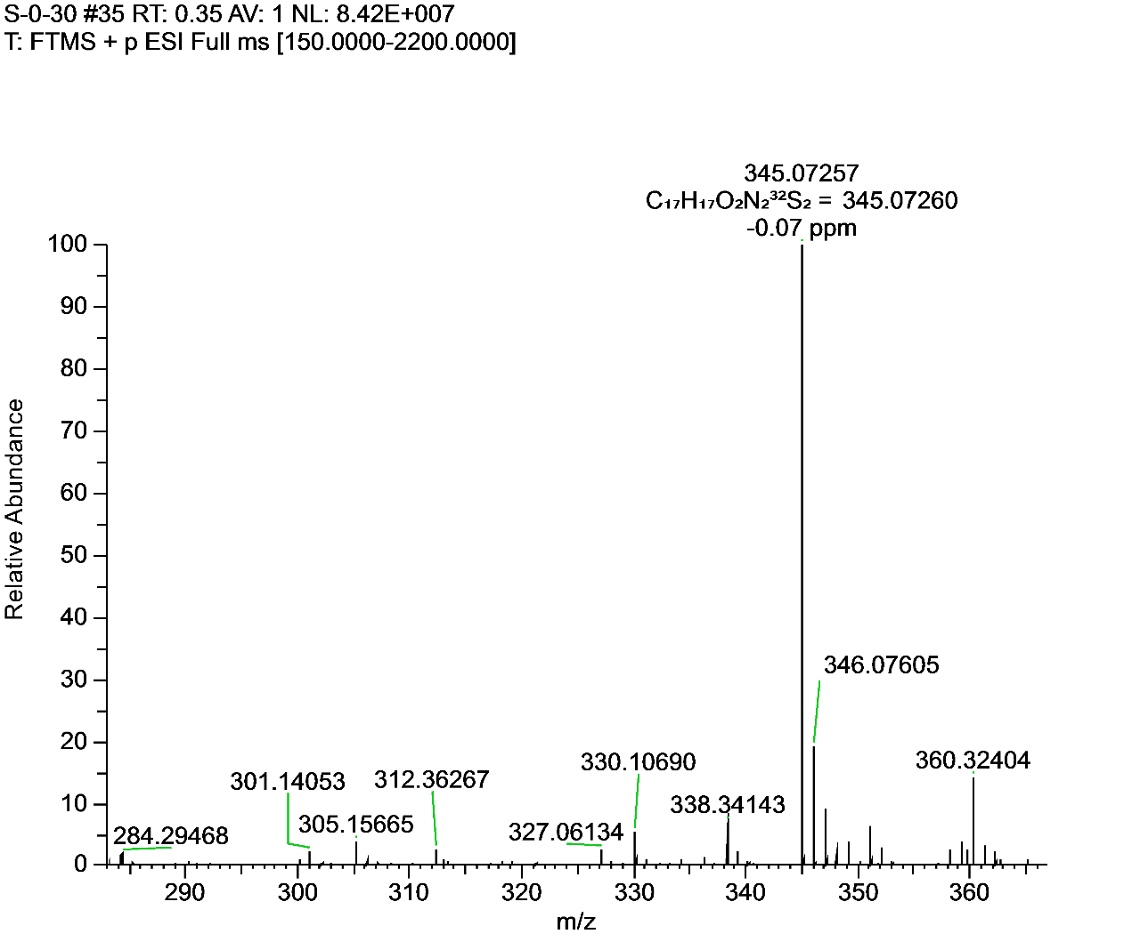

**Figure S23.** 1H NMR, 13C NMR and HRMS for **F18**.

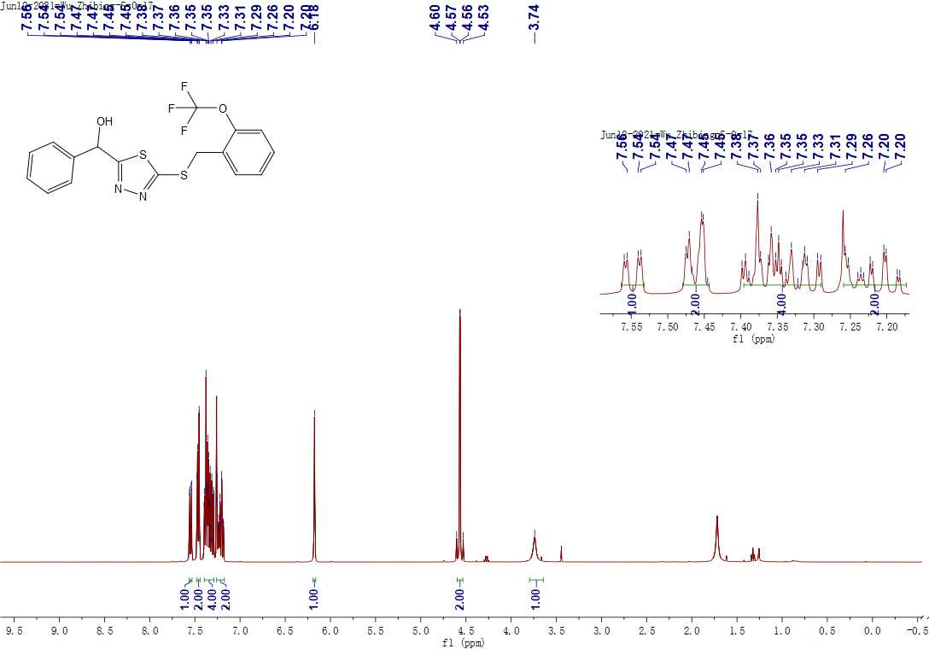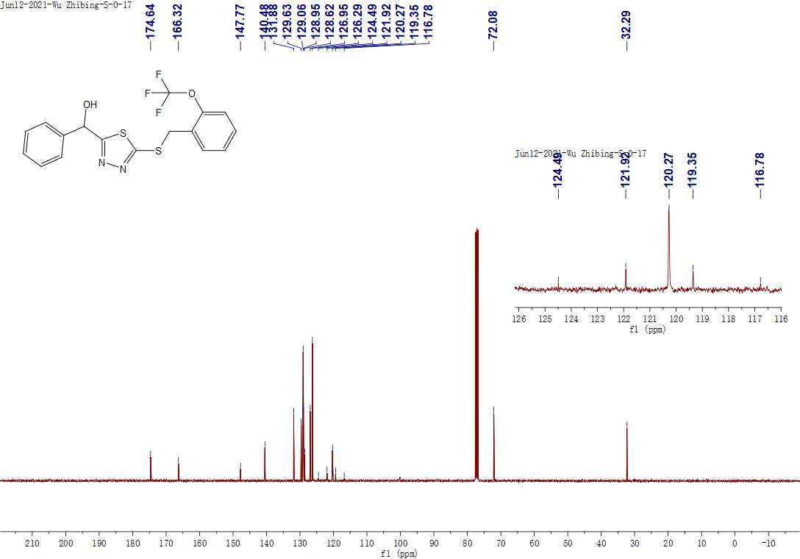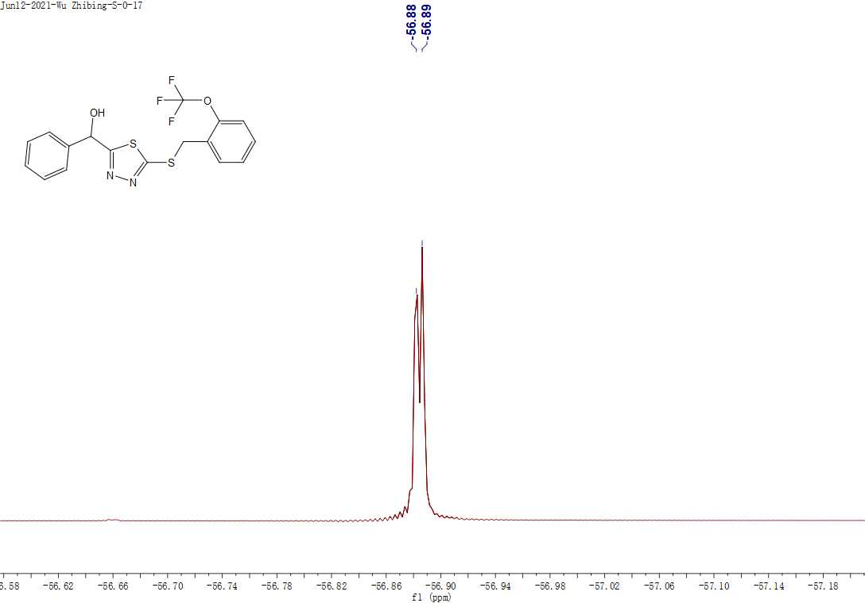 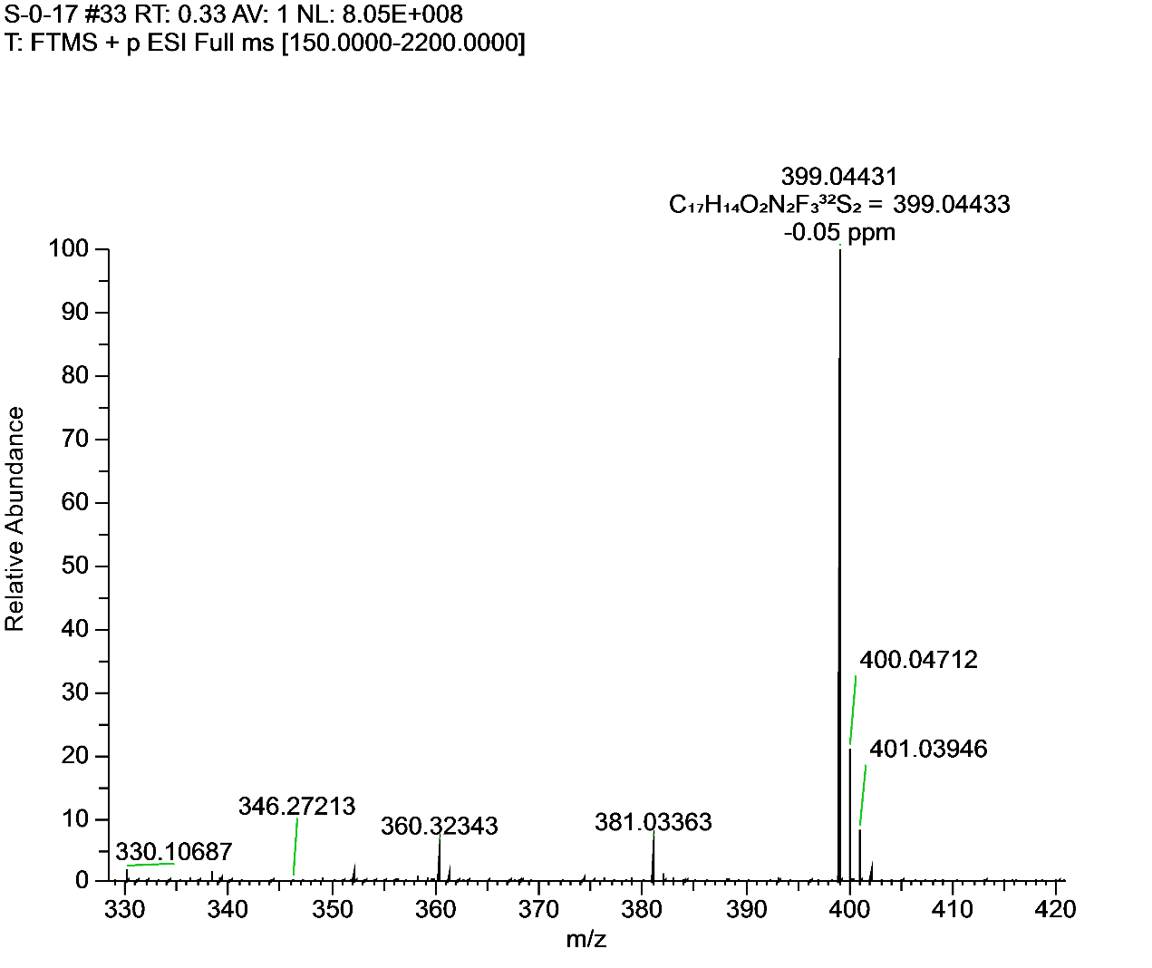**Figure S24.** 1H NMR, 13C NMR, 19FNMR and HRMS for **F19**.

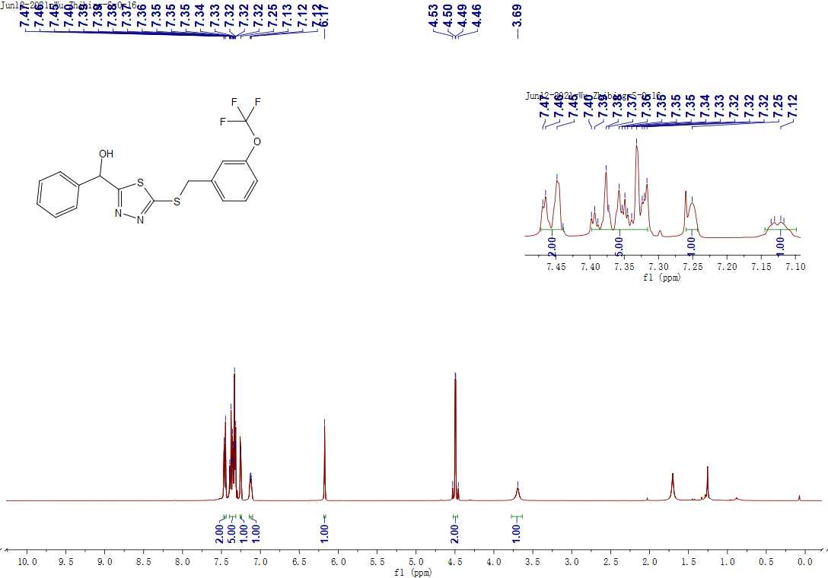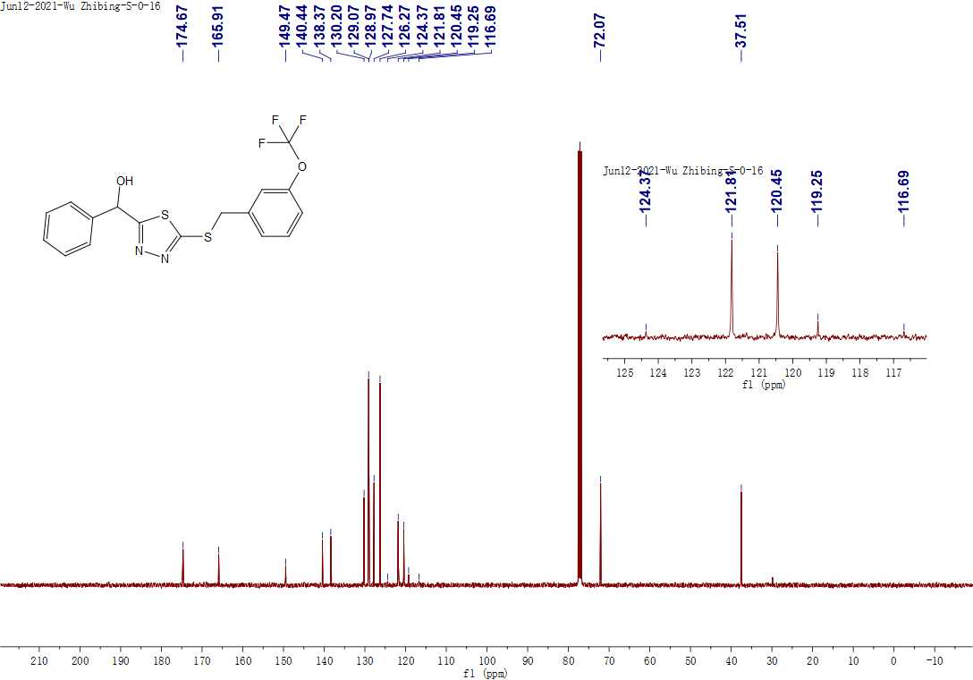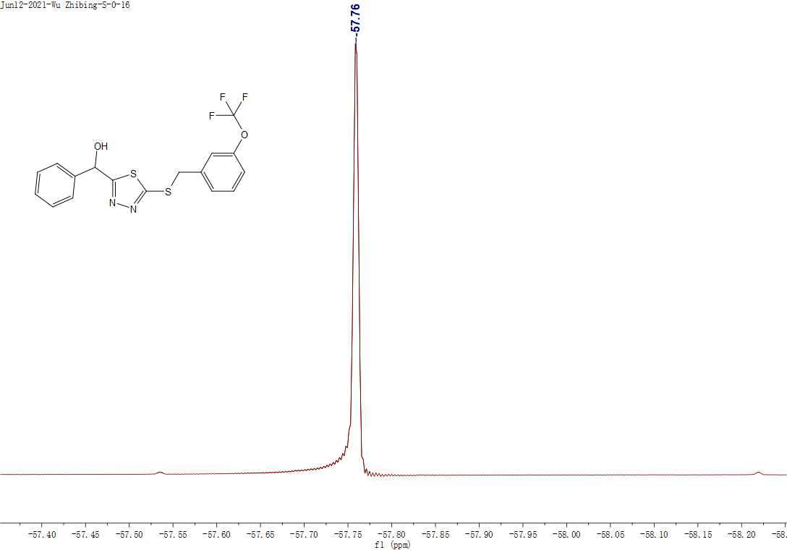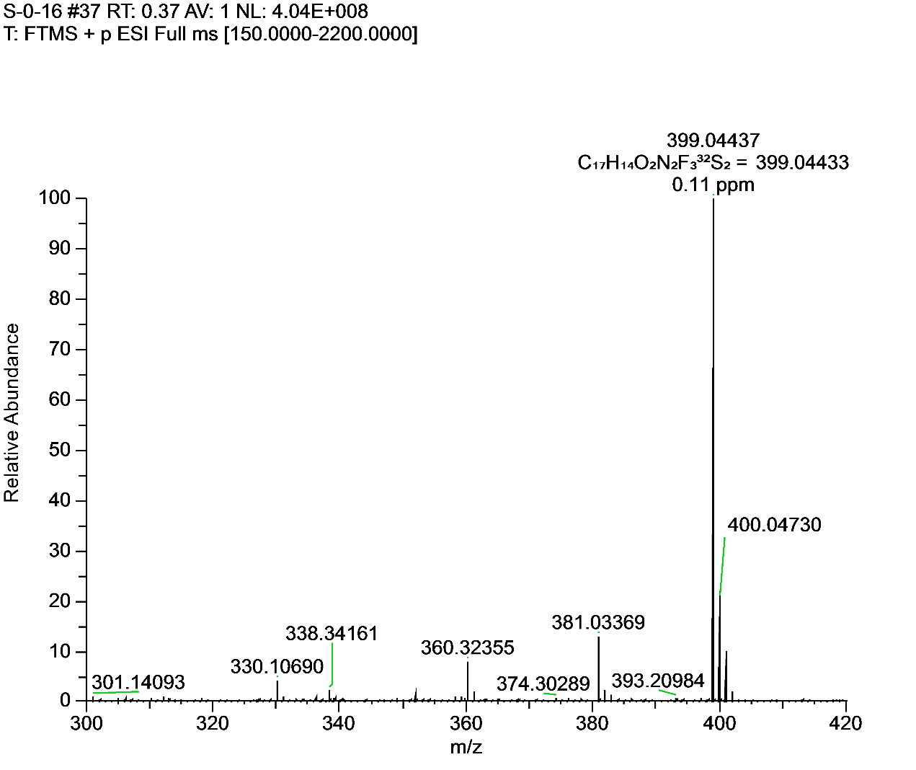**Figure S25.** 1H NMR, 13C NMR, 19FNMR and HRMS for **F20**.

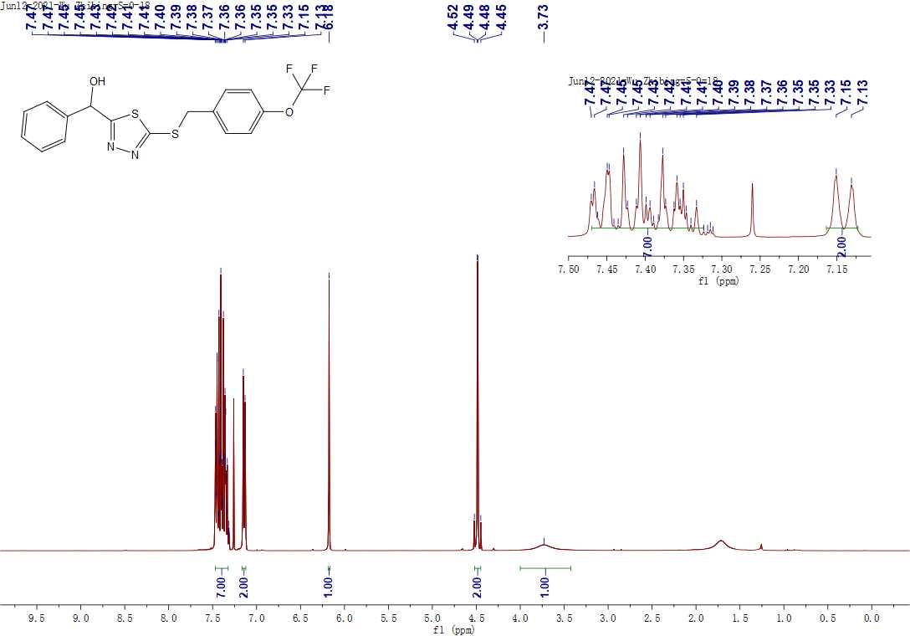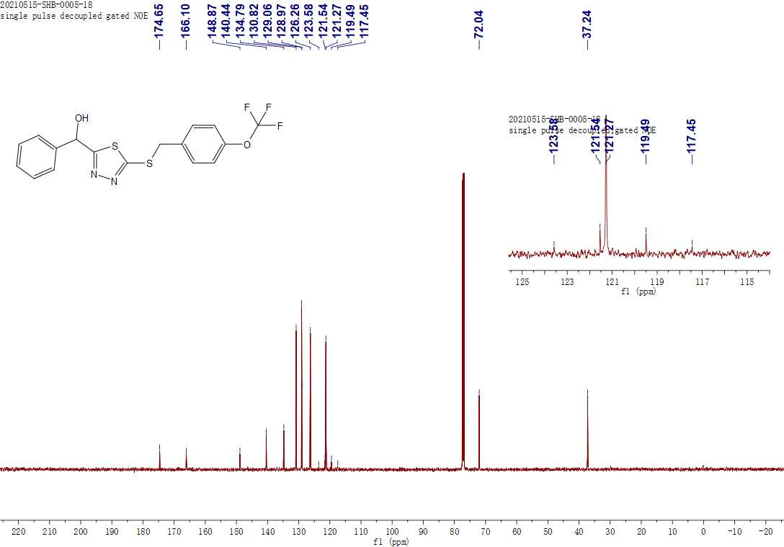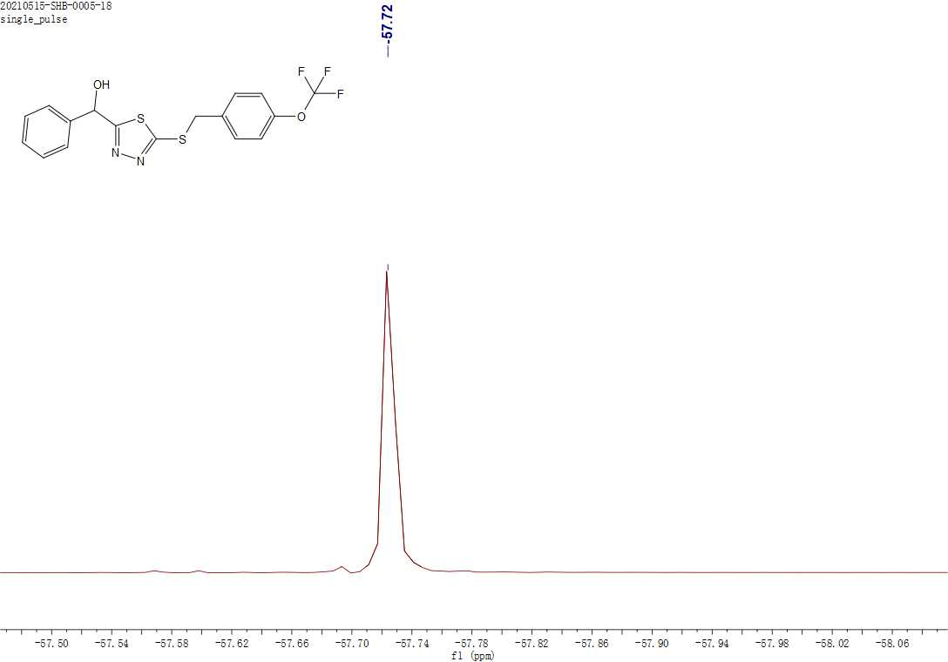 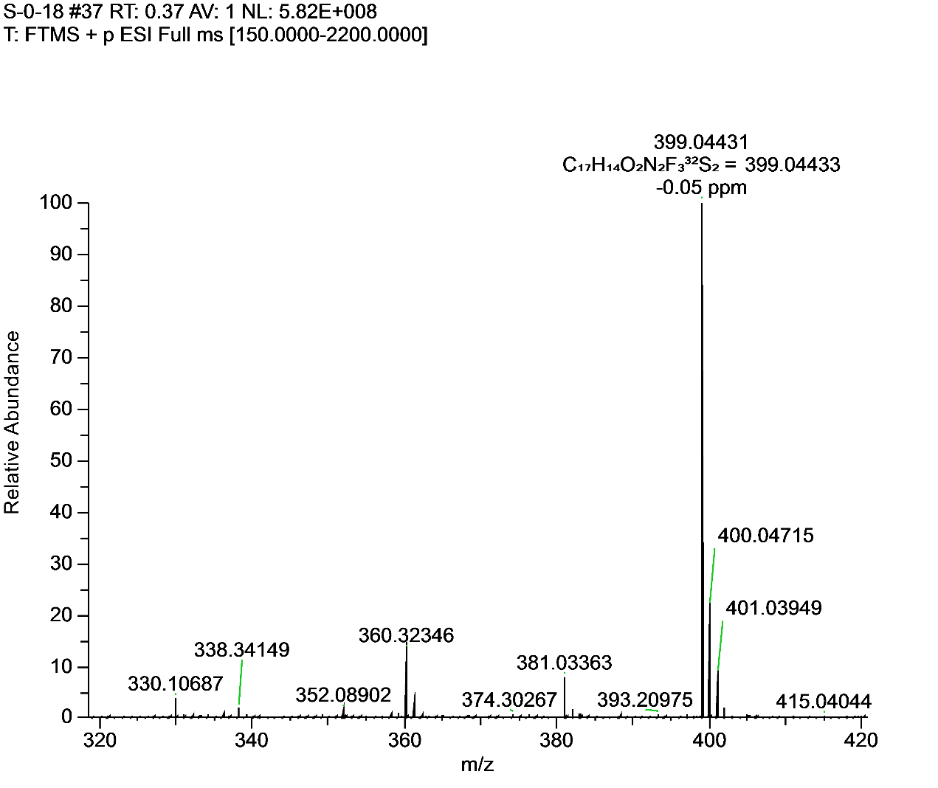**Figure S26.** 1H NMR, 13C NMR, 19FNMR and HRMS for **F21**.

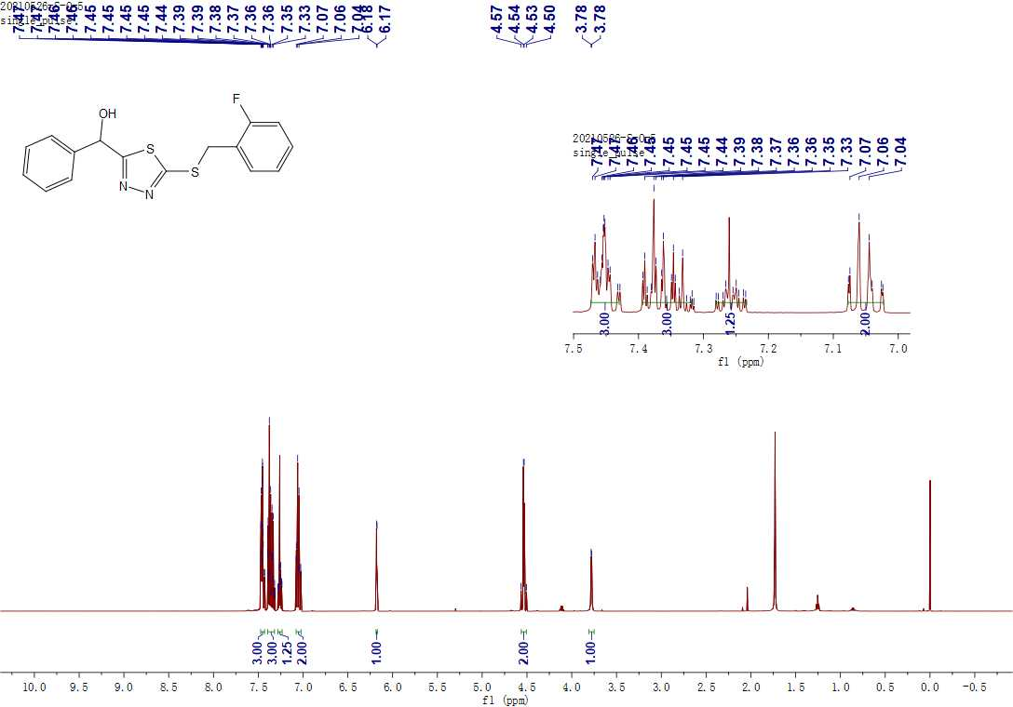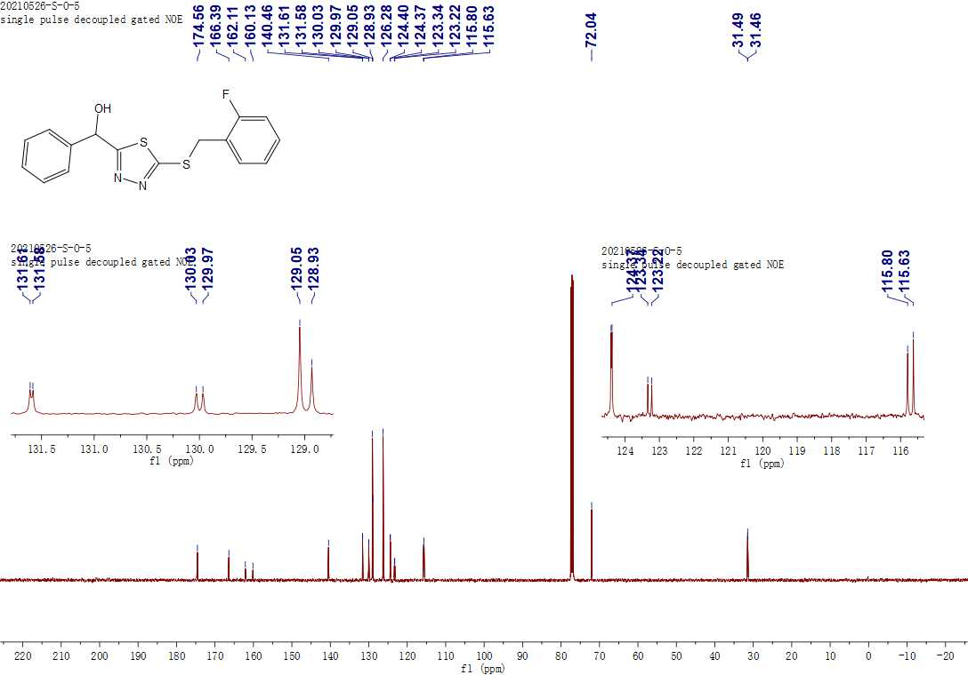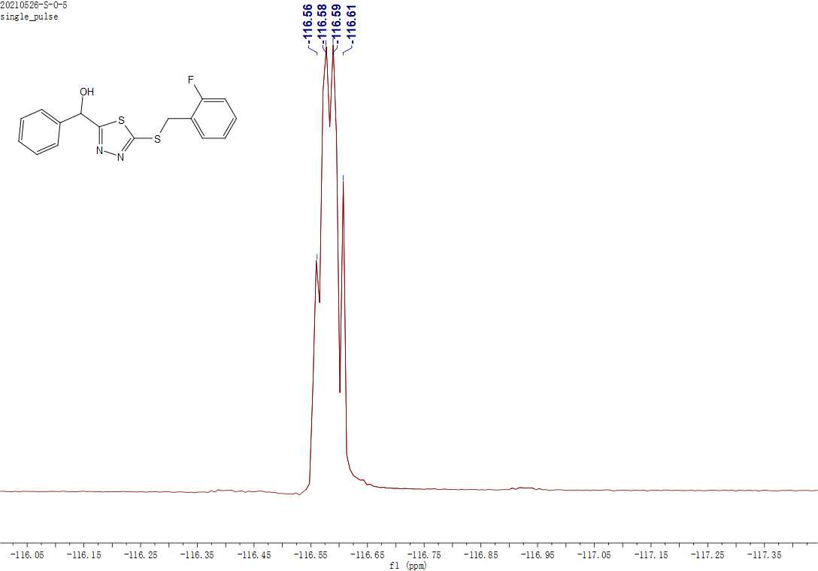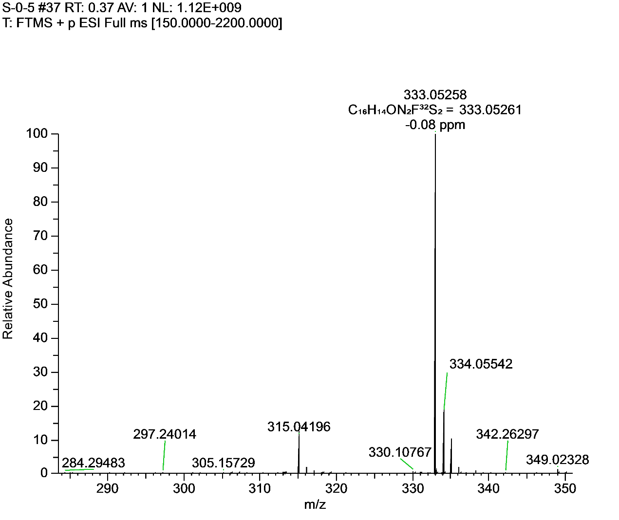**Figure S27.** 1H NMR, 13C NMR, 19FNMR and HRMS for **F22**.

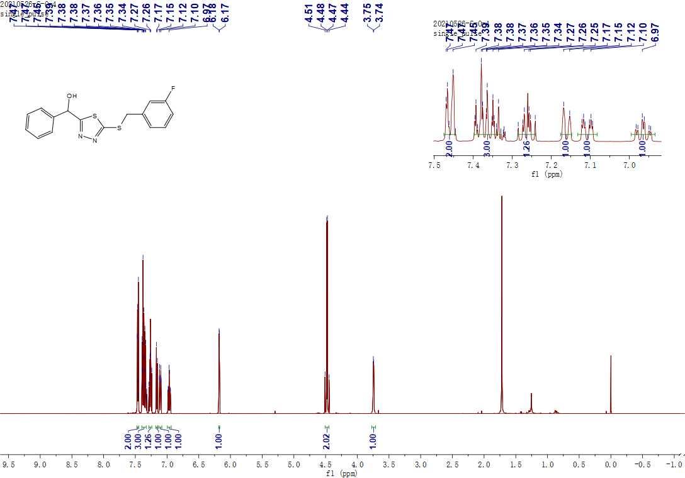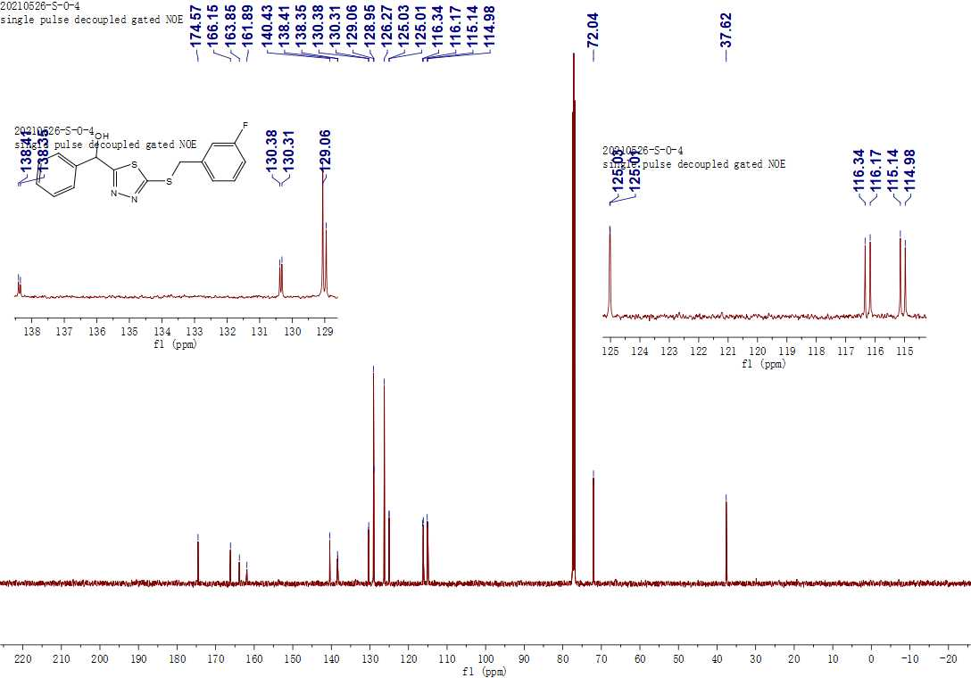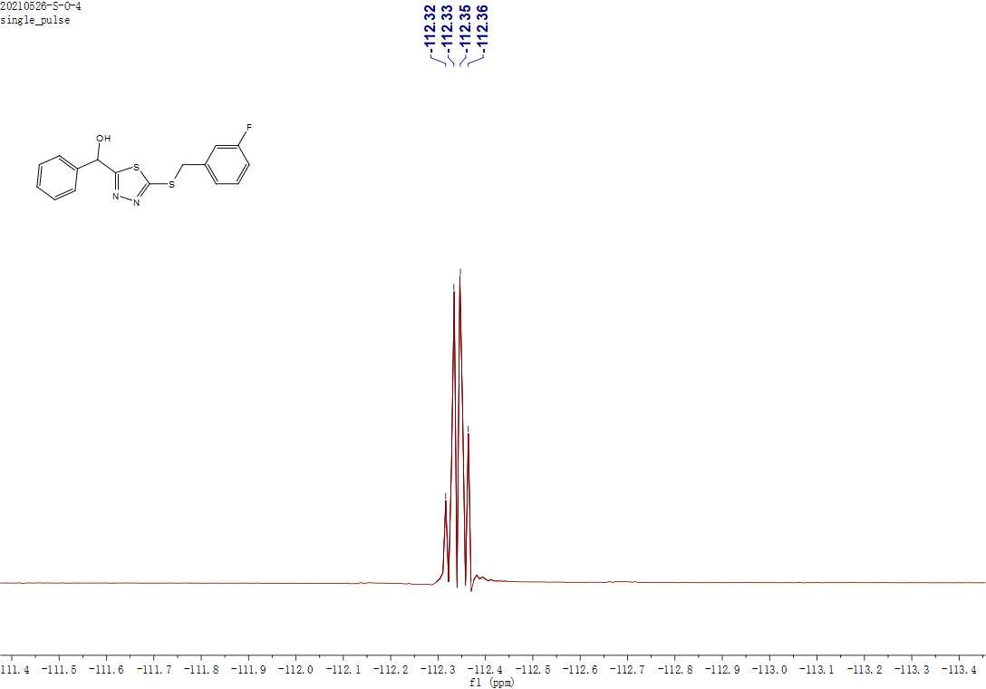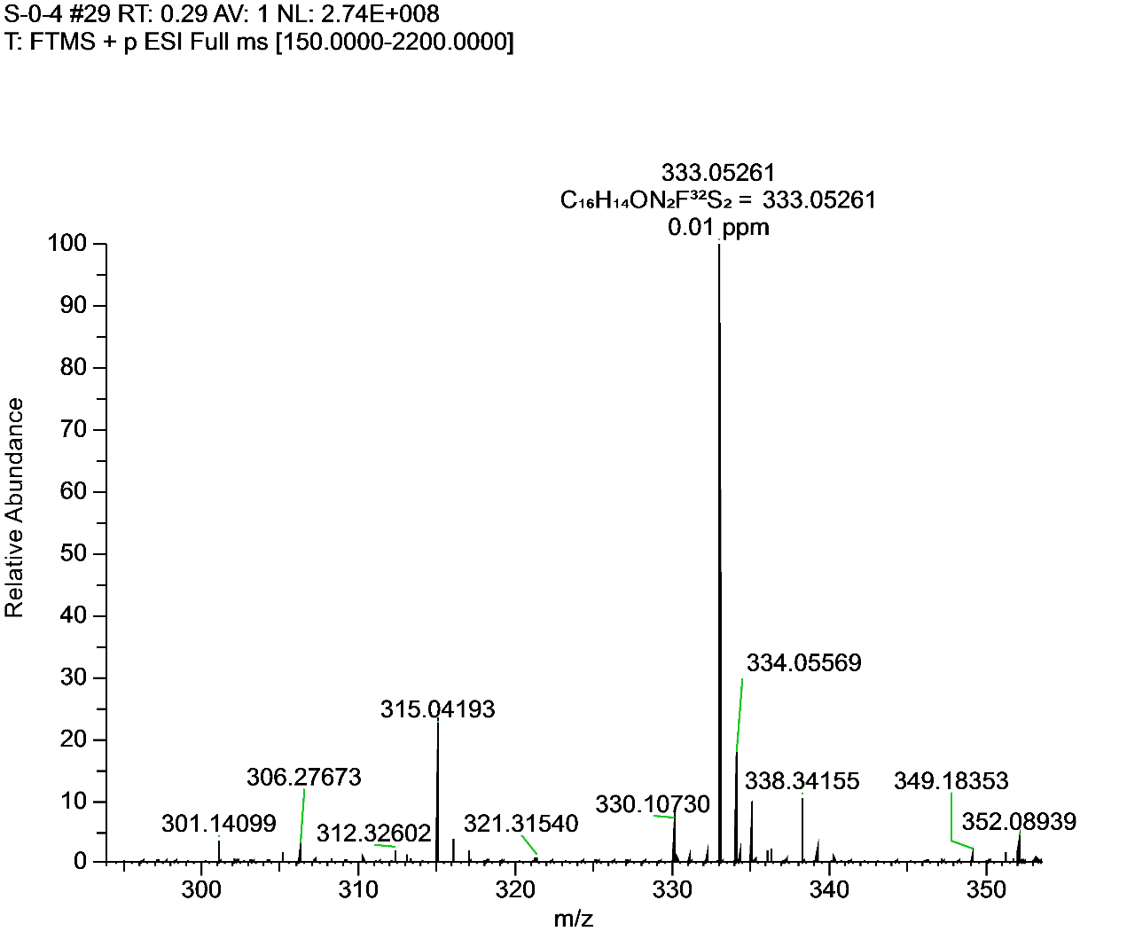**Figure S28.** 1H NMR, 13C NMR, 19FNMR and HRMS for **F23**.

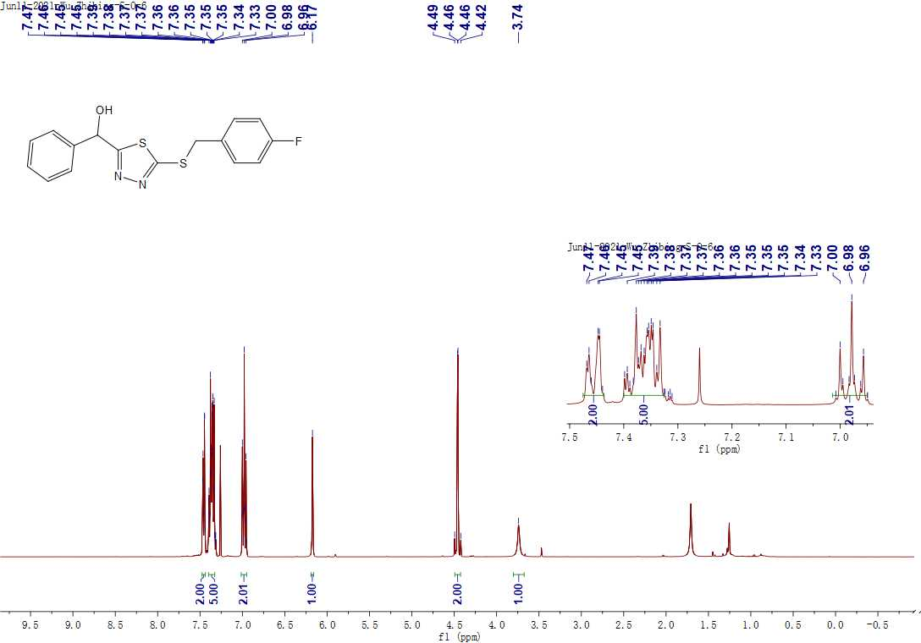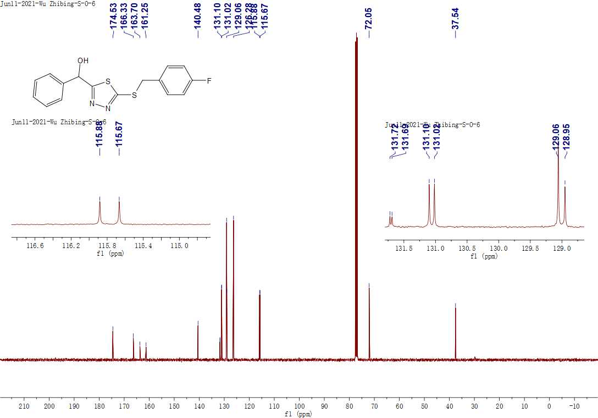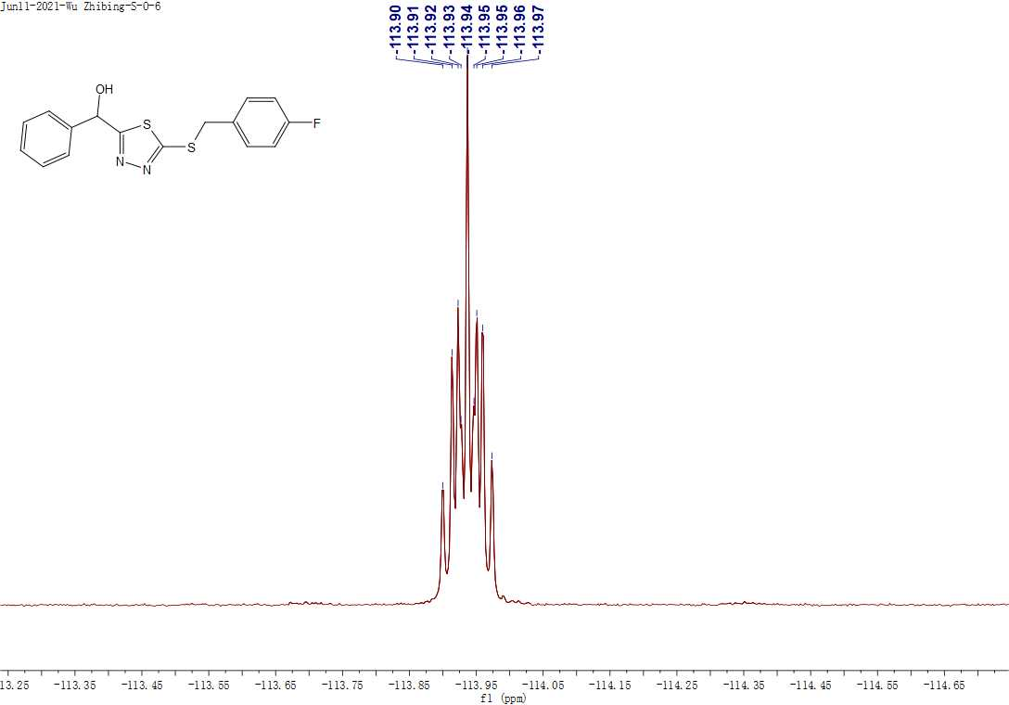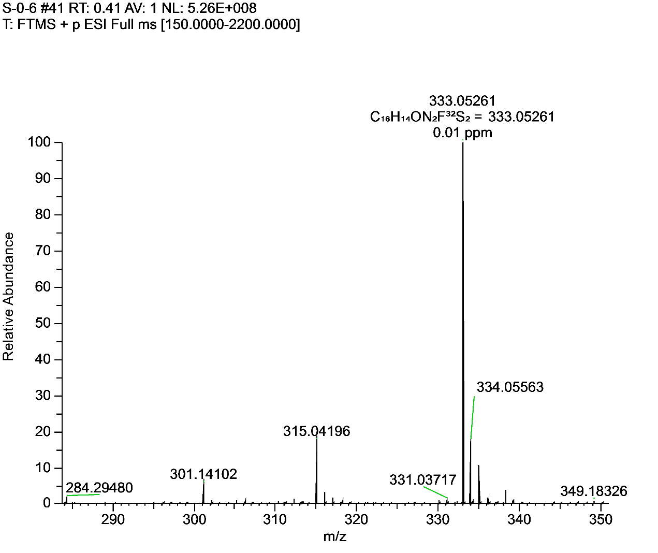**Figure S29.** 1H NMR, 13C NMR, 19FNMR and HRMS for **F24**.

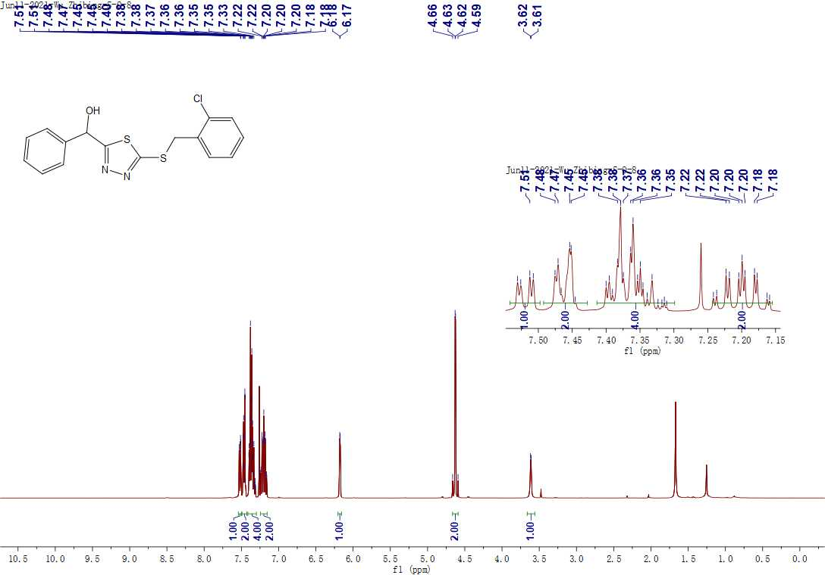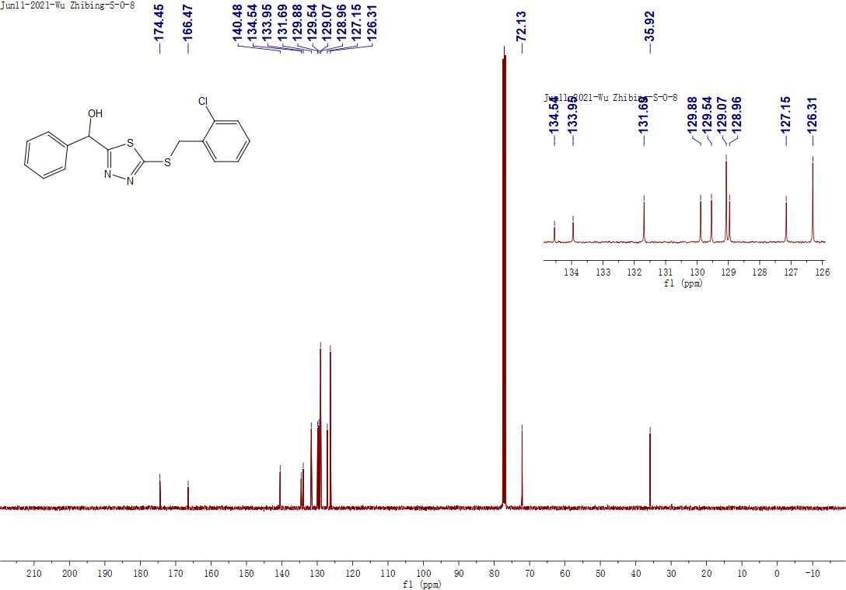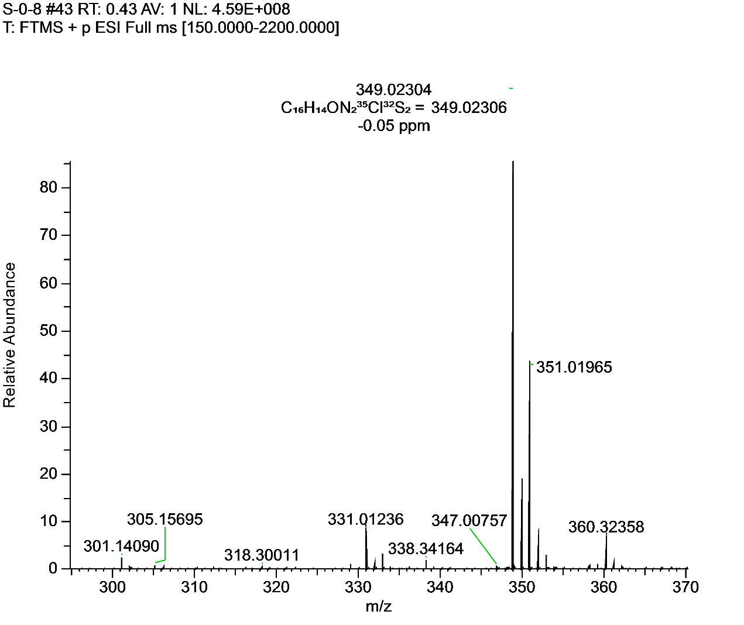**Figure S30.** 1H NMR, 13C NMR and HRMS for **F25**.

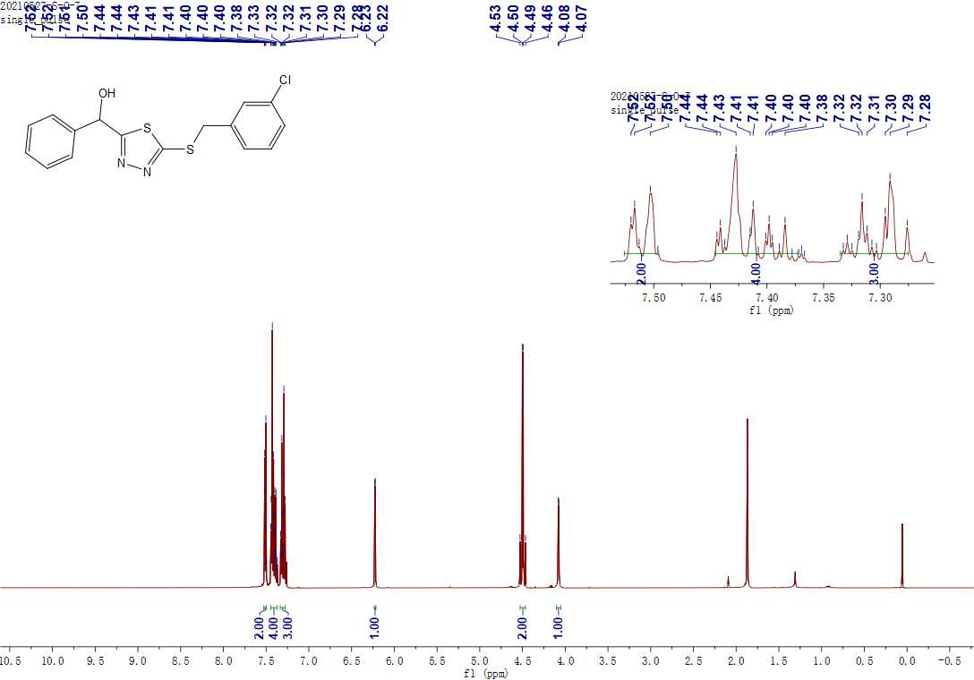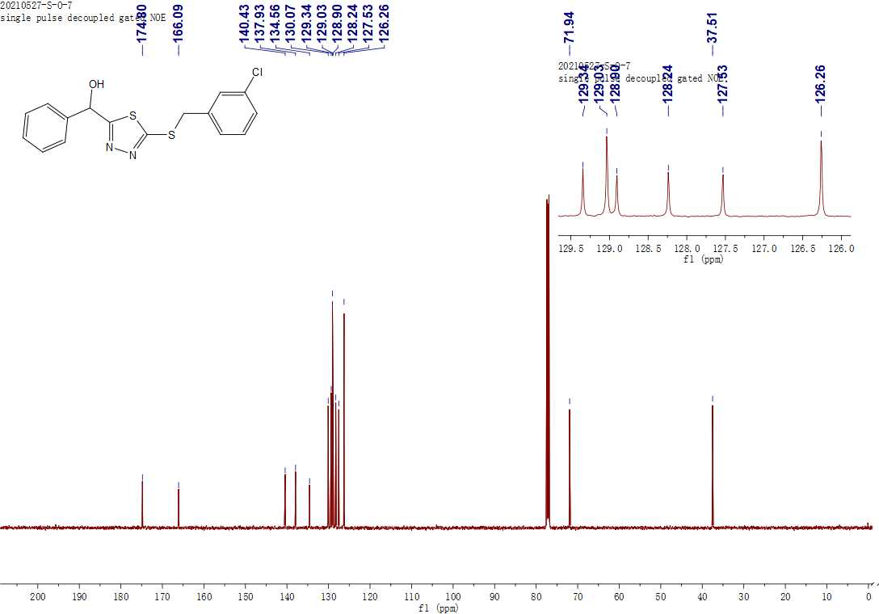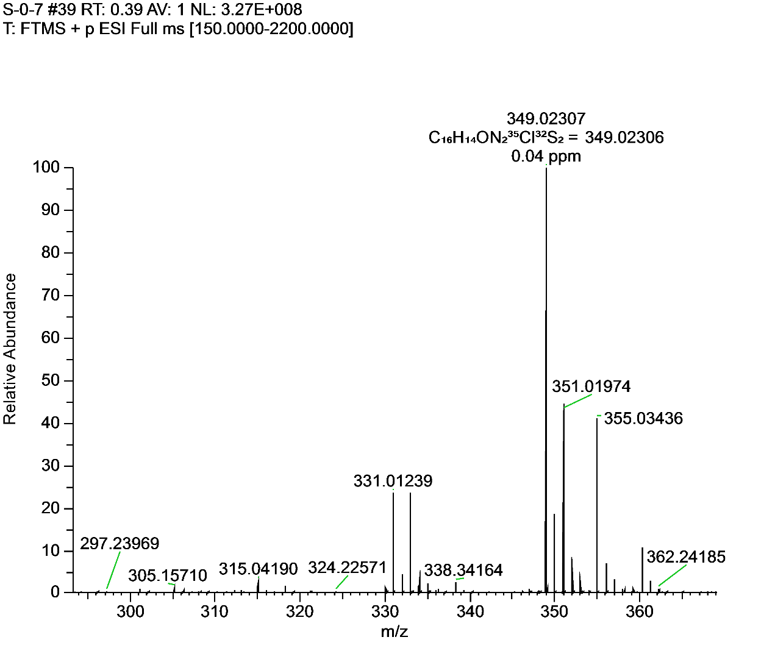**Figure S31.** 1H NMR, 13C NMR and HRMS for **F26**.

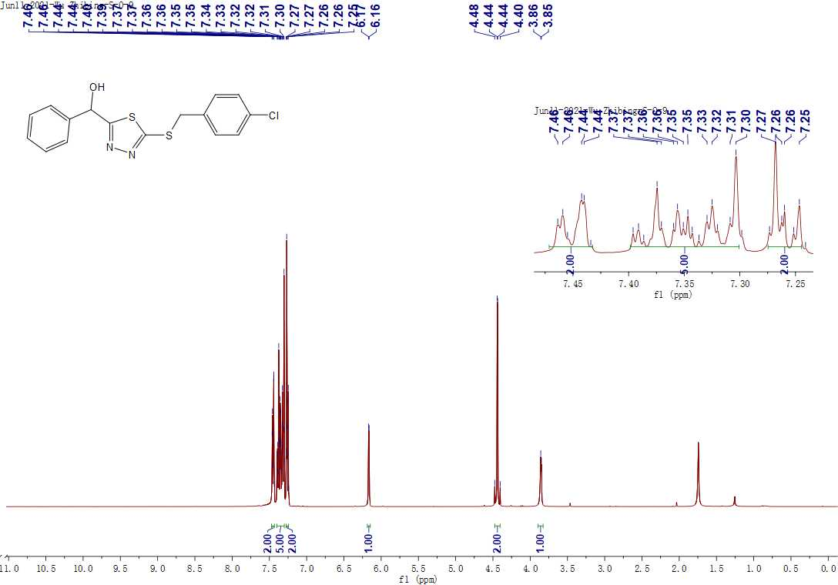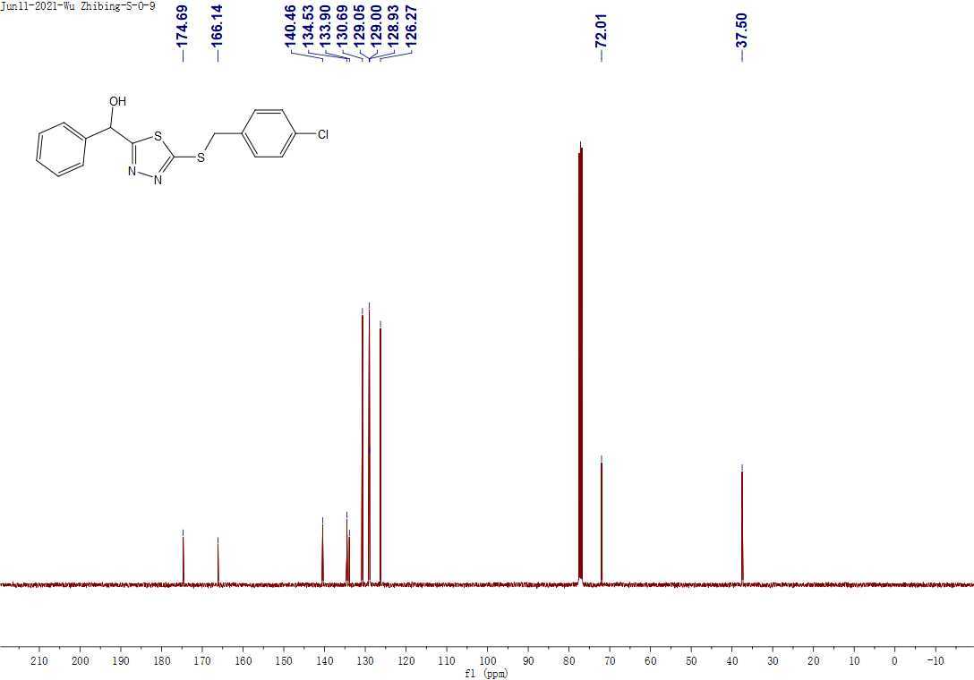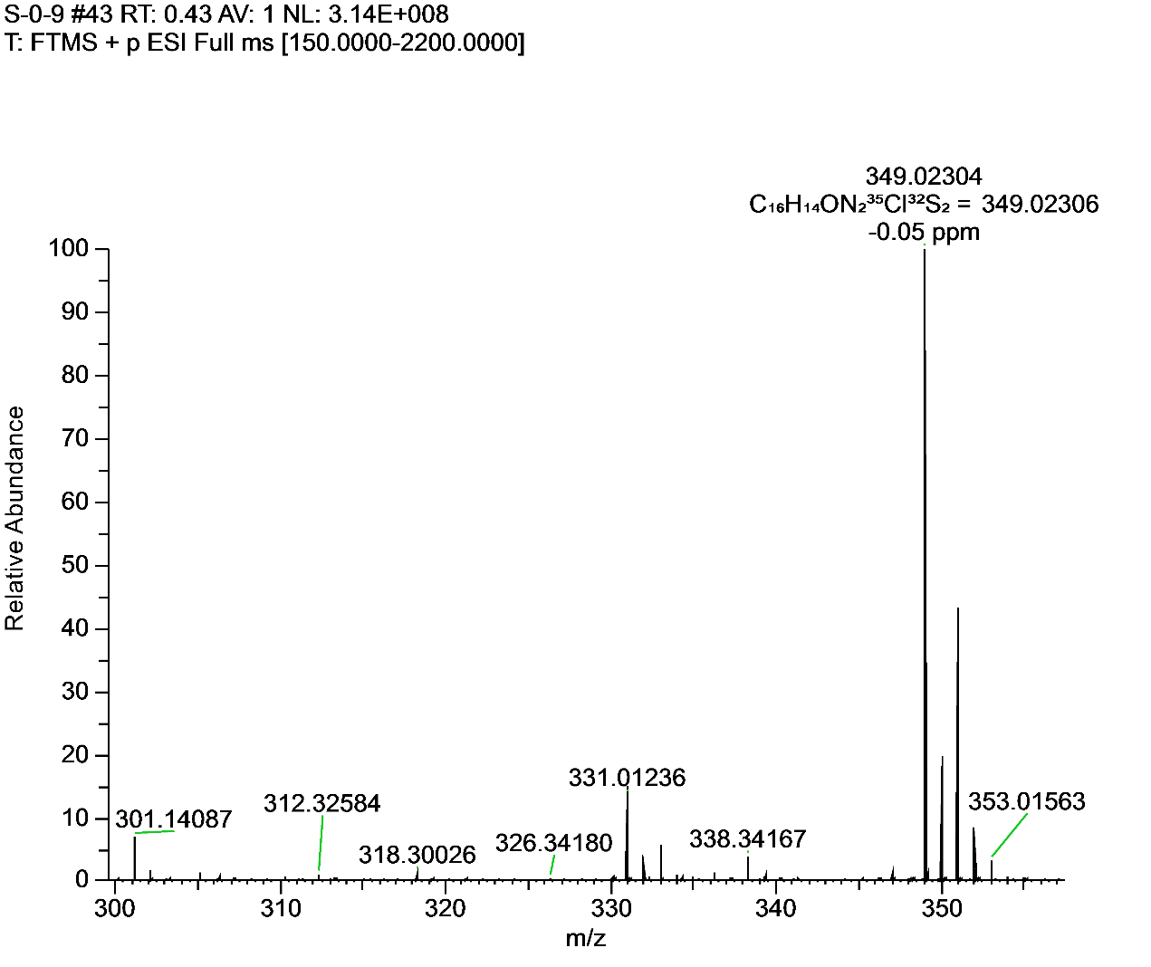**Figure S32.** 1H NMR, 13C NMR and HRMS for **F27**.

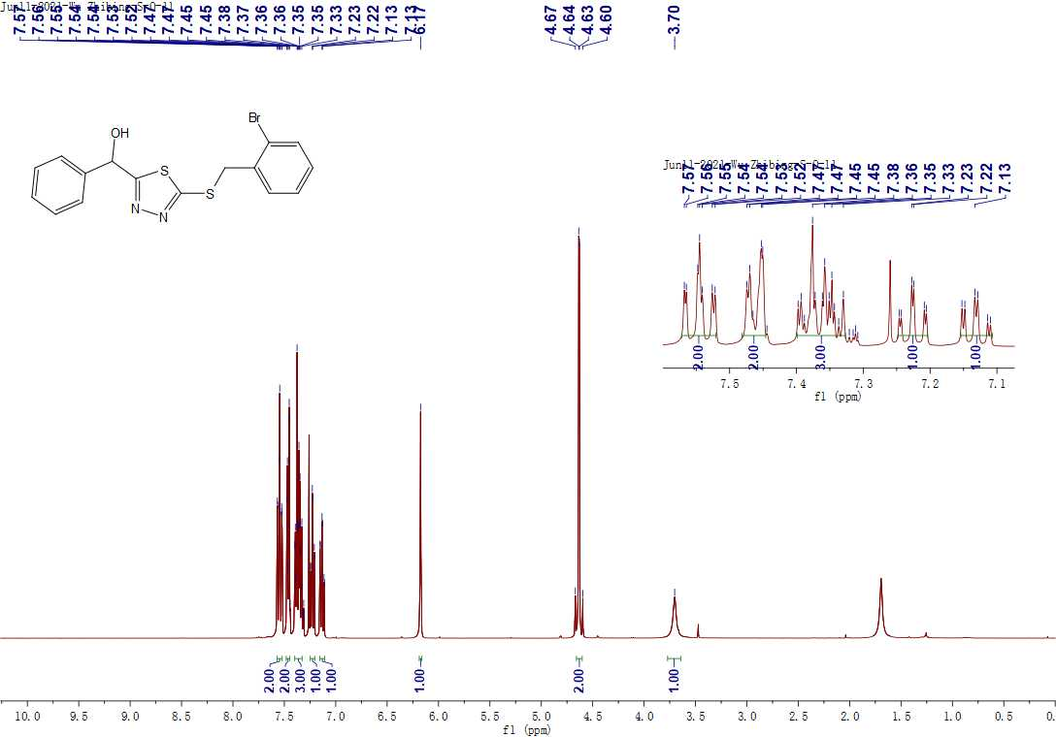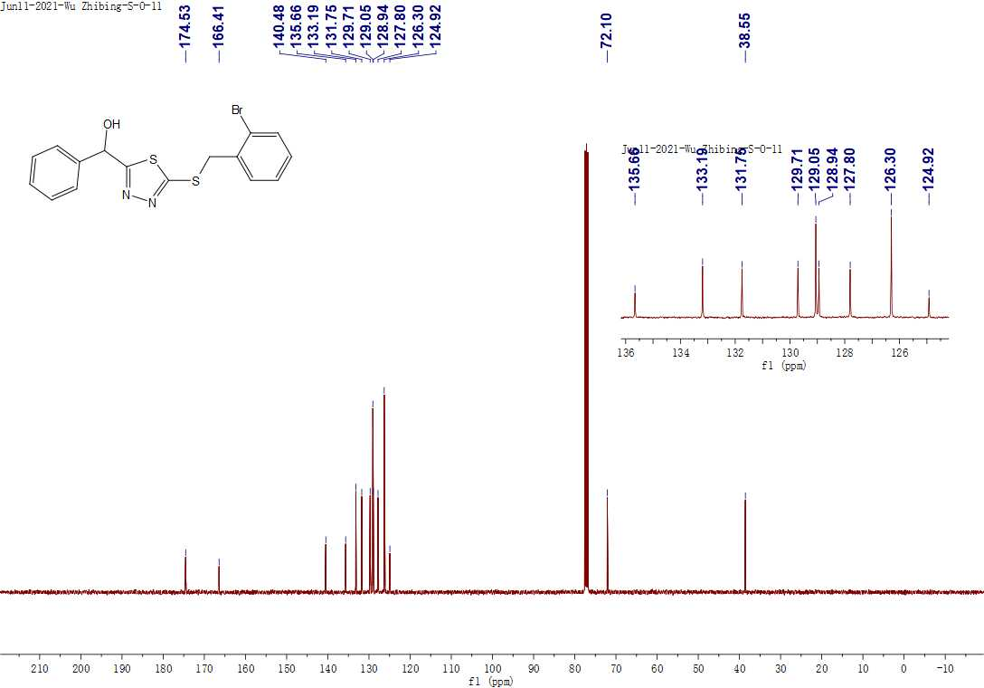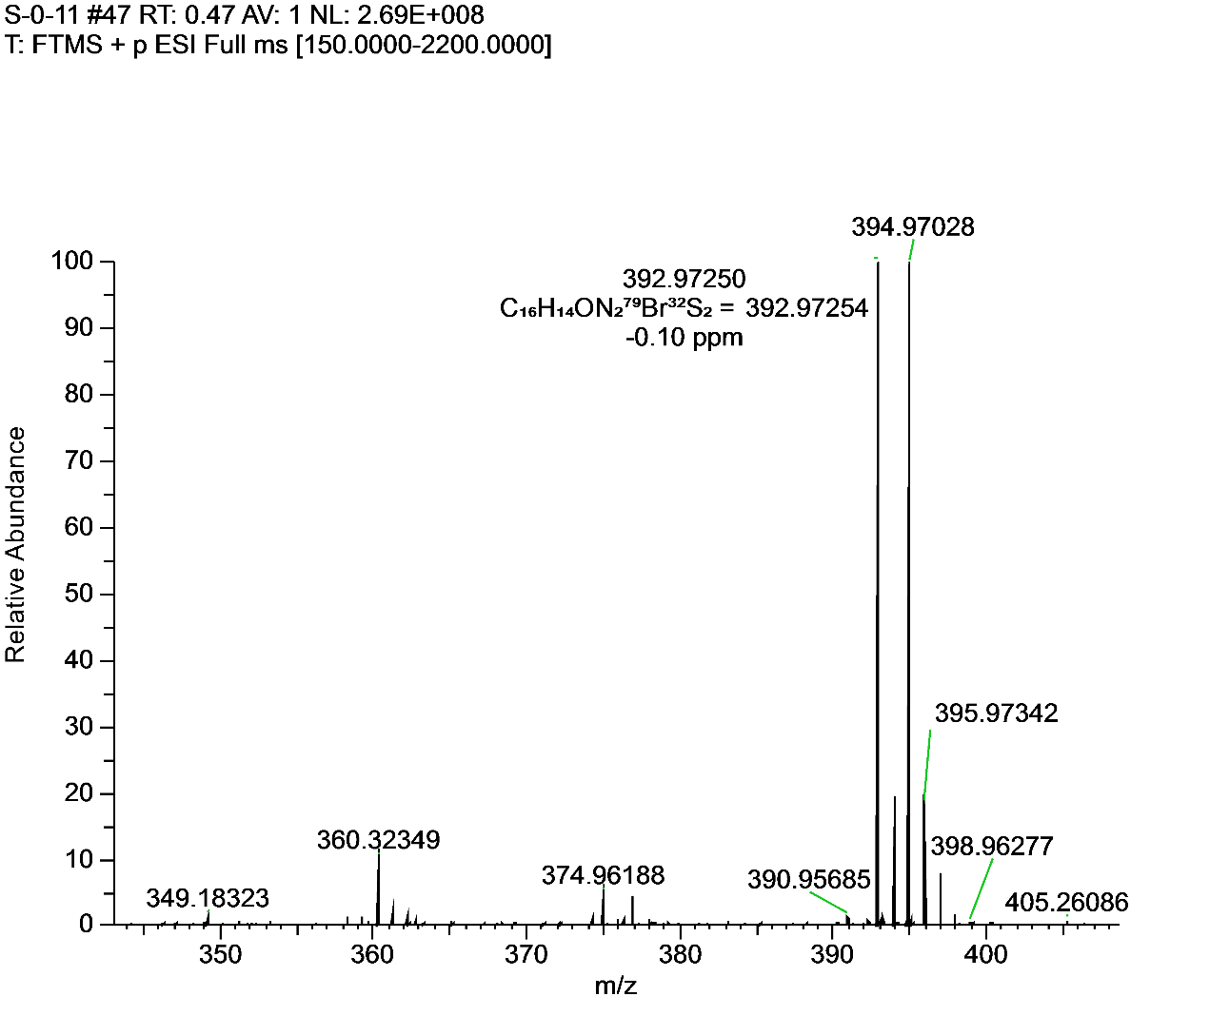**Figure S33.** 1H NMR, 13C NMR and HRMS for **F28**.

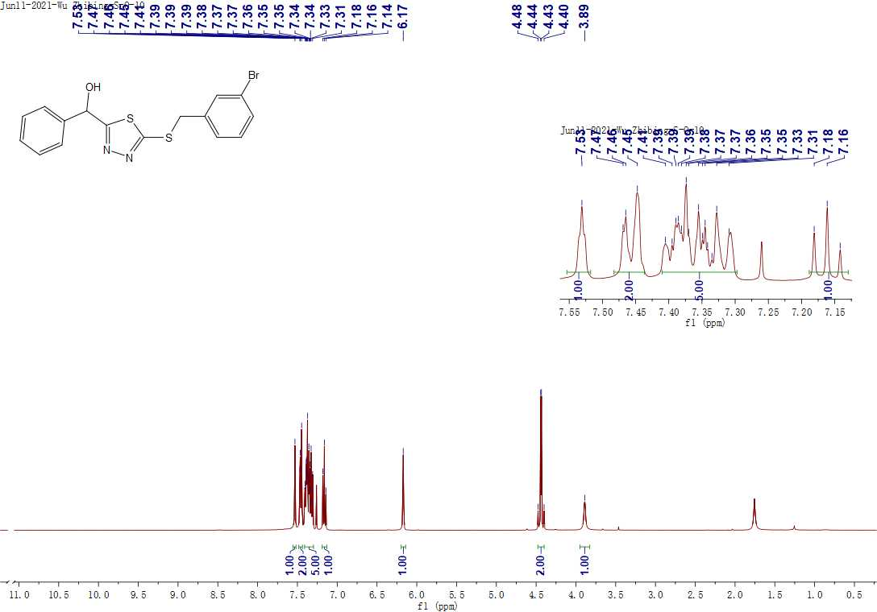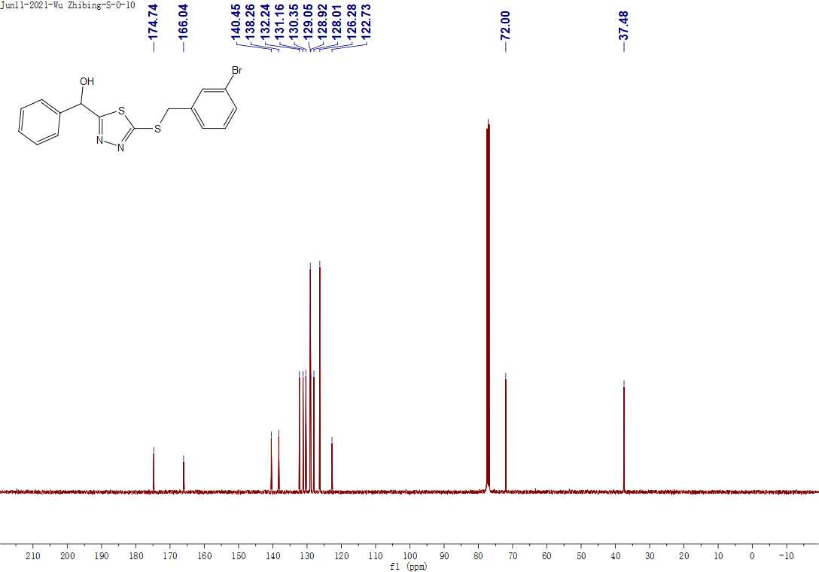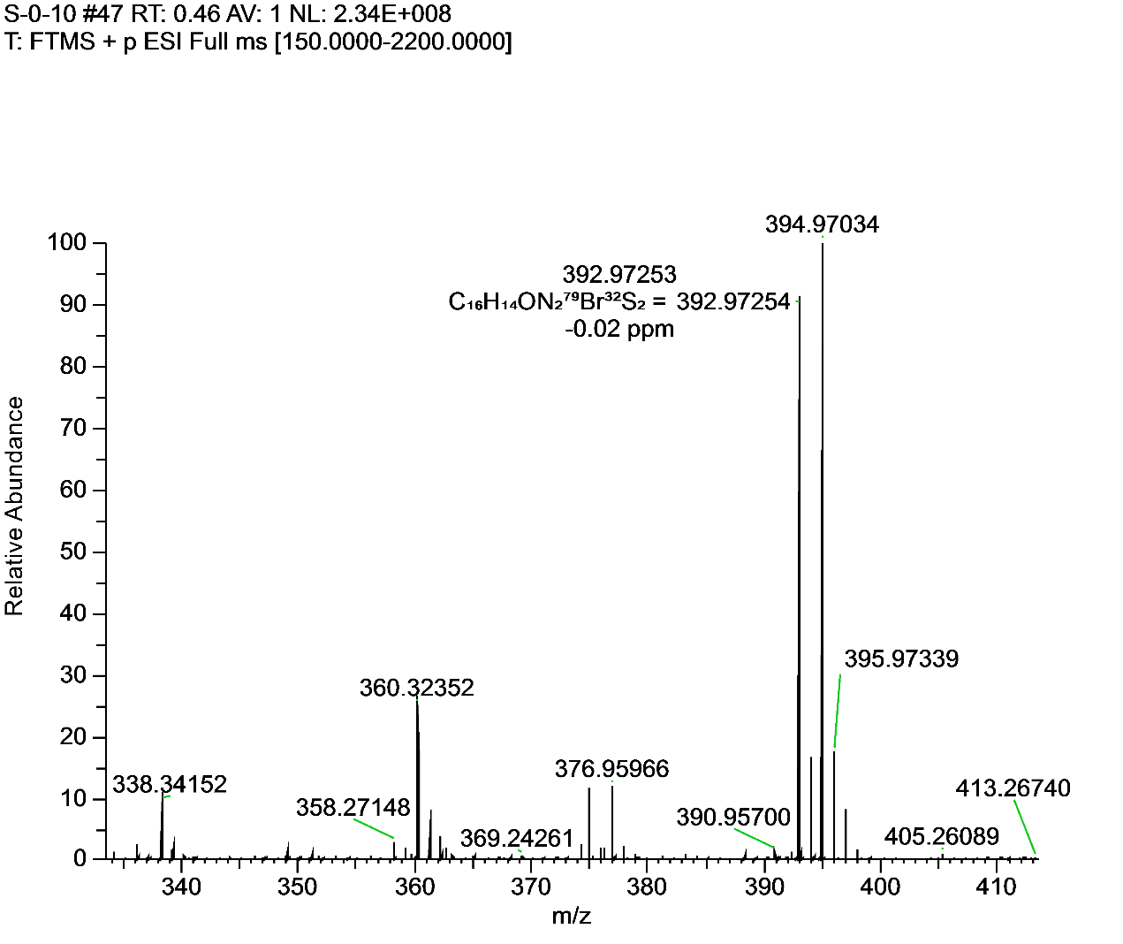**Figure S34.** 1H NMR, 13C NMR and HRMS for **F29**.

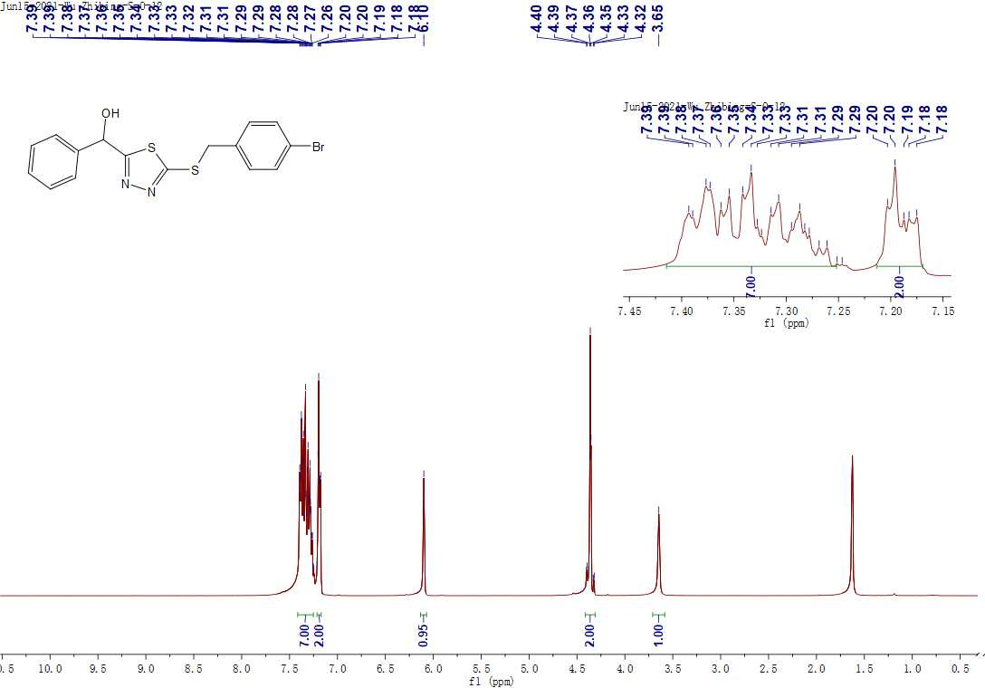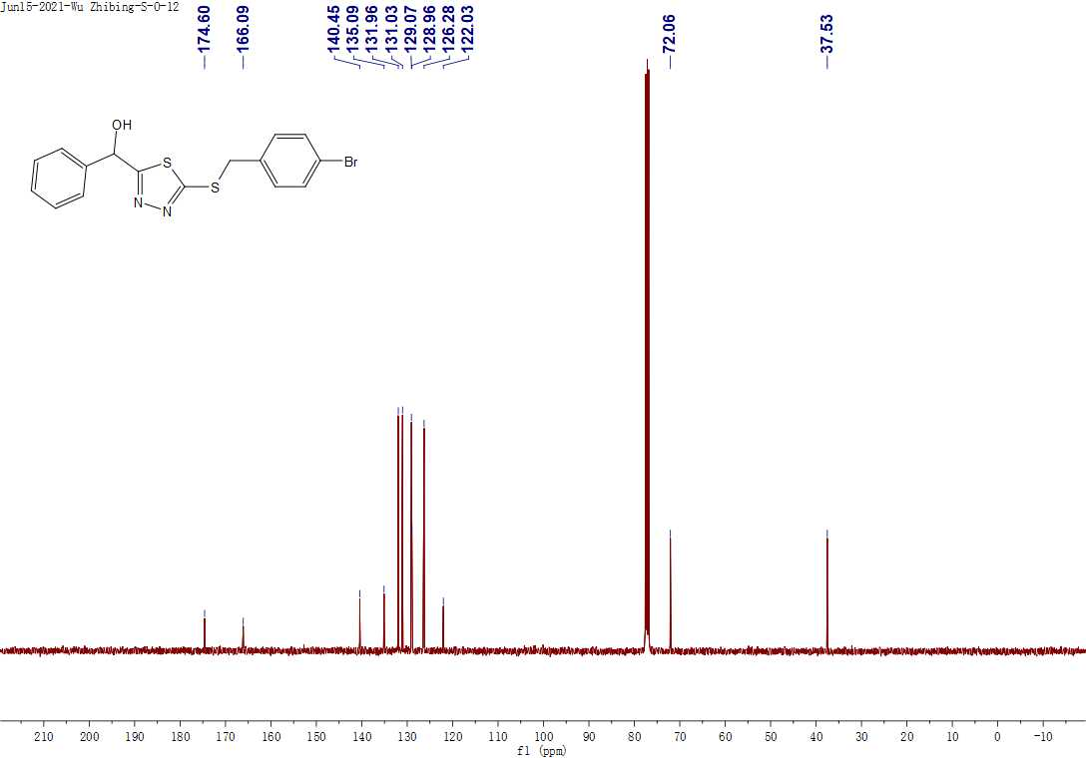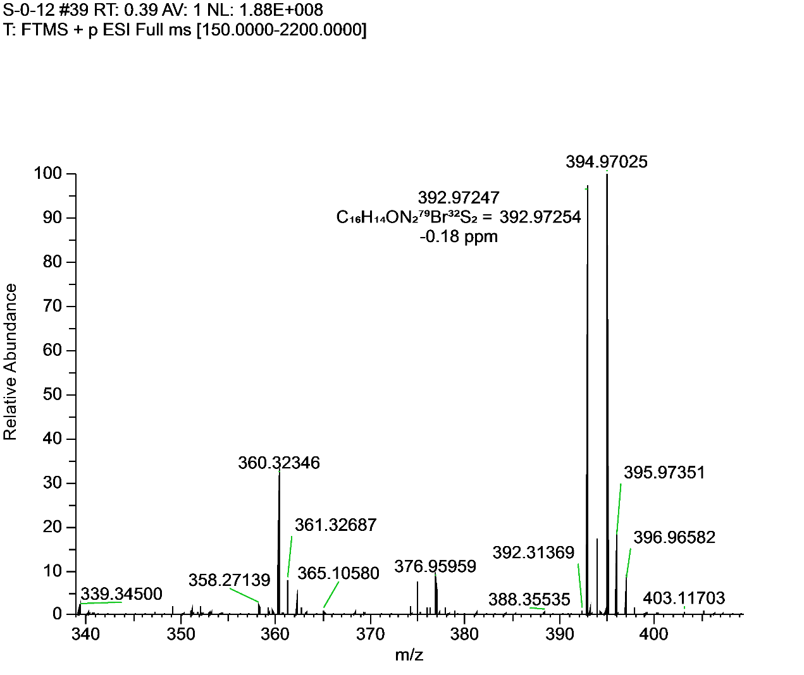 **Figure S35.** 1H NMR, 13C NMR and HRMS for **F30**.

**6. Crystallographic data of target compound F16**

**Table S1** Crystallographic data of target compound **F16**

|  |  |
| --- | --- |
| Identification code | A_pl |
| Empirical formula | C17H16N2O2S2 |
| Formula weight | 344.44 |
| Temperature/K | 293.15 |
| Crystal system | monoclinic |
| Space group | P21/c |
| a/Å | 9.5745(12) |
| b/Å | 7.6138(10) |
| c/Å | 23.623(3) |
| α/° | 90 |
| β/° | 92.271(5) |
| γ/° | 90 |
| Volume/Å3 | 1720.7(4) |
| Z | 4 |
| ρcalcg/cm3 | 1.330 |
| μ/mm 1 | 2.890 |
| F(000) | 720.0 |
| Crystal size/mm3 | 0.15 × 0.14 × 0.14 |
| Radiation | CuKα (λ = 1.54178) |
| 2Θ range for data collection/° | 7.49 to 144.152 |
| Index ranges | -11 ≤ h ≤ 11, -9 ≤ k ≤ 8, -29 ≤ l ≤ 29 |
| Reflections collected | 11899 |
| Independent reflections | 3279 [Rint = 0.1979, Rsigma = 0.1657] |
| Data/restraints/parameters | 3279/0/210 |
| Goodness-of-fit on F2 | 1.949 |
| Final R indexes [I>=2σ (I)] | R1 = 0.1532, wR2 = 0.4452 |
| Final R indexes [all data] | R1 = 0.4087, wR2 = 0.5971 |
| Largest diff. peak/hole / e Å-3 | 1.42/-1.05 |

The crystal structure of **F16** was confirmed via X-ray diffraction analysis:

Crystallographic data of compound **F16**: C17H16N2O2S2 (*M* =344.44 g/mol): monoclinic, space group P21/c (no. 14), *a* = 9.5745(12) Å, *b* = 7.6138(10) Å, *c* = 23.623(3) Å, *β* = 92.271(5)°, *V* = 1720.7(4) Å3, *Z* = 4, *T* = 293.15 K, μ(CuKα) = 2.890 mm-1, *Dcalc* = 1.330 g/cm3, 11899 reflections measured (7.49° ≤ 2Θ ≤ 144.152°), 3279 unique (*Rint* = 0.1979, *Rsigma* = 0.1657) which were used in all calculations. The final *R1*was 0.1532 (I > 2σ(I)) and *wR2* was 0.5971 (all data). The crystallographic data of target compound **F16** were deposited in the Cambridge Crystallographic Data Centre (CCDC) under deposition number of 2159799.

**7. Structures and inhibition rates of target compounds against six pathogenic fungi**

**Table S2** Structures and inhibition rates of the target compounds against six pathogenic fungi at 100 μg/mL and 50 μg/mL.a

|  |  |  |  |  |  |  |  |  |  |  |  |  |  |
| --- | --- | --- | --- | --- | --- | --- | --- | --- | --- | --- | --- | --- | --- |
| No. | Structures | Inhibition rate (%) | | | | | | | | | | | |
| *G. saubinetii* | | *A. solani* | | *V. dahlia* | | *G. zeae* | | *T. cucumeris* | | *B. dothidea* | |
| 100 μg/mL | 50 μg/mL | 100 μg/mL | 50 μg/mL | 100 μg/mL | 50 μg/mL | 100 μg/mL | 50 μg/mL | 100 μg/mL | 50 μg/mL | 100 μg/mL | 50 μg/mL |
| **E** |  | 19.6±1.5 | - | 36.6±1.4 | - | 40.9±1.3 | - | 14.8±1.4 | - | 0 | - | 0 | - |
| **F1** |  | 33.8±2.1 | - | 22.5±1.6 | - | 0 | - | 16.3±0.5 | - | 45.5±1.6 | - | 0 | - |
| **F2** |  | 44.9±2.6 | - | 33.5±0.9 | - | 28.7±0.8 | - | 28.9±0.5 | - | 45.2±1.1 | - | 11.0±0.9 | - |
| **F3** |  | 51.8±0.5 | 37.5±0.8 | 57.3±0.9 | 36.7±1.1 | 47.8±2.2 | - | 46.1±1.9 | - | 63.0±2.0 | 60.0±0.6 | 34.1±1.1 | - |
| **F4** |  | 56.2±0.5 | 39.7±0.5 | 50.8±0.9 | 41.2±0.5 | 42.8±1.4 | - | 45.2±0.5 | - | 65.9±0.6 | 63.6±1.0 | 34.7±0.9 | - |
| **F5** |  | 50.7±0.6 | - | 28.9±1.8 | - | 25.7±1.7 | - | 32.2±1.6 | - | 46.8±1.4 | - | 14.2±0.5 | - |
| **F6** |  | 35.5±2.1 | - | 12.0±2.7 | - | 0 | - | 34.3±1.0 | - | 14.8±5.1 | - | 0 | - |
| **F7** |  | 45.9±0.6 | - | 24.0±1.1 | - | 32.9±1.4 | - | 29.5±0.9 | - | 45.2±1.4 | - | 11.4±3.6 | - |
| **F8** |  | 46.3±2.0 | - | 20.0±1.9 | - | 7.7±0.5 | - | 20.5±2.4 | - | 44.0±1.1 |  | 21.1±1.4 | - |
| **F9** |  | 59.2±0.9 | 37.3±0.9 | 60.7±0.5 | 46.4±0.5 | 47.5±2.1 | - | 55.4±0.5 | 47.2±0.9 | 73.1±0.6 | 63.0±0.6 | 25.2±1.9 | - |
| **F10** |  | 72.9±1.7 | 69.9±0.0 | 69.9±0.6 | 49.4±2.0 | 55.7±0.9 | 33.8±1.3 | 55.4±0.5 | 50.1±0.5 | 70.8±0.6 | 60.3±0.6 | 21.2±2.6 | - |
| **F11** |  | 72.2±0.6 | 66.9±2.0 | 64.4±1.7 | 49.7±1.5 | 55.4±1 | 36.6±1.0 | 60.4±0.9 | 48.4±0.5 | 63.3±0.6 | 56.4±1.1 | 15.4±1.7 | - |
| **F12** |  | 19.3±1.3 | - | 12.9±2.2 | - | 6.2±1.0 | - | 12.5±1.4 | - | 17.6±1.4 | - | 17.3±1.0 | - |
| **F13** |  | 67.2±1.5 | 58.9±2.0 | 66.7±1.1 | 55.1±1.5 | 67.3±1.3 | 49.1±0.5 | 51.2±0.5 | 46.5±0.5 | 65.2±0.6 | 50.8±1.0 | 37.1±1.3 | - |
| **F14** |  | 73.2±2.1 | 68.2±2.1 | 73.1±1.0 | 57.1±0.6 | 65.9±0.9 | 44.6±0.9 | 49.7±0 | 44.7±0.5 | 66.2±0.6 | 58.9±0.0 | 71.2±2.5 | - |
| **F15** |  | 68.2±1.2 | 65.6±1.2 | 69.9±1.5 | 49.7±0.6 | 67.9±1.8 | 35.5±0.5 | 47.4±0.5 | 40.3±0.5 | 65.2±0.6 | 49.8±1.0 | 32.1±1.0 |  |
| **F16** |  | 56.7±0.5 | 37.8±0.9 | 67.5±0.9 | 56.0±1.4 | 47.5±1.3 | - | 49.1±1.0 | - | 52.0±1.6 | - | 12.9±0.9 |  |
| **F17** |  | 58.1±0 | 41.4±0.5 | 59.4±1.1 | 50.5±1.4 | 37.8±0.8 | - | 50.4±0.5 | 44.9±0.5 | 62.3±1.1 | 60.7±1.0 | 16.4±1.1 | - |
| **F18** |  | 35.8±1.5 | - | 21.8±1.4 | - | 6.9±1.3 | - | 16.9±0.9 | - | 36.6±1.4 | - | 0 | - |
| **F19** |  | 68.6±0.6 | 52.2±2.1 | 66.7±0.6 | 49.7±1.1 | 65.9±0.9 | 34.1±0.5 | 55.4±0.5 | 52.2±1.0 | 61.3±0.6 | 50.2±0.6 | 35.3±5.2 | - |
| **F20** |  | 68.9±1.0 | 60.2±2.5 | 68.6±0.6 | 51.3±1.5 | 67.0±0.5 | 34.1±0.5 | 63.6±0.5 | 52.5±0.9 | 65.9±0.6 | 59.7±0.0 | 23.4±1.6 | - |
| **F21** |  | 70.2±0.6 | 60.9±1.0 | 70.0±1.0 | 46.2±1.0 | 66.5±0.5 | 34.4±0.9 | 58.9±0.5 | 53.4±0.9 | 63.9±0.6 | 59.0±1.1 | 26.5±1.1 | - |
| **F22** |  | 61.6±0.5 | 40.3±0.5 | 61.3±0.5 | 48.6±0.5 | 35.9±1.3 | - | 47.8±1.9 | - | 63.8±1.6 | - | 29.1±2.2 | - |
| **F23** |  | 73.2±0.6 | 65.9±1.7 | 67.0±0.6 | 47.1±0.0 | 48.9±0.9 | 31.0±0.9 | 54.0±1.6 | 48.5±1.0 | 76.6±0.6 | 49.8±1.0 | 37.4±2.5 | - |
| **F24** |  | 68.9±1.0 | 53.8±1.0 | 59.6±1.7 | 35.6±1.0 | 53.4±0.5 | 27.6±0.0 | 48.2±0.5 | 39.1±0.9 | 72.9±1.0 | 64.5±0.6 | 35.2±2.1 | - |
| **F25** |  | 66.8±0.9 | 52.9±0.5 | 72.1±0 | 61.9±0.9 | 49.4±1.8 | - | 50.6±0.9 | 46.5±0.5 | 52.2±0.6 | 49.8±1.0 | 42.3±2.2 | - |
| **F26** |  | 72.2±0.6 | 64.5±0.6 | 70.8±0.6 | 50.0±1.0 | 54.8±0.9 | 29.8±0.5 | 50.6±0.9 | 46.5±0.5 | 63.2±0.6 | 60.9±1.0 | 23.4±1.6 | - |
| **F27** |  | 33.1±2.5 | - | 16.7±0.9 | - | 9.4±0.5 | - | 41.6±1.4 | - | 47.1±1.6 | - | 42.6±2.5 | - |
| **F28** |  | 64.9±2.0 | 53.8±2.7 | 60.9±0.6 | 55.1±1.1 | 42.6±0.5 | 38.6±0.9 | 50.6±0.9 | 46.5±0.0 | 50.8±0.0 | 35.8±1.0 | 35.7±0.8 | - |
| **F29** |  | 52.9±0.5 | 47.4±0.8 | 61.6±0.5 | 55.7±0.5 | 44.1±0.5 | - | 49.7±0.9 | 43.2±0.5 | 56.5±0.6 | 47.2±0.6 | 20.9±1.4 | - |
| **F30** |  | 17.4±0.5 | - | 10.2±1.3 | - | 6.8±2.0 | - | 5.6±1.4 | - | 25.4±1.1 | - | 12.1±0.5 | - |
| **Mandipropamid** |  | - | 15.9±0.8 | - | 43.9±0.5 | - | 8.4±0.9 | - | 39.9±0.5 | - | 31.7±1.0 | - | 8.2±0.5 |
| **Triadimefon** |  | 86.3±0.0 | 79.4±1.0 | 62.1±0.6 | 51.9±0.6 | 100 | 80.3±0.0 | 76.5±0.5 | 69.9±0.9 | 81.7±1.5 | 70.9±0.6 | - | - |

*G. saubinetii: Gibberella saubinetii; A. solani: Alternaria solani; V. dahlia: Verticillium dahlia; G. zeae: Gibberella zeae; T. cucumeris: Thanatephorus cucumeris; B. dothidea:* *Botryosphaeria dothidea*

a Values are mean ± SD of three replicates. “−” not teste.

**8. The EC50 values and regression equations of target compounds.**

**Table S3** The EC50 values and regression equations of target compounds against *G. saubinetii*, *A. solani* and *V. dahlia* *in vitro*.a

|  |  |  |  |  |  |  |  |  |  |  |
| --- | --- | --- | --- | --- | --- | --- | --- | --- | --- | --- |
| No. | Structures | *G. saubinetii* | | | *A. solani* | | | *V. dahlia* | | |
|  |  | EC50(μg/mL) | regression equation | R2 | EC50 (μg/mL) | regression equation | R2 | EC50 (μg/mL) | regression equation | R2 |
| **F3** |  | 102.8±3.5 | y=0.9785x +3.0312 | 0.968 | 91.9±2.0 | y=0.9662x+3.1032 | 0.962 | - | - | - |
| **F4** |  | 84.2±0.6 | y=1.017x +3.0418 | 0.990 | 119.0±4.7 | y=0.8781x+3.1774 | 0.941 | - | - | - |
| **F9** |  | 86.8±0.8 | y=1.2590x +2.5592 | 0.976 | 62.5±1.6 | y=1.0842x+3.0527 | 0.994 | - | - | - |
| **F10** |  | 23.3±0.1 | y=1.2681x+3.2650 | 0.918 | 50.0±1.4 | y=1.1030x +3.1265 | 0.928 | 88.4±0.8 | y=1.7465x+1.6006 | 0.988 |
| **F11** |  | 28.9±1.0 | y=0.9408x+3.6251 | 0.919 | 45.9±1.9 | y=0.9879x+3.3580 | 0.994 | 89.2±0.7 | y=1.7038x+1.6768 | 0.993 |
| **F13** |  | 43.3±0.5 | y=1.0699x+3.2494 | 0.958 | 42.3±3.1 | y=1.0356x +3.3157 | 0.930 | 58.7±1.3 | y=1.6852x+2.0197 | 0.988 |
| **F14** |  | 52.2±2.4 | y=1.6585x+2.1517 | 0.843 | 37.1±0.3 | y=1.7155x+2.3068 | 0.952 | 73.4±0.8 | y=2.3295x+0.6542 | 0.966 |
| **F15** |  | 11.4±0.2 | y=0.5648x+4.4028 | 0.934 | 36.6±1.5 | y=0.9287x+3.5485 | 0.958 | 69.6±2.4 | y=1.7150x+1.8396 | 0.942 |
| **F16** |  | 92.7±1.0 | y=1.1338x +2.7699 | 0.978 | 37.0±1.8 | y=0.8538x+3.6609 | 0.974 | - | - | - |
| **F17** |  | 90.1±1.4 | y=1.2722x +2.5132 | 0.956 | 63.8±0.2 | y=1.0116x+3.1741 | 0.934 | - | - | - |
| **F19** |  | 47.6±2.3 | y=1.0585x+3.2238 | 0.960 | 56.4±1.1 | y=1.1846x + 2.9251 | 0.953 | 66.2±1.1 | y=1.6383x+2.0171 | 0.975 |
| **F20** |  | 37.6±1.6 | y=1.2518x + 3.0289 | 0.988 | 42.1±0.9 | y=0.9239x+3.4989 | 0.951 | 72.1±0.8 | y=1.8553x+1.5535 | 0.967 |
| **F21** |  | 23.6±1.1 | y=0.9427x+3.7050 | 0.935 | 41.2±1.8 | y=0.9429x+3.4772 | 0.919 | 72.9±1.5 | y=1.7066x+1.8212 | 0.978 |
| **F22** |  | 69.2±1.0 | y=1.0692x+3.0326 | 0.974 | 70.5±0.5 | y=1.2097x+2.7642 | 0.959 | - | - | - |
| **F23** |  | 37.1±1.3 | y=1.8146x+2.1528 | 0.968 | 49.6±1.3 | y=1.0665x+3.1918 | 0.973 | 110.6±4.6 | y=1.7051x+1.5155 | 0.993 |
| **F24** |  | 47.7±0.6 | y=1.2114x+2.9666 | 0.960 | 76.4±1.4 | y=1.2086x+2.7239 | 0.942 | 102.9±1.1 | y=1.7695x+1.4392 | 0.978 |
| **F25** |  | 43.9±0.3 | y=0.9609x+3.4217 | 0.981 | 35.8±1.6 | y=1.0509x+3.3672 | 0.924 | - | - | - |
| **F26** |  | 31.4±0.8 | y=1.4690x+2.8011 | 0.962 | 47.1±1.3 | y=1.1211x+3.1241 | 0.954 | 95.8±0.8 | y=1.7147x+1.5971 | 0.994 |
| **F28** |  | 49.2±2.6 | y=0.9677x+3.3629 | 0.945 | 53.2±2.1 | y=1.0002x+3.2738 | 0.939 | 175.8±4.7 | y=1.0679x+2.6025 | 0.866 |
| **F29** |  | 91.0±3.8 | y=0.5915x+3.8413 | 0.924 | 48.2±1.8 | y=0.7243x+3.781 | 0.928 | - | - | - |
| **Triadimefon** | - | 14.8±0.5 | y=1.3542x+3.4166 | 0.986 | 45.3±0.6 | y=0.8472x+3.5972 | 0.992 | 2.9±0.2 | y = 0.9237x+4.567 | 0.834 |

*G. saubinetii: Gibberella saubinetii; A. solani: Alternaria solani; V. dahlia: Verticillium dahlia. a* Values are mean ± SD of three replicates. “−” not tested.

**Table S4** The EC50 values and regression equations of target compounds against *G. zeae* and *T. cucumeris in vitro.*a

|  |  |  |  |  |  |  |  |
| --- | --- | --- | --- | --- | --- | --- | --- |
| No. | Structures | *G. zeae* | | | *T. cucumeris* | | |
| EC50(μg/mL) | regression equation | R2 | EC50(μg/mL) | regression equation | R2 |
| **F3** |  | - | - | - | 31.3±0.6 | y=0.9213x+3.6226 | 0.910 |
| **F4** |  | - | -- | - | 15.3±0.8 | y=0.5933x+4.2965 | 0.940 |
| **F9** |  | 87.3±1.7 | y=1.0563x+2.9495 | 0.906 | 11.8±0.1 | y=0.5973x+4.3601 | 0.968 |
| **F10** |  | 63.0±1.8 | y=0.5641x+3.985 | 0.957 | 9.7±0.1 | y=0.4662x+4.5392 | 0.929 |
| **F11** |  | 54.9±1.3 | y=0.7284x+3.7327 | 0.975 | 18.7±0.8 | y=0.4228x+4.4619 | 0.982 |
| **F13** |  | 104.0±1.2 | y=0.5542x+3.8821 | 0.946 | 35.4±1.1 | y=0.6970x+3.9207 | 0.948 |
| **F14** |  | 112.7±4.1 | y=0.5784x+3.8132 | 0.925 | 27.7±0.4 | y=0.7930x+3.8563 | 0.995 |
| **F15** |  | 167.5±10.9 | y=0.3661x+4.1858 | 0.969 | 46.1±0.7 | y=0.8130x+3.6475 | 0.975 |
| **F17** |  | 108.1±1.4 | y=0.9254x+3.1180 | 0.915 | 25.7±1.7 | y=0.6759x+4.0469 | 0.940 |
| **F19** |  | 55.3±2.0 | y=0.5730x+4.0016 | 0.969 | 51.2±1.2 | y=0.7623x+3.6968 | 0.981 |
| **F20** |  | 49.1±0.5 | y=0.8969x+3.4834 | 0.932 | 20.0±0.4 | y=0.6146x+4.2009 | 0.943 |
| **F21** |  | 33.7±1.3 | y=0.4143x+4.3669 | 0.987 | 24.3±0.3 | y=0.5964x+4.1741 | 0.961 |
| **F23** |  | 81.4±2.6 | y=1.1547x+2.7936 | 0.948 | 34.9±1.0 | y=1.5215x+2.6528 | 0.944 |
| **F24** |  | 119.9±2.5 | y=1.0528x+2.8115 | 0.954 | 32.7±1.1 | y=1.2033x+3.1768 | 0.921 |
| **F25** |  | 93.8±2.4 | y=0.7060x+3.6076 | 0.927 | 60.6±3.4 | y=0.4162x+4.2581 | 0.981 |
| **F26** |  | 86.3±3.9 | y=0.5798x+3.8723 | 0.908 | 32.3±1.0 | y=0.8177x+3.7656 | 0.941 |
| **F28** |  | 92.3±4.0 | y=0.6035x+3.8141 | 0.966 | 116.4±3.8 | y=0.7159x+3.5211 | 0.952 |
| **Triadimefon** |  | 16.9±0.1 | y=1.0026x+3.7695 | 0.988 | 11.0±0.7 | y=0.8934x+4.0703 | 0.990 |

*G. zeae*: *Gibberella zeae*; *T. cucumeris*: *Thanatephorus cucumeris*. *a* Values are mean ± SD of three replicates. “−” not tested.