**Influence of pore structural properties in Metal-Organic Frameworks on the Host-Guest Interaction in drug Delivery**

*Xiao-Wei Yan a*†*, Somayeh Tarasi b*†*,*Su-Juan Wang *a*†*,* *Kobra Rostamizadeh d,**Mao-Lin Hu*c, Ali Morsali*b*, *Ali Ramazani*e ,f, Roghayeh Tarasi g, Yavar Ahmadih*

*a Guangxi Key Laboratory of Health Care Food Science and Technology, College of Food and Bioengineering, Hezhou University, No. 18 West Ring Road, Hezhou, Guangxi 542899, P.R. China*

b *Department of Chemistry, Faculty of Sciences, Tarbiat Modares University, P.O. Box: 14115-175, Tehran, Iran. E-mail:* [*Morsali_a@modares.ac.ir*](mailto:Morsali_a@modares.ac.ir)

*c College of Chemistry and Materials Engineering, Wenzhou University, Wenzhou 325035, China. E-mail: 00111024@wzu.edu.cn*

d *Zanjan Pharmaceutical Nanotechnology Research Center, Zanjan University of Medical Sciences, Zanjan, Iran.*

e *Department of Chemistry, Faculty of Science, University of Zanjan, Zanjan 45371-38791, Iran*.

f *Department of Biotechnology, Research Institute of Modern Biological Techniques (RIMBT), University of Zanjan, Zanjan 45371-38791, Iran. E-mail:* [*aliramazani@gmail.com*](mailto:aliramazani@gmail.com)*;* [*aliramazani@znu.ac.ir*](mailto:aliramazani@znu.ac.ir)

g *Department of Pharmacology, School of Medicine, Shahid Beheshti University of Medical Sciences, Tehran, Iran. h Department of Basic Sciences, Farhangian University, Tehran 1939614464, Iran.*

**Methods**

***In vitro cytotoxicity assay***. To evaluate the in vitro cytotoxicity of the synthesized MOFs on the growth of cancer cells, MTT [3-(4, 5-dimethylthiazol-2-yl)-2, 5-diphenyl tetrazolium bromide] assay against the HT-29 cell line was used. The cells were grown into 24-well plates (5 × 104 cells/well) containing RPMI (Roswell Park Memorial Institute, 1000 µL) culture medium and incubated in a humidified atmosphere of CO2 (5%) for 24h at 37 °C. Then, the cells were exposed to different concentrations of MOFs@Curcumin (100, 200 and 500 µg/µL) and curcumin (250, and 500 µg / µL in 0.1% DMSO) for 24h at 37 °C under 5% CO2. At this concentration, DMSO showed no significant cytotoxic effect on HT-29. The medium without any MOFs@Curcumin and curcumin was used as the control group. Then, 20 µL MTT labeling reagent (5 mg/mL PBS) was added to each well. After further incubation for 4h at 37 °C, the cell culture medium was removed and DMSO (1 mL) was added to each well and the plates were agitated for 1 min to solubilize the formazan crystals, formed during the MTT test. The optical density (OD) of each well was measured by a plate reader. The survival rate was determined according to the following equation:

Viable rate %=( OD (treated))/ (OD (control)) ×100

Where OD (treated) and OD (control) are absorbance of the cells in the treated group with MOFs and absorbance of the cells in the absence of MOFs, respectively.

***Activation Method.*** For the purpose of activation and to removing DMF molecules, synthesized crystals were then soaked in 5 mL of CH3CN solvent for 5 days, with fresh CH3CN added every 24 h. After 5 days, the CH3CN solution was decanted, and crystals were dried at 120 °C under vacuum for at least 24 h and crystals activated were obtained.

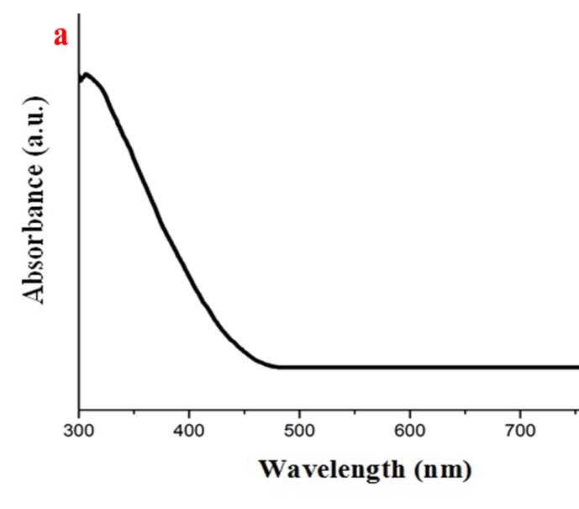

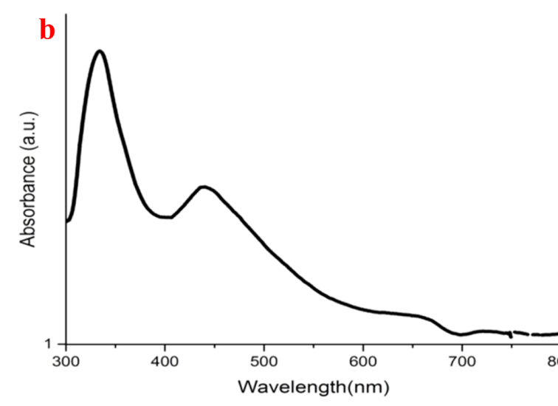

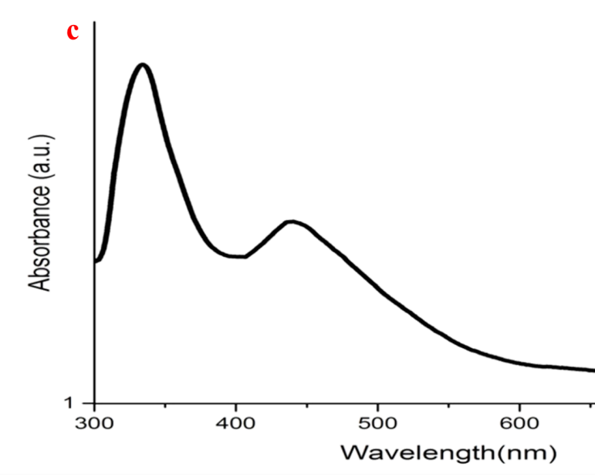

**Figure** **S1**. Solid state

Figure S1. UV-vis spectroscopy of (a) TMU-6(RL1), (b) TMU-6(RL1) and (c) TMU-59

Figure S2. Thermogravimetric analysis of TMU-6(RL1) and TMU-21(RL2)

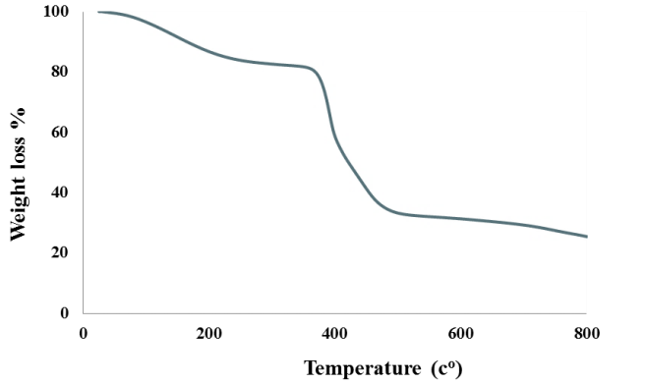

Figure S3. Thermogravimetric analysis of TMU-59

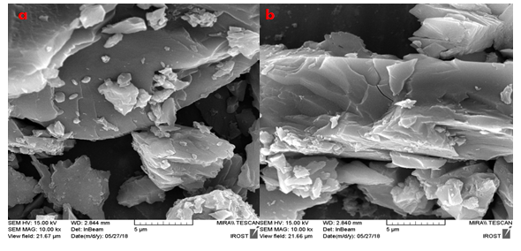

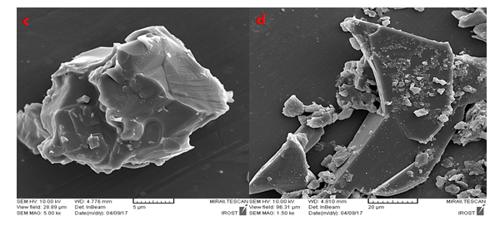

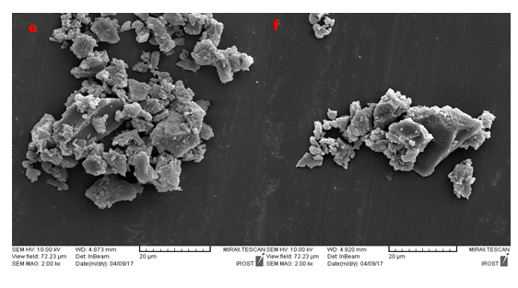

Figure S4. FE-SEM images of TMU-59 (a,b), TMU-6(RL1) (c,d) and TMU-21(RL2) (e,f) as-synthesized particles (a) Adsorption (b)

Figure S5.Fluorescence emission spectra and Stern -Volmer (SV) plots of TMU-21(RL2) dispersed in water solution at different concentrations of Curcumin.

Figure S6.Fluorescence emission spectra and Stern -Volmer (SV) plots of TMU-6(RL1) dispersed in water solution at different concentrations of Curcumin.

Figure S7.Fluorescence emission spectra and Stern -Volmer (SV) plots of TMU-59 dispersed in water solution at different concentrations of Curcumin.

|  |  |  |  |  |  |
| --- | --- | --- | --- | --- | --- |
| **Table S1**. Comparison of Contact angle, DLE, DLC, KSV and Detection Limit MOFs for  C curcumin | | | | | |
|  | Contact  angle of MOFs | Contact angl  (MOFs@Curcumin) | Drug loading  encapsulation  efficiency (DLE) | Drug loading  capability  (DLC) | KSV  (M-1) | Detection  Limit |
| TMU-6(RL1) | 590 | 1080 | 18% | 78% | 42958 | 38nM |
| TMU-21(RL2) | 710 | 1060 | 20% | 70% | 1×106 | 3.6nM |
| TMU-59 | 890 | 990 | 3.6% | 13.6% | 8740 | 375nM |
| Curcumin | 1260 | - | - | - | - | - |

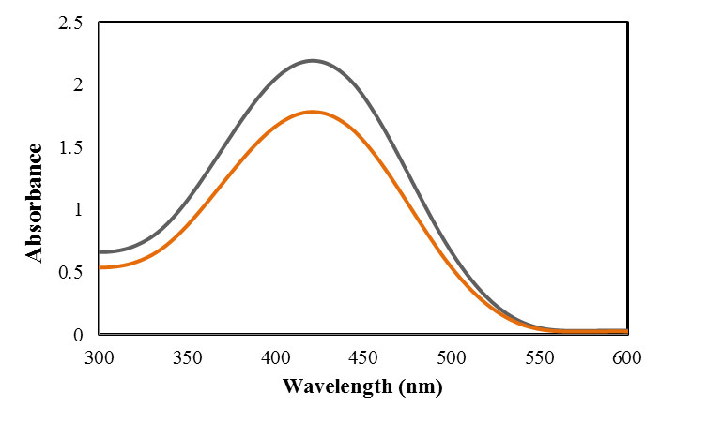

**a**

**b**

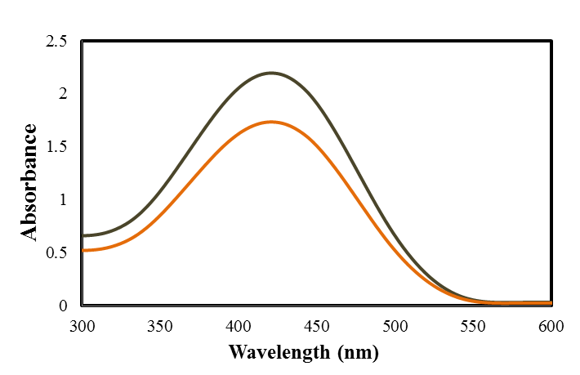

**a**

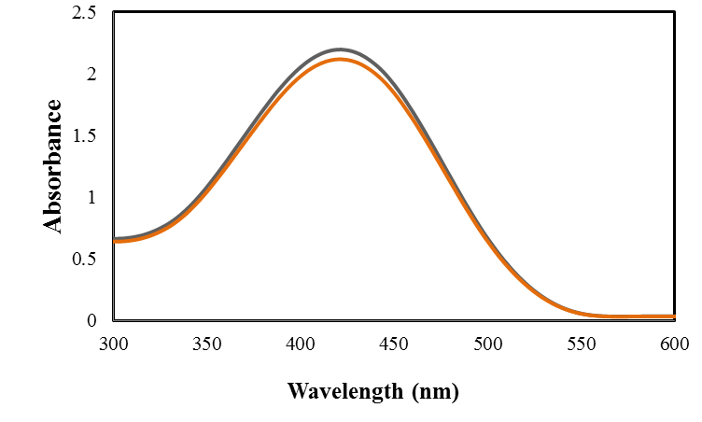

**c**

Figure S8. UV-vis spectra of Curcumin in the presence of (a) TMU-6(RL1), (b) TMU-21(RL2) and (c) TMU-59

**c**

**b**

**a**

**e**

**d**

Figure S9. (a) XPS survey spectrum and high resolution XPS spectra of (b) Zn 2p (c) C 1s, (d) O 1S, and (e) N 1S of TMU-6(RL1), respectively.

**c**

**b**

**a**

**e**

**d**

Figure S10. (a) XPS survey spectrum and high resolution XPS spectra of (b) Zn 2p (c) C 1s, (d) O 1S, and (e) N 1S of TMU-59, respectively.

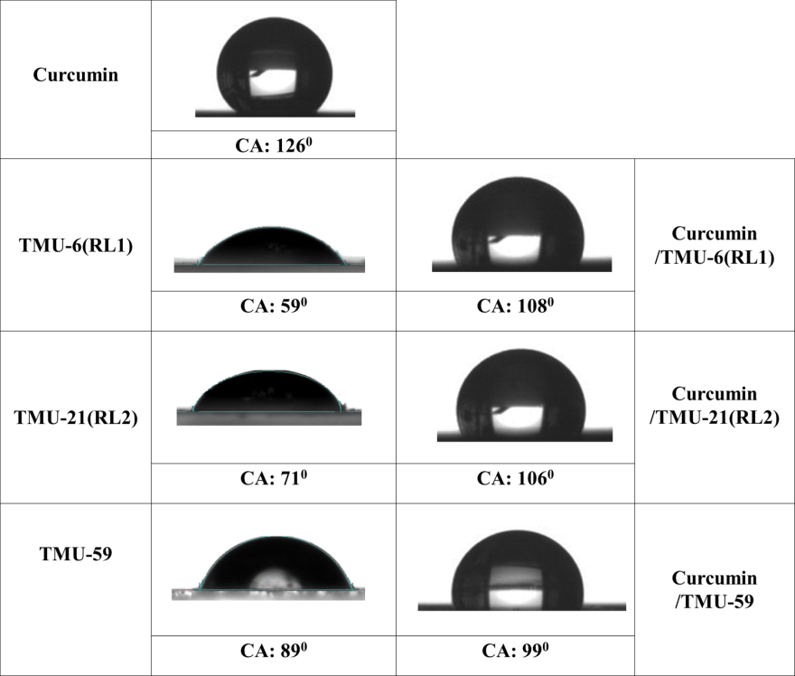

**TMU-59@Curcumin**

**TMU-21(RL2)@Curcumin**

**TMU-6(RL1)@Curcumin**

**3**

**2**

**1**

**Curcumin**

Figure S11. Contact angles of TMU-6(RL1)@Curcumin, TMU-21(RL2)@Curcumin, TMU-59@Curcumin and Curcumin