**Efficient methoxycarbonylation of diisobutylene over functionalized ZSM-5 supported cobalt complex catalysts**

Fuxiang Jina,b*, Jianfeng Wangc, Heyuan Songd, Zhengjun Quana, Qiao Liub, Yiming Yanb, Meirong Kangb, Hailong liu b*, Xicun Wanga*

a *College of Chemistry and Chemical Engineering, Northwest Normal University, Lanzhou 730070, Gansu, China*

*b State Key Laboratory for Oxo Synthesis and Selective Oxidation, Lanzhou Institute of Chemical Physics, Chinese Academy of Sciences, Lanzhou 730000, Gansu, China*

*c* *The eighth oil production plant, PetroChina Changqing Oilfield Company, Xi’an 710016, Shanxi, China*

*d School of Chemistry and Chemical Engineering, Lanzhou Jiaotong University, Lanzhou 730070, Gansu, China*

*Corresponding author. Tel: +860931-4968870; E-mail address: fxjin@licp.cas.cn; hlliu@licp.cas.cn; [wangxicun@nwnu.edu.cn;](mailto:wangxicun@nwnu.edu.cn;%20heyuansong@mail.lzjtu.cn)

E:\2020金福祥\2021二异丁烯羰基化反应\反应条件\催化剂量.tif

**Fig. S1** Reusability of in the ZSM-5iCPdPy@Co2(CO)8 for DIB methoxycarbonylation. Reaction conditions: N: Co =4:1(mol), CH3OH:DIB=15:1(mol), 6.0MPa CO, 140℃, 10h.

E:\2020金福祥\2021二异丁烯羰基化反应\反应条件\烯醇比.tif

**Fig. S2** Reusability of in the ZSM-5iCPdPy@Co2(CO)8 for DIB methoxycarbonylation. Reaction conditions: N: Co =4:1(mol), Co2(CO)8 4wt%, 6.0MPa CO, 140℃, 10h.

E:\2020金福祥\2021二异丁烯羰基化反应\反应条件\CO.tif

**Fig. S3** Reusability of in the ZSM-5iCPdPy@Co2(CO)8 for DIB methoxycarbonylation. Reaction conditions: N: Co =4:1(mol), Co2(CO)8 4wt%, CH3OH:DIB=15:1(mol), 140℃, 10h.

E:\2020金福祥\2021二异丁烯羰基化反应\反应条件\温度.tif

**Fig. S4** Reusability of in the ZSM-5iCPdPy@Co2(CO)8 for DIB methoxycarbonylation. Reaction conditions: N: Co =4:1(mol), Co2(CO)8 4wt%, CH3OH:DIB=15:1(mol), 6.0MPa CO, 10h.

E:\2020金福祥\2021二异丁烯羰基化反应\反应条件\时间.tif

**Fig. S5** Reusability of in the ZSM-5iCPdPy@Co2(CO)8 for DIB methoxycarbonylation. Reaction conditions: N: Co =4:1(mol), Co2(CO)8 4wt%, CH3OH:DIB=15:1(mol), 6.0MPa CO, 140℃.

E:\2020金福祥\2021二异丁烯羰基化反应\红外测试\循环红外.tif

**Fig. S6** FT–IR spectra comparison of the fresh and 6 times reused ZSM-5iCPdPy@Co2(CO)8

E:\2020金福祥\2021二异丁烯羰基化反应\BET\循环BET.tif

**Fig. S7** N2 adsorption–desorption isotherms comparison of the catalyst fresh and 6 times reused.

**Table S1** BET surface properties of ZSM-5iCPdPy@Co2(CO)8.

|  |  |  |  |
| --- | --- | --- | --- |
| Sample | BET surface  area (m2/g) | Pore volume (cm3/g) | Average pore width (nm) |
| Fresh | 241.7 | 0.11 | 7.04 |
| Reused 6 times | 120.4 | 0.09 | 5.76 |

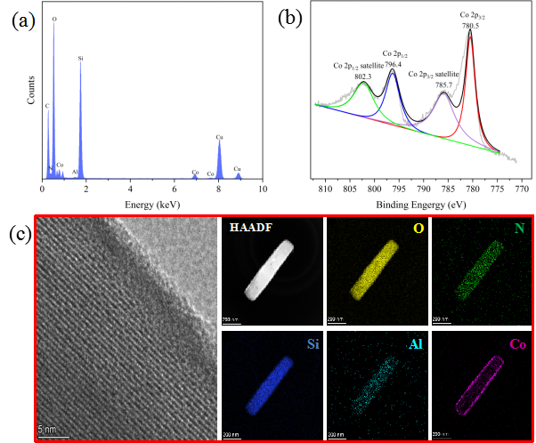

**Fig. S8** (a) EDS, (b) XPS and (c) HAADF-STEM analysis ZSM-5iCPdPy@Co2(CO)8 after the methoxycarbonylation of diisobutylene.

E:\2020金福祥\2021二异丁烯羰基化反应\热过滤实验\Graph2.tif

**Fig. S9** The effect of catalyst removal on the methoxycarbonylation of DIB.Reaction conditions: N: Co =4:1(mol), Co2(CO)8 4wt%, CH3OH:DIB=15:1(mol), 6.0MPa CO, 140℃, 10h.