## Supplementary Material

**Vasodilatory ingredients of essential oil from *Nardostachys jatamansi* DC.: Virtual screening, experimental validation and the potential molecular mechanisms**

**Bian-Xia Xue1,†, Si-Xia Liu1,†,** **Patrick Kwabena Oduro1, Nana Ama Mireku-Gyimah2,** **Li-Hua Zhang1,*, Qi-Long Wang1,*, Hong-Hua Wu1,\***

*1State Key Laboratory of Component-based Chinese Medicine, Institute of Traditional Chinese Medicine, Tianjin University of Traditional Chinese Medicine, 10 Poyanghu Road, West Area, Tuanbo New Town, Jinghai District, Tianjin 301617, People's Republic of China*

*2Department of Pharmacognosy and Herbal Medicine, School of Pharmacy, College of Health Sciences, University of Ghana, Legon-Accra, Ghana*

* **Corresponding authors:**

Li-Hua Zhang, Institute of Traditional Chinese Medicine, Tianjin University of Traditional Chinese Medicine, 10 Poyanghu Road, West Area, Tuanbo New Town, Jinghai District, Tianjin, 301617, China

Tel./fax: +86-022-59791830

E-mail address: zhanglihua200061@163.com (L.-H. Zhang).

Qi-Long Wang, Institute of Traditional Chinese Medicine, Tianjin University of Traditional Chinese Medicine, 10 Poyanghu Road, West Area, Tuanbo New Town, Jinghai District, Tianjin, 301617, China

Tel./fax: +86-022-59791830

E-mail address: [wangqilong_00@tjutcm.edu.cn](mailto:wangqilong_00@tjutcm.edu.cn) (Q.-L. Wang).

ORCID: https://orcid.org/0000-0002-4375-991X

Hong-Hua Wu, Institute of Traditional Chinese Medicine, Tianjin University of Traditional Chinese Medicine, 10 Poyanghu Road, West Area, Tuanbo New Town, Jinghai District, Tianjin, 301617, China

Tel./fax: +86-022-59791833

E-mail address: wuhonghua2011@tjutcm.edu.cn (H.-H. Wu).

ORCID: https://orcid.org/0000-0002-3089-4282.

**†Co-first authors:**

B.-X. Xue and S.-X. Liu contributed equally to this work and should be considered co-first authors.

|  |  |  |
| --- | --- | --- |
| **Table of Contents** | | **Page** |
| **Fig. S1** | The purity chromatogram and MS spectra of valerena-4,7(11)-diene | **1** |
| **Fig. S2** | Thepurity chromatogram and MS spectra of calarene | **2** |
| **Fig. S3** | Thepurity chromatogram and MS spectra of *β*-maaliene | **3** |
| **Fig. S4** | 1H NMR (400 MHz, CDCl3) spectrum of valerena-4,7(11)-diene | **4** |
| **Fig. S5** | 13C NMR (101 MHz, CDCl3) spectrum of valerena-4,7(11)-diene | **4** |
| **Fig. S6** | 1H NMR (400 MHz, CDCl3) spectrum of calarene | **5** |
| **Fig. S7** | 13C NMR (101 MHz, CDCl3) spectrum of calarene | **5** |
| **Fig. S8** | 1H NMR (400 MHz, CDCl3) spectrum of *β*-maaliene | **6** |
| **Fig. S9** | 13C NMR (101 MHz, CDCl3) spectrum of *β*-maaliene | **6** |
| **Fig. S10** | The predictive toxicological parameters of 48 ingredients in EONJ | **7** |
| **Fig. S11** | The plot of the pearson correlation analysis of the relationship between the GC-MS spectrum and the vasodilatory activities of EONJs | **8** |
| **Fig. S12** | The signaling pathway diagram of lipid and atherosclerosis | **9** |
| **Fig. S13** | The relationship diagram among common targets with PI3K and AKT | **10** |
| **Table S1** | The result of GCA between GC-MS spectrum and the vasodilatory efficacy of EONJ | **11** |
| **Table S2** | The result of PLSR between GC-MS spectrum and the vasodilatory efficacy of EONJ | **12** |
| **Table S3** | The canonical SMILES for the forty-eight phytochemicals from EONJs | **13** |
| **Table S4** | The drug-like properties of the forty-eight phytochemicals in EONJs | **15** |
| **Table S5** | The toxicological parameters of the forty-eight phytochemicals in EONJs | **17** |
| **Table S6** | The detailed information of the top 20 DO terms enriched significantly | **19** |
| **Table S7** | The detailed information of the top 20 KEGG terms enriched significantly | **20** |

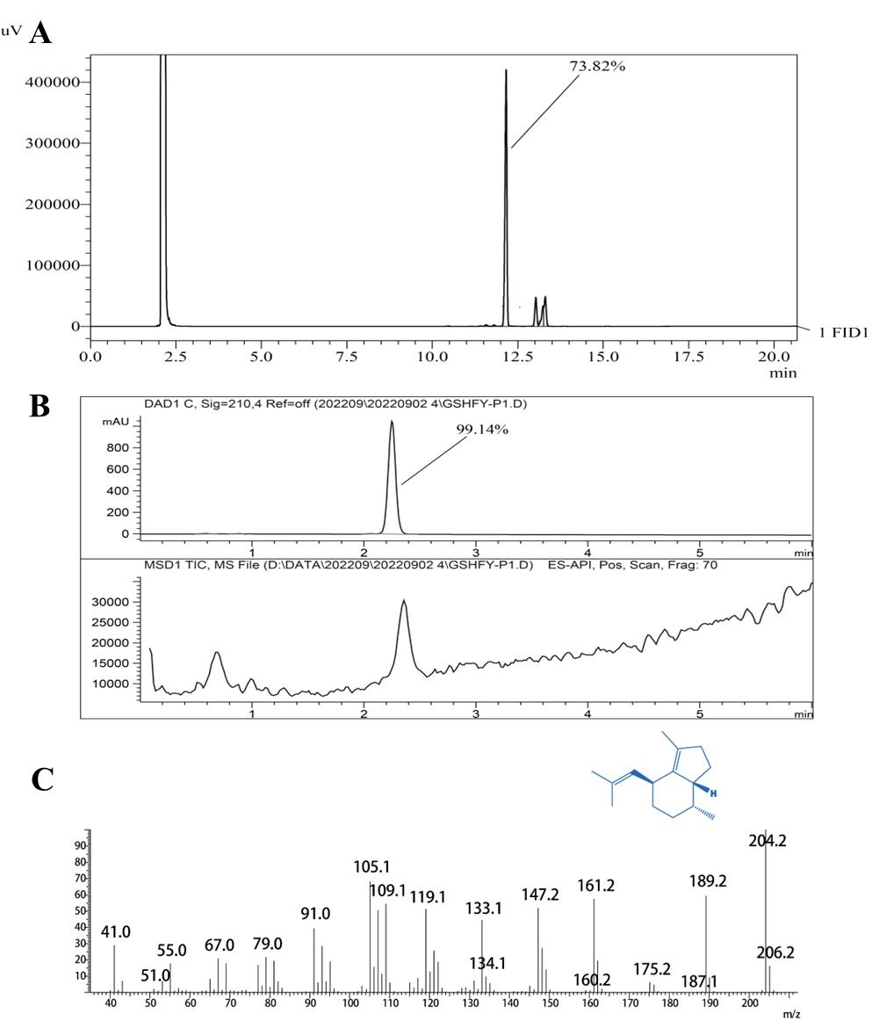

**Fig. S1** Thepurity chromatogram and MS spectra of valerena-4,7(11)-diene (A) The purity chromatogram of valerena-4,7(11)-diene by GC; (B) The purity chromatogram of valerena-4,7(11)-diene by LC-MS; (C) The MS spectra of valerena-4,7(11)-diene by GC-MS

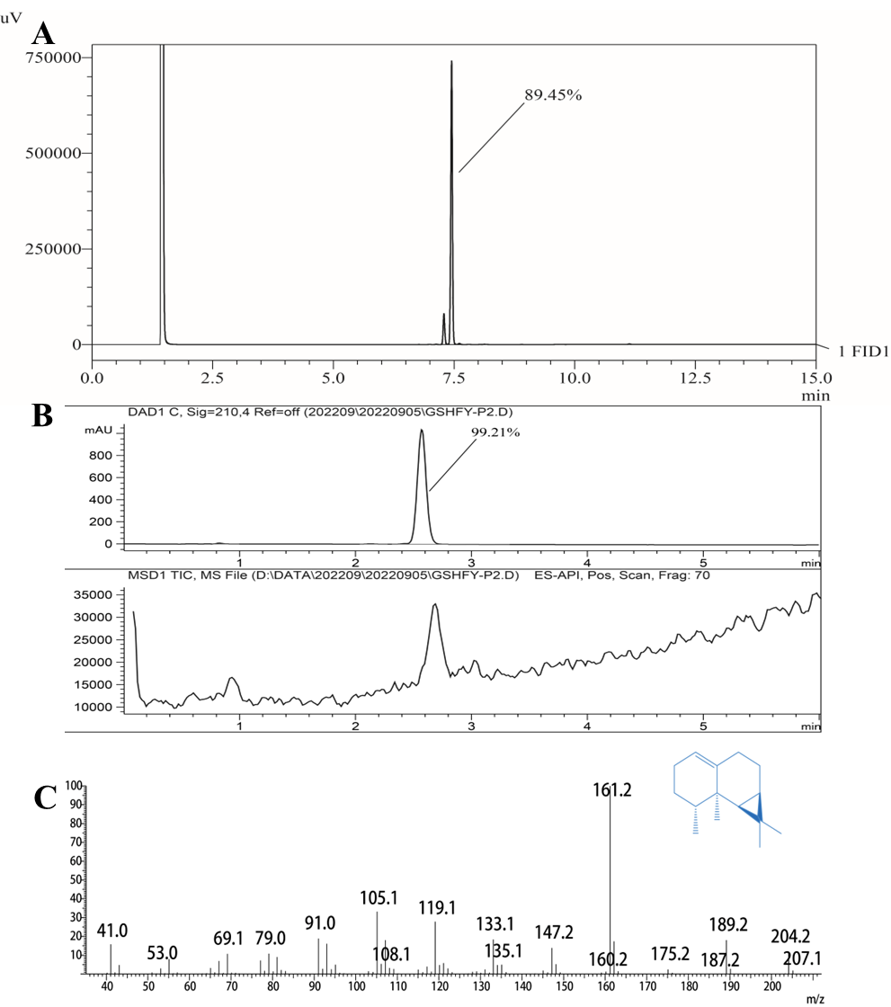

**Fig. S2** Thepurity chromatogram and MS spectra of calarene (A) The purity chromatogram of calarene by GC; (B) The purity chromatogram of calarene by LC-MS; (C) The MS spectra of calarene by GC-MS)

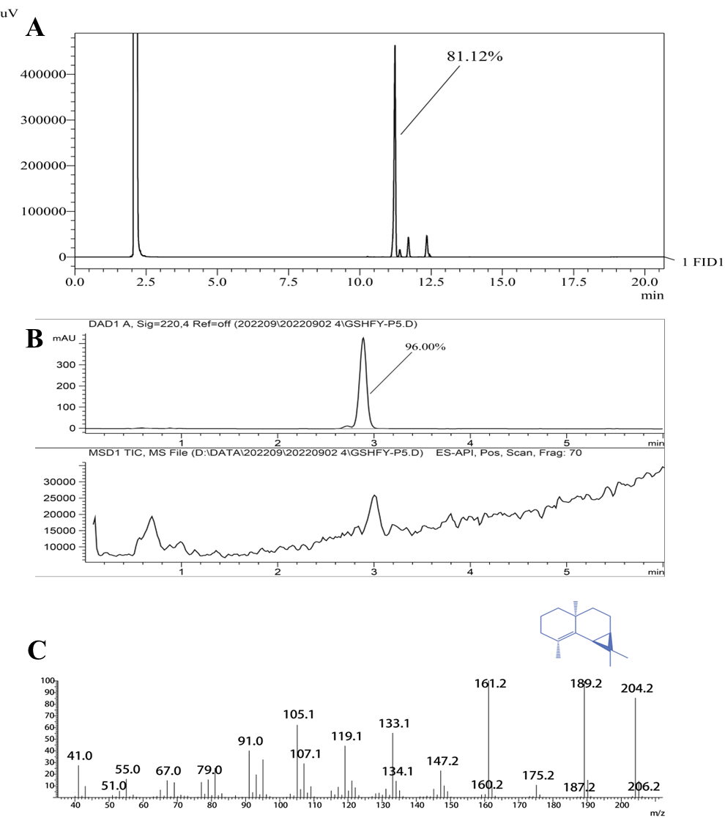

**Fig. S3** Thepurity chromatogram and MS spectra of *β*-maaliene (A) The purity chromatogram of *β*-maaliene by GC; (B) The purity chromatogram of *β*-maaliene by LC-MS; (C) The MS spectra of *β*-maaliene by GC-MS



**Fig. S4** 1H NMR (400 MHz, CDCl3) spectrum of valerena-4,7(11)-diene



**Fig. S5** 13C NMR (101 MHz, CDCl3) spectrum of valerena-4,7(11)-diene 

**Fig. S6** 1H NMR (400 MHz, CDCl3) spectrum of calarene



**Fig. S7** 13C NMR (101 MHz, CDCl3) spectrum of calarene

 **Fig. S8** 1H NMR (400 MHz, CDCl3) spectrum of *β*-maaliene **Fig. S9** 13C NMR (101 MHz, CDCl3) spectrum of *β*-maaliene



**Fig. S10** The predictive toxicological parameters of 48 ingredients in EONJ (The red and green circles represent active or inactive toxicological endpoints, respectively)



**Fig. S11** The plot of the Pearson correlation analysis of the relationship between the GC-MS spectrum and the vasodilatory activities of EONJs

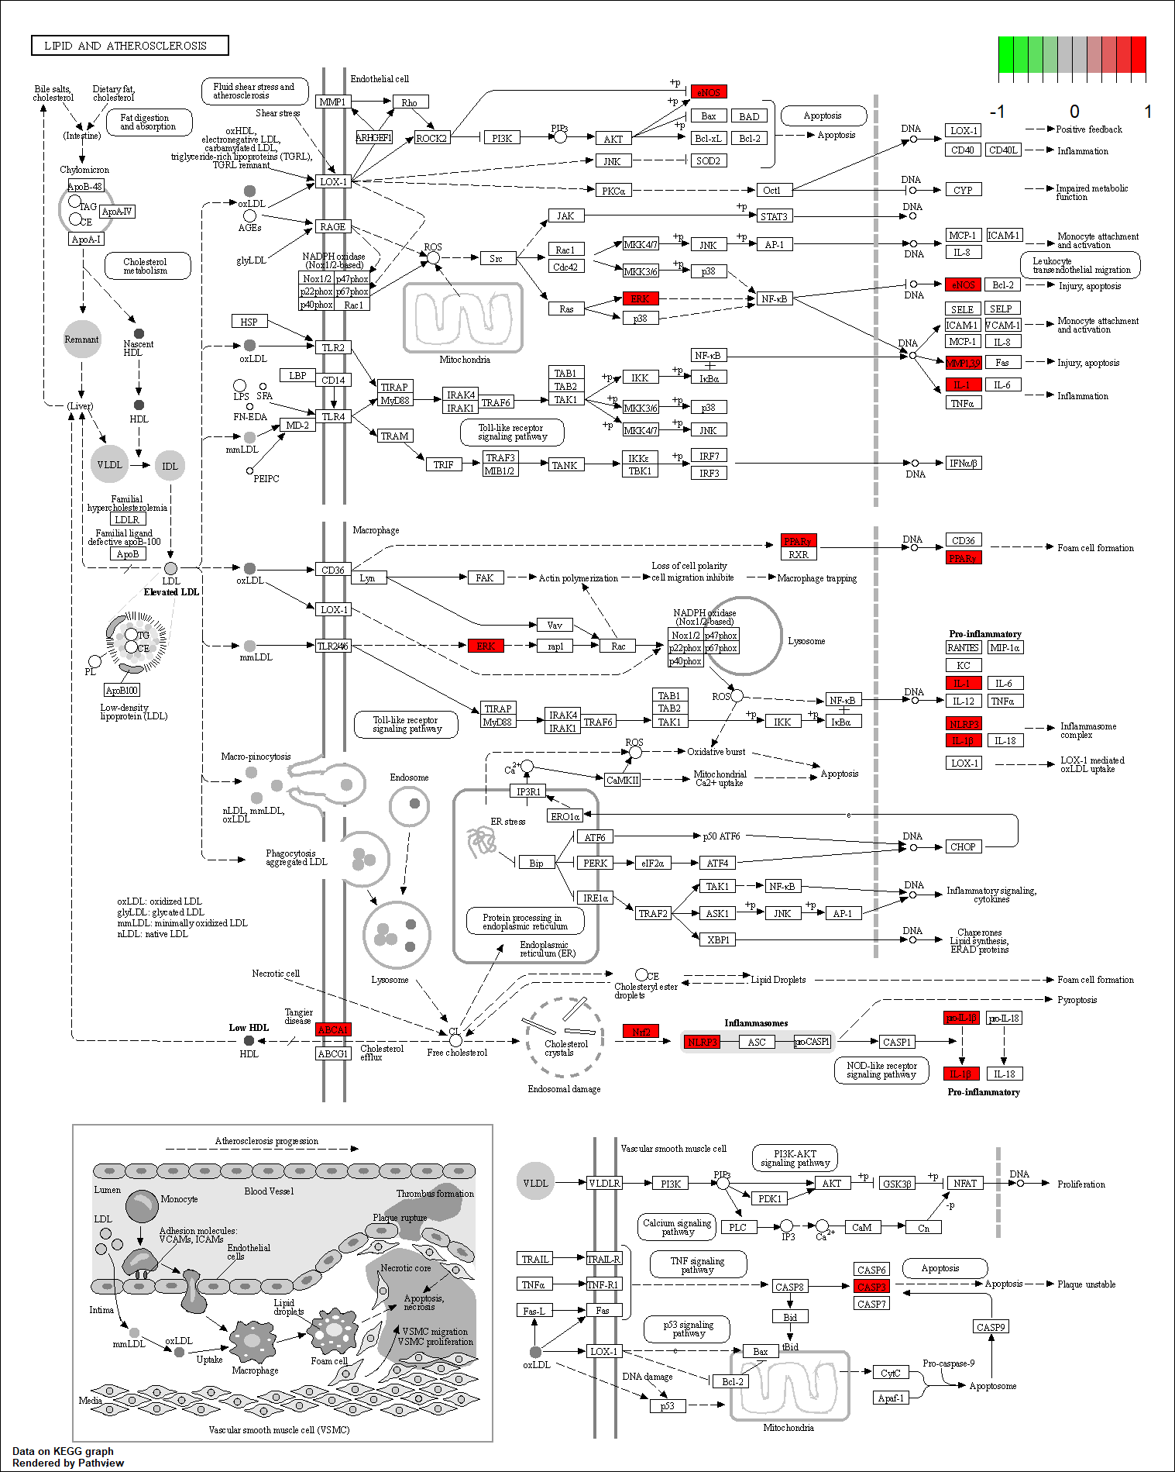

**Fig. S12** The signaling pathway diagram of lipid and atherosclerosis

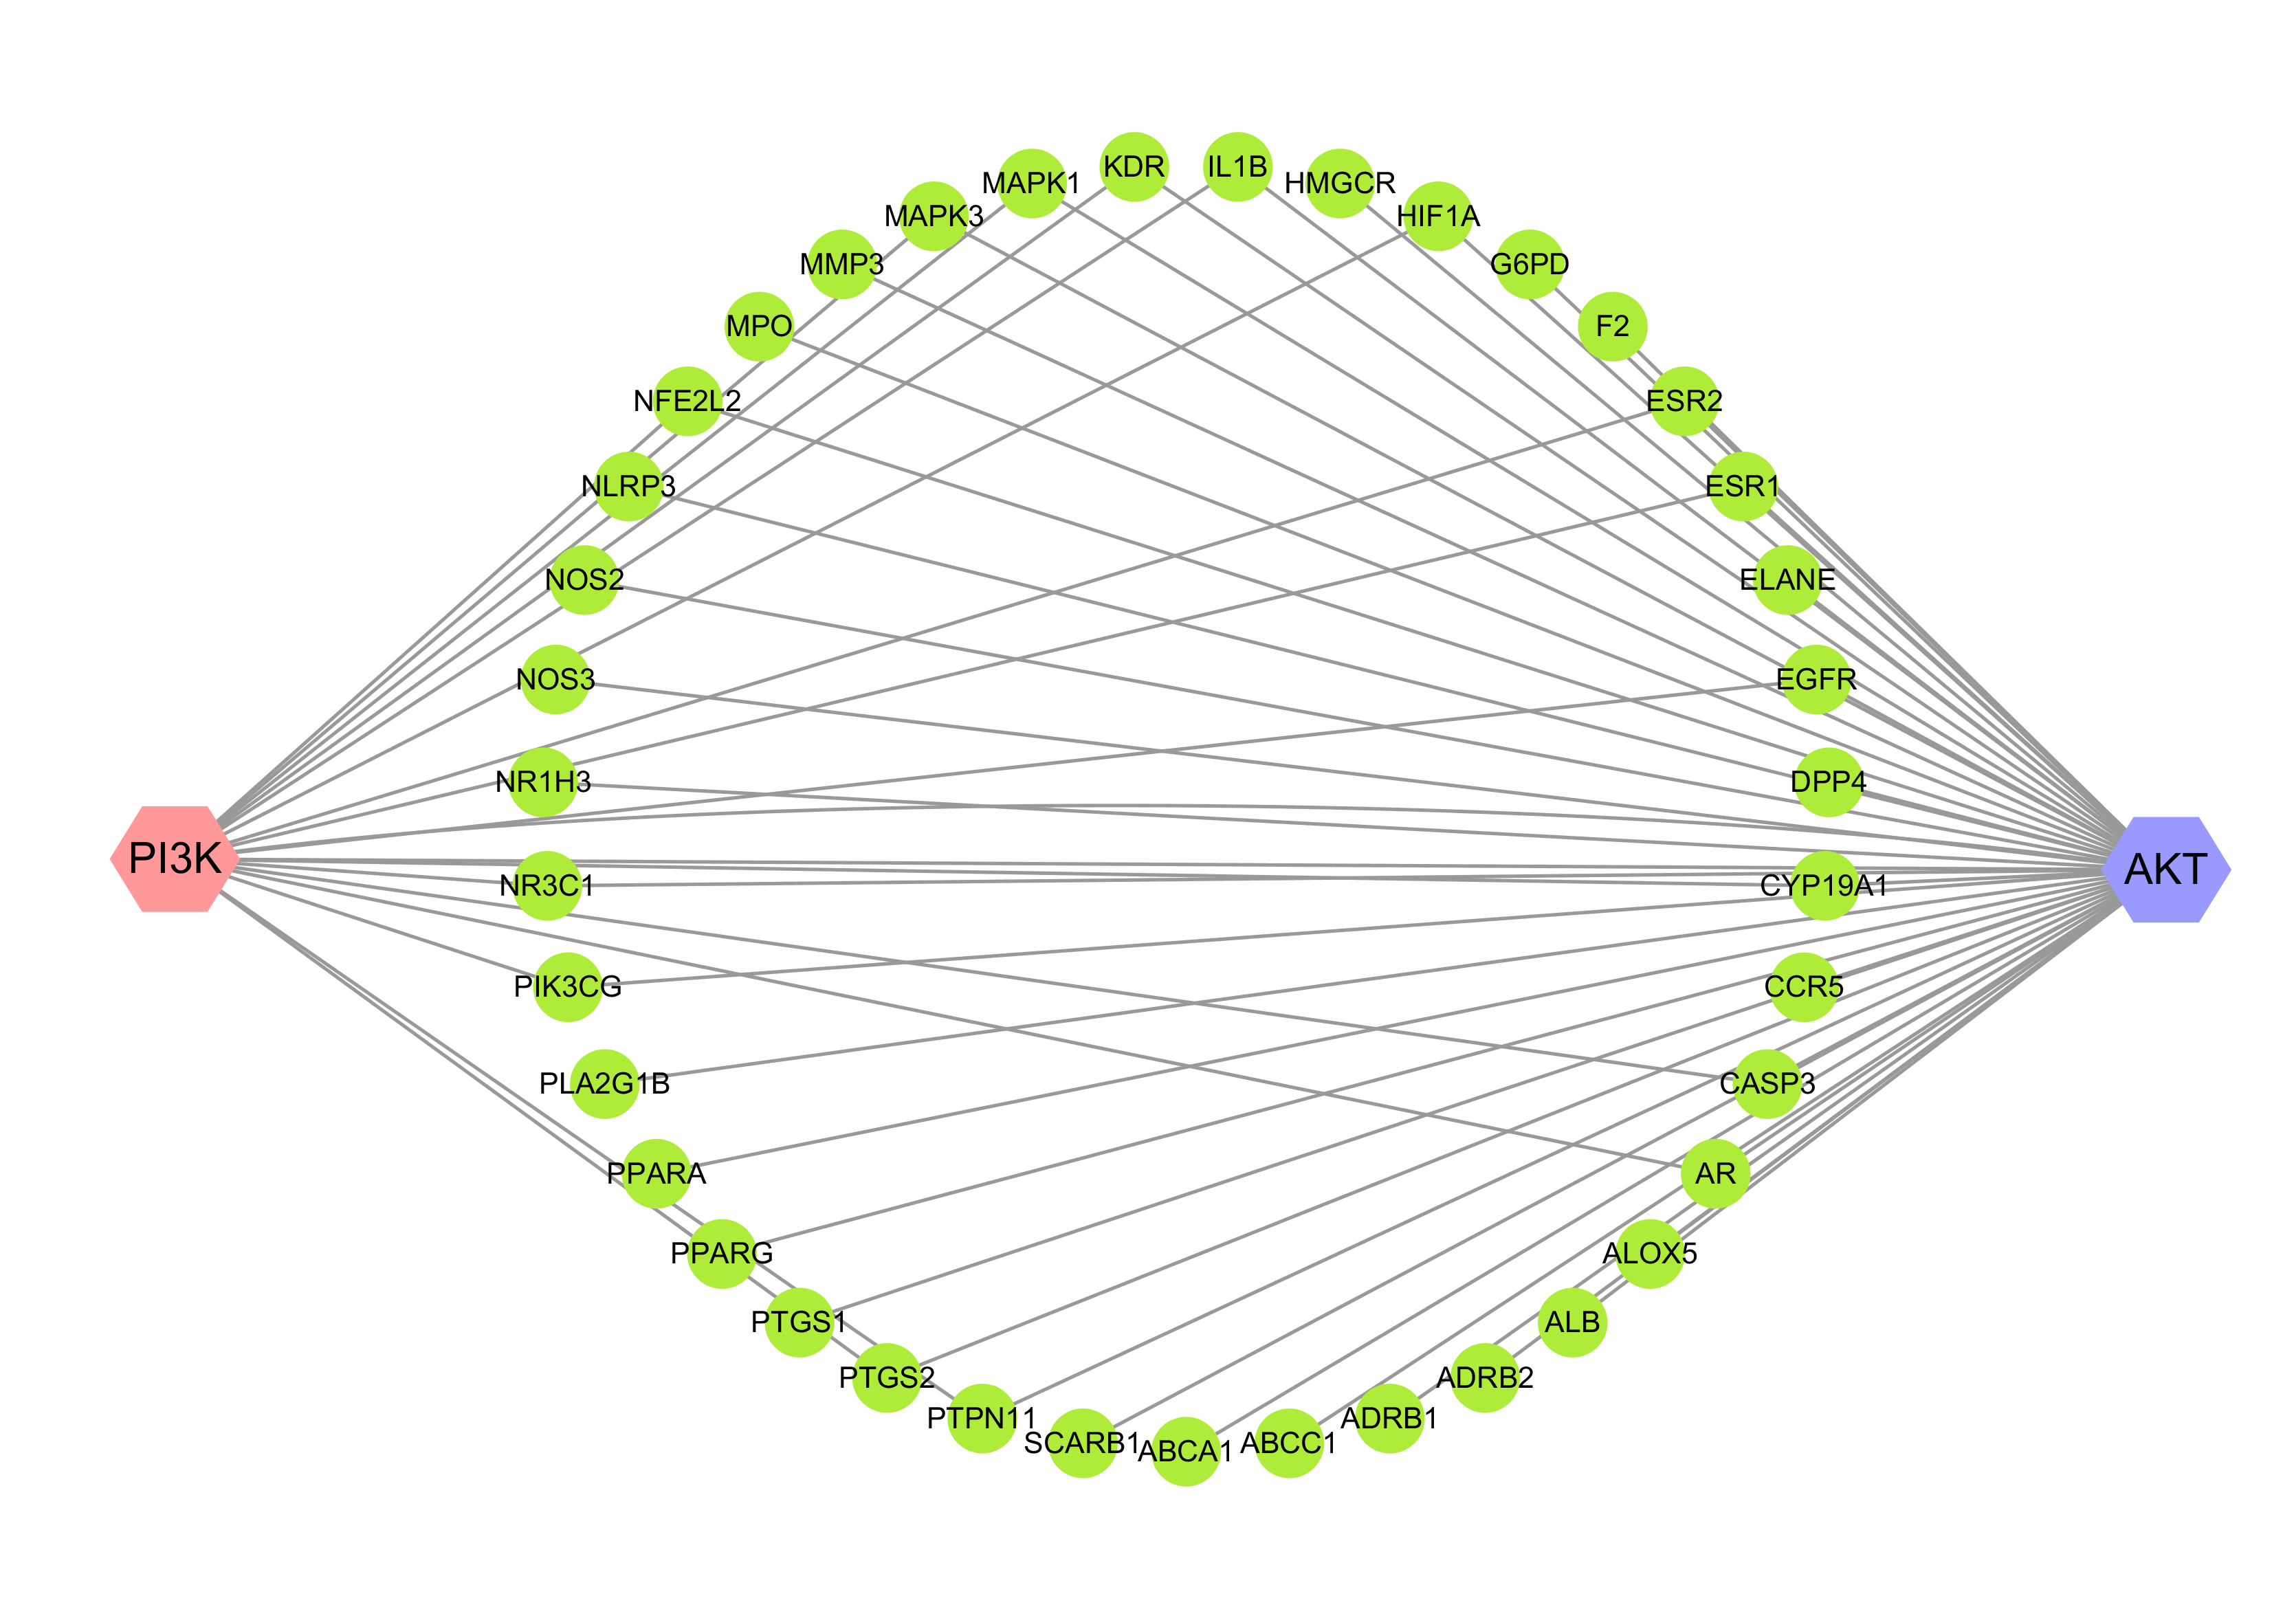

**Fig. S13** The relationship diagram among common targets with PI3K and AKT

**Table S1** The result of GCA between GC-MS spectrum and the vasodilatory efficacy of EONJ

|  |  |  |  |  |  |
| --- | --- | --- | --- | --- | --- |
| **Peak No.** | **Compound** | **Correlation degree (*r*)** | **Peak No.** | **Compound** | **Correlation degree (*r*)** |
| 1 | *β*-Pinene | 0.5752 | 25 | *trans*-*β*-Ionone | 0.6804 |
| 2 | *p*-Cymene | 0.7992 | 26 | Bicyclosesquiphellandrene | 0.5384 |
| 3 | D-Limonene | 0.6367 | 27 | Valencene | 0.6474 |
| 4 | 1,8-Cineol | 0.6498 | 28 | δ-Guaiene | 0.7178 |
| 5 | Terpinen-4-ol | 0.7256 | 29 | Nootkatene | 0.5371 |
| 6 | Methyl thymyl ether | 0.7365 | 30 | *α*-Maaliene | 0.7849 |
| 7 | Isothymol methyl ether | 0.6999 | 31 | *β*-Vatirenene | 0.5631 |
| 8 | 1,4-Dimethyltetralin | 0.7562 | 32 | Maaliol | 0.6876 |
| 9 | Methyl myrtenate | 0.5415 | 33 | Spathulenol | 0.6884 |
| 10 | Myrtenyl acetate | 0.8292 | 34 | Spirojatamol | 0.5388 |
| 11 | *δ*-EIemene | 0.6224 | 35 | (-)-Globulol | 0.7216 |
| 12 | *β*-Patchoulene | 0.7017 | 36 | Isoaromadendrene epoxide | 0.6145 |
| 13 | *β*-Elemene | 0.7635 | 37 | Selin-6-en-4*α*-ol | 0.7087 |
| 14 | *β*-Maaliene | 0.6858 | 38 | *α*-Cadinol | 0.5382 |
| 15 | (-)-Aristolene | 0.7738 | 39 | Isospathulenol | 0.5965 |
| 16 | (*E*)-*β*-Caryophyllene | 0.8540 | 40 | Aromadendrene epoxide | 0.7104 |
| 17 | Calarene | 0.8486 | 41 | Patchouli alcohol | 0.7711 |
| 18 | Guaia-6,9-diene | 0.5821 | 42 | Ledene oxide-(II) | 0.6966 |
| 19 | Seychellene | 0.8524 | 43 | Jatamansone | 0.5386 |
| 20 | Valerena-4,7(11)-diene | 0.8571 | 44 | Valerenol | 0.6438 |
| 21 | *α*-Patchoulene | 0.7876 | 45 | Valerenal | 0.6570 |
| 22 | *allo*-Aromadendrene | 0.5378 | 46 | Aristolone | 0.6125 |
| 23 | *γ*-Himachalane | 0.8098 | 47 | Nootkatone | 0.5385 |
| 24 | *γ*-Gurjunene | 0.6857 | 48 | (*Z*)-Isovalencenal | 0.5578 |

**Table S2** The result of PLSR between GC-MS fingerprints and the vasodilatory efficacy of EONJ

|  |  |  |  |  |  |
| --- | --- | --- | --- | --- | --- |
| **Peak No.** | **Compound** | **Regression coefficient (*r* ¢)** | **Peak No.** | **Compound** | **Regression coefficient (*r* ¢)** |
| 1 | *β*-Pinene | -0.0175 | 25 | *trans*-*β*-Ionone | -0.0512 |
| 2 | *p*-Cymene | 0.0095 | 26 | Bicyclosesquiphellandrene | -0.0205 |
| 3 | D-Limonene | -0.0077 | 27 | Valencene | -0.0188 |
| 4 | 1,8-Cineol | 0.0141 | 28 | δ-Guaiene | 0.0608 |
| 5 | Terpinen-4-ol | -0.0184 | 29 | Nootkatene | -0.0205 |
| 6 | Methyl thymyl ether | -0.0165 | 30 | *α*-Maaliene | -0.0149 |
| 7 | Isothymol methyl ether | 0.0086 | 31 | *β*-Vatirenene | -0.0240 |
| 8 | 1,4-Dimethyltetralin | -0.0680 | 32 | Maaliol | -0.0609 |
| 9 | Methyl myrtenate | -0.0205 | 33 | Spathulenol | -0.0549 |
| 10 | Myrtenyl acetate | -0.0491 | 34 | Spirojatamol | -0.0205 |
| 11 | *δ*-EIemene | 0.0621 | 35 | (-)-Globulol | -0.0597 |
| 12 | *β*-Patchoulene | 0.0011 | 36 | Isoaromadendrene epoxide | -0.0638 |
| 13 | *β*-Elemene | 0.0674 | 37 | Selin-6-en-4*α*-ol | -0.0510 |
| 14 | *β*-Maaliene | 0.0654 | 38 | *α*-Cadinol | -0.0205 |
| 15 | (-)-Aristolene | 0.0664 | 39 | Isospathulenol | -0.0661 |
| 16 | (*E*)-*β*-Caryophyllene | 0.0174 | 40 | Aromadendrene epoxide | -0.0483 |
| 17 | Calarene | 0.0498 | 41 | Patchouli alcohol | 0.0374 |
| 18 | Guaia-6,9-diene | -0.0282 | 42 | Ledene oxide-(II) | -0.0600 |
| 19 | Seychellene | 0.0159 | 43 | Jatamansone | -0.0205 |
| 20 | Valerena-4,7(11)-diene | 0.0166 | 44 | Valerenol | -0.0174 |
| 21 | *α*-Patchoulene | 0.0501 | 45 | Valerenal | -0.0569 |
| 22 | *allo*-Aromadendrene | -0.0205 | 46 | Aristolone | -0.0339 |
| 23 | *γ*-Himachalane | -0.0149 | 47 | Nootkatone | -0.0205 |
| 24 | *γ*-Gurjunene | 0.0596 | 48 | (*Z*)-Isovalencenal | 0.0284 |

**Table S3** The canonical SMILES for the forty-eight phytochemicals from EONJs

|  |  |  |
| --- | --- | --- |
| **No.** | **Compound** | **SMILES** |
| 1 | *β*-Pinene | CC1(C)C2CC1C(=C)CC2 |
| 2 | *p*-Cymene | CC(C)C1=CC=C(C)C=C1 |
| 3 | D-Limonene | CC(=C)C1CCC(C)=CC1 |
| 4 | 1,8-Cineol | CC12CCC(CC1)C(C)(C)O2 |
| 5 | Terpinen-4-ol | CC(C)C1(O)CCC(C)=CC1 |
| 6 | Methyl thymyl ether | COC1=CC(C)=CC=C1C(C)C |
| 7 | Isothymol methyl ether | COC1=CC(=CC=C1C)C(C)C |
| 8 | 1,4-Dimethyltetralin | CC1CCC(C)C2=CC=CC=C12 |
| 9 | Methyl myrtenate | COC(=O)C1=CCC2CC1C2(C)C |
| 10 | Myrtenyl acetate | CC(=O)OCC1=CCC2CC1C2(C)C |
| 11 | *δ*-EIemene | CC(C)C1=CC(C(C)=C)C(C)(CC1)C=C |
| 12 | *β*-Patchoulene | [H][C@]12CC[C@@](C)(C3=C(C1)[C@H](C)CC3)C2(C)C |
| 13 | *β*-Elemene | CC(=C)[C@@H]1CC[C@@](C)(C=C)[C@@H](C1)C(C)=C |
| 14 | *β*-Maaliene | CC1=C2[C@H]3[C@@H](CC[C@]2(C)CCC1)C3(C)C |
| 15 | (-)-Aristolene | C[C@@H]1CCCC2=CC[C@@H]3[C@@H](C3(C)C)[C@@]12C |
| 16 | (*E*)-*β*-Caryophyllene | [H][C@]12CC(C)(C)[C@]1([H])CC\C(C)=C\CCC2=C |
| 17 | Calarene | C[C@@H]1CCC=C2CC[C@@H]3[C@@H](C3(C)C)[C@@]12C |
| 18 | Guaia-6,9-diene | [H][C@@]12CC[C@H](C)[C@]1([H])C=C(CC=C2C)C(C)C |
| 19 | Seychellene | [H][C@@]12CC[C@@]3(C)[C@@]([H])(C1)[C@@H](C)CC[C@@]3(C)C2=C |
| 20 | Valerena-4,7(11)-diene | [H][C@]12CCC(C)=C1[C@@H](CC[C@H]2C)C=C(C)C |
| 21 | *α*-Patchoulene | [H][C@@]12CC3CC=C(C)C1(CCC2C)C3(C)C |
| 22 | *allo*-Aromadendrene | [H][C@]12CC[C@@H](C)[C@@]1([H])C1C(CCC2=C)C1(C)C |
| 23 | *γ*-Himachalane | [H][C@@]12CCC(C)C[C@]1([H])C(C)(C)CCCC2C |
| 24 | *γ*-Gurjunene | [H][C@]12CC[C@@H](C)C1=C[C@@H](CC[C@H]2C)C(C)=C |
| 25 | *trans*-*β*-Ionone | CC(=O)\C=C\C1=C(C)CCCC1(C)C |
| 26 | Bicyclosesquiphellandrene | [H][C@]12CCC(=C)C=C1[C@@H](CC[C@H]2C)C(C)C |
| 27 | Valencene | C[C@@H]1CCC=C2CC[C@H](C[C@@]12C)C(C)=C |
| 28 | *δ*-Guaiene | [H][C@@]12C[C@@H](CCC(C)=C1CC[C@@H]2C)C(C)=C |
| 29 | Nootkatene | [H][C@]1(CC=C2C=CC[C@@]([H])(C)[C@]2(C)C1)C(C)=C |
| 30 | *α*-Maaliene | CC1=CCC[C@@]2(C)CC[C@@H]3[C@H](C12)C3(C)C |
| 31 | *β*-Vatirenene | CC1CC=CC2=CCC(CC12C)=C(C)C |
| 32 | Maaliol | [H][C@@]12CC[C@]3(C)CCC[C@](C)(O)[C@@]3([H])[C@]1([H])C2(C)C |
| 33 | Spathulenol | [H][C@@]12CCC(=C)[C@]3([H])CC[C@](C)(O)[C@@]3([H])[C@]1([H])C2(C)C |
| 34 | Spirojatamol | CC(C)[C@@H]1CCC(=C)[C@]2(CCC[C@]2(C)O)C1 |
| 35 | (-)-Globulol | [H][C@@]12CC[C@@](C)(O)[C@]3([H])CC[C@@H](C)[C@@]3([H])[C@]1([H])C2(C)C |
| 36 | Isoaromadendrene epoxide | CC1CCC2C1C1C(CC3OC23C)C1(C)C |
| 37 | Selin-6-en-4*α*-ol | [H]C12C=C(CCC1(C)CCCC2(C)O)C(C)C |
| 38 | *α*-Cadinol | [H][C@@]12C=C(C)CC[C@@]1([H])[C@](C)(O)CC[C@H]2C(C)C |
| 39 | Isospathulenol | [H][C@@]12CCC(C)=C3CC[C@](C)(O)[C@@]3([H])[C@]1([H])C2(C)C |
| 40 | Aromadendrene epoxide | [H][C@@]12CC[C@@]3(CO3)[C@]3([H])CC[C@@H](C)[C@@]3([H])[C@]1([H])C2(C)C |
| 41 | Patchouli alcohol | [H][C@@]12CC[C@@]3(C)[C@@]([H])(C1)[C@@H](C)CC[C@@]3(O)C2(C)C |
| 42 | Ledene oxide-(II) | CC1CCC23OC2(C)CCC2C(C13)C2(C)C |
| 43 | Jatamansone | CC(C)[C@@H]1CC[C@]2(C)CCCC(=O)[C@]2(C)C1 |
| 44 | Valerenol | [H][C@]12CCC(C)=C1[C@@H](CC[C@H]2C)\C=C(/C)CO |
| 45 | Valerenal | [H][C@]12CCC(C)=C1[C@@H](CC[C@H]2C)\C=C(/C)C=O |
| 46 | Aristolone | C[C@@H]1CCCC2=CC(=O)[C@@H]3[C@@H](C3(C)C)[C@@]12C |
| 47 | Nootkatone | C[C@@H]1CC(=O)C=C2CC[C@H](C[C@@]12C)C(C)=C |
| 48 | (*Z*)-Isovalencenal | [H]C(=O)C(\C)=C1\CCC2=CCCC(C)C2(C)C1 |

**Table S4** The drug-like properties of the forty-eight phytochemicals in EONJs

|  |  |  |  |  |  |  |  |
| --- | --- | --- | --- | --- | --- | --- | --- |
| **No.** | **Compound** | **MW** | **Hdon** | **Hacc** | **Rbon** | **LogP** | **SAscore** |
| 1 | *β*-Pinene | 136.23 | 0 | 0 | 0 | 3.42 | 4.385 |
| 2 | *p*-Cymene | 134.22 | 0 | 0 | 1 | 3.50 | 1.251 |
| 3 | D-Limonene | 136.23 | 0 | 0 | 1 | 3.37 | 3.165 |
| 4 | 1,8-Cineol | 154.25 | 0 | 1 | 0 | 2.67 | 3.953 |
| 5 | Terpinen-4-ol | 154.25 | 1 | 1 | 1 | 2.60 | 3.665 |
| 6 | Methyl thymyl ether | 164.24 | 0 | 1 | 2 | 3.20 | 1.571 |
| 7 | Isothymol methyl ether | 164.24 | 0 | 1 | 2 | 3.21 | 1.546 |
| 8 | 1,4-Dimethyltetralin | 160.26 | 0 | 0 | 0 | 3.67 | 2.844 |
| 9 | Methyl myrtenate | 180.24 | 0 | 2 | 2 | 2.54 | 4.205 |
| 10 | Myrtenyl acetate | 194.27 | 0 | 2 | 3 | 2.88 | 4.168 |
| 11 | *δ*-EIemene | 204.35 | 0 | 0 | 3 | 4.49 | 4.343 |
| 12 | *β*-Patchoulene | 204.35 | 0 | 0 | 0 | 3.76 | 4.794 |
| 13 | *β*-Elemene | 204.35 | 0 | 0 | 3 | 4.65 | 4.188 |
| 14 | *β*-Maaliene | 204.35 | 0 | 0 | 0 | 4.43 | 4.020 |
| 15 | (-)-Aristolene | 204.35 | 0 | 0 | 0 | 4.36 | 4.217 |
| 16 | (*E*)-*β*-Caryophyllene | 204.35 | 0 | 0 | 0 | 4.24 | 4.172 |
| 17 | Calarene | 204.35 | 0 | 0 | 0 | 4.36 | 4.250 |
| 18 | Guaia-6,9-diene | 204.35 | 0 | 0 | 1 | 4.13 | 4.298 |
| 19 | Seychellene | 205.35 | 0 | 0 | 0 | 4.49 | 5.369 |
| 20 | Valerena-4,7(11)-diene | 204.35 | 0 | 0 | 1 | 4.28 | 4.023 |
| 21 | *α*-Patchoulene | 204.35 | 0 | 0 | 0 | 4.38 | 5.486 |
| 22 | *allo*-Aromadendrene | 204.35 | 0 | 0 | 0 | 4.34 | 4.223 |
| 23 | *γ*-Himachalane | 208.38 | 0 | 0 | 0 | 4.86 | 3.679 |
| 24 | *γ*-Gurjunene | 204.35 | 0 | 0 | 1 | 4.30 | 4.395 |
| 25 | *trans*-*β*-Ionone | 192.30 | 0 | 1 | 2 | 3.22 | 2.719 |
| 26 | Bicyclosesquiphellandrene | 204.35 | 0 | 0 | 1 | 4.24 | 4.135 |
| 27 | Valencene | 204.35 | 0 | 0 | 1 | 4.41 | 4.011 |
| 28 | *δ*-Guaiene | 204.35 | 0 | 0 | 1 | 4.30 | 3.904 |
| 29 | Nootkatene | 202.34 | 0 | 0 | 1 | 4.19 | 4.388 |
| 30 | *α*-Maaliene | 204.35 | 0 | 0 | 0 | 4.36 | 4.161 |
| 31 | *β*-Vatirenene | 202.34 | 0 | 0 | 0 | 4.12 | 4.506 |
| 32 | Maaliol | 222.37 | 1 | 1 | 0 | 3.58 | 4.277 |
| 33 | Spathulenol | 220.35 | 1 | 1 | 0 | 3.30 | 4.302 |
| 34 | Spirojatamol | 222.37 | 1 | 1 | 1 | 3.65 | 4.677 |
| 35 | (-)-Globulol | 222.37 | 1 | 1 | 0 | 3.41 | 4.218 |
| 36 | Isoaromadendrene epoxide | 220.35 | 0 | 1 | 0 | 3.53 | 4.564 |
| 37 | Selin-6-en-4*α*-ol | 222.37 | 1 | 1 | 1 | 3.58 | 4.133 |
| 38 | *α*-Cadinol | 222.37 | 1 | 1 | 1 | 3.43 | 4.020 |
| 39 | Isospathulenol | 220.35 | 1 | 1 | 0 | 3.26 | 4.336 |
| 40 | Aromadendrene epoxide | 220.35 | 0 | 1 | 0 | 3.54 | 4.831 |
| 41 | Patchouli alcohol | 222.37 | 1 | 1 | 0 | 3.56 | 5.250 |
| 42 | Ledene oxide-(II) | 220.35 | 0 | 1 | 0 | 3.59 | 5.062 |
| 43 | Jatamansone | 222.37 | 0 | 1 | 1 | 3.89 | 3.933 |
| 44 | Valerenol | 220.35 | 1 | 1 | 2 | 3.43 | 4.190 |
| 45 | Valerenal | 218.33 | 0 | 1 | 2 | 3.44 | 4.286 |
| 46 | Aristolone | 218.33 | 0 | 1 | 0 | 3.42 | 4.505 |
| 47 | Nootkatone | 218.33 | 0 | 1 | 1 | 3.58 | 4.178 |
| 48 | (*Z*)-Isovalencenal | 218.33 | 0 | 1 | 1 | 3.48 | 4.359 |

**Table S5** The toxicological parameters of the forty-eight phytochemicals in EONJs

|  |  |  |  |  |  |  |  |
| --- | --- | --- | --- | --- | --- | --- | --- |
| **No.** | **Compound** | **Hepatotoxicity** | **Carcinogenicity** | **Immunotoxicity** | **Mutagenicity** | **Cytotoxicity** | **Acute oral toxicity (LD50, mg/kg)** |
| 1 | *β*-Pinene | Inactive | Inactive | Inactive | Inactive | Inactive | 4700 |
| 2 | *p*-Cymene | Inactive | Active | Inactive | Inactive | Inactive | 3 |
| 3 | D-Limonene | Inactive | Inactive | Inactive | Inactive | Inactive | 4400 |
| 4 | 1,8-Cineol | Inactive | Inactive | Inactive | Inactive | Inactive | 2480 |
| 5 | Terpinen-4-ol | Inactive | Inactive | Inactive | Inactive | Inactive | 1016 |
| 6 | Methyl thymyl ether | Inactive | Active | Inactive | Inactive | Inactive | 880 |
| 7 | Isothymol methyl ether | Inactive | Active | Inactive | Inactive | Inactive | 880 |
| 8 | 1,4-Dimethyltetralin | Inactive | Inactive | Inactive | Active | Inactive | 6700 |
| 9 | Methyl myrtenate | Inactive | Inactive | Inactive | Inactive | Inactive | 700 |
| 10 | Myrtenyl acetate | Inactive | Inactive | Inactive | Inactive | Inactive | 2600 |
| 11 | *δ*-EIemene | Inactive | Inactive | Inactive | Inactive | Inactive | 5300 |
| 12 | *β*-Patchoulene | Inactive | Inactive | Inactive | Inactive | Inactive | 5000 |
| 13 | *β*-Elemene | Inactive | Inactive | Inactive | Inactive | Inactive | 5000 |
| 14 | *β*-Maaliene | Inactive | Inactive | Inactive | Inactive | Inactive | 5000 |
| 15 | (-)-Aristolene | Inactive | Inactive | Active | Inactive | Inactive | 4800 |
| 16 | (*E*)-*β*-Caryophyllene | Inactive | Inactive | Active | Inactive | Inactive | 5300 |
| 17 | Calarene | Inactive | Inactive | Active | Inactive | Inactive | 5000 |
| 18 | Guaia-6,9-diene | Inactive | Inactive | Inactive | Inactive | Inactive | 4390 |
| 19 | Seychellene | Inactive | Inactive | Inactive | Inactive | Inactive | 5000 |
| 20 | Valerena-4,7(11)-diene | Inactive | Inactive | Inactive | Inactive | Inactive | 3650 |
| 21 | *α*-Patchoulene | Inactive | Inactive | Inactive | Inactive | Inactive | 5000 |
| 22 | *allo*-Aromadendrene | Inactive | Inactive | Inactive | Inactive | Inactive | 5000 |
| 23 | *γ*-Himachalane | Inactive | Inactive | Inactive | Inactive | Inactive | 15380 |
| 24 | *γ*-Gurjunene | Inactive | Inactive | Inactive | Inactive | Inactive | 5000 |
| 25 | *trans*-*β*-Ionone | Inactive | Inactive | Inactive | Inactive | Inactive | 4590 |
| 26 | Bicyclosesquiphellandrene | Inactive | Inactive | Active | Inactive | Inactive | 5000 |
| 27 | Valencene | Inactive | Inactive | Inactive | Inactive | Inactive | 5000 |
| 28 | *δ*-Guaiene | Inactive | Inactive | Inactive | Inactive | Inactive | 5000 |
| 29 | Nootkatene | Inactive | Inactive | Inactive | Inactive | Inactive | 5700 |
| 30 | *α*-Maaliene | Inactive | Inactive | Inactive | Inactive | Inactive | 5000 |
| 31 | *β*-Vatirenene | Inactive | Inactive | Inactive | Inactive | Inactive | 3040 |
| 32 | Maaliol | Inactive | Inactive | Inactive | Inactive | Inactive | 5000 |
| 33 | Spathulenol | Inactive | Inactive | Inactive | Inactive | Inactive | 3900 |
| 34 | Spirojatamol | Inactive | Inactive | Active | Inactive | Inactive | 2000 |
| 35 | (-)-Globulol | Inactive | Inactive | Inactive | Inactive | Inactive | 2000 |
| 36 | Isoaromadendrene epoxide | Inactive | Inactive | Inactive | Inactive | Inactive | 5000 |
| 37 | Selin-6-en-4*α*-ol | Inactive | Inactive | Active | Inactive | Inactive | 890 |
| 38 | *α*-Cadinol | Inactive | Inactive | Active | Inactive | Inactive | 2830 |
| 39 | Isospathulenol | Inactive | Inactive | Active | Inactive | Inactive | 1016 |
| 40 | Aromadendrene epoxide | Inactive | Inactive | Inactive | Inactive | Inactive | 5000 |
| 41 | Patchouli alcohol | Inactive | Inactive | Inactive | Inactive | Inactive | 940 |
| 42 | Ledene oxide-(II) | Inactive | Inactive | Inactive | Inactive | Inactive | 5000 |
| 43 | Jatamansone | Inactive | Inactive | Inactive | Inactive | Inactive | 500 |
| 44 | Valerenol | Inactive | Inactive | Inactive | Inactive | Inactive | 1800 |
| 45 | Valerenal | Inactive | Inactive | Inactive | Inactive | Inactive | 5000 |
| 46 | Aristolone | Inactive | Inactive | Inactive | Inactive | Inactive | 1870 |
| 47 | Nootkatone | Inactive | Inactive | Inactive | Inactive | Inactive | 1870 |
| 48 | (*Z*)-Isovalencenal | Inactive | Inactive | Inactive | Inactive | Inactive | 5200 |

**Table S6** The detailed information of the top 20 DO terms enriched significantly

|  |  |  |  |  |  |  |  |
| --- | --- | --- | --- | --- | --- | --- | --- |
| **ID** | **Description** | **GeneRatio** | **BgRatio** | **p value** | **p.adjust** | **q value** | **Count** |
| DOID:9970 | Obesity | 53/263 | 313/8007 | 3.97E-24 | 2.87E-21 | 1.33E-21 | 53 |
| DOID:654 | Overnutrition | 53/263 | 322/8007 | 1.61E-23 | 5.81E-21 | 2.69E-21 | 53 |
| DOID:374 | Nutrition disease | 54/263 | 338/8007 | 2.53E-23 | 6.09E-21 | 2.82E-21 | 54 |
| DOID:680 | Tauopathy | 53/263 | 434/8007 | 1.91E-17 | 3.45E-15 | 1.60E-15 | 53 |
| DOID:10652 | Alzheimer's disease | 52/263 | 430/8007 | 6.23E-17 | 9.01E-15 | 4.17E-15 | 52 |
| DOID:3393 | Coronary artery disease | 46/263 | 348/8007 | 1.63E-16 | 1.96E-14 | 9.07E-15 | 46 |
| DOID:5844 | Myocardial infarction | 40/263 | 279/8007 | 1.18E-15 | 1.21E-13 | 5.62E-14 | 40 |
| DOID:936 | Brain disease | 48/263 | 454/8007 | 2.26E-13 | 1.99E-11 | 9.23E-12 | 48 |
| DOID:0060037 | Developmental disorder of mental health | 43/263 | 373/8007 | 2.48E-13 | 1.99E-11 | 9.23E-12 | 43 |
| DOID:0060041 | Autism spectrum disorder | 29/263 | 190/8007 | 2.74E-12 | 1.80E-10 | 8.34E-11 | 29 |
| DOID:12849 | Autistic disorder | 29/263 | 190/8007 | 2.74E-12 | 1.80E-10 | 8.34E-11 | 29 |
| DOID:2348 | Arteriosclerotic cardiovascular disease | 39/263 | 345/8007 | 6.89E-12 | 4.15E-10 | 1.92E-10 | 39 |
| DOID:0060040 | Pervasive developmental disorder | 29/263 | 201/8007 | 1.16E-11 | 6.44E-10 | 2.98E-10 | 29 |
| DOID:2349 | Arteriosclerosis | 39/263 | 356/8007 | 1.84E-11 | 9.49E-10 | 4.39E-10 | 39 |
| DOID:1936 | Atherosclerosis | 38/263 | 344/8007 | 2.68E-11 | 1.29E-09 | 5.97E-10 | 38 |
| DOID:655 | Inherited metabolic disorder | 37/263 | 331/8007 | 3.55E-11 | 1.60E-09 | 7.43E-10 | 37 |
| DOID:0060084 | Cell type benign neoplasm | 45/263 | 475/8007 | 6.41E-11 | 2.73E-09 | 1.26E-09 | 45 |
| DOID:18 | Urinary system disease | 45/263 | 478/8007 | 7.93E-11 | 3.18E-09 | 1.47E-09 | 45 |
| DOID:557 | Kidney disease | 44/263 | 461/8007 | 8.48E-11 | 3.22E-09 | 1.49E-09 | 44 |
| DOID:326 | Ischemia | 28/263 | 204/8007 | 9.03E-11 | 3.27E-09 | 1.51E-09 | 28 |

**Table S7** The detailed information of the top 20 KEGG terms enriched significantly

|  |  |  |  |  |  |  |  |
| --- | --- | --- | --- | --- | --- | --- | --- |
| **ID** | **Description** | **GeneRatio** | **BgRatio** | **p value** | **p.adjust** | **qvalue** | **Count** |
| hsa05207 | Chemical carcinogenesis - receptor activation | 0.2 | 212/8145 | 3.30E-08 | 7.17E-06 | 3.55E-06 | 12 |
| hsa04726 | Serotonergic synapse | 0.133333 | 115/8145 | 1.72E-06 | 0.000186 | 9.21E-05 | 8 |
| hsa05417 | Lipid and atherosclerosis | 0.166667 | 215/8145 | 3.17E-06 | 0.000229 | 0.000113 | 10 |
| hsa00590 | Arachidonic acid metabolism | 0.1 | 61/8145 | 5.02E-06 | 0.000272 | 0.000135 | 6 |
| hsa05145 | Toxoplasmosis | 0.116667 | 112/8145 | 1.63E-05 | 0.000656 | 0.000325 | 7 |
| hsa05133 | Pertussis | 0.1 | 76/8145 | 1.81E-05 | 0.000656 | 0.000325 | 6 |
| hsa04540 | Gap junction | 0.1 | 88/8145 | 4.20E-05 | 0.001302 | 0.000644 | 6 |
| hsa04657 | IL-17 signaling pathway | 0.1 | 94/8145 | 6.10E-05 | 0.00163 | 0.000806 | 6 |
| hsa04370 | VEGF signaling pathway | 0.083333 | 59/8145 | 6.76E-05 | 0.00163 | 0.000806 | 5 |
| hsa04933 | AGE-RAGE signaling pathway in diabetic complications | 0.1 | 100/8145 | 8.63E-05 | 0.001744 | 0.000863 | 6 |
| hsa05130 | Pathogenic Escherichia coli infection | 0.133333 | 197/8145 | 8.84E-05 | 0.001744 | 0.000863 | 8 |
| hsa04625 | C-type lectin receptor signaling pathway | 0.1 | 104/8145 | 0.000107 | 0.001922 | 0.000951 | 6 |
| hsa05205 | Proteoglycans in cancer | 0.133333 | 205/8145 | 0.000117 | 0.001922 | 0.000951 | 8 |
| hsa04659 | Th17 cell differentiation | 0.1 | 108/8145 | 0.000132 | 0.001922 | 0.000951 | 6 |
| hsa04066 | HIF-1 signaling pathway | 0.1 | 109/8145 | 0.000139 | 0.001922 | 0.000951 | 6 |
| hsa05160 | Hepatitis C | 0.116667 | 157/8145 | 0.000142 | 0.001922 | 0.000951 | 7 |
| hsa05230 | Central carbon metabolism in cancer | 0.083333 | 70/8145 | 0.000154 | 0.00195 | 0.000965 | 5 |
| hsa04668 | TNF signaling pathway | 0.1 | 112/8145 | 0.000162 | 0.00195 | 0.000965 | 6 |
| hsa05208 | Chemical carcinogenesis - reactive oxygen species | 0.133333 | 223/8145 | 0.000209 | 0.002386 | 0.00118 | 8 |
| hsa05140 | Leishmaniasis | 0.083333 | 77/8145 | 0.000241 | 0.002616 | 0.001294 | 5 |