**Supplementary material**

**Preparation and evaluation of poplar waste derived adsorbent for dye**

**removal：adsorption mechanism and DFT calculation**

Xiaojing Qina, Xiangwang Zeng b, Song Cheng b, c,d*, Baolin Xing b, c,d*, Dengke Jiang e, Saidan Zhaob, Changliang Shi b,c, Zhiguo Zhang b, c, Qiang Wangb,c, Chuanxiang Zhangb,c

(a. School of Surveying and Land Information Engineering, Henan Polytechnic University, Jiaozuo, 454003, China;

b. College of Chemistry and Chemical Engineering, Henan Polytechnic University, Jiaozuo 454003, China；

c. Collaborative Innovation Center of Coal Work Safety and Clean High Efficiency Utilization, Jiaozuo, 454003, China)

d. Henan International Joint Laboratory of Clean Coal Utilization, Henan Polytechnic University, Jiaozuo 454003, China

e. Chifeng Mountaing Gold Silver and Lead CO.,LTD, Chifeng, Inner Mongolia,

025450, China)

Corresponding author: Song Cheng, *E-mail addresses:* cskmust@163.com

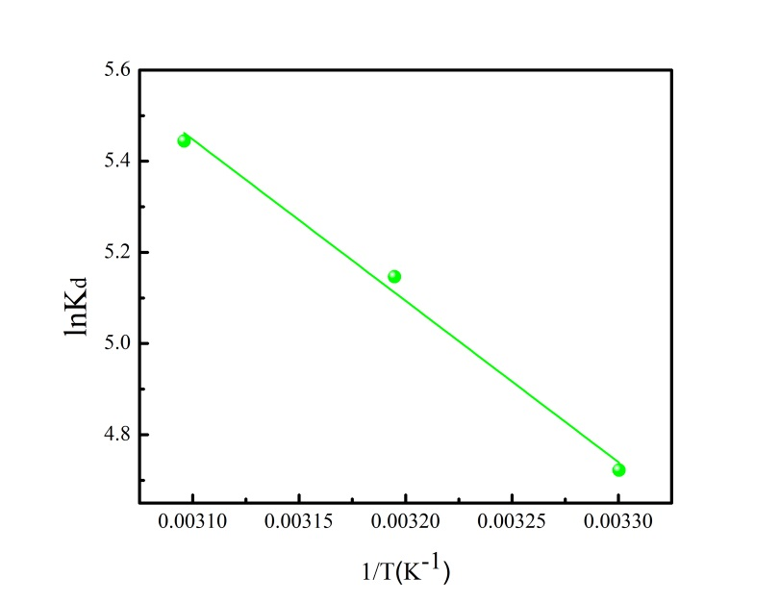

**Fig.S1** The slope and intercept of ln (Kd) vs. 1/T plot.

C:\Users\X230\Desktop\Graph2.tif

**Fig.S2** Reusability of PWA for MB adsorption.

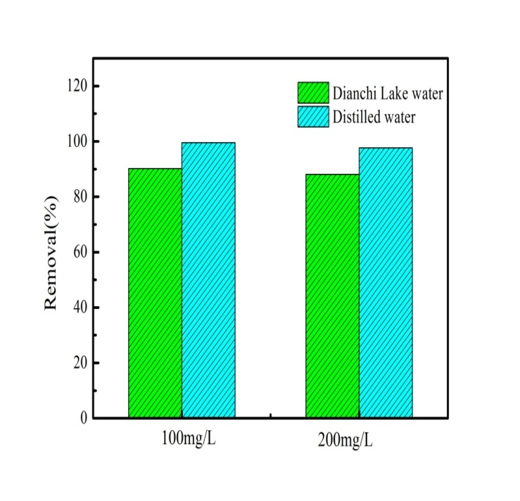

**Fig.S3** Comparison of MB removal on PWA in actual water and distilled water

**Table S1** Adsorption isotherm models adopted in this work and their parameters.

|  |  |  |
| --- | --- | --- |
| Isotherm | Equation | Parameters |
| Langmuir |  | Ce is the equilibrium concentration(mg/L)  Q0 (mg/g) is adsorption constant related to adsorption capacity  KL (L/g) is adsorption constant related to energy of adsorption |
| Freundlich |  | KF is adsorption constant related to adsorption capacity (mg/g).(L/mg)1/n  n is adsorption constant measuring the adsorption intensity |
| Dubinin-Radushkevich |  | α is the adsorption capacity(mg g-1)  β is the constant related to the adsorption energy (mol2kJ-2) |
| Temkin |  | A and B are constants |

**Table S2** Adsorption kinetic models adopted in this work and their parameters.

|  |  |  |
| --- | --- | --- |
| Kinetic models | Equation | Parameters |
| Pseudo-first order |  | qe is the uptake of methylene blue at equilibrium (mg/g).  K1 (1/min) is the adsorption rate constant, |
| Pseudo-second order |  | K2 (g/mg min) is the rate constant of second-order equation |
| Intraparticle diffusion |  | K3 (mg/g min1/2) is the intraparticle diffusion rate constant  C is a constant |
| Elovich |  | a (mg/g min) is the initial adsorption rat  b (g/mg) is related to the extent of surface coverage and activation energy. |

**Table S3** Fixed bed models and corresponding parameters.

|  |  |  |
| --- | --- | --- |
| Model | Equations | Parameters |
| Thomas | $$\frac{C_{t}}{C_{0}}=\frac{1}{1+exp[\left(\frac{K_{Th}}{V}\right)\left(q_{th}M-C_{0}Vt\right)]}$$ | *KTh* (mL min-1 mg-1) is the Thomas constant, *qth* (mg g-1)is the maximum adsorption capacity, *M* (mg) is the weight of ZnFe-BC, *V* (mL min-1) is the inlet flow. |
| Yoon-Nelson | $$\frac{C_{t}}{C_{0}}=\frac{\exp{(K_{YN}t-K_{YN}t_{0.5})}}{1+exp⁡(K_{YN}t-K_{YN}t_{0.5})}$$ | KYN (min-1) is the Yoon-Nelson constant and t0.5 (min) is the time required for 50% breakthrough. |