**Fractal Features of pH-sensitive Bimodal Mesoporous Silica-supported Bipyridine-proline Organocatalysts with Core-shell Structure and Their Application in Asymmetric Aldol Reaction**

Guangpeng Xu, Bingying Jia, Bang Xu*, Shiyang Bai, Jihong Sun*, Tallat Munir

Beijing Key Laboratory for Green Catalysis and Separation, Department of Chemical Engineering, Beijing University of Technology, Beijing 100124, China

Electronic Supporting Information Summary

**1. XRD Patterns**

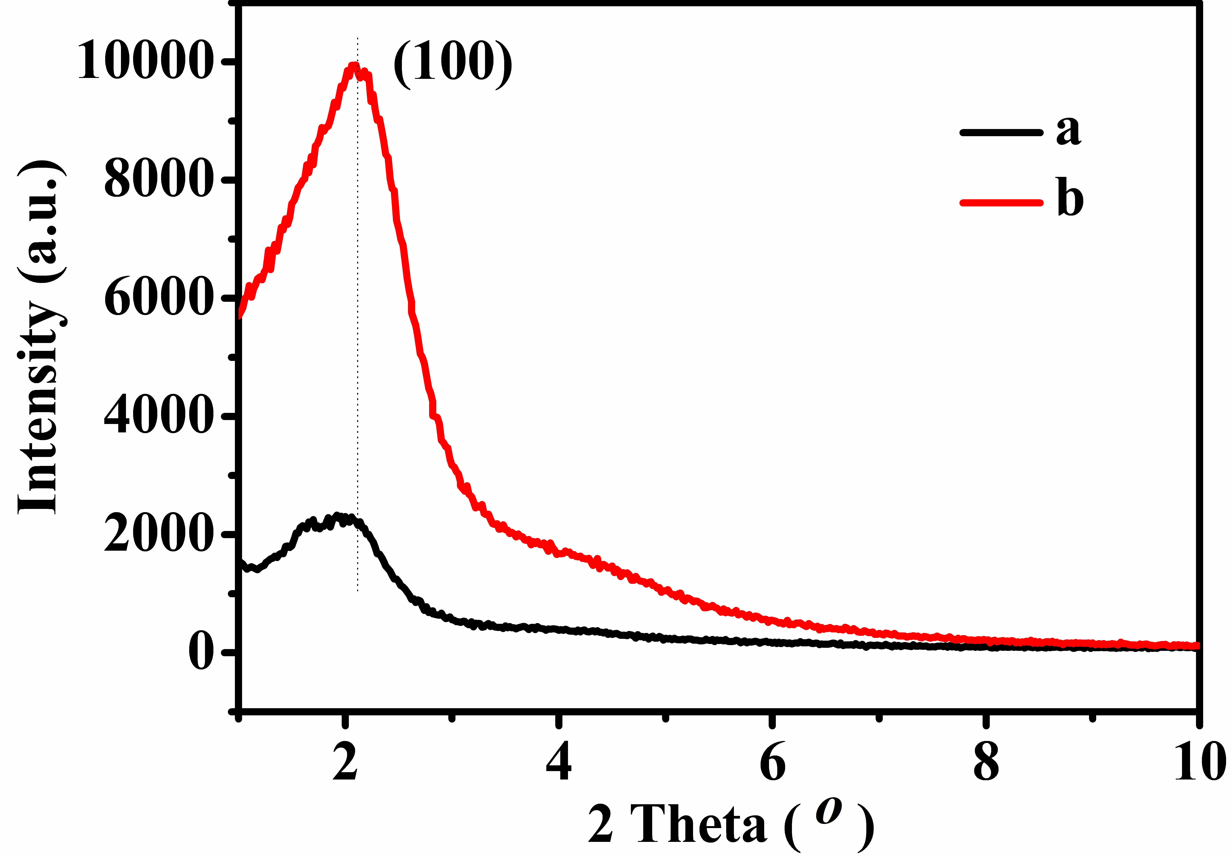

**Figure S1**. Small angle XRD patterns of (a) t-BMMs, (b) BMMs.

**2. Porod plots**

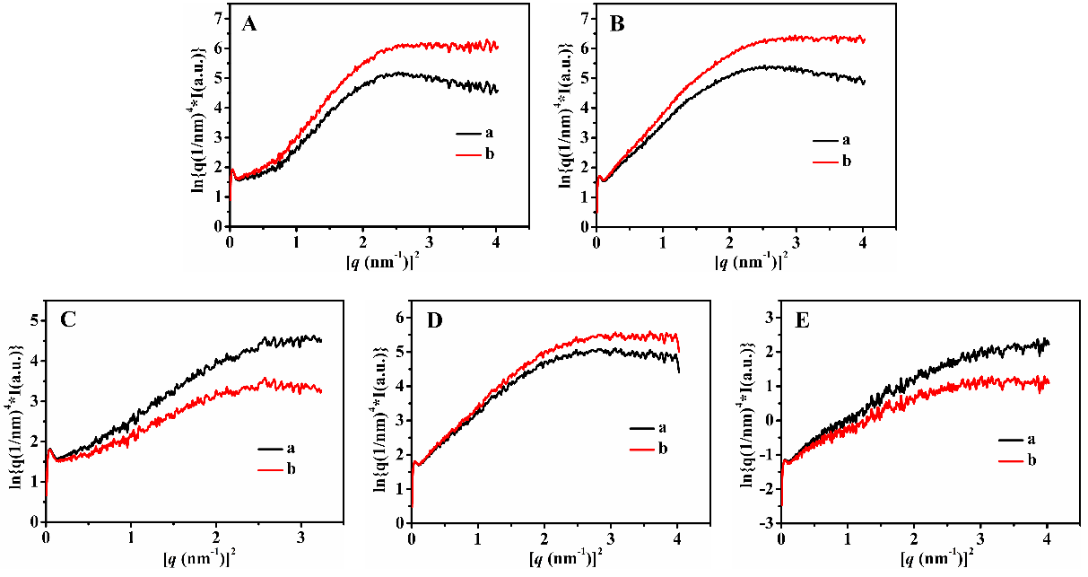

**Figure S2**. *ln[q4I(q)] ~ q2* curves of (A) t-BMMs, (B) t-BMMs-APS, (C) P-t-BMMs, (D) P-BMMs, and (E) P-Z@BMMs, in which, (a) Porod plot data with deviation, (b) deviation corrected Porod plot data.

**3. Textural parameters**

**Table S1.** Summaries of the textural parameters and porosity of all related samples.

|  |  |  |  |  |  |
| --- | --- | --- | --- | --- | --- |
| Entry | Sample | *SBET*  (m2/g) | *Pvol*  (cm3/g)[a] | Small mean pore  (nm)[b] | Large mean pore  (nm)[b] |
| 1 | t-BMMs | 33 | 0.21 | - | 36.15 |
| 2 | t-BMMs-APs | 642 | 0.60 | 2.35 | 41.53 |
| 3 | P-t-BMMs | 845 | 0.81 | 2.53 | 35.46 |
| 4 | P-BMMs | 913 | 0.83 | 2.60 | 33.44 |
| 5 | P-Z@BMMs | 877 | 0.77 | 2.59 | 39.41 |

[a] Estimated from the amounts adsorbed at a relative pressure (*P*/*P0*) of 0.99. [b] Their pore size distribution was calculated from the N2 desorption branches using the BJH method.

**Table S2.** Apparent hydrodynamic size and PDI of the related samples measured by DLS in aqueous.

|  |  |  |  |
| --- | --- | --- | --- |
| Entry | Sample | Hydrodynamic size (nm) | PDI |
| 1 | t-BMMs | 531 | 0.86 |
| 2 | t-BMMs-APs | 397 | 0.70 |
| 3 | P-t-BMMs | 1378 | 1.00 |
| 4 | P-BMMs | 1310 | 0.43 |
| 5 | P-Z@BMMs | 1267 | 0.48 |

**4. Elemental analysis**

**Table S3**. Elemental composition of P-Z@BMMs.

|  |  |  |  |  |  |  |
| --- | --- | --- | --- | --- | --- | --- |
| Samples | N  wt% | C  wt% | H  wt% | S  wt%[a] | Loaded Z wt%  (TGA results)[b] | Loaded Z  wt%[a] |
| P-Z@BMMs | 3.19 | 15.70 | 2.601 | 0.202 | 2.27 | 2.97 |

[a] The values of the loading of Z were calculated by the sulfur element content.

[b] Determined by TGA results.

**5. HPLC analysis for aldol products**

Table 2, Entry 1:

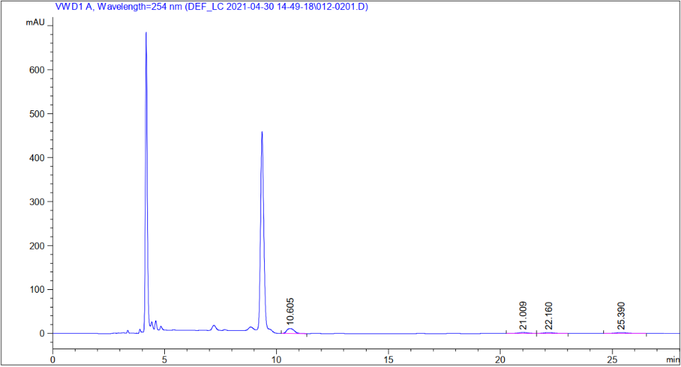

<Column Performance Report>

|  |  |  |  |  |
| --- | --- | --- | --- | --- |
| entry | Retention time (min) | area [mAU*s] | Area % | height [mAU] |
| 1 | 10.605 | 270.38132 | 53.9262 | 11.56497 |
| 2 | 21.009 | 74.36031 | 14.8308 | 2.55810 |
| 3 | 22.160 | 67.04949 | 13.3727 | 2.24358 |
| 4 | 25.390 | 89.60041 | 17.8703 | 2.44750 |

Table 2, Entry 2:

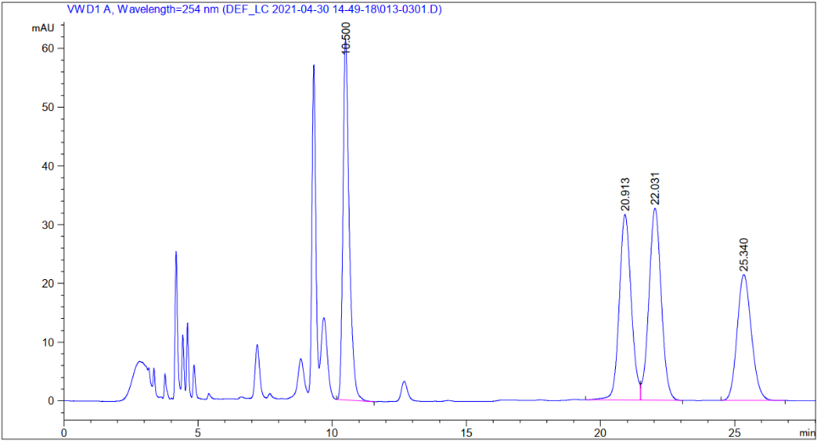

<Column Performance Report>

|  |  |  |  |  |
| --- | --- | --- | --- | --- |
| entry | Retention time (min) | area [mAU*s] | Area % | height [mAU] |
| 1 | 10.500 | 1004.84845 | 26.2647 | 61.32107 |
| 2 | 20.913 | 983.48456 | 25.7063 | 31.61844 |
| 3 | 22.031 | 1044.70947 | 27.3066 | 32.70816 |
| 4 | 25.340 | 792.81348 | 20.7225 | 21.42469 |

Table 2, Entry 3:

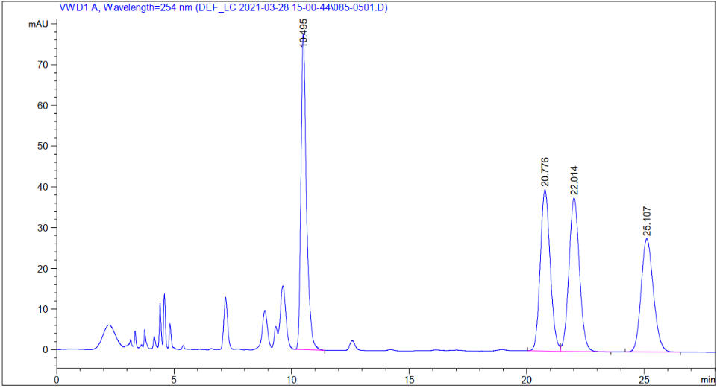

<Column Performance Report>

|  |  |  |  |  |
| --- | --- | --- | --- | --- |
| entry | Retention time (min) | area [mAU*s] | Area % | height [mAU] |
| 1 | 10.495 | 1263.72424 | 27.5216 | 77.40222 |
| 2 | 20.776 | 1157.60120 | 25.2105 | 39.61025 |
| 3 | 22.014 | 1165.10144 | 25.3738 | 37.59549 |
| 4 | 25.107 | 1005.32318 | 21.8941 | 27.78770 |

Table 2, Entry 4:

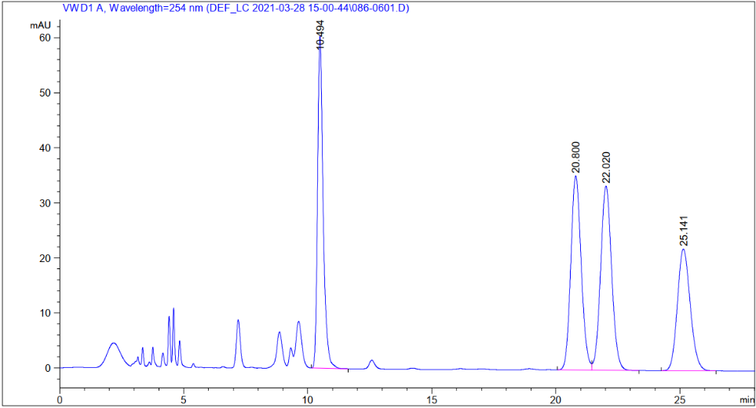

<Column Performance Report>

|  |  |  |  |  |
| --- | --- | --- | --- | --- |
| entry | Retention time (min) | area [mAU*s] | Area % | height [mAU] |
| 1 | 10.494 | 941.15802 | 24.7115 | 60.34603 |
| 2 | 20.800 | 1030.56335 | 27.0590 | 35.26522 |
| 3 | 22.020 | 1037.91382 | 27.2520 | 33.48490 |
| 4 | 25.141 | 798.94427 | 20.9775 | 22.13354 |

Table 2, Entry 5:

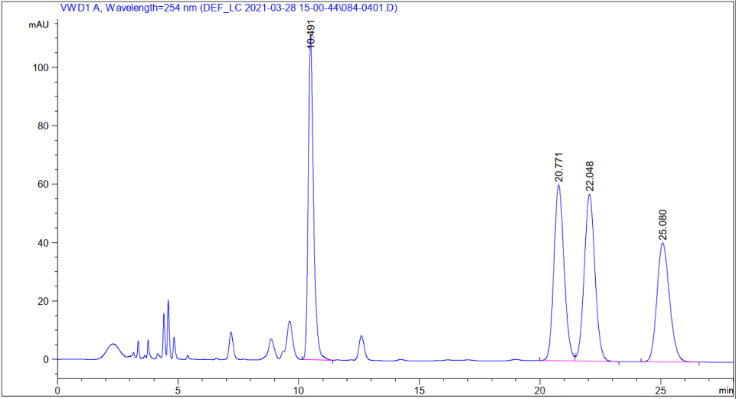

<Column Performance Report>

|  |  |  |  |  |
| --- | --- | --- | --- | --- |
| entry | Retention time (min) | area [mAU*s] | Area % | height [mAU] |
| 1 | 10.491 | 1697.79883 | 25.3371 | 111.09277 |
| 2 | 20.771 | 1761.83105 | 26.2926 | 60.17488 |
| 3 | 22.048 | 1766.11169 | 26.3565 | 57.12501 |
| 4 | 25.080 | 1475.11023 | 22.0138 | 40.70132 |

**7. Schematic representation of the research methodology**

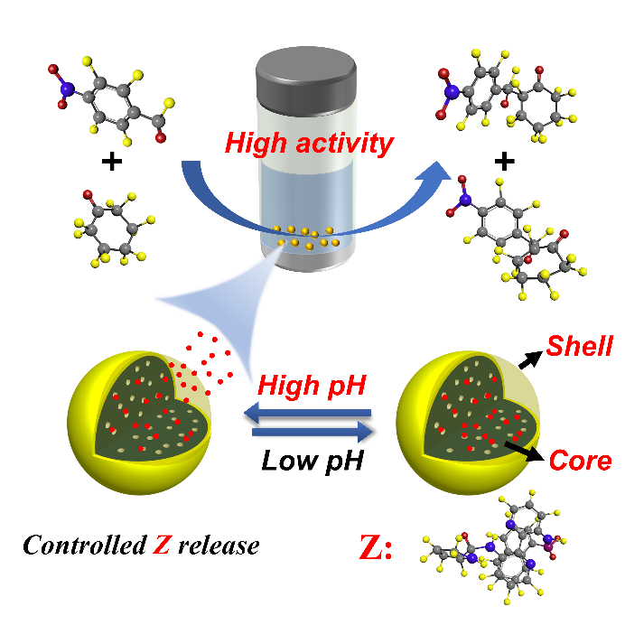

**Scheme S1**. Schematic representation of the research methodology.

**8. Comparative experiments for asymmetric aldol reaction**

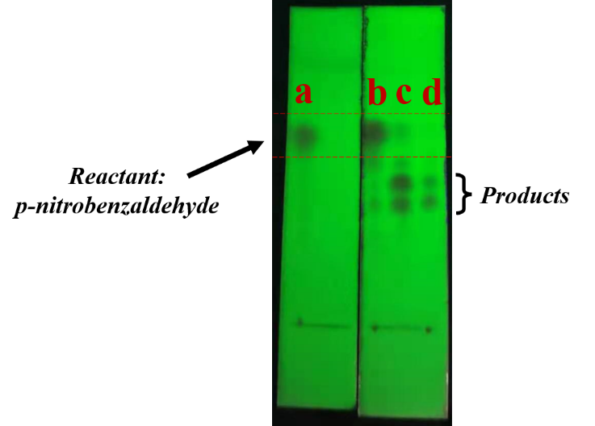

**Scheme S2**. Comparison of the results of TLC separation on the asymmetric aldol reaction catalyzed by P-Z@BMMs between the p-nitrobenzaldehyde and cyclohexanone under the different pH conditions. (a) control group (only reactant: p-nitrobenzaldehyde), (b) at acid condition (pH = 1.53), (c) at neutral condition (pH = 7.21), (d) at alkaline condition (pH = 8.02).