**Environmental remediation and generation of green electricity using constructed wetlands coupled with microbial fuel cell model system**

Alina Nazir1, Farhat Jubeen1, Misbah Sultan2, Abdul Ala Khurram3, Asma Abdul Latif4, Imran Altaf5, Sobhy M. Ibrahim2’6, Munawar Iqbal7,8, Arif Nazir*9

1Department of Chemistry, Government College Women University, Faisalabad, Pakistan

2Institute of Chemistry, University of the Punjab, Lahore, Pakistan

3Department of Earth Sciences, University of the Punjab, Lahore, Pakistan

4Department of Zoology, Lahore College for Women University, Lahore, Pakistan

5Institute of Microbiology, University of Veterinary and Animal Sciences, Lahore, Pakistan

6Department of Biochemistry, College of Science, King Saud University, P.O. Box: 2455, Riyadh 11451, Saudi Arabia

7Department of Chemistry, Division of Science and Technology, University of Education Lahore, Pakistan

8Department of Chemical and Pharmaceutical Sciences, University of Trieste, 34127 Trieste, Italy

9Department of Chemistry, The University of Lahore, Lahore, Pakistan

*Corresponding Author Email: [anmalik77@gmail.com](mailto:anmalik77@gmail.com)

**S1:**

***Medium for biofilm***

*G. sulfurreducens* serve as a catalyst in CW-MFC and was cultured with Geobacternutrient media. The medium contained 1.5 g NH4Cl, 0.60 g of Na2HPO4, 0.10 g KCl, 0.80 g of Na-acetate, 10 mL trace element solution, 10 mL vitamin solution, 2.5 g of NaHCO3 and 8 g of Na2-fumarate. The volume was made up to 980 mL using distilled water. The medium was autoclaved at 121°C for 20 min. There was the addition of bicarbonate, fumarate and vitamins in medium in anaerobic chamber whose pH was maintained at 7. Prior to use, high purity nitrogen gas (0.1 mL/min) was used to sparge the medium for 30 min in order to establish anoxic climate.

**S2:**

***Sludge inoculation and system working***

Activated sludge pretreated with 1M NaOH and 1M HCl to ensure anaerobic conditions. Pretreated anaerobic sludge (60g/L) along with (*Geobacter sulfereducens)* used to inoculate anode by blending with GAC. Before the start of conventional experiment wetland macrophyte (*Cymobopogon nardus)* acclimatized for 35 days against bacterial culture (*Geobacter sulfereducens* along with anaerobic sludge) by refreshing synthetic waste water (except CMX) after every 3 days. All the experimental reactors were operated under continuous up-flow mode with hydraulic retention time (HRT) of 3 days. HRT was maintained as 2ml/min via peristaltic pump and drip irrigation system [27]. The wastewater was fed to the reactors continuously after every three days. The synthetic wastewater include glucose (0.4g), NH4Cl (0.135g), NaH2PO4·2H20 (0.49g), Na2HPO4·12H2O (0.275g), KCl (0.13g), NaHCO3 (0.313g), and MgSO4 (0.025g) per liter of water, as reported by [25]. The operation carried for 90 days until the system produced reproducible voltage outputs. Digestion of root exudates or glucose by bacterial strain promote the oxidation reaction at anaerobic anode [28].The release electrons pass through the external circuit via copper wires sealed with epoxy resin to cathode (Fig. 3). Reduction of oxygen occurs at cathode by reacting with electrons and protons to generate water and green electricity [29]. Voltage output of the system (CW-MFC) record and measured by Hewlett-Packard multimeter (DT830D) digital multimeter.

**S3:**

**Composition of sludge**

 Sewage sludge contains 50%–70% organic matter and 30%–50% mineral components (including 1%–4% of inorganic carbon), 3.4%–4.0% nitrogen (N), 0.5%–2.5% phosphorus (P), and significant amounts of other nutrients. The sludge was collected from hospital sewage that probably may contain antibiotic resistant bacteria.

**S4:**

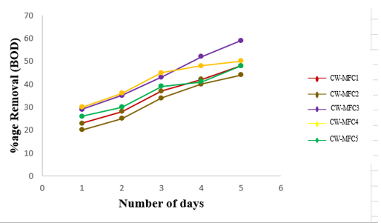

**Fig.** Removal percentage of BOD in all reactors of CW-MFCs after all trials