Supporting information

**Adsorption of PO43-, Cd(II), Pb(II), Cu(II), As(III), and As(V) using a carbonised Mn-based metal–organic framework**

**Yating Chen1,2,§, Zhao Chen1,2,3,§, Lingyu Yuan2, Yu Xiao1, Shu-Hua Zhang1,2,*,**

**Ning Li 1,\***

1*Guangdong Provincial Key Laboratory of Petrochemical Pollution Process and Control, Key Laboratory of Petrochemical Pollution Control of Guangdong Higher Education Institutes (College of Chemistry), Guangdong University of Petrochemical Technology, Maoming, Guangdong, 525000, P R China.*

2*Guangxi Key Laboratory of Electrochemical and Magnetochemical Functional Materials (College of Chemistry and Bioengineering), Guilin University of Technology, Guilin, 541004, P R China.*

*Corresponding author. E-mail address: [liningmmc@gdupt.edu.cn](mailto:liningmmc@gdupt.edu.cn) (N. Li) Zhangshuhua@gdupt.edu.cn (S.Zhang)

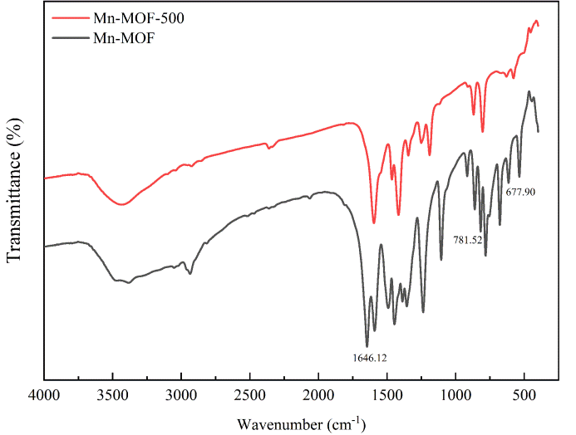

Fig S1. IR of **Mn-MOF** and **Mn-MOF-500**.

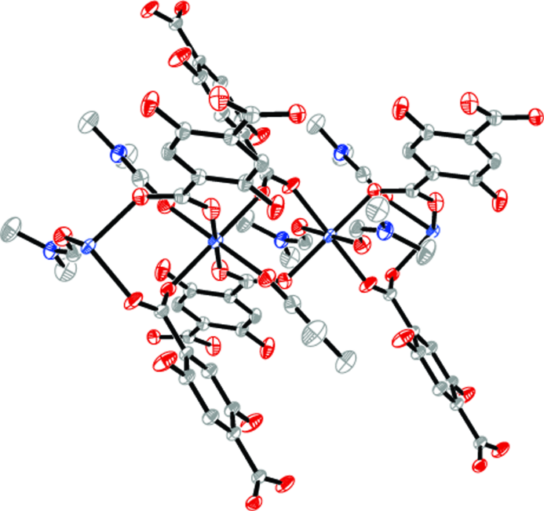

Fig. S2 1D chain of the **Mn-MOF**

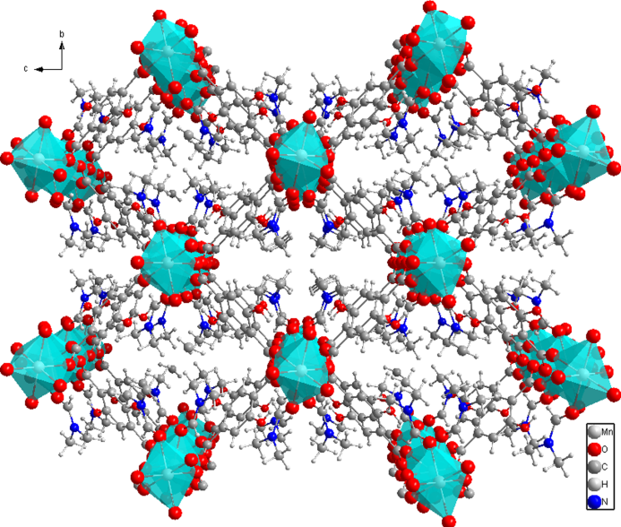

Fig. S3 3D network of **Mn-MOF.**

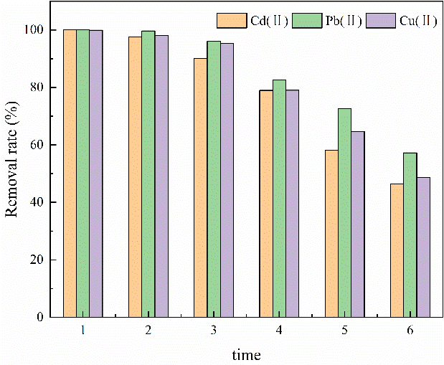

##### Fig S4 Effect of regeneration times on Cd(II), Pb(II), Cu(II) removal rate

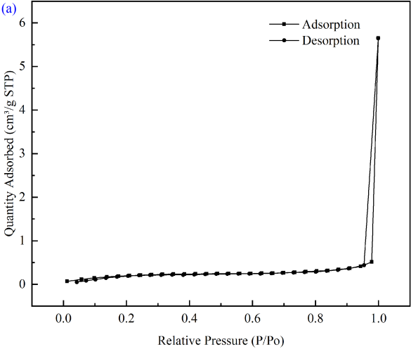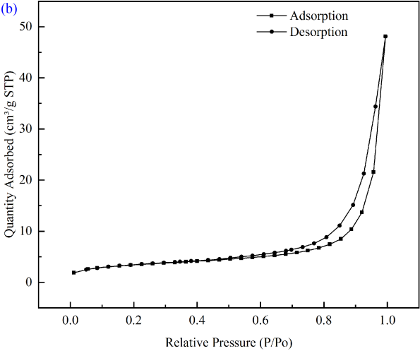

##### Fig.S5 BET nitrogen adsorption desorption isotherm results of **Mn-MOF** (a), **Mn-MOF-500** (b).

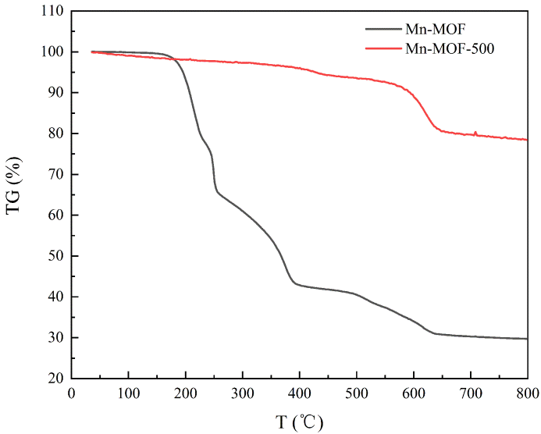

##### Fig.S6 TG curves of **Mn-MOF** and **Mn-MOF-500**.

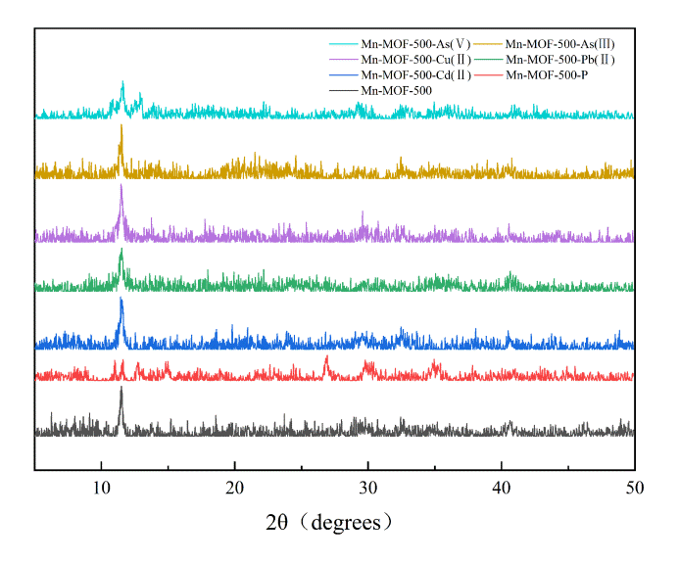

##### Fig S7 XRD curves of **Mn-MOF-500, Mn-MOF-500-P, Mn-MOF-500- Cd(II), Mn-MOF-500- Pb(II), Mn-MOF-500-Cu(II), Mn-MOF-500-**As(III)and **Mn-MOF-500-**As(V).

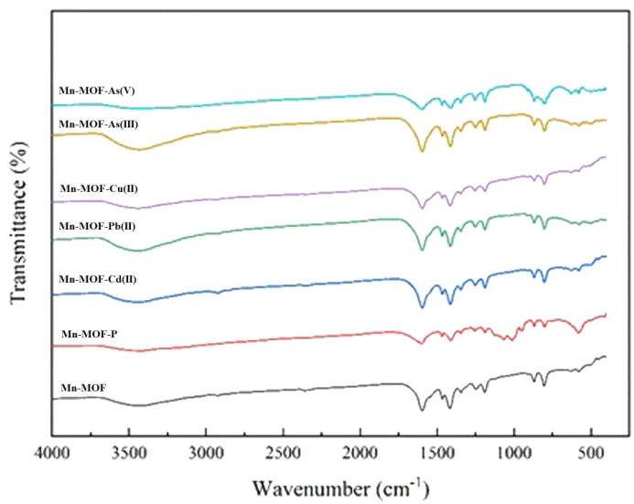

##### Fig. S8 IR curves of **Mn-MOF-500, Mn-MOF-500-P, Mn-MOF-500-Cd(II), Mn-MOF-500- Pb(II), Mn-MOF-500-Cu(II), Mn-MOF-500-**As(III)and **Mn-MOF-500-**As(V)**.**

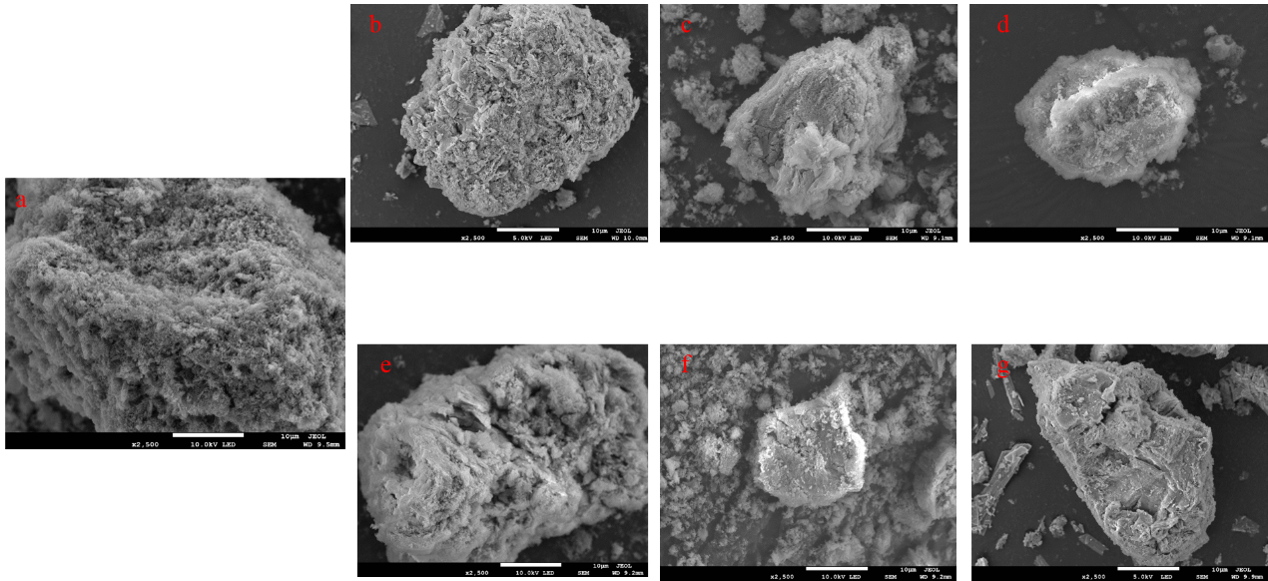

##### Fig. S9 SEM image of (a) **Mn-MOF-500**, (b) **Mn-MOF-500-P**, (c) **Mn-MOF-500-Cd(II)**, (d) **Mn-MOF-500-Pb(II)**, (e) **Mn-MOF-500-Cu(II)**, (f) **Mn-MOF-500-As(V)**, and (g) **Mn-MOF-500-As(V)**.

**1.1 Materials and physical measurements**

All chemicals were commercially available and used as received without further purification. KH2PO4 (AR), Cd(NO3)2·6H2O (AR), Pb(NO3)2·6H2O (AR), Cu(NO3)2·3H2O (AR), Na3AsO3 (AR), Na3AsO4 (AR) and DMF (AR) were purchased from Xilong Scientific Co., LTD. H4DHTPA (AR) and 1,3-di(4-pyridyl)propane (AR) were purchased from Beijing Huawei Ruike Chemical Co., LTD. Ultrapure water was prepared by the laboratory.

Elemental analyses (CHN) were performed using a PE 2400 Series II elemental analyzer. The X-ray crystal structure was determined with an Agilent G8910A CCD diffractometer using the SHELXL crystallographic software for molecular structure. The X-ray diffraction (PXRD) spectra of the samples were obtained using a PANalytical X’Pert3 powder diffractometer. X-ray photoelectron spectroscopy (XPS) was determined with an ESCALAB 250Xi X-ray photoelectron spectrometer (vacuum range: ≤5×10-10 mbar; spatial resolution: ≤20 μm; energy resolution: ≤0.45 eV; sensitivity: ≥25,000 counts per second). FT-IR spectra were recorded from KBr pellets in the ranges 4,000–400 cm-1 on a NioRad FTS-7 spectrophotometer. Thermogravimetric (TGA) measurements were performed by heating the crystalline sample from 25 to 900 °C at a rate of 10 °C/min in air on a Netzsch STA-449C thermal analyzer.

**1.2 Adsorption Experimental and Characterization**

**1.2.1 Optimum carbonization temperature selection**

Weigh a certain amount of KH2PO4, Cd(NO3)2·6H2O, Pb(NO3)2·6H2O, Cu(NO3)2·3H2O, Na3AsO3, and Na3AsO4 to prepare solutions containing P, Cd(II), Pb(II), Cu(II), As(III), and As(V) ions, respectively, and the ion concentration of the solutions was set to 50 mg/L. Weigh 0.02 g **Mn-MOF** and **Mn-MOF-n** materials in a 100 mL centrifuge tube, add 50 mL of the above solution to the centrifuge tube, respectively. The solutions were shaken in the shaker for a certain period of time, and then taken out. The solutions were filter using 0.22 μm membrane filtration. The filtrates were stored in a 10 mL plastic centrifuge tube. The concentrations of P before and after adsorption were measured by spectrophotometric method of ammonium molybdate. The concentrations of Cd(II), Pb(II), Cu(II), As(III), and As(V) in the solution after adsorption were determined by inductively coupled ion spectrometry. and all experiments were set to control groups and blank samples, and the final results were expressed as averages.

**1.2.2 Mn-MOF-500 univariate experiment**

**Effect of pH**: To select the optimal pH, 0.02 g of **Mn-MOF-500** and 15 mL of the solution (aqueous solution containing phosphate or Cd(II), Pb(II), Cu(II), As(III), and As(V) heavy metal ions) were added to the 100 mL centrifuge tube. The concentration of phosphate or each heavy metal ions, adsorption temperature, speed of the shaker and adsorption time were set to a fixed value. The pH value was set to a single variable. The influence of pH value on the adsorption effect was studied.

**The impact of dosing**: In the centrifuge tube of the same specification, different weights of Mn-MOF-500 and 15 mL the solutions of phosphate or each heavy metal ion were added. The pH value was set to the optimal pH. The adsorption temperature, ion concentration, shaker speed and time were set a fixed value. The dosage of **Mn-MOF-500** was set to a single variable. The effect of the dosage on the adsorption effect was explored.

the optimal experimental conditions were determined by calculating the removal rate and adsorption capacity. The calculation formula is as follows:

(1)



(2)



Where *η* is the removal rate( %), *c*0 is the ion concentration in the initial solution (mg/L), *c*e is the remaining ion concentration in the adsorbed solution (mg/L); *q*e is the adsorbent capacity of the adsorbent to the ions (mg/g), *V* represents the volume of the solution (L); and *m* represents the dose of the adsorbent (g).

**1.2.3 Adsorption isothermal experiment**

The pH value and the dosage of adsorbent are set as the optimal values. The adsorption temperatures are set to 288K, 298K, and 308K, respectively. The ion concentration in the solution maintains a certain gradient. The solutions were put into the gas bath constant temperature shaker table for 180 rap/min and shake for 24 h. The solutions were taken out and filter with a water-based 0.22 μm membrane filtration. The corresponding test method is used to test and calculate the ion concentrations. After that, the Langmuir adsorption isothermal model and the Freundlich adsorption isothermal model were used to fitting respectively. The calculation formula is as follows:

(3)



(4)



Where *q*e represents the adsorption capacity at equilibrium (mg/g); *q*max represents the theoretical maximum adsorption capacity calculated by the Langmuir adsorption isothermal model (mg/g); *c*e represents the residual concentration of ion in the solution after adsorption (mg/L); *b* indicates the constant associated with the adsorption energy, that is, the adsorption coefficient (L/mg). Equation 4 is the Frundlich adsorption isothermal model, which is a common empirical isothermal adsorption model, where *K*F and *n* are expressed as the Frundlich constant.

**1.2.4 Adsorption kinetics experiment**

The adsorption time is set to a single variable. The remaining conditions remain unchanged, and the adsorption results are fitted to the pseudo-first-order kinetic model and the pseudo-second-order kinetic model. The calculation formula is as follows:

(5)



(6)



For Equation 5, when the boundary condition is set to *t* = 0, *q*t = 0, when *t* = *t*, *q*t = *q*t, the formula is converted to:

(7)



Equation 7 is the pseudo-first-order adsorption kinetic equation, where *q*t represents the adsorption capacity at *t* time (mg/g); *q*e represents the adsorption capacity at the adsorption equilibrium (mg/g); *k* represents the pseudo-first-order kinetic constant (h-1); *t* represents the adsorption time (h); in Equation 6, *k* represents the pseudo-secondary kinetic constant (g·mg-1·h-1).

**1.2.5 Cycle and regeneration experiments**

The experimental conditions are set to contain PO43-concentration of 100 mg/L; The pH value is 5; The solution volume is 140 Ml; And the dosage of **Mn-MOF-500** is 0.7 g. Dried the adsorbed **Mn-MOF-500** which is placed in 140 mL of 0.1 mol/L NaCl solution. The solution was shaken on the shaking table for more than 5 h for desorption treatment. The desorbed **Mn-MOF-500** was dried and then applied to the adsorption PO43- experiment again. According to the above method, the experiment is cycled for six times.

The experimental conditions were set to Cd(II), Pb(II) and Cu(II) ion concentrations of 10, 50 and 50 mg/L, respectively. The pH value is 5. The solution volume is also 100 mL. The dosage of **Mn-MOF-500** was 0.2 g. Dried the adsorbed **Mn-MOF-500** which is placed in 140 mL of 0.1 mol/L NaCl solution. The solution was shaken on the shaking table for more than 5 h for desorption treatment. The desorbed **Mn-MOF-500** was dried and then applied to the adsorption Cd(II), Pb(II) and Cu(II) experiment again. According to the above method, the experiment is cycled for six times.

The experimental conditions were set to As(III), and As(V) ion concentrations of 50 and 100 mg/L. The pH value is 5. The solution volume is also 100 mL. The dosage of **Mn-MOF-500** was 0.1 g. Dried the adsorbed **Mn-MOF-500** which is placed in 140 mL of 0.1 mol/L NaCl solution. The solution was shaken on the shaking table for more than 5 h for desorption treatment. The desorbed **Mn-MOF-500** was dried and then applied to the adsorption As(III), and As(V) experiment again. According to the above method, the experiment is cycled for six times.

**1.2.6 Water solubility determination experiments**

Weigh 1 g of **Mn-MOF** or **Mn-MOF-500** respectively and put them into a 250 mL Erlenmeyer flask, and then add 100 mL of ultrapure water to each Erlenmeyer flask, seal the erlenmeyer flask, put it into the shaker table and shake for 24 h, and then take it out for the centrifugation, remove the supernatant, and dry the remaining materials in a 105 °C blast drying oven. Weigh the mass of each material with an electronic balance (me(**Mn-MOF**) =0.163g, me(**Mn-MOF-500**) = 0.989 g), and calculate the water soluble rate of the material. The calculation formula is as follows:



Where s is water soluble rate; m1 is the mass before dissolution of **Mn-MOF** or **Mn-MOF-500** (g); me is the dried mass afterdissolution of **Mn-MOF** or **Mn-MOF-500** (g). As a result, s(**Mn-MOF**) = 83.7%, s(**Mn-MOF-500**) = 1.1%.

**1.2.7 Characterization experiments**

Infrared was tested in the KBr environment; BET and mesoporous distribution (2-50 nm) were tested by adsorption and desorption of nitrogen at 77 K; the vacuum degree of the XPS analysis chamber is about 5×10-9 mbar, and the X-ray source is monochromatic AlK*a* source (Mono AlK*a*); XRD (Cu K*a*) scans the powder sample 5-50° for quick sweeping; and the thermogravity rises to 800°C at a rate of 10°C/min for data collection. Crystallography data was collected by X-ray single crystal diffractometer (Mo K*a*, *λ* = 0.71073 Å) at 298 K, and the simulated XRD data of the single crystal structure was obtained using the software of Mercury 3.1.

**1.3 Analysis of experimental results**

**1.3.1 Mn-MOF-500 univariate experimental analysis**

The experimental conditions were set to PO43- the initial concentration was 50 mg/L, and the volume ratio of **Mn-MOF-500** to the volume of aqueous solution containing phosphate and heavy metal ions was 0.02/15 g/mL, and the effects of different pH values (pH set to 3, 5, 7, 9, 11) on the adsorption performance were explored. The results are shown in Figure S10(a): the study shows that the removal rate and adsorption capacity (*q*e) change trend are the same, both with the increase of pH value first rise and then decrease, of which the best effect is at pH 5, removal rate and adsorption capacity (*q*e) are 84.69 % and 31.76 mg/g, respectively; therefore, the pH is set to 5 in the follow-up experiment.

The experimental conditions set the amount of dosing as a single variable, the rest of the conditions are unchanged, and the dosing amount is set to: 0.008, 0.01, 0.015, 0.02, 0.025, 0.03, 0.04, 0.05 g, and the results are shown in Figure S10(b). The results show that with the increase of **Mn-MOF-500** dosing, the removal rate gradually increases and eventually tends to be balanced, while the adsorption capacity gradually decreases, because with the increase of **Mn-MOF-500** dosing, the adsorption site increases, and the content of PO43- in the solution is fixed, so there is only a part of the adsorbent adsorbent adsorbent, resulting in a gradual decrease in the adsorption capacity; therefore, in the subsequent experiments, the amount of adsorbent is considered to save the amount of adsorbent, avoid waste, and the amount of adsorbent is set to 0.02 g in the follow-up experiment. Because when the amount of dosing is 0.02 g, the adsorption removal rate has exceeded 90%.

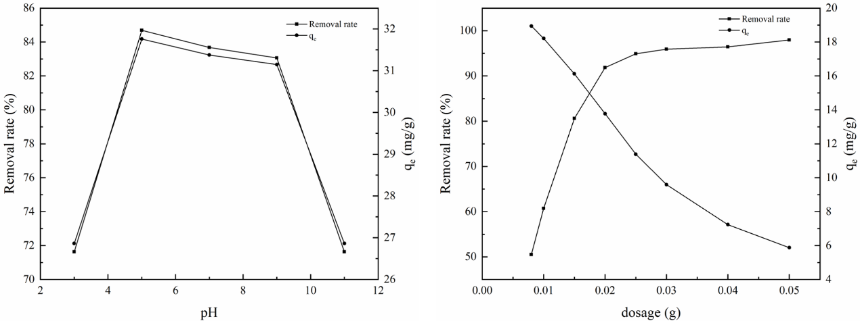

Figure S10 a. Effect of pH on the adsorption of PO43- by Mn-MOF-500; b. Effect of dosage on adsorption of PO43- by Mn-MOF-500.

To explore the effect of pH on the adsorption performance of **Mn-MOF-500** for Cd (II), Pb (II) and Cu (II) ions. The pH value was set as a single variable, and the other experimental conditions remained unchanged. Because the three metal ions are easy to precipitate under alkaline conditions, the pH value is set to 2, 3, 4, 5 and 6. Set the initial concentration of Cd (II), Pb(II), Cu (II) as 20 mg / L, 50 mg/L and 50 mg/L, respectively and the ratio of adsorbent to solution as 0.02/15 g / mL, 0.01/15 g / mL and 0.01/15 g/mL, respectively. The research results are shown in Figures S11a - S13a. The results show that the change rate of the adsorption performance of  **Mn-MOF-500** for Cd (II) with pH value is lower than that of **Mn-MOF-500** for Pb (II) and Cu (II) ions. When pH ≥ 5, the removal rate of Cd (II) by **Mn-MOF-500** is 97.19%, and the adsorption capacity is 14.58 mg / g, which has reached the adsorption saturation state. At the same time, when pH ≥ 5, the removal rates of Pb (II) and Cu (II) by **Mn-MOF-500** are more than 99 %, and the adsorption capacities of Pb (II) and Cu (II) are 74.95 mg / g and 71.52 mg / g, respectively which has reached the adsorption saturation state. Therefore, the pH was set to 5 in subsequent experiments.

The influence of adsorbent dosage is often the key factor to explore the adsorption performance. The dosage of **Mn-MOF-500** was set as a single variable to explore the effect of dosage on the adsorption performance of Cd (II), Pb (II) and Cu (II) ions. The research results are shown in Figures S11b - S13b. The results show that the removal rates of Cd (II), Pb (II) and Cu (II) by **Mn-MOF-500** increase with the increase of dosage, and the adsorption capacity decreases with the increase of dosage. Because with the increase of dosage, the adsorption sites increase and the removal rate increases. However, with the increase of adsorption sites, there will be non participating adsorption materials, which will also lead to the reduction of adsorption capacity. When the dosage of **Mn-MOF-500** is 0.05 g, 0.02 g and 0.02 g, respectively, the removal rates of Cd (II), Pb (II) and Cu (II) ions are 99.02%, 99.96% and 99.63%, respectively. Therefore, in the subsequent adsorption experiment, the dosage of mn-mof-500 for Cd (II), Pb (II) and Cu (II) adsorption is set as 0.05, 0.02 and 0.02 g, respectively.

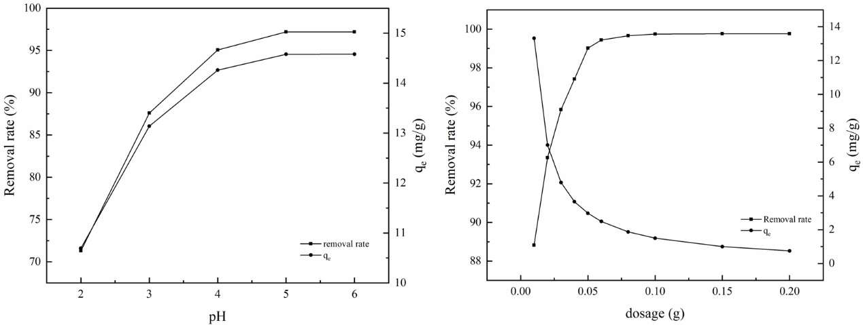

Fig S11 a. Effect of pH on the adsorption of Cd(II) by **Mn-MOF-500**; b. Effect of dosage on adsorption of Cd(II) by **Mn-MOF-500**

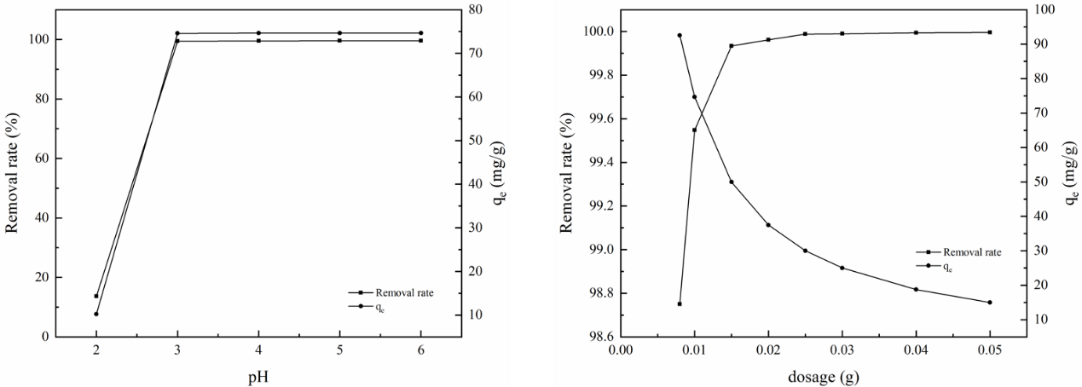

Fig S12 a. Effect of pH on the adsorption of Pb(II) by **Mn-MOF-500**; b. Effect of dosage on adsorption of Pb(II) by **Mn-MOF-500**

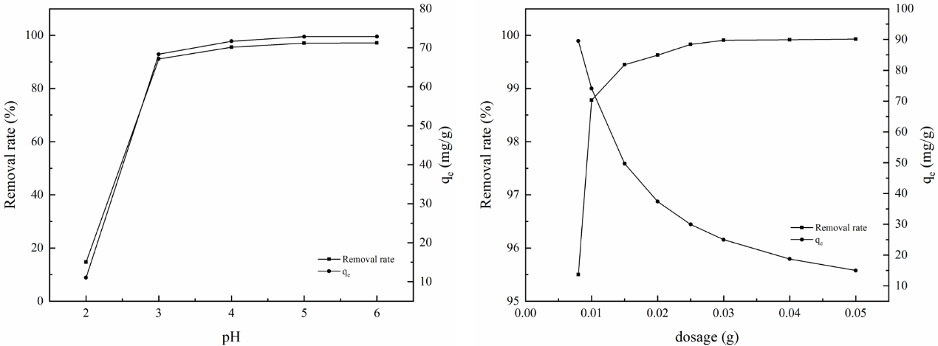

Fig S13 a. Effect of pH on the adsorption of Cu(II) by **Mn-MOF-500**; b. Effect of dosage on adsorption of Cu(II) by **Mn-MOF-500**

The pH value was set as a single variable and other experimental conditions remained unchanged. The effect of pH value on the adsorption performance of **Mn-MOF-500** for As(III), and As(V) was explored. Set the pH to 3, 5, 7, 9 and 11 respectively, the concentration of As(III), and As(V) in the solution is 20 mg / L, and the ratio of adsorbent dosage to solution volume is 0.02/15 g / mL. The research results are shown in Figures S14a and S15a. The results show that the removal rate and adsorption capacity of As (III) by **Mn-MOF-500** first increase, then decrease and increase with the increase of pH value. When pH = 5, the removal rate and adsorption capacity reach the maximum. The removal rate of As (III) is 88.31%, and the adsorption capacity of As (III) is 13.25 mg / g. The removal rate and adsorption capacity of As (V) by **Mn-MOF-500** first increased, then decreased, then increased and then decreased with the increase of pH value. Therefore, in the subsequent adsorption experiment of mn-mof-500 on As(III), and As(V), the pH value is set to 5.

The influence of adsorbent dosage is often the key factor to explore the adsorption performance. At the same time, determining the optimal dosage can save adsorbent materials and avoid unnecessary waste for subsequent experiments. Set the dosage of adsorbent as a single variable, the pH value of the solution is 5, the concentration of As(III), and As(V) in the solution are 10 mg / L, and 20 mg / L, respectively. The research results are shown in Figures S14b and S15b. The results show that the removal rate increases first and finally tends to balance with the increase of dosage and the adsorption capacity decreased with the increase of dosage. When the dosage is 0.05 g, the removal rate of As(III) by mn-mof-500 is 96.62%. With the increase of dosage, the removal rate increases very slowly. Therefore, in the subsequent adsorption experiment of **Mn-MOF-500** on As(III), the dosage is set as 0.05 g. When the dosage is 0.02 g, the removal rate of As(V) by **Mn-MOF-500** reaches 96.16%. Therefore, in the subsequent adsorption experiment of mn-mof-500 on As(V), the dosage is set as 0.02 g.

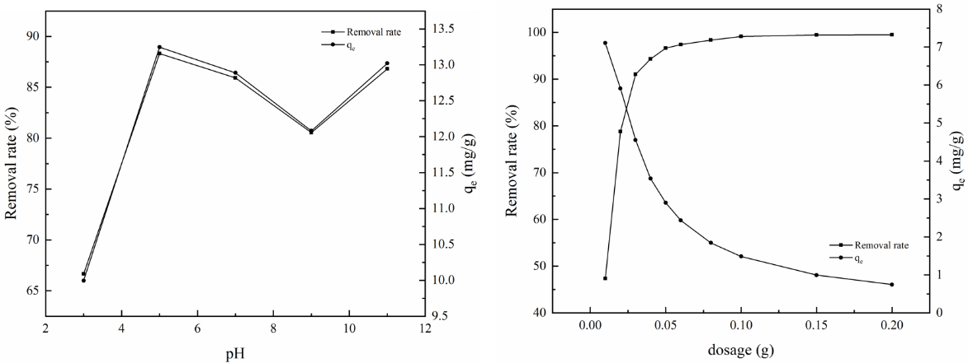

Fig S14 a. Effect of pH on the adsorption of As(III) by Mn-MOF-500; b. Effect of dosage on adsorption of As(III) by Mn-MOF-500

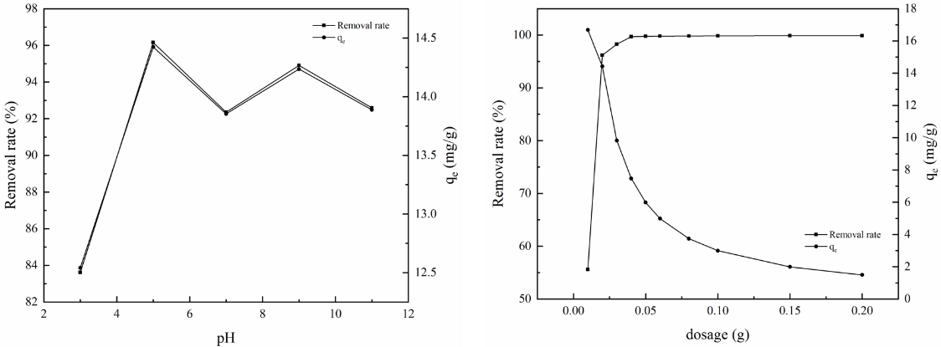

Fig S15 a. Effect of pH on the adsorption of As(V) by Mn-MOF-500; b. Effect of dosage on adsorption of As(V) by Mn-MOF-500

**1.3.2 Mn-MOF-500 zeta potential analysis**

Through potential testing of Mn-MOF-500, it was found that when the pH is less than 8, it is a positive potential, and when the pH is greater than 8, it is a negative potential. At the same time, when the pH is equal to 5, the positive potential is maximum, which is beneficial for its adsorption of heavy metal ions.



Fig S16. Mn-MOF-500 zeta potential analysis

Table S1. Crystallographic Data for **Mn-MOF**

|  |  |
| --- | --- |
| Complex | **Mn-MOF** |
| Formula | C14H18MnN2O8 |
| Formula weight | 397.24 |
| Temperature/K | Monoclinic |
| Space group | *I*2*/a* |
| *a* (Å) | 9.669(1) |
| *b* (Å) | 11.843(1) |
| *c* (Å) | 15.3399(11) |
| *β* (°) | 102.70(1) |
| *V* (Å3) | 1713.5(2) |
| *F*(000) | 820 |
| *Z* | 4 |
| *Dc* (g cm–3) | 1.540 |
| *μ* (mm–1) | 0.815 |
| *θ* range (°) | 3.44,25.00 |
| Ref. meas. / indep. | 4860, 1502 |
| Obs. ref.[*I* > 2*σ* (*I*)] | 1256 |
| *R*int | 0.0319 |
| *R*1 [*I* ≥ 2*σ* (*I*)] a | 0.0349 |
| *ωR*2(all data)b | 0.0990 |
| Goof | 0.991 |
| Δρ(max, min) (e Å-3) | 0.430, -0.386 |

a *R*1 = Σ||*F*o| – |*F*c||/Σ|*F*o|. b *wR*2 =[Σ*w*(|*F*o2|–|*F*c2|)2/Σ*w*(|*F*o2|)2]1/2

Table S2. Selected bond lengths (Å) and angles (°) for **Mn-MOF**

|  |  |  |  |
| --- | --- | --- | --- |
| Mn1−O3 | 2.146(2) | Mn1−O2B | 2.169(2) |
| Mn1−O1 | 2.187(2) | O1-Mn1-O1A | 180.0(1) |
| O3−Mn1−O3A | 180.0(1) | O3A-Mn1-O2B | 87.9(1) |
| O3−Mn1−O2B | 92.1(1) | O2B−Mn1−O2C | 180.0(1) |
| O3A−Mn1−O1 | 82.2(1) | O3-Mn1-O1 | 97.8(1) |
| O2B-Mn1-O1 | 89.8(1) | O2C-Mn1-O1 | 90.2(1) |
| Symmetry codes: (A) 0.5 − *x*, *y* + 1, − *z*; (B) *x* − 0.5, *y* + 0.5, *z* + 0.5; (C) 2 − *x*, 1.5 + *y*, 0.5 − *z*. | | | |