**Supplementary Material**

**Development and Validation of an LC-MS/MS Method for Simultaneous Determination of Three Organic Azido Impurities in Tetrazole-Containing Sartans**

Wisut Wichitnithada,b, Siriwan Nantapholb, Worathat Thitikornpongc,d and Pornchai Rojsitthisakc,d*

aDepartment of Analytical Development, Pharma Nueva Co., Ltd., Bangkok, 10900, Thailand.

bDepartment of Clinical Development, Pharma Nueva Co., Ltd., Bangkok, 10900, Thailand.

cDepartment of Food and Pharmaceutical Chemistry, Faculty of Pharmaceutical Sciences, Chulalongkorn University, Bangkok, 10330, Thailand.

dCenter of Excellence in Natural Products for Ageing and Chronic Diseases, Chulalongkorn University, Bangkok 10330, Thailand.

* Corresponding author

Pornchai Rojsitthisak, Ph.D.

Department of Food and Pharmaceutical Chemistry,

Faculty of Pharmaceutical Sciences, Chulalongkorn University,

254 Phayathai Road, Patumwan, Bangkok 10330 Thailand

Tel.: +66-2-218-8309; Fax: +66-2-254-5195; E-mail: [pornchai.r@chula.ac.th](mailto:pornchai.r@chula.ac.th).

1. **Residual plots, Regression analysis, and LOD & LOQ estimation**

**1.1 4′-(azidomethyl)-[1,1′-biphenyl]-2-carbonitrile (AZBC)**

SUMMARY OUTPUT

|  |  |  |  |
| --- | --- | --- | --- |
| *Regression Statistics* | | | |
| Multiple *r* | | 0.998607456 | |
| *r2* | | 0.99721685 | |
| Adjusted *r2* | | 0.997042903 | |
| Standard Error | | 1.991455002 | |
| Observations | | 18 | |
| ANOVA |  | |  | |  |  |  |  |  |  |
|  | *df* | | *SS* | | *MS* | *Fcal* | *FANOVA* |  |  |  |
| Regression | 1 | | 22735.99731 | | 22735.99731 | 5732.882143 | 7.0783 x 10-22 |  |  |  |
| Residual | 16 | | 63.45428841 | | 3.965893026 |  |  |  |  |  |
| Total | 17 | | 22799.4516 | |  |  |  |  |  |  |
|  |  | |  | |  |  |  |  |  |  |
|  | *Coefficients* | | *Standard Error* | | *t Stat* | *P-value* | *Lower 95%* | *Upper 95%* | *Lower 95.0%* | *Upper 95.0%* |
| *y*-intercept | -0.707876755 | | 0.761540336 | | -0.929532845 | 0.366425721 | -2.322270148 | 0.906516638 | -2.32227015 | 0.906516638 |
| Slope | 1.028043669 | | 0.013577664 | | 75.7157985 | 7.0783E-22 | 0.999260307 | 1.056827031 | 0.999260307 | 1.056827031 |

**LOD estimation**

LOD = (3.3 x σ) / S

**=** **(**3.3 x 0.761540336) / 1.028043669 = 2.445 ng/mL

When the test sample is prepared at the concentration of 5 mg/mL, the estimated LOD is

LOD = 2.445 / 5 = 0.49 ng/mg (μg/g) = 0.49 ppm

**LOQ estimation**

LOQ = (10 x σ) / S

= (10 x 0.761540336) / 1.028043669 = 7.408 ng/mL

When the test sample is prepared at the concentration of 5 mg/mL, the estimated LOQ is

LOQ = 7.408 / 5 = 1.48 ng/mg (μg/g) = 1.48 ppm

Where σ = the standard error of *y*-intercept of regression lines and S = the slope of the calibration curve.

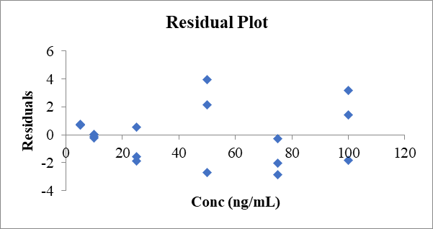RESIDUAL OUTPUT

|  |  |  |
| --- | --- | --- |
| *Observation* | *Predicted Y* | *Residuals* |
| 1 | 4.43234159 | 0.695606227 |
| 2 | 9.572559935 | -0.142554917 |
| 3 | 24.99321497 | 0.541155326 |
| 4 | 50.6943067 | -2.699324257 |
| 5 | 76.39539842 | -0.256913724 |
| 6 | 102.0964901 | 1.412792342 |
| 7 | 4.43234159 | 0.760834526 |
| 8 | 9.572559935 | -0.228856975 |
| 9 | 24.99321497 | -1.584283711 |
| 10 | 50.6943067 | 2.173731438 |
| 11 | 76.39539842 | -2.8590211 |
| 12 | 102.0964901 | 3.201051249 |
| 13 | 4.43234159 | 0.690588666 |
| 14 | 9.572559935 | 0.059151053 |
| 15 | 24.99321497 | -1.864263641 |
| 16 | 50.6943067 | 3.951955221 |
| 17 | 76.39539842 | -2.04918668 |
| 18 | 102.0964901 | -1.802461044 |

**1.2 5-(4′-(azidomethyl)-[1,1′-biphenyl]-2-yl)-1H-tetrazole (AZBT)**

|  |  |
| --- | --- |
| SUMMARY OUTPUT | |
|  |  |
| *Regression Statistics* | |
| Multiple *r* | 0.99920542 |
| *r2* | 0.998411471 |
| Adjusted *r2* | 0.998312188 |
| Standard Error | 1.146552015 |
| Observations | 18 |

|  |  |  |  |  |  |  |  |  |
| --- | --- | --- | --- | --- | --- | --- | --- | --- |
| ANOVA |  |  |  |  |  |  |  |  |
|  | *df* | *SS* | *MS* | *Fcal* | *FANOVA* |  |  |  |
| Regression | 1 | 13219.70808 | 13219.71 | 10056.21018 | 7.96833 x 10-24 |  |  |  |
| Residual | 16 | 21.03330435 | 1.314582 |  |  |  |  |  |
| Total | 17 | 13240.74139 |  |  |  |  |  |  |
|  |  |  |  |  |  |  |  |  |
|  | *Coefficients* | *Standard Error* | *t Stat* | *P-value* | *Lower 95%* | *Upper 95%* | *Lower 95.0%* | *Upper 95.0%* |
| *y*-intercept | 0.158172741 | 0.37883542 | 0.417524 | 0.681844418 | -0.64492247 | 0.961267956 | -0.644922475 | 0.961267956 |
| Slope | 0.989101978 | 0.009863338 | 100.2807 | 7.96833E-24 | 0.968192636 | 1.01001132 | 0.968192636 | 1.01001132 |

**LOD estimation**

LOD = (3.3 x σ) / S

= (3.3 x 0.37883542) / 0.989101978 = 1.264 ng/mL

When the test sample is prepared at the concentration of 5 mg/mL, the estimated LOD is

LOD = 1.264 / 5 = 0.25 ng/mg (μg/g) = 0.25 ppm

**LOQ estimation**

LOQ = (10 x σ) / S

= (3 x 0.37883542) / 0.989101978 = 3.830 ng/mL

When the test sample is prepared at the concentration of 5 mg/mL, the estimated LOQ is

LOQ = 3.830 / 5 = 0.77 ng/mg (μg/g) = 0.77 ppm

Where σ = the standard error of *y*-intercept of regression lines and S = the slope of the calibration curve.

|  |  |  |  |
| --- | --- | --- | --- |
| RESIDUAL OUTPUT | | | |
|  |  |  |
| *Observation* | *Predicted Y* | *Residuals* |
| 1 | 0.65272373 | -0.156780525 |
| 2 | 1.147274719 | -0.133061521 |
| 3 | 10.04919252 | -0.045132431 |
| 4 | 24.88572219 | 0.44923518 |
| 5 | 49.61327164 | 1.277917969 |
| 6 | 74.34082108 | -2.222469481 |
| 7 | 0.65272373 | -0.162865717 |
| 8 | 1.147274719 | -0.105650353 |
| 9 | 10.04919252 | -0.328323661 |
| 10 | 24.88572219 | 0.608593686 |
| 11 | 49.61327164 | 0.415148988 |
| 12 | 74.34082108 | -0.432985112 |
| 13 | 0.65272373 | -0.154752127 |
| 14 | 1.147274719 | -0.139152891 |
| 15 | 10.04919252 | -0.289752812 |
| 16 | 24.88572219 | 1.405386216 |
| 17 | 49.61327164 | -2.36296713 |
| 18 | 74.34082108 | 2.377611721 |

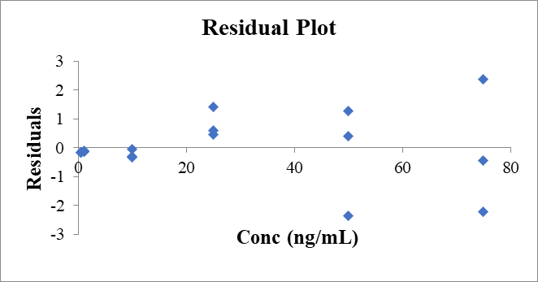

**1.3 5-(4′-((5-(azidomethyl)-2-butyl-4-chloro-1H-imidazol-1-yl) methyl)-[1,1′-biphenyl]-2-yl)-1H-tetrazole (AZTT)**

|  |  |
| --- | --- |
| SUMMARY OUTPUT | |
|  |  |
| *Regression Statistics* | |
| Multiple *r* | 0.999675583 |
| *r2* | 0.999351271 |
| Adjusted *r2* | 0.999310726 |
| Standard Error | 0.728012788 |
| Observations | 18 |

|  |  |  |  |  |  |  |  |  |
| --- | --- | --- | --- | --- | --- | --- | --- | --- |
| ANOVA |  |  |  |  |  |  |  |  |
|  | *df* | *SS* | *MS* | *Fcal* | *FANOVA* |  |  |  |
| Regression | 1 | 13063.30702 | 13063.30702 | 24647.627 | 6.16209 x 10-27 |  |  |  |
| Residual | 16 | 8.480041908 | 0.530002619 |  |  |  |  |  |
| Total | 17 | 13071.78706 |  |  |  |  |  |  |
|  |  |  |  |  |  |  |  |  |
|  | *Coefficients* | *Standard Error* | *t Stat* | *P-value* | *Lower 95%* | *Upper 95%* | *Lower 95.0%* | *Upper 95.0%* |
| *y*-intercept | 0.241353456 | 0.240544718 | 1.003362112 | 0.3306201 | -0.268578566 | 0.751285478 | -0.268578566 | 0.751285478 |
| Slope | 0.983233585 | 0.006262809 | 156.9956282 | 6.162E-27 | 0.969957024 | 0.996510147 | 0.969957024 | 0.996510147 |

**LOD estimation**

LOD = (3.3 x σ) / S

= (3.3 x 0.240544718) / 0.983233585 = 0.807 ng/mL

When the test sample is prepared at the concentration of 5 mg/mL, the estimated LOD is

LOD = 0.807 / 5 = 0.16 ng/mg (μg/g) = 0.16 ppm

**LOQ estimation**

LOQ = (10 x σ) / S

= (10 x 0.240544718) / 0.983233585 = 2.446 ng/mL

When the test sample is prepared at the concentration of 5 mg/mL, the estimated LOQ is

LOQ = 2.466 / 5 = 0.49 ng/mg (μg/g) = 0.49 ppm

Where σ = the standard error of *y*-intercept of regression lines and S = the slope of the calibration curve.

|  |  |  |
| --- | --- | --- |
| RESIDUAL OUTPUT | | |
|  |  |  |
| *Observation* | *Predicted Y* | *Residuals* |
| 1 | 0.732970249 | -0.238030977 |
| 2 | 1.224587041 | -0.204323617 |
| 3 | 10.07368931 | -0.197296198 |
| 4 | 24.82219309 | 0.963995923 |
| 5 | 49.40303272 | 0.45614219 |
| 6 | 73.98387235 | -0.962515563 |
| 7 | 0.732970249 | -0.239043123 |
| 8 | 1.224587041 | -0.202297274 |
| 9 | 10.07368931 | 0.097536629 |
| 10 | 24.82219309 | 0.09169085 |
| 11 | 49.40303272 | 0.601019804 |
| 12 | 73.98387235 | -0.787244044 |
| 13 | 0.732970249 | -0.229933811 |
| 14 | 1.224587041 | -0.238771438 |
| 15 | 10.07368931 | -0.103071274 |
| 16 | 24.82219309 | 1.362156079 |
| 17 | 49.40303272 | -1.348242637 |
| 18 | 73.98387235 | 1.17822848 |

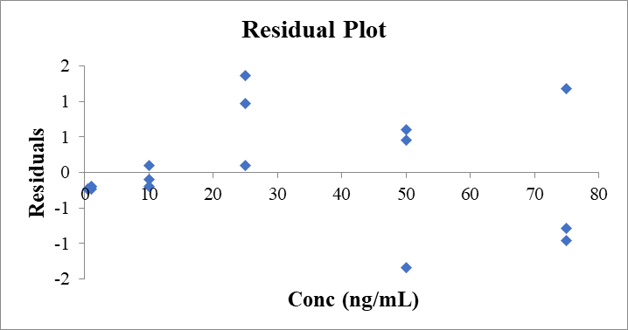

1. **Representative chromatograms of method validation experiments**

**2.1 System suitability**

**2.2 Linearity**

**2.3 Range**

Matrix: Losartan

Matrix: Irbesartan

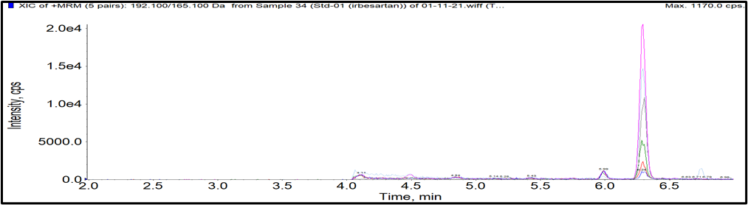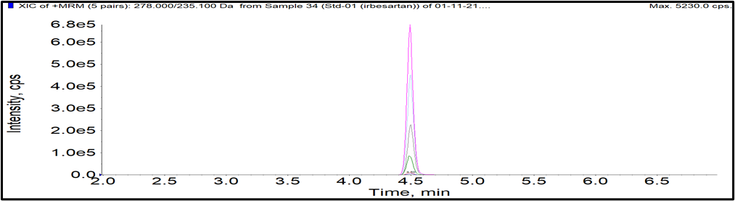

**AZBC**

**AZBT**

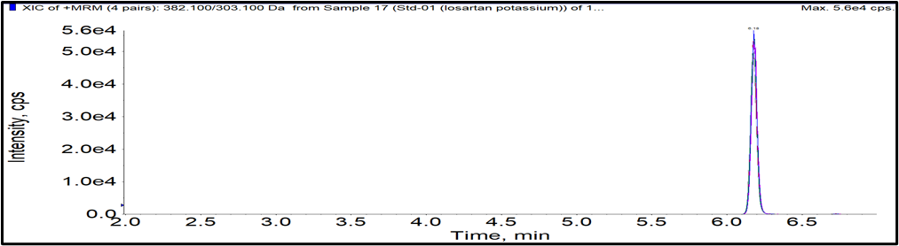

**Celecoxib**

Matrix: Olmesartan

**2.4 Accuracy and Precision (Blue = LOQ, Red = M QC, and Green = HQC)**

Matrix: Losartan

Matrix: Irbesartan

Matrix: Olmesartan

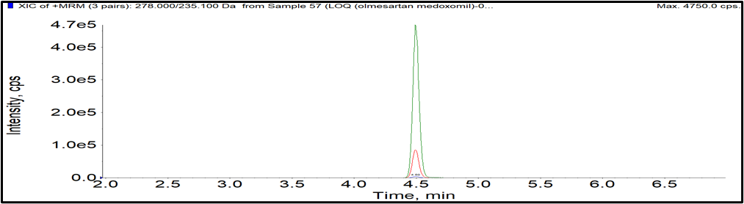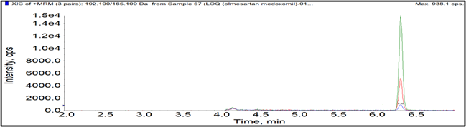

**2.5 LOD (blue line) and LOQ (red line)**

Matrix: Losartan

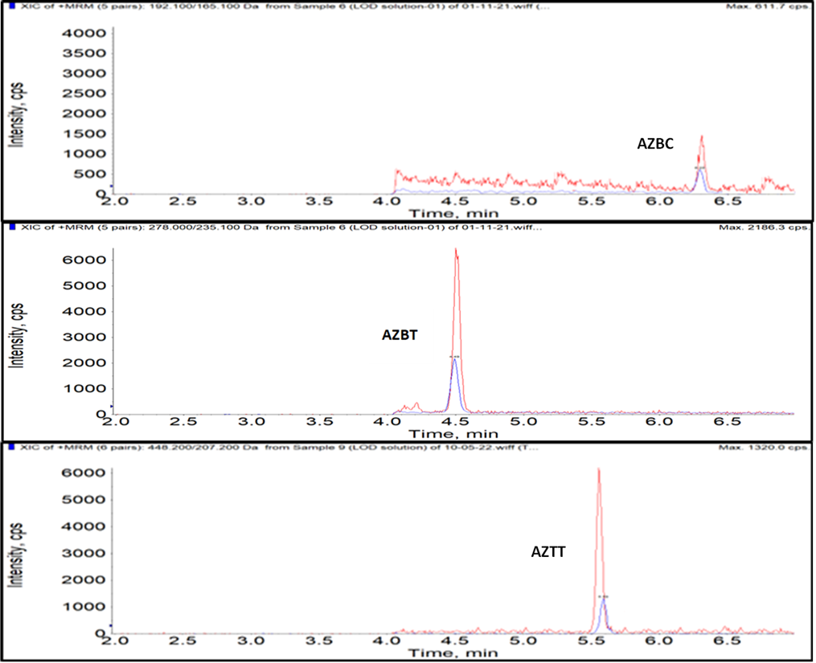

Matrix: Irbesartan

Matrix: Olmesartan

1. **The assessment of the greenness of the analytical method**

The greenness of analytical methods has recently gained attention and emerged as a challenging consideration. In evaluating the greenness of our analytical method for simultaneous determination of three organic azide impurities in sartan APIs and products, we conducted a qualitative assessment of the environmental impact of solvents, energy consumption, waste generation, safety, and analytical performance. The details are described as follows:

* 1. **Solvents**

In our analytical method, as described in the abstract, the mobile phase consists of 0.1% formic acid in water (solvent A) and 0.1% formic acid in acetonitrile (solvent B). The method operates under gradient elution mode with a flow rate of 0.5 mL/min and a total analysis time of 11.0 min. Water, used as solvent A, is a green solvent that has minimal environmental impact. Formic acid, added to water at 0.1%, is a relatively low concentration and should have a limited impact on the environment. Acetonitrile, used as solvent B, is a common solvent in analytical chemistry but is considered to have a moderate environmental impact due to its toxicity and non-biodegradability. However, it is worth noting that the consumption of acetonitrile in our method is low, with the flow rate being only 0.5 mL/min.

To address concerns about the environmental impact of acetonitrile, we suggest the following options for solvent recycling or substitution with greener alternatives as follows:

* 1. Solvent recycling

Implementing a solvent recycling system could help reduce the environmental impact of our method by decreasing the amount of acetonitrile waste generated. This approach would involve collecting and purifying used acetonitrile for reuse in the analytical method.

* 1. Greener alternative solvents

Although acetonitrile is known to have a moderate environmental impact due to its toxicity and non-biodegradability, considering recycling and greener solvent alternatives like isopropyl alcohol can be beneficial. However, it is important to note that method optimization and validation might be necessary when implementing these changes.

* 1. **Energy**

The energy consumption associated with our LC-MS/MS method can be mainly attributed to the operation of the LC system, the mass spectrometer, and any auxiliary equipment such as temperature control units.

1. LC System (Shimadzu Prominence)

The energy consumption of the LC system depends on the flow rate, mobile phase composition, and gradient program, as well as the operation time for each analysis. In our method, the flow rate is 0.5 mL/min, and the total analysis time is 11.0 min. Additionally, the energy consumption of the LC system is influenced by the column and autosampler temperatures, which are maintained at 35°C and 15°C, respectively.

1. Mass Spectrometer (AB Sciex API4000)

The mass spectrometer's energy consumption is mainly determined by the operation of the electrospray ionization (ESI) source and the instrument's internal components, such as the vacuum pumps and electronics. In our method, the Turbo ionspray™ interface is set at 500°C, and the ion spray voltage is 5500 V. The source parameters (collision gas, curtain gas, ion source gas 1 and ion source gas 2) are set at specific values, further contributing to the energy consumption of the instrument.

1. Auxiliary Equipment

Temperature control units for the column and autosampler contribute to energy consumption. In our method, these units maintain temperatures at 35°C and 15°C, respectively. Additionally, nitrogen gas is used as a carrier and fragmentation gas, which may have an indirect energy consumption impact due to the production and transportation of nitrogen. It is important to acknowledge that the method’s energy usage is an essential aspect of its environmental impact. To minimize energy consumption, it is recommended to optimize analysis times and instrument settings, as well as to consider energy-efficient equipment when possible.

* 1. **Waste**

The waste generated during the analysis using our LC-MS/MS method can be mainly classified into two categories: solvent and consumable wastes. Both types of waste can contribute to the environmental impact associated with the method.

1. Solvent Waste

The mobile phase consists of 0.1% formic acid in water (solvent A) and 0.1% formic acid in acetonitrile (solvent B). The flow rate is 0.5 mL/min, and the total analysis time is 11.0 minutes. Based on these parameters, approximately 5.5 mL of the mobile phase is used per analysis, with varying proportions of solvents A and B according to the gradient program. Acetonitrile is a volatile organic solvent, and its production and disposal can have environmental consequences. Additionally, formic acid, although present in a low concentration, can contribute to the waste's acidity.

To minimize the environmental impact of solvent waste, the following strategies can be employed in the laboratory:

* Optimize the gradient program and flow rate to reduce the total volume of solvents used.
* Recycle and reuse solvents when feasible, which can lower the consumption of fresh solvents and reduce waste generation.
* Properly segregate and treat solvent waste according to local regulations before disposal to minimize environmental impact.

1. Consumable Waste

Consumables such as sample vials, syringe filters, pipette tips, and other plastic or glassware used during sample preparation and analysis contribute to laboratory waste. The environmental impact of consumables waste mainly depends on the materials used and the volume of waste generated. The centrifugation and filtration steps used in the sample preparation method are anticipated to generate minimal waste in comparison to liquid-liquid extraction (LLE) and solid phase extraction (SPE) techniques. This is due to the fact that the filtered sample solution is directly transferred to a vial for subsequent analysis, reducing the need for additional sample handling and minimizing waste generation. This approach promotes a more environmentally friendly and sustainable analytical practice by conserving resources and reducing waste generation during sample preparation. Waste reduction and management strategies for consumables waste include:

* Using reusable or recyclable materials when possible to reduce waste generation.
* Properly segregating waste and following appropriate disposal procedures, such as recycling or incineration, in compliance with local regulations.
* Implementing good laboratory practices to minimize the use of consumables and optimize the number of analyses performed.
  1. **Safety**

In our LC-MS/MS method, the main hazardous substances used are acetonitrile and formic acid. Although formic acid is used in a low concentration (0.1%), it is still an acidic substance and should be handled with care. Acetonitrile, a volatile organic solvent, is used as a component of the mobile phase and can pose potential environmental risks if not managed properly.

To mitigate the potential environmental risks associated with these hazardous substances, the following measures can be taken in our laboratory:

1. Proper Storage

Acetonitrile and formic acid are stored according to their respective safety guidelines in well-ventilated areas, away from heat sources or ignition, and separate from incompatible materials.

1. Personal Protective Equipment (PPE)

In compliance with the guidelines of the GLP-certified laboratory, staff consistently wear suitable PPE, including lab coats, gloves, and safety goggles, while handling hazardous materials to reduce the risk of exposure.

1. Fume Hoods and Ventilation

Perform all operations involving hazardous substances in a fume hood or a well-ventilated area to minimize the inhalation of harmful vapors.

1. Spill Management

Establish and follow proper spill management procedures in case of accidental spills or leaks. This includes using appropriate absorbent materials, neutralizing agents, and personal protective equipment while handling and cleaning up spills.

1. Waste Disposal

Properly segregate and dispose of hazardous waste according to GLP regulations. This includes collecting waste solvents in designated containers, treating the waste to reduce its hazardous properties, and disposing of it through authorized waste disposal services.

1. Training and Awareness

Provide laboratory personnel with adequate training on handling hazardous substances and managing potential risks. All laboratory staffs are familiar with the safety data sheets (SDS) of the hazardous substances used in the method.

* 1. **Analytical performance**

The greenness of our LC-MS/MS method can be assessed in terms of its analytical performance, including sensitivity, accuracy, precision, and other validation parameters. These performance attributes contribute to the overall efficiency and effectiveness of the method, reducing the need for reanalysis and minimizing waste generation. Based on the abstract and LCMS conditions provided, the method demonstrates the following green aspects:

1. Sensitivity

The method offers sufficient sensitivity with limits of detection (LOD) and limits of quantification (LOQ) below the acceptable limits of azido impurities in pharmaceuticals, as per the ICH M7 guideline. The assay's high sensitivity enables the detection of low levels of impurities, reducing the need for repeated analyses.

1. Accuracy and Precision

The high accuracy of the developed method reduces the likelihood of false results, minimizing the need for additional confirmatory analyses and decreasing the use of resources. The high level of precision implies that the developed method produces consistent results, thereby reducing the need for repeated analyses and conserving resources.

1. Other Validation Parameters

The method also meets validation criteria for specificity, carryover, and robustness. High specificity ensures that the method accurately detects the target analytes without interference from other substances. Good carryover performance ensures that residual analytes from previous samples do not affect the subsequent analyses, while robustness indicates the method's ability to produce consistent results under minor variations in experimental conditions.

The method's robust analytical performance, characterized by high sensitivity, accuracy, and precision, along with other validated parameters, contributes to its greenness. By consistently providing reliable results, the method minimizes the need for reanalysis, conserves resources, and reduces waste generation, promoting a more sustainable and environmentally friendly analytical practice. The stability studies further suggest that the stock solutions can be preserved for up to 15 days, minimizing waste generation by avoiding unnecessary preparation of fresh solutions. Overall, the method's strong analytical performance and stability studies support its greenness by promoting efficient resource usage and waste reduction practices in line with sustainability principles.

**Supplementary Tables**

**Table 1S.** Parameters examined in the robustness experiment and their levels of variation

|  |  |  |  |  |
| --- | --- | --- | --- | --- |
| **Factor** | **Parameter** | **level ( ̶ )** | **regular level** | **level (+)** |
| F1 | Column temperature (°C) | 34 | 35 | 36 |
| F2 | Flow rate (mL/min) | 0.49 | 0.50 | 0.51 |
| F3 | Collision gas (psi) | 4 | 5 | 6 |
| F4 | Curtain gas (psi) | 24 | 25 | 26 |
| F5 | Ion source gas 1 (psi) | 59 | 60 | 61 |
| F6 | Ion source gas 2 (psi) | 49 | 50 | 51 |
| F7 | Ion spray voltage (kV) | 5.49 | 5.50 | 5.51 |
| F8 | Desolvation temperature (°C) | 495 | 500 | 505 |

**Table 2S.** Mean between back-calculated standard and calibration curve results **(***n = 3***)**

|  |  |  |  |  |  |
| --- | --- | --- | --- | --- | --- |
| **Compound** | **Slope** | ***y*-intercept** | ***r2*** | ***Fcal*** | ***F*ANOVA** |
| AZBC | 1.0280 | -0.7079 | 0.997 | 5732.882 | 7.078 х 10-22 |
| AZBT | 0.9891 | 0.1582 | 0.998 | 10056.210 | 7.968 х 10-24 |
| AZTT | 0.9832 | 0.2414 | 0.999 | 24647.627 | 6.162 х 10-27 |

See details in the supplementary material section 1

**Table 3S.** Plackett-Burman design and the results of the twelve experiments

|  |  |  |  |  |  |  |  |  |  |  |  |  |  |  |
| --- | --- | --- | --- | --- | --- | --- | --- | --- | --- | --- | --- | --- | --- | --- |
| **Exp. No.** | **Factora** | | | | | | | | | | | **Content (ng/mg) (Y)** | | |
| **F1** | **F2** | **D1** | **F3** | **F4** | **D2** | **F5** | **F6** | **D3** | **F7** | **F8** | **AZBC** | **AZBT** | **AZTT** |
| 1 | (+) | ( ̶ ) | (+) | (+) | ( ̶ ) | (+) | (+) | (+) | ( ̶ ) | ( ̶ ) | ( ̶ ) | 5.06 | 4.93 | 5.09 |
| 2 | (+) | (+) | ( ̶ ) | (+) | (+) | ( ̶ ) | (+) | ( ̶ ) | ( ̶ ) | ( ̶ ) | (+) | 5.07 | 4.91 | 5.12 |
| 3 | (+) | (+) | (+) | ( ̶ ) | ( ̶ ) | (+) | ( ̶ ) | ( ̶ ) | ( ̶ ) | (+) | (+) | 5.14 | 5.08 | 5.09 |
| 4 | ( ̶ ) | ( ̶ ) | ( ̶ ) | ( ̶ ) | ( ̶ ) | ( ̶ ) | ( ̶ ) | ( ̶ ) | ( ̶ ) | ( ̶ ) | ( ̶ ) | 5.00 | 4.96 | 5.07 |
| 5 | (+) | ( ̶ ) | (+) | (+) | (+) | ( ̶ ) | ( ̶ ) | ( ̶ ) | (+) | (+) | ( ̶ ) | 5.17 | 4.95 | 5.17 |
| 6 | ( ̶ ) | ( ̶ ) | (+) | ( ̶ ) | (+) | ( ̶ ) | (+) | (+) | ( ̶ ) | (+) | (+) | 4.98 | 5.04 | 4.96 |
| 7 | ( ̶ ) | (+) | ( ̶ ) | (+) | (+) | (+) | ( ̶ ) | (+) | ( ̶ ) | (+) | ( ̶ ) | 4.94 | 5.02 | 4.92 |
| 8 | (+) | (+) | ( ̶ ) | ( ̶ ) | ( ̶ ) | ( ̶ ) | (+) | (+) | (+) | (+) | ( ̶ ) | 5.13 | 5.12 | 5.09 |
| 9 | (+) | ( ̶ ) | ( ̶ ) | ( ̶ ) | (+) | (+) | ( ̶ ) | (+) | (+) | ( ̶ ) | (+) | 5.05 | 5.09 | 5.08 |
| 10 | ( ̶ ) | ( ̶ ) | ( ̶ ) | (+) | ( ̶ ) | (+) | (+) | ( ̶ ) | (+) | (+) | (+) | 4.97 | 5.01 | 5.13 |
| 11 | ( ̶ ) | (+) | (+) | ( ̶ ) | (+) | (+) | (+) | ( ̶ ) | (+) | ( ̶ ) | ( ̶ ) | 5.09 | 5.07 | 4.97 |
| 12 | ( ̶ ) | (+) | (+) | (+) | ( ̶ ) | ( ̶ ) | ( ̶ ) | (+) | (+) | ( ̶ ) | (+) | 5.09 | 4.97 | 5.10 |

(-) low factor level (+) high factor level

a F1, column temperature; F2, flow rate; D1, dummy1; F3, collision gas; F4, curtain gas; D2, dummy2; F5, ion source gas 1; F6, ion source gas 2; D3, dummy3; F7, ion spray voltage; F8, desolvation temperature

**Table 4S.** Factor effects (EX) and critical effects (Ecrit) on the analytical results

|  |  |  |  |
| --- | --- | --- | --- |
| **Factor (Fx)** | **Factor effect (Ex)** | | |
| **AZBC (ng/mg)** | **AZBT (ng/mg)** | **AZTT (ng/mg)** |
| F1 | 0.09 | 0.00 | 0.08 |
| F2 | 0.04 | 0.03 | -0.03 |
| F3 | -0.02 | -0.10 | 0.04 |
| F4 | -0.01 | 0.01 | -0.06 |
| F5 | -0.02 | 0.00 | -0.01 |
| F6 | -0.03 | 0.03 | -0.05 |
| F7 | 0.00 | 0.05 | -0.01 |
| F8 | -0.01 | 0.01 | 0.03 |
| D1 | 0.06 | -0.01 | -0.01 |
| D2 | -0.03 | 0.04 | -0.04 |
| D3 | 0.05 | 0.04 | 0.05 |
| Ecrit  (α = 0.05, df = 3) | **0.16** | **0.11** | **0.11** |

**Supplementary Figures**

**Figure 1S** Representative chromatograms of AZBC and AZTT obtained using methanol as the organic modifier in the mobile phase.