Chemical constituents and hepatoprotective properties of *Rhododendron simsii* Planch extract in Con A-induced autoimmune hepatitis

Fuqian Wanga,b, Weiguang Sunc, Zhou Lana, Yuan Zhoua, Lulu Lia,b, Ziheng Lia, Ling Chengc,*, Qiuyun You a,*, Qunfeng Yaoa,*

* Corresponding AuthorsE-mails: yaoqunfeng@hbtcm.edu.cn (Q. Yao); youqiuyun740723@hbtcm.edu.cn (Q.You) and chengling630614@hust.edu.cn (L. Cheng)

1. Faculty of Pharmacy, Hubei University of Chinese Medicine, Wuhan 430065, Hubei, People’s Republic of China.
2. Department of Pharmacy, Wuhan No.1 Hospital, Wuhan 430022, Hubei, PR China.
3. Hubei Key Laboratory of Natural Medicinal Chemistry and Resource Evaluation, School of Pharmacy, Tongji Medical College, Huazhong University of Science and Technology, Wuhan 430030, China

CONTENTS

**S1.** 1H NMR spectrum of quercetin 3-O-α-L-rhamnoside..................................................................................................3

**S2.** 13C NMR spectrum of quercetin 3-O-α-L-rhamnoside.................................................................................................3

**S3.** 1H NMR spectrum of Tamarixetin 3-rhamnoside.........................................................................................................4

**S4.** 13C NMR spectrum of Tamarixetin 3-rhamnoside.......................................................................................................4

**S5.** 1H NMR spectrum of isoquercitrin...............................................................................................................................5

**S6.** 13C NMR spectrum of isoquercitrin..............................................................................................................................5

**S7.** 1H NMR spectrum of hyperoside..................................................................................................................................6

**S8.** 13C NMR spectrum of hyperoside................................................................................................................................6

**S9.** 1H NMR spectrum of myricetin-3-O-α-L-rhamnopyranoside......................................................................................7

**S10.** 13C NMR spectrum of myricetin-3-O-α-L-rhamnopyranoside...................................................................................7

**S11.** 1H NMR spectrum of afzelin......................................................................................................................................8

**S12.** 13C NMR spectrum of afzelin.....................................................................................................................................8

**S13.** 1H NMR spectrum of quercetin-3-O-α-L-arabinofuranoside.....................................................................................9

**S14.** 13C NMR spectrum of quercetin-3-O-α-L-arabinofuranoside....................................................................................9

**S15.** 1H NMR spectrum of quercetin-3-O-α-D-arabinopyranoside..................................................................................10

**S16.** 13C NMR spectrum of quercetin-3-O-α-D-arabinopyranoside.................................................................................10

**S17.** 1H NMR spectrum of (+)-catechin...........................................................................................................................11

**S18.** 13C NMR spectrum of (+)-catechin..........................................................................................................................11

**S19.** 1H NMR spectrum of kaempferol.............................................................................................................................12

**S20.** 13C NMR spectrum of kaempferol............................................................................................................................12

**S21.** 1H NMR spectrum of dihydromyricetin...................................................................................................................13

**S22.** 13C NMR spectrum of dihydromyricetin..................................................................................................................13

**S23.** 1H NMR spectrum of quercetin................................................................................................................................14

**S24.** 13C NMR spectrum of quercetin...............................................................................................................................14

**S25.** 1H NMR spectrum of vanillic acid...........................................................................................................................15

**S26.** 13C NMR spectrum of vanillic acid..........................................................................................................................15

**S27.** 1H NMR spectrum of Gallic acid.............................................................................................................................16

**S28.** 13C NMR spectrum of Gallic acid............................................................................................................................16

**S29.** 1H NMR spectrum of Farrerol..................................................................................................................................17

**S30.** 13C NMR spectrum of Farrerol.................................................................................................................................17

**S31.** 1H NMR data of compounds 1–8..............................................................................................................................18

**S32.** 1H NMR data of compounds 9–15............................................................................................................................19

**S33.** 13C NMR data of compounds 1–15...........................................................................................................................19

S1. 1H NMR spectrum of quercetin 3-O-α-L-rhamnoside



S2. 13C NMR spectrum of quercetin 3-O-α-L-rhamnoside



S3. 1H NMR spectrum of Tamarixetin 3-rhamnoside



S4. 13C NMR spectrum of Tamarixetin 3-rhamnoside



S5. 1H NMR spectrum of isoquercitrin



S6. 13C NMR spectrum of isoquercitrin



S7. 1H NMR spectrum of hyperoside



S8. 13C NMR spectrum of hyperoside



S9. 1H NMR spectrum of myricetin-3-O-α-L-rhamnopyranoside



S10. 13C NMR spectrum of myricetin-3-O-α-L-rhamnopyranoside



S11. 1H NMR spectrum of afzelin



S12. 13C NMR spectrum of afzelin



S13. 1H NMR spectrum of quercetin-3-O-α-L-arabinofuranoside



S14. 13C NMR spectrum of quercetin-3-O-α-L-arabinofuranoside



S15. 1H NMR spectrum of quercetin-3-O-α-D-arabinopyranoside



S16. 13C NMR spectrum of quercetin-3-O-α-D-arabinopyranoside



S17. 1H NMR spectrum of (+)-catechin



S18. 13C NMR spectrum of (+)-catechin



S19. 1H NMR spectrum of kaempferol



S20. 13C NMR spectrum of kaempferol



S21. 1H NMR spectrum of dihydromyricetin



S22. 13C NMR spectrum of dihydromyricetin



S23. 1H NMR spectrum of quercetin



S24. 13C NMR spectrum of quercetin



S25. 1H NMR spectrum of vanillic acid



S26. 13C NMR spectrum of vanillic acid



S27. 1H NMR spectrum of Gallic acid



S28. 13C NMR spectrum of Gallic acid



S29. 1H NMR spectrum of Farrerol

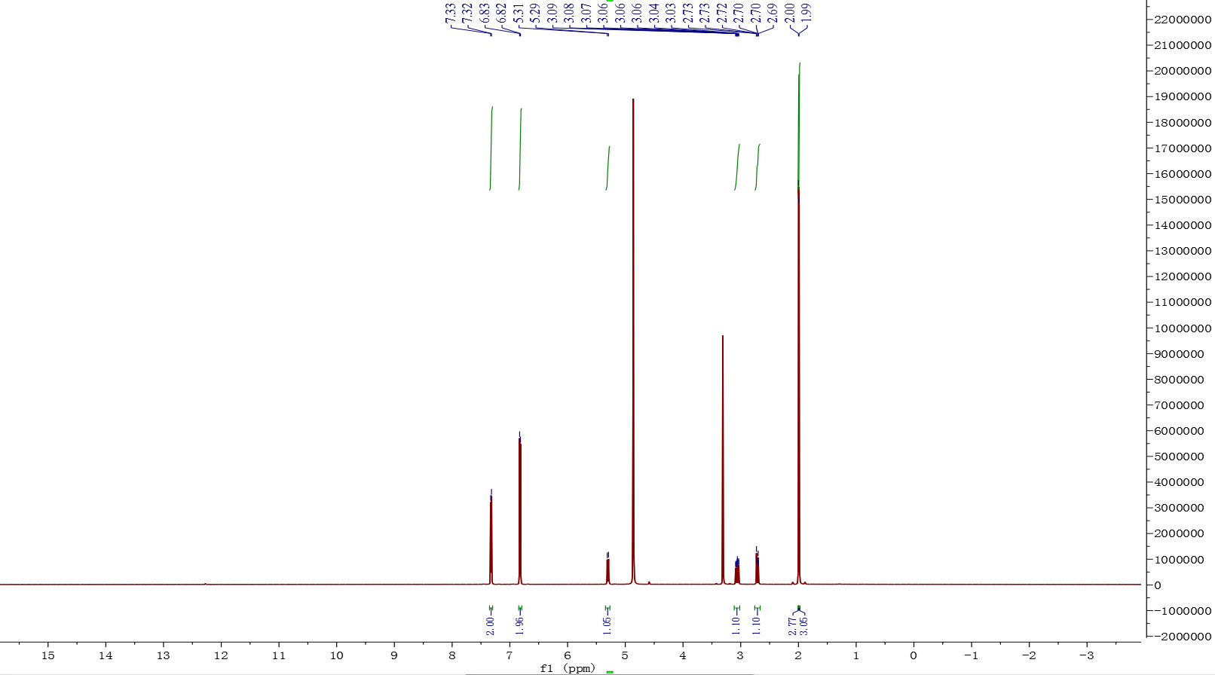

S30. 13C NMR spectrum of Farrerol

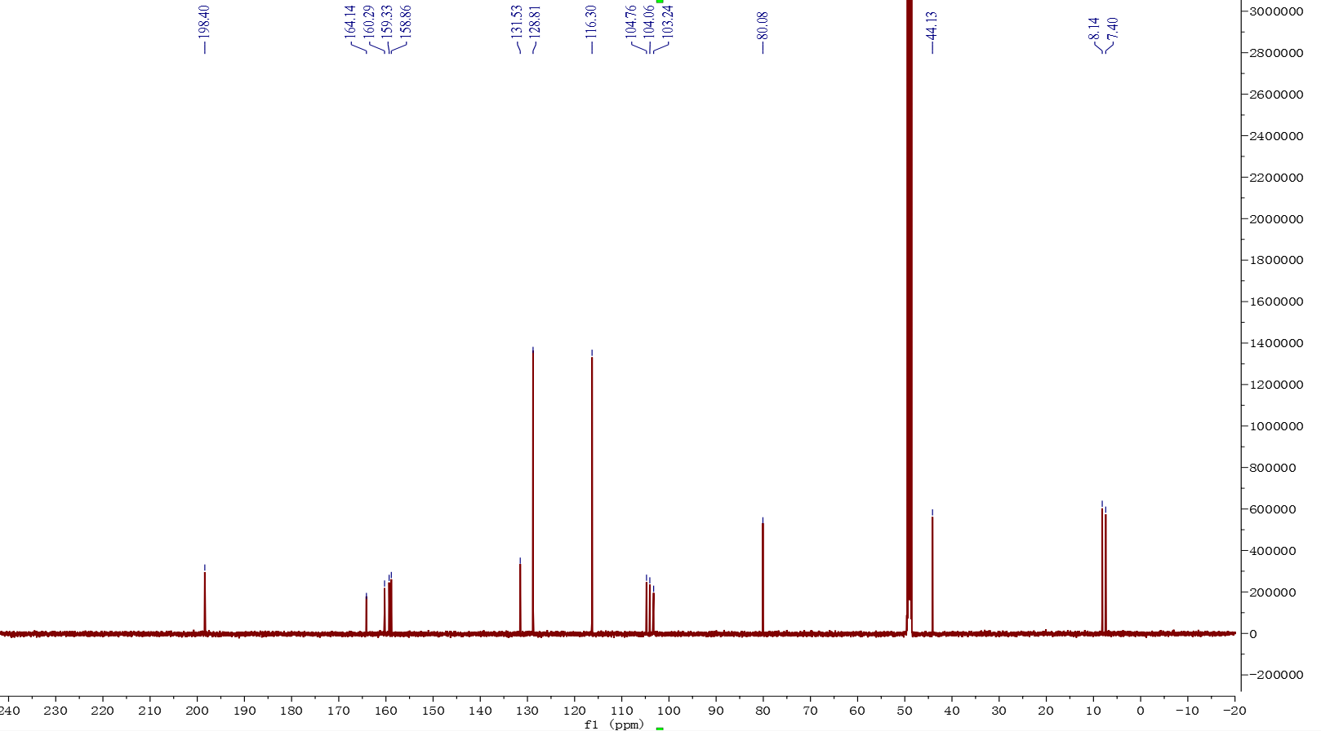

**Table 2.** 1H NMR data of compounds 1–8 (400 MHz, *J* in Hz)

|  |  |  |  |  |  |  |  |  |
| --- | --- | --- | --- | --- | --- | --- | --- | --- |
| **no** | **1** | **2** | **3** | **4** | **5** | **6** | **7** | **8** |
| 6 | 6.22 (d, 1.9) | 6.40 (d, 1.8) | 6.21 (d) | 6.23 (d, 1.9) | 6.22 (d, 2.1) | 6.23 (d, 2.0) | 6.20 (d, 2.1) | 6.19 (d, 1.7) |
| 8 | 6.39 (d, 1.9) | 6.23 (d, 1.9) | 6.41 (s) | 6.43 (d, 1.7) | 6.39 (d, 2.1) | 6.41 (d, 1.9) | 6.39 (d, 2.0) | 6.39 (s) |
| 1’ |  |  |  |  |  |  |  |  |
| 2’ | 7.36 (d, 2.0) | 7.36 (d, 2.1) | 7.73 (d, 2.1) | 7.87 (d, 2.0) | 6.97 (s) | 7.79 (d, 8.7) | 7.52 (d, 2.1) | 7.74 (d, 2.1) |
| 3’ |  |  |  |  |  | 6.96 (d, 8.8) |  |  |
| 5’ | 6.93 (d, 8.3) | 7.10 (d, 8.5) | 6.89 (d, 8.5) | 6.89 (d, 8.5) |  | 6.96 (d, 8.8) | 6.89 (d, 8.3) | 6.86 (d, 8.5) |
| 6’ | 7.33 (dd, 8.3, 2.0) | 7.44 (dd, 8.5, 2.1) | 7.61 (dd, 8.5, 2.0) | 7.61 (dd, 8.5, 2.1) | 6.97 (s) | 7.79 (d, 8.7) | 7.49 (dd, 8.3, 2.2) | 7.57 (dd, 8.5, 2.0) |
| 1’’ | 5.37 (d, 1.4) | 5.40 (d, 1.5) | 5.29 (d, 7.5) | 5.19 (d, 7.8) | 5.33 (d, 1.4) | 5.40 (d, 1.6) | 5.46 (s) | 5.15 (d, 6.6) |
| 2’’ | 3.77 (dd, 9.3, 3.3) | 4.24 (dd, 3.2, 1.6) | 3.51 (m) | 3.83 (d, 8.0) | 4.24 (dd, 3.2, 1.7) | 4.24 (dd, 3.3, 1.7) | 4.32 (dd, 3.0, 0.9) | 3.89 (dd, 8.4, 6.7) |
| 3’’ | 3.46 (m) | 3.75 (dd, 9.0, 3.3) | 3.45 (t, 8.8) | 3.58 (m) | 3.81 (dd, 9.5, 3.3) | 3.73 (d, 5.8) | 3.90 (dd, 5.2, 3.0) | 3.64 (dd, 8.4, 3.0) |
| 4’’ | 3.37 (m) | 3.35 (m) | 3.34 (t, 10.0) | 3.88 (d, 3.2) | 3.37 (m) | 3.33 (m) | 3.84 (q, 4.7) | 3.80 (m, overlap) |
| 5’’*a* | 4.24 (dd, 3.1, 1.4) | 3.35 (m) | 3.4 (m) | 3.50 (t, 6.0) | 3.54 (m) | 3.35 (m) | 3.49 (dd, 4.1, 2.0) | 3.82 (m, overlap ) |
| 5’’*b* | 3.44 (m) |
| 6’’*a* | 0.96 (d, 6.1) | 0.95 (d, 5.5) | 3.74 (dd, 11.9, 2.1) | 3.67 (dd, 11.2, 6.0) | 0.98 (d, 6.2) | 0.94 (d, 5.6) |  |  |
| 6’’*b* | 3.60 (dd, 11.9, 5.3) | 3.57 (m) |  |  |

record in CD3OD

**Table 3**. 1H NMR data of compounds 9–15 (400 MHz, *J* in Hz)

|  |  |  |  |  |  |  |  |
| --- | --- | --- | --- | --- | --- | --- | --- |
| **No** | **9** | **10** | **11** | **12** | **13** | **14** | **15** |
| 2 | 4.58 (d, 7.5) |  | 4.85 (d, 11.4) |  | 7.57 (d, 8.7) | 6.93 (s) | 5.30 (d, 12.8) |
| 3 | 3.99 (td, 7.9, 5.4) |  | 4.48 (d, 11.4) |  | 6.85 (d, 8.7) |  | 3.06 (dd, 16.9, 12.9) |
| 2.71 (dd, 16.9, 2.2) |
| 4*a* | 2.87 (dd, 16.1, 5.4) |  |  |  |  |  |  |
| 4*b* | 2.52 (dd, 16.1, 8.2) |  |  |  |  |  |  |
| 6 | 5.95 (d, 2.3) | 6.20 (d, 1.7) | 5.90 (d, 2.1) | 6.19 (s) | 7.58 (s) | 6.93 (s) |  |
| 8 | 5.87 (d, 2.2) | 6.42 (s) | 5.94 (d, 2.1) | 6.40 (s) |  |  |  |
| 2’ | 6.86 (d, 1.9) | 8.11 (d, 8.6) | 6.54 (s) | 7.76 (s) |  |  | 7.32 (d, 8.2) |
| 3’ |  | 6.93 (d, 8.9) |  |  |  |  | 6.82 (d, 8.6) |
| 5’ | 6.78 (d, 8.1) | 6.93 (d, 8.9) |  | 6.91 (d, 8.5) |  |  | 6.82 (d, 8.6) |
| 6’ | 6.74 (dd, 8.1, 1.9) | 8.11 (d, 8.6) | 6.54 (s) | 7.66 (d, 8.3) |  |  | 7.32 (d, 8.2) |
| 3,5-OH |  |  |  |  |  | 9.22 (s) |  |
| 4-OH |  |  |  |  |  | 8.87 (s) |  |
| 6-Me |  |  |  |  |  |  | 2.00 (s) |
| 8-Me |  |  |  |  |  |  | 1.99 (s) |
| -OMe |  |  |  |  | 3.91 (s) |  |  |
| -COOH |  |  |  |  |  | 12.27 (s) |  |

All except 14 (DMSO-*d6*) are record in CD3OD.

**Table 4**. 13C NMR data of compounds 1–15 (150 MHz)

|  |  |  |  |  |  |  |  |  |  |  |  |  |  |  |  |
| --- | --- | --- | --- | --- | --- | --- | --- | --- | --- | --- | --- | --- | --- | --- | --- |
| **no** | **1** | **2** | **3** | **4** | **5** | **6** | **7** | **8** | **9** | **10** | **11** | **12** | **13** | **14** | **15** |
| 1 |  |  |  |  |  |  |  |  |  |  |  |  | 123.3 | 120.9 |  |
| 2 | 158.5 | 158.9 | 158.6 | 158.8 | 159.9 | 159.4 | 159.5 | 159.0 | 83.0 | 148.2 | 85.4 | 148.1 | 125.4 | 109.2 | 80.1 |
| 3 | 136.2 | 136.4 | 135.7 | 136.0 | 136.4 | 136.4 | 135.0 | 136.2 | 68.9 | 137.4 | 73.8 | 137.3 | 115.9 | 145.8 | 44.1 |
| 4 | 179.6 | 179.6 | 179.6 | 179.8 | 179.8 | 179.8 | 180.1 | 180.0 | 28.7 | 177.6 | 198.4 | 177.4 | 152.8 | 138.4 | 198.4 |
| 5 | 159.3 | 158.6 | 163.2 | 163.3 | 163.4 | 163.4 | 163.2 | 163.6 | 157.9 | 162.6 | 165.5 | 162.6 | 148.8 | 145.8 | 160.3 |
| 6 | 99.8 | 94.7 | 100.0 | 100.3 | 99.9 | 99.9 | 100.0 | 100.5 | 96.4 | 99.4 | 97.4 | 99.5 | 113.9 | 109.2 | 104.8 |
| 7 | 165.9 | 166.0 | 166.2 | 159.1 | 166.1 | 166.1 | 166.2 | 166.7 | 157.7 | 165.7 | 168.8 | 166.2 |  |  | 159.7 |
| 8 | 94.7 | 99.9 | 94.8 | 95.0 | 94.8 | 94.9 | 94.9 | 95.3 | 95.6 | 94.6 | 96.4 | 94.6 |  |  | 103.3 |
| 9 | 163.2 | 163.2 | 159.1 | 159.1 | 158.6 | 158.7 | 158.7 | 159.2 | 157.0 | 158.4 | 164.6 | 158.4 |  |  | 164.1 |
| 10 | 105.9 | 105.9 | 105.8 | 105.9 | 105.9 | 106.1 | 105.7 | 106.1 | 100.9 | 104.7 | 101.9 | 104.5 |  |  | 104.1 |
| 1’ | 122.9 | 124.3 | 123.3 | 123.3 | 122.0 | 122.8 | 123.1 | 123.6 | 132.3 | 123.9 | 129.2 | 124.3 |  |  | 131.5 |
| 2’ | 116.3 | 116.6 | 116.1 | 116.4 | 109.7 | 132.0 | 116.9 | 118.0 | 115.4 | 130.8 | 108.1 | 116.1 |  |  | 128.8 |
| 3’ | 146.4 | 147.7 | 150.0 | 146.1 | 147.0 | 116.7 | 146.5 | 146.5 | 146.4 | 116.4 | 147.0 | 148.9 |  |  | 116.3 |
| 4’ | 149.8 | 151.6 | 146.0 | 150.2 | 138.0 | 161.7 | 150.0 | 150.5 | 146.5 | 160.1 | 135.0 | 146.3 |  |  | 158.9 |
| 5’ | 116.9 | 112.4 | 117.7 | 118.1 | 147.0 | 116.7 | 116.6 | 116.7 | 116.2 | 116.4 | 147.0 | 116.4 |  |  | 116.3 |
| 6’ | 122.8 | 122.7 | 123.2 | 123.2 | 109.7 | 132.0 | 123.2 | 123.4 | 120.2 | 130.8 | 108.1 | 121.8 |  |  | 128.8 |
| 1’’ | 103.5 | 103.5 | 104.4 | 105.7 | 103.8 | 103.6 | 109.6 | 105.2 |  |  |  |  |  |  |  |
| 2’’ | 72.0 | 71.9 | 75.8 | 73.5 | 72.2 | 72.1 | 83.5 | 73.4 |  |  |  |  |  |  |  |
| 3’’ | 72.1 | 72.0 | 78.2 | 75.4 | 72.1 | 72.3 | 78.8 | 74.7 |  |  |  |  |  |  |  |
| 4’’ | 73.2 | 72.1 | 71.3 | 70.3 | 73.5 | 73.3 | 88.1 | 69.7 |  |  |  |  |  |  |  |
| 5’’ | 71.9 | 73.2 | 78.5 | 77.5 | 72.0 | 72.2 | 62.7 | 67.5 |  |  |  |  |  |  |  |
| 6’’ | 17.6 | 17.7 | 62.7 | 62.2 | 17.8 | 17.8 |  |  |  |  |  |  |  |  |  |
| 4’-OMe |  | 56.4 |  |  |  |  |  |  |  |  |  |  |  |  |  |
| 5-OMe |  |  |  |  |  |  |  |  |  |  |  |  | 56.5 |  |  |
| 6-Me |  |  |  |  |  |  |  |  |  |  |  |  |  |  | 8.1 |
| 8-Me |  |  |  |  |  |  |  |  |  |  |  |  |  |  | 7.4 |
| COOH |  |  |  |  |  |  |  |  |  |  |  |  | 170.3 | 167.9 |  |

All except 14 (DMSO-*d6*) are record in CD3OD.