Supplementary Data
Design, synthesis, cytotoxic evaluation and molecular docking of novel 1, 3, 4-thiadiazole sulfonamides with azene and coumarin moieties as carbonic anhydrase inhibitors
Samir Bondock*ª, Tallah Albarqiª, Tamer Nasr^{b,c}, Nada M. Mohamed^{c}, Moaz M. Abdou^{d}
ªChemistry Department, Faculty of Science, King Khalid University, 9004 Abha, Saudi Arabia
^{b}Department of Pharmaceutical Chemistry, Faculty of Pharmacy, Helwan University, 11795 Helwan, Cairo, Egypt
^{c}Pharmaceutical Chemistry Department, Faculty of Pharmacy, Modern University for Technology and Information, MTI, Cairo, Egypt.
^{d}Egyptian Petroleum Research Institute, Nasr City, 11727, Cairo, Egypt
Correspondence
Samir Bondock, Chemistry Department, Faculty of Science, King Khalid University, 9004 Abha, Saudi Arabia.
Email: bondock@kku.edu.sa, bondock@mans.edu.eg

1. Materials and instrumentation
- All melting points were determined on Stuart SMP11 apparatus and were uncorrected.
- The IR spectra were recorded in KBr discs, on a Jasco FT/IR-460 plus spectrophotometer at College of Science, King Khalid University.
- The ¹H- and ¹³C-NMR spectra were recorded in DMSO-d₆ at 850 MHZ on a BrukerAvanceAV-850 NMRUltrshieldTM spectrometer at King Abdulaziz University, Jeddah, Saudi Arabia.
- Mass spectra were measured using the Shimadzu GC/MS-QP 1000 EX mass spectrometer at 70 eV, at the Micro Analytical Center, Cairo University, Giza, Egypt.
- Elemental analyses were carried out at the Micro Analytical Center, Cairo University, Giza, Egypt.
- Biological activities testing was carried out at the Holding Company for Biological Products and Vaccines, VACSERA, Giza, Egypt.

a) | b)
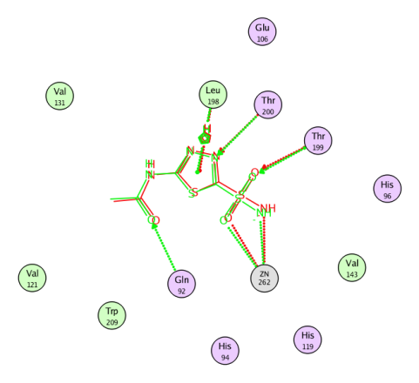 | 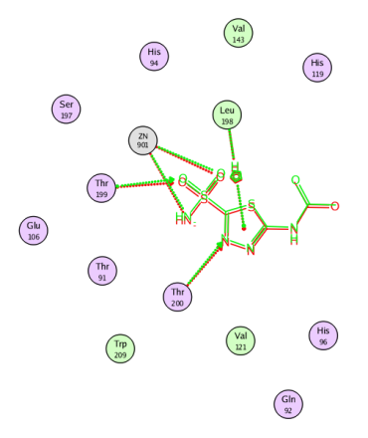
Figure S1. The superimposed orientations of the re-docked AAZ during validation protocol of molecular docking of hCAIX (a) and hCAXII (b) using PDB: 3IAI and 1JD0, respectively.

Table S1. Molecular docking results of 4, 5, 8, 10, 11, 13, 15 and 17 using hCAIX (PDB: 3IAI) and hCAXII (PDB: 1JD0) with the crucial amino acids highlighted in bold.

hCAIX |  |  |  |  |  |  |  |  |  |  |  |  |  | hCAXII
Cpd |  |  | Binding energy (Kcal/mol) | Interacting residues |  |  |  | Interaction type |  | Distance (Å) | Energy (Kcal/mol) |  |  | Cpd |  | Binding energy (Kcal/mol) |  | Interacting residues |  |  | Interaction type |  | Distance (Å) |  | Energy (Kcal/mol)
AAZ |  |  | -8.83 | Thr |  | 200 |  | H-acceptor |  | 2.84 | -1.60 |  |  | AAZ |  | -9.01 |  | Thr | 200 |  | H-acceptor |  | 2.81 |  | -1.10
 |  |  |  | Thr |  | 199 |  | H-acceptor |  | 2.85 | -4.90 |  |  |  |  |  |  | Thr | 199 |  | H-acceptor |  | 2.96 |  | -4.30
 |  |  |  | Zn |  | 262 |  | ionic |  | 2.05 | -15.30 |  |  |  |  |  |  | Zn | 901 |  | ionic |  | 1.96 |  | -17.00
 |  |  |  | Zn |  | 262 |  | ionic |  | 2.88 | -5.40 |  |  |  |  |  |  | Zn | 901 |  | ionic |  | 3.03 |  | -4.30
 |  |  |  | Leu |  | 198 |  | pi-H |  | 4.21 | -0.70 |  |  |  |  |  |  | Leu | 198 |  | pi-H |  | 3.52 |  | -0.60
 |  |  |  | Leu |  | 198 |  | pi-H |  | 4.34 | -0.60 |  |  | 1 |  | -9.96 |  | Thr | 91 |  | H-acceptor |  | 2.94 |  | -0.60
1 |  |  | -10.24 | Gln |  | 67 |  | H-acceptor |  | 3.17 | -1.50 |  |  |  |  |  |  | Leu | 198 |  | H-acceptor |  | 3.38 |  | -0.40
 |  |  |  | Thr |  | 199 |  | H-acceptor |  | 2.87 | -1.80 |  |  |  |  |  |  | Thr | 199 |  | H-acceptor |  | 3.02 |  | -4.30
 |  |  |  | Thr |  | 200 |  | H-acceptor |  | 3.22 | -1.20 |  |  |  |  |  |  | Zn | 901 |  | ionic |  | 2.80 |  | -6.00
 |  |  |  | Zn |  | 262 |  | ionic |  | 2.13 | -13.90 |  |  |  |  |  |  | Zn | 901 |  | ionic |  | 1.95 |  | -17.20
 |  |  |  | Zn |  | 262 |  | ionic |  | 2.66 | -7.20 |  |  | 9 |  | -11.6 |  | Asn | 69 |  | H-acceptor |  | 3.45 |  | -2.00
 |  |  |  | Val |  | 121 |  | pi-H |  | 4.43 | -0.50 |  |  |  |  |  |  | Thr | 199 |  | H-acceptor |  | 2.53 |  | -1.10
9 |  |  | -12.26 | Ser |  | 3 |  | H-donor |  | 3.70 | -0.40 |  |  |  |  |  |  | Thr | 199 |  | H-acceptor |  | 2.25 |  | -5.30
 |  |  |  | Val |  | 19 |  | H-donor |  | 3.56 | -0.20 |  |  |  |  |  |  | Thr | 200 |  | H-acceptor |  | 2.31 |  | -1.90
 |  |  |  | Asn |  | 62 |  | H-donor |  | 3.88 | 0.00 |  |  |  |  |  |  | Thr | 91 |  | H-donor |  | 3.31 |  | -0.30
 |  |  |  | Asn |  | 62 |  | H-acceptor |  | 2.42 | -1.80 |  |  |  |  |  |  | Zn | 901 |  | ionic |  | 1.94 |  | -17.5
 |  |  |  | Leu |  | 198 |  | H-acceptor |  | 2.48 | -0.30 |  |  |  |  |  |  | Leu | 198 |  | H-acceptor |  | 2.52 |  | -0.50
 |  |  |  | Thr |  | 199 |  | H-acceptor |  | 2.00 | -4.60 |  |  | 12 |  | -11.14 |  | Leu | 198 |  | H-acceptor |  | 3.37 |  | -0.40
 |  |  |  | His |  | 94 |  | H-acceptor |  | 2.49 | -0.80 |  |  |  |  |  |  | Thr | 199 |  | H-acceptor |  | 2.96 |  | -4.70
 |  |  |  | Zn |  | 262 |  | ionic |  | 1.95 | -17.20 |  |  |  |  |  |  | Ser | 132 |  | H-acceptor |  | 3.16 |  | -0.30
 |  |  |  | Ser |  | 3 |  | pi-H |  | 3.88 | -0.20 |  |  |  |  |  |  | Lys | 67 |  | H-acceptor |  | 3.28 |  | -7.70
 |  |  |  | Trp |  | 5 |  | pi-H |  | 2.70 | -0.60 |  |  |  |  |  |  | Zn | 901 |  | ionic |  | 1.96 |  | -17.10
 |  |  |  | Pro |  | 202 |  | pi-H |  | 3.21 | -0.20 |  |  |  |  |  |  | Zn | 901 |  | ionic |  | 2.73 |  | -6.60
12 |  |  | -11.48 | His |  | 94 |  | H-acceptor |  | 3.48 | -0.20 |  |  | 16 |  | -12.46 |  | Lys | 67 |  | H-acceptor |  | 3.10 |  | -0.60
 |  |  |  | Leu |  | 198 |  | H-acceptor |  | 3.19 | -0.40 |  |  |  |  |  |  | Leu | 198 |  | H-acceptor |  | 3.34 |  | -0.60
 |  |  |  | Thr |  | 199 |  | H-acceptor |  | 3.06 | -3.80 |  |  |  |  |  |  | Thr | 199 |  | H-acceptor |  | 3.04 |  | -4.00
 |  |  |  | Gln |  | 92 |  | H-acceptor |  | 3.40 | -1.20 |  |  |  |  |  |  | Zn | 901 |  | ionic |  | 3.03 |  | -4.30
 |  |  |  | Zn |  | 262 |  | ionic |  | 2.00 | -16.20 |  |  |  |  |  |  | Zn | 901 |  | ionic |  | 2.00 |  | -16.20
16 |  |  | -12.02 | Gln |  | 67 |  | H-donor |  | 4.12 | 0.00 |  |  |  |  |  |  | Leu | 198 |  | pi-H |  | 3.59 |  | -0.60
 |  |  |  | Thr |  | 199 |  | H-acceptor |  | 2.97 | -4.70 |  |  | 2 |  | -10.12 |  | Lys | 67 |  | H-acceptor |  | 3.19 |  | -3.20
 |  |  |  | Zn |  | 262 |  | ionic |  | 1.97 | -16.80 |  |  |  |  |  |  | Leu | 198 |  | H-acceptor |  | 3.31 |  | -0.60
 |  |  |  | Zn |  | 262 |  | ionic |  | 2.84 | -5.70 |  |  |  |  |  |  | Thr | 199 |  | H-acceptor |  | 3.06 |  | -3.80
 |  |  |  | Leu |  | 198 |  | pi-H |  | 4.53 | -0.20 |  |  |  |  |  |  | Zn | 901 |  | ionic |  | 3.09 |  | -3.90
 |  |  |  | Pro |  | 202 |  | pi-H |  | 4.22 | -0.40 |  |  |  |  |  |  | Zn | 901 |  | ionic |  | 2.00 |  | -16.10
 |  |  |  | Pro |  | 202 |  | pi-H |  | 3.84 | -0.50 |  |  |  |  |  |  | Leu | 198 |  | pi-H |  | 3.72 |  | -0.40
2 |  |  | -10.59 | Thr |  | 199 |  | H-acceptor |  | 2.89 | -1.60 |  |  | 11 |  | -12.31 |  | Leu | 198 |  | H-acceptor |  | 3.40 |  | -0.50
 |  |  |  | Thr |  | 200 |  | H-acceptor |  | 3.18 | -1.30 |  |  |  |  |  |  | Thr | 199 |  | H-acceptor |  | 3.06 |  | -3.90
 |  |  |  | Zn |  | 262 |  | ionic |  | 2.70 | -6.80 |  |  |  |  |  |  | Zn | 901 |  | H-acceptor |  | 2.90 |  | -0.40
 |  |  |  | Zn |  | 262 |  | ionic |  | 2.11 | -14.20 |  |  |  |  |  |  | Zn | 901 |  | ionic |  | 2.90 |  | -5.20
 |  |  |  | Val |  | 121 |  | pi-H |  | 4.16 | -0.80 |  |  |  |  |  |  | Zn | 901 |  | ionic |  | 2.00 |  | -16.20
11 |  |  | -11.84 | Thr |  | 199 |  | H-acceptor |  | 2.92 | -1.30 |  |  |  |  |  |  | Leu | 198 |  | pi-H |  | 3.58 |  | -0.40
 |  |  |  | Thr |  | 200 |  | H-acceptor |  | 3.11 | -1.50 |  |  | 14 |  | -11.7 |  | Lys | 67 |  | H-acceptor |  | 3.30 |  | -4.90
 |  |  |  | Zn |  | 262 |  | ionic |  | 2.04 | -15.50 |  |  |  |  |  |  | Asn | 62 |  | H-acceptor |  | 3.50 |  | -0.40
 |  |  |  | Zn |  | 262 |  | ionic |  | 2.80 | -5.90 |  |  |  |  |  |  | Leu | 198 |  | H-acceptor |  | 3.48 |  | -0.60
 |  |  |  | Val |  | 121 |  | pi-H |  | 4.15 | -0.70 |  |  |  |  |  |  | Thr | 199 |  | H-acceptor |  | 3.06 |  | -9.50
14 |  |  | -11.79 | His |  | 64 |  | H-acceptor |  | 3.01 | -3.10 |  |  |  |  |  |  | Zn | 901 |  | ionic |  | 1.97 |  | -16.80
 |  |  |  | Leu |  | 198 |  | H-acceptor |  | 3.68 | -0.30 |  |  |  |  |  |  | Zn | 901 |  | ionic |  | 2.77 |  | -6.20
 |  |  |  | Thr |  | 199 |  | H-acceptor |  | 3.10 | -1.60 |  |  |  |  |  |  | Leu | 198 |  | pi-H |  | 3.56 |  | -0.30
 |  |  |  | Thr |  | 200 |  | H-acceptor |  | 3.11 | -1.50 |  |  | 18 |  | -11.97 |  | Lys | 67 |  | H-acceptor |  | 3.06 |  | -8.50
 |  |  |  | Zn |  | 262 |  | ionic |  | 2.00 | -16.20 |  |  |  |  |  |  | His | 64 |  | H-acceptor |  | 3.61 |  | -0.50
 |  |  |  | Gln |  | 92 |  | pi-H |  | 4.28 | -0.50 |  |  |  |  |  |  | Leu | 198 |  | H-acceptor |  | 3.49 |  | -0.50
 |  |  |  | Val |  | 131 |  | pi-H |  | 4.54 | -0.30 |  |  |  |  |  |  | Thr | 199 |  | H-acceptor |  | 3.05 |  | -9.70
 |  |  |  | Val |  | 131 |  | pi-H |  | 3.75 | -0.30 |  |  |  |  |  |  | Zn | 901 |  | ionic |  | 2.74 |  | -6.50
18 |  |  | -12.02 | Thr |  | 199 |  | H-acceptor |  | 2.90 | -5.00 |  |  |  |  |  |  | Zn | 901 |  | ionic |  | 1.98 |  | -16.60
 |  |  |  | Zn |  | 262 |  | ionic |  | 2.69 | -6.90 |  |  |  |  |  |  | Leu | 198 |  | pi-H |  | 3.53 |  | -0.30
 |  |  |  | Zn |  | 262 |  | ionic |  | 2.05 | -15.20 |  |  |  |  |  |  | Pro | 202 |  | pi-H |  | 4.08 |  | -0.20
 |  |  |  | Val |  | 131 |  | pi-H |  | 4.07 | -0.60 |  |  | 5 |  | -11.29 |  | Thr | 91 |  | H-donor |  | 3.37 |  | -1.00
 |  |  |  | Val |  | 131 |  | pi-H |  | 3.64 | -0.40 |  |  |  |  |  |  | Lys | 67 |  | H-acceptor |  | 3.64 |  | -0.70
 |  |  |  | Val |  | 131 |  | pi-H |  | 4.40 | -0.30 |  |  |  |  |  |  | Asn | 62 |  | H-acceptor |  | 3.21 |  | -0.50
 |  |  |  | Asp |  | 132 |  | pi-H |  | 4.43 | -0.80 |  |  |  |  |  |  | Leu | 198 |  | H-acceptor |  | 3.24 |  | -0.50
 |  |  |  | Asp |  | 132 |  | pi-H |  | 4.62 | -0.30 |  |  |  |  |  |  | Thr | 199 |  | H-acceptor |  | 3.07 |  | -3.90
 |  |  |  | Leu |  | 135 |  | pi-H |  | 5.05 | -0.40 |  |  |  |  |  |  | Zn | 901 |  | ionic |  | 1.92 |  | -17.70
 |  |  |  | Leu |  | 198 |  | pi-H |  | 4.10 | -0.30 |  |  |  |  |  |  | Zn | 901 |  | ionic |  | 3.13 |  | -3.70
 |  |  |  | Leu |  | 198 |  | pi-H |  | 3.55 | -0.40 |  |  |  |  |  |  | Lys | 67 |  | pi-cation |  | 3.88 |  | -0.50
 | 5 | -12.03 |  |  | Gln |  | 92 |  | H-acceptor | 3.04 | -1.00 |  |  |  | 7 | -11.01 | Thr |  |  | 199 |  | H-acceptor |  | 2.91 | -4.90
 |  |  |  |  | Zn |  | 262 |  | H-acceptor | 2.88 | -0.40 |  |  |  |  |  | Zn |  |  | 901 |  | ionic |  | 2.52 | -8.60
 |  |  |  |  | Thr |  | 199 |  | H-acceptor | 2.99 | -1.50 |  |  |  |  |  | Zn |  |  | 901 |  | ionic |  | 2.08 | -14.70
 |  |  |  |  | Thr |  | 200 |  | H-acceptor | 3.10 | -3.90 |  |  |  |  |  | Asn |  |  | 62 |  | pi-H |  | 4.42 | -0.60
 |  |  |  |  | Zn |  | 262 |  | ionic | 2.00 | -16.10 |  |  |  |  |  | Leu |  |  | 198 |  | pi-H |  | 3.57 | -0.30
 |  |  |  |  | Val |  | 121 |  | pi-H | 3.99 | -1.00
 |  |  |  |  | Val |  | 121 |  | pi-H | 4.06 | -0.20
 | 7 | -11.27 |  |  | His |  | 64 |  | H-acceptor | 3.05 | -6.40
 |  |  |  |  | Thr |  | 199 |  | H-acceptor | 2.93 | -2.00
 |  |  |  |  | Thr |  | 200 |  | H-acceptor | 3.25 | -1.20
 |  |  |  |  | Zn |  | 262 |  | ionic | 1.98 | -16.60
 |  |  |  |  | Zn |  | 262 |  | ionic | 3.21 | -3.20
 |  |  |  |  | Gln |  | 92 |  | pi-H | 4.58 | -0.60

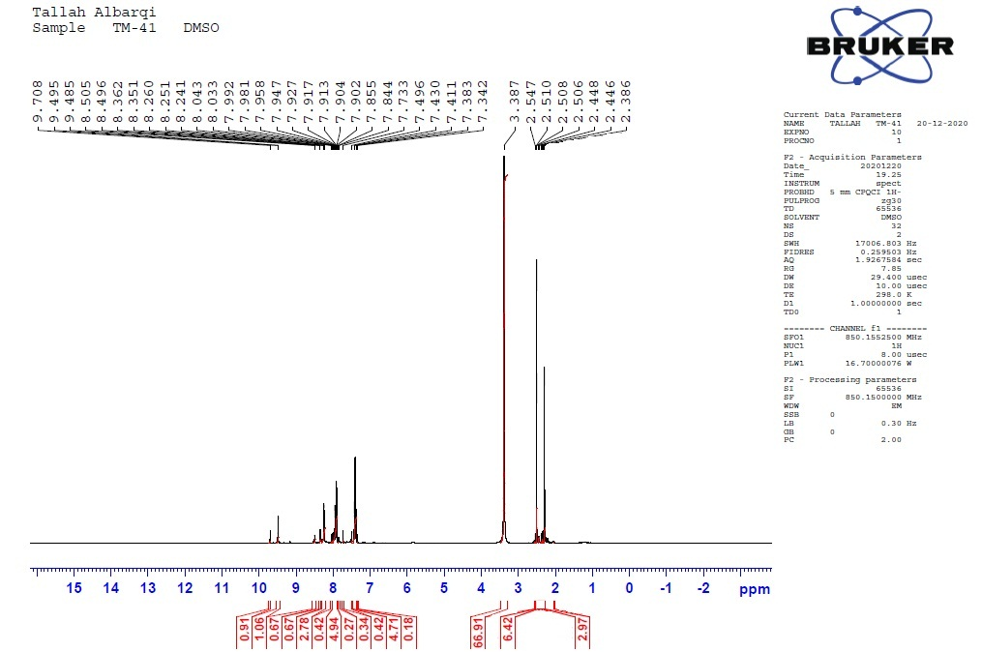
Figure S2. ¹H-NMR spectrum of compound 5.

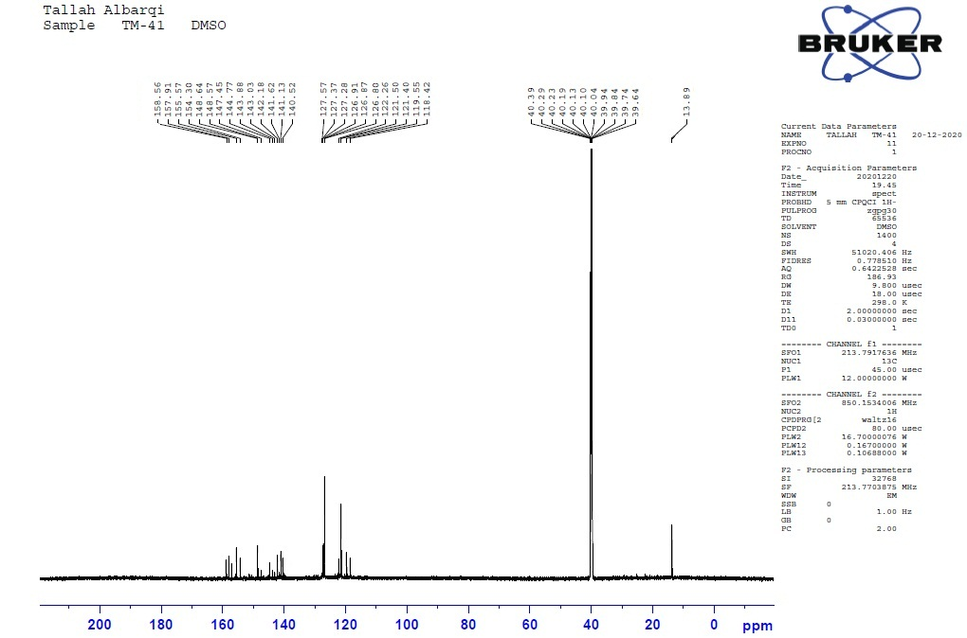
Figure S3. ¹³C-NMR spectrum of compound 5.

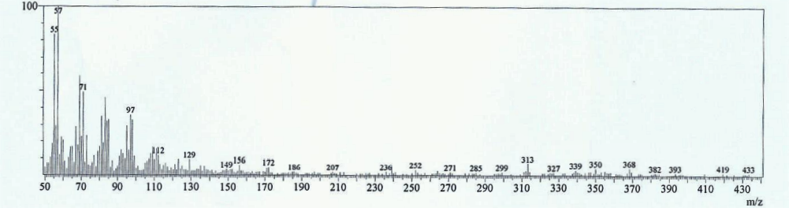
Figure S4. Mass spectrum of compound 5.

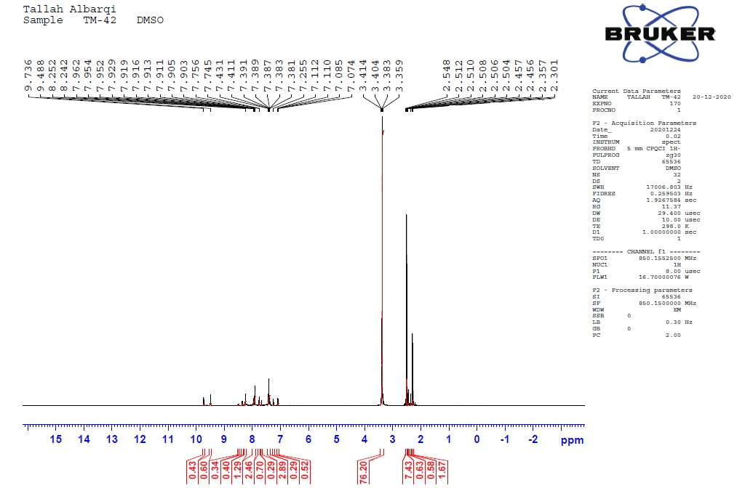
Figure S5. ¹H-NMR spectrum of compound 7.

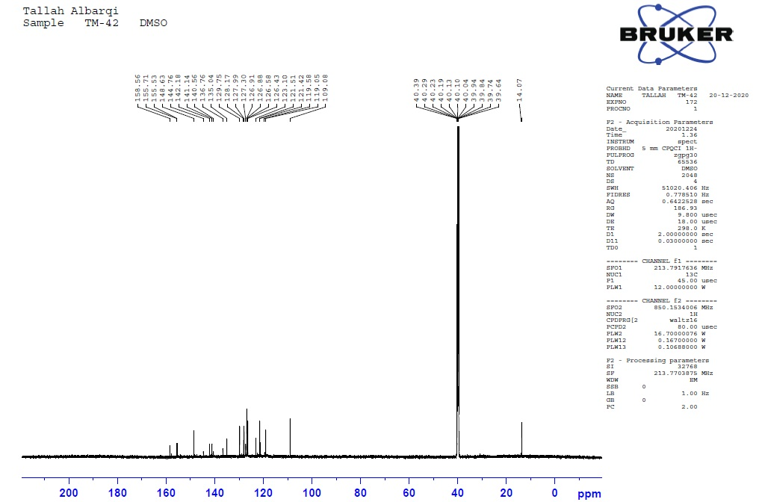
Figure S6. ¹³C-NMR spectrum of compound 7.

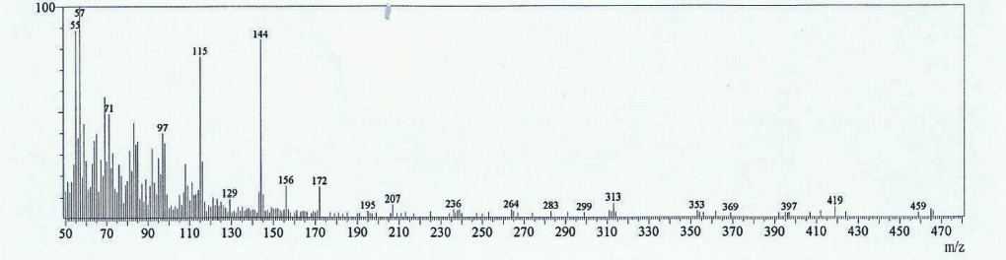
Figure S7. Mass spectrum of compound 7.

Figure S8. IR spectrum of compound 9.

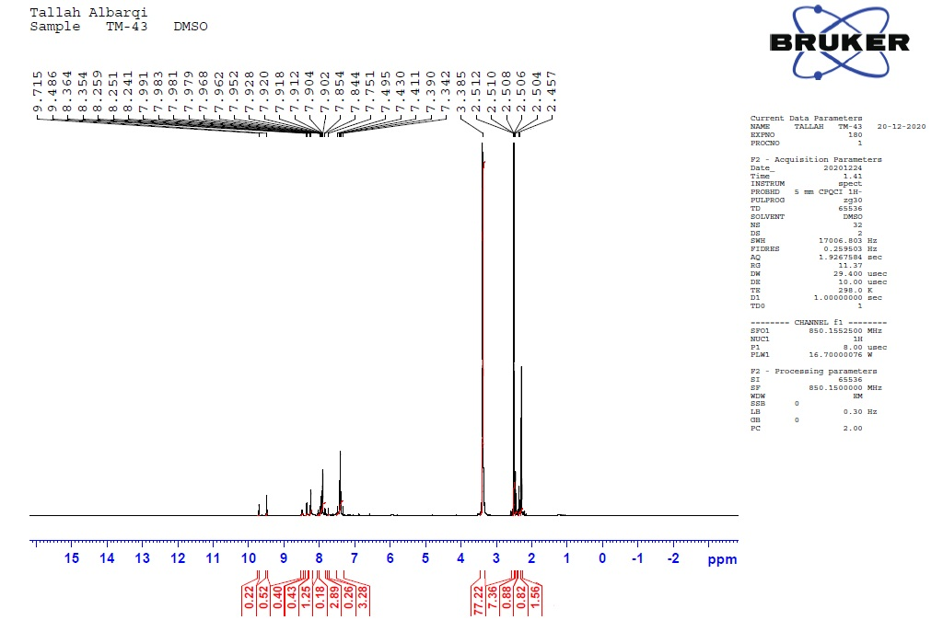
Figure S9. ¹H-NMR spectrum of compound 9.
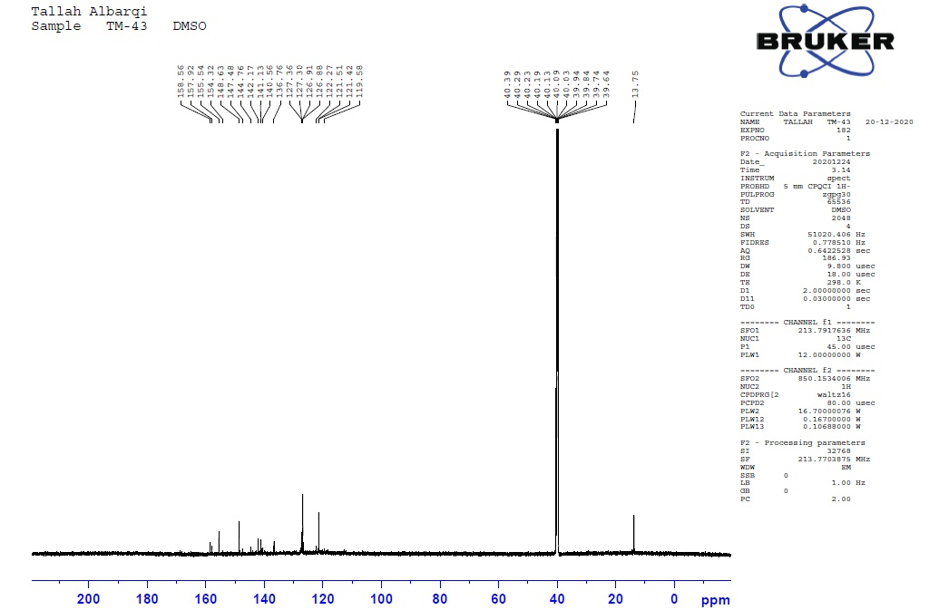
Figure S10. ¹³C-NMR spectrum of compound 9.
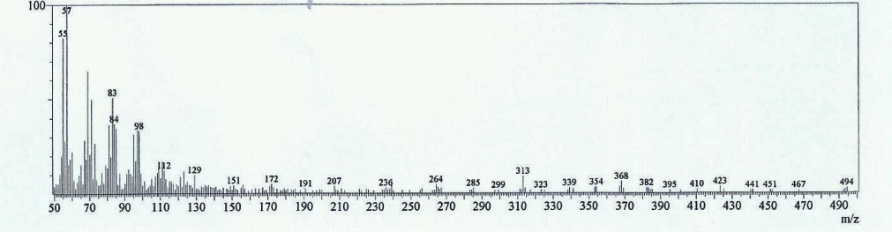
Figure S11. Mass spectrum of compound 9.

Figure S12. IR spectrum of compound 11.

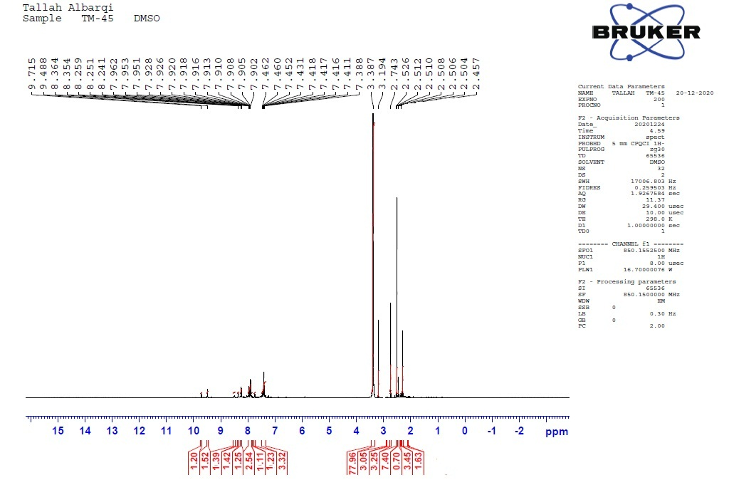
Figure S13.¹H-NMR spectrum of compound 11.
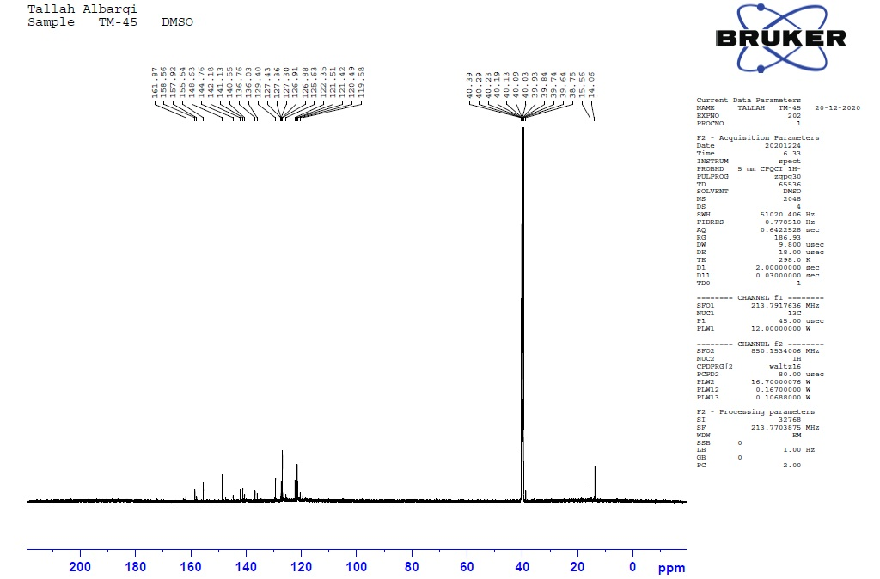
Figure S14. ¹³C-NMR spectrum of compound 11.
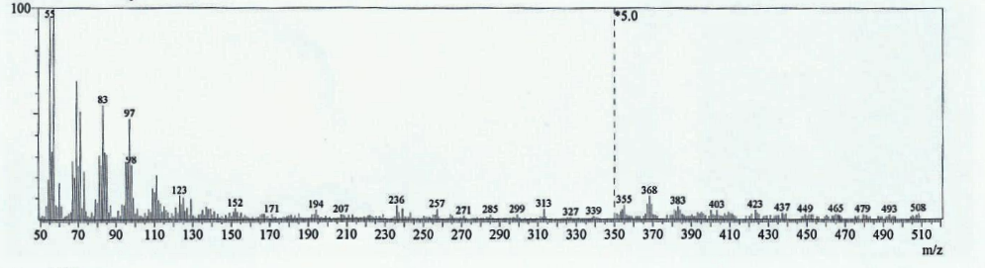
Figure S15. Mass spectrum of compound 11.

Figure S16. IR spectrum of compound 12.

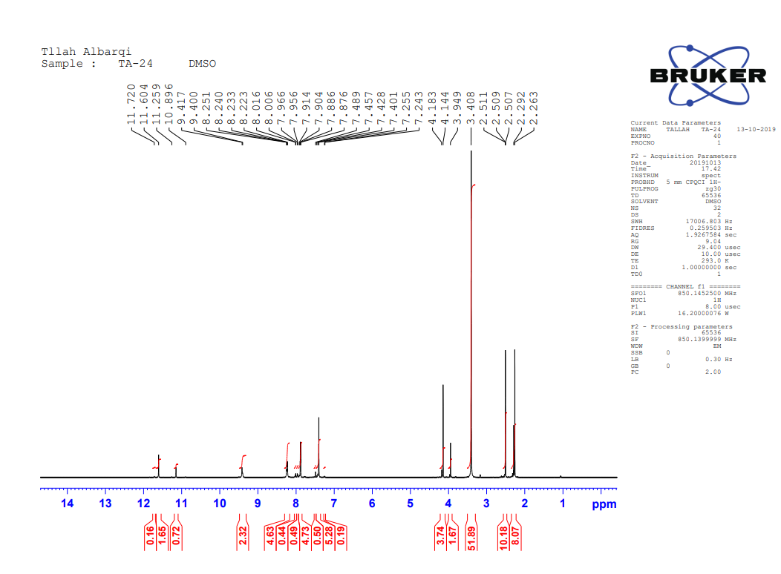
Figure S17.¹H-NMR spectrum of compound 12.
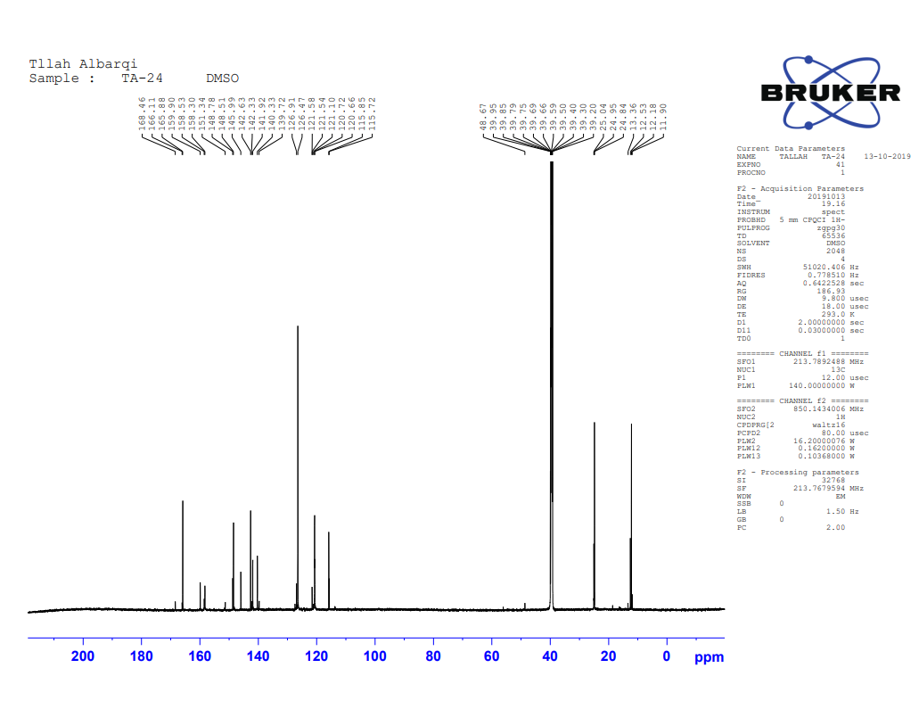Figure S18. ¹³C-NMR spectrum of compound 12.

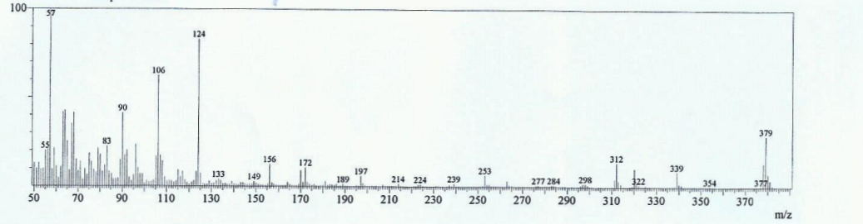
Figure S19. Mass spectrum of compound 12.

Figure S20. IR spectrum of compound 14.

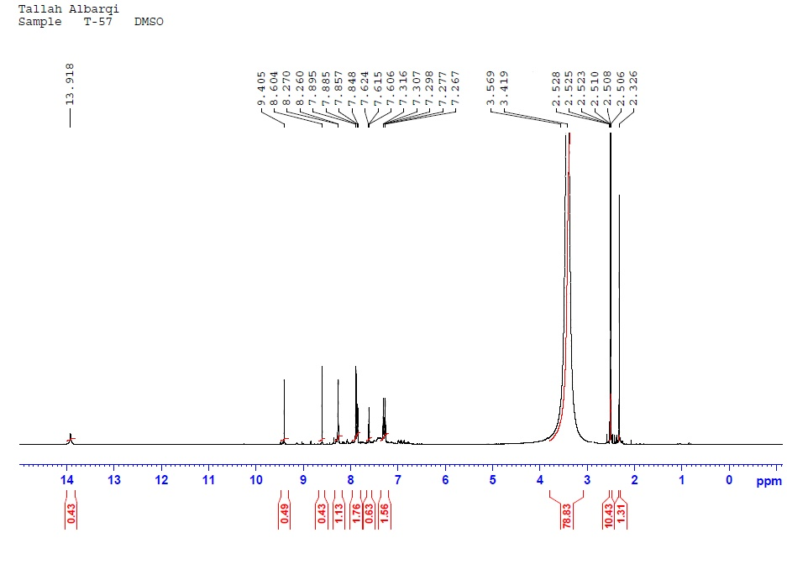
Figure S21.¹H-NMR spectrum of compound 14.

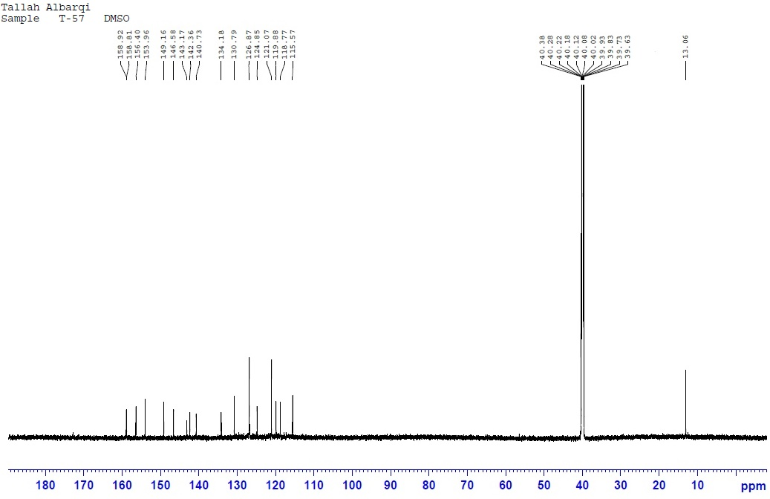
Figure S22.¹³C-NMR spectrum of compound 14.
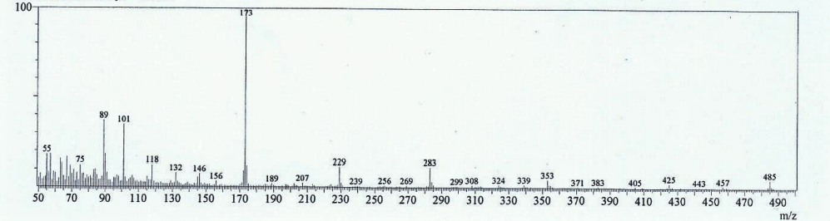
Figure S23. Mass spectrum of compound 14

Figure S24.IR spectrum of compound 16.
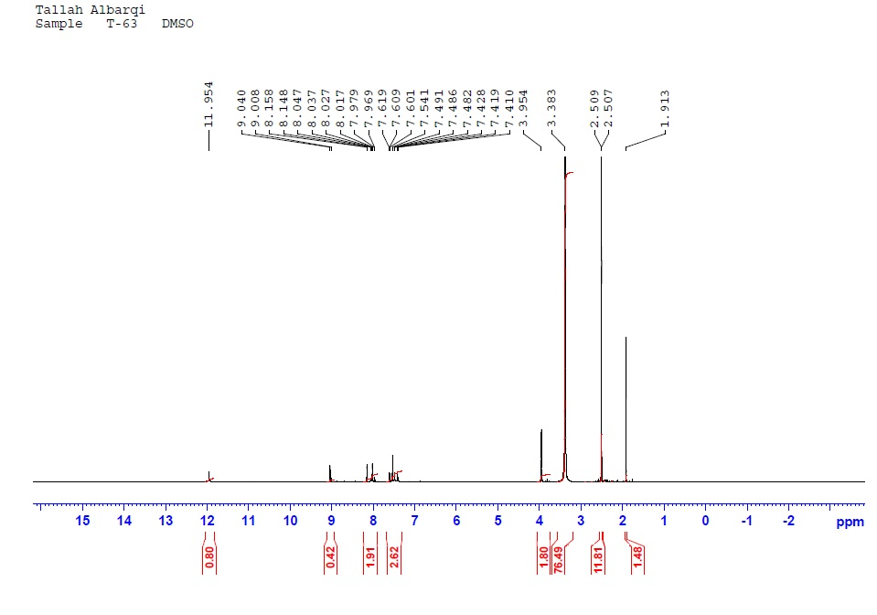
Figure S25.¹H-NMR spectrum of compound 16.

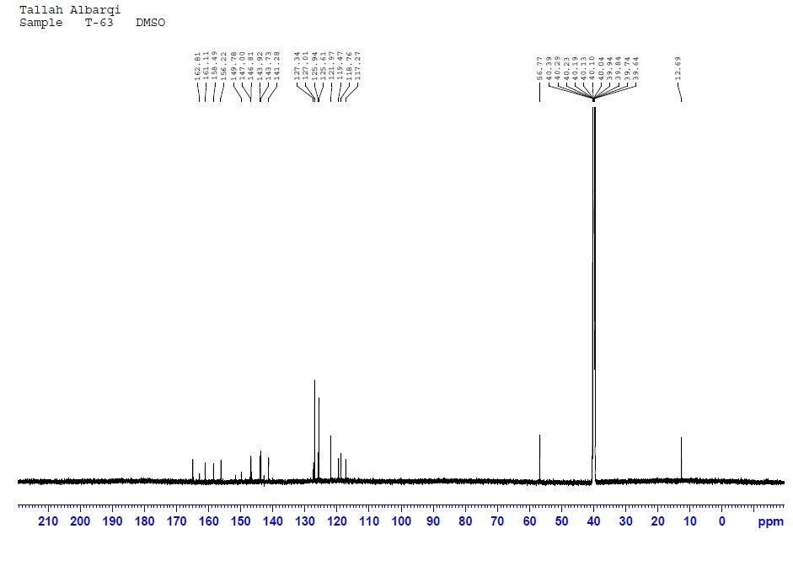
Figure S26.¹³C-NMR spectrum of compound 16.

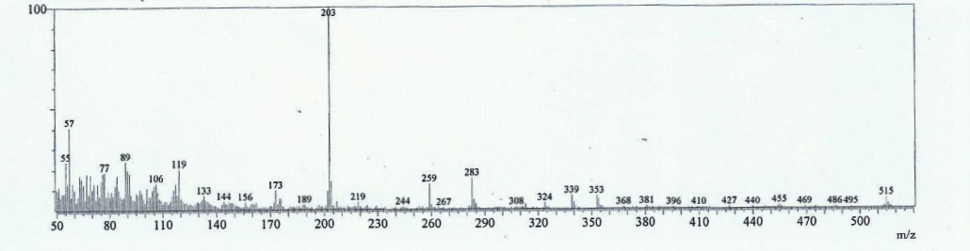
Figure S27. Mass spectrum of compound 16.

Figure S28. IR spectrum of compound 18.

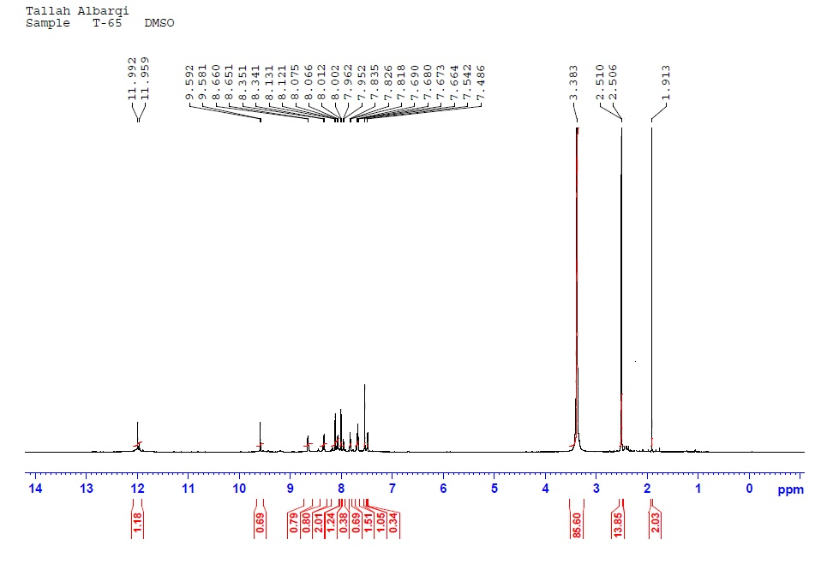
Figure S29. ¹H-NMR spectrum of compound 18.

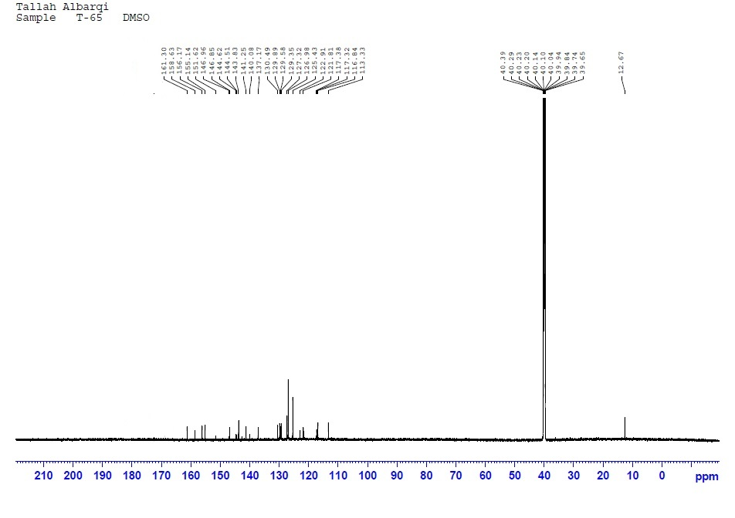
Figure S30. ¹³C-NMR spectrum of compound 18.
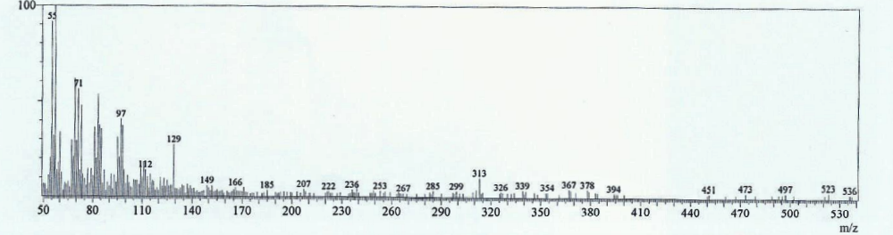
Figure S31. Mass spectrum of compound 18.

