**Supplementary material**

**Production of high-quality pyrolysis product by microwave–assisted catalytic pyrolysis of wood waste and application of biochar**

Hui Guoa, Xiaojing Qinb, Song Cheng c, d*, Baolin Xing c, d*, Dengke Jiang e, Weibo Mengb, Hongying Xiaf

a. School of Materials Science and Engineering, Henan Polytechnic University,

Jiaozuo 454003, China

b. School of Surveying and Land Information Engineering, Henan Polytechnic University, Jiaozuo, 454003, China

c. College of Chemistry and Chemical Engineering, Henan Polytechnic University, Jiaozuo 454003, China；

d. Collaborative Innovation Center of Coal Work Safety and Clean High Efficiency Utilization, Jiaozuo, 454003, China

e. Chifeng Shanjin Silver and Lead CO.,LTD, Chifeng, Inner Mongolia,

025450, China

f. Faculty of Metallurgical and Energy Engineering, Kunming University of Science and Technology, Kunming, 650093, China)

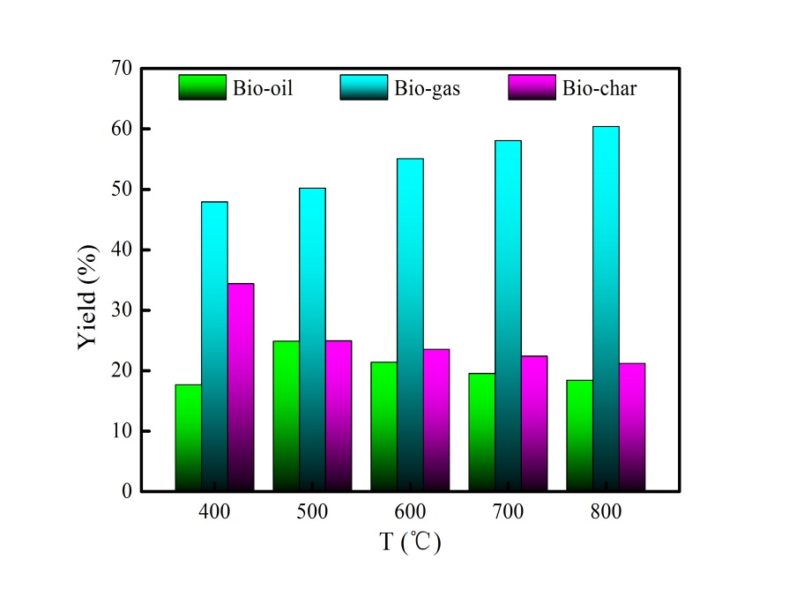

**Fig.S1** Yield of pyrolysis product at different pyrolysis temperatures without additive.

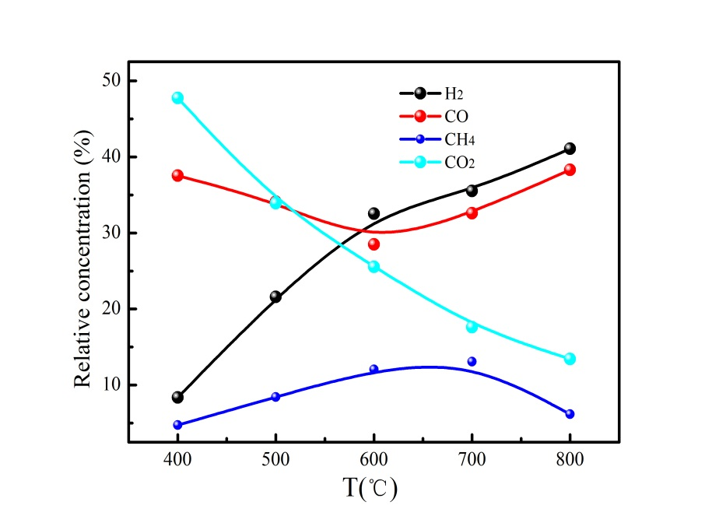

**Fig.S2** The bio-gas component of WS without adding additive under different pyrolysis temperature.

**Table S1** Adsorption isotherm models adopted in this work and their parameters.

|  |  |  |
| --- | --- | --- |
| Isotherm | Equation | Parameters |
| Langmuir |  | Ce is the equilibrium concentration(mg/L)  Q0 (mg/g) is adsorption constant related to adsorption capacity  KL (L/g) is adsorption constant related to energy of adsorption |
| Freundlich |  | KF is adsorption constant related to adsorption capacity (mg/g).(L/mg)1/n  n is adsorption constant measuring the adsorption intensity |