**Electrochemical determination of imatinib mesylate using TbFeO3/g-C3N4 nanocomposite modified glassy carbon electrode**

**Mahin Baladi1, Hakimeh Teymourinia2,3, Elmuez A. Dawi4, Mahnaz Amiri5, 6, Ali Ramazani2,3,**, Masoud Salavati-Niasari1,\***

*1Institute of Nano Science and Nano Technology, University of Kashan, P.O. Box 87317-51167, Kashan, Iran*

*2Department of Biotechnology, Research Institute of Modern Biological Techniques (RIMBT), University of Zanjan, P.O. Box 45371-38791, Zanjan, Iran*

*3Department of Chemistry, Faculty of Science, University of Zanjan, P.O. Box 45371-38791, Zanjan, Iran*

*4Nonlinear Dynamic Research Center (NDRC), College of Humanities and Sciences, Ajman University, P.O. Box 346, Ajman, UAE*

*5Neuroscience Research Center, Institute of Neuropharmacology, Kerman University of Medical Science, Kerman, Iran*

*6Department of Hematology and Laboratory Sciences, Faculty of Allied Medical Sciences, Kerman University of Medical Sciences, Kerman, Iran*

*\*\*Corresponding author: E-mail address****:***[*aliramazani@gmail.com*](mailto:aliramazani@gmail.com) *(***A. Ramazani)**

*\*Corresponding author. Tel.: +98 315 5912383; Fax: +98 315 5913201; E-mail address:* [*salavati@kashanu.ac.ir*](mailto:salavati@kashanu.ac.ir)(**M. Salavati-Niasari**)

**Table S1.** Porosity characteristics of synthesized nanomaterials from BET analysis

|  |  |  |  |
| --- | --- | --- | --- |
| Product | Vm (cm3 g-1) | as (m2 g-1) | Average pore diameter (nm) |
| TbFeO3 | 0.4228 | 1.8401 | 23.247 |
| TbFeO3/g-C3N4 | 1.7094 | 7.44 | 28.91 |

Table S2. Optimizing modifier value in determination of IMAT

|  |  |
| --- | --- |
| Different quantities of nanocomposite | Oxidation current of IAMT |
| 1 μL | 7.12 (μA) |
| 2 μL | 15.77 (μA) |
| 3 μL | 11.30 (μA) |
| 5 μL | 10.55 (μA) |

Table S3: Intraday and Inter day precision of IMAT

|  |  |  |
| --- | --- | --- |
| Measured Concentration (μM), %RSD | | |
| Concentration (μM) | Intra day | Inter day |
| 0.50 | 0.50, 1.12 | 0.49, 1.43 |
| 5.00 | 4.98, 0.99 | 5.05, 1.09 |
| 15.00 | 15.01, 0.74 | 15.11, 0.63 |

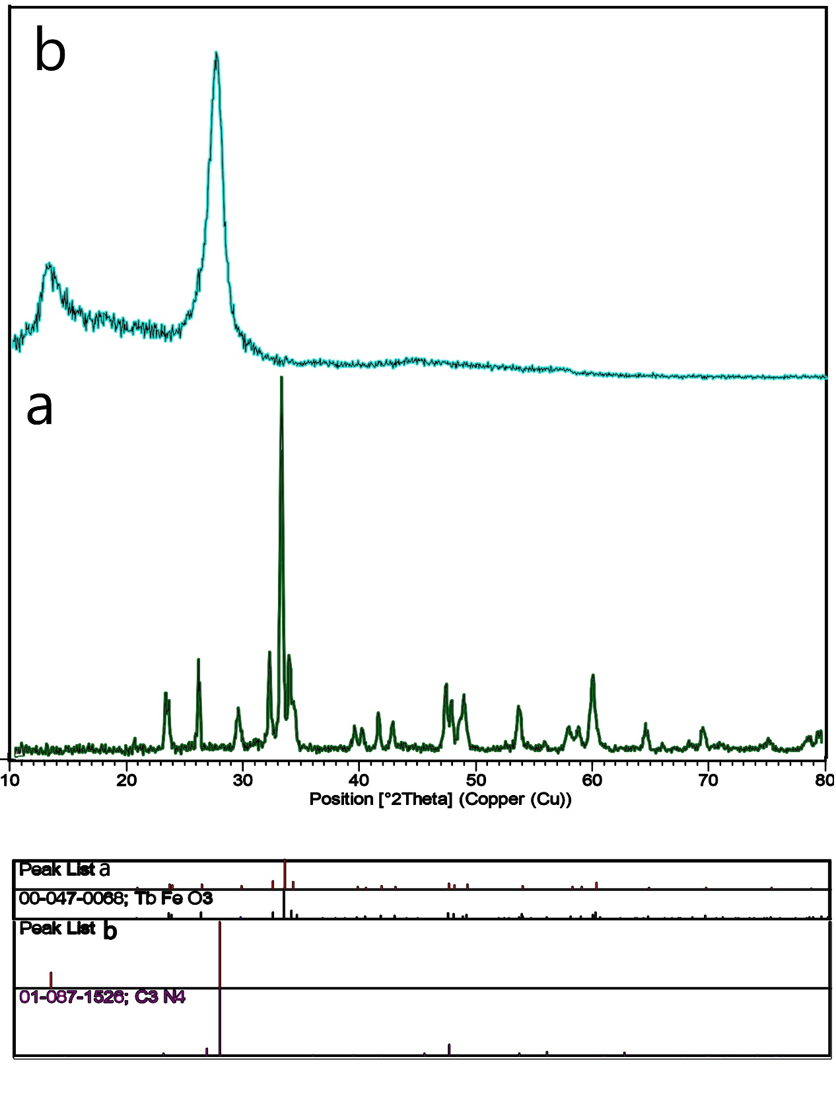

**Fig. S1.** XRD (a) patterns of the TbFeO3 nanoparticles prepared in the presence of diospyros kaki at 800 °C and (b) g-C3N4 at 550 °C for 4h.

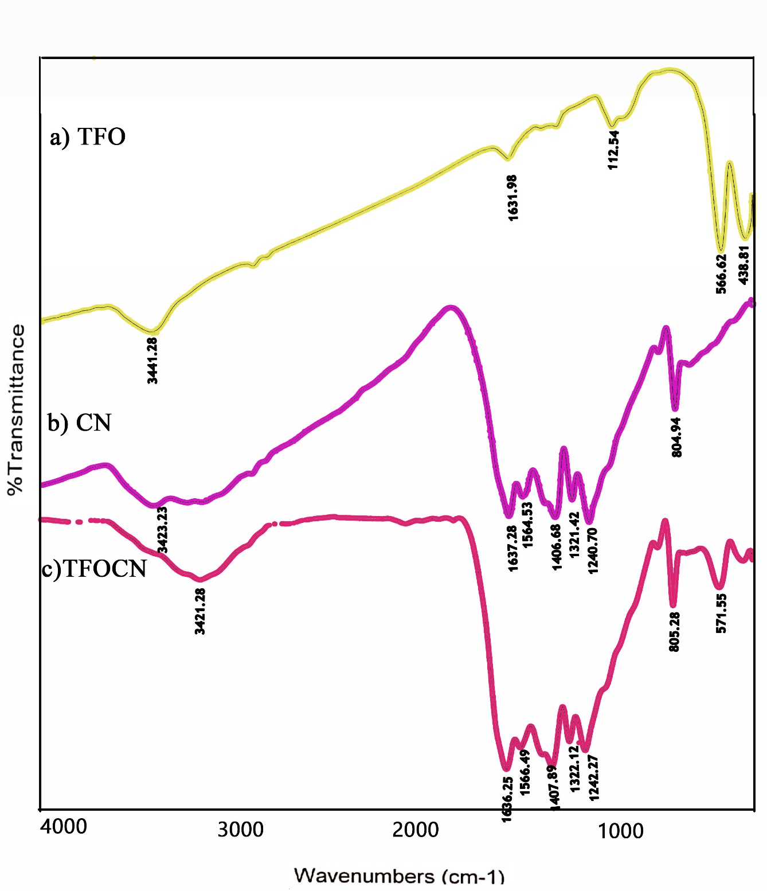

**Fig. S2.** The FTIR spectrum of (a) TbFeO3, (b) g-C3N4 and (c) TbFeO3/g-C3N4(1-1) nanocomposites .

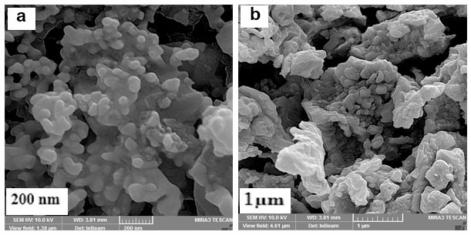

**Fig. S3.** SEM images of the TbFeO3 nanoparticles prepared using diospyros kaki as fuel at 800 °C for 4h.

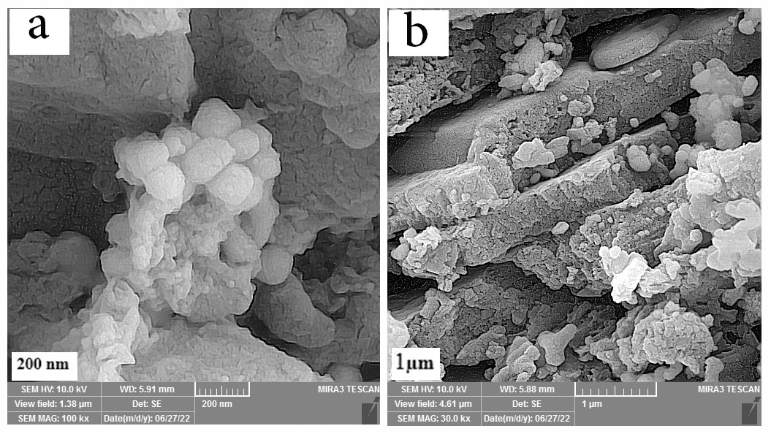

**Fig. S4.** SEM images of TbFeO3/g-C3N4 (1-1) nanocomposites.

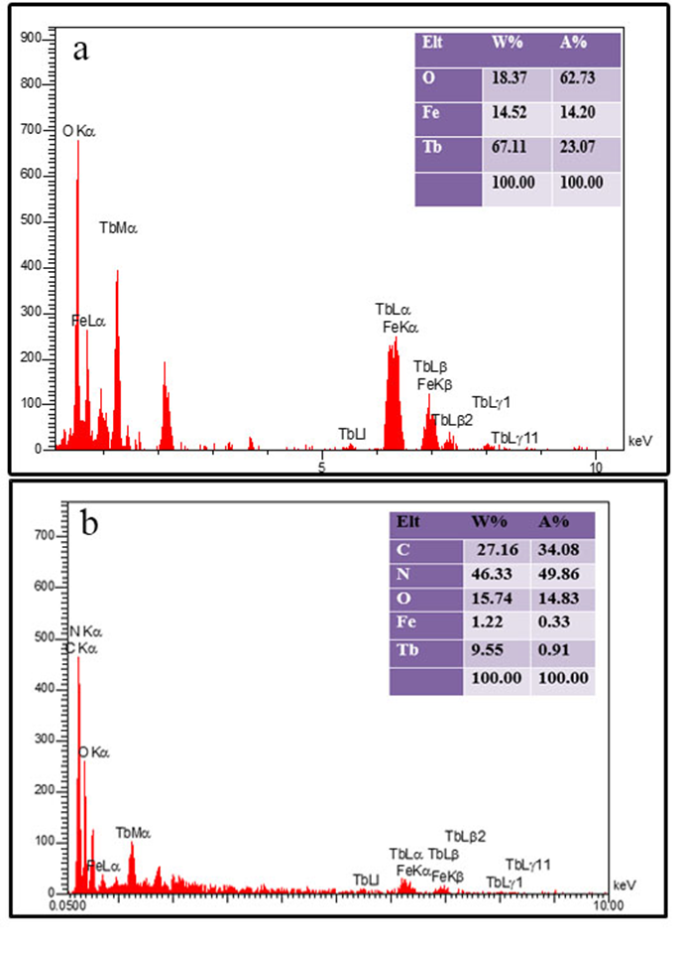

**Fig. S5.** EDS patterns of, (a) TbFeO3 and (b) TbFeO3/g-C3N4 (1-1) nanocomposites.

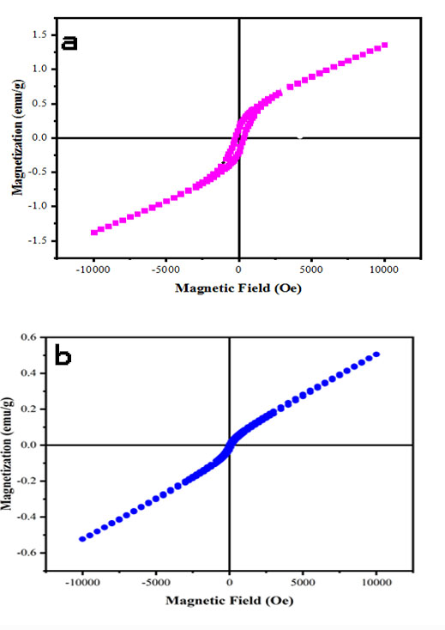

**Fig. S6.** M-H hysteresis at 300 K for VSM images of (a) TbFeO3 and (b) TbFeO3/g-C3N4 (1-1) nanocomposites.

.

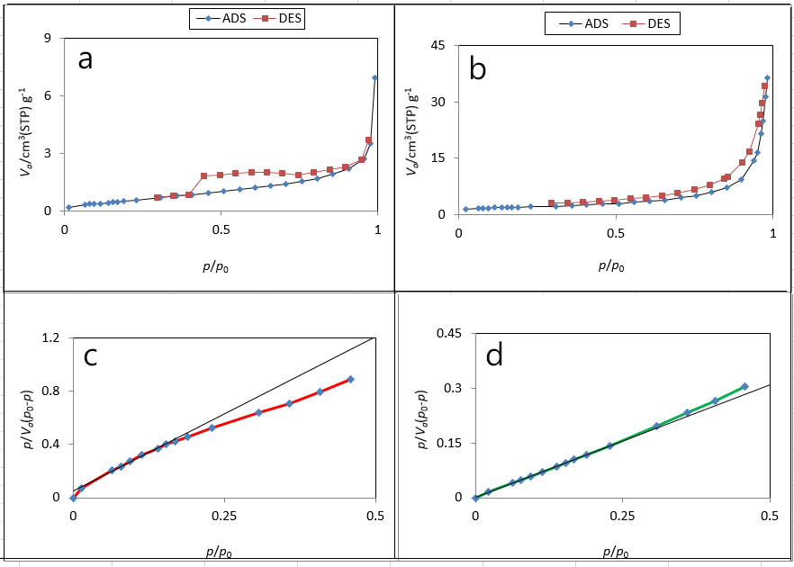

**Fig. S7.** N2 adsorption/desorption of (a,c) TbFeO3 and (b,d) TbFeO3/g-C3N4 (1-1) nanocomposites

Electrochemical impedance spectroscopy (EIS)

Electrochemical impedance spectroscopy (EIS) was employed as powerful technique to evaluate the improvement of the electrochemical behavior of the GCE toward used probe during different steps of modification by comparing the electron transfer resistance (Rct) given from the semicircle parts of obtained spectra. The values of Rct at the surfaces of GCE, g-C3N4/GCE and TbFeO3/g-C3N4/GCE resulted from the Nyquist plots were 2.35, 1.56 and 0.68 KΩ, respectively (Fig. S8).

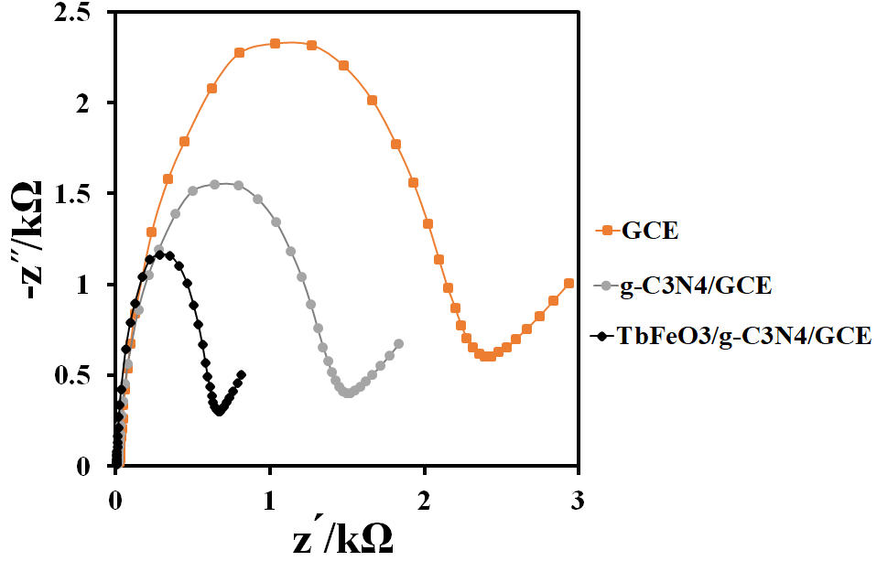

Fig. S8. Nyquist plots different electrodes in 0.1 M KCl and 1 mM K3Fe(CN)6/K4Fe(CN)6 solution

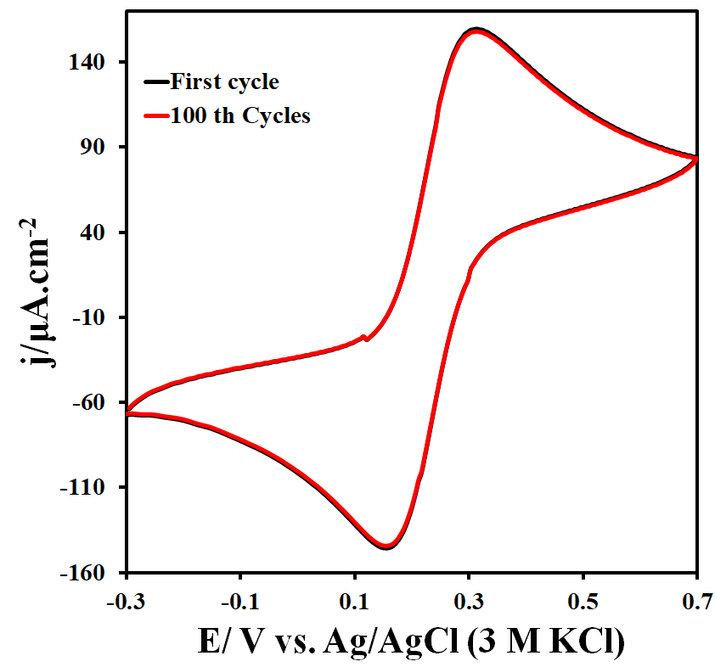

Fig. S9. Stability evaluation of the TbFeO3/g-C3N4/GCE surface in 0.1 M KCl and 1 mM K3Fe(CN)6/K4Fe(CN)6

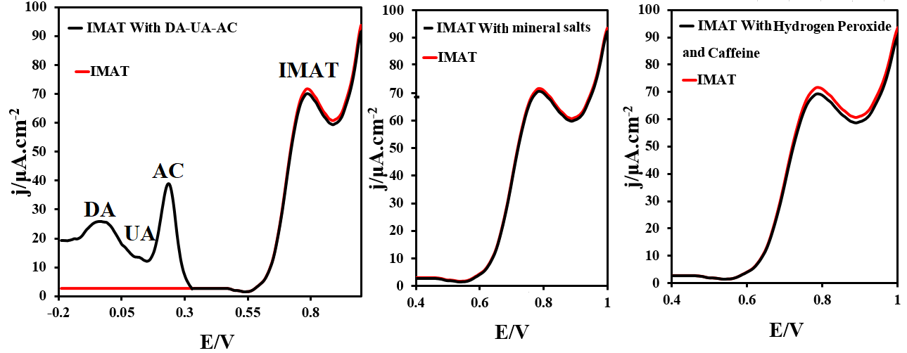

Fig. S10. DPVs 5 μM IMAT In the presence of various compounds on the TbFeO3/g-C3N4/GCE surface

**Statistical analysis**

One of the methods of statistical analysis is statistical inference, which leads to a decision about the statistical community through the information provided by a sample of the statistical population. Mean statistical tests, such as the t-test, are one of the types of methods that judge the mean. We used a t-test to compare the present developed method with another standard method and to evaluate the mean of the actual sample analysis results. The results of the IMAT detection in human blood serum sample by the DPV technique was compared with the UV spectroscopy method. Then a t-test inferential statistic was used to determine if there is a significant difference between the means of two methods. Statistical analysis of the results obtained by two methods (Table 2) ascertained that there was no significant difference among the methods at the confidence level of 95% (at p (t-value) > 0.05).

**Table 4**. Statistical comparison between the results of the DPV and UV method for the determination of IMAT

|  |  |  |  |  |  |
| --- | --- | --- | --- | --- | --- |
| Sample | Added | Item | DPV | UV | |
| Human blood serum | 0 µM | Mean (µM) | - | - | |
| *n* | 3 | | |
| 0.50 µM | Mean (µM) | 0.48 | | 0.46 |
| *n* | 3 | | |
| *p(t-value)* | 0.01 (0.05) | | |
| 5.00 µM | Mean (µM) | 4.86 | | 4.83 |
| *n* | 3 | | |
| *p(t-value)* | 0.4 (0.05) | | |
| 15.00 µM | Mean (µM) | 14.76 | | 15.58 |
| *n* | 3 | | |
| *p(t-value)* | 0.02 (0.05) | | |