**Supplementary Material**

**Study of the activity and stability of sulfonated carbon catalyst from agroindustrial waste in biodiesel production: Influence of pyrolysis temperature on functionalization**

Ana Paula da Luz Corrêaa, Paula Maria Melo da Silvaa, Matheus Arrais Gonçalvesa, Rafael Roberto Cardoso Bastosa, Geraldo Narciso da Rocha Filhoa, Leyvison Rafael Vieira da Conceiçãoa*.

a Federal University of Pará, Institute of Exact and Natural Sciences, Graduate in Chemistry Program, Laboratory of Catalysis and Oleochemical, 66075–110, Belém, Pará, Brazil.

*Corresponding author. Tel.: +55 91 98102 1185.

E-mail address: rafaelvieira@ufpa.br (Leyvison Rafael Vieira da Conceição).

Table S1 ― Raman analysis for biochars and catalysts: intensity of D and G bands.

|  |  |  |  |
| --- | --- | --- | --- |
| **Sample** | **ID (u. a.)** | **IG (u. a.)** | **ID/IG** |
| BC450 | 260.04 | 491.67 | 0.53 |
| BC600 | 167.62 | 291.41 | 0.57 |
| BC750 | 50.69 | 69.87 | 0.73 |
| BC450-S | 127.16 | 207.97 | 0.61 |
| BC600-S | 9.39 | 15.62 | 0.60 |
| BC750-S | 39.44 | 51.17 | 0.77 |

Figure S1 ― TG/DTG plots for the catalysts after reuse: (a) BC450-S, (b) BC600-S and (c) BC750-S.

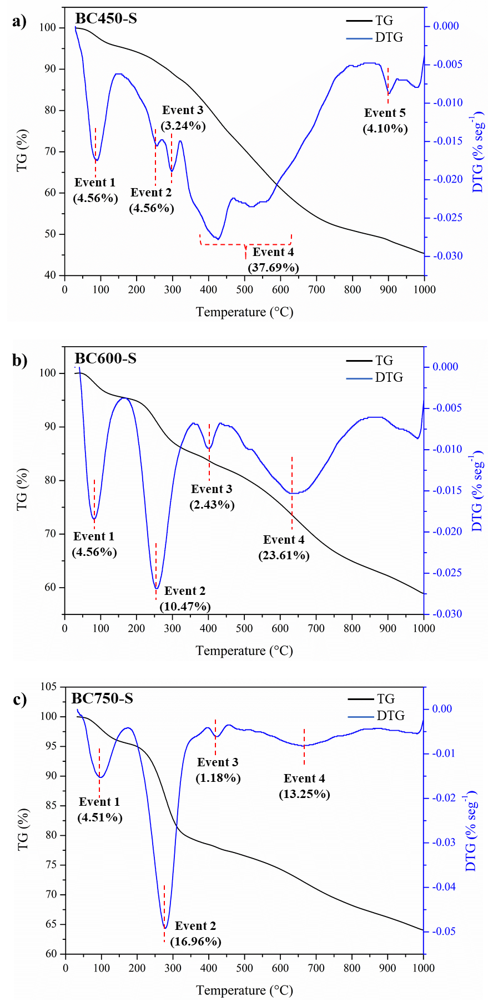

Figure S2 ― Graphical analysis of the effects of temperature and time variables in the first reaction cycle of the catalysts: Percentage of effects in (a), (c) and (e), and Probability graph in (b), (d) and (f).

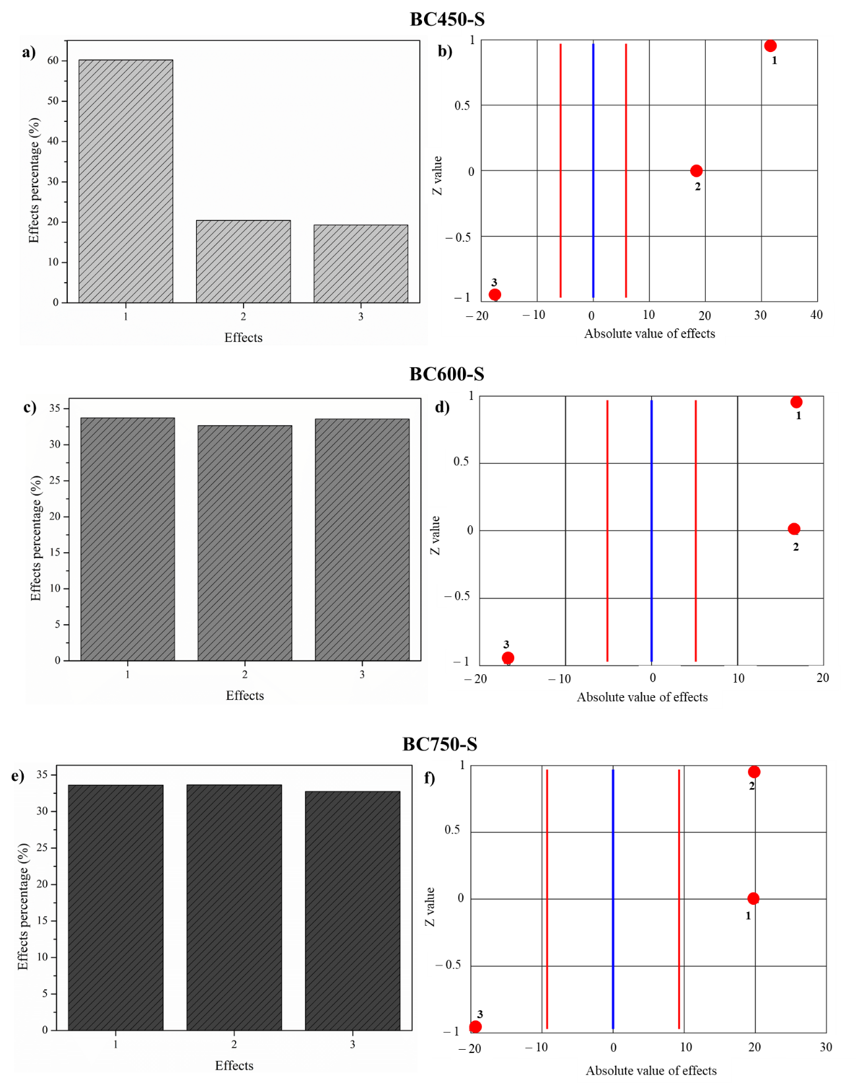

Figure S3 ― Graphical analysis of the effects of the temperature and time variables in the second reaction cycle of the catalysts: Percentage of effects in (a), (c) and (e) and Probability graph in (b), (d) and (f).

